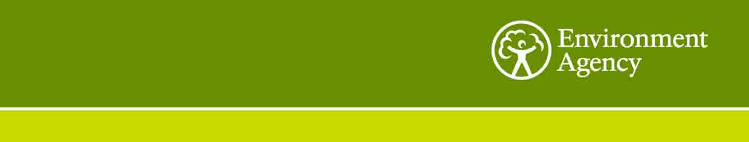

Expression of Interest

The Environment Agency (EA) intends to request quotes for the following project:
Project_2553 e2 – Sustainability Strategy and Engagement Plan Development

Summary:
- We need a consultant to support development of a new ground breaking sustainability strategy for the EA to deliver its strategic objectives to 2030.The Strategy will address the challenge of global sustainability, in the context of emerging mega-trends and aligning with the UN Sustainable Development Goals (SDGs). It will transform the way we work and show leadership in the way we address these urgent issues.

The key deliverables are:

An engagement plan and project timeline covering all phases of the project.

Provision of consultation and engagement tools, delivery of presentations, support and involvement in steering group meetings, workshops and events.

Senior level and external engagement interviews; collation and analysis of results with recommendations.

Providing system level knowledge of how to embed the strategy within the organisation particularly in relation to decision making. And advising on development of SMART targets and KPIs that will form part of a final strategy.

Delivery to very tight timescales – The initial findings and recommendations from the engagement and research must be ready in May. The strategy must be ready for full approval by October 2019.

Immediate start - The project must be set up, fully resourced and content for key events must be ready within one week of being engaged. The Consultants must have availability in the first month to deliver planned engagement and analysis.

We expect a minimum of three consultants will be allocated to this project, including a Director Consultant and Senior Consultant with extensive experience.

We are looking for a consultancy with extensive knowledge and experience of:

- Working with executive leaders to drive and set ambition, to deliver world-leading transformative sustainability strategies for large, complex organisations.
- Delivering effective, large-scale, communication and engagement plans with diverse stakeholders.
- Systems mapping, thinking and driving systemic change, futures work and mega trend analysis. And understanding of the UN SDGs and their application in business to drive real sustainability change and benefits.
- An international presence and access/links to external networks and world leading businesses in the sustainability field.
- An ability to resource, mobilise and work to very tight timescales.
- Share the same aims, vision and ambitions for the environment and society that are embedded within their company business model and work.

The intended start date for this work is 1 March 2019 and the whole project needs to be delivered by 31 October 2019. The first internal engagement meetings with senior managers in the organisation for this project is booked in for the start of March 2019.

Please can you respond with a short e-mail response within 5 working days (10am 18/01/19) to eira.coles@environment-agency.gov.uk to confirm if you would like to be considered for this further competition exercise. Please can you also confirm that you have the resource available to deliver the project within the timescales detailed above?

Yours Sincerely,

