Wandsworth Community Adult Health Services Specification

Authors
Name | Job Title
Dr Caroline Scott | GP Clinical Lead for Community Services (WCCG)
Claire Ratnayake | Director of Operations for Multi-Community Speciality provider (MCP)
Rebecca Wellburn | Director for Commissioning and Planning (WCCG)
Andrew McMylor | Director for Primary Care Development for MCP (WCCG)

Contributors
Name | Job Title
Dr Andrew Neil | Consultant Geriatrician Wandsworth. Secondary Care Doctor (WCCG)
Alison Benincasa | Divisional Chair of Community Services (SGUHFT)
Dr Rod Ewen | Clinical Lead for IT (WCCG)
Nick Beavon | Head Pharmacist (WCCG)
Patient Groups | From CRG’s, Commissioning PPGs and workshops
Professional Groups | Community Services Wandsworth, Wandsworth Borough Council, Commissioning Redesign Managers, St George’s Acute Services, Community Mental Health Team, Voluntary Sector

Table of Contents

1. Introduction 4
How the Model Operates 5
Functions of Care Approach 5
2. Overarching Aims and Objectives of CAHS 8
Geographical Coverage and Patient Caseload 8
3. Detail of Systems and Processes - Meetings 10
Daily Handover Meeting 10
Weekly Multidisciplinary Team (MDT) Meeting 11
4. Key Worker Concept 13
Key Workers for Patients, Family and Carers 13
Identifying Risk Levels in Patients 13
5. The Functions of Care 14
1) Central Access & Coordination hub – 8am-8pm Monday- Friday, 8am-4pm Saturday- Sunday 14
2) Facilitated and Supported Discharge (F&SD) 9-5pm Monday Friday, 15
8-4pm Saturday- Sunday 15
3) Maximising Independence (MI) – Monday - Friday 9-5pm Saturday - Sunday 8 - 4pm 16
4) Complex Case Management (CCM) & Scheduled and Ongoing Care (S&OC) 17
5) CAHS In-reach Nursing Home Team 7 days’ week service 9-5pm Monday to Friday , Saturday and Sunday on call service 10-6pm (bleep holder on call) 21
6) Specialist Nurses and Specialist Input (SN & SI) 23
All services operate 9-5pm 23
7) Planned Care Out-reach Services 23
8) Other Key Services aligned with CAHS 24
6. Out of Hours Provision – across all functions 25
7. Key services in Wandsworth Community Services – integral to the success of CAHS 25
Acute Admission Avoidance Pathway at Queen Mary’s Hospital 25
Step Up Bed Based Services QMH 26
Day Hospital at St John’s Therapy Centre and Queen Mary’s Day hospital 26
GP Rapid Response Service – led by MCP Lead Provider 26
Intermediate Care Bed Based Service at Ronald Gibson – led by Provider Brendoncare 26
8. Information Technology 27
9. Estates 28
10. Further Expectations of Provider 28
Safeguarding Adults at Risk 28
Staff Employed by Provider 29
Risk Management 29
Clinical Quality Review Group (CQRG) 30
MCP Mobilisation with Stakeholder Group and CAHS Performance Meeting (two-part meeting) 30
Infection Control 31
Complaints 31
11. Conclusion 31
12. Appendix 1 – Planning All Care Together Enhanced Care Pathway (PACT ECP) Suggested Standard Operating Procedures 33
13. Appendix 2 – Key Stakeholders 36
14. Appendix 3 – Glossary of Terms 37

Table of Figures

Figure 1: Patient Overview of the System............................................................................... 4
Figure 2: Community Services Functions Overview................................................................ 5
Figure 3: Weekly MDT Configuration...................................................................................... 9 Figure 4: Risk Groups............................................................................................................10
Figure 5: Access to Community Services.............................................................................. 11
Figure 6: Maximising Independence (MI) Pathway............................................................... 13
Figure 7: Complex Case Management Pathway.………....................................................... 14
Figure 8: Scheduled and Ongoing Care Pathway................................................................ 15

1. Introduction

This is a specification for Community Adult Health Services (CAHS) and describes the services that will be delivered in the borough of Wandsworth.

Wandsworth Clinical Commissioning Group’s model for Community Services is transformational and essential. The CAHS model seeks to improve the delivery of care for people in their own homes or at an appropriate clinical setting by linking systems and health professionals from health, social care and the voluntary sector together to enable staff to work more effectively. CAHS has now been operating for two years.

It is the intention of Commissioners and the Multispecialty Community Provider (MCP) Lead that the CAHS service be considered a pivotal service within the wider MCP model.

With the increasing health and social need in our aging population the centre of gravity for care needs to shift to people’s homes and away from locations such as secondary care. Our population expect this and the health and social care economy demands it. However, if people are going to be cared for out of hospitals we must commission and deliver improved community systems for this to be safe.

Improving access between primary care and community services has been a central theme for the transformation of Community Adult Health Services but even more important has been ensuring interlinked systems between secondary and community care to ensure timely, safe transfer from hospital to home to address the rising tide of avoidable admissions in all our local hospitals. This integration is essential for patient’s safety and experience and the ongoing financial feasibility and sustainability of the entire health and social care system.

It is apparent to observers of health and social care that community services have traditionally been commissioned in an ad-hoc and reactive way. This current service and the way they have been designed form an integral part of an entire whole systems approach which includes secondary and primary care transformation and cannot be uncoupled. CAHS is an ambitious model of care but improving community services’ ability to deliver care is vital and therefore radical solutions are essential.

Clinically led commissioning for health & social care integration presents an exciting opportunity to implement new ways of working together for our patients. The past two years have been an opportunity for more collaborative working amongst organisations. An example of this are the team of Social Workers and Social Care Support Workers that are aligned to CAHS and form part of the multidisciplinary team in the community. The team have clearly demonstrated successful integrated working and have been able to make a valuable contribution to services delivered by CAHS.

Overarching Governance Structure within the wider MCP Model

The CAHS team will form part of the overarching MCP model within Wandsworth. The MCP lead Provider recognises that CAHS is a vital service within the overarching model and will therefore work closely with the CAHS Provider to support the successful delivery of community services. The MCP lead therefore considers the below points as essential to the success of their relationship with a CAHS Provider:

- The MCP lead Provider and the CAHS Provider must consider the working relationship as stretching beyond a typical sub-contractual relationship that is managed at arm’s length in order to promote effective relationships to ensure CAHS delivers a high standard of services

- This collaborative approach to working will be delivered through some form of joint Governance structure, this approach will be used to support the CAHS management team to develop and improve services over the duration of the contract.
- Transparency around issues and risks in the service must be shared with the MCP lead at the earliest opportunity.
- Regular meetings between the MCP lead Provider and the CAHS Provider will take place to monitor performance via contractual KPIs.
- The MCP lead Provider will require the CAHS Provider to engage with a wider stakeholder group of organisations that are seen as key partners in the success of the MCP model

*Please note that proposed Governance arrangements that will exist between the MCP lead Provider and the CAHS Provider are still being developed and will be shared at the earliest opportunity.

How the Model Operates

The CAHS way of working is intended to subvert the traditional medical model where care is delivered by teams dedicated to a specific operational or disease pathway, which so often leads to silo working and fragmentation of services.

This model of care is holistic and facilitates the capacity to meet a person’s care needs wherever possible and for it to be delivered by any member of any team that has the capacity and capability. Patients’ needs are met by delivering care via activities referred to as ‘functions of care’.

Functions of Care Approach

The Functions of Care are:
- Access and Coordination
- Facilitated and Supported Discharge
- Maximising Independence
- Complex Case Management and Scheduled and Ongoing Care
- Specialist Input

An additional function available to CAHS patients in the community is a Rapid Response service which is a GP led model. This is operationally led by the MCP lead Provider via Primary Care who will work in partnership with CAHS staff to deliver a Rapid Response service. Patients are seen by a GP normally from their own practice within a target time of 2 hours for an urgent assessment.

It is essential to good clinical care that specialist services and disease specific pathways are recognised within these functions of care, ensuring that pathway care is still recognised as necessary and important especially as certain pathways are considered specialised. It is therefore essential that the CAHS specification is viewed as an evolving document and that the Provider of CAHS will work creatively and flexibly with the MCP Lead Provider once they are appointed and also with Commissioners to ensure the overall service can be developed so that the wider MDT in the Community works in an integrated way with acute colleagues such as Consultant Geriatricians and Diabetologists to provide outreach services in the form of specialist Tier 3 activity clinics. This will ensure appropriate and comprehensive pathways are developed and supported in the Community.
The MCP model is a vehicle for delivering care closer to the patient’s home which is more convenient and practical for patients wherever possible.

Care within the CAHS model embraces the person rather than expecting them to fit to a rigid pathway in order to have their care needs met. The functions are aligned around the person and react to their individual multi-factorial needs.

Figure 1: Patient Overview of the System

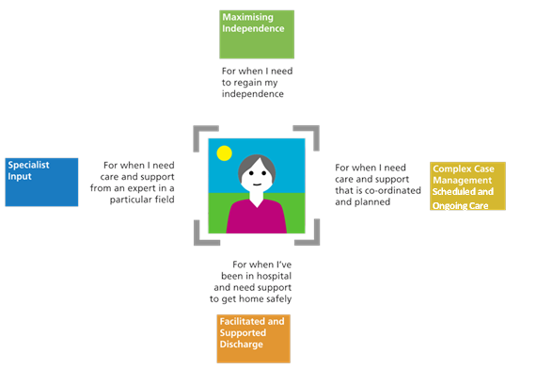

The diagram below further expands on how the functions of care will operate to deliver the care patients need and how the functions will be accessed by professionals who rely on community services to assist them in keeping people safe and healthy at home.

Figure 2: Community Services Functions Overview
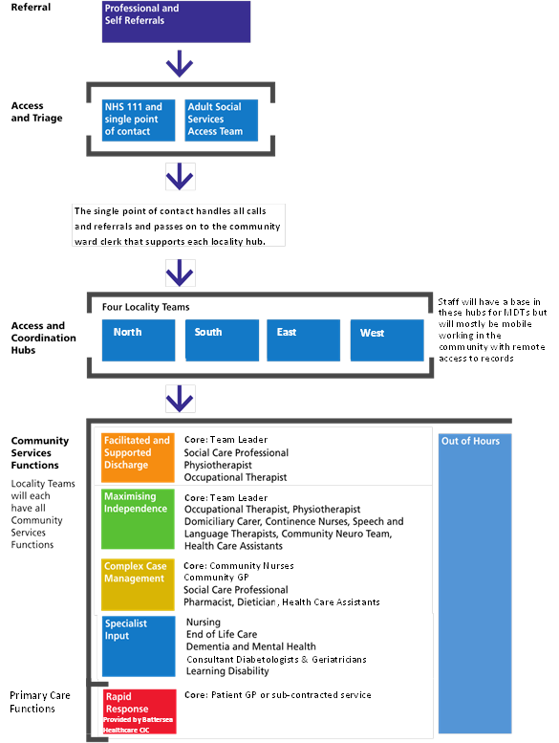
Primary Care Functions

2. Overarching Aims and Objectives of CAHS

- To provide a fully integrated, multi-professional, community-based service to meet people’s urgent and on-going health care needs.
- To reduce service fragmentation and ‘hand offs’ in an individuals’ care pathway.
- To dissolve complicated referral pathways, difficult access criteria and silo services.
- To foster a “yes service” culture focused on the needs of patients.
- To enable patients to remain well and independent in their own home wherever possible.
- To be a single point of contact accessing all available community care services and professionals including volunteers.
- To deliver person-centred, multidisciplinary, skilled and seamless care.
- To provide pro-active and anticipatory case management which is patient centred.
- To provide a reactive service delivering acute interventions when necessary.
- To be a platform providing access for all stakeholders: secondary, primary, voluntary sector care providers as well as patients and their families and carers.
- To facilitate safe and rapid discharge home if an admission is ever necessary.
- To facilitate closer working relationships once again between Community Nursing and Primary Care as they previously existed by having a named nurse linked to every practice.

The Community Adult Health Services (CAHS) must address the following needs within the Community:

- Improving access to community services via a single point through an Access & Coordination hub for all patients and health and social care professionals who need assistance to maintain care for people in the community
- Providing a complete service that has the necessary resources to provide full multidisciplinary care in patient’s own homes via an outreach service, integrated with primary, secondary, social & voluntary care agencies
- Enabling seamless and timely discharge from hospitals to home and interlinking between secondary, primary and community care systems. Community services must provide an in-reach service to facilitate effective and timely discharges

Geographical Coverage and Patient Caseload

Community services will be available to all relevant patients registered with a Wandsworth GP who are 18 years or over, the patient will generally be housebound either short term or long term.
However, with exception the Specialist Nursing teams listed below will provide specialist support to Primary care through the delivery of Tier 2 and 3 clinics within the community and this will be available for the more ambulant mobile patients as well as housebound patients:
- Heart Failure specialist nurses
- Respiratory Failure Specialist nurses
- Diabetes Specialist nurses
- Tissue Viability Specialist nurses
- Continence nurses Specialist nurses
The four geographical Locality CAHS teams in Community Services will all be aligned to each of the 42 GP Practices in Wandsworth.
All patients living in Lambeth registered with a Wandsworth GP will receive community nursing services from the community services team that deliver care to Lambeth residents, a separate contract exists for this service provision and remains in existence until further notice.
Wandworth Commissioned Services (‘Adult Community Services’)
There may be a cohort of patients that are registered with a Wandsworth GP Practice who are resident outside of the London Borough of Wandsworth. In such a scenario, the Provider remains responsible for providing services to them.
There may be occasions whereby it is neither expedient nor practical for the Provider to provide services to this cohort, although the Provider remains responsible nonetheless. In such scenarios, the Provider is permitted to enter into arrangements with the local community services Provider to provide such services. Any such arrangement would be at the Provider’s own expense.
The overall concern should relate to ensuring the needs of the patient being met, which includes securing the expedient provision of services that are fit for purpose and meet their clinical needs.

For avoidance of doubt, the Provider may not arbitrarily set a geographical distance outside of the borough that limits the reach of where it will provide services to.
If occasions emerge where there are concerns that the Provider may not be in a position to readily provide appropriate services to Wandsworth patients resident out of the borough and the Provider cannot make suitable arrangements with another provider organisation, then the Provider should contact the CCG at the earliest opportunity. This requirement does not detract from the fact that the Provider remains responsible for providing services to such patients.

It should be noted however that both the MCP Lead Provider and the CAHS Provider must regularly review the caseload to identify practices that are registering patients living at a significant distance outside of the borough. GPs must be reminded that they are responsible for advising the patient that the level of community service available to them may be reduced due to the extensive distance that the Community staff are required to travel to provide services and, in the event that it is needed, negotiating a like for like service with other providers may not always be possible. This will ensure patients expectations are managed where possible.

Wandsworth Resident Patients Registered with a Non-Wandsworth GP (‘Adult Community Services)
The Provider has not been commissioned to provide services to patients that are not registered with a Wandsworth GP Practice, yet whom are resident within the borough.
In a scenario where such a patient requires services, which would include domiciliary services or palliative care, the Provider may provide the services as either:
- an ad-hoc gesture of good will;
- as part of any reciprocal arrangements that the Provider develops; or
- through any cross-charging arrangements that the Provider develops.
For the purposes of ensuring a consistent approach to quality, any such activity should be seen as being governed by the principles and provisions of this contract.
It should be emphasised the interests of the patient should remain paramount and it would never be an acceptable scenario that a patient is denied care as a result of a charging dispute. If a scenario emerges where a different provider organisation refuses to either provide services to one of their own patients who is resident within Wandsworth, then the Provider should contact Wandsworth CCG expediently so that provisions can be made in order to resolve the issue. If the Provider believes that the patient has a clinical need to receive services, then they should provide such services whilst Wandsworth CCG seeks to resolve the matter.
Housebound people are defined as those who may be able to mobilise around their immediate environment, but for whom a home visit is the only practical means of enabling the person to access the service 'face-to-face’. People may be housebound on a short term, temporary basis (for example post-surgery, during an acute illness or if dying) or they may be housebound on a long term basis.

The Service must ensure that all such people can access services. For temporarily housebound people, this would be until such time as the person is able to attend clinic based services or their GP surgery. Home-based support for potentially vulnerable people who are functionally housebound must be delivered through integrated locality working; this includes providing support in care homes. The Service should be set up to ensure that access to services and support is improved, and as a result the Service should not exclude people who would otherwise not access care by another means.

The majority of the CAHS caseload are identified as 65 years and over.

3. Detail of Systems and Processes - Meetings

Meetings are considered essential and part of the daily routine of the team to ensure handover of ongoing patients care needs, to maintain effective oversight of staff and to robustly oversee and monitor the ongoing functionality of the whole system.

Regular meetings are an essential feature of the community services structure and the experience of undertaking them has demonstrated its immense value in improving communication. Occurrence and minimum attendance registers for the meetings below will be monitored. The Provider will be required to incorporate the following meetings within their operational delivery.

Community services will operate a management system with accountability for different staff groups within the varying functions. The Clinical Team Leaders are required to work with primary care, social care, mental health and voluntary sector colleagues as required to address activity and operational issues for their Locality on a daily basis.

Daily Handover Meeting

There will be a daily morning handover 7 days a week, 365 days a year where core members of the Multidisciplinary Team (MDT) on duty will discuss and coordinate care as a locality team.

- Based in each of the four locality MDT meeting rooms
- Face-to-face where possible or virtual via teleconferencing where not.
- There needs to be a clear and consistent structure to the daily meeting across all four locality teams.
- This meeting should be succinct
- The overall purpose is to update the team with changes in a patients’ condition overnight and assess and assign the team’s tasks for the day.
- During this meeting if capacity is considered an issue for the day and teams cannot be flexed to accommodate services at normal levels the MCP Lead Provider (Director of Operations) must be advised immediately of this issue

Suggested attendance

- Locality Manager – responsible for the operational delivery of the team
- Deputy Clinical Caseload Manager – deputy to Clinical Team Leader
- Senior Administration Manager – coordinates administration for MDTs
- Occupational Therapist and Physiotherapist – Maximising Independence (Therapy and Rehabilitation)
- GP – Complex Case Management – clinical lead for patients on the CCM caseload
- Social Worker – Complex Case Management – employed by the Local Authority but aligned to CAHS
- Community Nurses – Scheduled & Ongoing Care
- Facilitated and Supported Discharge Coordinator – one for each locality
- Specialist Nurses – one from each specialism including Respiratory, Heart Failure, Diabetes, Tissue Viability, Dementia and Continence
- Mental Health Nurses – employed by the Mental Health Trust but aligned to CAHS where possible

Roles & Responsibilities of Team Members

- The Clinical Team Leader (Chair) remains responsible for prompt time keeping, the record of attendance and ensuring all updates are entered on a patient white board in the office and appropriate amendments are made. Where relevant, reference must be made to the patients ‘my shared care plan’ on the white board to notify team members there is one in existence on the EMIS system.

- The Facilitated and Supported Discharge function (F&SD) will update the team on any proposed discharges into the locality for that day and any information they need, dependent on which function will be taking over the coordination of the patient’s care. The F&SD Coordinators must make contact with the acute wards within 24 hours of knowledge of admission (a list of admissions should be readily available from A&E departments in Acute Trusts). The F&SD Coordinators will advise the wards of the key worker responsible for the care of the patient in the community so the wards can liaise directly with the key worker or via the F&SD Coordinator to obtain specific information The coordinators must also liaise with the Acute wards to plan expedient and safe discharges. The F&SD Coordinators must carry a mobile phone and make their mobile number known to key staff within the acute setting and colleagues in CAHS as a means of contact

- Business Continuity Representatives from each function should operate within the safe staffing alert system and respond accordingly. The representatives will report any capacity issues due to unplanned sickness absence/leave to the Locality Manager enabling a rapid solution to be implemented and for management to be able to consider whether it is necessary to move staff from other Localities to cross cover and if that is not possible as a final resort invoke the business continuity procedure for Community Services Wandsworth. The MCP Director of Operations must be informed at this point

Weekly Multidisciplinary Team (MDT) Meeting

There will be a weekly MDT meeting. The MDT meeting will be held in the Locality offices and attended in person wherever possible. Attendance of core team members will be monitored as a Key performance indicator due to the importance of such a meeting which will be pivotal to the delivery of integrated care. Where it is not possible for key members of the MDT to attend, a teleconference system must be in place for staff to attend virtually. It is the responsibility of the CAHS provider to ensure such a system is available in all four localities.

The objective of the MDT discussion

The MDT meeting will focus on the most complex patients including Enhanced Care Pathway patients. The objectives of the MDT are to:

- Review patient goals and ensure appropriate movement between functions and to the wider whole system (e.g. to patient’s GP or secondary care).
- To facilitate effective working between the functions.

Patients to be discussed will be timetabled appropriately to allow for best use of staff resources. If a patient has a shared care plan held on EMIS, amendments to the care plan must be made during the MDT meeting. A patient will have a shared care plan if they are complex patients on the Enhanced Care Pathway (ECP). It is the responsibility of the chair of the MDT to ensure amendments are made to the patients’ care plan.

Core Members – full attendance at the four Locality MDTs is essential and the CAHS Provider will be monitored against a Key Performance Indicator recording weekly attendance

- Community Adult Health Services Clinical Team Leader (CAHS) GP – Chair
- Consultant Geriatrician – Employed by St George’s University Hospital Foundation Trust (SGUHFT) with an SLA between Wandsworth CCG and the acute Trust to oversee the operational outreach service from the acute Consultant Geriatrician team to community services
- Locality Manager
- Occupational Therapist and Physiotherapist – Maximising Independence
- Falls and bone Health team
- Clinical Caseload Manager – Complex Case Management
- Social Worker – Complex Case Management
- Specialist Nurses – Respiratory, Diabetes, Heart Failure, Tissue Viability, Dementia and Continence
- CAHS Pharmacist
- Community Nurses
- Wandsworth Registered GPs – to discuss their most complex patients
- Community Mental Health Nurse for the Locality – Employed by the Mental Health Trust
- Palliative Care Nurse - aligned to the End of Life Care Coordination Centre
- Voluntary Sector – Employed by a Voluntary Sector organisation but aligned to CAHS

Structure

There should be a consistent structure to the MDT meeting which will be adopted by all four locality teams. There should be an operating process/checklist that all MDTs should follow to ensure consistency of approach to running the MDT between the Localities.

The chair (CAHS GP) of the meeting will be responsible for:
- Providing structure and engaging all staff present to participate appropriately.
- Leading on a review of patient goals and agreeing a management plan.
- Timely running of the meeting to ensure it is productive especially when staff are scheduled to attend within a given time slot to discuss their patients

Figure 3: Weekly MDT Configuration
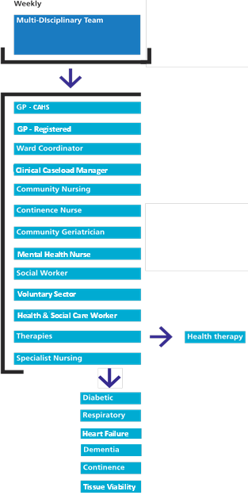

4. Key Worker Concept

Key Workers for Patients, Family and Carers

Every patient referred to the CAHS service will be assigned a key worker who will be the main point of contact for any queries that the patient or family and carers may have. The overriding care needs of the patient will determine the most appropriate professional to be assigned as the key worker (see table below). All patients and their carers must know who their individual key worker is and how to contact them in an emergency via the Access & Coordination hub . The Access & coordination hub should hold a register of patients and the aligned key worker and be able to contact them by mobile phone to advise them of the patients’ needs.

Overriding Need | Professional assigned to key worker role
Decreased mobility | Physiotherapist/Occupational Therapist
Clinical instability | Matron/Senior Nurse and/or GP
Social Care Needs | Social worker or Matron/Senior Nurse

Identifying Risk Levels in Patients

Patients will be risk stratified according to whether they are considered high, medium or low clinical risk. Depending on their risk stratification they will have different levels of input by community staff. This will be monitored closely and levels of clinician input will be adjusted accordingly.

In order to identify the most complex patients across primary care and CAHS, a risk stratification tool called Solis was used in identifying those patients that require more integrated care from a wider MDT.

Figure 4: Risk Groups
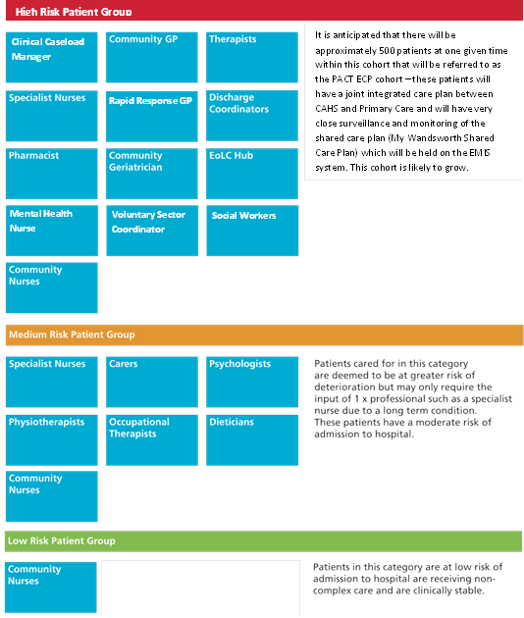

* N.B. It should be recognised that health and social care professionals delivering care to patients in the medium and low risk groups must at all times consider regular review of their patients as to whether they need to be escalated into the PACT ECP cohort due to the increasing complexity of their needs.

5. The Functions of Care

Community care will be grouped around the functions of care outlined below. This section presents a summary of each function.

1) Central Access & Coordination hub – 8am-8pm Monday- Friday, 8am-4pm Saturday- Sunday

This function describes the systems by which all stakeholders will access community health and social services and how these requests for assistance are responded to.

- For health services, the calls for assistance will be triaged by the 111 Provider (who currently provide the call-handling for 111 and Wandsworth Single Point of Contact (SPoC) service) who then transfer to a centralised Access and Co-ordination hub for CAHS. This Access and Co-ordination hub will be staffed by co-ordinators who will have intimate knowledge of services and functions within the four localities and be able to access the care needed directly with the appropriate staff.
- The Access and coordination hub will be managed by a senior Administrator who will be contactable by mobile phone to discuss any operational concerns. 111 and local GPs must be provided with this number
- Every shift, the Access & coordination team must have an experienced trained staff member, Band 6 or above, on duty to discuss triage/ referral concerns with. This individual does not need to be based in the office but must be contactable by phone.
- For social services the current call-handling systems will remain the same. The Wandsworth Access Team will however pass any relevant calls directly to the CAHS Social Work team that are a dedicated workforce of Social Workers working alongside CAHS in the community who provide a service for the CAHS caseload, especially those patients in the Complex Case Management function.

Figure 5: Access to Community Services

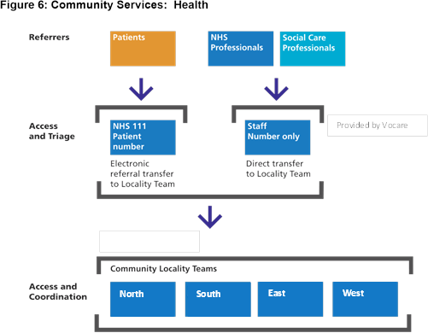

2) Facilitated and Supported Discharge (F&SD) 9-5pm Monday Friday,

8-4pm Saturday- Sunday

This function will ensure that the Facilitated and Supported Discharge team will provide an end to end service and will up follow patients for a two week period to ensure they are safely settled back into their own home environment. This will ensure discharges from hospital can occur as soon as possible and at a time appropriate to the patient and their families. The team will provide an in-reach element and work closely to support the hospital wards planning for discharge. The F&SD team will be flexible and when requested to do so will form part of any regular meeting with acute trusts to facilitate discharges – this may be in person or by conference call, whichever is most practical. The F&SD will help facilitate comprehensive discharges by liaising with the CAHS team in the community setting with each locality having their own F&SD nurse who will work with them. The F&SD staff will liaise with the wards within 48 hours of admission to commence early discharge plans and avoid unnecessary delays.

The core staff for this function will be experienced community nurses who are specifically employed in this role. In the event of leave and sickness the F&SD nurse will be required to cross cover each other to continue to support the discharges.

In addition to facilitating discharges (including into step down services) from the acute setting, CAHS will be required to in-reach to the community beds at Ronald Gibson House and on the Mary Seacole ward at Queen Mary’s Hospital, Roehampton (QMH) to facilitate early supported discharges. They will be required to work closely with the staff in these inpatient units.
All F&SD members must carry mobile phones and be accessible to promote urgent discharges especially at points of pressure in the system to enable capacity to be released in bed based services.

Daily Complex Discharge Review meeting (based in St George’s Hospital)

There is a scoping exercise currently being undertaken between community services, St George’s University Hospital Foundation Trust (SGUHFT) and social services to consider the implementation of a daily complex discharge meeting to discuss the most complex patients requiring discharge.

It is expected that SGUHFT will have approximately 90 - 100 ongoing complex discharges every week that will require multi-professional involvement and collaborative working to plan and arrange services for discharge. It is likely that the daily complex discharge reviews will require a senior member of community services to attend and form part of MDT team as they are central to the success of discharges.

The final operating process for this has not yet been defined but will be completed by January 2017.

3) Maximising Independence (MI) – Monday - Friday 9-5pm Saturday - Sunday 8 - 4pm

Maximising Independence for people wherever possible is expected to be an overarching ethos throughout community services. Every professional should be considering how their involvement is enabling a patient to live as independent a life as possible.

The Maximising Independence (MI) function is where the responsibility to provide and support rehabilitation and reablement lies. It is primarily led by physiotherapists and occupational therapists and continually bridges health and social care boundaries. The MI function will also provide a service to patients residing in Nursing Homes.

The MI team provide both urgent assessments and routine assessments for patients at home and have specific key performance indicators set around access times. For urgent referrals a telephone triage should take place within 24 hours of referral and the patient should be seen within 72 hours. For routine referrals the patient should to be seen within 3 weeks.

In addition, there are Speech and Language Therapists (SLTs) within the CAHS service who provide early assessments for patients with swallowing difficulties, many of whom have had a stroke. Urgent referrals to the SLTs should be triaged by telephone within 24 hours of referral and the patient should be seen within 72 hours. For routine referrals the patient should to be seen within 3 weeks.
The MCP model will be working with the acute Trusts and commissioners to support a discharge to assess model of care in the near future and the CAHS Provider must be prepared to work in scoping out opportunities for this service, it is anticipated that additional resources will need to be considered in due course for this once the scoping process has been completed

At the present time the strategic direction of travel is to develop one referral pathway to access reablement services. The CAHS Provider is currently working together with the Local Authority to develop this pathway. It is intended that this will produce a more seamless referral pathway for colleagues to refer into. This will ultimately address duplication of referrals in the system

Figure 6: Maximising Independence (MI) Pathway
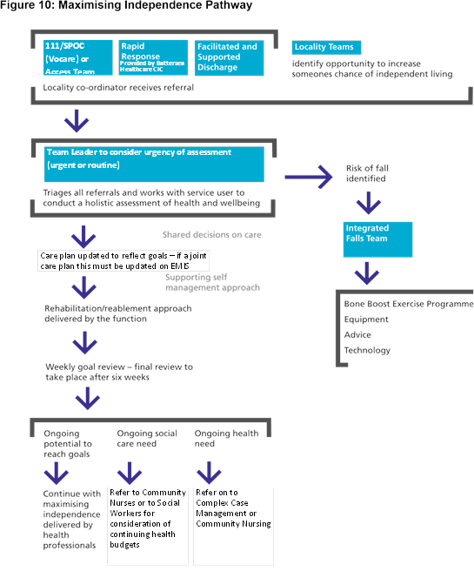

The Falls & Bone Health Service will be aligned to the CAHS service and will form part of the MI function. They will be managed as part of the MI service and day to day service and performance will be monitored as part of the overall MI function. If any KPIs are associated with this service, there will not be any financial penalty attached at this stage. At the present time, the budget for this service does not sit within the overall CAHS budget but it is anticipated that in due course this budget will transfer into CAHS, however this cannot be confirmed for the purpose of this procurement.

4) Complex Case Management (CCM) & Scheduled and Ongoing Care (S&OC)

Complex Case Management (includes the enhanced care pathway (ECP) cohort of patients) 9-5pm Monday- Friday

This function supports a truly multi-disciplinary platform to deliver home based care for those patients identified as the most vulnerable on the joint caseload between CAHS and primary care. This function was inspired by the previous Community Ward model. It intends to deliver a more consistent and co-ordinated service to a vulnerable cohort of patients through a wider MDT team providing holistic care to the patient and families. CAHS will be responsible for facilitating partnership working with other Providers through the coordination of effective MDT meetings.

The patient’s care will be overseen by a key worker and will be delivered by a core MDT team which includes; a CAHS GP, the patient’s own registered GP, a Clinical Caseload Manager, social workers, mental health nurses and a voluntary sector coordinator who will form part of the core CAHS team. The CAHS social workers will continue to be employed by Social Services but it has been agreed with Commissioners that the team will remain aligned to working with CAHS.

Patients will be identified using a predictive risk modelling tool - the current risk stratification tool used for this purpose is Solis Clarity. Health professionals will review the initial findings to verify that the tool is correctly identifying the patient’s level of complexity.

90% of records held by social services have NHS numbers so they can identify their most complex patients with high social care needs. All patients considered complex and requiring multi-professional involvement will have a personalised care plan developed by the MDT team. The care plan will have an escalation plan and will direct the patient and their relatives on what to do in an emergency situation and when there is deterioration in the patient’s condition.

It will be these patients who will form the majority of the discussions at the weekly MDT meetings. They will be a recognised cohort of patients and will be managed in a specific way through the Planning All Care Together Enhanced Care Pathway (PACT ECP). See appendix 1 for greater detail as to how this pathway will operate and the input required from CAHS to deliver an integrated pathway of care amongst multi-agencies.

Figure 7: Complex Case Management Pathway
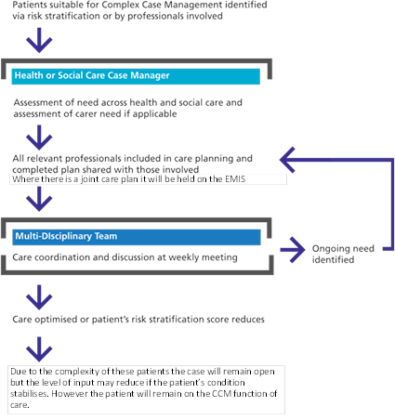

Scheduled and Ongoing Care (S&OC) 24hour service 7 days a week

Urgent Assessments – to be seen within 24 hours
Routine assessments – to be seen within 72 hours

This function will consist of a workforce including Community nurses and Health care support workers (HCSWs) who will deliver care to patients.
Many patients on the CAHS caseload in this function may be more clinically stable and will be managed independently by the community nursing workforce and primary care. These patients will not require as much input as the patients with complex long term conditions with multi-agency involvement.

However, the S&OC function will provide care to all patients on the CAHS Caseload over the weekend to ensure patients receive a seamless service from CAHS. This will be despite the level of acuity and they will therefore provide support to patients in the ECP cohort as well as the more stable patient cohort.
The Community nursing team will be required to offer services to the same standard and level of provision that any patient would receive if they were mobile and attending the GP practice to see the practice nurse. This will include the following:

- Standard Health checks as directed by the GP which includes Pulse, BP, and weight
- Flu jabs annually for over 65 yr olds and vulnerable patients with chronic long term conditions
- Phlebotomy services
- Spirometry
- Wound care
- Removal of sutures and staples
- The administration of Intravenous antibiotics
- End of life care

Many of the above will require ongoing training and regular updates and it is the responsibility of the Provider to ensure this occurs. The Provider will be expected to provide the MCP lead Provider with assurance around this and produce a register of annual training of its’ staff both trained and untrained.

In addition, the MCP Lead Provider is part of a Community Education Provider Network
(CEPN) on behalf of Health Education England and will be expected to work in an innovative and strategic way with the CAHS Provider to consider the workforce across Primary care and CAHS and look at roles and training needs to address any identified gaps in the skill set of staff. This is particularly important as both Primary care and Community services face large vacancies within their structures which is impacting negatively and compromising the level of care that can be delivered to our patient population.
Therefore, the CAHS Provider and MCP Lead will need to work together creatively to determine opportunities together to develop a workforce with appropriate skills where possible.

Effective working with primary care

Community nursing will continue to work closely with the patients registered primary care GP to assess the patients’ needs and whether there is a requirement to step up the level of intervention. If the patient’s health and social care needs have increased, the GP and Community Nurses should refer the patient to the CCM function for wider MDT support.

To ensure effective communication is maintained at all times between primary care and community nursing it is essential that the following occurs:

- Every Practice must have a senior named community nurse (band 6 minimum) who acts as a clinical lead and assumes overall responsibility for the patients in the practice. They will be the point of contact for the GPs to discuss any patients or any adjustments to care plans. GPs must have a direct contact number to access the Senior named nurse for their practice
- The senior named nurse will cover several practices depending on practice population size and caseload size and their time will therefore need to be shared across practices.
- Every Practice must be given a mobile phone number for the Senior named nurse aligned to their practice and advised if this number changes, this number must be given to the GP practice Manager or the most senior receptionist in the practice
- In the absence of the Senior named nurse another Senior colleague must carry the mobile to ensure contact can still be made
- The Senior named nurse will be required to attend the GP Practice meeting at least once a month to discuss any operational concerns related to community services and to feed back to primary care any concerns raised by their teams to ensure smooth running of the overall service.
- The senior nurse named nurse for the practice will act as a conduit between the practice and the other nurses in the team to promote effective communication between the practices and the Community nursing teams
- The Senior named nurses will be required to promote ongoing communication by attending primary care Locality meetings for the practices that they are responsible for every quarter.

Figure 8: Scheduled and Ongoing Care (S&OC) Pathway
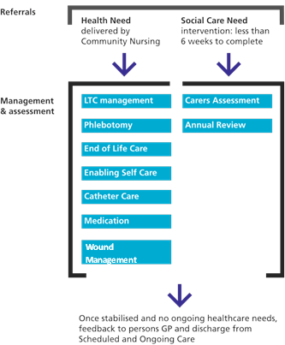

5) CAHS In-reach Nursing Home Team 7 days’ week service 9-5pm Monday to Friday, Saturday and Sunday on call service 10-6pm (bleep holder on call)

The CAHS service will have a ring-fenced team of staff dedicated to support the 1000 patients across Nursing homes in the borough of Wandsworth.
Wandworth has approximately 14 Nursing homes and they vary in the level of skills that staff possess leading to a variation in the confidence displayed to manage patients. The MCP Lead Provider therefore has dedicated a resource specifically to employ staff to support the local nursing home staff to deliver an equitable standard of care to the residents living in nursing homes. The In-reach team will work in partnership with the nursing home staff to help them to develop their skills and confidence to manage these patients with often multiple complex long term conditions. It is essential that the patients in the homes are also risk stratified by an appropriate tool to identify the most complex patients that are frequent attendees at A&E that often proceed to non-elective admissions. It is considered that many of these admissions could be avoided if staff had the appropriate skills and confidence to manage specific conditions, for example:

- Blocked Catheters requiring flushing
- Re- catheterisation
- Breathing difficulties
- End of life pain management
- falls

The dedicated Nursing Home in-reach team will include the following posts:

- Team Leader – the team Leader will lead the team and support the day to operations of the team ensuring capacity is being managed appropriately. The team leader will be responsible for the overall performance of the team and ensure the team are meeting the specific KPIs that have been set. A specific focus will be to ensure relationships are built between the in-reach team and the Nursing home staff to develop trust and confidence
The Team Manager must also oversee that all the patients considered to be in the high risk group across the 14 homes have a clearly developed personalised care plan and know what to do in a crisis should the patient deteriorate. The care plan should have clear guidance on who to contact in an emergency and when to convey to hospital

- Continence Nurse – the Continence Nurse will work directly with the Nursing Homes to consider the training needs of staff, particularly around catheter care, and also to look at product provision. The post holder will therefore oversee assessments for the appropriate continence products. In addition, the post holder will become familiar with patients who may be on the delirium pathway. Patients on the delirium pathway will benefit from early supported discharge with an individualised care plan and this is something which the Continence Nurses will be able to support with. The Specialist Continence nurse must carry a mobile phone and the number must be accessible by all homes. The wider CAHS workforce also has a Specialist Continence nurse and the continence nurses must therefore cross cover each other during periods of leave or sickness

- Consultant Geriatrician – the Consultant Geriatrician will attend MDT discussions at each of the Locality hubs (there will be a named Geriatrician assigned to each Locality hub) to support the development of the care plan, respond to queries from primary care and in-reach into the patient’s nursing home when required to offer a specialist opinion alongside the patient’s registered GP.

- Respiratory Nurse – the Respiratory Nurse will work directly with the Nursing Homes to consider the training and education needs of staff, particularly around respiratory conditions. There is a high incidence of patients over 75 years of age being conveyed and admitted into hospital for respiratory conditions. The post holder will therefore focus on addressing that need.

- Speech and Language – the Speech and Language Therapist will visit patients in the community both in their own homes and in Nursing Homes to assess those patients who have difficulty swallowing as there is a risk of them choking which could potentially lead to aspiration. The post holder would concentrate specifically on this aspect of the service to attempt to reduce the incidence of respiratory complications.

- Nursing Home Liaison Nurse - The Nursing Home Liaison Nurse will deliver training and ongoing educational support to Nursing Homes and act as a bridge between Nursing Homes and community services, assisting them to access services and understand what is currently accessible to patients in the homes. The post holder will also work closely with the Behaviour and Communication Support (BACS) team to identify target areas in the homes as well as work with the Continuing Health Care (CHC) team to ensure that the CAHS F&SD team are aware of CHC patients and where they may be able to assist in supporting them to return home safely.

The CAHS team’s approach will be one of partnership and support with the care home. The CAHS team will be required to discuss PACT ECP patients at the weekly MDTs and ensure these patients have a shared care plan held on EMIS that the wider MDT team including the nursing home staff develop and are aware of. The CAHS service will need to establish and maintain relationships with the care/nursing home managers and communicate clear information regarding Community Adult Healthcare Services available and referral pathways for all care home residents.

The Nursing or Care Home will continue to maintain their own patient records including care plans as is required by their regulator and to support the appropriate delivery of care with in the care/nursing home.

Commissioners will facilitate the development of a PACT ECP shared care plan that is shaped to meet the specific needs of care homes in partnership with care home providers and other partners.

In the meantime, the PACT ECP shared care plan will be held on EMIS for the use of primary care and CAHS staff. Primary care and CAHS will work in partnership with the nursing home staff to develop the care plan. The care / nursing home will have a copy of the shared care plan and any changes to the care plan made by primary care / CAHS will need to be communicated and discussed in a timely way with the care / nursing home.

The CAHS team in-reaching into the local Nursing Homes will require remote access to update records and review EMIS records. The team will be supported by the patient’s own GPs and the Consultant Geriatricians (employed by SGUHFT) as and when required.

It is essential that the CAHS service recognise that these patients are an extension of the CAHS caseload and must be managed in a consistent manner and receive an identical service to the patients receiving domiciliary care in their own homes in the community.

All patients will need to have an allocated key worker from the in-reach team and will require a personalised care plan including escalation plans that are developed in partnership with the staff in the homes, a copy of which is held in the home and on EMIS. Any updates need to be communicated.

A scoping exercise is currently being conducted to map the current levels of healthcare provision into Nursing Homes across the Borough. The CAHS provider will be required to work with Commissioners and care home providers to direct and develop the Nursing Home in-reach team and how they will work in subsequent years. This will be subject to the findings of the scoping exercise and review of evidence based good practice.

The CAHS Provider is expected to support the development and delivery of a service model that will provide co-ordinated input from existing generalists and specialists of multiple disciplines and providers in partnership with social care professionals and care home staff to ensure effective healthcare for individual residents and effective support for care homes.

Ongoing Education and Training Programmes for Nursing Home Staff

The staff in the home will be supported by the Nursing Home Liaison Nurses (two in total). The staff in these roles will work with the homes to identify ongoing training needs for trained staff and carers. The Nursing Home Liaison Nurses will work with the MCP Lead Provider as part of the CEPN who support education needs for the Wandsworth healthcare workforce. Together training programmes can be developed to meet the educational needs of the staff working in the homes

The Nursing Home Liaison Nurses will support and promote evidence based best practice and continuous improvement within the homes in partnership with care home staff.

6) Specialist Nurses and Specialist Input (SN & SI)

All services operate 9-5pm
(Discussion around an on call service for weekends may need to considered with the CAHS Provider for certain specialist nurses if considered necessary)

Specialist Nurses will be employed in sufficient numbers to support patient care in their own homes. The Specialist Nursing team will include:

- Diabetes Specialist Nurses
- Heart Failure Nurses
- Respiratory Nurse Specialists
- Tissue Viability Nurses
- Continence Nurses

In addition, there will be specialist Dementia Nurses that will be employed by South West London and St George’s Mental Health Trust. The Nurses will be aligned to the four Locality teams and will attend MDT meetings. They will use their specialist skills and knowledge to support the MDT to manage patients with Dementia and other Mental Health conditions. Clinical supervision sessions for these staff will be provided by the Mental Health Trust.

At present the Specialist nurses are required to provide support to patients in their own home, in addition they also support Primary care with Tier 3 clinics and will support Practice nurses to develop their skills and confidence to manage patients attending GP practices and clinics

7) Planned Care Out-reach Services

Specialist nurses will be required to provide services to patients in their own home including patients who are resident in Wandsworth Nursing Homes. There is a requirement for specialist nurses to attend clinical and commissioning forums as their roles develop over the subsequent years and to engage with any service development and redesign work that is commissioned to improve service delivery.

In due course the CAHS Provider will be required to work with the MCP Lead to scope out opportunities to shift activity from the acute setting into community but only where patients have been assessed as clinically safe to do so.

This model of working is in line with the Five Year Forward View which aims to bring services closer to the patient’s home; this will involve future scoping work to consider levels of activity that can be managed in the community in Tier 3 type clinics with specialist support for hospital consultants outreaching.
Scoping is underway this year and the CAHS Provider would need to demonstrate a willingness and keenness to work with the MCP Provider and other acute providers to develop services that can also be supported by the CAHS staff – Additional resources to deliver this type of service will also be considered as part of the scoping process

Diabetes will be the initial specialist area of focus for 2016/2017 and a developed model will be ready to launch from April 2018/2019 following a scoping exercise this year.

8) Other Key Services aligned with CAHS

Voluntary Sector

The Voluntary Sector will also be aligned to work closely with CAHS and will have specific roles within Community Services to support settling patients back home upon discharge from hospital. They will also provide a befriending service and support patients experiencing social isolation. There will be a separate specification for this service which clearly outlines how the service will align to CAHS especially in relation to the F&SD and the CCM functions.

End of Life Care

It is essential to deliver effective end of life care in people’s own homes wherever possible.
The service is provided by the End of Life Care Coordination Centre located in Trinity Hospice. A Senior Coordinator and carers support patients and their families by providing a night sitting service. The End of Life Care team in Wandsworth will be fully aligned to Community Services and work closely with the CAHS community nurses to deliver the crucial End of Life Care that is required to meet the needs of patients in their last few weeks of life. The staff from the End of life care centre will be required to attend the weekly MDTs in the four localities and facilitate discussion around the patients clinical and psychosocial needs. There is a separate specification for the end of care life centre.

The availability of the end of life care centre as a resource in wandsworth does not negate the responsibility that the CAHS team delivering superlative end of life care as to patient’s on the caseload. It is considered in Wandsworth that end of life care is everyone’s business. The CAHS service also has a dedicated role of an End of life care facilitator to support staff education and ensure end of life care is at the forefront of staff minds.

End of life care facilitator

This post leads end of life care and should be considered a pivotal role in the CAHS Team
This role is there to act as a nurse with a specialist interest in delivering end of life care and can act as an expert in the team. The post holder is responsible for delivering training to staff around the management and care of patients dying, this may include training around the practical care required and the psychological needs of the patient and families.

The Provider will be responsible for maintaining a register of training and staff attendance.
This is something that the Provider will be required to evidence to the MCP lead Provider that training is being delivered to staff. The post holder will also play a very important role in the weekly MDTs in helping staff to support patients with terminal conditions. The post holder is expected to carry out home visits with the CAHS staff to help them review patients care where required and additional support is needed from an expert in the field of Palliative care.
The Provider will also be required to monitor the patients in the service and maintain a record of the patients preferred place of death and the success rate in achieving this outcome for patients.

6. Out of Hours Provision – across all functions

It is essential that all services are provided 24 hours a day, 7 days a week. GP Out of Hours services will be will be provided by the 111 Provider and delivered according to their contract.

All End of Life Care patients should have a yellow folder in the house advising the doctor on call of the management plan and wishes of the patient especially in terms of location as to where the patient wishes to die.

Nursing staff within CAHS provide a 24 hours a day, 7 days a week service based on a shift pattern. Visits to patients should be flexible and adjusted appropriately according to patient care needs.

The Social Services Emergency Duty Team operates an out of hours’ service to support the community nursing team. The CAHS team should give patients the emergency number for social services should they require assistance out of hours.

7. Key services in Wandsworth Community Services – integral to the success of CAHS

Acute Admission Avoidance Pathway at Queen Mary’s Hospital

Rapid Access clinic

The Acute Admission avoidance pathway is referred to as the Rapid Access clinic (RAC). This clinic is based at Queen Mary’s Hospital (QMH). The service is led by a Consultant Geriatrician who will review deteriorating patients in the community who are registered with a Wandsworth GP. Patients will be seen within a few hours of referral to the service. On occasions where appropriate and deemed safe for the patient to wait for a review, the patient can be booked to attend the RAC pathway within a few days of referral.

Once in QMH there is an opportunity for patients to receive a full suite of diagnostics which are readily accessible on site. If required, the deteriorating patient can be admitted into a step up bed in QMH where possible, avoiding an acute attendance to A&E leading to an unnecessary admission

The CAHS team will work closely with the staff working in the RAC pathway and will have direct referral rights into the service. The CAHS team will also support the RAC staff in supporting patients back into the community if an admission is not required. The CAHS team will work together to ensure the patient has sufficient services in the community to facilitate a safe transfer and to manage them in the home environment.

Consultant Geriatrician Out patient clinic

In Addition, QMH also has an out-patient service for patients to be seen by a Consultant Geriatrician and is intended that many of the Patients identified in the high need cohort of the CAHS caseload from the ECP pathway will benefit from a referral into this service. In addition, more stable patients that are not yet considered to fit within the high needs cohort group of patients but these patients may benefit from a more proactive approach to care. The teams operating this service will have access to EMIS and can therefore update the management/care plan of the patients so that this can be viewed by CAHS staff and local GPs in the service delivering care in the community.

Step Up Bed Based Services QMH

Wandsworth Clinical Commissioning Group commission 21 beds at QMH for patients registered with a Wandsworth GP. These beds should be used as step up beds for when a patient requires rehabilitation or clinical stabilisation. The number of beds are limited and therefore they must be utilised carefully and appropriately. The CAHS team will need to liaise with the acute Provider SGUHFT that manages these beds. This will aim to reduce unavoidable non-elective admissions to acute beds when a higher level of clinical intervention is not required.

Discussion between the community and the acute Provider SGUHFT will serve to prioritise transfers into these beds. The CAHS team will lead the discussions regarding patients within the community that may urgently require a community step up bed.

Day Hospital at St John’s Therapy Centre and Queen Mary’s Day hospital

At the present time there is an ongoing review of the utilisation of St John’s Day Hospital. The CCG will work with the Provider for St John’s (SGUHFT) to consider the most appropriate usage of the estate for delivering services. This review will be completed within this financial year (2016/2017).

GP Rapid Response Service – led by MCP Lead Provider

The Rapid Response service is a GP led model which responds to referrals to assess deteriorating patients within 2 hours. The service is available for all patients aged 18 years and over who are at risk of a non-elective admission. Referrals will be made predominantly by CAHS staff, local GPs and the London Ambulance Service. The CAHS team will need to work effectively with the Rapid Response GP service to ensure appropriate referral to the service if an urgent assessment is required.

In addition, the Rapid Response GPs will also refer the patient back to community services for additional care and support if they feel the patient is safe to remain at home. CAHS will need to respond expediently to ensure a sufficient service is available to manage the patient at home to avoid an unnecessary admission to hospital, increasing the level of intervention and care package for the patient where necessary.

Intermediate Care Bed Based Service at Ronald Gibson – led by Provider Brendoncare

Wandsworth CCG commission 16 intermediate care beds of which 2 are non-weight bearing beds from Brendoncare at the Ronald Gibson House nursing home for Wandsworth patients likely to benefit from a time limited period of rehabilitation.

The Intermediate Care Bed Based Service (ICBBS) is provided by the Brendoncare Foundation (BCF) at Ronald Gibson House (RGH) in conjunction with the CAHS team and a Locality GP employed by the CAHS Provider working in partnership with Wandsworth Department of Education and Social Services Department (WDESS).

Brendoncare (the provider at Ronald Gibson House) provides accommodation, hotel services, nursing and care services.

Community Services staff will provide:
- A therapy in-reach service (TIS) principally physiotherapy and occupational therapy functions and coordination and patient flow management
- Enhanced skilled registered nursing interventions (when required for identified patients through CAHS)
- Weekly dietetic input subject to individual patient referral
- Manage referrals and pre admission assessments (through CAHS and the Facilitated and Supported Discharge Function (FSD)/Trusted Assessors).
- Medical cover is provided by an ICBBS GP (present at the home 3 hours a day Monday – Friday) and SGUHFT consultant Senior Health Medicine will lead weekly MDT meetings

A social work resource is assigned to the beds to support timely discharge planning and throughput. Please refer to the full ICBBS specification for details.

Brendoncare as responsible provider need to agree to accept the referral this decision is made in discussion with the TIS (and the ICBBS GP when appropriate). The CAHS Provider will support the development of appropriate community referral pathways.

BCF and CAHS Provider are jointly responsible for ensuring a high level of occupancy and a short average length of stay, for the ICBBS whilst ensuring the health and safety of admitted patients.

8. Information Technology

EMIS is the computer system the Provider will be expected to use for community services in due course. This system is currently being used by Primary care. In addition, the system is also already being used across primary care and CAHS for the most complex patients receiving care from the complex care function who are largely ECP patients with multiple
co-morbidities who have a shared care plan.

The remainder of the CAHS caseload records are held on RIO at present, however in due course when there is an opportunity for the Provider to re-consider the contract at the point it is up for renewal, the MCP lead Provider would like to be involved with the CAHS Provider as part of that tender process to ensure the most appropriate system is selected that is also compatible with the wider MCP strategy and direction of travel.

The selection of an IT system cannot be carried out by the CAHS Provider independently and must be signed off with overall approval from the MCP Provider.

The CAHS Provider will be required to migrate to full usage of the EMIS system in stages to ensure there is an IT system that is able to integrate care planning across community services and primary care. There is also a portal system currently used by secondary care that is able to access and view EMIS data but is unable to view the RIO system. Therefore the EMIS system or a version of this is considered the most practical system to facilitate integrated care.

Robust Information Governance will be of paramount importance in the safe use of computer systems. The Provider will be required to demonstrate compliance is met according to required policies and procedures outlined by Commissioners.

Mobile devices/technology will be utilised throughout community services. At present a proportion of CAHS staff have mobile devices in place. The Provider will be required to increase the use of mobile devices and equip their staff with them to deliver care and update records remotely. The Provider must demonstrate an intention to move towards towards mobile devices for their staff as this will be required to fit within the MCP model and way of working.

The Provider will be responsible for purchasing and maintaining all IT equipment at their cost and ensuring their staff are trained in appropriate clinical governance processes and what action to take when a breach of Governance rules occur. The provider will be required to maintain a log of all staff users and be responsible for disabling logins at the point staff leave the service

All staff will be required to undertake appropriate training around IG requirements and appropriate records of training must be made available to the MCP leader when requested

9. Estates

Having the appropriate buildings to work from is fundamental to the effective provision of community services. The Provider will be expected to work with Commissioners as the community estate is reviewed over the coming years to align with the Five Year Forward View and deliver the Multispecialty Community Provider model of which CAHS will be significantly involved. Over the next 2-3 years the requirements will become clearer as the estate is scoped out. The CAHS Provider will need to commit to engaging with the Lead Provider of the MCP to develop this work further.

It is particularly important that in the scoping of the estate the co-location of the CAHS workforce, in particular the Community Nursing team, is thought through. These teams should be considered carefully to foster effective ongoing working relationships between community nursing and primary care.

There is also an intention to reduce the use of fixed office space wherever possible and support CAHS to work more remotely, therefore hot desking will be used more readily and staff will use mobile devices to update patient records whilst out in the community rather than being required to return to base to undertake this. This will ensure that there is an increase in patient/staff facing time and staff can work in the most productive way possible.

The MCP Provider is also in the process of doing some scoping around this area and will share the information it has with the CAHS Provider as to potential availability of estate
It is however the responsibility of the CAHS Provider to secure appropriate premises and secure their own financial arrangements in the forms of licences/leases with the appropriate relevant party.

10. Further Expectations of Provider

Safeguarding Adults at Risk

It is essential that this is regarded as ‘everyone’s business’ throughout health and social services. The Provider will be required to have a robust process in place to ensure this is central to every intervention. The Provider will be required to work closely with social services colleagues who will lead any necessary investigations once alerts have been made by the Provider. All staff will be required to undertake level 1 safeguarding training and Prevent and all clinical staff will be required to undertake level 1 and level 2 safeguarding training. The Provider will be required to ensure the CAHS staff comply with the Care Act 2014 and comply with all local and national guidance associated with caring for adults at risk

Staff Employed by Provider

The Provider will ensure that all staff employed are suitably vetted and qualified to perform their roles within each function and have the necessary skills and competence to deliver the care associated with their role.

Staff will be required to undertake mandatory training as determined by the Provider. In addition, the Provider must ensure that staff are provided with appropriate training to fulfil their roles safely and competently. All evidence of training and relevant audits must be made available to the MCP for inspection as requested and must be produced within a reasonable time frame agreed
Many of these reports/audits will be shared at a joint Clinical Quality reference group

The Provider must have sufficient Human Resource (HR) policies and procedures to address any issues relating to staff competence, capability and conduct. The Provider must ensure that there is sufficient Human Resource support to advise on the recruitment of new roles to form part of the expanding CAHS team as well as the outreach team from the acute setting such as Consultant Geriatricians and Diabetologists colleagues.

CAHS Workforce

The Provider will be required to share the current workforce with the MCP lead Provider at the monthly contract and performance meeting in the form of a current establishment with live vacancies in the service.

It is the provider’s responsibility to maintain a recruitment tracker and share with the MCP lead Provider the action plan to recruit into vacant posts and progress on this work, this will also be monitored at the contract and performance meeting.

The Provider will be required to have exit interviews with all staff leaving the organisation to identify trends on what staff are leaving, this will support the provider and MCP lead Provider to consider recruitment opportunities.

Workforce planning is needed across community services in Wandsworth and the Provider will be required to work with the MCP Provider to consider roles and responsibilities and future training opportunities for its staff.

The Provider of CAHS will not be permitted to alter the CAHS establishment without discussion with the Director of Operations of the MCP for approval and sign off as the wider MCP model will need to be taken into account and this discussion will ensure the impact can be considered appropriately. The Provider will however be expected to be creative around posts and recruitment consider alternative posts where attempts to fill posts have been unsuccessful over a period of time.

The Provider will also be required to report on any vacancies part year and any attached underspend. The MCP Lead Provider and the CAHS Provider can consider these posts together and the underspend aligned to these posts which must be reinvested back into the overall MCP model which includes the CAHS service within the financial year to ensure this funding is used to enhance the overall service.

Risk Management

Appropriate risk management must be resourced, delivered and monitored. The Provider must maintain risk registers to record risks appropriately and transparently and this information should be readily shared with Commissioners at the monthly Clinical Quality Reference Group (CQRG).

The Provider will also be responsible for developing relevant recovery/action plans to address the risks. The Provider is required to demonstrate a willingness to work with Commissioners by working in partnership to consider risks together. Commissioners will support the Provider to review the service model if there is found to be fundamental operational issues arising with aspects of the service which is impacting negatively on service delivery and therefore increasing risk to patient care.

Clinical Quality Review Group (CQRG)

A monthly meeting for commissioners and providers to review the clinical quality of the service will be held.

Membership and Quorum to be confirmed

Points for discussion/review:

- Patient safety incidents.
- Serious Untoward Incidents including unexpected deaths within community services.
- Trends which require urgent remedial action and the implementation of any clinical action plan.
- To review and approve policies in relation to the performance management of quality issues within Providers.
- To review Make a Difference alerts (MAD) that are occurring in the community.
- Provide an overview of any joint open complaints and progress in addressing them (patient non-identifiable) considering any trends and addressing with appropriate action plans where required.
- Provide an overview of any joint clinical investigations that are currently open.
- Review patient satisfaction feedback.
- Provide an overview of open safeguarding incidents under investigation (patient non-identifiable).
- To review any day to day operational issues that could raise a risk to patient safety.
- Review of staffing- skill mix to provide assurance to the commissioner that current levels are safe for caseloads being managed and that they comply with any evidence-based and workforce assurance tools.
- Close monitoring of recruitment trackers to address vacancies

Clinical dashboard: A clinical quality dashboard will be monitored jointly between the Provider and the MCP Lead. The group will scrutinise Provider performance in a positive and constructive manner against the community services contract. The Provider will also be required to expediently share evidence of any required risk assessments and recovery plans. The membership for this group will be reviewed regularly and amendments made as required.

MCP Mobilisation with Stakeholder Group and CAHS Performance Meeting (two-part meeting)

There should be a monthly meeting to formulate measures of performance and jointly monitor progress against expectations and to address any unforeseen issues developing either financially or operationally during the ongoing major transformation of community services which are integral to the Multispecialty Community Provider model. Many of CAHS KPIs will be interdependent with the CAHS team working in a collaborative manner with other Providers to deliver the service in an effective manner. This is particularly important for successful MDT meetings and care planning to ensure care is delivered in an integrated manner.

It is essential over the next few years that these meetings are maintained as the MCP model continues to evolve. Feedback from staff will help inform the developing model and allow for regular adjustments to practice as needed. An example of this may be to review how effectively the weekly MDTs are operating and what can be done to improve overall productivity.

Membership
- Clinical Lead for Community Services (CAHS)
- Clinical GP Lead for Community Services (MCP)
- Director of Operations (MCP)
- Community Services Director of Operations (CAHS)
- Provider Lead for Contracts for Community Services (CAHS)
- Project Managers where necessary for Community Services (CAHS)
- Chief Executive (MCP)
- Medical Director (MCP)
- Project Manager (MCP)
- Chief Executive of voluntary sector (TBC)
- Operational Manager for the Mental Health Trust (SWLSGH)
- Social Worker Project Team Leader (WBC)
- Quality Lead for Healthwatch Wandsworth (Healthwatch)
- Contracts Manager (MCP Lead)
- Contracts Manager (CAHS)

A business and performance dashboard and risk registers will be developed, maintained and monitored and shared for the group for discussion.

Infection Control

All staff will be required to use appropriate infection control procedures and the Provider will need to demonstrate appropriate training and monitoring of this. Staff will be required to comply with all national guidelines related to infection control and all local policies. Infection control reports and audits generated by the Provider will be shared periodically with Commissioners at the CQRG.

Complaints

The Provider must be able to evidence a robust and responsive system to deal with complaints. Complaints must be responded to within 15 working days and exceptions to this recorded with the reasons for delayed responses. The overall trends in complaints will be shared at the monthly CQRG and response times for meeting the 15 working day target must be shared with Commissioners. The Provider and Commissioner will work in partnership to consider the trends in complaints and where considered necessary adjust the service model to address complaints and improve service delivery.

11. Conclusion

Redesigning the way our population is cared for by our health and social services is essential. We can no longer afford to provide care that is designed for the benefit of the service rather than the patient. Providing a platform for specialist secondary care expertise and mental health services to access the community services and enabling community expertise to reach into secondary care is essential if our population are going to stay healthy and independent at home.

The CAHS service in its current form is going to form an integral part of the MCP model and the Provider will required to work alongside the Lead Provider of the MCP to transform community services and to support this work as it evolves over the next few years as greater focus will be dedicated to bringing services closer to the patients home wherever possible.

The CAHS team is pivotal to the facilitation of effective multidisciplinary working to deliver seamless care to the residents of Wandsworth requiring health and social care services. This ongoing transformational change to services over the next few years within the community requires ambition, creativity, courage and determination from both Commissioners and Providers alike.

12. Appendix 1 – Planning All Care Together Enhanced Care Pathway (PACT ECP) Suggested Standard Operating Procedures

Process for referring PACT ECP patient into CAHS

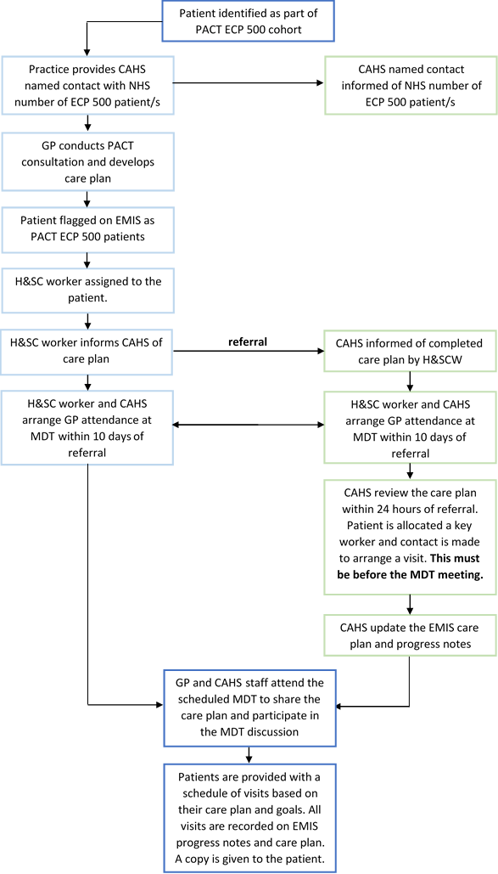

Process for referring patients into Rapid Response service

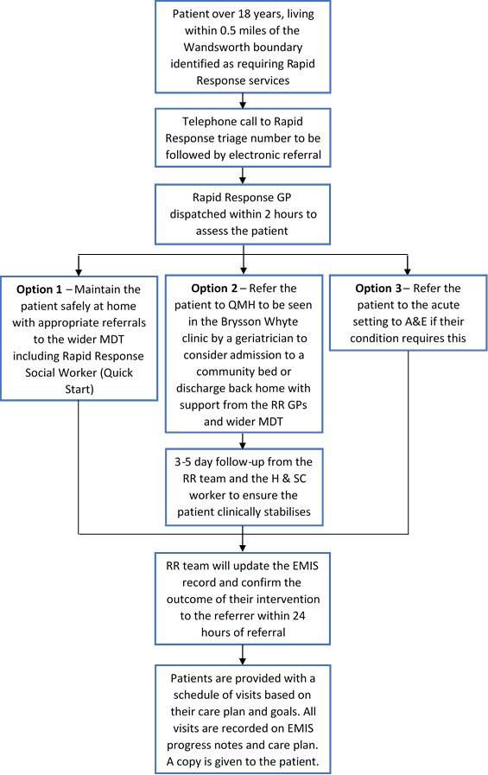

Process for discharge planning for PACT ECP patients

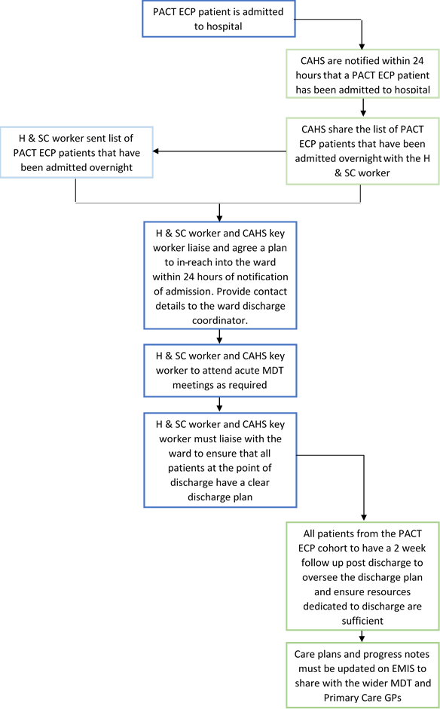

13. Appendix 2 – Key Stakeholders

Wandsworth Clinical Commissioning Group ……………………………………………. WCCG
Multispecialty Community Provider ………………………………………………………… MCP
Community Adult Health Services ……………………………………………………….... CAHS
St George’s University Hospital NHS Foundation Trust ……………………………... SGUHFT
Wandsworth Borough Council …………………………………………... WBC (Local Authority)
111 ……………………..…………………………………………………… Out of Hours Provider
Age UK …………………………………………………………………………….. Voluntary Sector
Wandsworth Healthwatch ………………………………………………… Patient Representative
Brendoncare …………………………………….. Ronald Gibson House Rehabilitation Provider
Wandsworth Public Patient Involvement Groups …………………………………………… PPI

14. Appendix 3 – Glossary of Terms

Functions of care within CAHS:

Access & Coordination ………………………… ……………………………………………. A&C
Complex Case Management and Scheduled and Ongoing Care ………….. CCM and S&OC
Facilitated and Supported discharge ……………………………………………………… F&SD
Maximising Independence ……………………………………………………………………… MI
Specialist Nursing and input ……………………………………………………………… SN & SI

Other terms:

Acute Admission Avoidance Pathway ………………………………………………………. AAA
Rapid Access clinic …………………………………………………………………………… RAC
Queen Mary’s Hospital (Mary Seacole ward) ……………………… Step Up Community Beds
Rapid Response GP service…………. Provided by Battersea Healthcare CIC via local GPs
Quick Start Home Care service ……………… Provided by CAHS Provider via Social Carers

