Resurfacing of Emsworth Road Playground, Lymington, Hampshire SO41 9BS

Lymington & Pennington Town Council invites tenders from suitably experienced play equipment / play surface providers to resurface two thirds of an existing play area.
Please quote for the supply & installation based on the following:
- All existing 9 pieces of play equipment to remain in situ & be undamaged from the resurfacing works required underneath them.
- Only the play equipment outlined in red (see below) is required to be resurfaced underneath, as the playground was partially resurfaced in 2021 with eco-mulch & the roundabout has wet pour underneath already.
- An eco-mulch surface is the preferred option, however wet pour will be considered if the budget does not allow for eco-mulch, or any other options felt to be viable in this location & within budget.
- Welfare facilities (if required) are to be located within the playground site only. Public toilets are within walking distance of the site (approx. 5 mins).
- Access for machinery is via a gate to the rear of Parish Court, Barfields, Lymington, SO41 9BS.
- A site visit is recommended prior to tender.
- The available budget is £30,000 (exc VAT). If your quote is over budget, please still submit quote details.
- Works to commence Autumn 2023.
- Inspection costs not to be included in the quote – as this will be carried out by our own independent play inspector (if required).
Additional inclusions within quote
- Proposed method statement
- Proposed program of works
- Supplier’s lead time
- Protective compound herras fencing while the works are carried out and a means of storing building equipment securely (if required)
- To include spoil/muck/bark/mat removal
- Make good & flat the areas left cleared of bark & without new surfacing.
- To include delivery of goods to the site
- To individually show the cost for resurfacing under each piece of equipment
Submission of Tender
- The tender quote(s) should be submitted to the council offices by 17.00 on Friday 18th August 2023

Site is located at Emsworth Road Playground, Lymington, Hampshire, SO41 9BS
Aerial View of the Playground
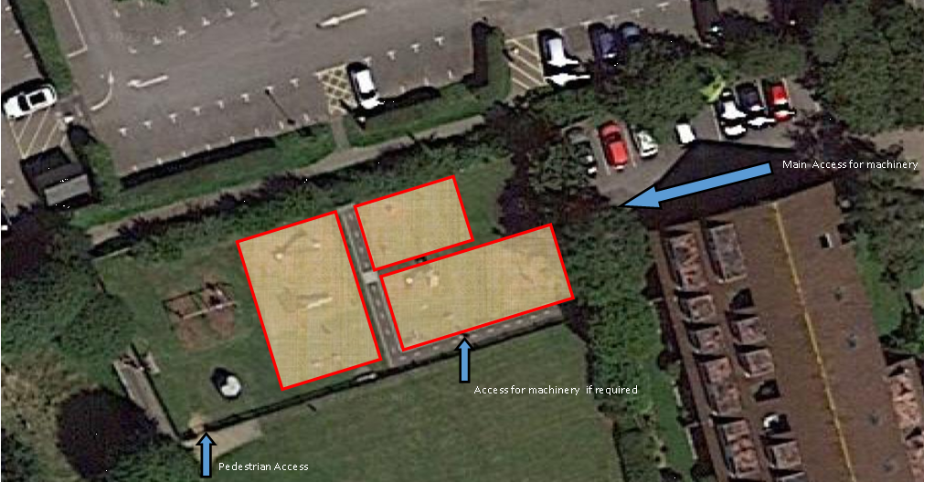
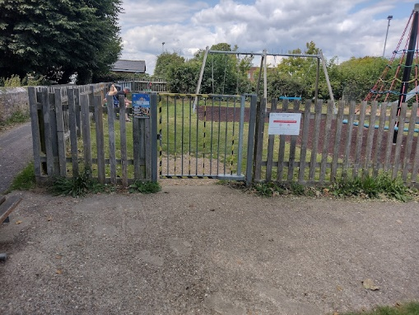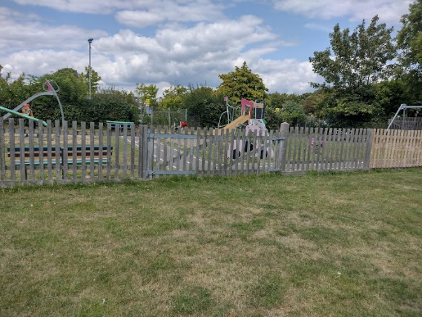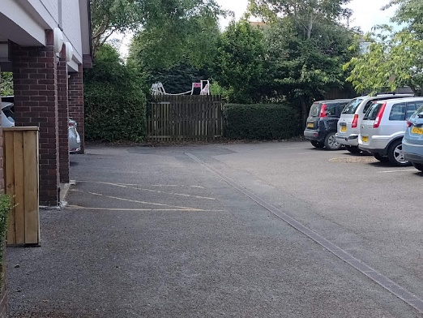
Pedestrian Gate Middle Gate access Access via Parish Court

Photos of the site – existing pieces to be resurfaced underneath
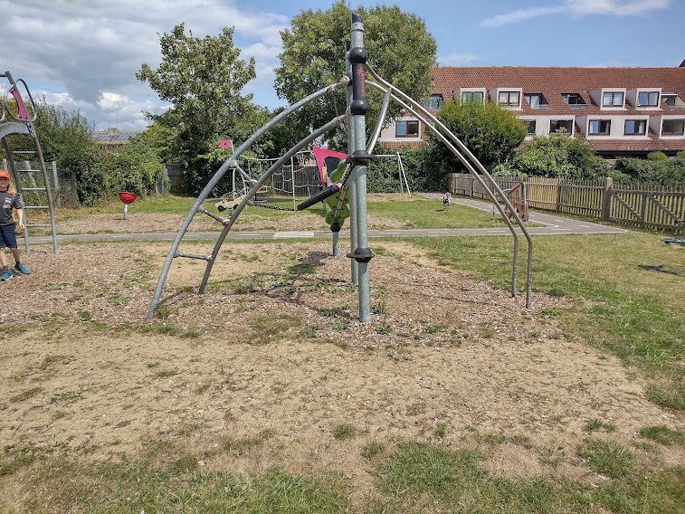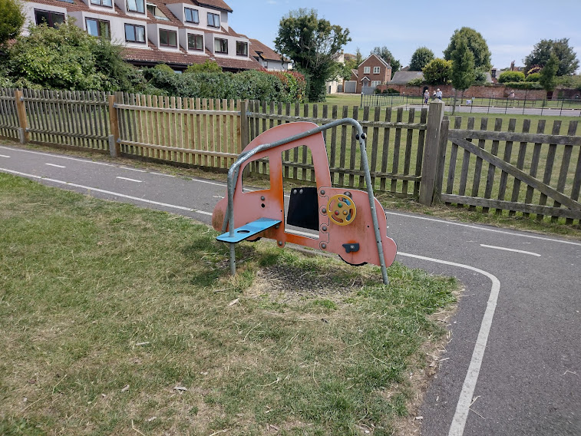
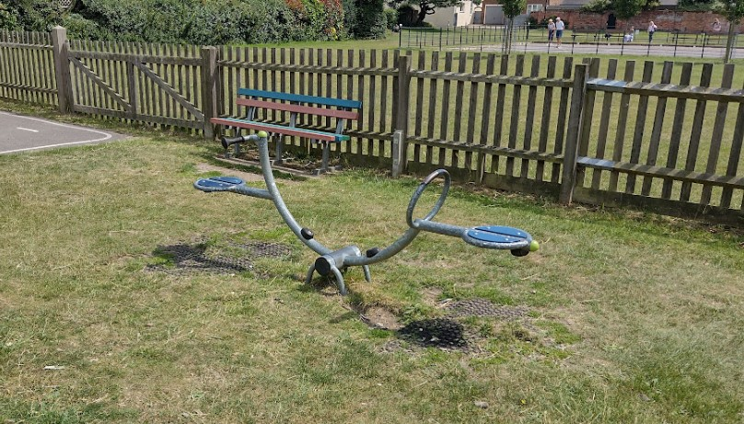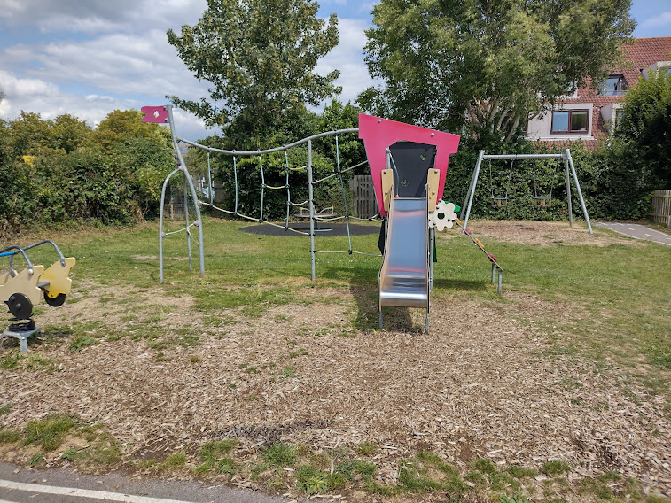

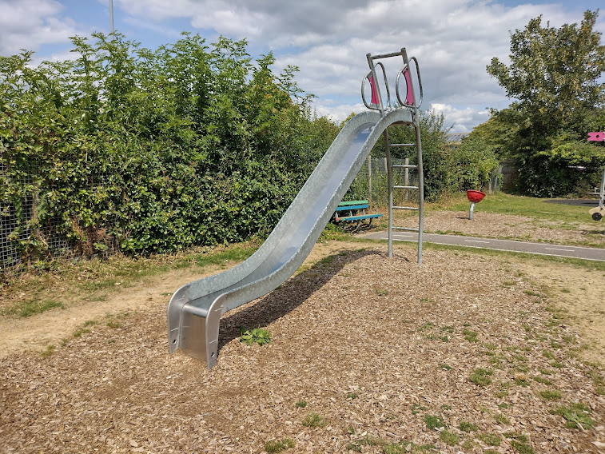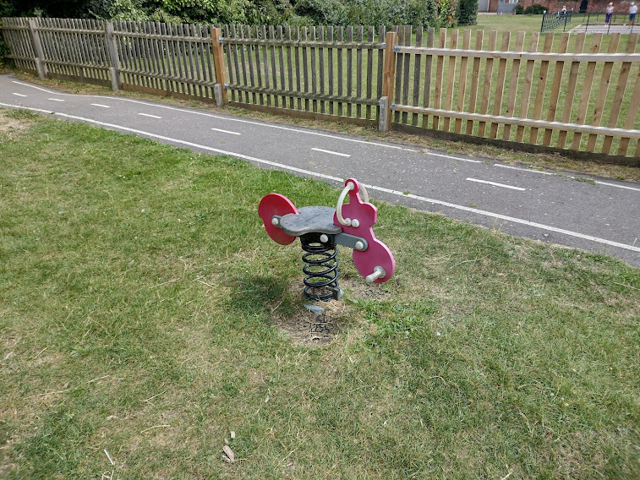

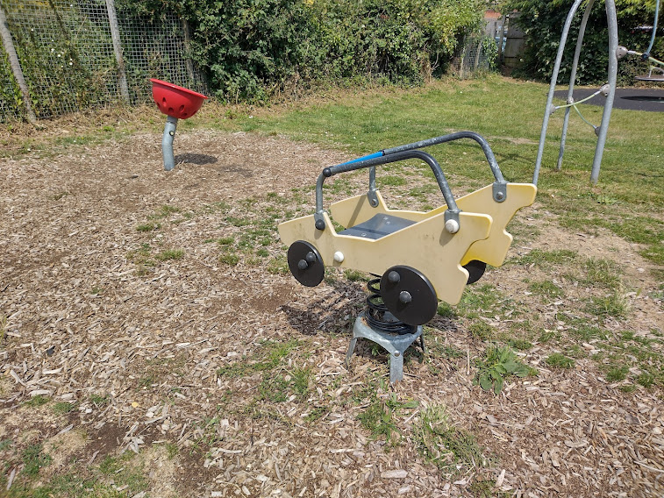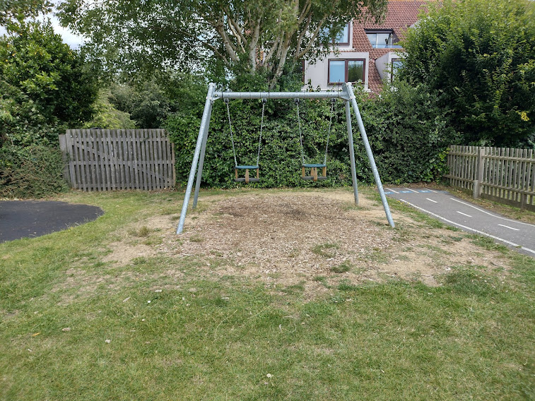

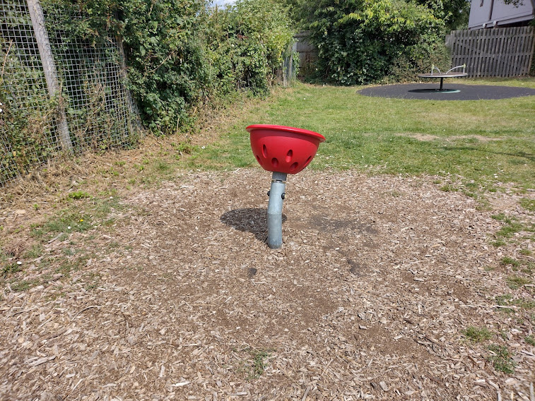

Photos of play equipment that do NOT require resurfacing
