CHANGE CONTROL NOTICE (CCN)
Contract Title: | Contract for the Provision of Travel and Venue Solutions (The Contract)
Contract Reference: | CCYZ22A04 | Contract Change Number: | CCYZ22A04-1
Date CCN issued: | 20/08/2025 | Date Change Effective from: | 31/08/2025
Between: The Crown Commercial Service (The Customer) and Click Travel (The Supplier)

- The Contract is varied as follows:

  - The contract will be extended by 6 months, for the period 1 September 2025 to 29 February 2026, with a cost increase of
£600,000. This cost includes all expenses but excludes VAT.

- Words and expressions in this Change Control Notice shall have the meanings given to them in the Contract.
- The Contract, including any previous Contract changes, authorised in writing by both Parties, shall remain effective and unaltered except as amended by this Change Control Notice.
Change authorised to proceed
by: (Customer’s
REDACTED TEXT under FOREDACTED TEXT under FOIA Section
40, Personal Information
40, Personal Information
representative):
Signature Print
Name and Job Title Date
Authorised for and on Vicki Williams
REDACTED TEXT under FOREDACTED TEXT under FOIA Section
40, Personal Information
40, Personal Information
behalf of the Supplier: Country Manager UKI Sep 3, 2025

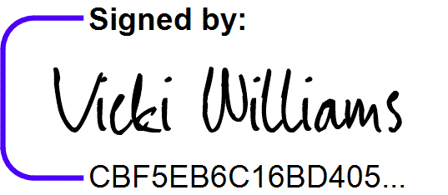
Signature Print Name and Job Title Date
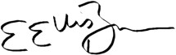
Authorised for and on behalf of the Customer:
REDACTED TEXT under FOREDACTED TEXT under FOIA Section
40, Personal Information
40, Personal Information
15th September 2025

Signature Print Name and Job Title Date
 | Liz Ellis-Brown  Head of Operational Finance | 21/08/25

