

Dear Sir/Madam
Invitation to tender to deliver Harpenden Green Spaces Haycut 2024 - 2026
We, Harpenden Town Council, have approximately 28 hectares of meadow and grassland that require an annual hay cut and collect. This is separate to the many hectares of normal amenity grass that must be maintained throughout the year. HTC sites provide vital access for local people in Harpenden to engage with nature and safely enjoy the green spaces. Each Summer, five of these sites undergo cut and collect grassland management in specific areas. This is to ensure that the meadows stay in good condition and that floristic diversity is promoted annually.
We are seeking tenders to complete the scheduled cut and collect in the summer of each of the next three years 2024 to 2026, to a high standard, with specific attention to ensuring health and safety compliance in public spaces, as set out within the tender specification. It is intended that the successful contractor will be approved by the Community Services Committee on 17 January 2024. The works must be undertaken between the period of 1st August – 14th September each year.

Our Tender pack for this opportunity is enclosed/attached with this communication and can be found on our website at the following link: https://www.harpenden.gov.uk/the-council/vacancies-and-tenders
Please follow the instructions within the tender specification.
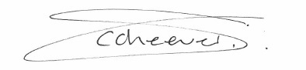
Yours sincerely,

Carl Cheevers
Town Clerk, Harpenden Town Council
Harpenden Town Council
Town Hall, Leyton Road, Harpenden. AL5 2LX
Tel: 01582 768278

