**Memorandum of Information (MOI)**

**PROVISION OF INTEGRATED URGENT CARE SERVICES**

**ON BEHALF OF**

**SOUTH WEST LONDON CLINICAL COMMISSIONING GROUP**

**(as the Contracting Authority)**

**Date of Publication: 13/08/21**

**Version: 1**

# Purpose

The purpose of this Memorandum of Information (MOI) is to provide potential Bidders with an overview of the South West London (SWL) Integrated Urgent Care (IUC) service procurement, which is being undertaken by the SWL Clinical Commissioning Group (SWL CCG), covering the boroughs of: Croydon, Kingston, Merton, Richmond, Sutton and Wandsworth.

This MOI is intended only as a preliminary background explanation for the procurement of the service. It is in no way intended to form the basis of any decision on the terms upon which SWL CCG will enter into any contractual relationship. This MOI is supported fully by the further details provided in the SWL IUC Service Specification.

# SWL IUC Procurement

**2.1** **Definitions**

SWL CCG wish to commission an Integrated Urgent Care service across SWL CCG for the provision of integrated 24/7/365 urgent care access, clinical advice and treatment which incorporates the elements of the NHS 111 service and GP Out of Hours services. The contract length will be for three years with a two-year option to extend.

The SWL IUC service specification includes the requirement to establish a Clinical Assessment Service (CAS) as part of the overall specification, containing clinicians with varying skillsets, e.g. GPs, pharmacists, nurses. The SWL IUC service will ensure the most appropriate service for patient’s needs are delivered, offering all patients a consistent 24/7 urgent care service. The service will follow the Consult and Complete model, booking the patient into Primary Care (in hours, extended access, GP Primary care Centre) and Urgent Care locations, based on the disposition reached and advising the patient to attend an emergency setting or dispatching an Ambulance if an Emergency disposition is reached

The SWL vision for an Integrated Urgent Care Service is one where all sections of the community are equally able to access the service. A detailed Equalities and Health Inequalities Impact Analysis (EHIA) has been carried out and the resulting recommendations have informed the SWL IUC service specification. The service will maximise and ensure effective links communities across SWL, particularly those groups identified within the EHIA who may find accessing urgent care services challenging.

SWL CCG’s requirement will most likely be delivered by a lead provider, with the SWL CCG inviting a provider solution through a single IUC service contract for the whole of the requirement, apart from an element of the call management that will support more integration with the ambulance service – this will be provided by The London Ambulance Service (LAS). In light of SWL CCG’s knowledge and engagement with current providers and the wider market, it is recognised that this contract will be delivered with the lead provider working alongside other providers and with the primary Call centre and Clinical hub (based in the SWL geography and taking no less than 75% of calls).

There is an expectation that the SWL IUC service should be innovative and developed with regard to increasing clinical access rates beyond the minimum specified by SWL CCGs for each year of the contract using the provider’s expertise in delivering activity within the service model, but within the constraints of the financial envelope available for each year of the contract. The contract will require the re-triage of 90% of ED and 90% of Cat 3 and Cat 4 initial dispositions arrived at through the Health Advisors assessment. The available primary care clinical records (CMC, SCR, SCR-ai, SystmOne, EMIS) of each patient will need to be reviewed within the clinical hub, where this flags on a PDS search and subject to consent from the patient

**2.2** **The Commissioning Organisation**

NHS South West London Clinical Commissioning Group (CCG) is responsible for planning, commissioning and buying health services for people living and working in South West London.

As a CCG, we’re a membership organisation made up of over 180 GP practices within South West London. We serve just under 1.5 million people across our six diverse boroughs:

* Croydon
* Kingston
* Merton
* Richmond
* Sutton
* Wandsworth

We were formed on 1 April 2020 through the merger of these six borough CCGs. Our ambition for south west London continues to be to bring together health and care leaders in each borough, ensure that they remained clinically led and retain the ability to engage with and consider the needs of their local communities.

Together we co-designed our own model for the way that we worked with our GPs, our local health and care partners and we discussed the proposed merger at CCG governing body meetings with our GP members, engaged with staff, local authorities, provider trusts, Healthwatch, and other stakeholders to design proposals that the six CCG Governing Bodies could consider and agree.

NHS South West London CCG is a member of the South West London Health and Care Partnership along with other SW London health and care organisations and partners.

We manage local healthcare budgets of over £2.3 billion and commission a range of health services on behalf of our residents. The services that we’re responsible for include primary care, hospital treatment, rehabilitation services, urgent and emergency care, community health services, mental health and learning disability services.

**South West London Health and Care Partnership**

South West London Clinical Commissioning Group, NHS provider trusts, local authorities, and patient representatives across south west London form the South West London Health and Care Partnership. South West London’s Health and Care Partners are:

* NHS South West London Clinical Commissioning Group – bringing together Croydon, Kingston, Merton, Richmond, Sutton and Wandsworth
* Our six local authorities: Croydon, Kingston, Merton, Richmond, Sutton and Wandsworth
* Our acute and community providers: Central London Community Healthcare, Croydon Health Services NHS Trust, Epsom and St Helier University Hospitals NHS Trust, Hounslow and Richmond Community Healthcare, Kingston Hospital NHS Foundation Trust, The Royal Marsden Foundation Trust, St George’s NHS Foundation Trust, and Your Healthcare
* Our two mental health providers: South West London and St George’s Mental Health NHS Trust, South London and the Maudsley NHS Foundation Trust
* GP Federations in each of the six boroughs
* London Ambulance Service
* Six Healthwatches
* Key borough voluntary sector organisations.

**South West London healthcare system**

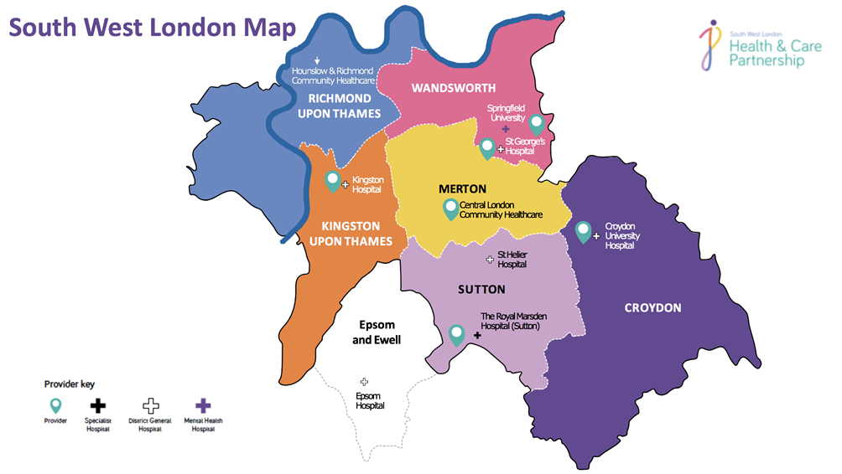

## 2.2.1 Population

### As at June 2021, the total population of the South West London Boroughs was 1,509,745 with a 15.2% population growth over the last 19 years. Population average age was 36.5 and it increased by 1 year since 2002. The SWL area is ageing slower than England and Wales in which the age grew by 1.6 years in the same period. The population overall is growing faster than population in England and Wales which grew by 13.0%.

12% of people in SWL are over 65 (compared to 17% nationally) but this varies across the Boroughs.

### 2.2.2 Health Risks

* 20% of 10 year olds are obese, compared to national average of 20%
* 14% of adults smoke in the London region, compared to national average of 14%
* 22% of adults are inactive in the London region, compared to national average of 22%
* 533 hospital admissions out of 100,000 in the London region are related to alcohol, compared to national average of 632

### 2.2.3 Health Indicators

* 8,497 people in South West London have been assessed to have moderate frailty an 3,464 have severe frailty
* 1 in every 345 adults receive long-term support for learning disabilities, national average is 1 in 300
* 7.1% of adults have depression, national average in 9.9%
* 4.5% of over 65s have a dementia diagnosis, national average in 4.3% and rates of new diagnosis are 11.1/1000 people, the same as the national average.
* 8% of people have diabetes
* 181 admissions per 100,000 people for stroke
* 32 people per 100,000 under 75s die from coronary heart disease
* 348 new cancer cases per 100,000
* 9500 people have rheumatoid arthritis
* 15% of the population suffer from back pain

### 2.2.4 Mental Health

Across south west London we have a high number of children who are self-harming.

Since January 2018, we have come together as a children and young people’s partnership group, made up of Head Teachers, GPs, mental health professionals, health and social care professionals and the voluntary sector from across south west London - people on the frontline who work with children every day.

### 2.2.5 Race

South West London STP is in the most ethnically diverse region of the London with:

* 45% white British
* 15% white non-British
* 18.5% Asian
* 13% Black
* 8.5% Mixed and other Ethnic Minorities.

8,196 people in the London region identify themselves as Gypsies or Travellers, out of 58,000 across England as a whole.

### 2.2.6 Sexuality

2.6% of the population in the London region identify as LGBT, compared to 2.1% for England as a whole.

### 2.2.7 Deprivation

Average weekly wages range from £509 in Sutton to £722 in Wandsworth (compared to £530). Around 4% unemployment in most areas but only 3.6% in Wandsworth and 7.4% in Croydon (compared to 4% nationally).

30,500 people in South West London seek advice from Citizens Advice each year:

* 28% of advice requests relate to benefits, including universal credit
* 19% are for advice on debt and other financial services
* 16% have concerns about their housing
* 5% people want advice on relationships and family.

**2.3** **Current Integrated Urgent Care service in SWL**

SWL CCG commissions services from – and works in partnership with – a range of providers to improve the health and wellbeing of residents through appropriate and effective out of hospital services. The CCG commissions a range of services: NHS 111, GP Out of Hours, primary care, community services, mental health services, elective and emergency hospital care as well as linking to local authority services and services commissioned from the voluntary sector.

The CCG currently commissions NHS 111 services for all registered, unregistered and temporary resident patients with a SWL GP through one contract with Vocare.

The CCG currently commissions GP Out of Hours (GP OOH) cover, for all practices (where practices have elected for the CCG to commission cover), from several providers, including Vocare (via SELDOC), Croydon Urgent Care Alliance (CUCA) and East Berkshire GP Out of Hours Service (EBGPOOHS).

# Strategic and Local Context

## 3.1 National Drivers for change

NHS 111 services, (telephone and on-line) as outlined within the NHS Long Term Plan and supported by NHS England and Public Health awareness campaigns, is the first place patients should contact for an urgent healthcare need, when their GP Surgery is closed, or they cannot access their GP Surgery.

NHS England’s (NHSE) Five Year Forward View (FYFV), published in October 2014, set out objectives for sustaining and improving the NHS by addressing three gaps:

* Health and wellbeing;
* Care and quality; and
* Finance and efficiency.

The NHSE FYFV outlines that CCGs are required to redesign urgent and emergency care services to integrate between A&E departments, Ambulance services, urgent treatment centres, and integrated urgent care services (formally NHS 111 and GP OOH services). This is supported by

* Multi-disciplinary Clinical Assessment Service (CAS) Guidance released in July 2016;
* Urgent and Emergency Care delivery plan;
* Urgent Treatment Centre commissioning standards 2016; and
* Integrated urgent care commissioning standards 2017.

The IUC Commissioning standards summarise ‘the offer for the public will be a single-entry point - NHS 111 - to fully integrated urgent care services in which organisations collaborate to deliver high quality, clinical assessment, advice and treatment and to shared standards and processes and with clear accountability and leadership’.

As part of the FYFV and the Next Steps, NHS England and NHS Improvement have highlighted the importance of commissioners delivering a functionally integrated urgent care service to help address the fragmented nature of out-of-hospital services. Where services can be provided closer to home this can help to tackle the rising pressure on all urgent care services (primary, secondary, ambulance services and emergency admissions). The opportunity to improve patient’s experience of, and clinical outcomes from, urgent care is huge.

In late August 2017, NHS England introduced a new national service specification for the provision of integrated 24/7 urgent care access, clinical advice and treatment which incorporates the elements of NHS 111 service and GP OOH services. The requirement is to deliver a “Consult and Complete” model transitioning away from the current models of “Assess and Refer”. This will be achieved through the NHS 111 number becoming the key co-ordinating function for all urgent care needs. Patients will access urgent care through NHS 111 via telephone 24/7 and on-line 24/7 and via their GP.

The SWL CCGs’ IUC service specification includes for the specific requirement to establish a Clinical Assessment Service (CAS) as part of the overall service provision. This IUC service will offer all patients a consistent 24/7 urgent care service, through Clinical assessment, ensuring that the most appropriate service for each patient’s needs are delivered or booked (where a service can accept appointment booking).

## 3.2 Local Drivers for change

SWL residents have a broad range of health and care needs. These needs are changing over time in different ways and at different paces.

SWL’s population is ageing with consequent increasing needs for health and social care. People are living longer with more – and more complex – long term conditions which the National Health Service (NHS) medical model is ineffective at tackling single-handed. The population with these conditions is expected to grow at a faster rate than the overall population over the next five years; and costs of treatment are also anticipated to accelerate.

Analysis points to significant observable inequality and variation in the way that health and care services are accessed and provided. This means that some people in SWL find it harder to access the support they need and do not receive the breadth of support they require, with there being significant access and demand in walk in Urgent Care services.

SWL’s changing local health needs require a considered response. In previous years, the traditional model of commissioning NHS 111 and GP Out of Hours has worked by delivering year-on-year improvements in both services offered and patient experience. However, the scale of variance and inequality presents a more substantial challenge. Tackling this will require a coordinated, multi-agency approach with responsibility for driving improvements and co-ordinating across multiple providers to ensure the people of SWL receive the support they need from the most appropriate provider at the right time.

As well as an approach to co-ordinated commissioning, the new integrated urgent care model is needed to improve population health outcomes and deliver an effective healthcare system 24/7 to SWL residents, delivering a consult and complete model, with increased access to Clinicians.

The various and changing needs of the population overall drive the CCG’s strategic direction and commissioning decisions - and will determine the nature of the integrated urgent care provided by the local health and care system in the future. A core requirement of this system is that it will understand the specific needs of the SWL population, as well as its individual communities, and design its services to meet these needs.

## 3.3 Patient and public feedback

An Equalities Analysis was developed in 2015 to support collaborative commissioning, utilising available evidence, patient and key stakeholder engagement across all SWL Boroughs.

Between 17th December 2018 and 31st January 2019 commissioners undertook an online patient survey. The survey was placed on CCG websites and was promoted via SWL CCGs social media channels, where patients were asked a series of questions with a view to gaining patient insight on:

* Patients’ current experience of 111
* The services that patients wish to access via 111
* Patient groups suitable for transfer straight to a clinician
* Ways of promoting 111 use

A total of 176 patients fully or partially completed the survey and the responses have been incorporated into the SWL IUC service specification.

In SWL with the assistance of all engagement leads across SWL CCGs and the SWL IUC Patient Advisory Group (PAG), engagement tools and language to promote NHS 111 have been developed which support the ‘call before you walk’ approach. This is to ensure that the maximum number of patients call NHS 111 or contact (NHS 111 online) before deciding to walk into an urgent care setting. In addition, there has been national print, social media and television advertising make all patients in England aware of NHS 111 both on the telephone and on-line.

These national and local campaigns have increased the utilisation of the service, as this has been seen from the recent NHS 111 national awareness campaign. This has created additional demand to services in SWL, specifically in May and June this year. This is likely to continue, with an expectation of an increase in call volume through the life of the contact of approximately 6%/annum, although accurate forecasting in these challenging times has been extremely difficult.

## 3.4 Key Service Requirements

|  |
| --- |
| **KEY SERVICE REQUIREMENTS**  These are key requirements that include but are not limited to;  **Providers must ensure:**   1. They are available to accept calls and digital referral from the NHS 111 telephony and NHS 111 Online platforms and to provide any subsequent face-to-face treatment, or make onward referral for face-to-face treatment 24/7, 365 days a year (including leap year days). 2. A responsible GP is available 24/7 to allow for generalist clinical consultation at all times, with other professionals employed according to times of local need. 3. CDSS systems are used within the licencing requirements of that system. 4. The ability to link to ambulance systems is in place in order to facilitate activating an emergency response where required. 5. Call streaming through Interactive Voice Recognition (IVR) or an equivalent system may be beneficial for the management of callers with dental symptoms. 6. Clinical staff receive suitable training on the management of callers with dental symptoms (including trauma) in order to appropriately refer or manage cases that cannot be referred to another service. 7. Clinical staff working in the service have received training on Toxbase or its equivalent to ensure that analgesia overdose can be identified and managed amongst dental callers. Referral to services returned in the Directory of Services, considering them (and as long as suitable then offering them to the patient) in the order returned where an end point has been provided to refer to that service through ITK (migrating to the FHIR standards as they become available) or NHSmail. 8. As many episodes of care as possible receive clinical assessment as part of the telephony journey, including specialist clinicians where appropriate, in order to achieve the best assessment of the patient. This is linked to the desire to complete the episode of care as fully as possible, resulting in provision of self-care, booking into onward services or prescribing of appropriate medications (e.g. the ‘consult and complete’ model). 9. Implementation of a solution capable of direct appointment booking with destination services through the chosen clinical workflow system. 10. Connection to GP Connect to facilitate booking and access to records. 11. That the chosen workflow system has the ability to send an electronic Post Event Message (PEM). 12. Consideration is given to how the chosen workflow system interoperates with NHS 111 Online. 13. The chosen workflow system has technical integration with the Personal Demographics Service (PDS). 14. The chosen workflow system can provide Patient Flag functionality, allowing Health Advisors and health care professionals to be proactively alerted where important information is available to assist with, and direct, the specific care that is provided to the patient. 15. The chosen workflow system has ability to integrate with the National Repeat Caller Service. 16. The chosen workflow system has the ability to query the Child Protection Information System (CP-IS). 17. An equitable service is provided, whether or not a caller is registered on the GP Choice scheme. 18. A systematic process is in place to regularly seek out, listen to, and act on patient feedback on their experience of using the service. 19. Electronic referral methods are utilised where possible. 20. Clinicians within the IUC CAS, whether physically co-located or working remotely, shall work to standard professional competencies and must be exposed to regular review and clinically led audit. 21. Consideration has been given to the NHS 111 Workforce Blueprint in relation to service delivery. 22. Call handling and clinical advice staff are enabled to work remotely with access to the appropriate technology. 23. They are contributing as necessary to the data requirements for the provision of national metrics (e.g. as nominated lead data provider where appropriate or suppliers of relevant data to the lead data provider). The provider has an obligation to work with other local providers to ensure the provision of national data as specified by NHS England and the commissioner. This relationship will be underpinned by the commissioner. 24. They are involved in planning and preparedness for response to a major incident, including any pandemic response. 25. Where they have responsibility for premises (e.g. call centres and/or IUC Treatment Centres) they should meet the required standards as outlined in the Service Specification. 26. Following assessment, the service must agree with the caller the appropriate next step to meet the patients’ needs and the caller should be provided with the most appropriate safety-netting advice and asked to re-contact the service should symptoms worsen or the patient condition changes. |

## 3.5 Clinical Vision

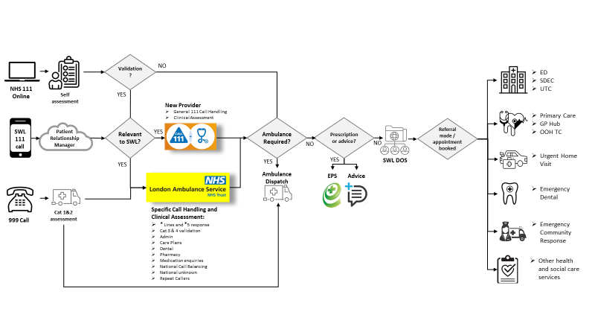

## 3.6 Service volumes

***Note:*** *The information shared within this section 3.6, is being set out here to provide overall context and is not intended to take precedence over the same or similar information contained within the Contract, Service Specification, ITT Document 1 Bidder Instructions, or Financial Model Template. In the case of any discrepancies, the Bidder is advised to seek clarity from the Contracting Authority.*

**Activity assumptions**

The SWL CCG have modelled the anticipated demand for the new IUC service throughout its initial 3-year term and these will be used to define the Core Activity within the contract and used for the purposes of evaluating bids received through the procurement process.

1. **Calls managed**

|  |  |  |  |  |  |
| --- | --- | --- | --- | --- | --- |
| SWL CCG/ICS | Year -2  2020/21 | Year -1  2021/22 | Year 1  2022/23 | Year 2  2023/24 | Year 3  2024/25 |
| Calls offered NHS 111 | 400390 | 404394 | 424614 | 450090 | 477096 |
| Calls Answered NHS 111 | 392315 | 396238 | 416050 | 441013 | 467474 |
| cas activity |  |  |  |  |  |
| Telephone advice | 69973 | 70673 | 74206 | 78659 | 83378 |
| Face to FaCE | 13957 | 14097 | 14801 | 15689 | 16631 |
| Home visits | 5308 | 5629 | 5629 | 5967 | 6325 |

1. **Contacts from NHS Online**

|  |  |  |  |  |  |
| --- | --- | --- | --- | --- | --- |
| SWL CCG/ICS  111 Online | Year -2  2020/21 | Year -1  2021/22 | Year 1  2022/23 | Year 2  2023/24 | Year 3  2024/25 |
| requesting a call back | 4717 | 7924 | 8320 | 8736 | 9173 |
| ed validation | 960 | 11248 | 11810 | 12401 | 13020 |
| other* | 7849 | 972 | 486 | 243 | 121 |

*\*Mainly National and Local Covid assessment*