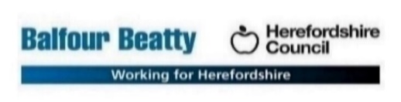

**Herefordshire Capital Drainage – Expression of Interest**

**Background**

BBLP have received additional capital investment from Herefordshire Council to enhance the drainage network on Herefordshires roads.

At this moment in time there is not a scope for individual sites, however the below requirements detail what would be needed from a sub contractor to support in delivering these works.

The initial scope of works will be starting November 2024 and finishing 31st March 2025. The contract would be in place until 31st May 2026 to undertake any adhoc drainage works required.

**Works to be procured**

A civils contractor capable of undertaking works detailed below. Programme of works from December 2024 – March 2025. Then adhoc sites from April 2025 to May 31st 2026.

Sites will be identified from known defects on the network, as well as new surveys being undertaken and identifying issues on site.

Drainage dig down and repairs of broken pipes, gullys, headwalls, dig out ditches, grips etc.

All reinstatement to be undertaken by sub contractor. Hot material to be laid if carriageway has been excavated.

**Procurement Strategy**

A single sub contractor is to be procured for civils drainage works with a schedule of rates. Once appointed as each element of works comes forward a bill of quantities will be prepared for those works and price for that scheme based on the tendered schedule of rates will be submitted by the contractor.

**Experience required**

* Gully installations
* Replacement of pipework
* New headwalls or repairing old
* Reinstatement of carriageway with hot material
* Grip installation (concrete)
* Dig out ditches
* CSCS cards
* SMSTS/SSSTS at least one person on site
* EUSR 1 and 2
* gCAT4+ trained, at least two operatives on site trained