**Grimsby Institute SEA Grant Tender**

**Date:** July 2022

**Contents**

Overview / description of the equipment 3-28

Warranty 29

**Overview / description of the Equipment**

Equipment Overview

Thermodynamics Kit HP4159 Quantity 1

The Thermodynamics kit helps to teach the temperature related behaviour of mechanical systems.

The kit includes experimental apparatus including metal blocks with heating elements, linear rods with heaters, Leslie cube and Jolly bulb.

Also included are measuring instruments such digital thermometers, energy meter and infrared thermometer.

**Learning objectives**

* Heat capacity of liquids
* Heat capacity of solids
* Linear expansion of heat
* Heat absorption
* Heat radiation
* Expansion of gases - Charles' Law
* Boyle's Law
* Additional power supply required - please enquire for further information

3.1 Complete Fundamental Mechanics

This full set of equipment allows students to understand the principles of fundamental statics, materials and dynamics engineering systems in one portal set of equipment.

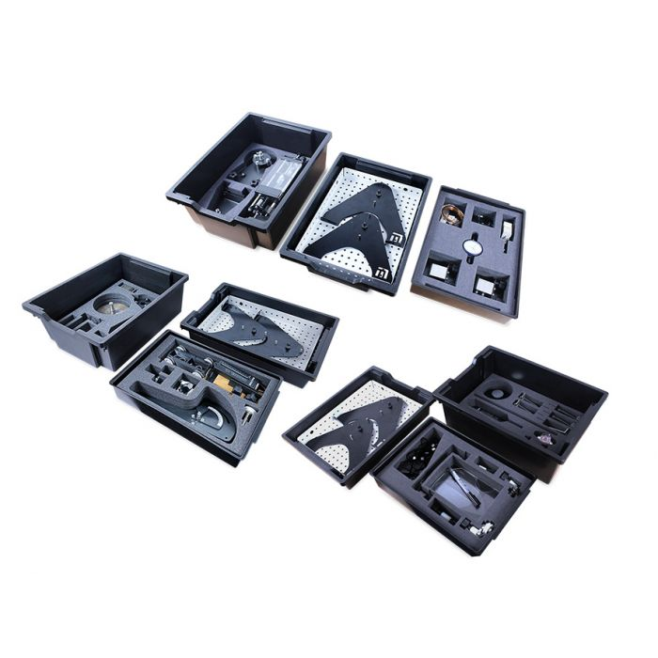

Included in this equipment are the full contents of the following kits:

**Statics Fundamentals: FM1883 x3**

This set of equipment covers the needs of students studying forces, moments, beams and more. Students use the storable work panel (included) to construct a range of experiments, which allow you to study a full course in static engineering systems. A full 10-hour workbook is included free of charge in the Learning Centre for this kit.

Learning objectives:

* Forces (mass, force, weight, combining, parallelogram, triangle and polygon
* Centre of gravity
* Units of weight and mass
* Free body diagrams
* Force vectors
* Coplanar forces
* Bow’s notation
* Principles of moments and moment of forces
* Distinguishing between moments and torque
* Equilibrium of forces
* Levers and the term mechanical advantage
* Simply supported beams
* Concentrated and uniform distributed loads
* Different types of pinned supports

**Curriculum**: T-Level City & Guild Maintenance, Installation and Repair Engineering & Manufacturing (Mechanical pathway)

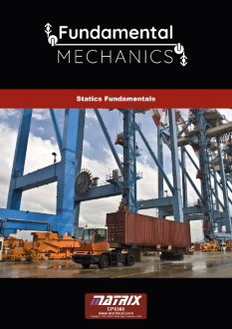

**Materials Fundamentals FM1292 x3**

This set of equipment covers the needs of students studying torsion, stress and strain, elastic constants, Young’s Modulus and more. Students use the storable work panel (included) to construct a range of experiments, which allow you to study a full course in material principles. A full 10-hour workbook is included free of charge in the Learning Centre for this kit.

Learning objectives:

* Torsion of rods
* What effect has Polar second moment of area on torque and modulus of rigidity
* What effect has torque, shape, length and material on rod deflection
* Tensile test using plastic, aluminium and mild steels
* Understand the terms stress and strain
* Introduction to Youngs modulus for different materials
* Terms elastic deformation and plastic deformation
* Terms yield strength and ductility
* Shear force tests
* Shear stress and shear strain
* What effect has second moment of area on beam deflection
* What effect has load, shape, length and material on beam deflection
* Different types of supports for beams

Curriculum: T-Level City & Guild Maintenance, Installation and Repair Engineering & Manufacturing (Mechanical pathway)

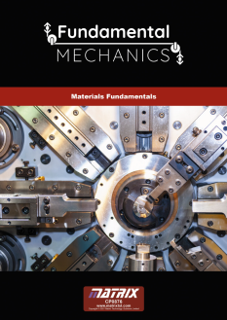

**Dynamics Fundamentals:**

This set of equipment covers the needs of students studying pulleys, static and sliding friction, mechanisms and energy conversion. Students use the storable work panel (included) to construct a range of experiments, which allow you to study a full course in dynamic engineering systems. A full 10 hour workbook is included free of charge in the Learning Centre for this kit.

Learning objectives:

* Kinetic and gravitational energy parameters and principles
* Dynamic parameters and principles
* Newton’s Law of Motion
* Mechanical efficiency and advantage
* Flywheel experimentation
* Toggle mechanisms
* Single and compound Pulley experimentation
* static and sliding friction on Inclined planes (with frictional surfaces and rollers)

Curriculum: T-Level City & Guild Maintenance, Installation and Repair Engineering & Manufacturing (Mechanical pathway)

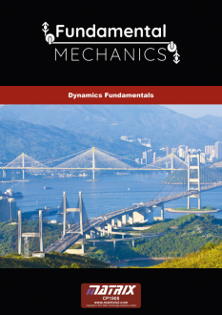

3.3 Fundamental Fluid Mechanics FM1000 X 1

Our new Fundamental Fluids range allows students to gain a hands-on understanding of the key principles of Fluid mechanics. The equipment is centred around a work-station, which provides flow control and sensor feedback to the user via a display. Users have the capability to log system results via USB or network connection or produce results from experimentation using manually taken readings.

The workstation is fitted with a pump and range of sensors, which connect via panel mounted sockets. Users then mount a range of modules including a Venturi tube, a manometer, viscosity apparatus, losses in bends/transitions etc. in order to study the learning outcomes of seven separate experiments using the one system. These seven experiments are displayed clearly on the next page.

This equipment is provided with a full course in Fundamental and Advanced Fluids.

Learning objectives:

* + Bernoulli’s equation and using Venturi flow meter
  + Using manometers
  + Pressure losses in bends & pipes
  + Series and parallel pumps
  + Centrifugal pump characteristics
  + Measuring viscosity (using Stoke’s law)
  + Centre of pressure of partially and fully submerged surfaces
  + Calibrating a bourdon gauge.

Curriculum: T-Level City & Guild Maintenance, Installation and Repair Engineering & Manufacturing (Mechanical pathway)

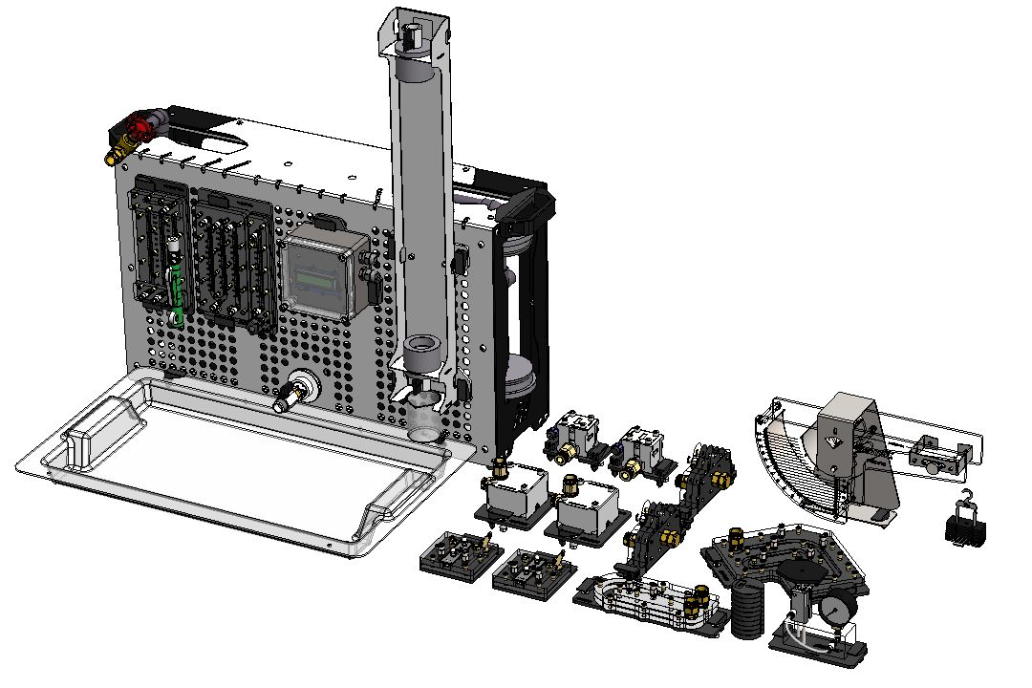

**Bending Moments ST8801 x1**

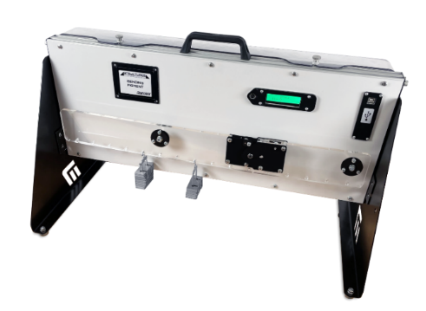

This kit allows students to apply loads to hangers suspended along a beam, held between two supports. One support allows rotational movement, acting as a pinned support, whilst the other allows translational movement, acting as roller support.

A load cell measures the bending moment due to the load applied by the student and students’ can then create positive and negative bending moments. Point loads and uniformly distributed loads can be applied across the beam in order for students to gain experience of various different situations for their experimentation. An integrated load cell measures the force applied across the cut and is displayed on the built in LCD display.

The display has a push button zero feature for experimental setup. The experiment is powered by a USB cable to PC or wall plug. If the USB is connected via a PC port, data acquisition can be output directly into excel or further experimental analysis and simulation.

Learning Objectives:

* + Bending moment at the cut due to a varying single point load
  + Bending moment at the cut due to a moving single point load
  + Bending moment at the cut due to a uniformly distributed load
  + Bending moment at the cut due to a point load and uniformly distributed load in superposition

Curriculum: T-Level City & Guild Maintenance, Installation and Repair Engineering & Manufacturing (Mechanical pathway)

**Bending Stress ST5671 x 1**

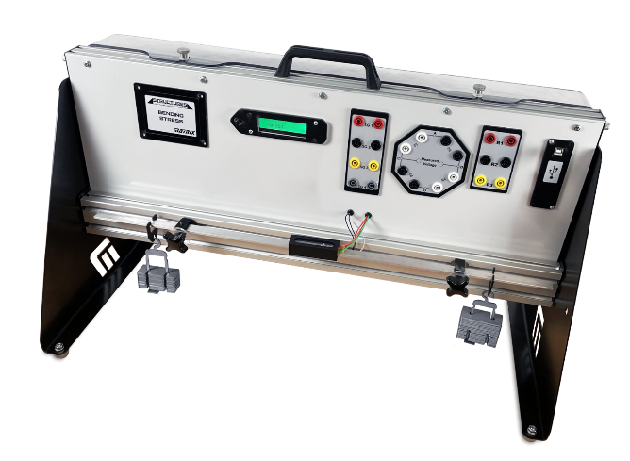 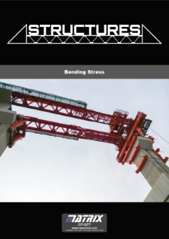

The bending stress structures product provides students with a beam with 4 strain gauges attached to it. These strain gauges are then connected into the back panel allowing simple 4mm banana plug socket connections to conduct the experiment.

The experiment explores the bending stress in a beam with applied loads. Using equations for bending deflection and stress, the theoretical value can be compared to the output of the experiment. The strain gauges can be connected up using the 4mm banana cables into 3 different Wheatstone bridge configurations. Student can then explore the behaviour of a quarter bridge, half bridge and full bridge configuration. High precision resistors are used to make up the Wheatstone bridge in the absence of a strain gauge.

The LCD display shows the millivolt change of the output from the Wheatstone bridge. With a zero button to reset the experiment.

The experiment is powered by a USB cable to PC or wall plug. If the USB is connected via a PC port, data acquisition can be output directly into excel or further experimental analysis and simulation.

Learning Objectives:

* + Stress and strain relationship
  + Strain gauges as instruments
  + Finding the neutral axis by experiment and calculation
  + Quarter, half and full Wheatstone bridge applications, with advantages and disadvantages

Curriculum: T-Level City & Guild Maintenance, Installation and Repair Engineering & Manufacturing (Mechanical pathway)

Automotive High Voltage Battery Circuits LK5281

The kit includes a number of small lead acid and lithium-ion batteries that can be built for form various batteries with different voltage and current capabilities. Students construct circuits around these batteries and understand the battery circuits used in modern electric vehicles including charging systems, voltage upconverters and downconverters, battery management systems. Students build batteries of different voltage and current capabilities and measure and characterise battery performance and test batteries. Various fault components are included so that students can understand fault finding in battery systems. Students will also require the Matrix DC motor / Brushless DC motor pair (available separately, see HP2001). Suitable for Level 3 students and technicians. A full workbook of exercises is provided.

Learning objectives:

* Lead Acid battery technology
* Lithium Ion battery technology
* Testing of batteries
* Battery construction
* Building large batteries from small batteries
* Charging systems
* Battery management systems
* Voltage converters
* Powering DC motors
* Powering three phase motors
* Three phase generators
* Fault finding in battery systems
* Electric vehicle project

DC Brushless Motor Pair HP2001 X 1

This permanently coupled Brushless motor and DC motor on a platform is required for study of the following kits:

* LK2410 Automotive motors, generators & charging systems
* LK5281 Automotive high voltage battery circuits

The Brushless motor acts as a three-phase generator. We control the speed by controlling the PWM or the voltage input, which means this product behaves a bit like a variable wind speed wind turbine or a motor in an electric vehicle.

Fluke 115 true RMS digital Multi meter HP1324 x1

This digital multimeter is an optional add-on to our modern electrical machines training system. For use with this system, the user will require two units of this product.  
  
This allows for electrical and electronic testing when using the electrical machines system in manual mode.

25MHz PC based oscilliocope / signal generator pack HP8279 x 1

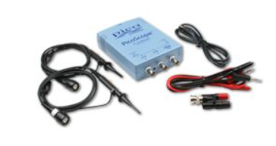

This pack is based on a PicoScope 2205 dual-channel PC Oscilloscope which has a bandwidth of 5MHz and samples at 40Msamples per second - 8 bit. It has two input channels which are used as oscilloscope or spectrum analyser inputs and it includes an arbitrary waveform generator.

This pack is based on a PicoScope 2205 dual-channel PC Oscilloscope which has a bandwidth of 5MHz and samples at 40Msamples per second - 8 bit. It has two input channels which are used as oscilloscope or spectrum analyser inputs and it includes an arbitrary waveform generator.  
  
FREE ACCESSORIES WITH THIS PACK:  
  
This great value for money pack also contains two Scope probes, a BNC male to dual 4mm binding post, a pair of 4mm croc clip leads and a USB lead.

ECU Architecture logic (DIN) LK1800 x1

This kit allows students to investigate Electronics Control Unit circuits using a pre-programmed micro ECU. Students start by building a fully functioning ECU with inputs, a relay and a transistor output and carry out the bulk of learning with it. Students construct a circuit around the ECU, select one of 14 programs on the ECU and work through the workbook provided. The workbook includes a number of fault finding exercises so that students can understand how faults in ECU circuits can be diagnosed and interpreted. Suitable for Level 3 students and technicians. A full workbook of exercises is provided.

Learning objectives:

* ECU operation and structure
* Logic functions
* Pulse width Modulation
* Inputs and switches
* Sensors – light, temperature, Hall effect
* Transistor and relay outputs
* Simple actuators – motors and solenoids
* Fibre optics
* Fault finding in ECU circuits

Curriculum: T-Level City & Guild Maintenance, Installation and Repair Engineering & Manufacturing (Mechatronic pathway)

Automotive Fault Finding LK8170 X1

This kit teaches students and automotive technicians the techniques of fault finding in an automotive context. Students are provided with a series of clear worksheets which take them through a series of practical exercises using Locktronics components and base boards. The worksheets start with instruction on using multimeters and current clamp meters for testing each type of component and making basic measurements. Students are then guided through debugging circuits using multimeters and clamp meters using techniques like fault grids

Learning objectives:

* Use of multimeters and clamp meters
* Current, voltage, resistance, capacitance, continuity
* Voltage drop
* Testing resistors, potentiometers, bulbs, switches, relays, thermistors, batteries
* Open circuit faults
* Short circuit faults
* Ground faults, and corrosion
* Fault finding techniques and fault grids
* Fault finding projects

Curriculum

AC/DC Current Clamp HP5561 X1

Current clamps enable you to measure currents without breaking the electrical circuit. Current clamps are designed with jaws that can be opened, placed around the conductor and clamped shut to form a magnetic loop around the conductor.  
  
Current clamps offer a safe, cost-effective, simple and accurate way to take current measurements.

Basic Automotive Electricity LK2240 X1

This set of equipment covers the electrical properties of materials, electricity and electrical circuits. The solution includes component carriers, baseboard, power supply and storage trays. Suitable for Level 1 and 2 students and technicians. A full workbook of exercises is provided.

Learning objectives:

* Ohm’s law
* Voltage power
* Current –DC
* Resistance
* Magnetism
* Electromagnetism
* Electrical units and symbols
* Electrical terminology
* DC motors
* Switches
* Solenoids and principles of relays

Curriculum: T-Level City & Guild Maintenance, Installation and Repair Engineering & Manufacturing (Mechatronic pathway)

CAN Bus systems and operation LK8416 X1

This kit allows a fully functioning CAN bus system, mimicking vehicle operation, to be set up using 4 MIAC Electronics Control Units representing Instrument panel, Front ECU, Powertrain control, and Rear ECU. A fifth MIAC is used for system diagnosis, releasing faults and viewing CAN bus messages. Students are tasked with setting up a fully working CAN bus system, inserting faults and using hardware and software tools to understand fault diagnosis procedures and practice. The solution includes component carriers, baseboard, power supplies and storage trays. Curriculum, including experiments and teachers notes, is available from our resources page.

Topics include:

* Advantages of CAN
* ECU action and function
* CAN message structure
* Start-up routines
* Wiring in CAN bus systems
* Intelligent design
* CAN bus diagnosis
* Scan tool use in fault diagnosis and release

Curriculum: T-Level City & Guild Maintenance, Installation and Repair Engineering & Manufacturing (Mechatronic pathway)

Power Systems LK6946 x1

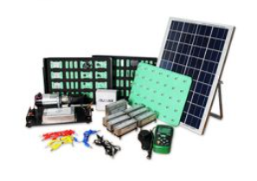

This kit combines our Locktronics learning system with a solar panel rig and a miniature wind turbine rig that can be used for experiments in Power and Energy electronics. The solar panel rig includes a full-sized solar panel - rated at 120 watts - that generates a reasonable amount of power under classroom/laboratory lighting. The kit also contains a variable speed DC motor coupled to a three-phase generator which produces up to 20 watts of power, replicating an industrial wind turbine. Together the solar panel rig and wind turbine rig can be used to provide varying amounts of energy, with varying voltage and current, in the lab. Students use these accessories with the Locktronics Power and Energy Electronics kit and 3.7V Lithium-ion batteries to conduct a range of experiments in domestic energy systems.

**Learning objectives / experiments:**

* Sources of power and energy
* Wind turbine operation and output
* Solar panel operation and output
* Energy conversion – upconverters and downconverters
* Energy efficiency
* Batteries and series parallel configurations
* Lead Acid and Li-ion battery charge and discharge characteristics
* Powerwall technology
* Wind turbines
* Wind turbine power dumping
* Three phase rectification
* Voltage inversion – DC to AC

Curriculum: T-Level City & Guild Maintenance, Installation and Repair Engineering & Manufacturing (Mechatronic pathway)

Power and Energy Electronics LK3568 x1

The solution first explores power components including diodes, BJT, MOSFET, IGBT, SCR, thyristors and triacs and then moves on to showing how these are used in power circuits including rectifiers, converters and inverters.

Worksheets are supplied which guide students through the learning activities.

**Learning objectives/experiments include**

* Diodes, BJT, MOSFET, IGBT, SCR, thyristors and triac components
* Speed control of DC motors
* Using inductive components for energy transfer
* Half and full wave rectifiers
* Fixed voltage regulators
* Buck and boost converters
* Single phase inverters using MOSFET and thyristor
* Modern power electronics topologies
* Sources of renewable energy

Curriculum: T-Level City & Guild Maintenance, Installation and Repair Engineering & Manufacturing (Mechatronic pathway)

Siemens Step 7 V16 Software X 1

SIMATIC STEP 7 is the world's best known and most widely used programming software in industrial automation. This 12-seat licence allows users to control the AU9077 (see 2.3) within an educational environment.

The Automatics smart factory AU3686 X1

allows students to get experience of several processes/technologies that are commonly used in manufacturing and modern-day Industry 4.0 principles. This includes conveyor systems, sensing systems, pneumatic pick and place technology, DC motor drives, and stepper motor drives.

The factory includes of several coloured components—plastic (and other material) discs. A conveyor belt moves these pieces into the factory, where user programmed sensors sort the discs into rejection bins etc. Some are picked off the conveyor by a suction device and a stepper motor-controlled gantry sorts the discs into appropriately coloured containers.

The smart factory is completely self-contained and can be stored away in one of our standard trays. The smart factory can be used with Siemens (or another brand) 12V or 24V) PLC and is also compatible with our AllCode MIAC. Various order codes apply.

Learning objectives / experiments:

* + Factory control and automation systems
  + Software design for automation
  + DC motor and stepper drives
  + Conveyor and gantry systems
  + Vacuum pick and place systems
  + Component sensing and sorting
  + System design with more than one controller (some systems)

Curriculum: T-Level City & Guild Maintenance, Installation and Repair Engineering & Manufacturing (Mechatronic pathway)

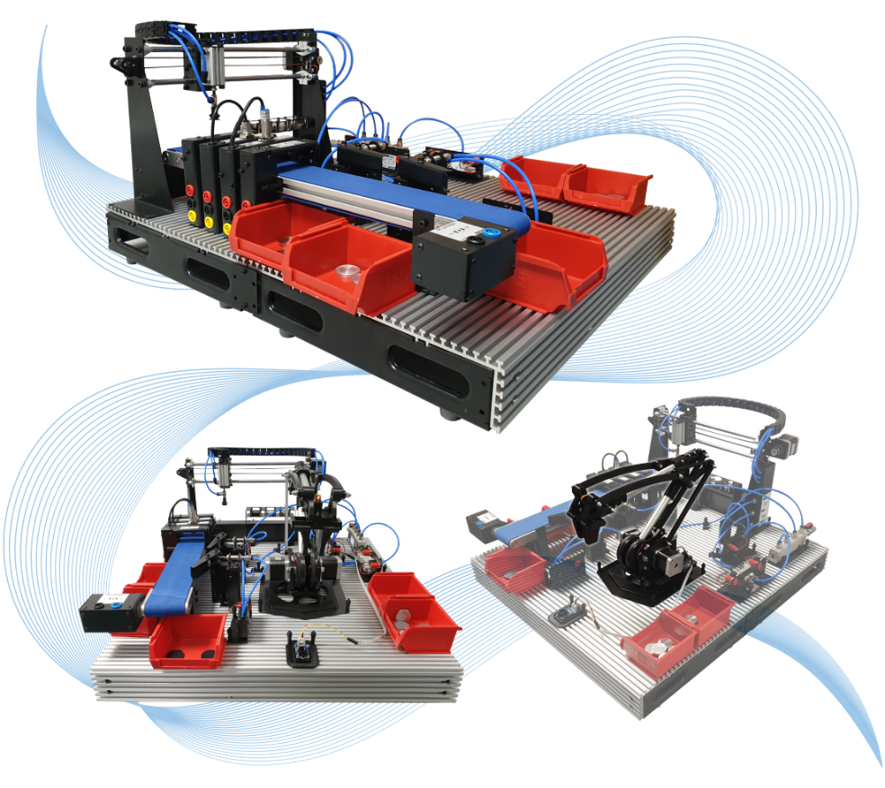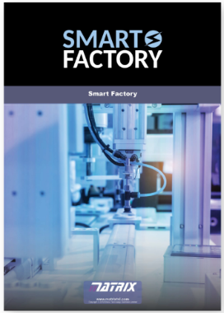

1.6 Robot Arm solution (RB1387) x1

Our new robot arm production cell consists of a rugged stepper controlled 6 degrees of freedom arm bolted to a base plate and a mat that provides a range of exercises mimicking industrial robot arm production cells. The arm itself delivers accurate and repeatable movement with base rotation, single plane shoulder, elbow, wrist motion, a functional gripper, and a wrist rotator.

The Bluetooth and Wi-Fi enabled host controller board can be programmed directly from Flowcode, or Microchip’s MPLAB. A full 3D Flowcode simulation is available. The control system is also shipped with a full Application Program Interface so that the robot can be controlled using any Bluetooth enabled device such as a PC, Android, or Apple MAC device using a range of software applications including C++, LabView, Python, and App Inventor as well as remote applications over the web. The kit is supplied with several coloured counters which can be moved by the arm into different locations in the work cell.

Learning objectives:

* Robot cell design and programming
* Microcontroller programming
* Sensors and actuators in robotics
* Kinematics: 3D movement in robotic systems
* Web based control
* Programming in many languages

Curriculum: T-Level City & Guild Maintenance, Installation and Repair Engineering & Manufacturing (Mechatronic pathway)

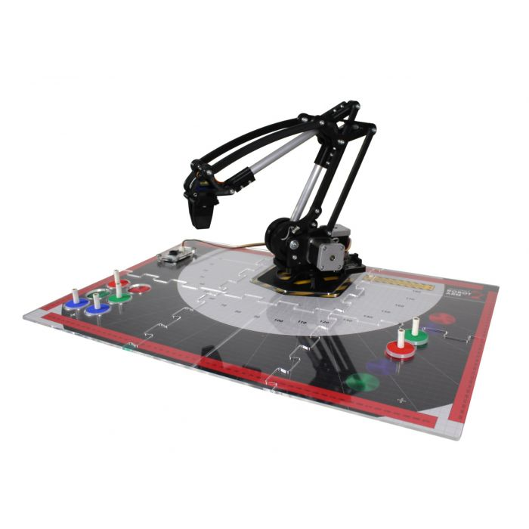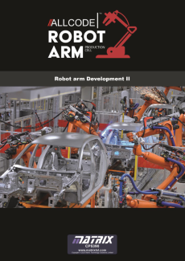

Compressor AU1050 X1

This desk mounted compressor is an oil-less piston compressor, with a small electric 1/8HP motor that is designed to operate on the Automatics platform. It is powerful, compact, reliable and quiet. It includes a dial showing the pressure in the output pipe (0 to 100psi), an on/off switch and air outlet switch and an air pressure adjustment knob. The unit is powered from 240V

Electrical Installation & HVAC 2 solution LK4063 x1

The learning outcomes of this kit closely aligned with City and Guilds 8202 unit 202 in Electrical science.  The kit includes a comprehensive range of practical assignments in electricity, basic circuits and the use of multimeters for measuring and fault diagnosis.  The kit is supplied with a comprehensive set of printable worksheets and teacher's notes.

Learning objectives/experiments

* The principles of electricity
* The principles of basic electrical circuits
* The principles of electromagnetism
* The operating principles of a range of electrical equipment
* The principles of A.C. theory
* Includes our new residual current device

Curriculum: T-Level City & Guild Maintenance, Installation and Repair Engineering & Manufacturing (Mechatronic pathway)

Op Amps add on LK6906 X3

This pack includes an op-amp and associated component carriers which facilitate the study of op amp circuits. This kit only contains the component carriers - baseboards, power supplies and storage trays should be bought separately. Material on the worksheets includes:

* Comparators
* Non-inverting amplifiers
* Inverting amplifiers
* Summing amplifiers
* Schmitt trigger circuit
* Relaxation oscillator
* RC time constant

Curriculum: T-Level City & Guild Maintenance, Installation and Repair Engineering & Manufacturing (Mechatronic pathway)

Fault Finding in Electronic Circuits LK3566 x1

This solution allows students to gain experience of fault finding on several analogue and digital systems. Students first learn how to use test equipment and test the major groups of active and passive components. Then students are given a fully working circuit so that they can understand the circuits' function. Supervisors then insert one of a number of faults on each circuit and the student must deduce the fault through the use of the appropriate instruments. Faulty components are clearly marked underneath the carrier. Five fully tested and assembled circuits supplied.

Curriculum: T-Level City & Guild Maintenance, Installation and Repair Engineering & Manufacturing (Mechatronic pathway)

**2.0 Process Control & Instrumentation**

Collective Learning objectives:

* Drive systems and their scaling factors
* Sensor characteristics, scaling factors, calibration
* Valve characteristics and calibration
* On/off control systems, oscillation, hysteresis
* System time constants
* P control systems and offset error
* PI control systems
* PID control systems
* Control functions and block diagrams
* Pseudocode implementation of P, PI and PID systems
* Recognition of problems in PID systems
* Integral wind up issues and overcoming them
* Derivative filtering
* Ziegler Nichols algorithm
* Manual tuning of PID systems
* Servo control systems
* Inverting pendulums

Curriculum for all systems: T-Level City & Guild Maintenance, Installation and Repair Engineering & Manufacturing (Mechatronic & Mechatronic pathway)

2.2 Pressure Process Control System CT1733 x1

The Pressure system consists of a variable speed reciprocating air pump (compressor), the speed of which can be adjusted by students, a pressure vessel and an outflow system. The outflow system allows the air to escape via either a manually operated needle valve - providing an ongoing outflow, or via a solenoid valve and second needle valve - providing a step change in outflow. The vessel pressure is measured by a Bourdon type mechanical gauge along with a pressure sensor. The Bourdon gauge provides a visual indication of the pressure in the vessel and a means for students to check and calibrate the controller input from the pressure sensor.

INCLUDES

* + UK head for 24V PSU
  + 24V PSU 60w 2.5A
  + Pressure process control system
  + USB lead

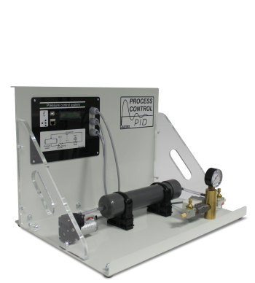

2.3 Temperature Process Control System CT1491 x1

The temperature process control system includes a heated plate within a duct. Two thermocouples connect to the controller and an external meter to allow students to check and calibrate the controller input. A fan at one end of the duct blows the ambient air over the block, to change the control conditions and provide a disturbance to the system. The system allows students to adjust the heater power and the air flow rate to develop a PID based control system then adjust these parameters to achieve the required time/temperature change profile for the system in response to step changes in the system requirements.

INCLUDES

* + UK head for 24V PSU
  + 24V PSU 60w 2.5A
  + Temperature process control system
  + USB lead

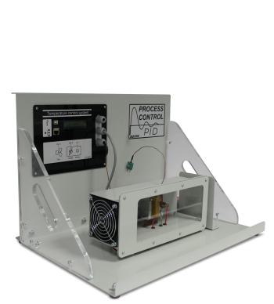

2.4 Flow Process Control System CT0673 x1

The Flow system consists of a water tank, variable speed pump, a turbine type flow sensor, an electrically operated proportional valve and a variable area flow meter (rotameter). This allows students to adjust the flow rate via the pump speed and the valve opening to develop PID based control system.

INCLUDES

* + 4mm x 1.5mm Wall clear PVC tube (300mm)
  + UK head for 24V PSU
  + 24V PSU 60w 2.5A
  + Flow process control assembly
  + Barley pot for process control
  + USB lead

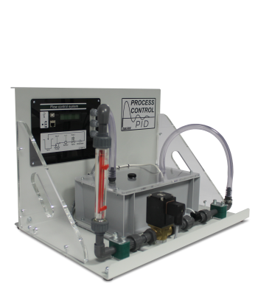

2.5 Servo/Pendulum Motor Control System CT9513 x1

We also provide a solution for motor control training, a configuration very different to the Flow, Level, Temperature and Pressure systems, which have a motor or pump that only drives one way. Instead, we use transistors as switches to control the direction of current in a motor. Students’ can then study the speed and position of a motor with one set of training equipment.

INCLUDES

* + UK head for 24V PSU
  + 24V PSU 60w 2.5A
  + Servo Pendulum motor control system
  + USB lead

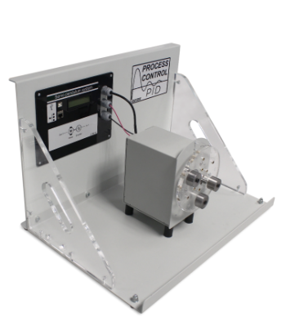

The display has a push button zero feature for experimental setup. The experiment is powered by a USB cable to PC or wall plug. If the USB is connected via a PC port, data acquisition can be output directly into excel or further experimental analysis and simulation.

Learning Objectives:

* + Shear force at the cut due to a varying single point load
  + Shear force at the cut due to a moving single point load
  + Shear force at the cut due to a uniformly distributed load
  + Shear force at the cut due to a point load and uniformly distributed load in superposition

Curriculum: T-Level City & Guild Maintenance, Installation and Repair Engineering & Manufacturing (Mechatronic/Mechanical pathway)

**Reactions of a Simply Supported Beam:**

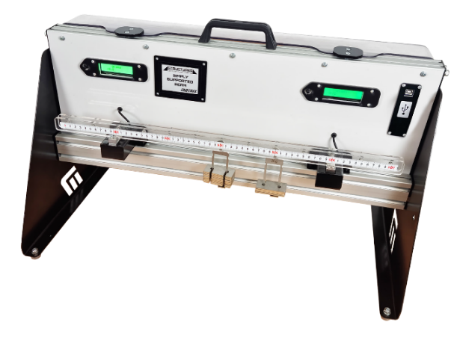 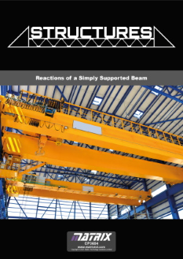

This product allows student to explore the behaviour of reaction forces on beam with supports. Two ‘simply supported’ supports are attached to load cells so that a precise measure of reactional force can be measure

for a loading parameter. The load cell output in connected to the LCD displays and the USB interference for data acquisition, for further experimental analysis.

The beam has a measure indicator for accurate distance measured between supports, while both support blocks can slide along the rail for exploring the behaviour of varying length. The beam has incremental pins for hanging weights on at different places to create different point loads and can balance the weights on top to create uniformly distributed loads.

Overhanging point loads can be achieved too to create negative reaction forces to show direction of forces. This allows student to explore reactional forces that are positive and negative and the principle of superposition.

Learning Objectives:

* + Reactions due to point loads
  + Reactions due to UDL’s
  + Reactions due to overhangs
  + Reactional force changes due to varying distance between supports.

Curriculum:

**Deflection of Beams:**

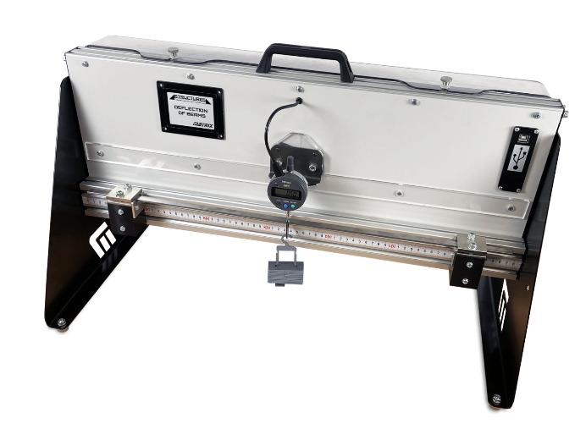 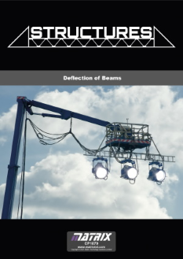

This kit allows students to utilise a range of beams in order to understand the elastic properties of beams and cantilevers.

Beams can be fitted to one support to form a cantilever, or between two supports with different fixing methods, forming simply supported and fixed or ‘encastre’ beams. Students apply loads and measure the deflection. This product includes a set of ‘specimens’ of different metals for comparison of the elastic properties. It also allows the student to vary the length of the beam to see how this affects the magnitude of deflection for a given load.

The Digital Mitutoyo dial has its own display, but it is connected to the USB interface so data acquisition can occur across the USB cable.

Learning Objectives:

* + Beam bending formula
  + Deflection due to point loads and UDLs (uniformly distributed loads)
  + How beam fixings affect deflection of: Simply supported beams, Fixed or ‘encastre’ beams, Cantilever beams, Propped cantilever
  + Shape of a deflected beam
  + Beam length and deflection
  + Beam material and deflection — the elastic (Young’s) modulus
  + Beam cross-section and deflection — the Second Moment of Area (‘I’ value) – and material stiffness

Curriculum:

**Torsion of Rods:**

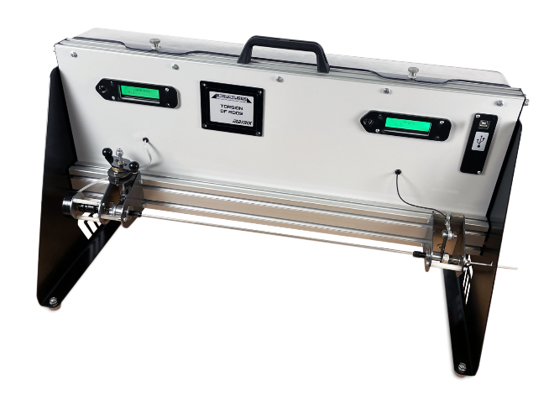 

This kit allows students to understand the torsional elastic properties of rods. Students choose from a selection of test rods and fit them to the experimental work panel. They can adjust the distance between the chucks for tests on varying rod length. Each chuck includes pointers that work with the scale on the platform for accurate positioning.

Students apply angular deflection to the specimen using a chuck which includes a precision potentiometer to measure the angular deflection, which is then displayed on the LCD display. The other chuck connects to a load cell to measure the resulting torque, which is displayed on the other LCD display. Students use textbook beam equations to predict the deflection and torque relationship and compare the calculated results with the measured results. This helps confirm the reliability of the textbook equations and the accuracy of the experiment results.

This product includes a set of rods of different metals for comparison of the elastic properties, dimensions and polar second moment of area (‘J’ value). It also allows the student to vary the effective length of the rods to see how this affects the magnitude of deflection for a given torque. The angle and load cell output is connected to the USB interference and can have the data acquisition through the USB cable.

Learning Objectives:

* + Torsion formula
  + Rod length and angle of twist relationship
  + Rod material and angular deflection— the elastic (shear) modulus (G)
  + Rod cross-sectional dimensions and torsion—the polar second moment of area (J)

Curriculum:

PIC Micro Controller system development Kit Combo X3 BL0524

The BL0524 E-blocks2 PIC microcontroller system development kit contains a [PIC programmer board](http://www.matrixtsl.com/webshop/e-blocks2-pic-programmer.html) (with Ghost technology) and [combo board](http://www.matrixtsl.com/webshop/e-blocks2-combo-board.html), which is covered in removable acrylic for lab protection purposes and presented on a printed panel, which not only looks great but also provides a student friendly solution for microcontroller development. This kit also includes a keypad board, a prototype board, a motors and actuators training board, a relay board and a Grove sensor mother board plus the relevant sensors on infrared, temperature, humidity, ultrasonic.

This kit is also supplied with power supply, USB and a neat, Gratnell’s tray storage solution.

For learners, this kit is compatible with our 'Introduction to microcontroller programming' course which is available for free [here](http://www.matrixtsl.com/resources/files/datasheets/Microcontroller%20compete%20course.pdf). This 50-hour course teaches the basics of developing projects based on microcontrollers using our Flowcode software. The kit is also compatible with MPLAB, and other compilers and assemblers that produce hex for PIC microcontrollers, and is flexible hardware platform for learning C code, Assembly and other languages. A free utility which can send hex code into the microcontroller on the PIC programmer - Mloader - is available as a download from our web site.

This solution is our combo version.  You can see the modular version [here](https://www.matrixtsl.com/webshop/pic-microcontroller-system-development-kit-modular.html).

This product includes an BL0011 PIC programmer which, when combined with Flowcode, provides access to the advanced In-Circuit Test and In-Circuit Debug features found in our revolutionary Ghost Technology.

**4.0 Electrical Machines & Motors EM6637-2 qty 1**

4.1 Modern Electrical Machines EM6637-2 Qty 1

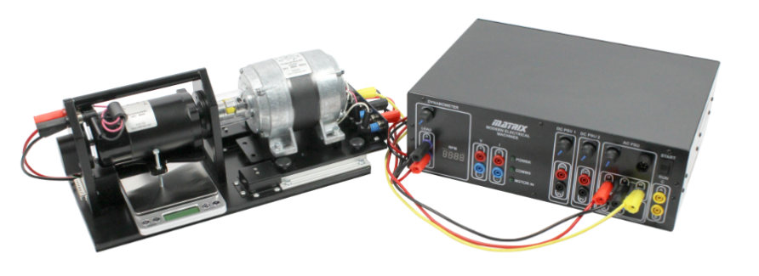

Modern electrical machines training system is a revolutionary way of safely studying the characteristics of different motor types in a learning environment. This solution includes eight different types of machine, integrated power supply and control box and PC-based applications for advanced controller of the different machine types. Further to this, we provide four separate curriculum manuals for teaching electrical machines principles using manual control with external meters, using PC control and also control using MATLAB or LabVIEW.

Dynamometer:

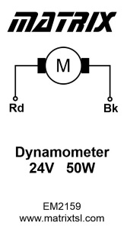 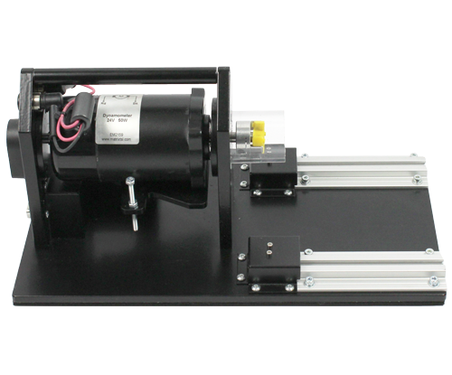

The Dynamometer is made up of a long shafted Permanent Magnet DC machine free rotating between bearings mounted in a cradle. One side of the machine can be coupled to any of our test machines using a push fit safety coupling housed in a plastic tube which ensures that no moving parts are accessible. The Dynamometer cradle takes torque measurements in both directions of rotation: anti-clockwise with a spring balance, and clockwise with a strain gauge linked to the control unit. The Dynamometer is fitted with two 4mm shrouded safety connectors which are used to add an electrical load to the machine and are also used as a DC machine (24V 50W) when testing machines as generators.

Brushless motor:

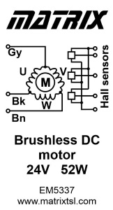 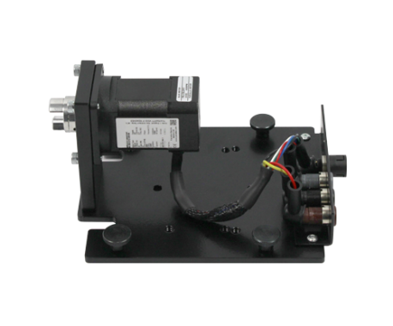

The Brushless DC motor is a small 24V 52 watt device with 8mm shaft and safety coupling. The 6 pole device is driven by a 24V three phase supply and has Hall effect sensors to sense rotor position. The machine is fitted with 4mm connectors for drive and a 5 way connector for Hall sensors.

DC motor:

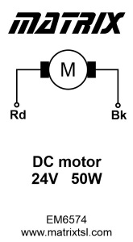 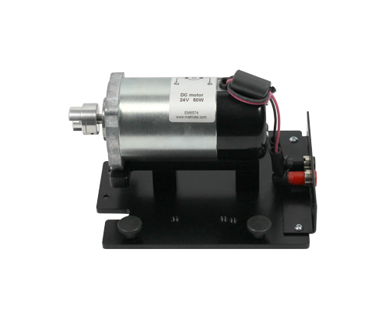

The 24V 50W Permanent magnet DC motor is a simple machine with two magnetic poles for the stator and a wound rotor with carbon brushes. The machine is fitted with 4mm shrouded connectors.

Universal motor:

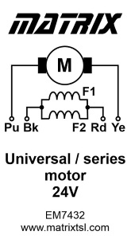 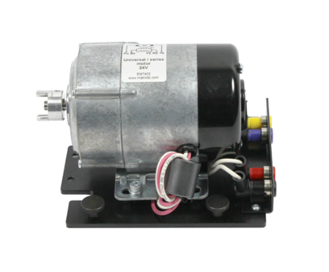

The series motor can be driven from 24V AC or 24V DC and has a 2-pole wound stator and a wound rotor with carbon brushes. Rotor and stator connections are made on separate 4mm shrouded connectors.

Single Phase motor:

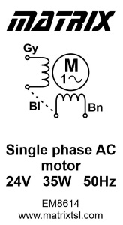 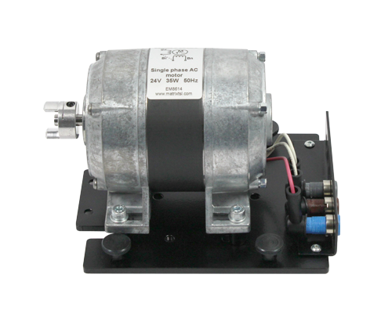

The single phase 24V 35W induction motor has a 4-pole wound stator with two windings for start and run. Connection is provided on 4mm shrouded connectors with a common terminal, start terminal and run terminal. Requires an external capacitor (included inside the Control unit) to start rotation.

Shunt motor:

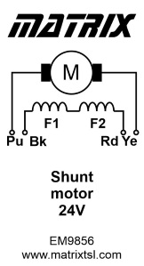 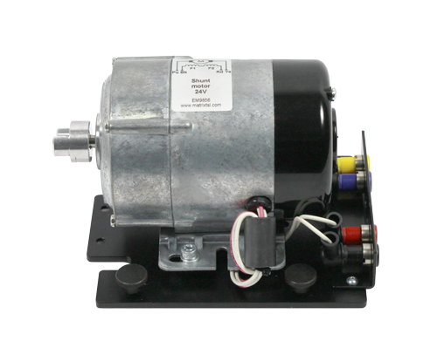

The shunt motor is a 24V device with a 2 pole wound stator a wound rotor with carbon brushes. Rotor and stator connections are made on separate 4mm shrouded connectors so that the field and armature can be excited by separate DC power supplies.

Three Phase motor:

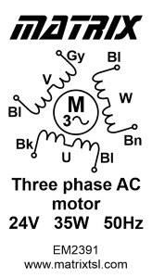 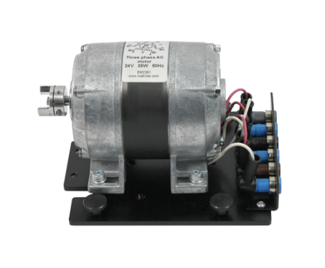

The three phase 24V 35W induction motor has a 2-pole wound stator. Connection for each winding is provided on 4mm shrouded safety connectors.

Learning objectives:

* + How to safely operate electrical machines
  + The function and operation of test meters and the dynamometer
  + How to determine current, voltage and power in DC, single phase AC & three phase AC circuits
  + How to measure torque, power output and efficiency of an electrical machine
  + The operation of DC motors and generators and their speed torque characteristics
  + The control of DC motors with PWM
  + Speed torque characteristics of DC motors and generators (dynamo).
  + Shunt motors and their speed torque characteristics
  + Series motors and their speed torque characteristics
  + Equivalent circuits of DC motors
  + Series motors operating with AC
  + The operation of single-phase AC machines
  + Use of start run capacitors and phase shift in current
  + Speed control of single-phase AC machines
  + Modern variable frequency speed drives and their operation – digital and pseudo-sine
  + The operation of three phase AC induction motors
  + Speed control of a three phase AC induction motor using variable frequency drives and the six step drive method
  + Synchronous speed and slip in induction motors
  + The operation of a brushless DC motor
  + The operation of three phase AC permanent magnet generators (PMGs)
  + How to calculate the efficiency of a system

Curriculum:

Micro CNC System System controller and Baseplate CN4079-v2 X 2

* Unit 23 of BTEC Higher National: CAD/CAM
* Unit 43 of the BTEC National award in Engineering: Manufacturing CNC machines processes

The Micro CNC system controller and base plate allows you to control our Micro CNC machines using a variety of software packages.  The CNC system controller is compatible with our range of multi axis CNC machines.  The base plate includes all power supplies and an industrial standard computer with stepper motor driver circuitry and a USB port for connection to your PC.  The unit is fitted with a single IEC mains connector and includes a number of output sockets for the stepper motors of the CNC machines.

The individual machine components are easily fastened to the base plate, providing a solid and tidy machine which can easily be put away for storage.  Windows compatible.  Includes safety guard.

3 Axis Micro CNC Milling machine CN4234 x2

The 3 axis Micro CNC milling machine allows students to understand how G codes are used to control a CNC operated milling machine.  The three stepper motors and DC motor connect to our CNC system controller hardware to allow full control of the miller using the G code file host software.  Students can use the hardware and software to see how each G code command affects the machine operation and create complex work pieces from PU blocks or acrylic pieces.

**Learning objectives/experiments**

* 3 axis CNC machine construction
* Simple G and M code protocol
* CNC machine operation using G Codes
* Creation of milled parts using CNC technology

**Additional proposal inclusions**

**Warranty**

All products carry at least one-year warranty as standard. Furthermore commissioning and training for new equipment require inclusive.