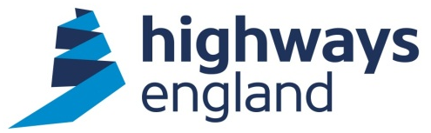  Our ref: CDF PC3a/b 0025  Your ref:  BAM Nuttall/ Morgan Sindall JV (BMJV)  Via Bravo Solutions | Sharon Cuff  Procurement Director  Highways England  Lateral  8 City Walk  Leeds  West Yorkshire  LS11 9AT  22 December 2017
CDF PC3a/b 0025- Smart Motorways Programme- Delivery Partner for M27 J4-11

Dear Sir/Madam

On behalf of Highways England, I am writing to accept your recent offer to carry out the above-mentioned Package Contract within the terms of the Collaborative Delivery Framework agreement.

The Package Contract is a Package order, awarded under Lot 3b of this Framework.

The commencement date will be authorised by the Project Manager, Deborah Makinde.

This will form Order CDF PC3a/b 0025 to the Agreement.

You should note that we will not pay for any work unless it has been specifically authorised in writing within the terms of the Agreement.

Category Management

CDF Delivery Partners are required to utilise any live category specific arrangements Highways England has in place. Early engagement and appointment of a specialist subcontractor is required to drive efficiency during the scheme development through supply chain input. Highways England will arrange to discuss these requirements further and agree a joint action plan shortly following award. Current live category arrangements are:

- Temporary Traffic Management
- Traffic Management Technology

Collaborative Performance Framework

The CPF toolkit has now been tailored to suit individual types of task orders/contracts and as a result of this the Project Manager will liaise with Highways England’s Commercial Team to identify and issue the CPF toolkit that is relevant to this specific contract. A CPF will be required in accordance with the CPF guidance and FAQ documents. The CPF may be considered by the Company when allocating future work and other contractual mechanisms.

Invoicing

Invoices should be sent to FS Payments at Highways England, The Cube, 199 Wharfside Street, Birmingham, B1 1RN, quoting the Project Manager’s
name, Blanket Purchase Agreement number and release number, both obtainable from the Project Manager.

Please note you must not make any public announcements and all media enquiries should be directed to the Highways England Press Office.

Please acknowledge receipt of this letter by return.

Yours sincerely,

Sharon Cuff
Procurement Director

