**Tregarne Sunday School Request for Quotations.**

**14th October 2021**

**Contents**:

Part One: Preliminaries

Part Two: Specification for works

Part Three: Summaries (Summary of costs/ Quality Evaluation)

Appendix One: Planning Drawings

Appendix Two: Photos.

|  |  |
| --- | --- |
| **Checklist** | **Submitted Yes/No** |
| Summary of costs (before and/or after 30/6/2022) |  |
| Details of heritage experience |  |
| Proposed programme and timetable |  |

**Part One Preliminaries**

**1.0 Overview**

1.01 The former Tregarne Chapel and Sunday School, Tregarne Terrace, St Austell, PL25 4BE are adjoining buildings located to the North East of St Austell on a well-used pedestrian route from the Railway Station. Although not listed, both buildings have historic importance to the town and are a key part of the Conservation Area.

1.02 The Chapel and Sunday School have been vacant since 1994 but are now being converted by the new owner. The Chapel is being converted to provide four three bed dwellings. The former Sunday School conversion includes a one-bedroom flat, 2No two bedroomed flats, covered car parking spaces for five cars and cycle storage.

1.03 St Austell Townscape Heritage scheme is funding repair work to key historic buildings in the town. Repairs to the former Tregarne Sunday school are being discussed as a potential project for the scheme. As formal tendering is a funding requirement tenders are now being requested for conversion of the former Sunday School only.

**2.0 Outputs**

2.01 St Austell Townscape Heritage scheme is a multi-funded repair scheme funded by National Lottery Heritage Fund, Cornwall Council, St Austell Town Council and St Austell BID. Key historic buildings are being repaired to a high standard using traditional construction techniques and materials. The aim for the former Sunday school is to convert it well as a reference for other future historic building work in the town. This will retain and repair original building fabric, enhance the character of the Conservation Area and bring a previously vacant building back in to use.

**3.0 Contract Management**

3.01 The tendering process will be managed by St Austell Town Council, a part funder of the Townscape Heritage scheme. Tenders will be advertised through ‘Contracts Finder’. Returned tenders should be send by email to: [info@staustell-tc.gov.uk](mailto:info@staustell-tc.gov.uk) clearly marked Tregarne Sunday School tender.

They will be then assessed independently. A proposed timetable is as follows:

* Tender request date: Thursday 14th October 2021
* Tender return deadline: 12.00 noon on Wednesday 3rd November 2021
* Tender evaluation: Monday 8th November 2021
* Notification of bidders: Week commencing Monday 8th November 2021

(by St Austell Town Council)

* Project commencement: Monday 22nd November 2021
* Project Completion: Thursday 30th June 2022 (unless agreed

Otherwise)

3.02 The Townscape Heritage scheme finishes on 30th June 2022. Two tenders are requested. The first to complete works by 30th June 2022. The second, if completion by 30th June 2022 is not possible, is to complete the works at the earliest opportunity after 30th June 2022. A draft timetable with proposed start and completion dates is required for the later.

3.03 It is expected that the successful tenderer enters in to a JCT Minor Works Building contract or equivalent with the building owner who will be the client for the works. The building owner will be applying separately for a Townscape Heritage scheme grant for the works.

3.04 The successful contractor should carry out all work in accordance with the Construction Design and Management (CDM) Regulations 2015 including the appointment of an appropriate Principle Designer.

3.05 The contractor is expected to have the following minimum levels of insurance cover:

* Employers Liability (statutory requirement under the Employers Liability Compulsory Insurance Act 1969): Five million pounds
* Public/Products liability (or General liability) cover for injury, loss or damage suffered by a third party due to negligence or breach of statutory duty of the policyholder: Five million pounds

**4.0 Award Criteria**

4.01 Submitted quotations will be evaluated in terms of both price and quality with a weighting of 70% price and 30% quality. The full evaluation breakdown is as follows:

* Price: 70%
* Experience of work on historic buildings: 20%
* Ability to complete the work within specified deadline: 10%

4.02 Details and examples of other work carried out on historic buildings should be provided along with a draft programme for the works.

4.03 A summary sheet for the tender breakdown and required information for the quality assessment are included in Part 3.

**5.0 Further information**

5.01 If any further information is required, please contact Andrew Richards on

07483 364378 or [Andrew.richards@cornwall.gov.uk](mailto:Andrew.richards@cornwall.gov.uk)

**Part Two**

**Specification for former Tregarne Sunday School conversion,**

**St Austell, PL25 4BE**

**Contents**

1.0 General

2.0 Demolitions/Groundworks

3.0 Services, site and External Works

4.0 Substructure works

5.0 Superstructure/Structural work

6.0 Ground Floor

7.0 Intermediate Floor

8.0 External Walls

9.0 Internal walls/Separating walls

10.0 Internal walls/partitions

11.0 Roof

12.0 External doors

13.0 Windows/roof windows

14.0 Internal doors

15.0 Joinery

16.0 Ceilings

17.0 Plumbing/Wastes/Drainage/Sanitary ware

18.0 Internal Staircases

19.0 Safety/ Fire Protection/Security

20.0 Rainwater goods

21.0 Building services-electrical

22.0 Building services-mechanical

23.0 Building Services-other

24.0 Site services

25.0 Finishes/Decorations

26.0 Fixtures/Fittings

27.0 Unforeseen Works

28.0 Direct Order/Separate contract works

**Specification**

**1.00 GENERAL:**

1.01 Scope of works:

• Repair of the external envelope of the former Sunday School,

• conversion of the building to include a one-bedroom flat and car parking spaces for five cars on the ground floor and 2No two-bedroom flats on the first floor.

1.02: Tenders should be for full completion of the project with the three flats fully fitted and furnished and ready for tenants to move in.

1.03On completion of the works all associated (temporary, re-routed, etc) services connections to be made safe and removed or reinstated, all disturbed hard landscaped area around the perimeter of the site to be made good.

1.04 The Contractor may use the church car park opposite the chapel at a cost of £37.50 per month for parking. The contractor, site operatives and all those involved in the project works should familiarise themselves with existing vehicular and pedestrian movements and comply with all relevant Health & Safety requirements and all necessary temporary protection measures.

1.05: Contractors’ working arrangements, working times, personnel management and security, etc. to be proposed by the Contractor and agreed with the Client.

1.06: Contractors will be working within the context of an urban domestic environment due to the proximity of public and private roads and the neighbouring building(s). All due care and attention must be taken, and all necessary allowances made to ensure that nuisance and disruption are eliminated or minimised, and that any such eventualities are restricted to agreed times, limits, etc. – all to be agreed with the Client. Particular care and attention should be taken during all trenching and similar operations.

1.07: Compliance with current legislation**:** All materials and works are to fully comply with all current relevant legislation, British Standard Specifications and Codes of Practice, Building Regulations, CDM Regulations, etc. as and when appropriate. The Contractor will have responsibility for Health & Safety for all on site operations.

1.08: All materials and works are to be as specified, with all manufacturers’ instructions strictly followed, and substitutions will not be acceptable without the prior written approval of the client. In this Specification the term ‘or similar approved’ shall be construed accordingly.

In particular, all works are to fully comply with BS 8000 ‘Workmanship on Building Sites’ and Approved Document ‘Regulation 7 – Materials and Workmanship’.

1.09**:** Harmful emissions are to be minimised by:

(a) avoiding the use of chemical treatments such as formaldehyde;

(b) avoiding treatment of timber other than that which is necessary to comply with other provisions specified – such as life expectancy and location of component(s);

(c) where possible undertaking any such necessary treatment industrially prior to use;

(d) ensuring that no asbestos is specified or used;

(e) ensuring that no CFC’s or HFC’s are in any product incorporated;

(f) ensuring that wood preservatives and paints do not contain pentachlorophenol (PCP).

1.10: All necessary removal, remediation, labelling and recording works in connection with ACM (asbestos containing materials) that may be found on this site or within existing structures (to be demolished or otherwise) are to be undertaken by a licensed specialist contractor, fully in accordance with the requirements of all current Legislation, approved Codes of Practice and Guidance Notes for work with asbestos and asbestos containing materials. If required, an Asbestos Survey is to be undertaken, and an associated Report produced, by a specialist firm, which will set out the asbestos incidence involved and recommendations for all necessary actions required in relation to this project.

1.11: Health and Safety:Generally, there is a risk of injury or death in construction if the works are not properly planned and supervised. The contractor must not undertake any element of the work without first having carried out the necessary risk assessments and prepared detailed method statements. All relevant best practice guides, British Standard Specifications and Codes of Practice etc. are to be used accordingly.

1.12: Demolitions are a high-risk activity. Such works to existing buildings, building elements, site excavation, etc. should only be commenced after the following steps are undertaken:

• identification of hazard;

• assessment of the risks associated with the hazards;

• control of the identified risks;

• review of the process.

1.13: Appropriate staging/platforms are to be used when working at height. Material/component sizes are to be selected to avoid unmanageable weights when installing. Appropriate temporary support to be used during removal and installation of new structural elements.

1.14: On any leadwork the contractor is to follow recommendations outlined in "The Control of Lead at Work Regulations” and “Lead Sheet Training Academy”, in particular including having a suitable fire extinguisher to hand at all times during the work.

1.15: Electrical installations - working with electricity can kill. Particular care should be taken when working outdoors or in wet surroundings. All electrical installations should be fitted to BS7671 requirements and to be fully in accordance with all current relevant regulations (incl. Building Regulations Approved Document Part P - latest edition), British Standard Specifications and Codes of Practice, etc. Power,

1.16: lighting, ventilation, heating etc. are all to be in accordance with design parameters in appropriate CIBSE guidelines and recommendations.

1.17: Necessary risk assessments and detailed method statements should be prepared prior to starting on site by the contractor/sub-contractor for all relevant projects and project elements.

1.18: All works involving existing parts of the building are to be considered as provisional and details of any problems found or not anticipated are to be reported to for further instruction.

1.19: Unless specified as hardwood (which should be from sustainable sources) all timber is to be softwood of the required quality and is to be pressure preservative treated by an approved company to the approval of the Client, taking into account the historic importance of the building.

1.20: Unless otherwise specified all fixings are to be in Type 316 austenitic stainless steel and as more particularly described in the specification.

1.21 Scaffold: Provide scaffold to complete building 500mm below fascia board. Provide a separate cost for scaffolding allowing for pavement licence.

**2.00 DEMOLITIONS/GROUNDWORKS:**

2.01: Any demolitions, site clearance and preparatory/enabling works may be carried out as a separate or an integral element of the main overall works package on site prior to the commencement of the project works proper. Certain works, such as the removal of parts of the roof structure, must not be carried out until the new supporting structure has been installed.

2.02: Demolition works (if required) to existing site/premises, to be all as shown on relevant drawings – note demolition is a risk and must be undertaken by competent personnel with suitable machinery and protection.

2.03: All existing services found are to be recorded and marked. Any to be removed, relocated or rerouted are to be properly made safe, cut back, extended, terminated, etc. as and where necessary to suit the new requirements, strictly in accordance with all appropriate rules, regulations and guidelines issued by statutory authorities, service providers and client.

2.04: Any further site strip of existing tarmac, temporary surfacing, concrete slabs, vegetation, top soil, etc., as found necessary to approved bearing levels, and making up of levels with approved fill, to be specifications, details, etc., to suit levels and setting out on proposed drawings. All unwanted arisings to be carted away for disposal off-site subject to any appropriate agreement with client.

2.05: Any existing elements identified for retention by the employer, as part of the demolition or site clearance works, to be suitably protected prior to reuse and/or relocation as instructed.

2.06: All materials not suitable for reuse on site to be recycled wherever possible and/or cleared away from site to be properly and safely disposed of/deposited at licensed tip premises. The Site is to be cleaned and tidied upon completion to leave it ready for immediate occupation.

2.07: The demolition works to be undertaken by the Contractor comprise the removal of sections of the ground floor and gallery, the electrical wiring and fittings, the heating pipes, radiators etc, sanitaryware, damaged plaster. The cast iron columns and balustrade to the gallery and cast-iron radiators are to be carefully set aside for reuse

**3.00 SERVICES, SITE AND EXTERNAL WORKS:**

3.01: Works to existing and new site and mains supplies to be strictly in accordance with specialist sub-contractor’s proposals and mains services providers’ and specialists’ requirements. Combined services trenches, crossovers, sub-stations, transformers, governors, meters, equipment housings, ducts, chambers, etc., to comply likewise.

3.02: All the new flats are to be connected to the existing combined sewerage system. All the new flats are to be connected with 25mm alkathene pipes and underground meters to South West Water’s mains water distribution system. Include for forming two trenches from the existing water main to the meters and stopcocks located in the underground parking area, continuing the three pipes to the stopcocks serving each flat.

3.03: Include the Prime Cost Sum of £15,000for South West Water’s Water and Sewerage Infrastructure and Connection Charges. Add for profit and other oncosts required.

3.04: All the new flats are to be connected to Western Power Distribution (WPD)’s mains electricity distribution system. The Contractor is to liaise fully with WPD in making the connections, make all arrangements for collecting and installing WPD’s ducting, for the necessary road closure and traffic management and is to undertake all necessary excavation and reinstatement.

3.05: Include the PC Sum of £9,000 for WPD’s services in making these connections. Add for profit and other on-costs required

3.06: Include for making good any macadam surface around the building following completion of all drainage, radon and other works. Make good to all adjoining surfaces. Allow for new gulley and connections to side of building on Tregarne Terrace facing chapel.

**4.00 SUBSTRUCTURE WORKS:**

4.01: The works envisaged under this section are in relation to:

• Radon protection measures (e.g. sump and vent pipework, etc)

• Ground floor below-slab trenches, ducts, etc. for incoming services, etc;

• All to be completed strictly in accordance with clients and specialist suppliers’ requirements.

4.02: Any necessary ground stability and/or compaction improvement procedures, etc. to be undertaken to suit building sub-structure requirements and nature of existing conditions.

4.03: Only cement to BS EN 197-1:2000 will be used in concrete work.

4.04: Damp proof courses and membranes, cavity trays, radon protection measures, etc. all to Specialist details and specifications, and to be installed strictly in accordance with manufacturers’ instructions/recommendations.

4.05: Storage of sand, aggregate, cement and pre-stressed lintels on site is to be monitored carefully to avoid damage or deterioration due to contamination, damp etc. Newly cast concrete to be protected from damage by impact, frost, excessive heat, dampness etc.

**5.00 SUPERSTRUCTURE/STRUCTURAL WORK:**

5.01: Works essentially relate to conversion of the building to three self-contained flats with five ground floor car parking. All to be completed strictly in accordance with the clients and specialist suppliers’ requirements.

5.02: All new ground bearing floor slab, internal walls and partitions, intermediate floors and ceilings to be constructed in accordance with all current relevant standards and legislation.

5.03: Structural steelwork to be installed as on plan and to engineer's specification including pad stones, and any repairs to main roof caried out. Structural work to be carried out in line with attached structural calculations, DAS Structures Ltd, May 2021.

5.04: Reuse original steel columns, staircases and panelling, if possible, in conversion.

**6.00 GROUND FLOOR:**

6.01: Works essentially comprise:

* Garage Floor
* Floor to Ground Floor unit

6.02: Garage Floor: Construct garage floor by digging out existing floor and inserting approx. 650 tons of hardcore bringing the level up-by 1.6 metres and finish with road roller and 20mm granite chippings.

6.03: Ground floor Flat floor: Create ground bearing slab to following construction:

• 2.5mm floor finish zone (or to client requirements) on,

• 2 coats of Isocrete M-Bond Extra dpm applied to,

• 65mm Flowcrete Isocrete Fast K-Screed installed to manufacturer's details/specification with underfloor heating laid on,

• 500 Gauge separation layer laid over,

• 100mm thick Recticel Eurothane GP floor insulation over,

• R.I.W. Red Radon membrane – lapped/bonded and taped to the Visqueen Zedex DPC with approved double-sided tape over,

• 1000 Gauge polythene membrane – lapped/bonded and tapped to vertical DPC with approved double-sided tape over,

• 150mm thick reinforced concrete slab to Structural Engineers specification laid on,

• Min. 25mm sand blinding over,

• 150mm clean well compacted hardcore, including excavated material subject to Engineer’s approval

6.04: Damp-proof membrane DPM/Radon barrier to comprise Visqueen Radon membrane to be linked at the floor to wall junctions using Visqueen Zedex DPC linked with manufacturer’s double-sided tape (to be lapped and jointed with all adjacent DPM's/DPC's in accordance with manufacturers details and specification). Minimum 150mm wide laps at joints and all pipe penetrations and structural steel to be suitably sealed with recommended Visqueen jointing system and penetration details – note that this needs to ensure integrity of the radon membrane as well as the DPM performance. Compatibility between systems and the laps and bonding of the membrane materials is critical and should be carried out in strict accordance with Visqueen’s installation requirements and specification.

6.05: Insulation to floor of flat to comprise 100mm thick Recticel Eurothane GP floor insulation (to achieve min elemental U Value of 0.15 W/m2K).

6.06: New floor finishes are to be installed/laid as per client specification. All materials and finishes to be installed strictly in accordance with respective manufacturer’s recommendations. All finishes noted above are to client specification and cannot be considered as ‘or equal to approval’ unless permission is obtained from the client. Note: 2.5mm allowance made for floor finishes above FL’s indicated on drawings. FL’s are top of substrate/construction levels unless otherwise indicated and allowances to be made at all threshold positions and setting out of internal fixtures and fittings to suit. Consistent finished floor levels to be maintained, using appropriate levelling screed to make up discrepancies between differing finish/material/thicknesses and substrate inconsistencies.

6.07: In all areas, flooring to conceal all new building services containment (ducting, conduits, pipework, cabling, etc. - for lighting, small power, data, telecom’s, etc) as and where required to suit layout arrangements.

6.08: All materials, finishes and colours to be all as per client requirements.

**7.00 INTERMEDIATE FLOOR:**

7.01: Works essentially comprise:

First Floor Construction:

• 2.5mm floor finish zone (or to client requirements) on,

• 18mm t&g wbp chipboard floor boards fixed through,

• 19 mm gypsum-based board

• 70mm deep resilient battens, with underfloor heating laid between, on

• 25mm acoustic slab laid between battens and,

• 15mm thick P5 Egger boards on,

• 254 deep Easi-joist type floor structure to Structural Engineer/Specialist’s details/specification with ceiling beneath of

• 100mm acoustic slab,

• 16mm deep resilient bars and,

• 2 layers of 15mm British Gypsum Soundblock board with,

• British Gypsum Plaster skim finished with emulsion paint.

7.02: New floor finishes to be installed strictly in accordance with respective manufacturer’s recommendations. All finishes noted above are to client specification and cannot be considered as ‘or equal to approval’ unless permission is obtained from the client. Note: 2.5mm allowance made for floor finishes above FL’s indicated on drawings. FL’s are top of substrate/construction levels unless otherwise indicated and allowances to be made at all threshold positions and setting out of internal fixtures and fittings to suit. Consistent finished floor levels to be maintained by accurate construction to suit final finishes.

7.03: In certain areas, flooring to conceal all new building services containment (ducting, conduits, pipework, cabling, etc. - for lighting, small power, data, telecom’s, et al) as and where required to suit layout arrangements.

7.04: All materials, finishes and colours to be all as per client/employer requirements.

7.05: Any re-used cast iron columns supporting the intermediate floor are to be carefully removed, trimmed to the required length at the foot and positively positioned on concrete padstones and to steel beams above with packing as necessary, methods to be approved by the consulting Structural Engineer,

**8.00 EXTERNAL WALLS:**

8.01: Clean down render on Trevarthian Road and Tregarne Terrace elevations. Repair any render or stonework as required taking special note of:

* top stone arches
* Rotten timber on south west elevation
* Area above main doors

8.02: Replacement render to be lime based. Approval of a sample panel is required. Replace any missing or dislodged render detailing to match original detailing. Finish with approved mineral paint to agreed colour applied in accordance with manufacturer’s instructions.

8.03: South West elevation: Clean all the stonework using a high-pressure spray of clean water. Check all the remaining original lime mortar pointing and carefully rake out, with hand tools only, those joints which are loose or otherwise defective to a depth both of at least 50mm and to sound mortar beneath. Repoint as necessary using a matching lime mortar

8.04: Replace all broken air vents. All required vents to be robust appropriate design in steel or terracotta.

8.05: Install 75mm thick insulation to internal face of all external walls. Finish with emulsion paint on 15 Gyproc Wallboard and skim.

8.06: Visqueen Zedex high performance DPC, or equal to be used. To be placed in load bearing walls as and where radon protection membranes pass through walls, and fully lapped and bonded. All to details and strictly in accordance with the manufacturers (Visqueen) recommendations. In all instances compatibility between membranes and manufacturers recommendations is paramount.

8.07: Any new lintels required to match original details.

8.08: Any required wall ties to be to Structural Engineers design requirements – all to be stainless steel. Ties should be evenly distributed over the wall area, except around openings, and should preferably be staggered. At vertical edges of an opening, unreturned or unbonded edges additional ties should be used at a rate of one per 300mm height, located not more than 225mm from the edge.

8.09: All materials, finishes and colours to be all as per client requirements**.**

**9.00 INTERNAL PARTY/SEPARATING WALLS**:

9.01 Party Walls: Generally, to be two skins of 100 mm dense concrete block with all joints completely filled with 50 clear cavity bridged by Ancon RT4 Lightweight Acoustic Stainless Steel Cavity Ties in accordance with manufacturer’s requirements, with Recticel insulation at base of cavity, taking suitable steps to ensure cavity is not obstructed by droppings, finished with 15 Gypsum plaster and emulsion paint

**10.00 INTERNAL WALLS/PARTITIONS: (i.e. NON-PARTY OR SEPARATING)**

10.01: Wall Construction: Internal Stud Partition

* British Gypsum Plaster skim and emulsion paint finish on,
* 12.5mm British Gypsum Soundbloc plasterboard on,
* 100x50mm TBC CLS timber stud wall to Structural Engineer's details/specification, partially filled between studs with,
* Minimum 50mm Isover APR1200 Acoustic insulation with,
* 12.5mm British Gypsum Soundbloc plasterboard with,
* British Gypsum Plaster skim and emulsion paint finish.

10.02: All Lintels to/as per Structural Engineer's schedule/specification.

10.03: Flexible joints and/or deflection head details at partition junctions with structural, roof joists, as and where indicated and required – and maintaining fire and/or acoustic performance requirements to suit. All to accord with partition system supplier’s recommended details. Structural Engineer's to confirm where deflection at partition head abutments with roof soffit, where deflection is confirmed, deflection head details are to be provided to partition heads all to manufacturer’s standard details and specification.

10.04: Partitioning to incorporate all new building services conduits, pipework, cabling, etc. (lighting, power, data, telecom’s, etc) as and where required.

10.05: Wall finishes to be all as per client requirements.

10.06: Timber partition walls to bathrooms, kitchens, etc. to have either nom 12mm tile backer board (e.g. Hardi Backer Board, or equal to approval) to provide secure and safe fixing ground for handrailing, sanitaryware, kitchen units, etc. or MR Grade Plasterboard on plywood sheathing. Internal walls of bathrooms and WC’s shall be designed to take support aids and shower seats which are suitable for persons up to 130kg in weight.

10.07: Min. 50mm high performance Isover APR1200 Acoustic Partition Slab (or equal approved) sound deadening quilt to be provided between studs to bathroom, WC’s, Utility, plant room, risers, etc, min. 25mm batts or quilt can be used for the other partitions. All to be installed in accordance with the manufacturer’s recommendations and in accordance with the relevant legislation and approved documents. Foil backed board or vapour check barrier to all wet area walling e.g. bathrooms, utility etc.

10.08: Skirtings, architraves, door frames to be in softwood and painted to client selection and approval. Window cill boards to be in poplar on grounds to suit and to be decorated to match other timber joinery and client/employer requirements.

**11. 00 ROOFING**

11.01: Rear gable projection to main roof:

* Carefully remove existing slate to rear hip and fix treated battens fixed with stainless steel nails through,
* Proctor Roofshield or Protect VP400 Plus LR or similar approved breather
* membrane – lapped to Manufacturer's details/specification over,
* 25x50 treated counter battens fixed with stainless steel nails to
* 50x100mm treated supports @ 400mm centres between principal rafters fixed
* to structural engineer’s approval, infilled with
* 50mm clear cavity and filled between 100x50 joists with,
* 125mm Actis Hybris insulation installed in accordance with Manufacturer's
* details/specification and underlined with,
* 45mm Actis HCONTROL HYBRID insulation– taped/sealed joints to
* Manufacturer's details/specification, fixed with,
* 38x50mm battens with,
* VCL lapped and taped and finished in habitable spaces with
* 12.5mm British Gypsum plasterboard with,
* British Gypsum Plaster skim for paint finish.
* Re-slate rear gable projection in 24 by 12” reclaimed Delabole or Trevillet slate
* Re-slate rear hip in 24x12 imported slate.
* Replace broken slates on main roof as required.
* Replace hip and ridge tiles in black angled clay hip and ridge tiles.
* Repair timberwork as necessary.
* Boxed gutters around roof lantern and parapet to be repaired as necessary (Note Buddleia growing in parapet in several places so removal needs doing to bottom of root).
* Rebuild missing chimney from gutter level and install new pot.
* Repair flat roof section in far corner next to neighbours’ entrance moving outlet to other side.
* Remove rooflights and replace defective roofs to flat roof sections either side of rear gable projection?
* Square roof lantern to be removed and new one installed to match.

11.02: Single storey corner section roof:

* Carefully remove slate for reuse and fix new battens as required as above. The removed slates are to be carefully stripped from the roofs and sorted. Sound slates are to be carefully set aside and mixed ready for reuse and defective slates are to be carted away. The Contractor is to assess the slates and reuse the existing sound slates previously set aside on whole roof slopes. Include for providing and fixing proprietary over-fascia vents and eaves guards. Replace any defective timberwork as required.
* Re-slate single story section using as many of the removed slate as possible and top up with matching reclaimed local slate where required. A “Slate and a Half” is to be employed wherever necessary to ensure that no slates narrower than a full slate are used. Neatly trim all slates (not with an angle grinder or similar) to ensure neat and straight joint adjoining all valleys and soakered hips. All slates are to be twice nailed with 3.2diameter copper clout nails.
* Hips to be mitred or lead.
* Carefully Take down ventilation house. Repair as required, paint and refix. Use reclaimed Delabole or Trevellett slates on roof with lead ridge.
* Take down defective chimneys and rebuild in reclaimed brick to same height and detail. Re-bed pots, replacing any damaged pots in matching detail
* Fix soakers and cover flashing on abutments and chimneys as required. Replace flat roof with correct code lead and expansion rolls as required.

11.03: Main Roof:

* Replace broken slates on main roof as required.

11.04 All roofs:

* Include for renewing all lead flashings to the roof slating and gutters in machine cast lead, generally as existing including hip and abutment soakers to the lower roofs in Code 4, apron flashing and cover flashings in Code 5 and valley linings in Code 6. All details to be in accordance with the relevant British Standard and the recommendations of the Lead Development Association
* Fix soakers and cover flashing on abutments and chimneys as required. Replace flat roof with correct code lead and expansion rolls as required.
* Services penetrations through roof finishes to be kept to the minimum. Any required are to be designed to finish flush with the roof slating and to be properly installed, and fully sealed and weatherproofed to details and in strict accordance with roof materials used and manufacturer’s instructions.
* Include for carefully removing hip and ridge tiles where required and for re bedding these upon completion of the re-slating, providing matching tiles to match where required to replace defective ones and positioning a sloping slate or broken tile under every joint and bedding in lime mortar the ridge tiles in accordance with the best practice, leaving the bottom edge of the tiles un-pointed.
* All elements and components to be used and installed strictly in accordance with the manufacturer’s instructions and recommendations.
* Replace any missing or defective facia boards in poor condition to match original and paint in agreed colour and type of paint.
* Remove all plastic guttering and downpipes and replaced with cast-iron or aluminium (ogee profile guttering, round downpipes).  Fix new downpipes if required.  Allow for new gulley in front of double garage doors to prevent a build-up of water.

**12.00 EXTERNAL DOORS**

12.01: Replace double doors and arched fanlight on angled side entrance at junction of Tregarne Terrace and Trevarthian Road to match details of original.

12.02: Carefully sand down and repair main double entrance doors off Trevarthian Road

12.03: Tall opening to rear to have timber panelled French Doors with small paned fanlight over.

12.04: Supply and fit Wooden garage double doors to style shown on plans.

12.05: Provide new door furniture to all doors to agreed details

12.06: Paint all doors in approved high quality timber paint to agreed colour and minimum 8-year lifespan.

12.07: Glazing all to comply with requirements of BS EN 12600:2002 and BS 6262/EN 12600 with regard to safety, security, thickness, type, etc., incorporating toughened and/or laminated glass to suit. Sealed units to be glazed into frames strictly in accordance with GGF (Glass and Glazing Federation) recommendations.

12.08: All glazing to be in accordance with Approved Document K, Q and 7. Toughened or laminated safety glazing to be provided to critical locations as follows: (a) Where glazing is less than 800mm above finished floor level to windows; (b) Where glazing is less than 1500mm above finished floor level to doors & side panels; and (c) Where glazing is less than 1500mm above finished floor level to windows next to doors. Safety glass should conform to BS EN 572-3, BS EN 572-6, BS EN 12150-1, BS EN ISO 12543-2 or BS EN 13024-1 and have a performance classification of BS EN 12600.

12.09: Doors shall be securely fixed to the surrounding structure at a maximum of 600mm centres with a minimum of four fixing points per side and sealed externally with mastic.

12.10: New doors to be supplied by an approved manufacturer from their relevant standard ranges. To be BSI (British Standards Institute) Kitemark approved, factory glazed (where appropriate) and to comply with the AAA scheme requirements.

12.11: Ironmongery to clients’ specification within manufacturer’s range.

12.12: Heights of door furniture above floor level: door handles – 1040mm; letter plates - 900mm; all other door furniture to allow for ease of operation by disabled/elderly persons.

12.13: Door frames: shall be set back from the building face by not less than 50mm; shall be securely fixed to the structure at maximum 600mm centres and 300mm from each corner; shall have an integral rebated stop (min 18mm deep); and shall be sealed externally with mastic.

12.14: Mastic sealant pointing generally to be Fosroc ‘Nitoseal MS100’ non-staining, one-part hybrid silyl modified polymer sealant around aluminium frames. Colour to be used generally to match external wall finish rather than door frames. All to be used with recommended associated joint fillers, primers, etc., and strictly in accordance with manufacturer’s recommendations.

**13.00 WINDOWS/ROOF WINDOWS:**

13.01: Repair, overhaul and ease as necessary all seven arched sliding sash windows on Trevarthian Road front elevation and single storey corner section, replacing sash weights, cords, and pulleys as required. Any scarfing timber to be of same properties as original timber. Replace any broken or missing glass, replacing coloured glass like for like. Ensure all windows are easily openable from floor level. Where any window is beyond repair make a new window to match in every respect, using such material as is possible from the original window or from other similar original windows.

13.02: Reinstate original timber boarding to internal window reveals of all windows in new flats (Twelve windows)

13.03: On south West elevation replace all five windows with new timber double hung four pane vertical sliding sash windows.

13.04: On the Tregarne Terrace elevation replace square top window and bathroom window with new timber double hung vertical sliding sash window.

13.05: Three tall arched windows with coloured glazing to rear gable projection to be replaced in timber to match original design and detailing.

13.06: Remove stonework to original window opening above garage door to side elevation, installing 3 structural lintels underneath and over garage door Fix new timber double hung vertical sliding sash window over garage door building up any stonework under new window.

13.07: All painting to be in high quality paint to approved colour with minimum of 4 coats with expected minimum 8 years life on woodwork, masonry paint 3 coats breathable also 8 years minimum expected life.

13.08: Supply and install five recessed painted, manual, centre pivot, triple glazed PK10 Velux Rooflights to main roof, including all associated electrical work and connection with the fire alarm system, all in accordance with the Building Regulations as indicated on the drawings (noting that RL. 01 is existing) complete with Velux EDN recessed slate flashing kits where applicable.

13.09: All glazing to be in accordance with Approved Document K, Q and 7. Toughened or laminated safety glazing to be provided to critical locations as follows: (a) Where glazing is less than 800mm above finished floor level to windows; (b) Where glazing is less than 1500mm above finished floor level to doors & side panels; and (c) Where glazing is less than 1500mm above finished floor level to windows next to doors. Safety glass should conform to BS EN 572-3, BS EN 572-6, BS EN 12150-1, BS EN ISO 12543-2 or BS EN 13024-1 and have a performance classification of BS EN 12600.

13.10: Ironmongery and window furniture all to clients/employer’s specification, within manufacturer’s range and capabilities. All window fittings, easy-clean friction hinges, restrictor stays, security locks, etc. to match ironmongery finish. Generally, to be stainless steel. All to be corrosion resistant type. Corrosion resistant internal components to suit. Opening fittings must be accessible and no higher than 1500mm above floor level.

13.11: Ten-year written guarantees are to be provided for sealed multi-glazed units. Final specification of actual glazed units to suit locations and sizes shown and to comply with the requirements of British Standards BS 6262:2005 regarding security, type and thickness.

13.12: Internal sill boards to be min. 25mm thick and nom 225mm wide treated natural softwood, paint finished to specifications and schedules. To project nom 25mm beyond internal wall face, and have nom 50mm ‘ears’ at side reveals. Final arrangement to be to the approval of the client to co-ordinate with any internal aesthetic judgements.

13.13: Mastic sealant pointing, where required, generally to be Fosroc ‘Nitoseal MS100’ non-staining, one-part hybrid silyl modified polymer sealant around aluminium frames. Colour to be used **generally to** match external wall finish rather than window/door frames. All to be used with recommended associated joint fillers, primers, etc., and strictly in accordance with manufacturer’s recommendations.

13.14: All new materials, finishes and colours to be all as per client/employer requirements.

**14.00 INTERNAL DOORS:**

14.01: Original internal doors have been stored for reuse and should be reused where possible and painted.

14.02 Where new internal doors are required, they should generally be solid or semi-solid core flush leaves.

14.03: Internal doors to comply with BS EN 942, and fire-rated doors (as required) to be in accordance with BS 8214:2008, and performance of fire doors to comply with requirements of standard test procedures specified in BS 476: Part 22: 1987 or BS EN 1634-1: 2000.

14.04: Internal doors generally to be solid timber (Softwood/Poplar T.B.C if decorated or to be undecorated/finished natural hardwood to client’s special requirements) panel doors all to client’s details and specification. Internal doorframes generally to be proprietary or purpose-made joinery items to detail. FR standard units complete with all necessary intumescent and/or smoke seals and acoustic seals as appropriate. Gaps between fire door frames and walls/partitions to be sealed with an approved intumescent caulking.

14.05: Minimum clear opening to internal doors is to be 750mm, unless specifically stated otherwise. Generally, single leaf doors to suit 2.100m high x 800mm wide or 2.100m x 900 standard co-ordinating dimensions – contractor to allow for manufacturer’s tolerances. Ironmongery to be generally, from silver satin anodised/polished aluminium ranges, with steel/fire rated components to fire doors.

14.06: Ironmongery to primarily comprise feature lever handles, roses/backplates, escutcheons, etc. to both sides. Doorstops shall be fitted where damage to walls or fittings may occur.

14.07 All internal doors shall have a level threshold. Doors shall not be obstructive or hazardous when opened.

14.08: Doors to WCs/Bathrooms to have min. 10mm clear gap between the floor finish and the underside of the door and a bathroom bolt.

**15.00 JOINERY:**

15.01: Skirtings, architraves, window sill boards, etc. all to profiles as required by client, and be chamfered, pinned and fitted in unbroken lengths wherever possible, with mitred and scribed corners.

15.02: Architraves to be nom 50x19mm softwood mouldings. Frames to be packed out as and where necessary to allow a full architrave wherever possible.

15.03: Door frames, glazed screens, etc., all as described in relevant section notes above and to details agreed with the client.

15.04: Internal sill boards to be min. 22mm thick (finished). Poplar (hardwood).

15.05: Other joinery items, such as column casings, etc. all to Contractor design for approval by Client.

**16.00 CEILINGS:**

16.01: New ceilings to be one or more layers of British Gypsum 15 or 12.5mm Soundbloc board with staggered joints (MR grade in Bathrooms/WC/Utility) with skim plaster and emulsion paint finish throughout. Plaster to be applied in accordance with PD CEN/TR 15123:2005, BS EN 13914-2:2005, BS 8481:2006 "Code of practice for internal plastering" with all joints and angles reinforced with Gyproc joint tape.

16.02: Ceilings are to conceal all new building services ducting, conduits, pipework, cabling, etc. (for ventilation, lighting, small power, data, telecom’s, fire detection/alarms, et al) as required to suit new arrangements. Ceilings to incorporate new lighting fittings to defined layout (by others/specialists), supply and extract ventilation diffusers, flush access panels, etc. as and where detailed.

16.03: Flush access panels, service penetrations and the like, through ceilings and linings to achieve and maintain the necessary acoustic and fire/smoke attenuation/performance to suit the location and general areas to achieve specific integrity.

**17.00 PLUMBING/WASTES/DRAINAGE/SANITARYWARE:**

17.01: All waste plumbing to conform to BS EN 12056-2:2000, BS4514: 2001, and BS EN 3943:2001 standards, to Part H1 of The Building Regulations. All internal waste drainage to be in muPVC, unless specifically stated otherwise, and to suit selected sanitaryware/fittings. All pipework to be fully sealed, jointed, and tested to ensure integrity (air positive pressure test of at least 38mm on a water gauge for not less than three minutes). All to be installed strictly in accordance with the manufacturers’ recommendations.

17.02: All fittings to have resealing type 75mm deep seal traps. Wastes to be min: 100mm diameter to wc’s (at min 9mm/m fall); 38mm diameter to sinks, urinals, and showers (at nom 18-90mm/m fall); 32mm diameter to wash hand basins (at nom 80-100mm/m fall). Provision for washing machines shall include a 38mm diameter standpipe with trap. Anti-syphonage fittings to be used on S type traps, and on whb branches exceeding 3.000m long. Air admittance valves to specification to be ‘Durgo’ or similarapproval, and terminated above highest spill over level of connected appliances and pipe run served by AAV. WCs to be connected to branch pipes using ‘MultiQuick’ or equal to approval fittings. Internal vent and soil vent pipes to be taken to external air up through roof/walls to detail**.**

17.03: SVP's to be min 100mm, and VP's to be min 75mm. Such termination's to use proprietary permanent louvre ventilators preferably terminating through the eaves fascia board but otherwise finishing flush with the slated roof surface or finished flush with the wall surface with a 1550x150 or225 terracotta vent to match existing (positions to be agreed beforehand), weather sealed to the wall/roof to prevent moisture ingress, and positioned at least 900mm above head of any opening windows or other opening into the building located within 3000mm (to Redland Thruvent Terminal or perforated cover).

17.04: All drainage work comprises extension and alteration of the existing drainage leading to the SWW Main Sewer and shall be carried out in accordance with the recommendations of BS EN 752:2008 “Drains and Sewer Systems Outside Buildings”, and the appropriate plans, details, specifications, etc.

17.05: SVP’s penetrating through floors and slabs to be appropriately isolated for fire and both thermally and acoustically from the rooms above and below. Sanitary pipework is not permitted to penetrate cavity barriers. Cast iron pipework is to be used, as appropriate, where necessary to achieve compliance. Height of lowest connection to the SVP above the invert of the drain to be 450mm.

17.06: All rising soil and vent pipes to be encased in duct casing comprising softwood framing covered in two layers of British Gypsum 12.5mm ‘Soundbloc’ plasterboard and finished with 2.5mm plaster skim coat. Such encased soil and vent pipework shall be insulated with 25mm thick mineral wool.

17.07: Pipework shall be uPVC or muPVC and pipes and fittings shall be white where exposed internally with lettering etc avoided or hidden and decorated to blend in with the surrounding wall finish externally.

17.08: All pipework should be concealed where possible, with joints in concealed pipework being kept to a minimum. All soil pipework from WCs is to be boxed in. Access panels shall be provided at rodding points, being fixed with brass cups and screws to be easily removed and replaced without damage**.**

17.09: New sanitary ware to client’s specification and in locations shown on the GA plans. Include the Prime Cost Sum of £8,500 for the supply and delivery of sanitary ware in accordance with client’s specification. Add for profit and other on-costs required.

17.10: Rodding/cleaning eyes shall be provided: at the start of all sanitary pipe runs; at all changes of direction in sanitary pipework; at the base of all SVP’s and stub stacks immediately above all adjacent floor levels and at any other locations necessary to ensure that access is available to all parts of the installation for cleaning and clearance of blockages. All sanitary pipework is to be concealed wherever possible. Removable access panels or similar shall be provided to ensure that access is available to all rodding and cleaning eyes and at all other areas where maintenance is required, fixed with brass cups and screws to be easily removed and replaced without damage.

17.11: All pipework runs shall be installed as straight as is possible with the minimum number of bends, and laid to adequate and self-cleansing falls. To be securely clipped, supported, or suspended in place with approved proprietary fixings and fittings. Offsets in the ‘wet’ position of SVP’s and stub stacks are not permitted. Branch pipes shall not discharge into a stack in such a way as to cause crossflow, nor be connected to a stack/SVP lower than 450mm above invert of the tail of the bend at the base of that stack/SVP. Long radius (min 200mm to centreline) rest bends shall be provided at the base of all SVP’s and stub stacks as necessary.

17.12: Pipes - Clayware or plastic drain pipes and fittings with flexible joints shall comply with BS EN 295-1:2013 and be laid to falls to be self-cleaning. Clayware gullies, shoes, traps etc, together with their metal gratings, cover buckets, etc, shall be equal in all manufacturers’ catalogues and approved.

17.13: Bedding - Granular Bedding, where required for pipes with flexible joints, shall be approved granular material consisting of the two parts of broken stone or gravel passing an 11.2 sieve and retained on a 4.75 sieve, thoroughly mixed with one part of free drainage coarse sand. The pipes shall be laid on a bed of granular material 100mm deep spread and compacted over the full width of the trench. In the trench excavations all soft pockets shall be dug out and the excavated material removed. The resulting voids shall be filled with granular material and consolidated. After bedding aligning and levelling pipes, further granular material shall be placed evenly and consecutively on each side to halfway up the pipe. Backfilling to remainder of the trench shall be continued as described in BS EN 752:2008 after inspection.

17.14: Manholes: Inspection Chambers and access points are to be provided in accordance with the requirements of the Building Regulations. Inspection covers and frames shall comply with BS EN 124-1:2015 and shall be obtained from an approved manufacturer. Frames to covers shall be bedded in 1:3 cement mortar and the covers in grease and sand. All inspection covers located within the curtilage of the building are to be of the bolt or screw down type and the frames are to be suitably and permanently mechanically fixed to the manhole or inspection chamber.

17.15: Rainwater pipes shall discharge into back inlet gullies with easy access to the pot for cleaning, to be approved. Provide adequate rodding access in order to be able to keep the drainage system free-flowing.

17.16: All drains to be checked and power washed upon completion.

17.17: Testing - The whole of the drainage system shall be inspected and tested in accordance with the recommendations of BS EN 752: 2008 “Drains and Sewer Systems Outside Buildings”. All drains, gullies, manholes etc, shall be cored, cleaned and flushed on completion.

17.18: Include for designing and installing hot and cold water and underfloor heating systems (by Continental or other approved specialist) within the ground, first and roofspace floor levels, to the nine flats, to accord with all Building Regulations, Codes of Practice and other usual requirements generally with copper supply pipe runs with soldered and tested joints in all hidden locations and multi-layer heating pipe runs with no joints other than manifold connections.

**18.00 INTERNAL STAIRCASES**

18.01: Carefully remove two existing staircases to either side of main doors on Trevarthian Road elevation and store any usable sections for reuse.

18.02: New internal stairs to comprise of softwood staircase to suit floor levels measured on site with hardwood handrail.

18.03: Stairs to be min. 1150 or 750mm (as applicable) minimum clear width. Stair handrail set at 900mm above pitch line of stair. Landing balustrade to be 1100mm high handrail and balustrading/spindles, set so that a 100mm diameter sphere will not pass between.

18.04: Minimum finished headroom to all stairs to be 2.000m, measured vertically from the pitch line. Where tapered treads occur, stair soffit must sweep up above those treads to ensure that minimum headroom is maintained in all positions.

18.05: Stairs and steps are to be designed, approved by the Client and constructed to be safely negotiated. Single steps and other hazards are to be avoided.

18.06: All handrails to be set 900mm above stair pitch line.

18.07: Stairs to be finished with knotting, priming and stopping and painting in three coats except for handrails which are to be polished all as per client requirements.

18.08: The stairs are to have timber treads and risers and will finish coplanar with the wall face/edge of stair.

18.09: Balustrading and handrail details are to be submitted for approval by the Client and the stair manufacturer.

18.10: All to be designed and installed in strict accordance with the relevant Building Regulations Approved Documents.

**19.00 SAFETY/FIRE PROTECTION/SECURITY:**

19.01: All new fire detection equipment to conform to BS 5839-1:2013 subject to M&E consultant design. Smoke and heat alarms to be mains operated and conform to BS EN 14604:2005 or BS 5446-2:2003 and have standby power supply. Cabling to be fire resisting and conform to BS 5839-6:2013. All installed to fire officers’/building control officers’ satisfaction and in accordance with Approved Document B.

19.02: Soil vent pipes penetrating designated half-hour fire protected construction, zones, areas, etc. to be provided with intumescent collars at underside of floor slab, or to be in cast iron pipework, or to be encased in min (e.g. British Gypsum 12.5 Gyproc‘Fireline’, or equal to approval) plasterboard to detail to provide min. 30 minutes FR protection. At one-hour compartment penetrations appropriate protection or encasement (e.g. British Gypsum 2 layers of 12.5 Gyproc ‘Fireline’, or equal to approval) plasterboard to detail to be provided to achieve 30 minutes FR rating. All other service penetrations, junction gaps, etc., to be fire stopped/caulked, fitted with fire dampers, etc., to achieve same applicable standard.

19.03: The main door entry system for the two flats is to be inter-linked as necessary to the fire alarm system to allow free egress under emergency conditions. The ground floor flat to be separate with its own fire breaks.

19.04: All structural steelwork and structural timber framing to support upper floors to be protected to achieve a min. 30 minutes or as required FR rating (e.g. British Gypsum 12.5 Gyproc ‘Fireline’ board or equal and approved) or exposed steelwork and exposed reused cast iron columns to be painted/treated with intumescent paint or clear coating to specialist specification.

**20.00 RAINWATER GOODS**

20.01: All above ground rainwater goods to be cast iron or aluminium ogee profile. Below ground drainage to be all as consulting engineer’s scheme details.

20.02: Carefully remove and cart away all existing gutters, bucket heads and downpipes and all associated fixings, carefully recording positions and sizes.

20.03: Carefully remove and cart away all existing fascia boards and associated timber parts and provide and fix new in pressure preservative treated softwood with stainless steel fixings and decorated in a colour and paint system to be approved by the Client generally to match existing.

20.04: Provide and fix to all eaves of the main roof new Marley Alutec Evolve 130x95mm Ogee aluminium cast aluminium rainwater gutters or similar approved.

20.05: The gutters are to be jointed with proprietary mastic and stainless-steel fixings as instructed by the gutter manufacturer. Provide and fix to the eaves of the two lower roofs Marley Alutec Traditional Victorian Ogee 109x54 Aluminium gutters and fascia brackets with 63 circular Tudor downpipes. Include for touching up all minor damage occurring during installation, which is to be kept to a minimum by careful handling. Include for 300 long access pipe with fixing at the bottom end of each rainwater pipe.

20.06: System components to be complete with all necessary clips, brackets, fixings, joints, seals, sealants, fixings, etc. to suit, and to be installed strictly in accordance with the supplier’s and manufacturer’s recommendations. All materials are to be either pre-painted aluminium or stainless steel.

20.07: Underground drainage to be approved by the Building Inspector. Position of Rodding eyes/access points to be agreed with client.

**21.00 BUILDING SERVICES – ELECTRICAL:**

(To be confirmed by specialist sub-contractor for approval by the Client)

21.01: Electrical installations to specification and current IEE wiring regulations. All new electrical work is to be installed and certified under a self-certification scheme by a contractor registered with BRE Certification Ltd., British Standards Institution, ELECSA Limited, NAPIT Certification Ltd. or NICEIC Certification Services Ltd.

21.02: New electrical accessories (e.g. socket outlets, data outlets, light switch plates, etc) are to be MK or Crabtree of the recessed type, specification and distribution to be agreed with client.

21.03: As a matter of policy all cable/wiring containment shall be concealed (e.g. within floor, ceiling, partition voids) wherever possible, or hidden within light coves, recesses, or behind fixed furniture items. No surface-mounted or visible trunking or conduits should be used.

21.04: 100% of new light fittings will be energy efficient (lamps having a luminous efficacy greater than 40 lumens per circuit-watt). External lighting to be energy efficient and to automatically switch off when not in use.

21.05: Switches and sockets to be fitted no lower than 450mm above floor level (to bottom of fitting), and no higher than 1200mm above floor level (to top of fitting).

21.06: The electrical installation is to comprise all necessary cabling and fittings to comply with current Building Regulations, NHBC Standards and otherwise.

21.07: Electric charging points to be installed for all 5 car parking spaces.

**22.00 BUILDING SERVICES – MECHANICAL:**

(To be confirmed by specialist sub-contractor for approval by the Client)

22.01: Mechanical installation works are to enable project to be completed and operated fully in accordance with the stipulated layout, design arrangements and specifications as set out in the drawings and specifications, unless there is conflict with any relevant UK regulations, standards, etc. In such instances, further clarification and/or instructions are to be sought from the Client.

22.02: Extraction fans generally to be controlled by operating the light switch. In these rooms, provide a 10mm gap under the door to maintain supply air. Extract fan to be provided to kitchen/utility room/bathrooms/WC’s as per Approved Document F1 table 5.1a. To have a minimum intermittent extract rate located in the kitchen of 30l/s adjacent to hob or 60l/s elsewhere. 30l/s for utility and 15l/s for bathrooms or a continuous extract rate of 8l/s. WC’s to have 6l/s. The fan itself should be placed in a location to be approved by the Architect, on the ceiling or the wall, as high as possible, to avoid draughts and close to the source of moisture generation, preferably less than 400mm below ceiling level. The control for the extract should be automatic using a humidity or occupancy sensor the choice to be discussed with and approved by the Client.

22.03: Heating to be radiators in two upper storey flats and underfloor heating in ground floor flat. Allow for towel rails and electric options for all bathrooms.

22.04: Supply terminations, isolators, etc. to suit specialist equipment and services to be as indicated on plans and to suit client advised requirements.

22.05: Visible external elements on building (e.g. vent grilles, cowls, etc) to be avoided where possible, otherwise kept flush with positions, designs and colour matching to be discussed with and approved by the Architect, in all cases complying with the prohibition of external pipework stipulated in the planning permission.

22.06: Pipes and ducts outside of building fabric insulation layers or in semi-exposed conditions to be insulated with insulation material having a thermal conductivity at 40°C not exceeding 0.35W/m2K.

**23.00 BUILDING SERVICES – OTHER:**

(To be confirmed by specialist sub-contractor/supplier for approval by the Client)

23.01: Include the Prime Cost Sum of £4,500.00 for Building Regulations Plan Assessment and Site Inspection Fees to be carried out by MC Plan and Site Services (Flats) and Cornwall Council (House).

**24.00 SITE SERVICES:**

25.01: New mains water to be installed as described in 3.02 above. Contractor to provide certificate of potable water at completion.

25.02: New electric supply and meter connections/positions to be agreed with client and installed as described in 3.04 above

**25.00 FINISHES/DECORATIONS:**

25.01: Knotting to comply with BS 1336:1971.

25.02: The priming paint for woodwork to comply with BS 7956:2000, iron and steel priming will comply with BS 2523:1966 type B, aluminium and nonferrous metal primer to be zinc chromate and for galvanised or sherardized surfaces is to be calcium plumbate to BS 3698:1964 type A. See also BS 5082:1974, BS 5358:1976 which has partially replaced BS 2523:1966.

25.03: The whole of the painting to be carried out in accordance with the recommendations of BS 6150:2006+A1:2014 and/or to the manufacturer’s recommendations for specialist finishing.

25.04: All surfaces to be properly prepared and nail holes and other imperfections to be stopped with hard stopping. All paintwork to be thoroughly rubbed down between coats.

25.05: All walls and ceilings to receive a minimum of one mist and two full coats of emulsion paint and sufficient to achieve a blemish-free finish.

25.06: All internal woodwork to be primed on back surfaces before fixing to walls.

25.07: All internal joinery where painted, with the exception of self-finished surfaces, is to be knotted, primed all round, stopped and painted with two undercoats and one top coat oil-based gloss paint, or one undercoat and two coats gloss finish – depending on the manufacturer’s specification.

25.08: Metalwork to be painted is to be primed all round, stopped and painted with two undercoats and one top coat oil-based gloss paint, or one undercoat and two coats gloss finish – depending on the manufacturer’s specification.

25.09: Paints, stains and similar finishes used are to be from the following manufacturers.

(a) – Akzo Nobel Decorating Coatings.

(b) – ICI Dulux Trade Paints

25.10: The specification used in each instance is to guarantee a life of five years before re-application becomes necessary.

25.11: There is to be no added lead in paint.

25.12: Areas of bare plaster and porous surfaces should receive a sealer prior to the application of wall tiles.

25.13: Silicone sealant shall be applied to the junction between all wall facing and worktops and sanitary fitments.

25.14: Proprietary flexible L shape sealer strip shall be installed under the lower course to seal to bath, lavatory basin and worktops.

25.15: Floor finishes are to be as supplied by Crown Carpets, St Blazey Gate and shall comprise:

* Entrance Hall: Orotex Enterprise Heavy Tread Entrance Matting.
* Stairwell (all levels): Condor Saxon Heavy Contract Gel Backed Cut-Pile Carpet with adhesive.
* Flats: Cormar Apollo Plus with Roma Underlay where underfloor heating and grippers, except
* Bathrooms and Kitchens: Halls Galaxy Heavy Domestic Slip-Resistant Vinyl, including sealant to all perimeters.
* White ceramic tiles to be fixed and grouted with waterproof mould resistant combined adhesive/grout, to specification. Include for tiling in the following areas in all the flats and semi-detached house:
* To minimum 500 above kitchen units including returns within 300.
* To minimum 700 above wash basins including returns within 300.
* To full height above shower trays.
* The top of boxings within bathrooms.

**26.00 FIXTURES/FITTINGS:**

26.01: The two flats and bungalow to be fitted out to architect's speciation including water, electric and gas (boxes to be put in parking area).

26.02: Internal fittings-all Kitchens to be Howdens’ gloss grey including appliances plumbing, gas combi Worcester boiler and sanitary ware. Allow for dishwasher in each unit and tiling 450mm above each worktop.

26.03: Electrics all white labour and materials including charging points.

26.04: Include for the supply and delivery of plumbing, gas combi Worcester boilers and sanitary water and kitchen units and appliances by Howdens, St Austell in accordance with the client’s specification. Sanitary ware to be all white ideal standard. Add for profit and other on-costs required. Include for taking delivery, checking and installing these units complete with all necessary plumbing and electrical connections etc.

**27.00 Unforeseen Works**

28.01 Allow 10% Design and Build risk for any unforeseen work.

**28.00 DIRECT ORDER/SEPARATE CONTRACT WORKS:**

29.01: None - The Works must ensure that all the accommodation is handed to the client on Practical Completion ready for immediate occupation.

**Part Three: Summaries**

1. **Summary of costs**

The Contractor hereby acknowledges that they have read and fully understood the Specification and Terms and Conditions together with the documents referred to in the Terms and Conditions and hereby offers to carry out and complete the works in accordance with the Specification for:

|  |  |  |
| --- | --- | --- |
| **Name of Contractor** |  |  |
| **Date of tender** |  |  |
| **Item** | **Cost for completion before 30/6/2022** | **Cost for completion to specified date after 30/6/2022 if completion before 30/6/2022 is not possible.** |
| 1.Scaffolding |  |  |
| 2.Demolitions/Groundworks |  |  |
| 3.Services, site and External Works |  |  |
| 4.Landscaping |  |  |
| 5.Substructure works |  |  |
| 6.Superstructure/structural work |  |  |
| 7.Ground Floor |  |  |
| 8.Intermediate Floor |  |  |
| 9.External Walls |  |  |
| 10.Internal walls/Separating walls |  |  |
| 11.Internal walls/partitions |  |  |
| 12.Roofing |  |  |
| 13.External doors |  |  |
| 14.Windows/roof windows |  |  |
| 15.Internal doors |  |  |
| 16.Joinery |  |  |
| 17.Ceilings |  |  |
| 18.Plumbing/Wastes/Drainage/Sanitary ware |  |  |
| 19.Internal Staircases |  |  |
| 20.Safety/ Fire Protection/Security |  |  |
| 21.Rainwater goods |  |  |
| 22.Building services-electrical |  |  |
| 23.Building services-mechanical |  |  |
| 24.Building Services-other |  |  |
| 25.Site services |  |  |
| 26.Finishes/Decorations |  |  |
| 27.Fixtures/Fittings |  |  |
| 28. Design and Build Risk at 10% |  |  |
|  |  |  |
| PC sums: |  |  |
| South West Water/sewerage infrastructure and connection charges | £15,000 |  |
| Western Power Distribution connections | £9,000 |  |
| Sanitary ware | £8,500 |  |
| Building Regs/inspection fees | £4,500 |  |
|  |  |  |
| **Total Cost** |  |  |

**Signature**

**Date**

1. **Quality Evaluation**

The quality evaluation will be 70% price and 30% quality. The quality assessment will be scored as below.

Each scored question/section will be allocated a score between 0 and 5 in accordance with the table set out below:

Applicants that receive a score of 2 or less in any of these questions/sections shall be excluded from the remainder of the evaluation process and their Quote shall not be considered further, unless the Town Council, at its absolute discretion, decides otherwise (the Town Council must evidence why such discretion was exercised)

|  |  |  |
| --- | --- | --- |
| **Scoring Matrix for Quality Criteria** | | |
| **Score** | **Judgement** | **Interpretation** |

|  |  |  |
| --- | --- | --- |
| 5 | Excellent | Exceptional demonstration of the relevant ability, understanding, experience, skills, resource and/or quality measures required to provide the goods/works/services. Full evidence provided where required to support the response. |
| 4 | Good | Above average demonstration of the relevant ability, understanding, experience, skills, resource and/or quality measures required to provide the goods/works/services. Majority of evidence provided to support the response. |
| 3 | Acceptable | Demonstration of the relevant ability, understanding, experience, skills, resource and/or quality measures required to provide the goods/works/services, with some evidence to support the response. |
| 2 | Minor Reservations | Some minor reservations of the relevant ability, understanding, experience, skills, resource and/or quality measures required to provide the goods/works/services, with little or no evidence to support the response. |
| 1 | Serious Reservations | Considerable reservations of the relevant ability, understanding, experience, skills, resource and/or quality measures required to provide the goods/works/services, with little or no evidence to support the response. |
| 0 | Unacceptable | Does not comply and/or insufficient information provided to demonstrate that there is the ability, understanding, experience, skills, resource and/or quality measures required to provide the goods/works/services, with little or no evidence to support the response. |

**Quality Assessment (30% of total)**

Please detail your approach to the two questions below and provide any relevant supporting information or evidence in your submission. The “child” weightings for the quality assessment are:

|  |
| --- |
| 1. Heritage experience of lead contractor and any specialist sub-contractors (20%) |
| Enter response here including relative examples |
| 2. Programme and timetable (10%) |
| Enter response here. Please provide proposed timetable for the works indicating if they can be completed before 30th June 2022. If this is not possible, please provide an alternative timetable for the works. |

**Signature**

**Date**

**Appendix 1 Planning Drawings (**[PA21/05140 | Alterations and conversion of dwelling (former Chapel) to form 4 No self-contained dwellings and alterations to former Sunday school to create 3 No self contained flats and undercroft garage parking | Tregarne Chapel Tregarne Terrace St Austell Cornwall PL25 4BE](https://planning.cornwall.gov.uk/online-applications/applicationDetails.do?activeTab=documents&keyVal=QT3SK6FGJQJ00)). Structural Engineers drawings are separately attached.

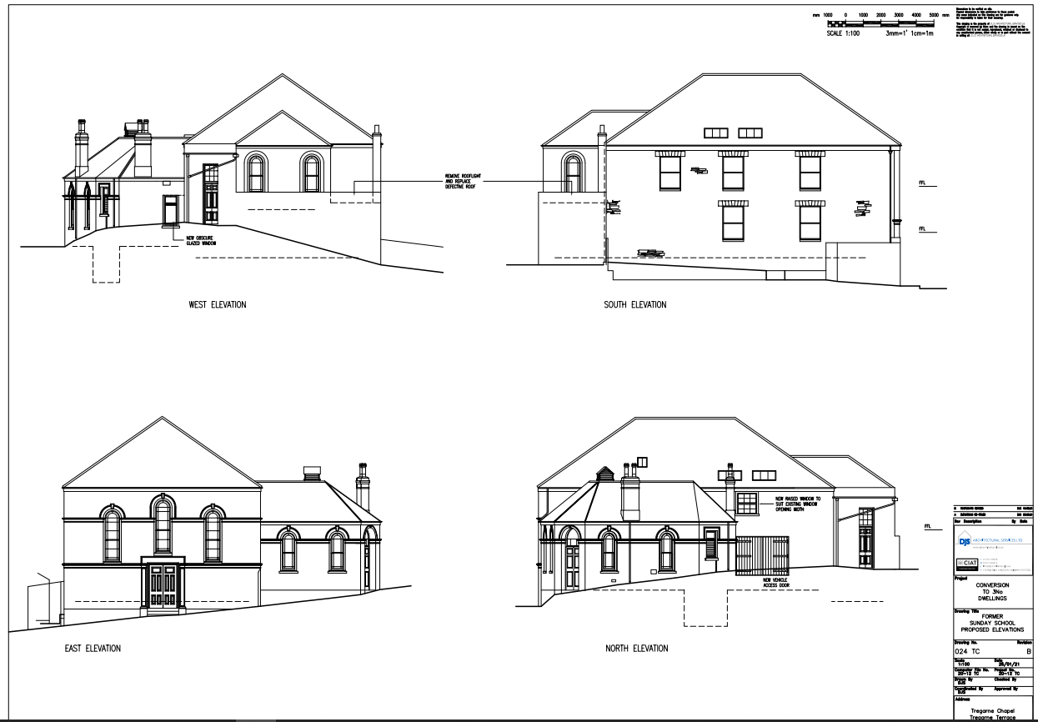

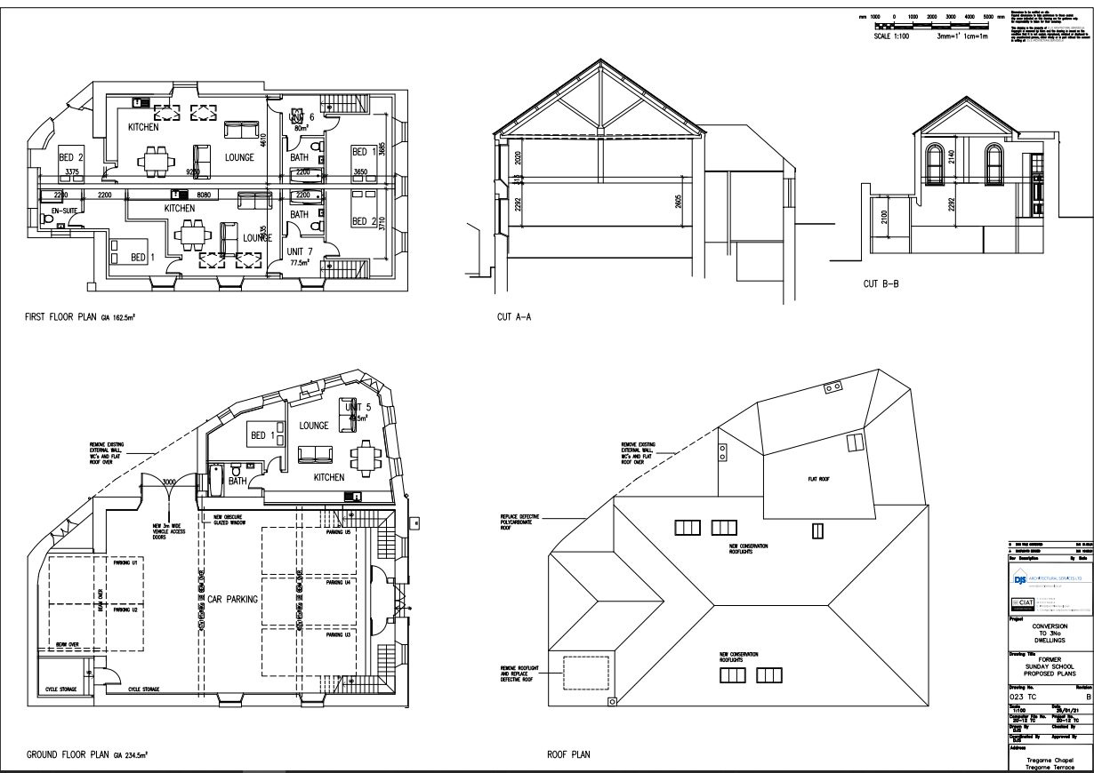

**Appendix 2 Photos**

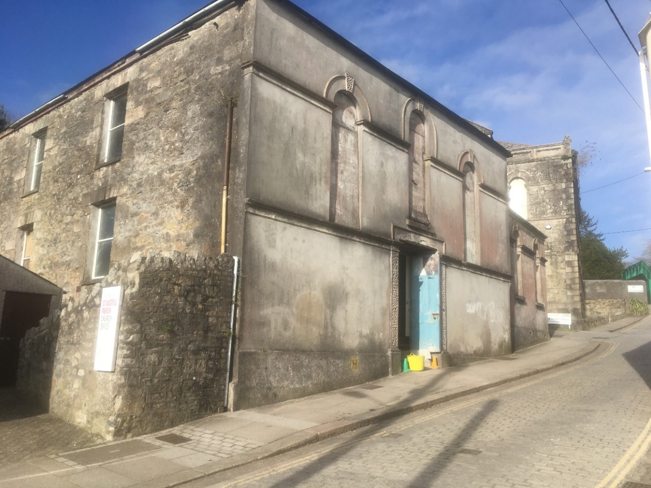

Photo 1

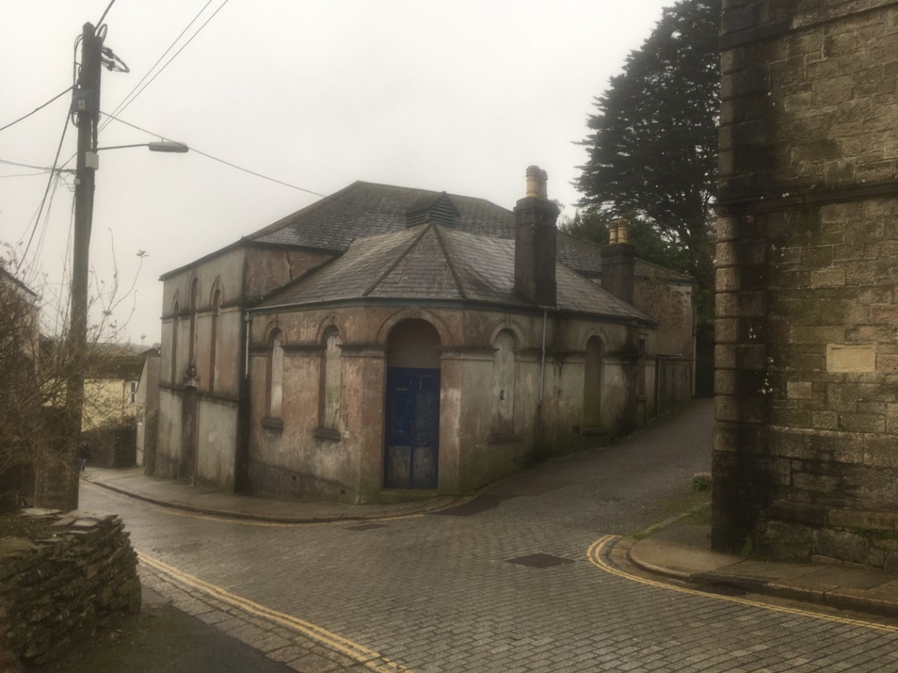

Photo 2

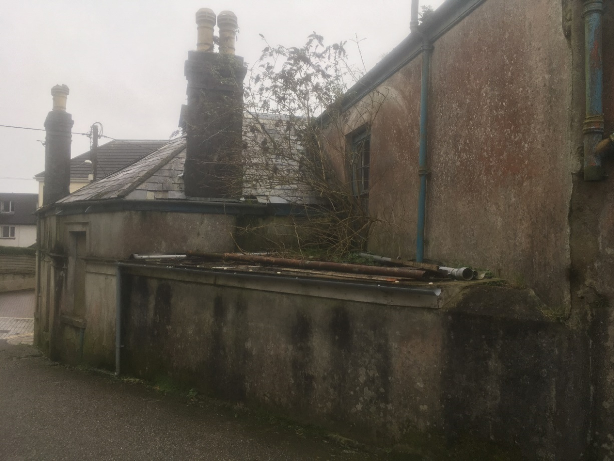

Photo 3

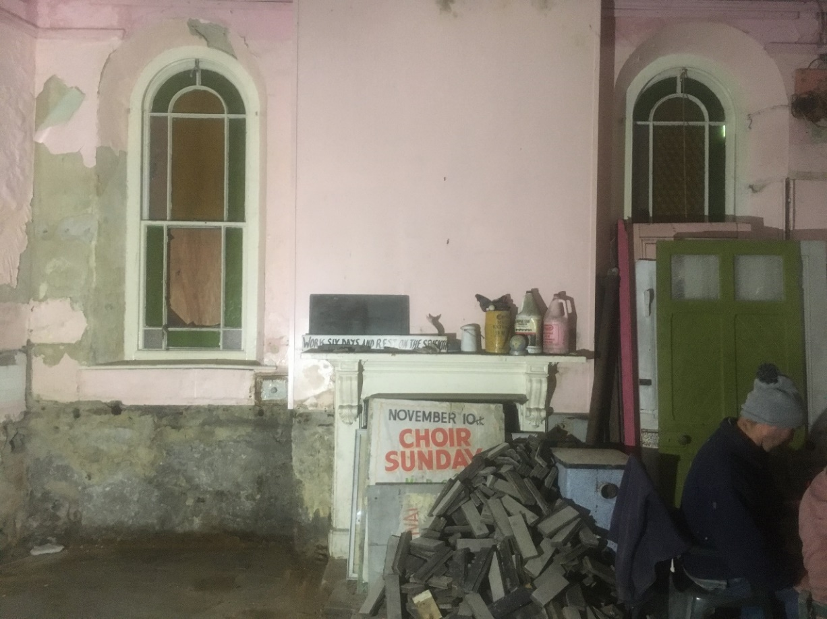

Photo 4

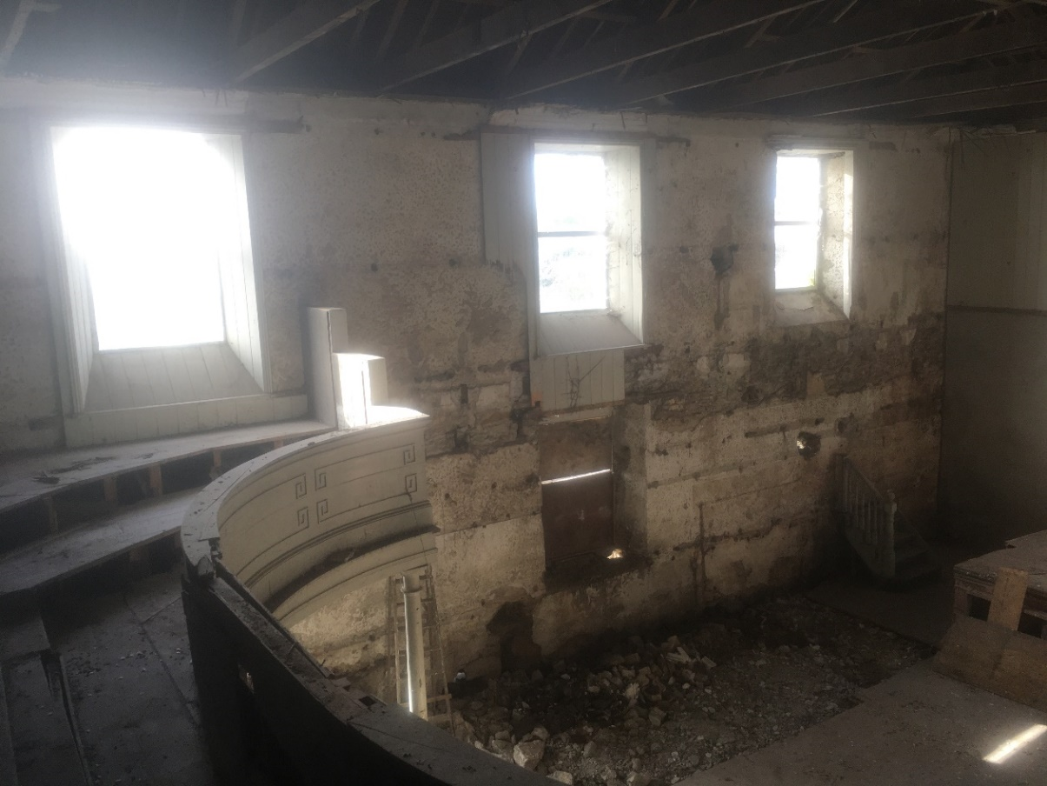

Photo 5

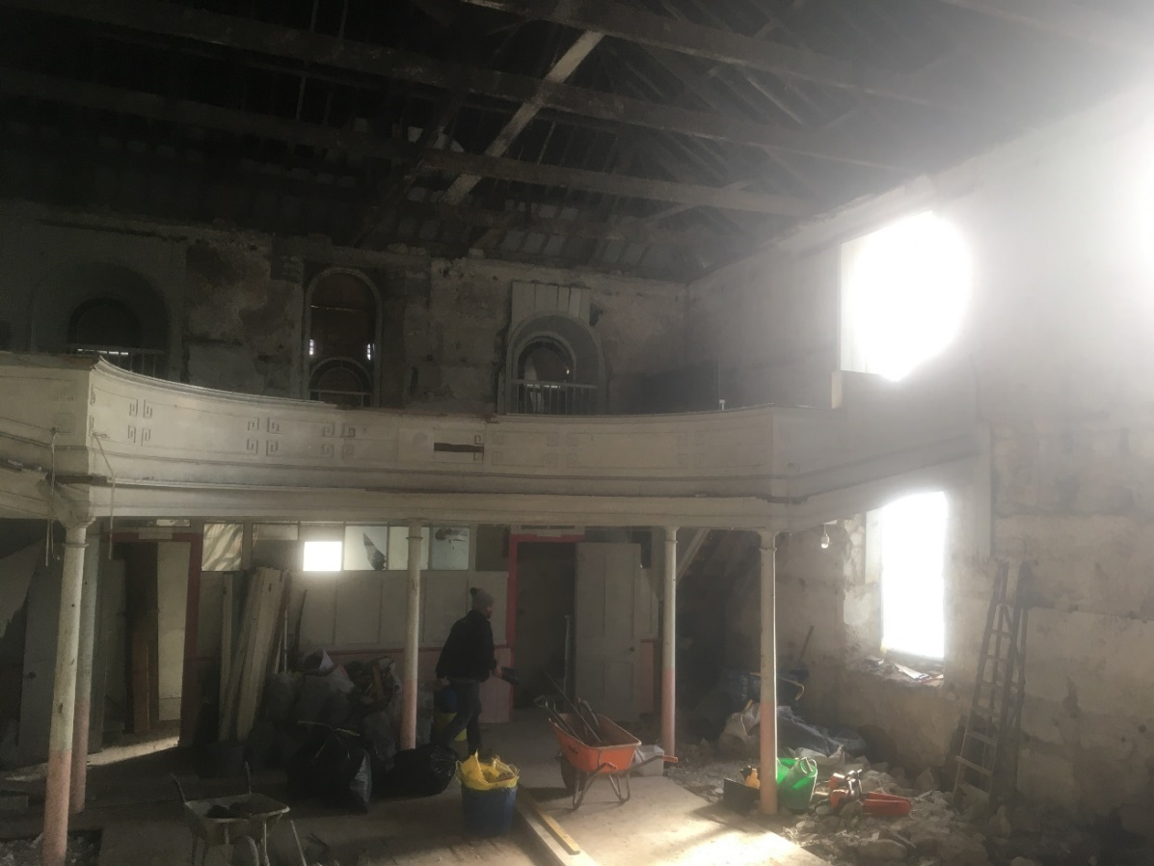

Photo 6

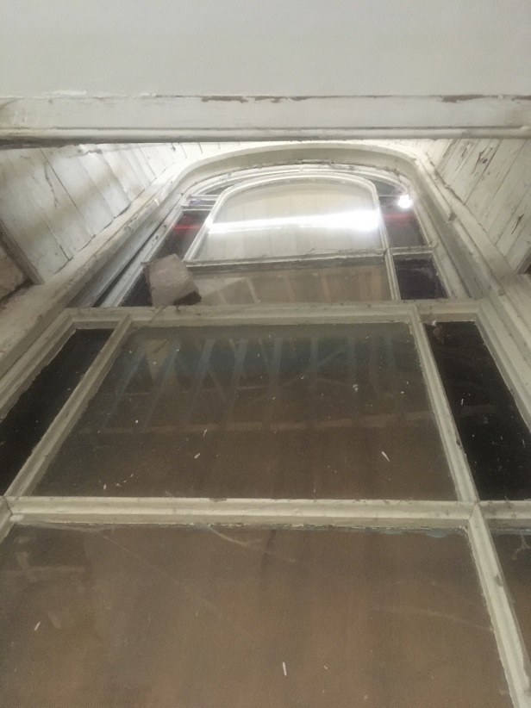 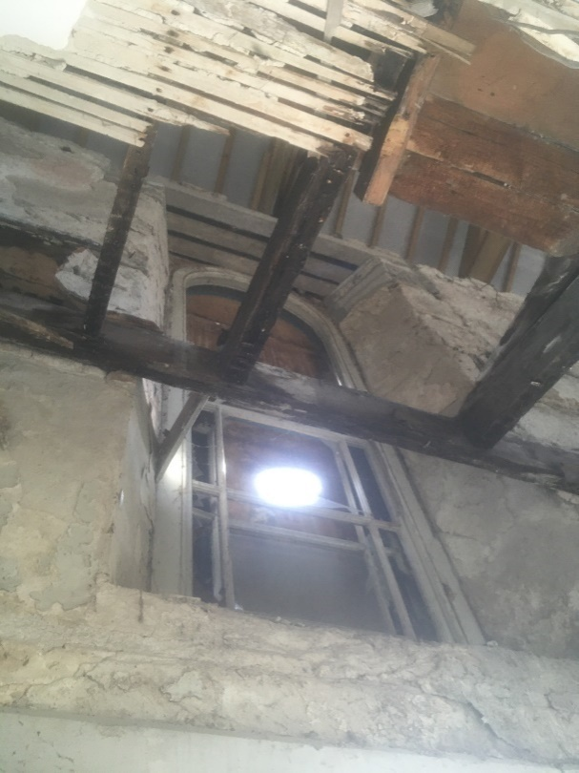

Photo 7 Photo 8

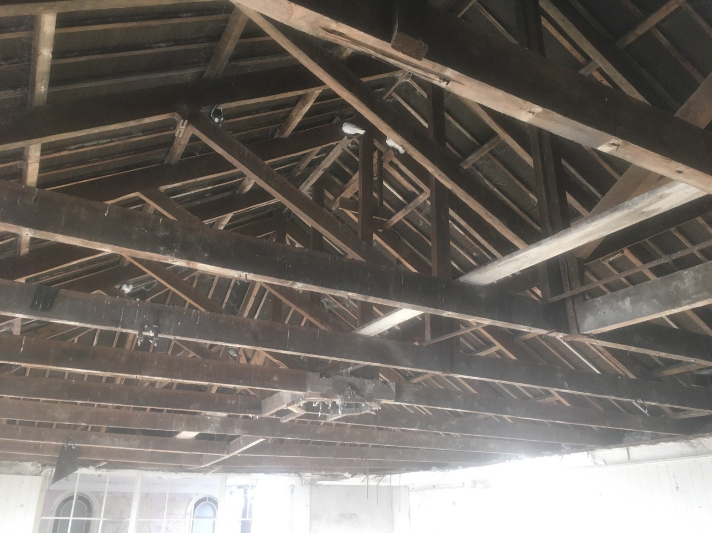

Photo 9

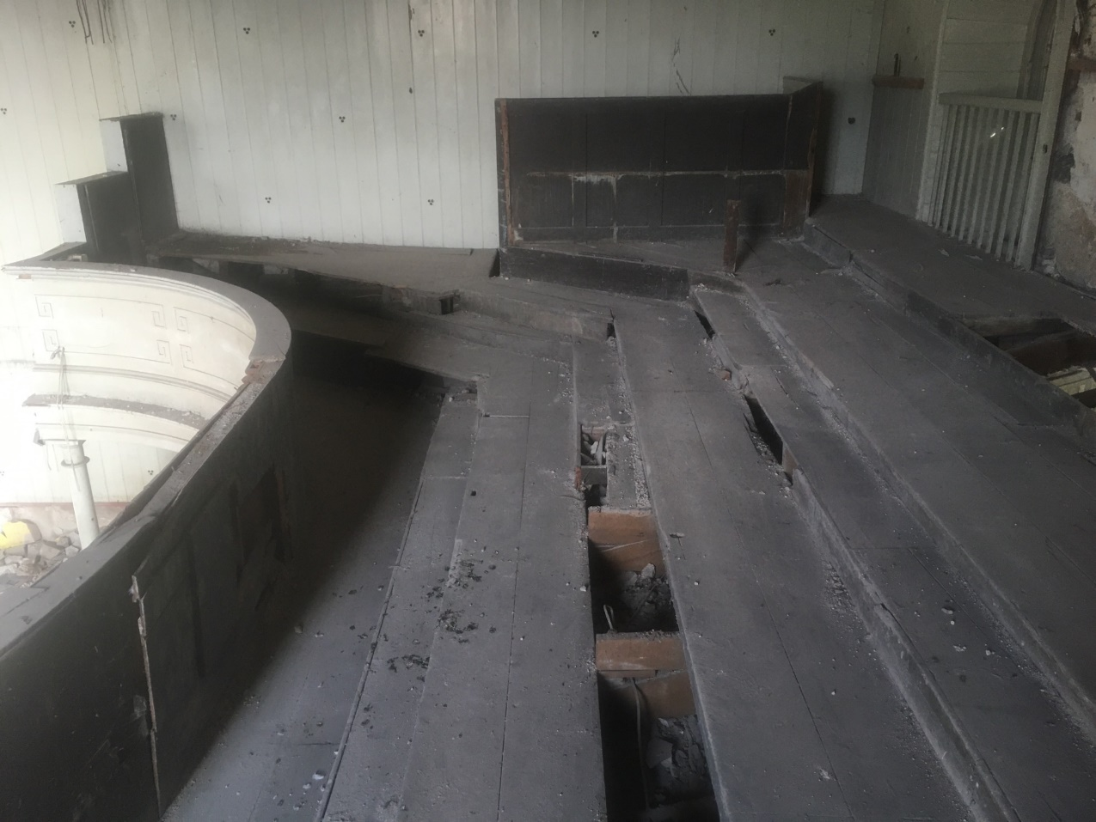

Photo 10

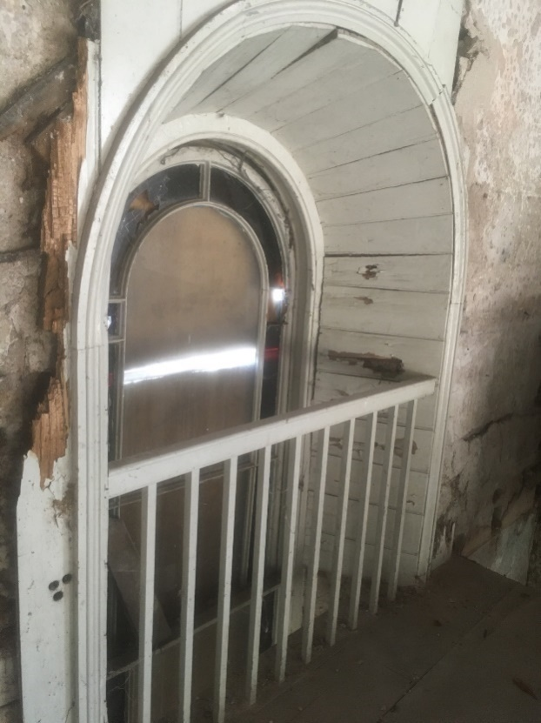

Photo 11