|  |
| --- |
| **Request for Proposals**  for the Design, Production, Testing and Delivery of  High Power RF Arc Detectors for the ESS |

Abstract

This Request for Proposals (RFP) is for the design, production, testing and delivery of components for the RF distribution system of the European Spallation Source in Lund. These are arc detectors to work in RF components of types WR1150 and WR2300 HH. These will be used with a waveguide system from separate tenders.

**Document change record**

|  |  |  |  |
| --- | --- | --- | --- |
| Issue | Date | Modified Section/Sheet | Comment |
| 1 | 11/03/16 |  | First draft |
| 4 | 10/01/17 |  | Draft version for review |
| 5 | 20/01/17 |  | 1st comments from ESS |
| 6 | 27/02/17 |  | Final draft for comments |
| 7 | 08/03/17 |  | Final version |

Written by: Rob Edgecock

# scope of supply

## Introduction to ESS

ESS ERIC is a Swedish limited liability company jointly owned by the Swedish and Danish Governments. The core business of the company is to design, plan, construct, commission, operate and decommission the European Spallation Source (ESS). The ESS ERIC is located in Lund, Sweden, co-hosted by Sweden and Denmark and has more than 22 Partner Countries, including the UK. The UK contribution is coordinated by STFC. The facility will deliver its first neutrons in 2019 and is expected to be fully operational by 2025.

The European Spallation Source (ESS) will be one of the largest infrastructures in Europe and will be used for materials research. It will use a long pulsed superconducting linac and accelerate a 62.5 mA proton beam current to the energy of 2000 MeV. Peak beam power to the target will be 125 MW, 7 times more than the highest power existing facility. The layout of the accelerator is shown in Figure 1-1.

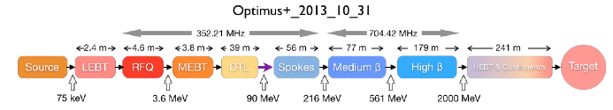

Figure 1‑1 : Schematic of ESS Linac

STFC are providing a number of goods and services on behalf of the ESS. This tender is for the procurement of waveguides, bends and some coax components of the RF distribution system (RFDS) for the cold linac (including the Spoke, Medium beta elliptical and High beta elliptical). Further tenders will be made for the other RFDS components and its support structure.

The Headquarters of the ESS are currently located at:

European Spallation Source ERIC

Tunavagen 24,

Lund,

Sweden

**1.2 List of acronyms**

DAP - Delivered at Place

EMC - Electromagnetic Compatibility

EMI - Electromagnetic Interference

EN - European Standards

ERIC - European Research Infrastructure Consortium

ESS - European Spallation Source

FAT - Factory Acceptance Test

HB/MB - High Beta/Medium Beta elliptical cavities

HH - Half Height

IEC - International Electrotechnical Commission

ISO - International Organization for Standardization

MTBF - Mean Time Between Failures

QR Code - Quick Response code

RFDS - Radio Frequency Distribution System

RFP - Request For Proposals

RoHS - Restriction of Hazardous Substances

SAT - Site Acceptance Test

STFC - Science and Technology Facilities Council

**1.3 Objective**

The parameters of the RFDS are given in Table 1-1. The RF pulse width is 3.5 ms and the pulse repetition frequency is 14 Hz. For the purpose of this tender, the medium beta (MB) elliptical components and the high beta (HB) elliptical components will be combined and use the parameters for the HB.

**Table 1‑1: Details of system for cold linac**

|  |  |  |  |  |  |
| --- | --- | --- | --- | --- | --- |
| **Linac module** | **Frequency (MHz)** | **Peak Amplifier power (kW)** | **Ave Amplifier power (kW)** | **Number of RFDS systems** | **Waveguide** |
| Spokes | 352.21 | 400 | 20 | 26 | Coax 6-1/8 inch and WR2300 HH* |
| MB | 704.42 | 1200 | 60 | 36 | WR1150 |
| HB | 704.42 | 1500 | 75 | 84 | WR1150 |

*: HH- half height waveguide

***1.3.1 Items included in the supply***

The supply shall comprise the components of the RFDS shown in Table 1-2. The details can be found in section 4.

The Arc detector system includes the sensor head or a view port to be mounted on the waveguide on one side and the connector to the interlock system on the other side as shown in Figure 1-2. The logic unit or a modular detector system shall include a remote interface and an interface to the Fast interlock module. This interface can be via 1 or 2 cables, which can be finalised during the Design review. Documentation on this interface shall be included in the tender

The supply shall comprise the components of the RFDS shown in Table 1-2. The details can be found in section 4.

Table 1‑2: Components of the RFDS included in this tender

|  |  |
| --- | --- |
| **Component** | **Number required** |
| Arc detector | 238 to 558* |
| Detector modular systems/logic units | Depends on technology |
| Cables to modular detector systems/logic units and interlock system | Depends on technology |

*Note that the number of arc detectors required is currently uncertain. The minimum required is 238 and the maximum is 558.

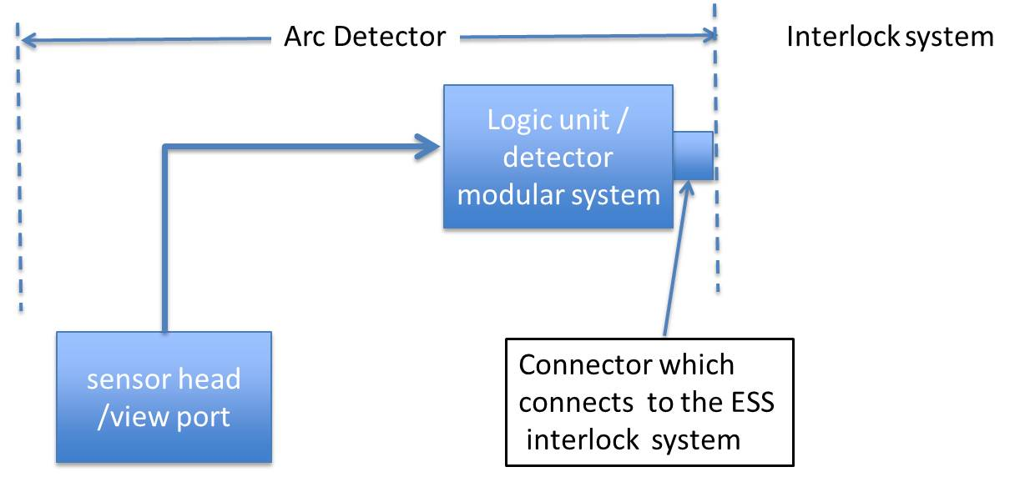

Figure 1-2: Schematic layout of the arc detector system

Factory acceptance testing (FAT) must be made at the Suppliers or at the sub-Suppliers premises. Please refer to section 6.2 for more information.

Site acceptance testing (SAT) will be performed for some equipment following delivery at the ESS, Lund, Sweden.



### Items not included in the supply

The following products and services are not included in the supply:

1. Test, measurement and control system and associated test equipment required for testing at ESS;
2. External electrical cables and protections;
3. Installation, including lifting equipment and tooling
4. Control systems

### Items supplied by STFC

None.

## Delivery

The proposed delivery schedule is shown in Table 1-3. The first column in Table 1-3 is the week number in which a delivery should take place. For each week number, the number of arc detector systems that should be delivered are given. If the supplier is unable to meet this schedule, an alternative must be proposed as part of the tender process. It is possible to combine deliveries, but all the required components must be available during or before the specified week. Note that deliveries from Week 22/2018 onwards will only be required if >238 units are needed. The cost of delivery should be included in the tender using DAP as defined in Incoterms 2015.

**Table 1-3: Delivery schedule.**

|  |  |
| --- | --- |
| **Week** | **Number of arc detector systems to be delivered** |
| 50/2017 | 24 |
| 1/2018 | 24 |
| 4/2018 | 24 |
| 7/2018 | 22 |
| 10/2018 | 32 |
| 13/2018 | 32 |
| 16/2018 | 32 |
| 19/2018 | 48 |
| 22/2018 | 32 |
| 25/2018 | 32 |
| 28/2018 | 32 |
| 31/2018 | 32 |
| 34/2018 | 32 |
| 37/2018 | 32 |
| 40/2018 | 32 |
| 43/2018 | 32 |
| 50/2018 | 32 |
| 1/2019 | 32 |
| **Total** | **558** |

If required by the ESS, STFC reserves the right to delay delivery by up to three months to be compatible with ESS operations, with one month’s notice. There shall be no extra charge to STFC for this.

**1.5 Warranty**

The equipment shall be warranted for at least two years from the date of site acceptance (usually within one month of delivery) or from three months after delivery if site acceptance is delayed.

# General requirements

**2.1 Supplier’s responsibilities**

The Supplier is solely responsible for meeting all the requirements of this Request for Proposals (RFP) and for all aspects of the performance of the device: mechanical, electrical, thermal, as well as safety aspects, including testing and certification.

The Supplier will be responsible for the final design, the production methods and the correct performance of all the items supplied, irrespective of whether they have been chosen by the Supplier or suggested by STFC. Any approval or acceptance by STFC of the design and components does not release the Supplier from their responsibilities in this respect.

The Supplier will be required to work in close contact with the Project Manager at STFC at all stages of the contract, in order to resolve any technical issues or problems that arise in the most timely and efficient manner. All contact with STFC referred to below should also take place with the Project Manager.

**2.2 Contract management**

***2.2.1 Contract engineer***

The Supplier shall assign an engineer to be responsible for the technical execution of the Contract and its follow-up, including all contacts with STFC, throughout the duration of the Contract.

***2.2.2 Time schedule and progress reports***

A written progress report shall be sent to STFC every month during the contract. This report must contain as a minimum a list of activities and milestones achieved since the previous report, any delay or technical issues which are likely to affect the performance or the schedule and any proposals to address these slippages or technical issues and an updated schedule and/or milestone list.

The Supplier will inform STFC immediately in writing where a delay of more than two weeks against any milestone in the agreed programme is anticipated. The Supplier shall make available evidence of all corrective actions being undertaken to mitigate the impact on the contract deliverables.

Throughout the project the Supplier shall report any risks or concerns that specifications cannot be met as soon as possible, with a full explanation of why they cannot be met. Submitting such reports shall not result in the Supplier being released of their responsibility for meeting their contractual liabilities under the contract.

***2.2.3 Factory access and inspections***

STFC reserves the right to carry out regular and/or spot inspections at the Supplier’s premises and where deemed necessary that of its sub Suppliers. Contract inspections concern all contract compliance issues including schedule and quality performance.

STFC and the ESS reserve the right to be present to witness any tests carried out at the Supplier's or any sub-contractor’s premises.

***2.2.4 Design report and production***

A detailed design report shall be submitted to STFC for approval within one month after notification of the contract. STFC will give its approval or refusal, in writing, within one month following the date of the design review meeting. This design report shall include:

1. A drawing of the mechanical layout;

2. A drawing of electrical layout (where relevant)

3. Interfaces with other parts of the ESS RF system

4. Complete list of parts;

5. Where relevant, data sheets of the main components and subsystems, including the performance;

6. Demonstration that the components will meet the specifications;

7. A detailed Gantt chart, showing the schedule for the procurement of materials, manufacturing, factory acceptance testing and delivery

***2.2.5 Technical and progress meetings***.

***2.2.5.1 Design review meeting***

Within one month of the submission of the design report, a design review meeting shall be held with the Supplier at STFC. At this review, the Supplier will present in detail their plan for the execution of the contract, a Quality Assurance plan, the proposed design solution and a list of interfaces with the other parts of the RFDS. STFC and the Supplier must agree that the solution proposed is suitable and can proceed for manufacturing. The design report shall be updated according to the decisions agreed on, during this meeting.

During the design review, the Supplier shall provide STFC with the risk register for the design and construction of the equipment. The required mitigations shall also be provided. A hazard analysis must also be included.

A set of minutes will be produced by the Supplier following the meeting, accurately recording the agreements and actions, and sent to STFC for approval.

***2.2.5.2 Progress meetings***

A programme of technical and progress meetings will be agreed between the Supplier and STFC during the Design review meeting. These should take place at least every month and may take place via a remote connection.

***2.2.6 Design approval prior to manufacture***

Unless otherwise agreed in writing, STFC must approve the final design report before the Supplier proceeds to ordering of any materials, components or equipment required to fulfil this contract and equipment manufacture shall not start without STFC’s written prior agreement on the design.

***2.2.7 Deviations***

If, after the Contract is placed, the Supplier discovers that they have misinterpreted this RFP, this will not be accepted as an excuse for deviation from it and the Supplier shall deliver equipment in conformity with this RFP at no extra cost.

During execution of the Contract, any and all deviations proposed by the Supplier from this RFP, contract or any other subsequent contractual agreement, shall be submitted to STFC in writing. STFC reserves the right to reject or accept such proposals without justification.

STFC reserves the right to modify this RFP during execution of the Contract. Such modifications shall be mutually agreed between STFC and the Supplier.

No acceptance or approval by STFC of any procedure or test shall release the Supplier from their responsibility in fulfilling the terms of the contract.

# Engineering standards and manufacturing specifications



## Materials and workmanship

### Metric system

The design, systems, parts and components shall be in accordance with the metric system.

## Design principles

Unless stated otherwise in this RFP, the following design principles shall apply.

### Reliability and lifetime

ESS attaches great importance to a design which is extremely reliable and requires a minimum of maintenance.

### It is expected that the operational lifetime of these components is higher than 20 years considering 6000 hours of operation per year and the worst-case operation conditions in this specification (all components shall be rated according to the worst-case design principle). Since the conditions of operation are known and these are passive components, a reduced number of random failures should be foreseen for these components for the expected 20 years of operational lifetime. The probability of having a failure within the 20 years of operational lifetime for each component should be lower than 10%.

### Thermal design

The power dissipation in any component, under any foreseen service condition, shall not exceed 75% of the rated power dissipation for the component.

Please include the maximum operating temperature of the arc detector in the tender response.

### Mechanical layout

The layout shall facilitate easy access to components for replacement and to simplify inspection and maintenance.

All parts shall be easily accessible for rapid repairs and exchange in case of failure.

## Applicable directives, regulations and standards

The following directives, regulations and standards are applicable for the execution of the Contract

### European standards and regulations

European directives and regulations applicable for components include but are not necessarily limited to those listed in the table below. The table also references standards harmonized with the European directives and regulations list.

Table 3‑1: Table listing of European Directives and Regulations applicable for the components

|  |  |  |  |
| --- | --- | --- | --- |
| Subject of Directive / Regulation | Reference / link to Directive & Regulation) | E.g. of products | Reference / link to harmonized standards1) |
| **Restriction of the use of certain hazardous substances (RoHS)** | [2011/65/EU](http://eur-lex.europa.eu/legal-content/EN/TXT/PDF/?uri=CELEX:32011L0065&from=EN) | Electrical and electronic products | [RoHS](http://ec.europa.eu/growth/single-market/european-standards/harmonised-standards/restriction-of-hazardous-substances/index_en.htm) |
| **EMC directive** | [2004/108/EC](http://eur-lex.europa.eu/legal-content/EN/TXT/?uri=CELEX:32004L0108&locale=en) |  | [EMC](http://eur-lex.europa.eu/legal-content/EN/TXT/PDF/?uri=CELEX:32004L0108&from=EN) |
| **Low Voltage Directive** | 2006/95/EC |  |  |
| **1** Harmonized standards are technical specifications of products meeting essential requirements set out by European Directives and Regulations. These standards are usually used as means to demonstrate compliance with European Directives and Regulations. | | | |

***3.3.2 EMC standards***

The components shall comply with the following EMC standards concerning conductive noise emission and immunity:

* Noise emission, according to CISPR 11; EN 55011 class B, for AC mains input;
* Immunity according to IEC-61000-4 (Level 4).

Compliance to these standards is mandatory, irrespective of whether or not such standards may be considered formally not applicable to this specific equipment.

### ESS standards

The selection of materials used for the design of the components should be done according to the recommendations specified in ESS-0063691.

Such standards may be found in the following web links:

<https://edms.cern.ch/file/335725/LAST_RELEASED/C1_E.pdf>

<https://edms.cern.ch/file/335745/4/E_IS23.pdf>

<https://edms.cern.ch/file/335806/1.02/IS41_E.pdf>

The supplier may, at its discretion, submit to STFC for consideration a proposal for exemption, waiver or substitution of ISO or EN Standards with the supplier’s country National or other such Standard which is harmonized for compliance with European directives and regulations relevant for components.

### Other international standards

Unless noted otherwise in this specification, all equipment and drawings should comply with the relevant I.E.C. standards, recommendations and reports including the latest revision.

## Documentation

All documentation, information and drawings shall be produced in MS Word, .pdf and .dxf formats. All documentation, including “as built” drawings, certificates, manuals, etc, shall be written in English.

A complete set of “as-built” documentation shall be supplied to STFC for each component before delivery starts, on CD-ROM’s containing all files.

Where deviations from the information, electrical schematics, mechanical drawings or components are authorized by STFC during manufacture, the Supplier must note the changes. The set of “as-built” documentation shall reflect all the changes and updates.

### Technical documentation

#### Operating manual

An operating manual of all devices and subsystems shall be provided in electronic format and one in hardcopy.

The detailed operation and/or tuning procedure (if any) shall be included in the manual. The manual shall also include detailed assembly/disassembly instructions, routine maintenance requirements, fault diagnosis instructions, start-up procedures and operation controls and functionalities, where appropriate.

#### Manufacturing drawings

A complete set of drawings shall be provided in electronic format. The drawings shall be prepared in accordance with ISO 8015:2011 or BS 8888. A complete set includes:

* Detailed mechanical construction drawings;
* Detailed electrical circuit diagrams, if appropriate;
* Complete mechanical assembly in 3D (.dxf or STEP format);
* Wiring diagrams, if appropriate;
* Complete list of parts including details of all components, manufacturer, type number and, whenever applicable, datasheets.

# Technical requirements

This section describes the technical requirements for all the RF distribution components for this tender.

## General data

All the components shall operate with high reliability for at least 20 years and shall be able to withstand frequent stoppages without affecting performance and reliability.

Note that the number of arc detectors required is currently uncertain, as the number of HB cavities is unknown and the specifications for some locations are unknown. The costs should be given for the range 238 to 558 arc detector systems to be supplied. The number required will be known by the design review meeting.

### 4.1.1 Naming, Information and documentation

All the components shall be marked with unique identifier. The exact form of this shall be discussed at the Design Review meeting. As well as a written label, this identifier should be encoded on the component using a QR code. All information concerning the component should include this unique identifier.

When delivered, each component needs to be accompanied with a report indicating:

1. unique identifier
2. respective drawing number;
3. measured mechanical dimensions;
4. deviation from the specifications (within the tolerances);
5. components total weight;
6. results of the Factory Acceptance Tests

A copy of these documents shall be sent to STFC prior to shipping.

***4.1.2 Packing and delivery***

The Supplier is responsible for the packing and the transport to the test site in Sweden, as specified by ESS, without damage or deterioration in performance. Should any damage occur during transport, the supplier is responsible for repairing this. The crates should have tiltwatch and shockwatch indicators or equivalent.

The following must be clearly displayed on the outside of the container(s):

a. Contact name;

b. Delivery address;

c. The STFC contract number;

d. The weight of each loaded container;

e. Support points for transport and lifting;

f. Unique identifiers of the contents

* 1. **Arc Detectors**

Microwave devices and systems working in high-power area may quickly build up extremely high electric field strength. The disruptive strength of the air may exceed its breakdown strength, because of humidity or contamination. In such cases, electrical breakdown in the form of arcing is possible. In this case part of the microwave energy is reflected and the arc travels back to the source. If the arc energy reaches values above 5 J, waveguide and microwave source might be subject to considerable damages and might even be completely destroyed. Up to an energy level of about 1 J the energy dissipation induced by an arc leads to an evaporation of particles contaminating the waveguide. Once ignited these arcs grow over the full height of the waveguide and travel towards the RF source. The burning plasma can cause serious damage to the metal surfaces or ferrite materials.

To avoid this damage, four arc detectors are required per waveguide run for MB and HB and three per waveguide run for spoke. These can be located in up to 5 places for spoke and 7 for MB/HB, see Figures 4-1 and 4-2. Note that the 7th potential location for MB/HB is on the directional coupler between the circulator and the load.

Earlier experience shows that there are many spurious trips due to the arc detectors. Whenever an arc is detected, the signal from the RF amplifier is withdrawn, leading to a beam trip in many cases. To fulfill 95% beam availability, which is a target of ESS, it is important to avoid the spurious trips.

See ESS-0038184.3 for the drawing of the arc detector interface on the RFDS. The sensor head / view port of the arc detector shall be mounted on the RFDS via the interface. The sensor head/ view port shall be connected to the logic unit / detector modular system via cables / optical fibres. The logic unit / detector modular system shall give a signal to the ESS interlock system to withdraw the RF drive power to the amplifier.



*Fig 4-1: Possible locations for spoke arc detectors*

The location of the logic unit / detector modular system will be dependant on the technology selected. For a non rack-mountable logic unit, the minimum length of cable between the sensor head and logic unit is 5m and the maximum length is 10m. The minimum length of cable between the logic unit and the interlock system is 10 m and the maximum length can be 25 m. For rack mountable logic unit, the minimum length of the fibre between the viewport and the detector modular system is 10 m and the maximum length can be 25m.

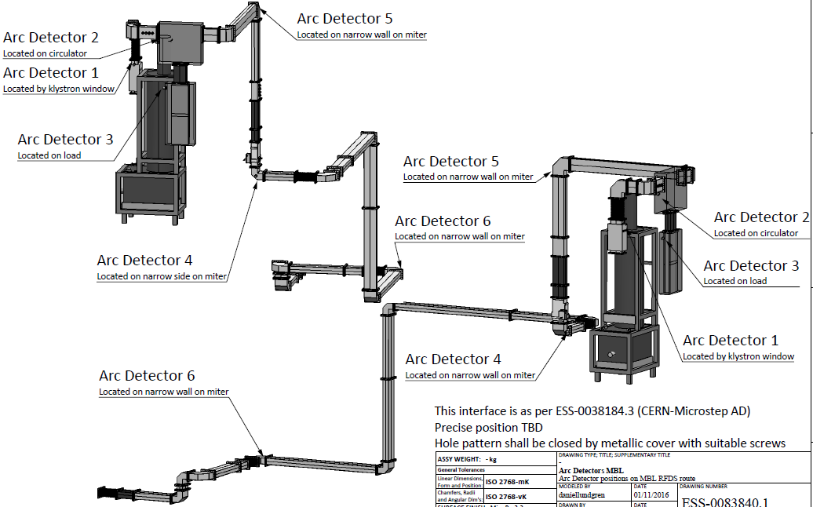

*Fig 4-2: Possible locations of arc detectors for MB and HB*

For this tender, the cost of cables/fibres shall be given for the maximum requirements. The actual requirements will be discussed during the design review meeting.

The functional specification that the arc detector systems must achieve is given in Table 4-1.

*Table 4-1: Functional Specifications for the arc detectors*

|  |  |  |  |
| --- | --- | --- | --- |
| No. | Functional Specification | Function / Value | Comment |
| 1 | The arc detector shall avoid false detection of arcs |  | The supplier shall demonstrate how spurious arc detection will be minimised |
| 2 | The arc-detector shall have a provision to test the arc detector from the control room |  |  |
| 3 | Minimum arc detector sensitivity | <5 lux |  |
| 4 | The response time of the arc detectors | < 25 μs | The response time includes fault detection, transmission of signal to logic unit / interlock unit and opening the pin diode to withdraw the RF signal. |
| 5 | The arc detector shall reliably detect arcs to protect the RF equipment like the loads, circulators and the shutter switches. |  | The supplier shall demonstrate reliability of the arc detection. |
| 6 | The arc detector shall work in a heavy industrial environment. |  | The supplier shall demonstrate reliable working of arc-detector in dusty, industrial environment. |
| 7 | Interface hole pattern on RF equipment |  | This is shown in drawing ESS-0038184.3. |
| 8 | Connector on the arc detector connecting to the ESS interlock system |  | To be finalised during the Design Review |
| 9 | Length and location of the cables or fibres from the arc-detector to the receiver / logic unit and to the interlock system |  | To be finalised during the Design Review, but see the minimum and maximum distances described in Section 4.2 |

# Information about ESS requirements

This section gives various requirements coming from the ESS.

* + 1. ***Cooling requirements***

It is not expected that any components in this tender will require cooling.

* + 1. ***Air Insulation***

No components shall require any gas other than air at standard temperature and pressure; SF6 or pressurization shall not be used.

* + 1. ***Safety***

All equipment shall be designed for safe operation.

* High voltages should be protected to prevent contact.
* Non-Ionising radiation.

For non-ionising radiation ESS will adopt the Swedish guidelines available from the [Swedish Radiation Safety Authority](http://www.stralsakerhetsmyndigheten.se/In-English/Enactments/Regulations/), which generally adopts best practice from the European guidelines.

The microwave power leakage from any RF system shall not exceed 0.35 mW/cm2 (3.5 W/m2) average power.

* Ionising Radiation (X-Radiation).

The x-radiation dose from any equipment shall not exceed 1.0 μSv/h at point of contact at full power.

* Electromagnetic Interference (EMI).

Any potential electromagnetic interference generated shall be advised to STFC by the supplier and optimum methods of suppression shall be considered. Electromagnetic noise transmission through input and output connections and by direct radiation should be considered.

* + 1. ***Gallery temperature***

The temperature in the RF Gallery is expected to be maintained at 22.5ºC ± 5ºC for operation, however for testing in the test halls and for maintenance periods, the equipment shall be capable of being operated in an ambient temperature of 22.5ºC ± 10ºC but such that there will be no condensation on components.

# Factory Tests and Delivery

The factory tests shall establish that the equipment completely fulfils this RFP. If the tests show that any part of the specification is not met, then it shall be corrected and the tests shall be repeated by the Supplier at no extra cost to STFC. The equipment shall be fully tested in the factory, but ESS reserves the right to repeat any of the tests.



## General arrangements for tests

The test at the factory must establish that all items of the equipment completely meet the performance requirements described in this RFP.

Testing shall at all times conform with local safety codes. In the event of marginal design or performance, STFC reserves the right to require additional or more extensive testing to be conducted at no extra cost to STFC

Throughout the contract, the test requirements which are to be carried out by the supplier prior to delivery (to demonstrate compliance with this RFP) shall be reviewed along with STFC. All the test procedures shall be formulated and all test procedures shall be identified for STFC’s approval.

STFC, ESS and its authorised representatives must have access to the premises of the Supplier for the purposes of inspection and witnessing of tests. STFC must be entitled to witness all tests defined in this RFP and must be sent in advance the planned schedule of the tests with at least 10 days notice.

STFC reserves the right to reject any material or component which does not fulfil this RFP.

It will be a condition of final acceptance that the Supplier must have provided to the satisfaction of STFC and ESS, full documentation as specified throughout this RFP, to cover all systems and components embodied within this contract

## Factory tests

The factory and site acceptance testing will include any or all of the tests specified in the preceding sections of this specification and shall serve to demonstrate compliance with all requirements of this RFP. The plans for Factory Testing should be specified in the tender.

Following tests shall be performed at the Factory for all the arc detectors to ensure they meet the requirements:

1. Visual inspection to examine workmanship, cables/optical fibres, connectors,
2. Verification of the dimensions and finish;
3. Verification of the reliable working of arc detector ;
4. Verification of the self-test function;

In addition, for at least the first 5 arc detectors and then for at least every 20th arc detector, it should be demonstrated that the response time and sensitivity in Table 4-1 are achieved.

## Approval before delivery

The results of all FAT must be recorded on test certificates in English and sent to STFC before delivery of the tested components to the ESS. Delivery of these components shall not commence until successful completion of all the tests and after written authorisation by STFC.

## Site acceptance tests

Acceptance tests will be carried out at ESS or ESS approved site in Sweden on selected items to establish that the equipment meets the specification and that no damage or changes have occurred during transport. These tests will be performed on equipment in crates for which the tiltwatch or shockwatch indicators have triggered. They will also be performed on selected equipment at random. These tests will be performed within four weeks of arrival at the ESS.

Site acceptance will be given by STFC only after all items have been delivered in accordance with the conditions of the contract, all tests specified have been successfully completed, all other documents and certificates have been supplied to STFC.

In the event of any errors being found during the site acceptance tests, the Supplier shall correct them immediately at their cost.

1. **QUALITY ASSURANCE AND GUARANTEES**

The Supplier shall maintain and apply a quality assurance program compliant with ISO-9001 or equivalent for the design, manufacture and testing of all systems and equipment provided by them. CE marking or equivalent of equipment should be applied wherever required.

The system shall be designed and constructed with an expected operational lifetime of greater than 20 years and a probability of failure of <10% during that time.

It is expected that after an initial testing period that the system will be powered continuously.

**ANNEX I**

**Arc detector viewport drawing**

ESS-0038184.3_3-1.pdf

**Possible arc detector locations drawings**

MB/HB: ESS-0083840.1_1.pdf

Spoke: ESS-0084548.2_1.pdf