**Technology Services 2 Agreement RM3804 Framework Schedule 4 - Annex 1**

# Order Form

In this Order Form, capitalised expressions shall have the meanings set out in Call Off Schedule 1 (Definitions), Framework Schedule 1 or the relevant Call Off Schedule in which that capitalised expression appears.

The Supplier shall provide the Services specified in this Order Form to the Customer on and subject to the terms of the Call Off Contract for the duration of the Call Off Period.

This Order Form should be used by Customers ordering Services under the Technology Services 2 Framework Agreement ref. RM3804 in accordance with the provisions of Framework Schedule 5.

The Call Off Terms, referred to throughout this document, are available from the Crown Commercial Service website <http://ccs-agreements.cabinetoffice.gov.uk/contracts/rm3804>

## Section A General information

This Order Form is issued in accordance with the provisions of the Technology Services 2 Framework Agreement RM3804.

|  |
| --- |
| **Customer details** |
| **Customer organisation name** Home Office |
| **Billing address**  **REDACTED** |
| **Customer representative name** **REDACTED** |
| **Customer representative contact details**  **REDACTED** |

|  |
| --- |
| **Supplier details** |
| **Supplier name**  European Electronique Ltd |

|  |
| --- |
| **Supplier address**  **REDACTED** |
| **Supplier representative name** **REDACTED** |
| **Supplier representative contact details REDACTED** |
| **Order reference number or the Supplier’s Catalogue Service Offer Reference Number**  N/A |

## Section B Overview of the requirement

|  |  |  |
| --- | --- | --- |
| **Framework Lot under which this Order is being placed** | | **Customer project reference** |
| 1. TECHNOLOGY STRATEGY & SERVICES DESIGN | ☐ | CCZN21A47 |
|  |  |  |
|  |
| 2. TRANSITION & TRANSFORMATION | ☐ | **Call Off Commencement Date** |
|  |  |  |
| 3. OPERATIONAL SERVICES    a: End User Services b: Operational Management |  |  |
|  |
| ☐ |
|  |
| ☒ |
|  |
| c: Technical Management d: Application and Data Management  4. PROGRAMMES & LARGE PROJECTS  a. OFFICIAL |
| ☐ |
|  |
| ☐ |
|  |
|  |
|  |  |
| ☐ |  |
|  |  |
| a. SECRET (& above) |
| ☐ |  |

|  |  |  |
| --- | --- | --- |
| **Call Off Contract Period (Term)** |  | |
| **Start Date:** 01/08/2021  **End Date:** 31/07/2022    **Call Off Initial Period**  12 months |  | |
| **Call Off Extension Period (Optional)**  6 months | |
| **Minimum Notice Period for exercise of Termination Without Cause** (Calendar days) | | 30 days |

|  |
| --- |
| **Additional specific standards or compliance requirements**  The Authority operates from a secure location therefore any Supplier personnel required to attend the Authority’s sites must have a minimum security clearance level of CTC.  **Customer’s ICT and Security Policy** N/A  **Security Management Plan**  N/A |

## Section C Customer Core Services Requirements

Please provide details of all Services required including the locations where the Supplier is required to provide the Services Ordered**.**

|  |  |  |  |  |  |  |  |  |  |  |  |  |  |  |  |  |  |  |  |  |  |  |  |  |  |  |  |  |  |  |  |  |  |
| --- | --- | --- | --- | --- | --- | --- | --- | --- | --- | --- | --- | --- | --- | --- | --- | --- | --- | --- | --- | --- | --- | --- | --- | --- | --- | --- | --- | --- | --- | --- | --- | --- | --- |
| **Services**    The support and maintenance must be inclusive of the following:  24 hours, 7 days cover inclusive of Public / Bank Holidays.  4 hour response time from receipt of call.  Onsite support within the above response time.  All parts and materials covered under the support and maintenance.  Hardware diagnostic and replacements.  **Table 1 - Support and Maintenance Required**   |  |  |  | | --- | --- | --- | | **Quantity** | **Part no.** | **Description** | | **Hardware and Software Support** | | | | 1 | H1K92 A3 | HP 1Y 4 hr 24x7 Proactive Care SVC | | 2 | H1K92A3 9LJ | HP B-Series 8/8 and 8/24 Switch Support | | 1 | H1K92A3RD0 | HP 3PAR 7200 OS Suite Base LTU Supp | | 1 | H1K92A3 RD1 | HP 3PAR 7200ReplicationSuiteBaseLTU Supplier | | 1 | H1K92A3RD4 | HP 3PAR 7200 Data OptSuite Base LTU Supp | | 1 | H1K92A3RDB | HP 3PAR 7200 Reporting Suite LTU Supp | | 1 | H1K92A3 RDC | HP 3PAR 7200 App Suite LTU Supplier | | 1 | H1K92A3RWG | HP Intelligent Infra Analyzer LTU Sup | | 48 | H1K92A3S6L | HP 3PAR 7200 OS Suite Drive LTU Supp | |

|  |  |  |  |  |  |  |  |  |  |  |  |  |  |  |  |  |  |  |  |  |  |  |  |  |  |  |  |  |  |  |  |  |  |  |  |  |  |  |  |  |  |  |  |  |  |  |  |  |  |  |  |  |  |  |  |  |  |  |  |  |  |  |  |  |  |  |  |  |  |  |  |  |  |  |  |  |  |  |  |  |  |
| --- | --- | --- | --- | --- | --- | --- | --- | --- | --- | --- | --- | --- | --- | --- | --- | --- | --- | --- | --- | --- | --- | --- | --- | --- | --- | --- | --- | --- | --- | --- | --- | --- | --- | --- | --- | --- | --- | --- | --- | --- | --- | --- | --- | --- | --- | --- | --- | --- | --- | --- | --- | --- | --- | --- | --- | --- | --- | --- | --- | --- | --- | --- | --- | --- | --- | --- | --- | --- | --- | --- | --- | --- | --- | --- | --- | --- | --- | --- | --- | --- | --- |
| |  |  |  | | --- | --- | --- | | 48 | H1K92A3S6M | HP 3PAR 7200 Replic Suite Drive LTU Supp | | 48 | H1K92A3S6N | HP 3PAR 7200 DataOptSuite Drive LTU Supp | | 24 | H1K92A3TGE | HP 3PAR7000 920GB SAS SSD Supp | | 1 | H1K92A3TRE | HP 3PAR StoreServ7200c2NStrgbase HWSupp | | 4 | H1K92A3WSF | HP 3PAR Internal Entitlement Purpose | | 56 | H1K92A3WUT | HP 3PAR 7000 Drives over 1TB Support | | 3 | H1K92A3WUW | HP 3PAR 7000 Drive Enclosure Support | | 2 | H1K92A3WUX | HP 3PAR 7000 Adapter Support | | 1 | AC133A | HP InsideDatacenter XLg Item LogisticSVC | | 32 | AJ716B | HP 8Gb Short Wave B-Series SFP+ 1 Pack |       In addition to the renewal of the support and maintenance identified within Table 1    **5 days onsite additional support from an HPE Master ASE accredited engineer.**  24/7 (inclusive of public/bank holidays) support and maintenance on hardware and software;  24/7 (inclusive of public/bank holidays support) hardware diagnostic, replacements and support cover for hardware;  4 hour onsite response time from receipt of call, provided by the vendor;  This support needs to be provided by the vendor by an SC cleared engineer with HOE master ASE accreditation.  **Table 2 – Authority Existing SAN Hardware**   |  |  |  | | --- | --- | --- | | **Quantity** | **Model #** | **Hardware Description** | | **Production, including switches and rack:** | | | | 1 | BW904A | HP 642 1075mm Shock Intelligent Rack | | 1 | E7X65A | HP 3PAR StoreServ 7200c 2N St Cent Base | | 2 | QR486A | HP 3PAR 7000 4-pt 8GB/s FC Adapter | | 14 | E7X49A | HP M6710 1.2TB 6G SAS 10K 2.5in HDD | | 2 | E7W24B | HP M6710 920GB 6G SAS 2.5in MLC 5yr SSD | | 2 | AM868B | HP 8/24 Base 16-ports Enabled SAN Switch | | 3 | QR490A | HP M6710 2.5in 2U SAS Drive Enclosure | | 42 | E7X49A | HP M6710 1.2TB 6G SAS 10K 2.5in HDD | | 6 | E7W24B | HP M6710 920GB 6G SAS 2.5in MLC 5yr SSD | | 1 | TK808A | HP Rack Front Door Cover Kit | | 24 | QK734A | HP Premier Flex LC/LC OM4 2f 5m Cbl | | 8 | QK733A | HP Premier Flex LC/LC OM4 2f 2m Cbl | | 2 | H5M68A | HP 7.3kVA 230V 20out INTL bPDU | | 1 | BW932A | HP 600mm Rack Stabilizer Kit | | 1 | BW932A | Include with complete system | |
| |  |  |  | | --- | --- | --- | |  | B01 |  | | 1 | BW906A | HP 42U 1075mm Side Panel Kit | | 2 | AF534A | HP Intelligent Mod PDU 32a Intl Kit | | 1 | 120672-B21 | HP 9000 Series Ballast Option Kit |     **Table 3 – Authority Existing SAN Software**   |  |  |  | | --- | --- | --- | | **Quantity** | **Part no.** | **Software Licences** | | 1 | BC767B | HP 3PAR 7200 Reporting Suite LTU | | 1 | BC768B | HP 3PAR 7200 App Suite VMware LTU | | 48 | BC746A | HP 3PAR 7200 OS Suite Drive LTU | | 1 | BC745B | HP 3PAR 7200 OS Suite Base LTU | | 1 | BC747A | HP 3PAR 7200 Replication Suite Base LTU | | 48 | BC748A | HP 3PAR 7200 Replication Suite Drive LTU | | 1 | BC749A | HP 3PAR 7200 Data Opt Suite Base LTU | | 48 | BC750A | HP 3PAR 7200 Data Opt Suite Drive LTU | | 1 | BD362AAE | HP 3PAR StoreServ Mgmt/Core SW E-Media | | 1 | BD363AAE | HP 3PAR 7000/7450 OS Suite E-Media | | 1 | BD372AAE | HP 3PAR App Suite for VMware E-Media | | 1 | BD373AAE | HP 3PAR Reporting Suite EMedia | | 1 | TC472AAE | HP Intelligent Inft Analyzer SW v2 E-LTU | |

### Sites for provision of the Services

Datacentre 1: Home Office Technology (PLS) Police National Computer ServicesG05, Hendon Data Centre, Aerodrome Road, Colindale, London NW9 5JE

Datacentre 2: DR Site approx. 15 miles from DC1 (Details will be provided to the successful supplier).

|  |  |  |  |  |
| --- | --- | --- | --- | --- |
| **Additional Clauses** |  |  | |  |
| **Applicable Call Off Contract Terms**    **Additional Clauses and Schedules** |  |  | |  |
|  | **Optional Clauses** N/A | |  |
|  |  |  | |  |
| **A: SERVICES – Mandatory**  **The following clauses will automatically apply where Lot 3 services are provided (this includes Lot 4a & 4b where Lot 3 services are included).**    A3: Staff Transfer |  |  | |  |
|  |  | |  |
| ☐ | C: Call Off Guarantee | | ☐ |
|  | |  |
| D: Relevant Convictions | | ☐ |
|  | |  |
| E: Security Requirements | | ☐ |
| A4: Exit Management  **A: PROJECTS - Optional**    A1: Testing  A2: Key Personnel  **B: SERVICES - Optional**  *Only applies to Lots 3 and 4a and 4b*  B1: Business Continuity and Disaster  Recovery  B2: Continuous Improvement &  Benchmarking  B3: Supplier Equipment  B4: Maintenance of the ICT Environment  B5: Supplier Request for Increase of the Call Off Contract Charges  B6: Indexation  B7: Additional Performance Monitoring Requirements |  | F: Collaboration Agreement | ☐ | |
|  |
|  |
| ☐ |
|  |  |  | |
| ☐ | G: Security Measures | ☐ | |
|  |
|  |
|  |  |  | |
| ☐ | H: MOD Additional Clauses | ☐ | |
|  |  |  | |
| ☐ | **Alternative Clauses** |  | |
|  |  |  | |
| ☐ |  |  | |
|  |  |  | |
| ☐ |  |  | |
|  |  |  | |
| ☐ | Scots Law Or | ☐ | |
|  |  |  | |
| ☐ | Northern Ireland Law | ☐ | |
|  |  |  | |
| ☐ | Non-Crown Bodies | ☐ | |
|  |  |  | |
|  |
|  | Non-FOIA Public Bodies | ☐ | |

|  |  |  |
| --- | --- | --- |
| **Collaboration Agreement** | |  |
| **Organisations required to collaborate**  (Collaboration Suppliers)N/A |  |  |
| An executed Collaboration Agreement shall be delivered from the Supplier to the Customer within the stated number of Working Days from the Call Off  Commencement Date  **OR** | N/A |
|  |  |
| An executed Collaboration Agreement from the Supplier has been provided to the Customer and is attached to this Order Form. | ☐ |

|  |
| --- |
| **Licensed Software**  **Supplier Software Third Party Software**  N/A N/A |
| **Customer Property**  Items licensed by the Customer to the Supplier (including any Customer Software, Customer Assets, Customer System, Customer Background IPR and Customer Data) N/A |
| **Call Off Contract Charges and Payment Profile**  Include Charges payable by the Customer to the Supplier (including any applicable Milestone Payments and/or discount(s), but excluding VAT) and payment terms/profile including method of payment (e.g. Government Procurement Card (GPC) or BACS)  **REDACTED** |

|  |  |  |  |  |  |  |
| --- | --- | --- | --- | --- | --- | --- |
| The total contract value shall be £48,213.30 (excluding VAT and excluding the extension option).  Payment will be made upon successful delivery of the services required.  Each invoice **MUST** state a valid purchase order number as issued by the Contracting Authority.  Each invoice should list an elemental breakdown of services supplied.  Payment will be made 30 days following receipt of a correctly submitted invoice.  It is expected that the winning bidder will provide e-invoicing where invoices anticipated per month are greater than 10. The winning bidder will also be required to provide an electronic catalogue to support e-invoicing/regular requirements where applicable.  All electronic invoices should be sent directly to the accounts payables team at:  **REDACTED**  All paper based invoices should be submitted for the attention of Accounts Payable at the following address(s):  **REDACTED** | | | | | | |
| **Undisputed Sums Limit (£)** | | | | N/A | | |
|  | | | |  | | |
| **Delay Period Limit (calendar days)** | | | | N/A | | |
|  | | | |  | | |
| **Estimated Year 1 Call Off Contract Charges (£)** | | | | N/A | | |
| **Enhanced Insurance Cover** | | | | | | |
| Third Party Public Liability Insurance (£) | | | |  | | |
| N/A | | |
|  | | | |  | | |
| Professional Indemnity Insurance (£) | | | | N/A | | |
| **Transparency Reports**N/A | | | | | | |
| **Quality Plans** *(*  Time frame for delivery of draft Quality Plans from the Supplier to the Customer  N/A– from the Call Off Commencement Date (Working Days) | | | | | | |
| **Implementation Plan** | | | | | | |
| Time frame for delivery of a draft Implementation Plan from the Supplier to the  Customer – from the Call Off Commencement Date (Working Days) N/A | | | | | | |
| **BCDR**    An executed BCDR Plan from the Supplier is required prior to entry into the Call Off Contract  **OR** | | | | | | ☐ |
|  | | | | | |  |
|  | | | | |  |
| Time frame for delivery of a BCDR Plan from the Supplier to the Customer – from the Call Off Commencement Date (Working Days)  Disaster Period (calendar days) | | | | | N/A | |
|  | |
| N/A | |
| **GDPR**  N/A  ____________________________________________________________________________    **Supplier Equipment** | | | | | | |
|  | | | | | | |
|  |  | | | | | |
| X - Service Failures (number) | Y  N/A – Period (Months) N/A | | | | | |
|  | | | | | | |
| **Key Personnel & Customer Responsibilities** | | | | | | |
|  | | | | | | |
|  | |  | | | | |
| **Key Personnel**  **REDACTED** | | **Customer Responsibilities** | | | | |
|  | | | | |
| N/A | | | | |
| **Relevant Conviction(s)** N/A | | | | | | |
| **Appointment as Agent** | | | | | | |
|  | | | | | | |
|  | | |  | | | |
| Specific requirement and its relation to the Services | | | Other CCS framework agreement(s) to be used | | | |
|  | | |  | | | |
| N/A. | | | N/A | | | |

**SERVICE LEVELS AND SERVICE CREDITS**

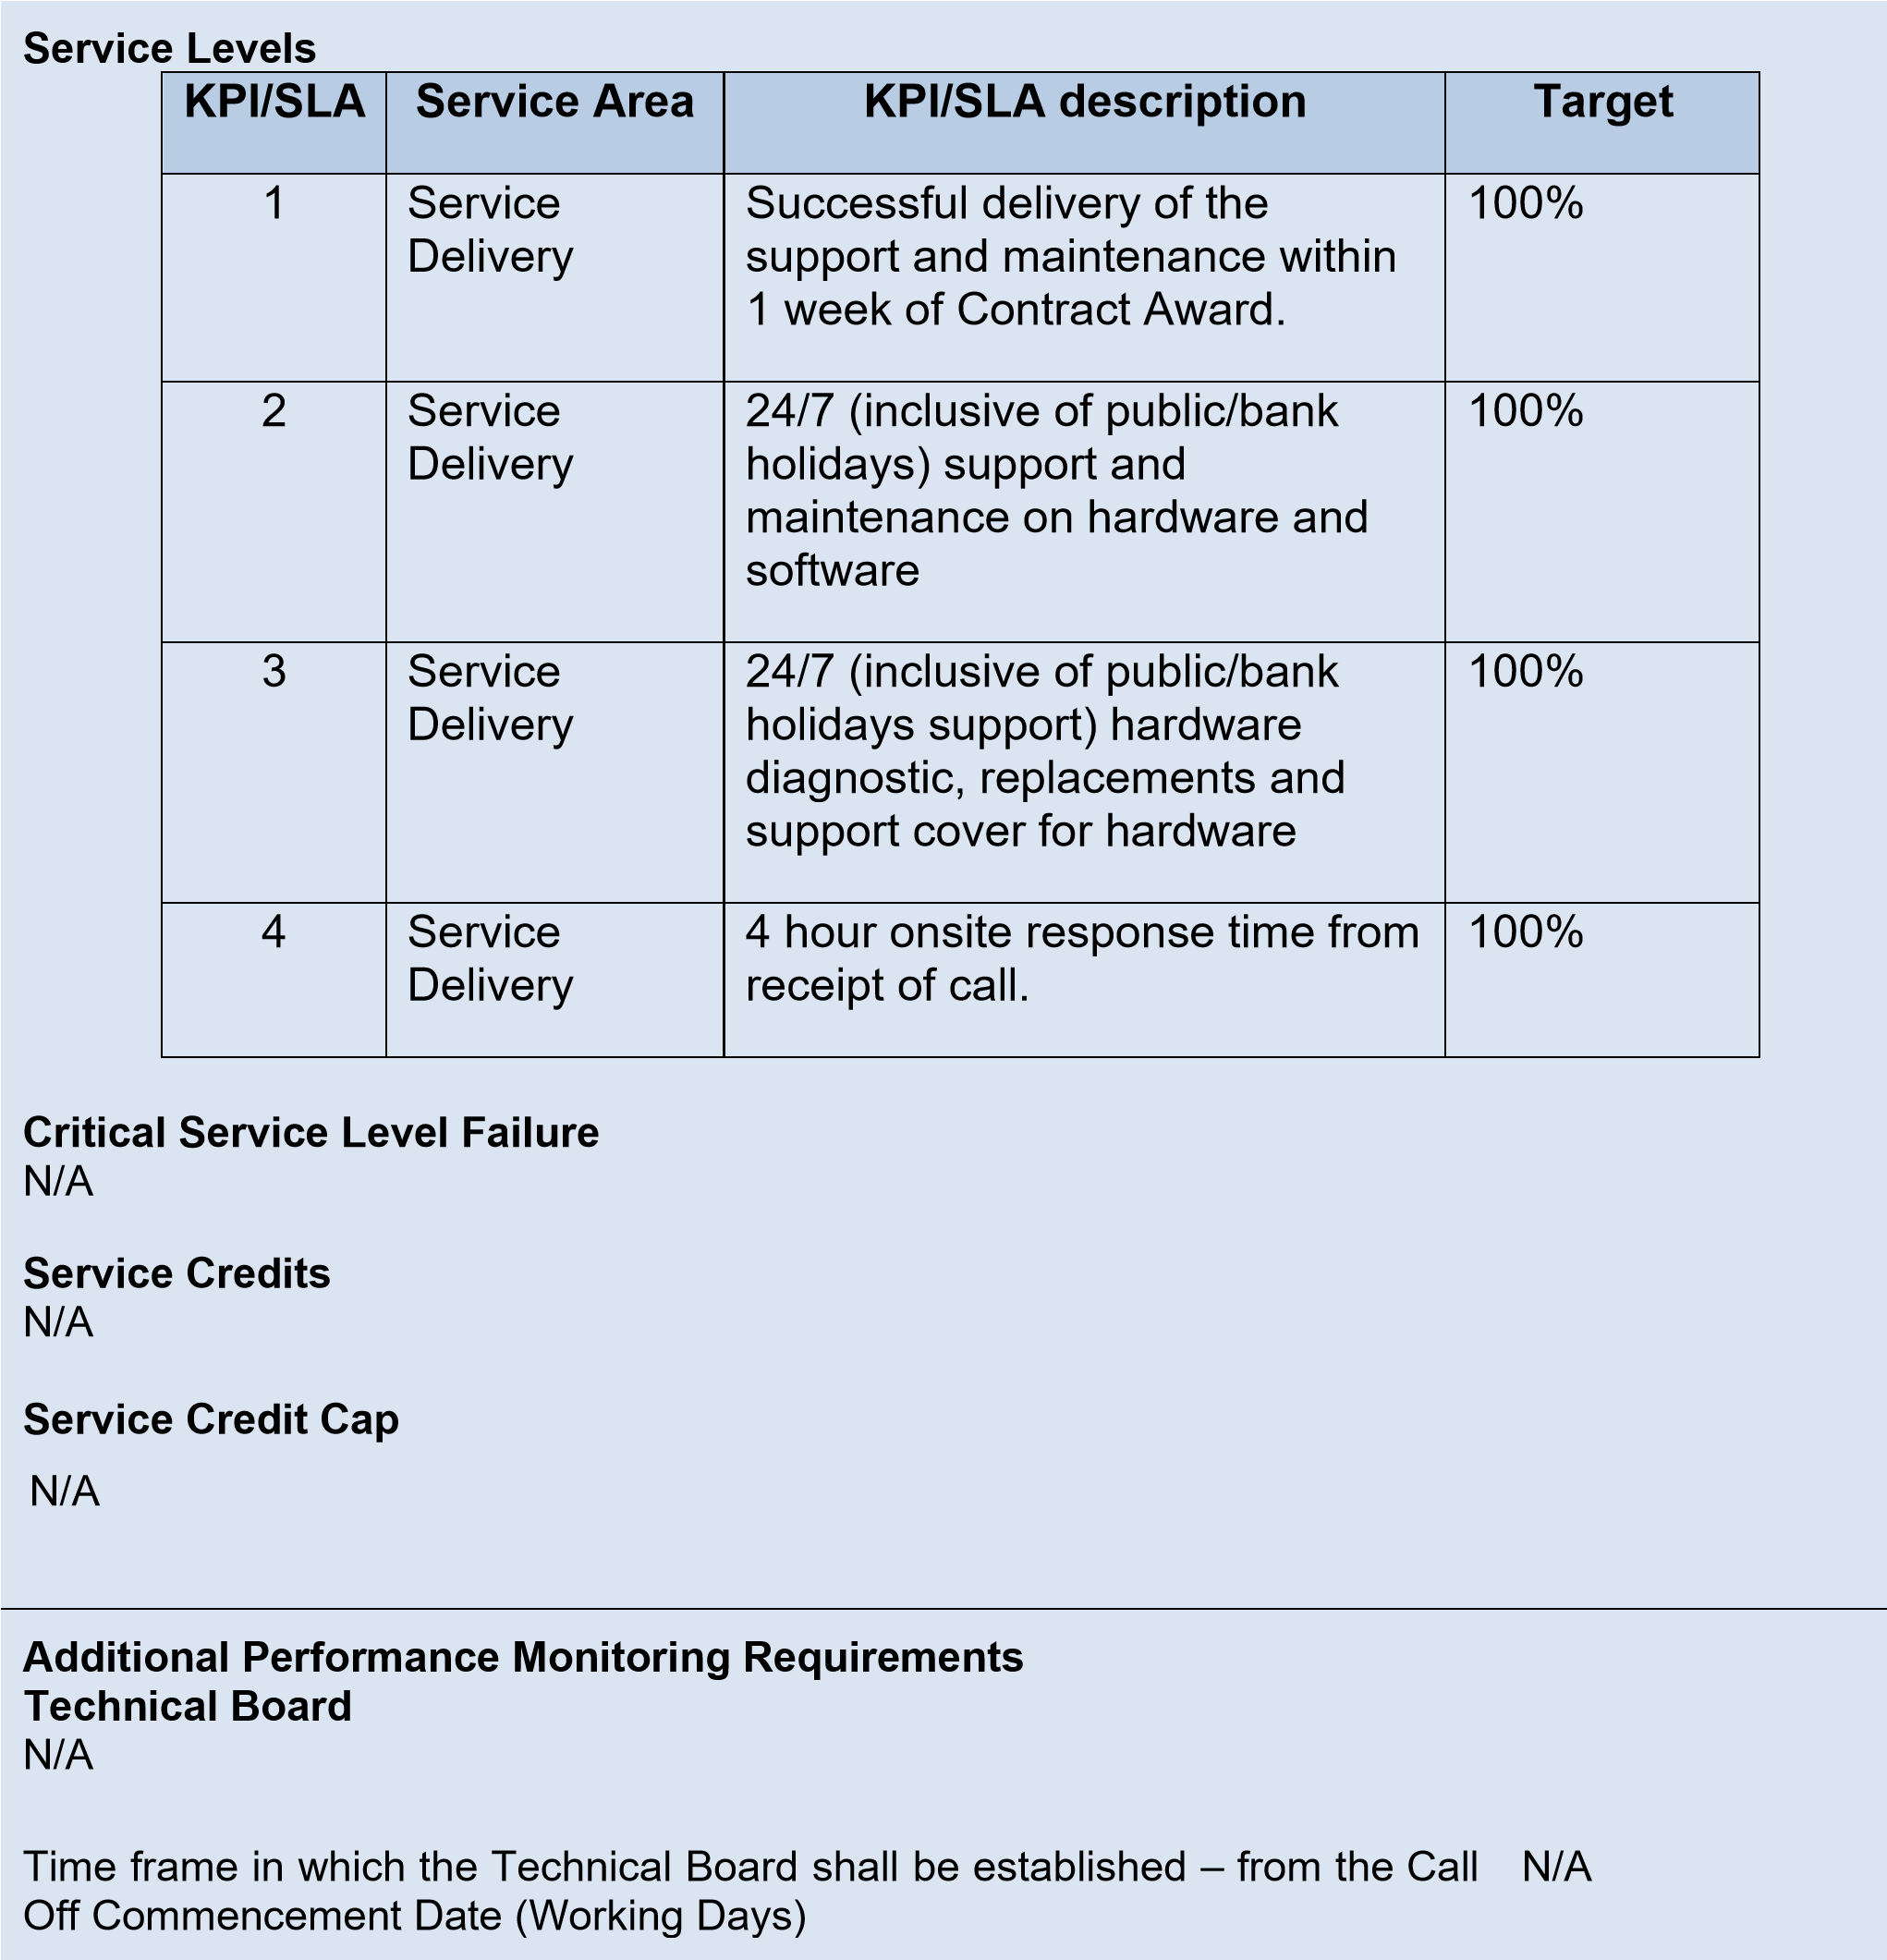

## Section D Supplier response

### Commercially Sensitive information N/A

**Total contract value**

The total contract value shall be £48,212,68 (excluding VAT and excluding the extension option).

EE & DTP are recommending the renewal of an existing HPE support contract and is recommending Home Office Technology, Police Live Services (HOT PLS) renew by purchasing a support contract renewal directly from HPE. Doing so will allow continuation of the HPE support service HOT PLS have benefitted from over previous years. The service DTP is recommending is

HPE’s Proactive Care 24x7 with DMR (Defective Media Retention) Service. The renewal, as described by DTP, will ensure that all support services are delivered by HPE in an identical manner to how they have been delivered up until this point. HPE’s Proactive Care 24x7 with DMR Service provides a complete break/fix support service for customers. The service-level agreement (SLA) included in this renewal provides 24x7x365 coverage with a 4-hour response from the time of receipt of an incident being logged. The DMR addition to this contract allows failed storage media to be retained by HOT PLS for either secure preservation or destruction. All of the hardware listed in section 6 of ‘Attachment 3 – Statement of Requirements’ (included within the documentation set provided by HOT PLS) is included in the renewal being offered here to HOT PLS by DTP. To confirm, the ONLY way of renewing the current contract in place is for the HPE Service Agreement IDs (SAIDs) listed below to be renewed. Any deviation from the below will mean that the support currently active will not continue as is. HPE SAIDs that must be included in renewal to guarantee continuation of support: • 1084 8410 9113 • 1084 8410 9283 HPE’s Proactive Care 24x7 with DMR Service uses HPE’s Foundation Care 24x7 Service support product as the basis of its service but adding key enhancements. DTP expects that from the point of receiving an order, the support renewal will be active within 3-5 working days and DTP will prioritise this order through its own internal systems and request prioritisation with HPE as DTP understands the importance of the current support agreement continuing without interruption. In the event of a service incident, HPE Proactive Care provides HOT PLS with an enhanced call experience with access to advanced technical solution specialists, who will manage your case from start to finish with the goal of reducing the impact to your business while helping you resolve critical issues more quickly. HPE employs enhanced incident management procedures intended to provide rapid resolution of complex incidents. In addition, the technical solution specialists providing your HPE Proactive Care support are equipped with automation technologies and tools designed to help reduce downtime and increase productivity. Should an incident occur, HPE Proactive Care includes on-site hardware repair if it is required to resolve the issue. You can choose from a range of hardware reactive support levels to meet your business and operational needs. HPE Proactive Care includes firmware and software version analysis for supported devices, providing you with a list of recommendations to keep your HPE Proactive Care covered infrastructure at the recommended revision levels. You will receive a regular proactive scan of your HPE Proactive Care covered devices, which can help you to identify and resolve configuration problems. HPE Proactive Care also provides quarterly incident reporting intended to help you identify problem trends and prevent repeat problems. Page 2 of 2 HPE Proactive Care uses Remote Support Technology (RTS) to enable faster delivery of services by collecting technical configuration and fault data. Running the current version of Remote Support Technology is required to receive full delivery and benefits from this support service. Given this is a renewal of an existing HPE Proactive Care support contract, DTP assumes the latest version of RTS is deployed however if this is not the case, DTP can work with HOT PLS to configure this as part of the consultancy days it has quoted. As requested by HOT PLS, DTP has provided pricing for 4 days’ consultancy for a check of the 3PAR arrays covered under this renewal. The consultancy will be provided by **REDACTED** who is an HPE Master ASE (MASE) certified engineer across HPE storage technologies, including the HPE 3PAR StoreServ portfolio. **REDACTED** has extensive experience with the storage arrays covered by this renewal and therefore the additional 2 days’ consultancy for familiarisation activities are not necessary. DTP has provided pricing as requested by HOT PLS however due to the way HPE structure pricing for support renewals, itemised pricing in the way requested is impossible to provide. As such, DTP has provided an estimated itemised price. The total cost of the renewal for both applicable SAIDs (at detailed above) is £44,812.68 plus VAT. We would be happy to answer any further queries HOT PLS has regarding the renewal offered.

## Section E Call Off Contract award

This Call Off Contract is awarded in accordance with the provisions of the Technology Services 2 Framework Agreement RM3804.

The Supplier shall provide the Services specified in this Order Form to the Customer on and subject to the terms of this Order Form and the Call Off Terms (together referred to as “the Call Off Contract”) for the duration of the Call Off Contract Period.

### SIGNATURES

**For and on behalf of the Supplier**

|  |  |
| --- | --- |
| Name | **REDACTED** |
| Job role/title | **Frameworks Manager** |
| Signature | **REDACTED** |
| Date | **15/07/2021** |

**For and on behalf of the Customer**

|  |  |
| --- | --- |
| Name | **REDACTED** |
| Job role/title | **Senior Systems Engineer, SEO** |
| Signature | **REDACTED** |
| Date | **17/07/2021** |