Request for Quotation

PROVISION OF
Website Design Services

Please respond by
12 June 2018 12.00 hrs

- SATELLITE APPLICATIONS CATAPULT
The Satellite Applications Catapult is a technology and innovation company seeking to transform the way the world uses satellite technology and data. The aim of the UK sector is to grow to a £40bn industry by 2030 – this is an exciting opportunity and the Catapult is at the heart of this effort to accelerate growth in the industry.

We do this by helping organisations to grow their businesses. We bring together industry, researchers, end-users and Government to explore and develop new ideas for using space technology and data.

To help businesses overcome barriers to growth we focus on three simple principles:
• We work to energise markets, which is all about working with other industry sectors to see how they might make better use of satellite technology and data.
• We seek to empower technologies, so we look to see how the UK space sector could take advantage of new and emerging technologies such as Artificial Intelligence (AI) and machine learning, robotics and autonomy.
• We enable growth, by providing a range of business support services, from business modelling and product design to opening access to R&D, export and finance.

The Catapult has delivered over 200 innovation projects over the past five years mainly driven through our four ‘market’ programmes. These are areas where we believe there are real opportunities for space applications to make a difference. Our programmes are Blue Economy (the marine and maritime sector), Intelligent Transport Systems, Sustainable Living (energy, agriculture and the extractive industries) and Government Services.

We are part of a network of ten Catapults across the UK set up by Innovate UK, the Government’s innovation agency, and each focused on a technology that could deliver jobs and economic growth in the UK.

- PURPOSE OF THIS DOCUMENT
The purpose of this request is for the Satellite Applications Catapult to receive sufficient information from potential Suppliers interested in supplying the specified requirements and to allow an assessment to be made of their capacity and suitability to supply the goods and/or services.

Please respond in the format detailed below. Responses should contain:
- Organisational information (Section A);
- The Response Requirements (Section B);
- Provision of commercial and pricing Information (Section C); and,
- Your response to the requirements detailed in Annex A and to the evaluation criteria in Section 9

- SPECIFICATION OF REQUIREMENTS
Refer to the Statement of Work in Annex A which details the requirements for this project.

- AWARD TERMS
Any Contract awarded will be let based on the Satellite Applications Catapults’ provided terms and conditions (see Annex B). Terms and conditions will not be amended after the contract award has been made. Any questions regarding terms and conditions should be made in writing before the closing date for responses to this RFQ.

- CLARIFICATION QUESTIONS
The Catapult will not enter into detailed private discussions regarding the goods or services being procured. Clarification questions about the procurement should be submitted through the procurement@sa.catapult.org.uk email address by 12:00hrs on 01 June 2018. Please use the following reference when submitting questions related to this RFQ: RFQ-FY19-05.

Answers to all clarification questions will be issued to all vendors who signal their intent to respond, by close of business on 05 June 2018.

- CONFIDENTIALITY
All information provided in this document shall remain confidential between the Supplier and the Satellite Applications Catapult. The Satellite Applications Catapult will not share this information with any other organisations or Public Bodies without the permission of the Supplier.

- DISCLAIMER
The Satellite Applications Catapult reserves the right to award a contract to any or no Vendor responding to this invitation, and to amend any information or any requirements contained in the documentation. Suppliers should form their own conclusions about the methods and resources needed to meet these requirements.

The documentation and the information contained within it are the property of the Satellite Applications Catapult; all rights, including intellectual property rights, are reserved.

Suppliers may withdraw their responses at any time prior to accepting the notification of award by sending a notice of withdrawal to the Satellite Applications Catapult.

The Satellite Applications Catapult shall observe all its obligations under the Data Protection Act 1998 and associated legislation which arise in connection with this tender.

Any expenditure, work or effort undertaken by your Company prior to the award of a contract is a matter solely for your Company’s own commercial judgement.

- TIMETABLE
The indicative timetable is set out in the following table:
Deadline for receipt of questions | 12:00hrs 01 June 2018
Issue of Question & Answer documentation | 05 June 2018
Deadline for receipts | 12:00hrs 12 June 2018
Presentation Agenda announced | 15 June 2018
Presentation from the three highest ranked Respondents | 22 June 2018
Notified of award decision | 25 June 2018
Purchase Order awarded | 25 June 2018
Works Completed by | TBC 2018

IMPORTANT NOTE: No extensions to the deadline for responses will usually be granted with very limited exception to situations where a Bidder finds themselves seeking to request an extension due to reasonable extenuating circumstances, those circumstances being beyond the Bidder’s control and unforeseen to them.

- THE EVALUATION APPROACH
The Award will be based upon the assessment made by the Satellite Applications Catapult of the information submitted by vendors responding to the request, outlined within Annex A. The Table below contains a list of all criteria which will be used to evaluate responses:

Criteria | Title | Max score available
A | Relevant experience of the company in delivering assignments of a similar nature to the one detailed in Annex 1 | 20
B | Vendors will be required to demonstrate how their proposed design for the website meets the aims, target audience & required functionality as detailed at Annex 1 | 30
C | Pricing Information - Section C1. The vendor who offers the lowest evaluated sum will be awarded the highest score available (20) whilst other higher priced offers will be scored proportionally lower. | 20
D | Please provide details of the team proposed to undertake the project, citing relevant experience of the individuals as well as any issues they have encountered in projects like this, and how these issues were resolved. | 20
E | Details of your proposed timetable to complete the assignment | 10
Maximum score available: |  | 100

You should submit a response to this invitation addressing the requirements above and those detailed in Annex 1.

Following a review and initial scoring of responses in accordance with criteria A to E (listed above), the three highest ranked Respondents will be invited to present their proposals in more detail to members of the Catapult’s Marketing team. Vendors will be contacted in this regard on 15 June 2018.

It is intended that the presentations will take place on 22 June 2018.

Tenderers should assume a 60-minute time slot for a formal presentation of up to 30 mins with the remainder for questions and answers. The presentation must be capable of being delivered on a projector with a PC attached (both of which can be supplied if required).

For each Tenderer the senior manager that would be responsible for delivering the contract is required to attend the presentation. Tenderers may also be required to make themselves available to attend additional meetings/telephone calls if required.

Following the conclusion of these meetings, the evaluation team will re-visit their scoring, in the light on information presented at the presentations and then re-submit their final scores for each vendor.

The vendor who achieves the highest overall evaluated score will be nominated as the Preferred Supplier and issued with a contract based upon the Catapults Standard terms & Conditions for the Supply of Goods & Services (Annex B). This contract will be for a period required to build the website. Support will be provided inhouse and hosted through Innovate UK.

- RESPONSE REQUIREMENTS
Please use this document, including all the attachments to return by email to procurement@sa.catapult.org.uk by 12.00 on 12 June 2018.

 | Supplier | Buyer
Company Name:- |  | Satellite Applications Catapult Ltd
Contact Name:- |  | Lorraine Hoult
Telephone Number:- |  | 01235 567999
Email Address:- | @ | procurement@sa.catapult.org.uk
Position within the Company |  | Financial Accountant
Persons authorised to sign on behalf of the Company |  | Stuart Martin – CEO

SECTION A – SUPPLIER ORGANISATION INFORMATION
Please ensure that you complete the questions relevant to your organisation.
A1 | Full name of the organisation submitting the quotation
A2 | Please confirm the status of the Supplier to be considered:
 | A response to this question is for the Catapult to understand the Supplier.
A | Your organisation is bidding to provide the services required itself
B | Your organisation is bidding in the role of Prime Contractor and intends to use third parties to provide some services (If yes go to question A3)

A3 | If your answer to A2 was b, please indicate in the table all sub-contractors or members of the consortium which will be responsible for each element of the requirement.
 | If you have answered ‘yes’ to question b or c, please response to this question.
Element of Requirement |  | Company / Organisation | How much of the requirement will they directly deliver (%)
 |  |  | %
 |  |  | %

A4 | Details about the organisation named in A1:
A | Company Registration Number
B | Date of Registration
C | Registered Address
D | Annual turnover
E | VAT Registration Number (if applicable)
F | Please select the legal status of the organisation applying | 1 | a public limited company
 |  | 2 | a limited company
 |  | 3 | a sole trader
 |  | 4 | a partnership
 |  | 5 | a Limited Liability Partnership
 |  | 6 | a consortium
A5 | Conflicts of Interest/Related Parties
Is there any other work being undertaken or likely to be undertaken by your organisation (or consortium) which could give rise to a conflict of interest?
If Yes please provide details below

Is your organisation, or are any members of your organisation, related parties to any members of the Satellite Applications Catapult? (A related party could be a family member, relative, friend, prior business supplier or related corporation)

SECURITY REQUIREMENTS
A6 | Do you have a company representative who is responsible for security |  |  |  | Yes  No
A7 | Does your organisation operate an Information Security Management system certified to International, European or equivalent standard (e.g. BS EN ISO 27001) or is your company certified to Cyber Essentials Plus? |  |  |  | Yes  No
A8 | If you have answered “Yes” to the above, please provide: | Name and approval certificate Number
 |  | Certificate Expiry Date
A9 | Please self-certify that your organisation has an in-house policy for the management of information security that fully complies with current legislative requirements. |  |  |  | Yes  No
A10 | Has your organisation (or any member of your proposed consortium, if applicable) Directors or partner or any other person who has powers of representation, decision or control been convicted of any offences named within Annex C (if yes please provide details in separate annex) |  |  | Yes  No

SECTION B – RESPONSE REQUIREMENTS
This section seeks to understand how your organisation can meet the requirements of the User Requirement Specification
B1 | User Requirement Specification
Please confirm you have attached your organisations response to the Specification of Requirements (Annex A).

B2 | Indemnity and Liability Provision
Please confirm your organisation insurances:
Professional Indemnity - £5m
Employers Liability - £5m
Public/Products Liability - £5m

SECTION C – COMMERCIAL AND PRICE INFORMATION
The following section outlines the commercial and price offer based on the User Requirement Specification.
Prices submitted should be fully inclusive (Ex VAT) in GBP not subject to variation.
Tender Ref:
Company Name:
A. Personnel Rate card for contract period |  |  | Rates
 |  |  | Hourly | Daily
Insert Resource #1 type & description of activities
Insert Resource #2 type & description of activities
Insert Resource #3 type & description of activities
B. Equipment Costs |  |  | Unit price
Please detail the costs of any equipment which will be required to
fulfil the services during the contract period.
Total Equipment Costs: |  |  | £0.00
C. Costs for completing the scenario |  | Qty | Unit Cost | Total Cost
Please insert all Resources/equipment (see above) and/or |  |  |  | £0.00
other costs required to complete the contract |  |  |  | £0.00
 |  |  |  | £0.00
 |  |  |  | £0.00
 |  |  |  | £0.00
FIXED COST FOR CONTRACT COMPLETION: |  |  |  | £0.00
For the avoidance of doubt:
1. The prices/rates quoted in this offer worksheet are exclusive of VAT.
2. The prices/rates should be based on an eight (8) hour working day.
3. Scenario cost to include travel & subsistence which shall be charged as detailed within ITT.
Signed
Print Name
Position in company: (e.g. Director, Partner, Principal, Company Secretary)
For and on behalf of: (i.e. organisation's name)
Dated:

C2 | Optional Extras
Please outline if there any additional options outlined in your quotation that were not identified in our original User Requirement Specification.

SECTION D – DATA PROTECTION

D1 | Data Protection
Irrespective of whether you are successful in your tender and insofar as the tender includes personal data (as defined under GDPR), we would like to retain your contact details in the event that a suitable opportunity arises. If you are happy for us to hold this information please tick this box.
Yes, we are happy for you to retain our tender for the purposes outlined above.
No, we are not happy for you to retain our tender.
Your information will only be held for 2 years from the date of conclusion of the tender process. You are able to withdraw consent at any time by contacting procurement@sa.catapult.org.uk and your refusal to consent will in no way affect this tender process.

UNDERTAKING
To be signed by an Officer of the Supplier’s Company in their own name on behalf of the Company.
I certify that the information provided is accurate to the best of my knowledge and that I accept the conditions and undertakings requested in the Request for Quotation.
Signed for and on behalf of the Company
SIGNATURE
Name of person signing on behalf of the Company
PRINT
Position in the Company
PRINT
Company’s name and address
PRINT
Date

Annex 1
Requirements.
The Project
As a part of the Catapults Network, our website of the past 5 years has been in the original template set up for the launch of the network. The website has served as an information source, but is now in need of a refresh of structure and design in order to cater for our growing organisation. The current site is able to provide information but needs reorganisation and updating to feature key successes of the company as opposed to the original aims and plans. The current design is static and features large amounts of blank spaces and text. The aim is for a more dynamic site showcasing what we do, how we do it, and to bring in new communities by highlighting opportunities available to them.
Please see the current website here: https://sa.catapult.org.uk
The current site has 3 central Catapult branding features which will need to be retained (albeit in an updated form) in the new site. These are:
- Catapult logo top left
- Links to other Catapults maintained in the header
- Certain elements of the footer
Aims of new website
The aim of the new site is to provide information on the company - what we do, and what we have to offer - with the ultimate objective of new attracting new organisations to work with us or to take advantage of the facilities and services we offer.
Target audience
Our main target audiences are organisations – both industry and academia – working with satellite technology or data, and organisations in other markets who can benefit from space-enabled applications. Our 4 focus market programmes are Blue Economy, Intelligent Transport Systems, Sustainable Living and Government Services, so targeting these audiences with their own landing pages is key, but attracting new market areas by showing the capabilities of space data is also an aim.
Functionality requirements
- Flexibility in page structure, potentially with a modular design so that sections can be brought in and out of pages easily
- Dynamic homepage
- Events calendar
- Display available facilities and how to book, including room specifications
- Facility booking/enquiries
- Allow easy updating for Marketing team with user friendly CMS – currently using Wordpress
- Our 4 key programmes need a ‘hub’ area each with landing page and info pulled through to the area from news/events etc (template for new)
- SEO friendly
- Responsive design
- In line with Disability Discrimination Act
- Explore options of customer login to sign up for events without registering each time, update their own mail preferences, and update contact details. This would need to have forms integrated so we know who has registered for an event when logged in.
- Search functionality
- Development site for updates
- Clickable rather than rollover menu, with improved structure - open to suggestions
- Direct linkage to Constant Contact – or other EMS for the future
Website content
- We will be updating the content, removing out of date content, reviewing copy, and adding information to the programme areas
- Current size of website = 450 pages
- Agency to build templates for key pages, Catapult to do populating of pages
- Target size = approximately 20 page templates (e.g. news item, event page, blog post)
Graphics
- We already have a large image library to use
- Graphics must be focused on applications (no rockets etc unless specifically requested)
- In-house graphic designer to work with team on new graphics
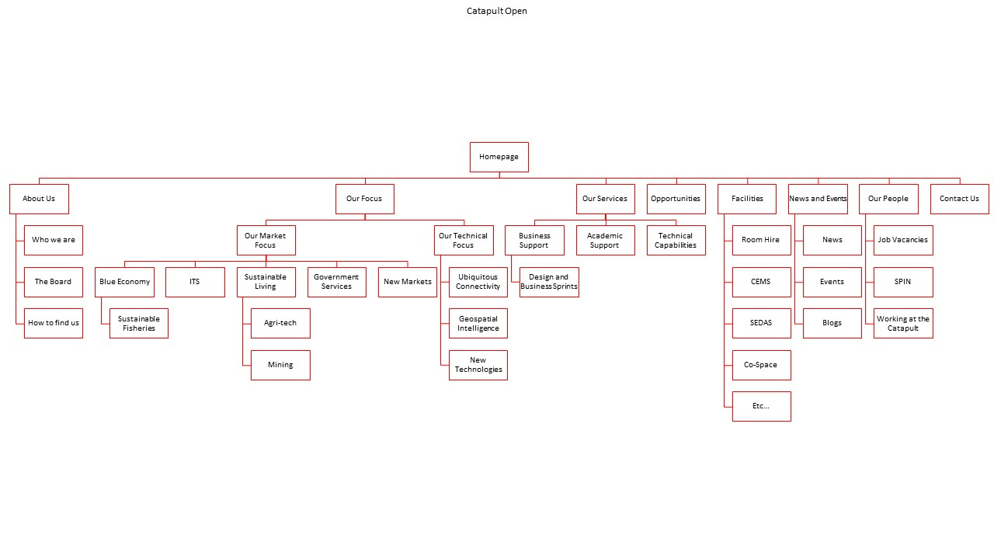
Site Structure (rough draft we’re happy to be challenged on and will update throughout process)

Annex B
Catapult Terms & Conditions

Please see separate document

