INVITATION TO TENDER

To supply a managed service for Street Marshals from
June 2024 to May 2025

Introduction
Taunton is the County Town of Somerset and was one of the first towns in the Southwest to be awarded Garden Town Status and has a population of around 60,000. Taunton Town Council is committed to enhancing security and safety measures to tackle the rise in Anti-Social Behaviour and improve safety and security for members of the public, its community and businesses through engagement, education and problem solving.
The offer must;
Create a safe and welcoming place: by using street ambassadors/marshals to create a friendly and welcoming place for people to shop and spend time in, improving the safety and security of the town centre. Safer towns will lend itself to increased footfall and more potential business for local retailers. The safe streets will entice people to venture out and explore the area, providing a boost to the local economy and improve investment opportunities.
The role of the street marshal will be to assist where possible, approach groups of people to ensure all is well and to be that helping hand, you’ll be required to engage with local businesses and identify hotspots of ASB issues.
Street marshals will look to work with a range of town centre users, this will include businesses, residents, visitors, community groups, street performers, buskers and street traders, the local policing team to ensure that the town maintains a safe and secure environment for all to prosper and grow.
Street marshals could have certification, licenses and training in the following;
- SIA
- Conflict management
- Physical intervention
- Safeguarding children
- Vulnerable adult protection
- Welfare and vulnerability engagement
- “Ask for Angela”
- First Aid
- Prevention of violence against women and girls
- Anti-racism, LGBTQA+

Supporting Local Business Communications: Street marshals will support the town centre businesses by allowing the businesses to report town centre issues, ranging from verbal abuse, shoplifting and more serious crime towards businesses via the radio link system.
Street marshals can help in the following ways;
- To provide reassurance by having a physical presence
- Be the eyes and ears on the ground to provide accurate and detailed intelligence.
- Educate members of littering and dog fouling and to help preserve the environment.
- Deterring conspiracy to commit a crime.
- Act as point of contact for enquiries and help and support visitors when needed.
- Support vulnerable people.
- Act as a professional witness.
- A point of contact for businesses to assist with reporting crime and other ASB issues.
- Carry out any initiatives that derive from the Town Council.
Wardens are not:
- Replacement for policing services
- Emergency response team
- A 24/7 hour service
- Parking or Enforcement Officers.

Taunton Town Centre Patrol Plan (February 2024) – Image 1
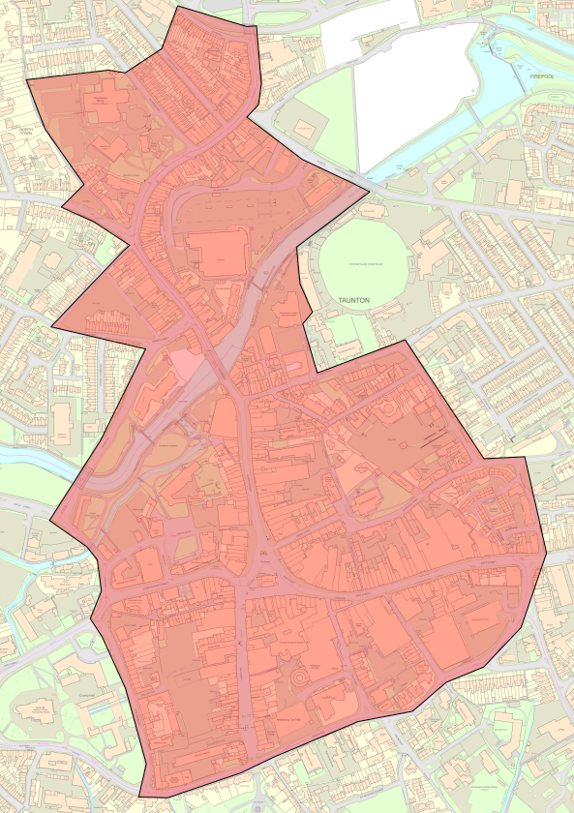
The successful contractor will be suitably experienced and qualified to undertake this tender and be able to provide examples of similar successful projects which they have been involved in.
The street marshals shall be suitably trained and hold:
- SIA Licences
- Certified in Conflict Management
- Adult and Child Protection/ Safeguarding Measures
- WAVE Welfare and Vulnerability Engagement
- First Aid
- Prevention violence against women and girls.
Tender submissions must detail how the business experience and training requirements are met. The successful contractor will deliver this contract with suitably trained personnel.
Sub-contracting by the contractor is not permitted without the consent of Taunton Town Council. Tender submissions must specify whether the intention is to sub-contract.
Taunton Town Council recognise that radios will be required from the Somerset CCTV team

Instructions to tenderers
All tenderers are requested to let the Council know on receipt of this Invitation To Tender (ITT) that:
- they wish to submit a tender and the
- name of tenderer contact where all communications regarding this tender should be addressed to.
If there are omissions, discrepancies or enquiries concerning the ITT document these should be emailed to operations@taunton-tc.gov.uk
Any clarification queries regarding the tender document must be submitted as soon as possible. Any answers to clarifications will be emailed to all known interested tenderers prior to the submission date.
All tenderers are recommended to visit the town and carry out a site survey with an officer of the Town Council prior to submission of the tender document.
All tenders must be for Anti-social behaviour patrols in the form of Street Marshals as specified in the ITT. If there are omissions or errors in the tender submitted to the Council the tenderer may be required to justify the price/items concerned. Any price adjustments to the tender made by agreement with Taunton Town Council and the tenderer will be confirmed in writing by the tenderer to the Town Council before final acceptance by the Town Council.

Submission
Tenders may be submitted in a sealed envelope marked ‘Tender – ASB, Operations and Events Manager, Taunton Town Council, Deane House, Belvedere Road, Taunton TA1 1HE. Tenders by post or by email must be received by 5pm on 30 May 2024
Tenders received after 5pm on 30 May 2024 will not be considered.

Timetable
Taunton Town Council to award the contract in 2024.
The proposed timescale is as follows:
Activity | Date
Dispatch of ITT | 25 April 2024
Return of ITT | 30 May 2024
Evaluation of ITT | June 2024
Notification of successful tenderer | June 2024
Service commencement | August 2024

Taunton Town Council reserves the right to change the timetable and will notify tenderers where a change takes place.

Tenders - assessment and evaluation
All tenders will be assessed on the following services:
- Patrol Coverage
  - Assess the approach to patrols for adequate coverage.
- Incident reporting
  - Accuracy and timeliness of incident reporting to track and address issues effectively.
- Community engagement
  - How will interactions and engagements with stakeholders take place.
- Response times
  - Average response times to incidents and requests for assistance within the town centre
- Conflict resolution
  - Assess relevant and suitable qualifications and training.
- Safety measures
  - The safety and security of wardens to ensure the effectiveness tackling ASB issues.
- Collaboration with authorities.
  - Assess the collaboration approach to other authorities to ensure effect and measured approach is taken.
Each compliant tender will be judged against the following criteria:
Description | Weighting
Experience of successful working with authorities | 22
Evidence of experience, capability, and training of personnel | 23
Safety and Security | 20
Climate and Environment Considerations | 5
Value for money | 30
Total | 100

The Council will not be bound to accept the lowest priced or any tender submitted and may reject any tender if it is incomplete or vague.
Tenders will be judged by the Communities Committee of Taunton Town Council and may be referred to full Council or delegated to Town Clerk for final approval. If the tenderer is required to attend a meeting to discuss their proposals, this will be at no additional charge to the Town Council.
The Town Council may require additional information as appropriate for each tender. This ITT has been prepared in good faith and Taunton Town Council does not accept any liability or responsibility for the adequacy, accuracy, or completeness of the information.
Each tenderer must make its own independent assessment of the proposed terms after making such investigations and take such professional advice as it deems necessary to determine its interest in the contract.
The tenderer must include in their tender:
a) Information concerning the contractor, including details of experience, training, and staff competencies.
b) A suggested patrol schedule and or programme.
c) Experience of working with other authorities for example the Council and Police.
d) Method statements on minimising safety risk and upholding security measures.
e) A separate document confirming the costs, including payment terms.
Figures quoted must be the total fixed price, excluding VAT, for the works concerned, including all parts of this ITT. This will include uniform, PPE, Equipment and personnel costs. Pricing should be all inclusive of every aspect to deliver and maintain the service for the duration of the contracted 12-month period. The contractor’s submission should also include a breakdown of the total fixed price to deliver all elements of the specification, into the annual cost. Unless otherwise stated by the response in the tender document. Financial arrangements will be agreed with the successful contractor. The contractor should conduct all necessary due diligence in advance of submitting their tender as the Council will not accept liability for additional payments.
f) The names and contact details of two referees who have received a similar service in the past 24 months.
Please note that the contractor selected to undertake this contract will have to provide documentary evidence of insurances, health and safety policies, method statements and any relevant personnel training prior to contract award.
In addition, the contractor selected will have to provide a full method statement and risk assessment to demonstrate how the patrols will work and that they are carried out safely.

Tender conditions
The tender shall provide an irrevocable offer to provide the services. The successful tenderer shall conclude a formal contract with Taunton Town Council which shall embody the tenderer’s offer.
It is clearly understood that the ITT and the submission of the tender shall not in any way bind the Town Council to enter a contract with the tenderer or involve the Town Council in any financial commitment whatsoever in this respect.
Any interested organisation who directly or indirectly canvasses any member or official of the Council concerning the evaluation of the tender, or who directly or indirectly obtains, or attempts to obtain, information from a member or official concerning any other tender will be disqualified. If at any stage during the process it is discovered canvassing has taken place, that organisation and its tender may be disqualified from the tender process.

Tenderers responsibilities
The tenderer is responsible for obtaining all information necessary for the preparation of its tender and all costs, expenses and liabilities incurred by a tenderer in connection with the preparation and submission of a tender shall be borne by the tenderer. Each tenderer should satisfy themselves before submission as to the accuracy of the prices and rates and cover all obligations and all necessary information for risks and contingencies which might affect the tender.

Confidentiality
All information supplied by the Town Council in connection with this ITT shall be treated as confidential by tenderers except that such information may be disclosed so far as is necessary for the purpose of obtaining sureties, guarantees and quotations necessary for the preparation and submission of the Tender.

Specification
Communication and Monitoring
- Equipment
  - Bodycam
  - Mobile phones
  - Data
  - Radios that link to Somerset’s CCTV Team.
It will be the street marshals responsibility to ensure their radio is charged and operational before each shift.
- PPE
  - Covert stab vest
- Remote with Somerset’s local CCTV network system.
Reporting
- To report all security and ASB issues within the boundary area of the town through to Somerset’s CCTV Team via radio.
- Ensure all data protection regulations are followed.
Uniform
The street marshals must be well presented and comfortable and protected from the UK weather.
- Smart casual appearance with coat/jacket/fleece/t-shirt
- Branded Clothing (Taunton Town Council logo).
- Branded with text as Town Centre Marshals.
- Black/dark trousers and dark boots or shoes
Events
The team will support up to 4 town centre events each year, these will be:
- Christmas Light Switch on
- Remembrance Day Parade
- Taunton Together (Free community Cultural Event)
- Taunton Carnival
Taunton Town Council is tendering with a view to agreeing a contract with a supplier from August 2024. The contract will run for 12 months, up to July 2025.
The areas where the street marshals should concentrate their efforts are within the mains streets in Taunton Town Centre, although can extend accordingly to the geographical area of Image 1
- East Street
- North Street
- The High Street
- Fore Street.
- Station Road
The street marshals will maintain a high-profile presence in designated areas by undertaking regular patrols on foot. There are currently no public space protection orders in these areas.
The service provider maybe be required to work flexibly day and nighttime hours and adapt their patrolling schedule accordingly based on the data that is captured. The town council would seek to find preventative measures with the aim of reducing ASB across the town.

Statistics
Taunton Town Centre has a number of keys areas where ASB issues are reported these are East Street, North Street, High Street and Taunton Road in Taunton.
Top ASB Locations | Reported Numbers
Taunton outside of town area | 25
East Street | 24
North Street | 22
High Street | 21
Station Road | 20
Total | 112
ASB Incidents Over Time (June 2022 – May 2023)
Jun | Jul | Aug | Sep | Oct | Nov | Dec | Jan | Feb | Mar | Apr | May
142 | 144 | 145 | 142 | 147 | 147 | 143 | 140 | 136 | 133 | 132 | 129

Safe working practices must be adhered to and the contractor will need to show evidence of the relevant professional and public liability cover to the value of £10M.

Requirements for personnel of street marshals
Standard to be achieved.
- Public Safety and Security
To achieve a safe and welcoming town centre by patrolling the areas where ASB issues are frequently reported to deter anti-social behaviour and to reduce escalation. Providing assistance on crowd control and emergency procedures. Street marshals to operate in pairs at unsocial hours for safety and security purposes.
Street marshals must comply with all requirements under section 2 (3) of the 1974 Health and Safety at Work Act (HASAW), as far as reasonably practicable, to ensure the health, safety and welfare of all employees.
- Community Engagement an Assistance
Street Marshals will be expected to engage with the local community, aiding visitors and residents and serve as a point of contact for questions or concerns on public safety issues.
- Incident Reporting
Street Marshals will be responsible for the reporting of incidents and issues and will be responsible for identifying trends, hotspots and other concerns in the town centre.
To update the Town Council at reoccurring scheduled meetings on issues and for the Town Council to look further into developing initiatives to reduce ASB.
- Collaboration with Local Authorities.
The street marshals will be required to work closely with the police, local community organisations such as ARC (Taunton’s association for the homeless) and youth providers to identify initiatives to help tackle anti-social behaviour issues across the town.
- Public Health Awareness (Safeguarding and Vulnerable People)
The street marshals will need to show empathy and understanding to those who identify as vulnerable or appear to have mental health concerns.
- Professional Conduct
The street marshals will demonstrate the necessary skills for their duties and conduct themselves in a professional manner that reflects the professionalism of the Town Council
- Communications
The street marshals will have effective communication skills with all stakeholders and have skills to de-escalate situations and keep the Town Council informed of issues and situations by various channels. Somerset’s CCTV control room prevents crime and increases community safety. The cameras are monitored 24/7 and has Police airwave radios and are directly linked to the Police Control Room.
The street marshals who will act as ambassadors for the town centre and will be representing the town council in the heart of the town and community and will require to present a professional and friendly demeanour.
Timings
Taunton Town Council shall provide the contractor with statistical information, which would indicate the days of operation and therefore where the resource shall be allocated. The street marshals can work a flexible shift pattern to address the ASB issues across the town centre. It will be the responsibility of the street marshals to communicate their shifts with the Operations Manager and must not exceed the allowance of 32 hours per week, (16 hrs per street marshal)
Assistance with and provision of documents
The Town Council may ask to see any relevant documentation to support the role of the street marshal should be provided to the Council any requests for documentation / certificates within five working days.
Please note that the contractor is responsible for supplying street marshals to the specification standard.

Additional points and overarching conditions
- The service provider will be responsible for supplying street marshals and all other necessary pieces to cover the duties of street marshals
- The service provider will be responsible for establishing excellent working relationships with a range of key stakeholders and community groups.

- Taunton Town Council to have a direct communication link to the street marshals to share updates and intelligence.
- Street marshals to have a clocking in and clock out system so that hours can be recorded and monitored.
- Tenderers must certify within their tender submissions that they can meet the required timescales.

Payment
Payment for services to the contractor will be made upon the receipt of a satisfactory VAT invoice and may be made in instalments. Full terms are to be agreed once the contract has been awarded.
The total budget for this tender will not exceed the value of £38,000 in a 12-month period.

