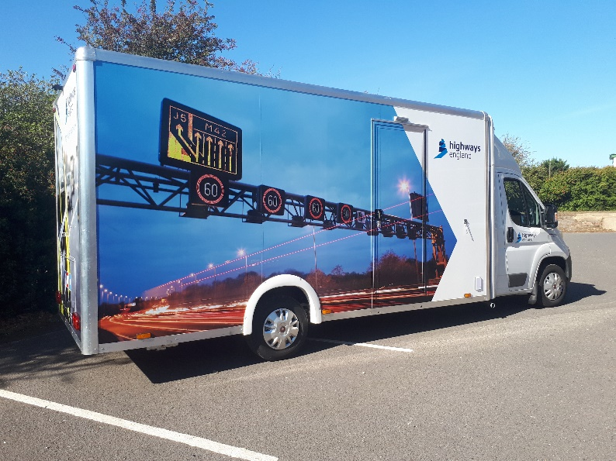

RIP

engagement van

# Contents

Help and support 4

The van 5

Things you need to know before booking the van 6

Booking the van 7

Van measurements 8

Van equipment 9

Hire driver information 12

The day of an event 13

After an event 14

Frequently asked questions 15

# Help and support

Your **regional consultation manager** will:

* Help you decide when and how to maximise use of the van
* Be responsible for booking the van, talking you through what to expect and working alongside you to ensure you have all your preparation in place
* Confirm arrangements for delivery of the van
* Be available and answer any questions you have on using the van
* Gather feedback from you to improve the way the van is managed and the customer experience

Their details are:

|  |
| --- |
| North west and Yorkshire north east |
| Cheryl Russell |
| cheryl.russell@nationalhighways.co.uk |
| 07543 237557 |
|  |
| Midlands and east |
| Tom Sanders |
| tom.sanders@nationalhighways.co.uk |
| 07526 178956 |
|  |
| South west and south east |
| Damian Greenfield |
| damian.greenfield@nationalhighways.co.uk |
| 07889 300558 |

If you are unable to speak to your regional consultation manager send an email to RIPvan@nationalhighways.co.uk and a member of the team will respond within 48 hours.

When the van is used at an event, the National HighwaysCustomer Contact Centre(CCC)can provide support out of office hours - call 0300 123 5000.



## Safety

* Health and safety is our first imperative at National Highways and

it is everyone's responsibility. Our vision is that everyone gets home safe and well

* Each region has health and safety managers who can support you with any health and safety queries
* If you feel that something is unsafe, speak up and raise your concerns to your line manager or regional consultation manager

# The van

The RIP engagement van is a 3.5 tonne box van that has been customised to be used as a fully accessible mobile venue.

It has internal and external display boards, seating, display tables and a 50-inch television screen. This is no ordinary transit van!

The van also has an optional gazebo that can be set up alongside to create more space for displaying materials and speaking to members of the public in a sheltered area.

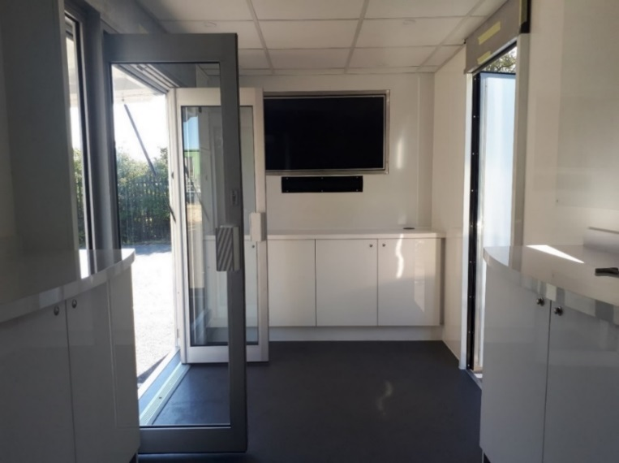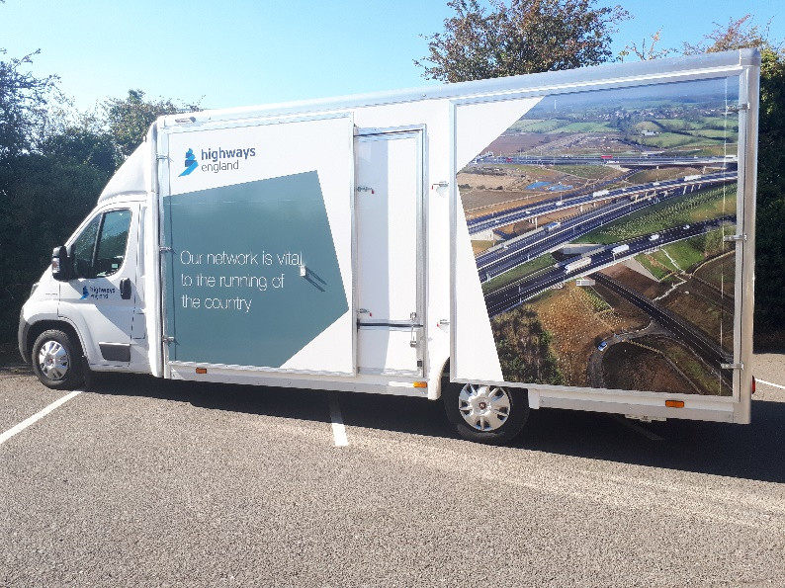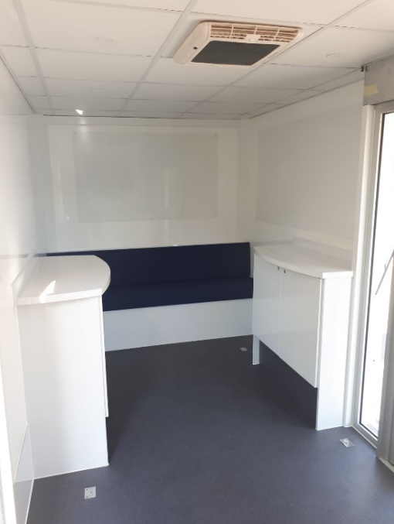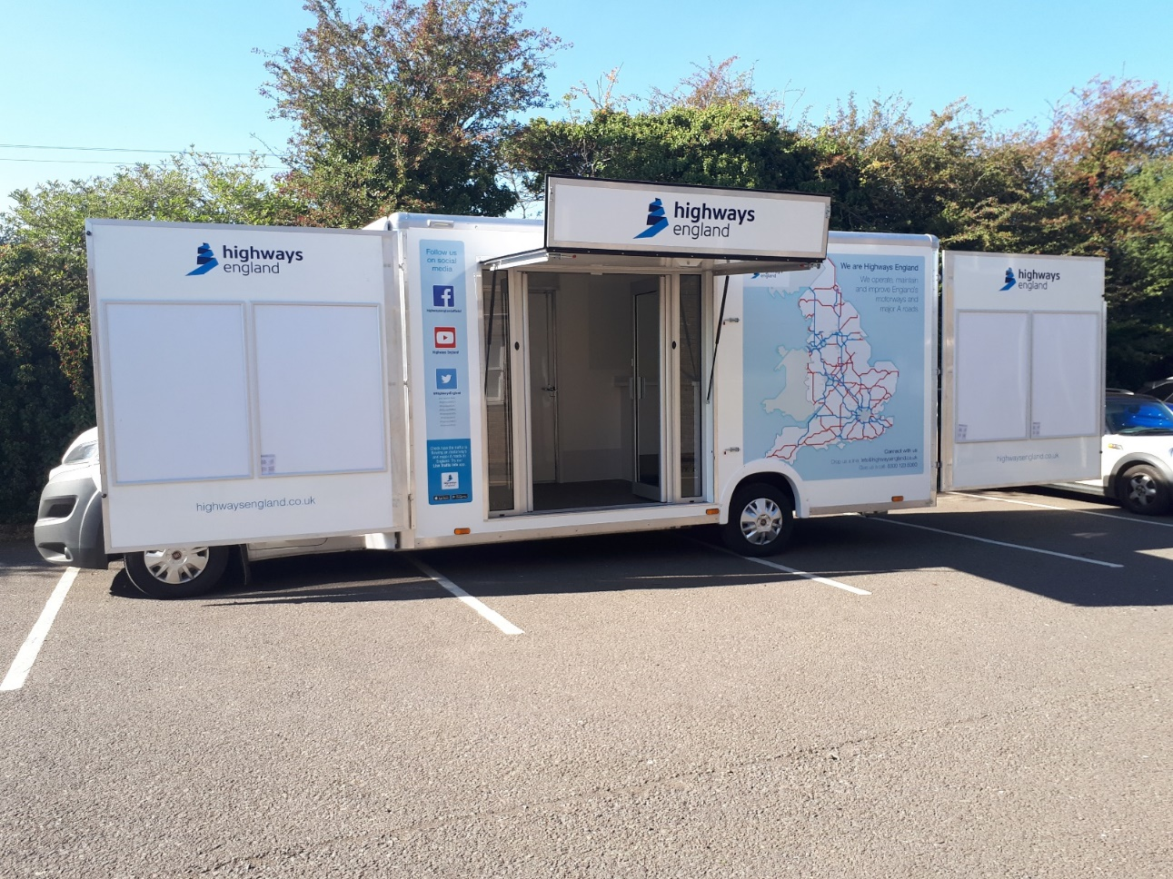

# Things you need to know before booking the van

* You should speak to your regional consultation manager as soon as you start planning a public consultation or engagement event. They can help you to decide when and where to use the van most effectively
* There is no cost to delivery teams for using the van - costs are covered by the Regional Investment Programme non-roads budget
* The van can hold approximately 10 people comfortably inside, and 10-15 people in the gazebo. It is recommended that three members of staff (excluding the hire driver) should be present during an event
* Any materials to be used in the van must be provided and transported to the van by the team using it **on the day of the event.** This includes brochures, maps, posters, and video or image files for use on the television screen (via a USB stick)
* You should contact your regional communications manager **6 weeks before an event** takes place to organise materials to be created and printed
* Content for the television screens will need to be put on a USB stick. Any USB stick can be used in the van laptop and television equipment, but if you’re transferring files from a National Highways computer, you can only use an ‘Iron Key’ USB stick for security reasons
* **A dynamic risk assessment must be completed by the team using the van ahead of an event.** Your regional health and safety manager can provide guidance on this
* A risk assessment and equality impact assessment (EqIA) have already been completed for the van. Your regional consultation manager will provide you with copies
* **Public liability insurance is not required for an event where the van is being used**. National Highways is a government owned company and we self-indemnify for public liability claims, so there is no legal requirement for us to hold public liability insurance
* The van should be transported to and from the event location by a professional hire driver. This driver will set up the van and ensure it is safe and ready to use. The hire driver will be arranged by your regional consultation manager
* The van should be parked on a hard surface such as concrete or hardcore, however it can be parked on soft surfaces such as grass if needed
* All staff attending an event to work in the van must make their own travel arrangements to get to the event location and must complete all relevant *working away from the office* (WAFO) processes (including *driving for work*). Your line manager can provide further guidance on this.

# Booking the van

Booking the van is simple and your regional consultation manager will help you every step of the way.

The RIP engagement van calendar is available to view on Microsoft Outlook - search for ‘RIP engagement van’ in the Outlook address book. This calendar shows you when and where the van is being used so you can plan your events accordingly.

To start you just need to provide your regional consultation manager with the following information:

* The dates you want to use the van
* The location of the event

Your regional consultation manager will then discuss the details of your booking with you and support you every step of the way.

If your plans change,please make your regional consultation manager aware as soon as possible, so your booking can be amended and the van can be made available to other teams.

# Van measurements

The van is 3.3 metres in height. The internal height of the rear cabin is approximately 2.3 metres.

The table and pictures below summarise the size of the van when it is packed away and when it is set up in exhibition mode.

|  |  |
| --- | --- |
| Situation | Measurements |
| Van packed for transit | 7.5 metres long and 2.3 metres wide |
| Van set up for an event (without gazebo) | 7.5 metres long and 4.5 metres wide |
| Van set up for an event (with gazebo) | 7.5 metres long and 7.5 metres wide |

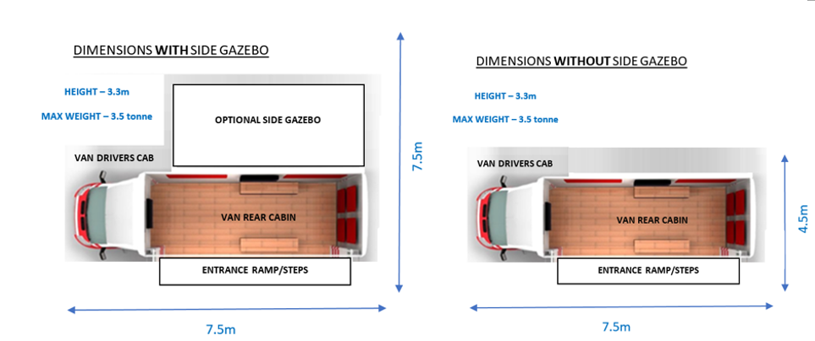

**12.5m**

**12.5m**



## Safety

* It is important that the space where the van is set up provides

enough room for people to move in and around it safely

* If a car park is being used to set up the van, the traffic cones provided with the van must be used to section off an area, so other vehicles do not drive near to the van
* The gazebo should only be used when the weather is suitable. It has weights on the legs but in windy weather there is still a risk that the gazebo could become unsafe

# Van equipment

## Gazebo

This is branded with National Highways logos and can be set up alongside the van next to the single access door, creating more space for displaying materials and speaking to members of the public

## External poster boards (x4)

A0 print size - these can be used for displaying event specific information

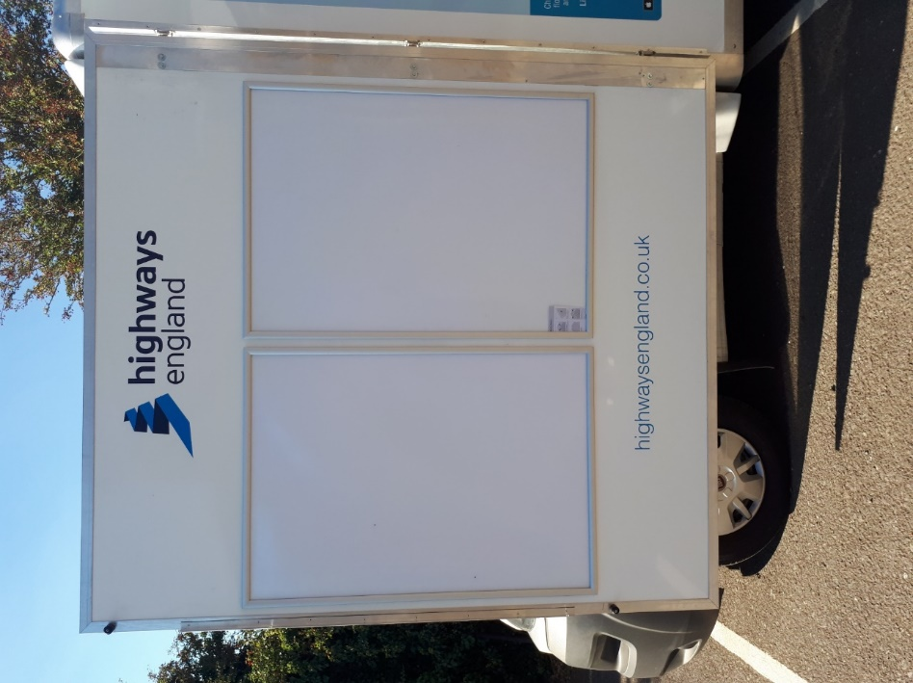

## Access ramp and steps

Steps and an access ramp are available into the main doors of the van, and a set of steps into the single door of the van

## Large portable display table

180 cm long x 70 cm wide - can be set up in the gazebo for displaying materials

## Fridge

Located inside one of the cupboards in the rear cabin, this can be used for storing staff food and drink items

## Internal display boards (x3)

Can be used to display materials inside the van - magnets are provided

|  |  |
| --- | --- |
| Board | Measurements |
| Board one | 220 cm long x 90 cm high |
| Board two | 150 cm long x 90 cm high |
| Board three | 170 cm long x 90 cm high |

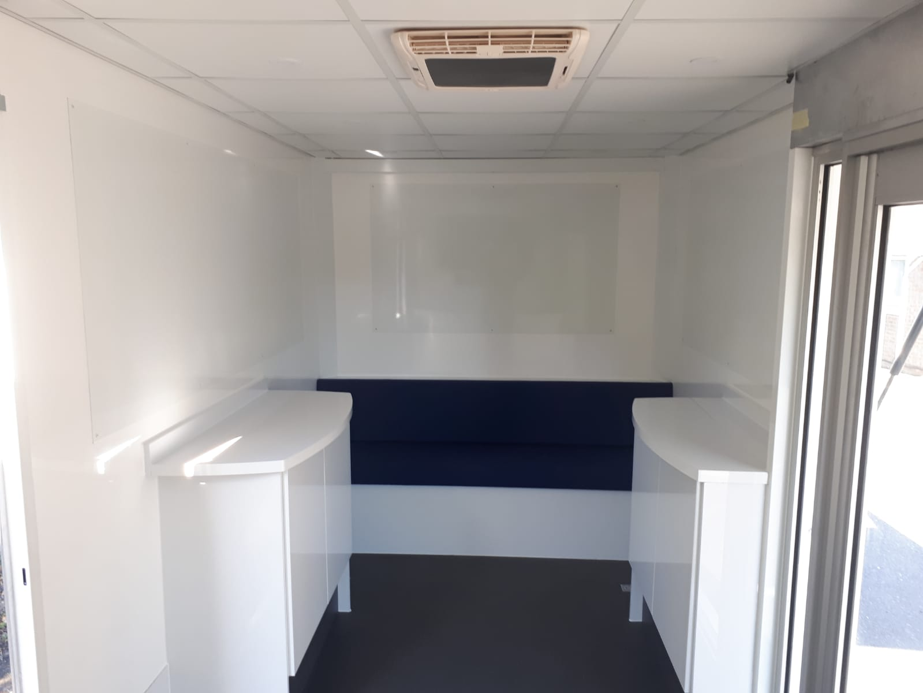

Board two

Board one

Board three

## Hearing loop (audio induction Loop)

A sound system which is inside the van, and can be used by people with hearing aids. It provides a magnetic, wireless signal that is picked up by a hearing aid when it is set to the T (telecoil) setting.

## Electric generator

Provides electricity to the rear cabin and can be powered by diesel fuel or by being plugged into a mains electrical socket.

## Laptop

Can be used to load files onto the television – the laptop does not require a username or password, and any USB stick can be used with it. It’s stored inside a cupboard, with a wireless mouse.

## Cycle rack

Can hold up to four bikes and should be set up outside the van in a safe, accessible place.

## 50-inch television

Built-in television and speaker system - can be used for showing image, presentation or video files.

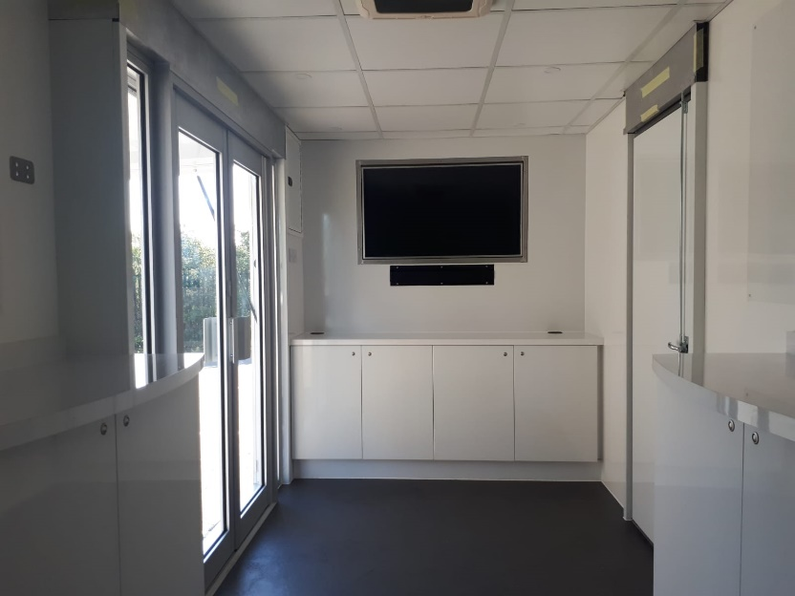

## Storage cupboards (x2)

These can be used for displaying and storing materials inside the van.

**Internal display table and storage cupboard**

## Bench seat

Fixed at the back of the rear cabin, this can be used comfortably by three adults.

## Air conditioning

This air conditioning unit can be used to heat or cool the rear cabin.



## Safety

* Safety equipment is provided with the van including fire extinguishers,

PPE and a first aid kit

* National Highways staff should not set up any of the van equipment

# Hire driver information

For health and safety purposes, a hire driver will be used for each deployment of the van.

The hire driver will be arranged by your regional consultation manager when you book the van.

If an event is cancelled within 7 days of the event start date the hire driver will still need to be paid for. **It is important that everything is done to avoid any late event cancellations unless it is absolutely necessary.**

Before, during and after an event the hire driver will:

* Complete vehicle checks before driving the van to the event location
* Fuel the vehicle
* Set the van up safely
* Clean the van inside and out before it’s used
* Pack away the van safely at the end of an event
* Complete vehicle checks before driving the van to its overnight parking location
* Return the van keys to an agreed safe location



## Safety

* A hire driver is a professional trained driver hired to operate the

van on behalf of National Highways

* Before the van is open to the public staff must complete a safety tour of the van with the hire driver

# The day of an event

On the day of the event you must ensure:

* The location where the van will be used is accessible, so it can be quickly, and safely set up ahead of the event start time
* A member of the team must be at the event location to meet the van and driver, to ensure it is set up in the correct location
* A staff briefing must take place **before the start of every event** where the van is being used, and this must include:
  + An overview of the event and its purpose
  + An explanation of the materials available during the event
  + Confirmation of the times that the event will be taking place
  + Staff welfare information, including how breaks will be managed
  + A safety tour of the van, with particular focus on safety equipment and how to use it
  + What to do if there is an accident or an emergency during the event
  + Confirmation of travel arrangements for staff at the end of the event
  + A reminder the van should be kept clean and tidy, and that all staff belongings should be locked away



## Safety

* Any concerns about the van’s equipment or set up **must be**

**raised** with the hire driver

* Staff must support one another when working in the van, and must take regular breaks
* National Highways staff must not set up or dismantle the van, unless they have been fully trained to do so – this is the responsibility of the van hire driver
* Staff working in the van must wear appropriate clothing and footwear for working in an outdoor environment
* ‘Pop up’ exhibition banners should only be used inside the gazebo
* Staff should use a ‘buddy system’ when travelling home to check that their colleagues have arrived home safely after an event

# After an event

After an event has taken place you will be contacted by your regional consultation manager to:

* Get feedback on the event
* Get feedback on the van booking process
* Ask for any pictures taken during an event
* Confirm if the van is needed for any future events

An electronic feedback form will also be used to gather key feedback information for the team managing the van.



## Safety

* **All feedback is important** as it helps to ensure the van is managed in a safe and efficient way for all teams

# Frequently asked questions

## Why should I use the RIP engagement van?

The van enables us to:

* Engage with road users in locations close to our network such as motorway service stations, business parks and shopping centres
* Attend community events that many road users visit such as county shows or festivals
* Engage with communities in areas where venues for information events aren’t readily available, especially in rural villages

Similar vans have been used by other teams within National Highways and feedback from members of the public has been very positive.

## Will this van replace fixed event venues such as village halls?

No, the van should be used in addition to venues such as village halls, hotels or community centres to increase the number and types of people that we engage when running public events.

## What if the dates I want to use the van are not available?

Your regional consultation manager will work closely with you to identify times where particular project schemes may require the van. This will help to ensure that the van is available for RIP project schemes during key periods of engagement and consultation. If your preferred dates are not available, your regional consultation manager will work with you to suggest and agree alternative dates.

## Who pays for the fuel?

The hire driver will pay for the fuel used; the cost for this will be covered by the Regional Investment Programme non-roads budget.

## I don’t have anything to show on the TV screen – is that an issue?

No, there is a USB stick available inside the van that can be used to show the National Highways corporate video and other National Highways information on the screen.

## Can anyone other than a hire driver drive the van?

No, a driver will be provided with every booking. This is to ensure staff can concentrate on engaging with the public and not have to be concerned with setting up and dismantling van for use.

## Can staff travel to an event inside the van?

No, staff must travel to an event separately to the van for safety reasons and the van may be travelling to another location after the event has finished.

## What happens to the van after the event has ended?

The hire driver will close down the van and either return it to the storage depot, park the van in an agreed location overnight, or move it to the next event.

## What happens if the van breaks down before or during an event?

Full breakdown cover is in place for the van. If there is an issue requiring breakdown assistance this will be dealt with by the Customer Contact Centre.

## What happens if there is an accident or emergency whilst using the van?

A full staff briefing should take place ahead of any use of the van. This should include all procedures relating to health and safety, security, accidents and emergencies. National Highways employees must also follow the relevant National Highways *working away from office* (WAFO) procedures when working in the van, just as if they were working in a fixed venue.

## Who can I speak to about the van if I have more questions?

Please speak to your regional consultation manager or email RIPvan@nationalhighways.co.uk and someone will get in touch with you within 48 hours.



