Future Commissioning of the 16+ services:

The overall principles for Hampshire’s 16+ Support and Accommodation offer is that all placements are made based on effective assessment of need and in conjunction with the Young Person.
The objectives are:
- Create a service that is fit for purpose with appropriate accommodation and support to meet the needs of young people;
- Provide locations where young people can have easy access to the community, colleges and employment opportunities;
- Offer appropriate support to those most in need;
- Raise aspirations by providing a service that is sustainable whilst allowing and encouraging the young person to achieve.
Details of the model are below along with the indicative tender timescales and other current opportunities.

Three year contracts will be offered for all services with the option to extend for a further two years.

The model will follow this pathway:
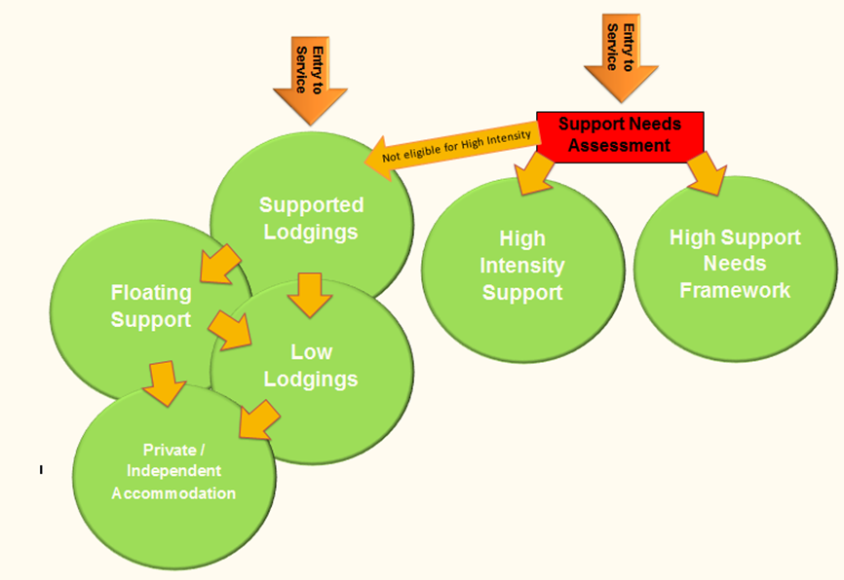

Overview of services:
Supported Lodgings:
Supported Lodgings provision will be increased across the County and will include emergency beds. This will be main point of entry to the service.
Floating Support
Floating support to accommodate 18-21 year olds with Stage 2, less complex to moderate needs. It is envisaged that accommodation would be in the style of a shared house with a maximum of six bedrooms, close to transport links and ideally within walking distance of a town centre/college, however, Providers will be invited to offer alternative solutions. An average of 2-5 hours of direct support per week should be offered.
Low Lodgings
A post 18 offer to facilitate young people in transitioning to maintaining independence through their own tenancies. Low Lodgings will provide rentable rooms in homes with an appropriate host/landlord who does not provide direct support to the young person, but who is has undertaken safeguarding training, is DBS checked and alert to risky behaviours.
High Intensity Support Service:

4 to 6 bed units in each area accessible to young people who are assessed by Children’s Services as having a high support need. The accommodation and support offer will be for young people predominantly 16 and 17 years of age where supported lodgings is not deemed appropriate for their needs. The units will offer a structured Stage 1 service with a focus on education, training and employment, and individual support for mental health needs and behavioural issues. This service will offer approximately 15 hours per week direct support to young people.

High Support Needs Framework:
A framework agreement to provide supported accommodation for those with more complex needs who cannot be accommodated in the current accommodation due to risk factors.
This framework is currently being advertised here:
https://in-tendhost.co.uk/hampshire/aspx/ProjectManage/12356

Indicative Bed Numbers:

 | Hart & Rushmoor | Test valley | Winchester & Eastleigh | Basingstoke & Deane
Supported Lodgings | 29 | 11 | 12 | 10
Stage 1 - High Intensity Support | 6 | 4 | 4 | 6
Stage 2 - Floating Support | 0 | 0 | 0 | 0
Floating Support | 6 | 8 | 8 | 8
Low Lodgings | 5 | 5 | 5 | 5
Emergency Bed | 1 | 1 | 1 | 1
 | New Forest | East Hants | Havant, Fareham & Gosport
Supported Lodgings | 12 | 9 | 44
Stage 1 - High Intensity Support | 4 | 4 beds (no tender) | 6
Stage 2 - Floating Support | 0 |  | 0
Floating Support | 4 |  | 8
Low Lodgings | 5 | 2 | 7
Emergency Bed | 1 | 0 | 1

Indicative Timetable:

Supported & Low Lodgings:

- Invitation to Tender Published (30-Nov-18)
- Invitation to Tender Returned (30-Jan-19)
- Evaluation Complete (20-Feb-19)
- Contract Award (02-Mar-19)
- Start Date (01-Apr-19)

High Intensity & Floating Support:
Contracts will be offered in lots across the County via a tender process to be delivered to the following timetable:

- Invitation to Tender Published (19-Jan-19)
- Invitation to Tender Returned (7-Mar-19)
- Evaluation Complete (7-Apr-19)
- Contract Award (30-Apr-19)
- Start Date (01-June-19)

