**Lindisfarne in Beal – Natural England Depot**

**Scoping Document PV Upgrade – February 2025**

**Generally**

The works: Involve the upgrading of the existing single-phase inverter and battery installation to a 3-phase inverter with additional batteries.

**As Existing:**

There is already a single-phase system, with PV strings connected to the inverters via a total of 4 strings from 3 roof / building mounted arrays, which is a 13kW system.

The current PV system is dual set up, with 4 strings to DC isolators, and connected to two Solax X3 G4 7.5kW hybrid inverters, see Schematic No1. These are wired back to the electrical network via individual 32A

CPD’s, A 63A RCBO and AC isolator to a 63A CPD in the main distribution board. See **Schematic 1** for the configuration.

**Existing system details and photos:**

**Photo 1:** Shows the system, as currently installed on the first-floor landing area.

**Photo 2:** Shows the new 3 phase distribution board.

**Photo 3:** Shows the incoming mains and breakers located to the right of the 3-phase distribution board, all of which is located on the ground floor, and is directly below the Solax battery / inverter system.

**Photo 4 and Site Plan:** The Solax system is behind the middle roller shutter door, on the back wall.

**Existing As Installed Information:** Certification and details of the system. See attachment below.



1. **Scope of the works:** Is to price and provide clarification / confirmation of all of the following within a quotation for the works:
   1. **The contractor is to provide a schematic**: of the intended installation, in relation to the existing system.
   2. **Replacement of the inverters**: Remove the 2 existing inverters and replace with a X3-Ultra 15 kW inverter. This to have a 2-port connection for the batteries and 4 string connectivity for the PV strings.
   3. **Batteries:** Retain the two master 5.8kW batteries and add two 5.8kW slave batteries, and to be set up in ‘master + slave’ configuration. The contractor ‘must’ check that the new batteries are either a version 1 or version 2 to align with the existing master batteries already installed. These will sit in front of the existing batteries.
   4. **DC isolators and Connections:** Adapt and include for the existing for the new set up, using the existing DC and AC isolators and re-connect the entire system, so that it conforms to manufacturers specifications, standards, and IEE 18th edition regulations. Utilise existing equipment as necessary.
   5. **Power and cabling:** The system is currently isolated and needs to be set up to a 3-phase configuration to the new distribution unit (directly below the system). Each phase should be connected to allow the inverter to balance the loads across the site.
   6. **Containment:** Include for all containment and new cabling, or utilise the existing, all to conform to IEE regulations 18th edition.
   7. **Existing equipment and cabling:** strip out and remove from site redundant systems, and isolate /tidy up all cabling.
   8. **Connectivity to the Solax Cloud:** Upon completion the contractor is to ensure the system is fully set up and re-configured to allow for remote monitoring both themselves and for the customer. Login details will be provided when on site.
   9. **Builders Works:** Allow for all works that are non-electrical, associated with the installation.
   10. **Testing and Certification:** Check and test all systems are working and provide an electrical certificate upon completion of the works.

**2.0 Accreditation and Insurances:** The contractor shall provide confirmation of registration of the NICEIC and be accredited to the MCS standards and also provide confirmation of Public liability insurance to a minimum of £1milllion.

**3.0 Welfare:** The site will provide access to toilets and a kitchen.

**4.0 Access, location and Parking:** The site is open from 8am until 4.30pm and is controlled via a CCTV system with card access. Parking is available within the ‘yard’ and you can unload directly adjacent building. All visits to be agreed with the Operational Manager, Andrew Craggs.

* **The site is located:** - Natural England, National Nature Reserve, Beal Station, Beal, Berwick-on-Tweed, Northumberland TD15 2SP.

**5.0 Health and Safety:** The contractor is expected to provide a set of RAMS prior to works commencing on site, and proof of qualifications for any installer, on the day.

**6.0 Equipment and materials:** The battery system should have a minimum of a 10-year warranty, a Certificate of Conformity and a manufacturers data sheet. All proof to be provided within the tender return.

**7.0 Site Inspection:** The contractor has the opportunity to visit site or utilise the information provided, in order to provide a fixed priced for the supply and installation of the Scope of Works.

**8.0 Tender Return:** The contractor is to provide the following documents with the tender return, on the due date, as set out within ‘Contract Finder’.

* Priced Scope of Works items 1.1 to 1.10 + 2.0 inclusive.
* Quotation with Specification / Material list
* Warranty confirmation for the battery and Inverter, plus a data sheet.

**9.0 Procurement:** Natural England will set up the successful contractor on their supplier list, and then raise an order for the works, with payment upon completion. Payment is usually within 14 days.

**Schematic 1:** System as installed.

**Photo 1:** Existing system, as is. Situated directly above the dist board, see photos 2 & 3

**Photo 2:** New 3 phase distribution board (directly below the solar system.

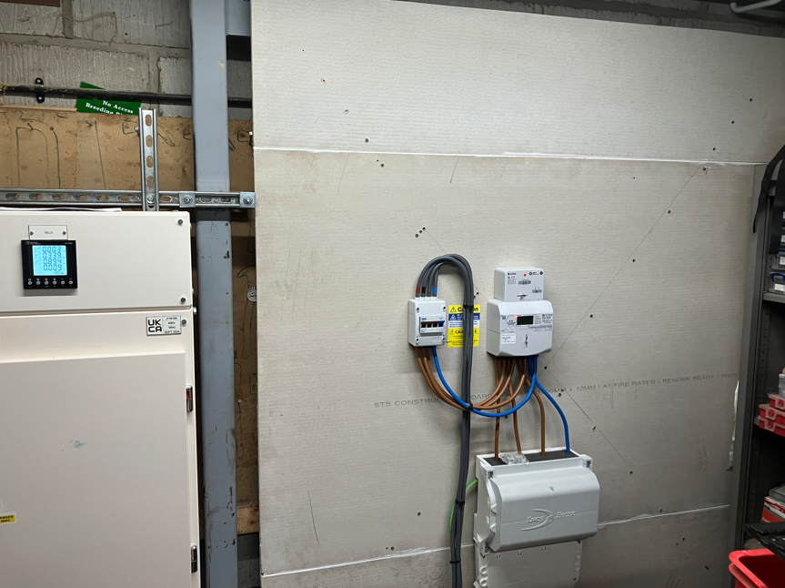

**Photo 3:** New incoming 3 phase cable to isolator and meter.

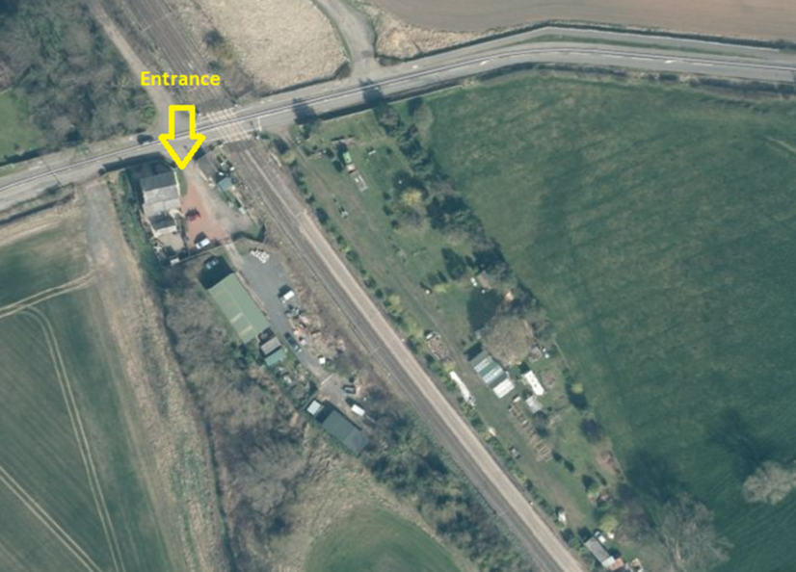

**Site Location:** The Address: Beal Station, Beal, Berwick-on-Tweed, Northumberland TD15 2SP

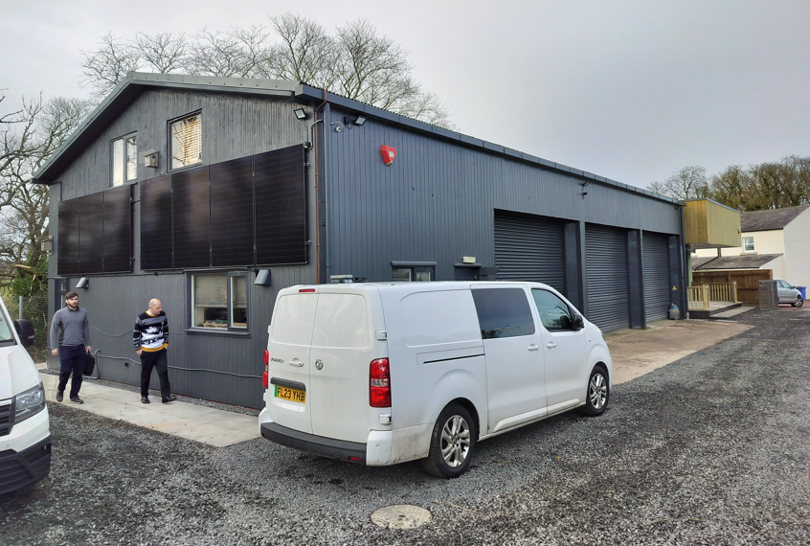

**Photo 4:** The existing building with the Solax system, showing some of the PV panels.

**Site Plan:** Showing location within the existing building