Peak District Dales SAC Protected Site Strategies Pilot- Effectiveness of agri-environment scheme (AES) in delivering condition on the dales: Part 2-Field monitoring (Peak 2g2).

Appendix 1: Location of SSSIs and units forming monitoring contract. Please view on Magic Map Application (defra.gov.uk) for more detail.
Fig 1a. Coombs Dale SSSI units.
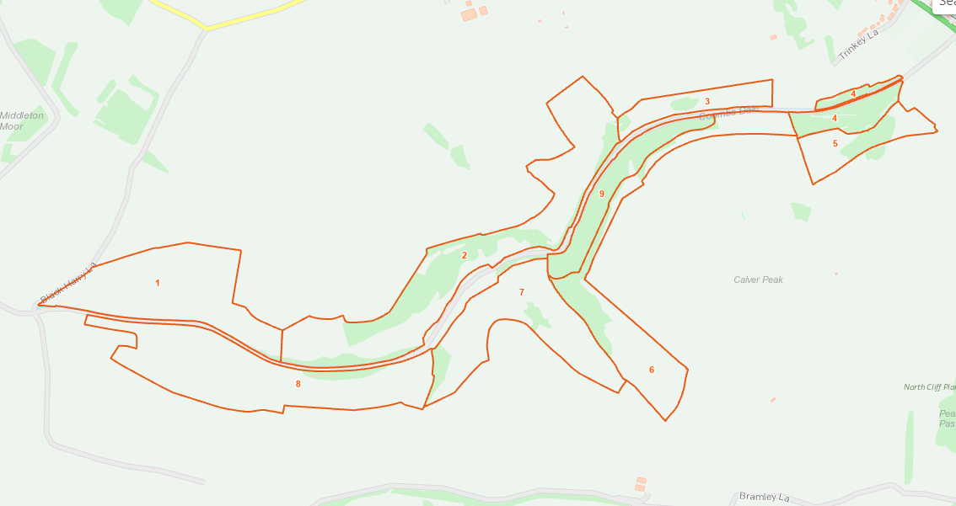

Fig. 1b. Long Dale and Gratton Dale SSSI units
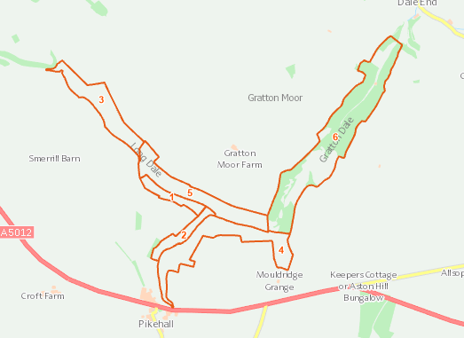
Fig. 1c. Long Dale, Hartington SSSI units
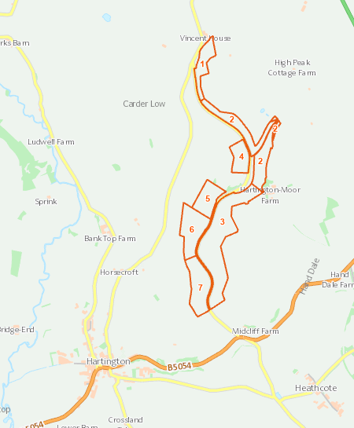

Fig. 1d. Boundary of The Wye Valley SSSI
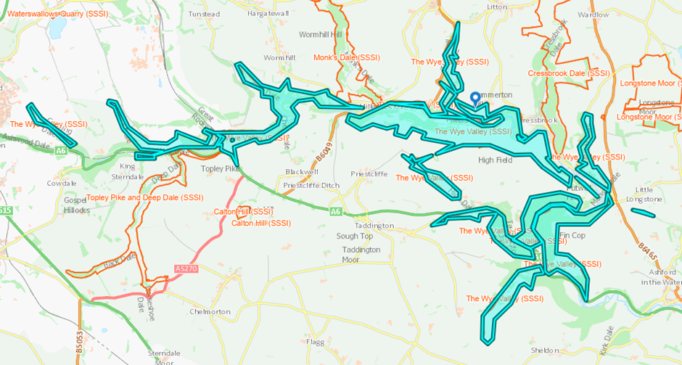

Fig. 1e. Units within northern part of The Wye Valley SSSI (includes units in adjoining SSSI-please compare to Fig. 1d). Unit 1 lies within the isolated dale (Cunning Dale) to the west of unit 4

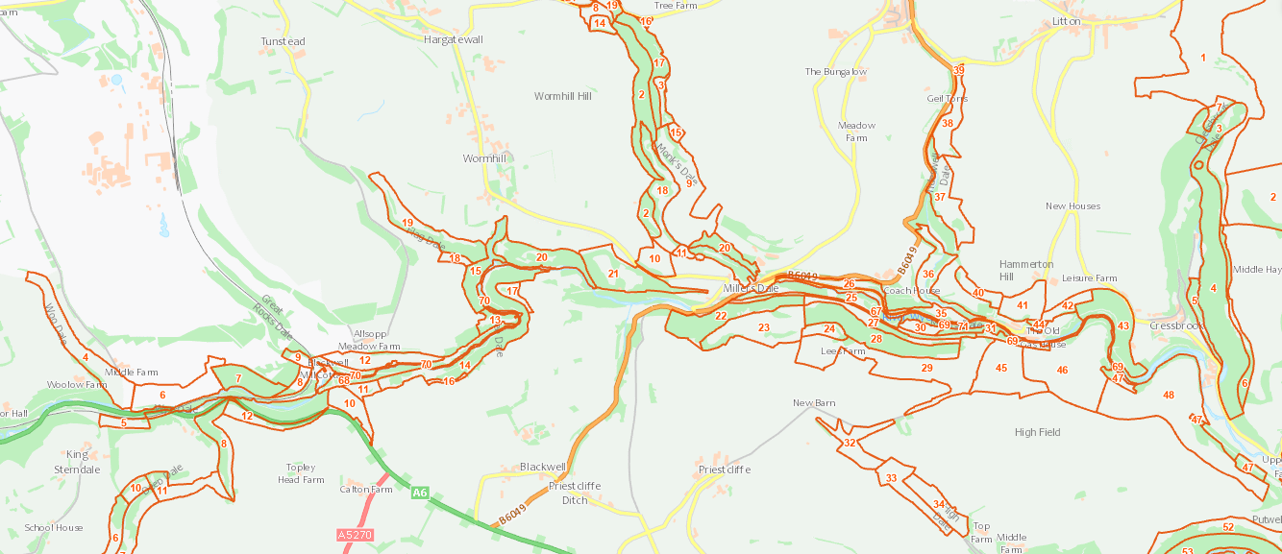

Fig. 1f. Units within southern part of The Wye Valley SSSI (includes units in adjoining SSSI-please compare to Fig. 1d)

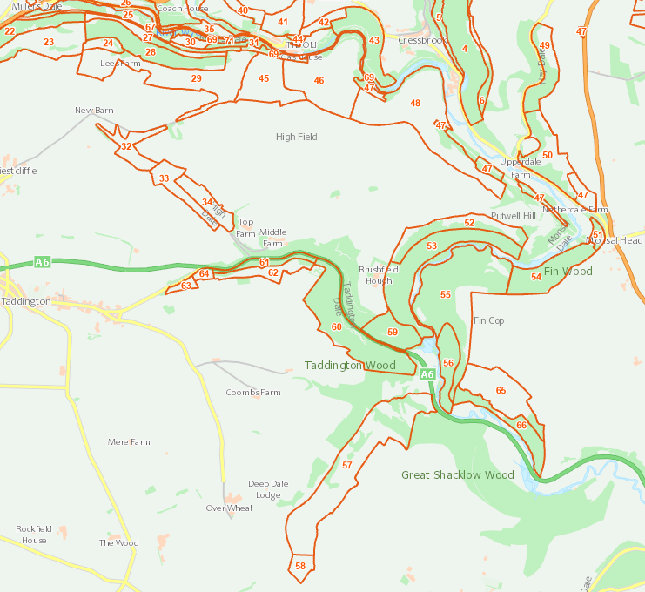

Fig. 1g. Boundary of Topley Pike and Deep Dale SSSI
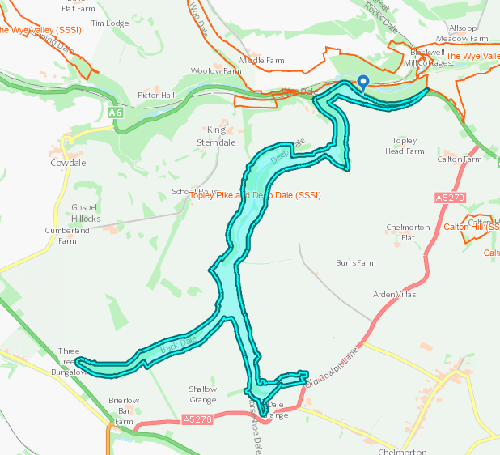

Fig. 1h. Units within Topley Pike and Deep Dale SSSI (includes units in adjoining SSSI-please compare to Fig. 1g)
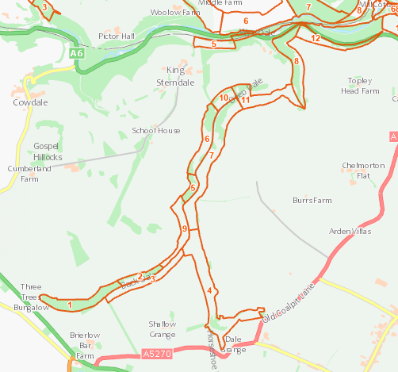
Fig. 1i. Boundary of Via Gellia Woodlands SSSI
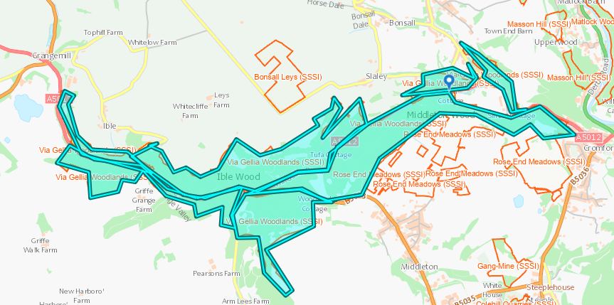

Fig. 1j. Relevant units within Via Gellia Woodlands SSSI. Please compare to Fig. 1i.

