ProContract Supplier Registration

- Navigate to this page from https://procontract.due-north.com/register

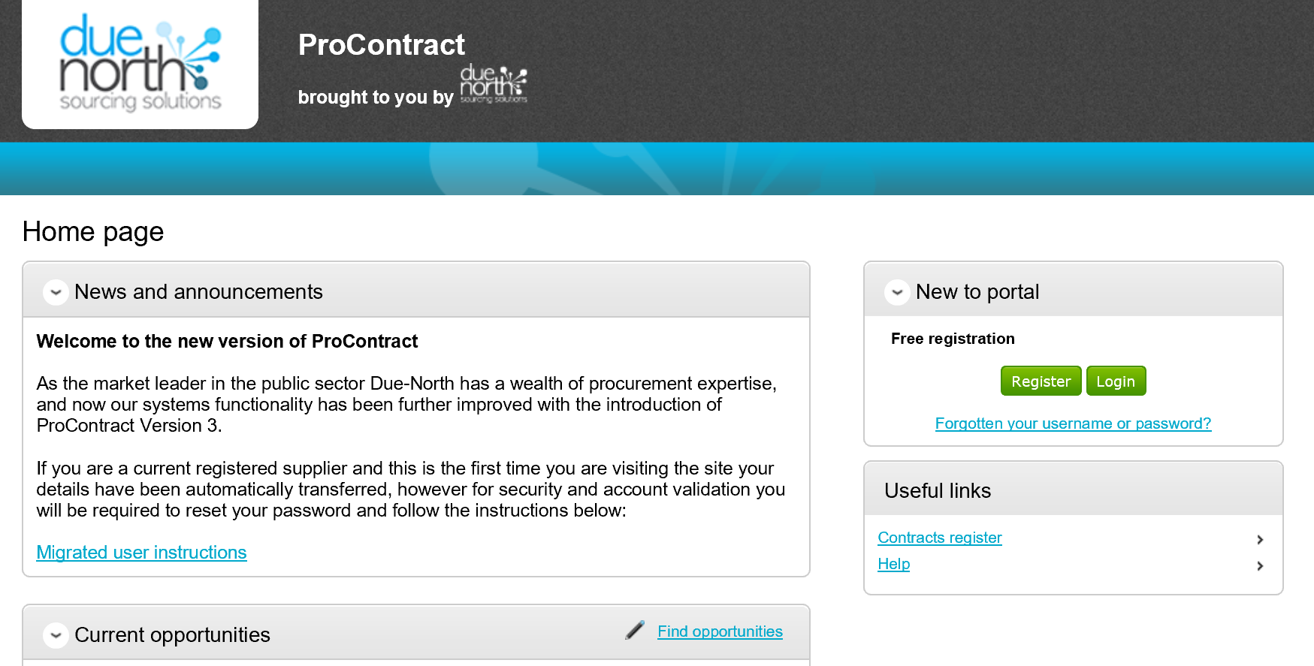

- Click on “Register”
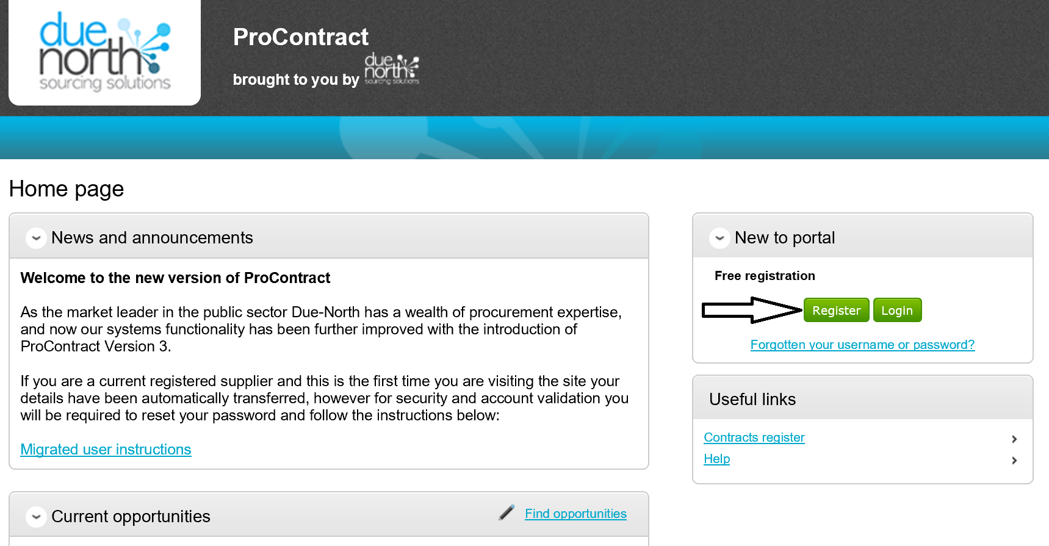

- Complete Registration form (1. Requirements – 5. Confirmation)
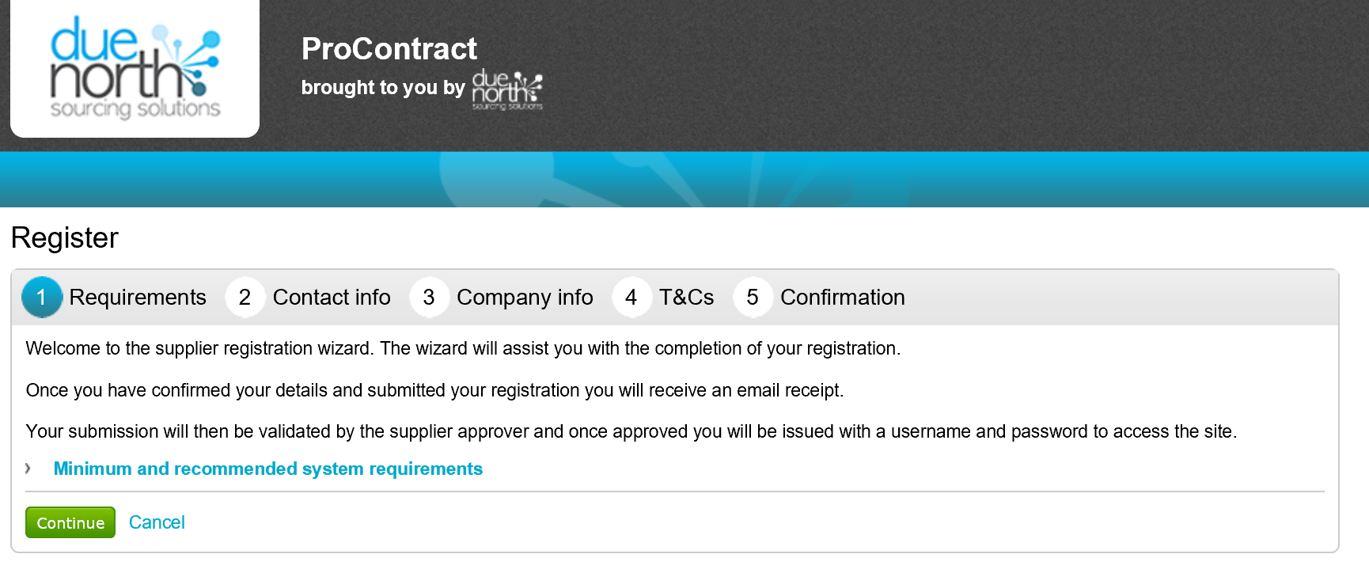
- Conclude Registration form and click on “Submit Registration).
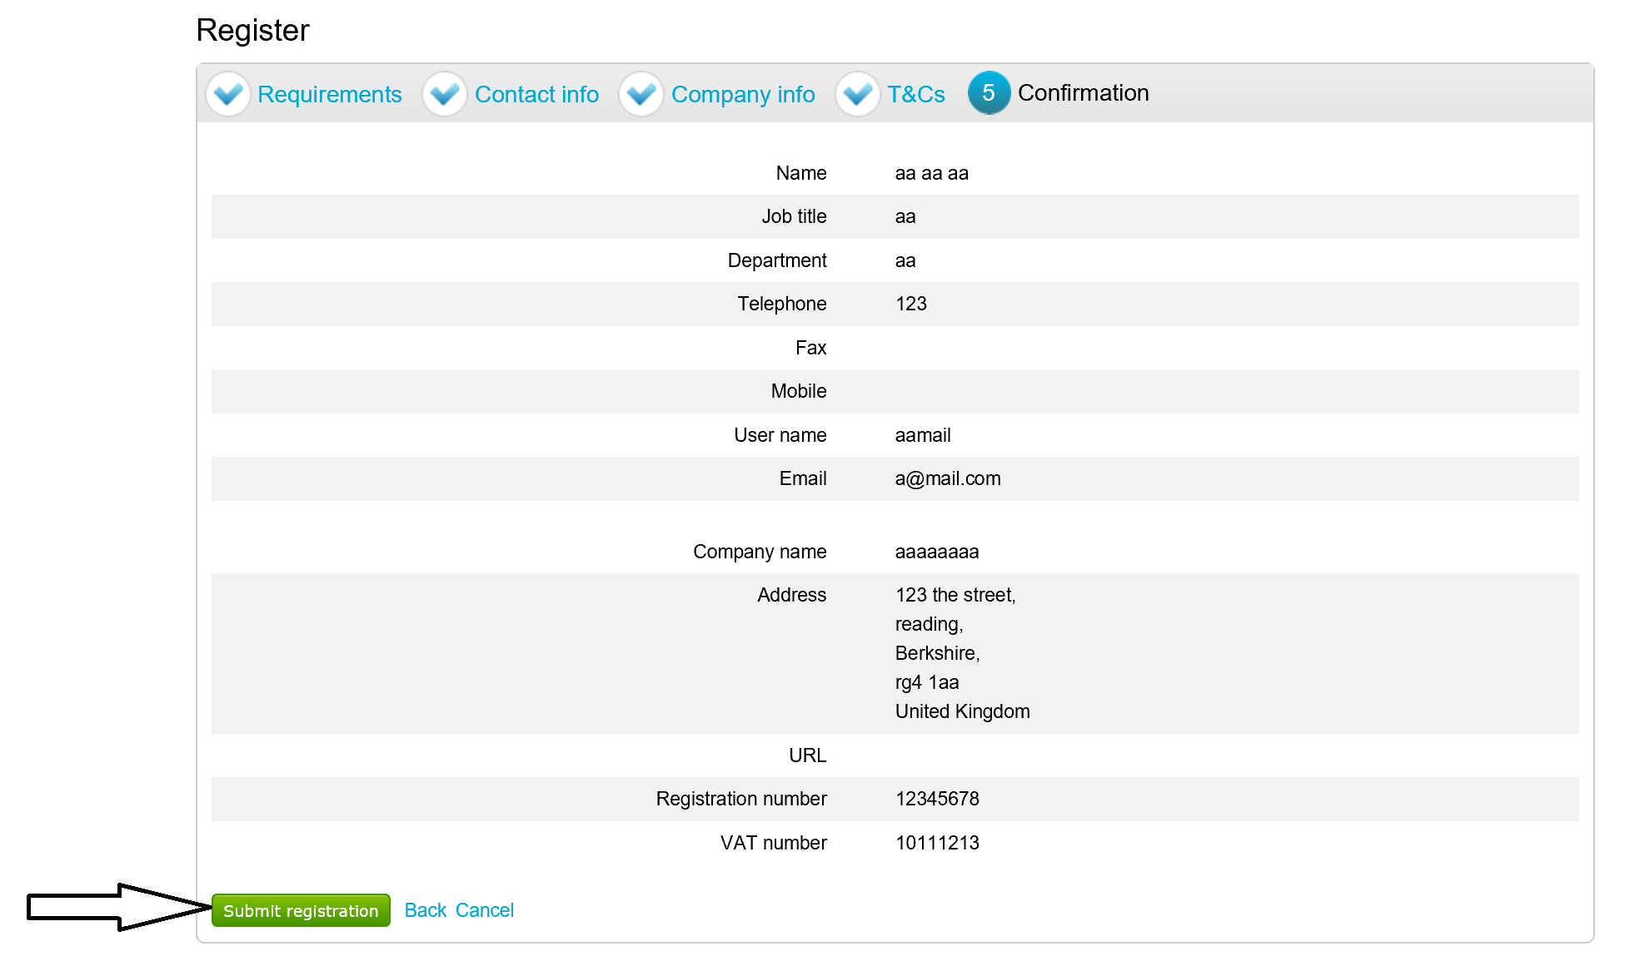

- You will receive an email confirmation upon completion. Once validated, you will receive a user name and password enabling access to the portal and view/access to procurement opportunities. In the event that you experience difficulties in completing the registration process, and/or your application is declined, please contact the supplier helpdesk on 01670 597136 (email: support@due-north.com)

London APMS GP Contracts Questionnaires

- Navigate to “Find Opportunities”

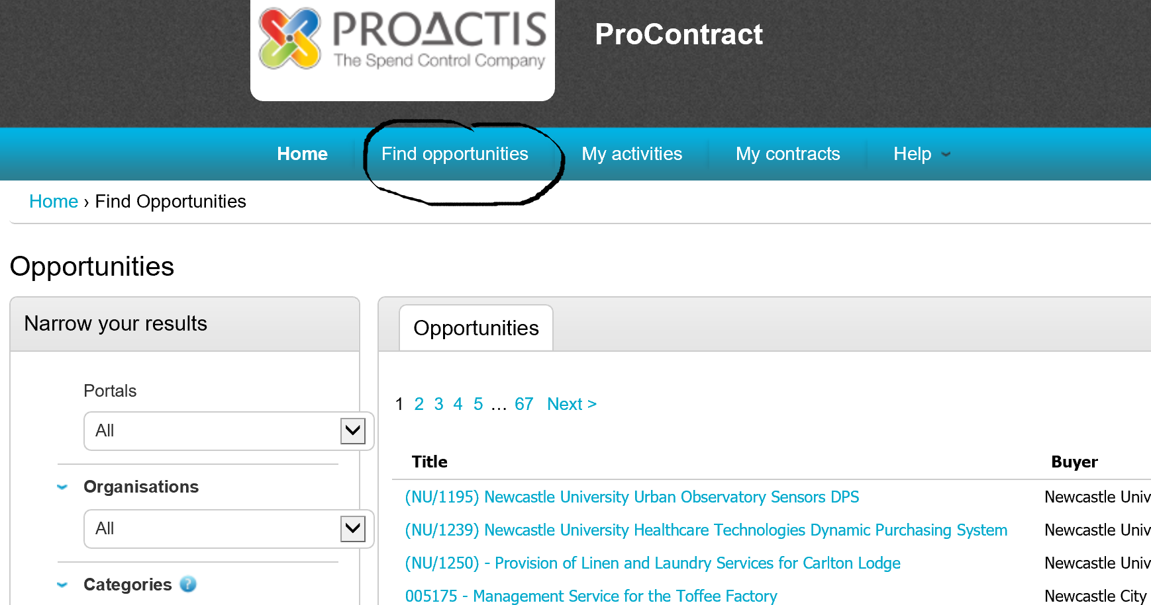

- Type “London” and “APMS” into the keywords area. Click on “Update” button. Opportunity will appear under main menu (RTL057P – London APMS GP Contracts (T5)

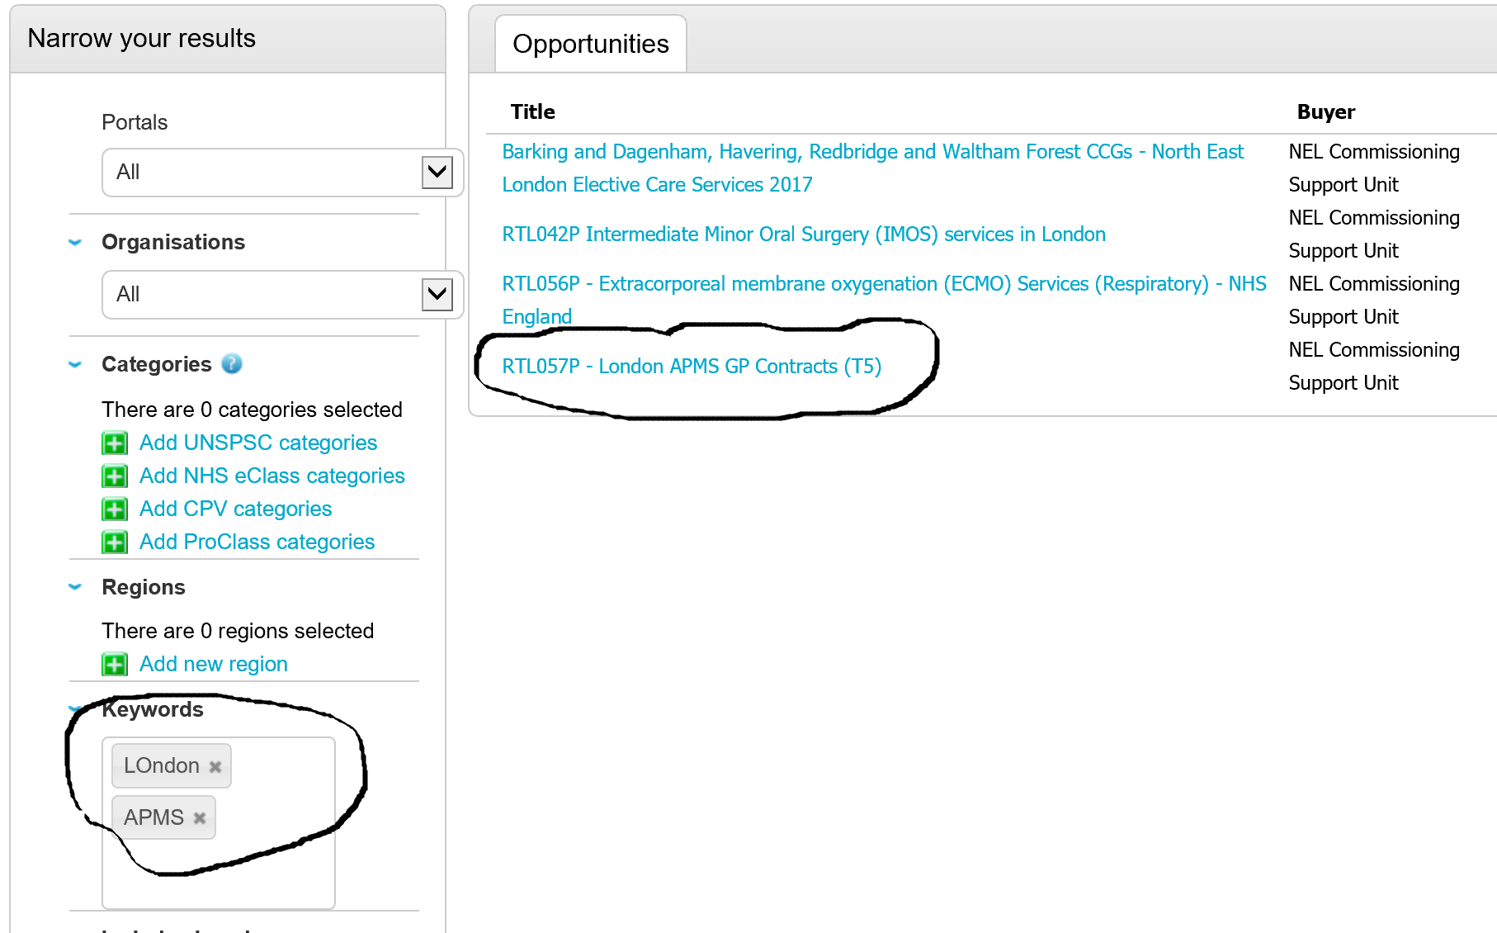

- Click on link (RTL057P – London APMS GP Contracts (T5). Then click on “Register interest in this opportunity”

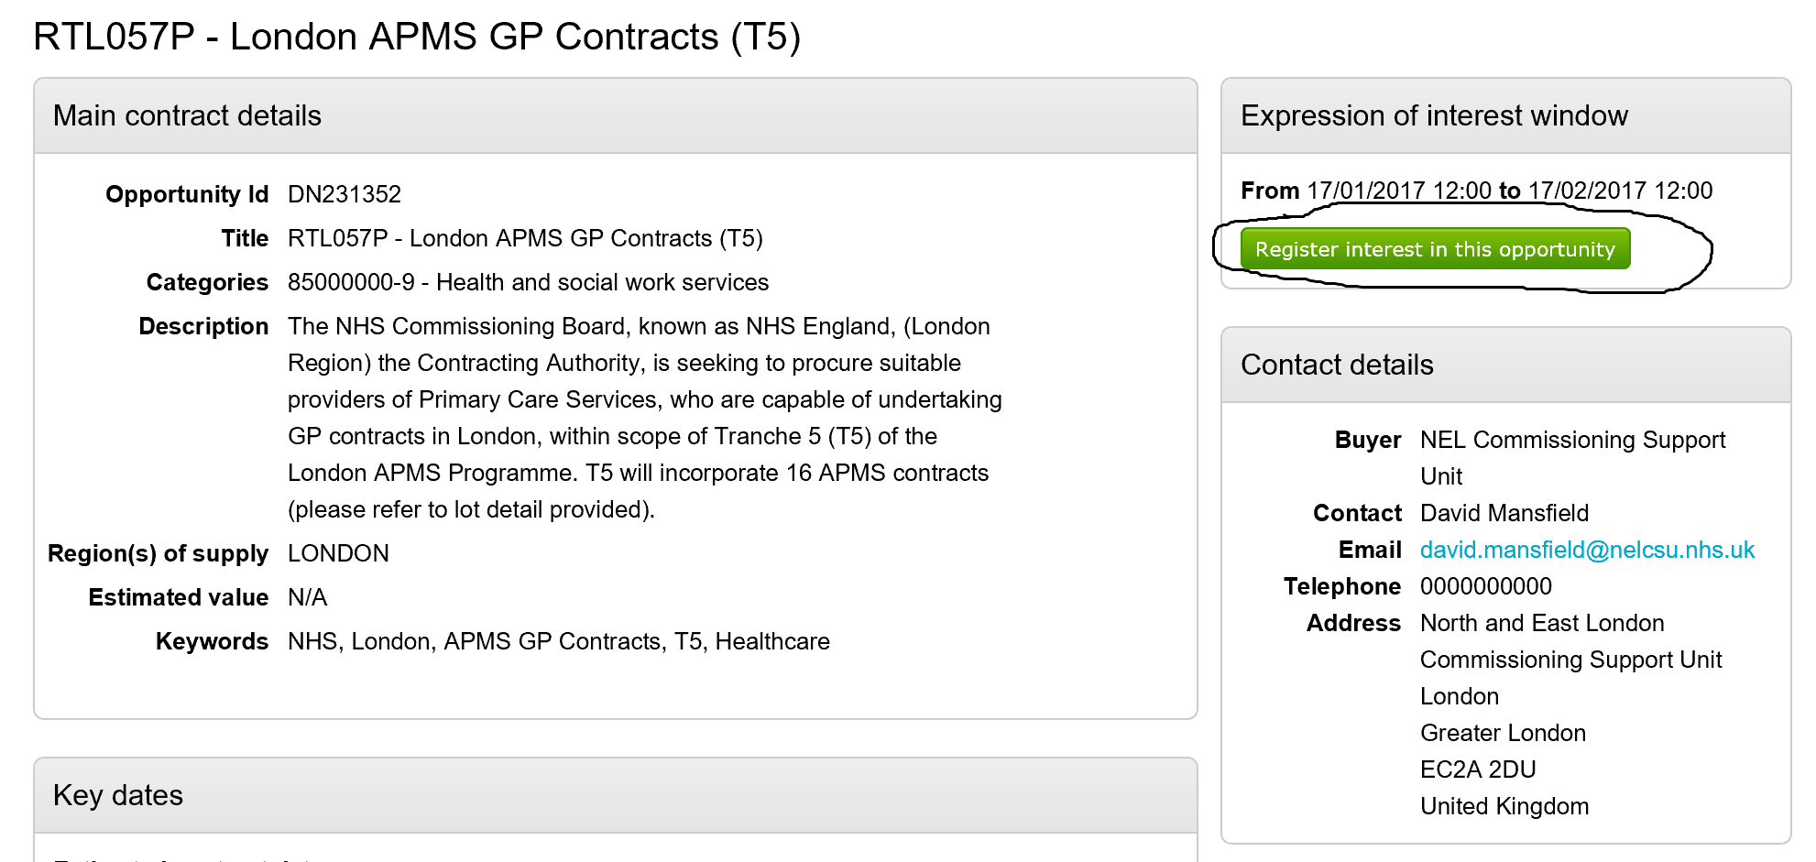

- Click on “Home”. Then place tick in box next to NEL Commissioning Support Unit, and click on “update” (under My activities)

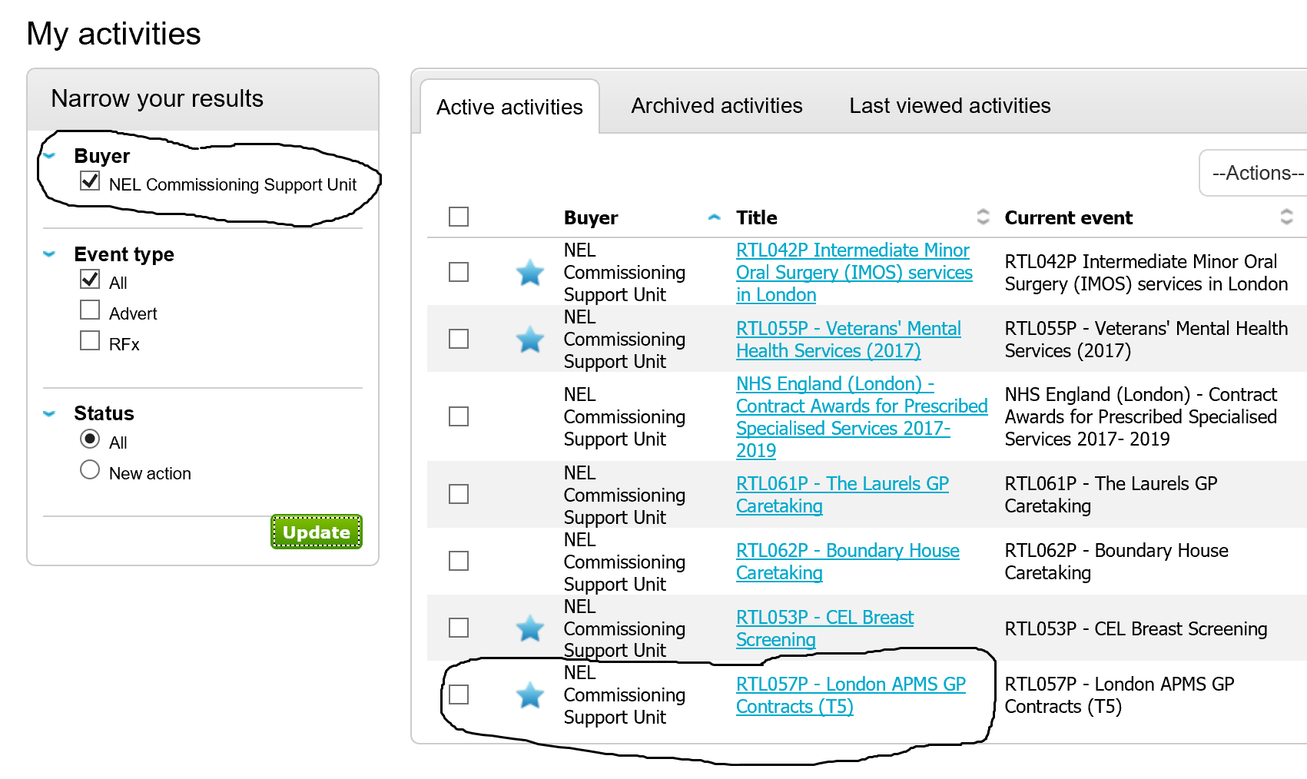

- Click on link (RTL057P – London APMS GP Contracts (T5). Note, “expression of Interest” will indicate “accepted”. Click on “Start”

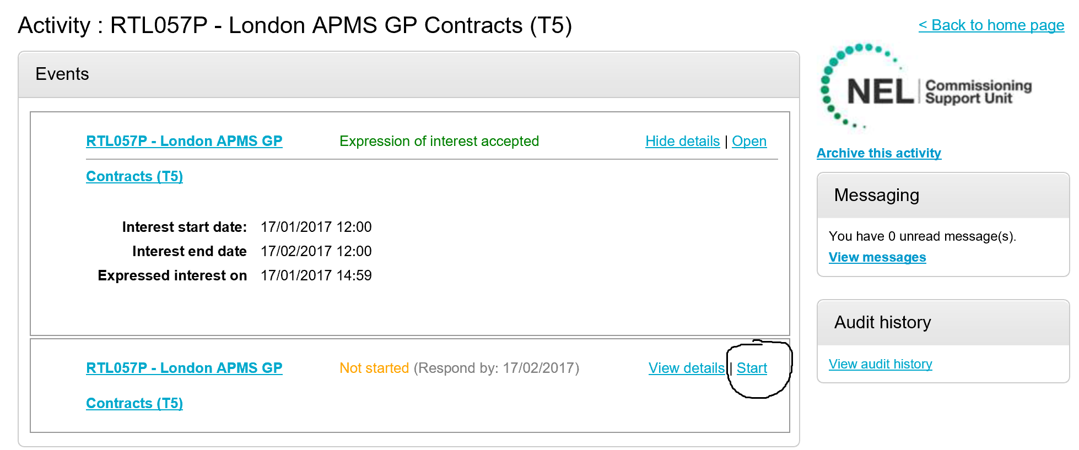

- Click on “start my response”. Note access to documentation under “Attachments”

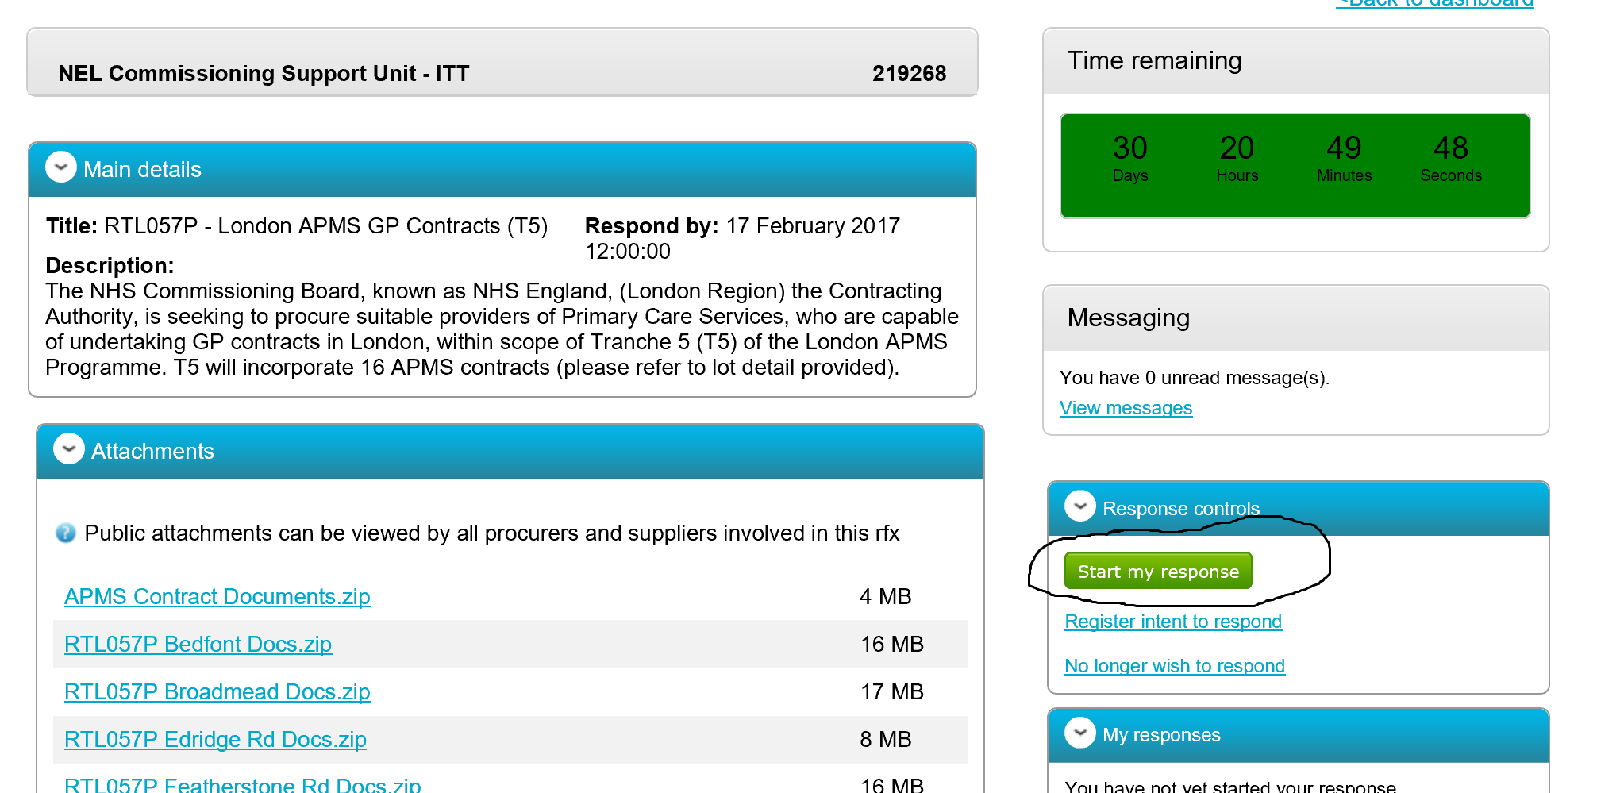

- Proceed through “Create ITT response” screens. Click on “Continue” following completion of each screen

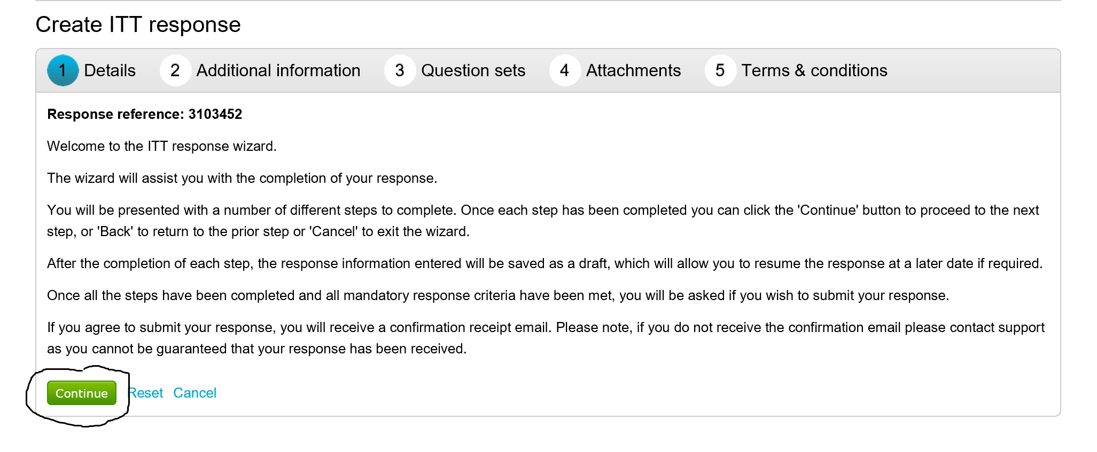

- Complete questionnaires within “Question sets” screen. You must complete one version of the “Initial Eligibility Questionnaire”, and one version of the “ITT Generic Questionnaire”. You only complete the “ITT Specific Questionnaires” for those practices wherein you intend to submit an ITT response. ie. If bidding for Bedfont Practice only, you are only required to complete the “ITT Specific Questionnaire” for Bedfont Practice. Note, the status bar will indicate how far you have progressed with your response, and when complete.

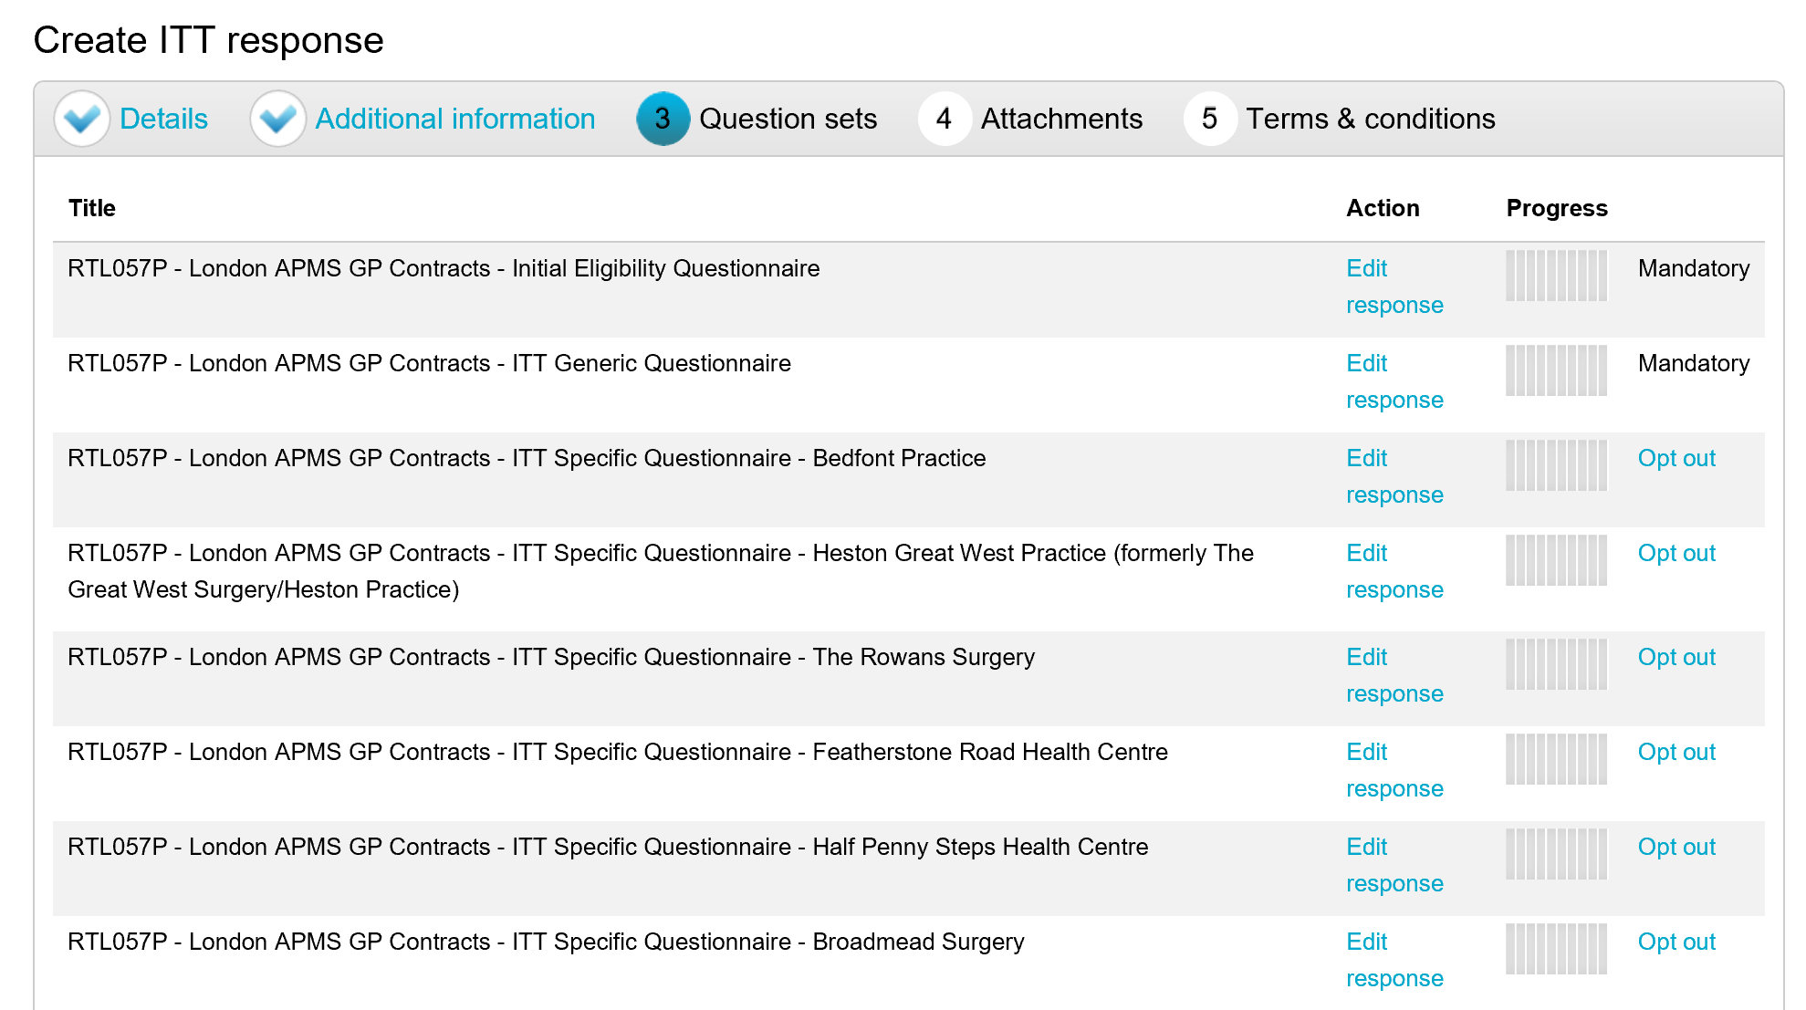

- When you have finished your ITT response, click on “continue”. Proceed to the “Terms & Conditions” tab, and click on “Accept”, then “Finish”. You have now completed your ITT response

