westsussex.gov.uk

Document 2B

SUBWAY PUMPS, SUBWAY LOCATION DETAILS

Provision of Services for the Maintenance of Pump Equipment on Highway Drainage Assets

January 2025

© West Sussex County Council

Contents

Page

2 Holm Farm
4 Hole Street
6 Crawley Avenue
8 Ifield Road
10 Bewbush
12 Seymour Road
14 Breezehurst Drive
18 Wickhurst Lane
20 Lewes Road
23 Rock Common
25 Chapel Road
27 Northgate
29 Leisure Centre
31 Church Path
33 Mile Oak
35 Ferry Footbridge
38 East Wolves Roundabout
40 St. Augustines Close

1300 – Holm Farm
Location: Crawley Road Eastbound, RH12 4SE Parish: Colgate
Easting: 522,970 Northing: 134,484
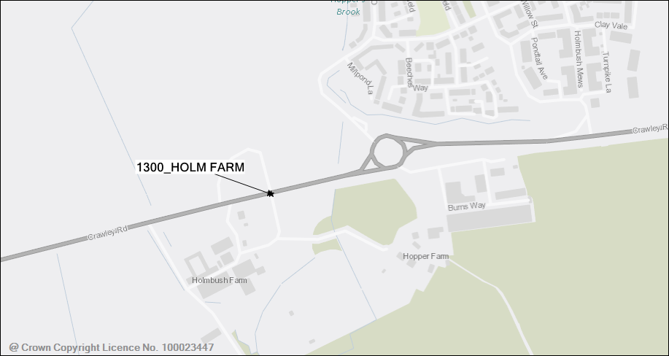
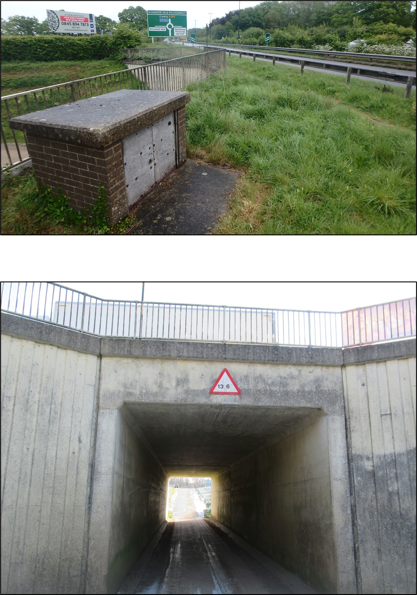

1599 – Hole Street
Location: Dumbrells Farm Way, RH20 3DE Parish: Ashington
Easting: 513,231 Northing: 115,542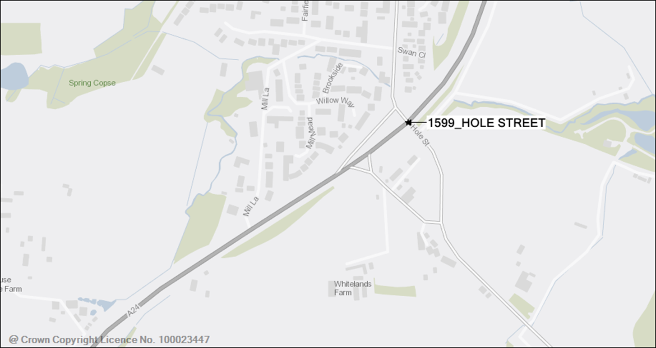
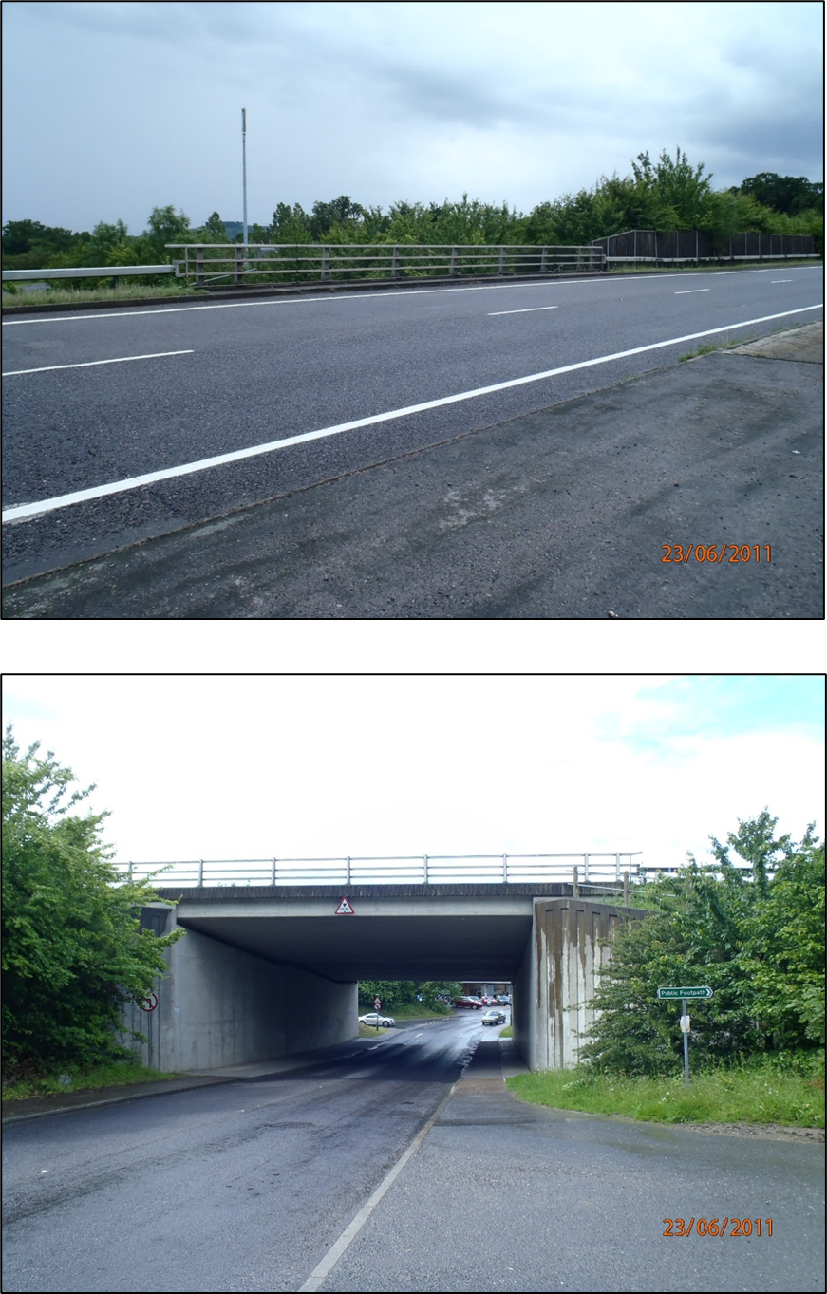

2006 – Crawley Avenue Subway
Location: Crawley Avenue, RH11 8QQ Parish: Crawley
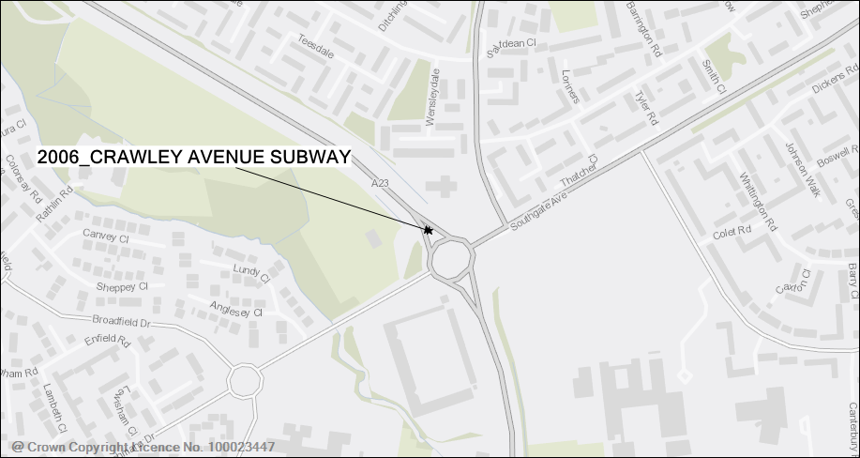
Easting: 526,490 Northing: 135,105
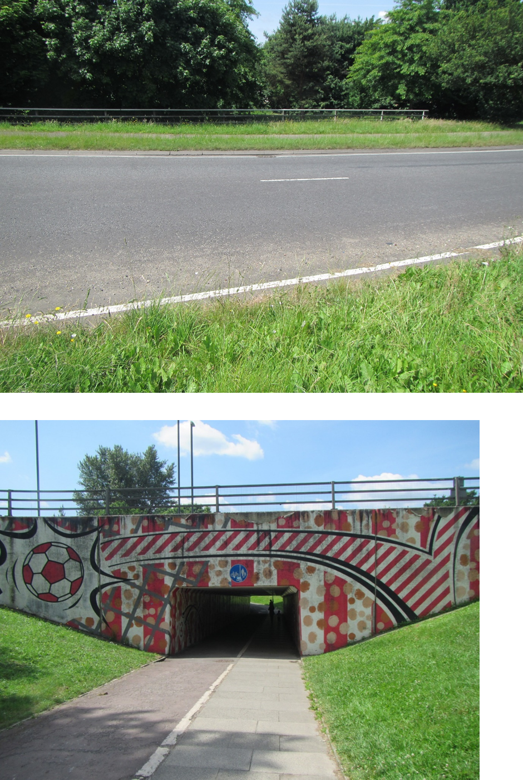

2008 – Ifield Road Subway
Location: Crawley Avenue, RH11 0AQ Parish: Crawley
Easting: 525,732 Northing: 137,185
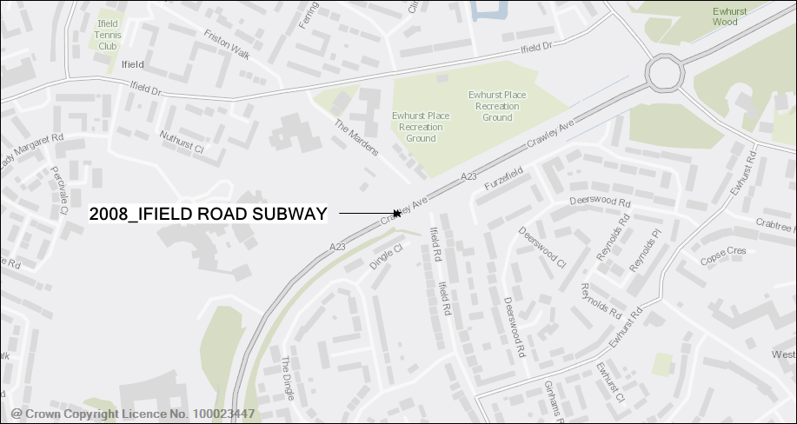
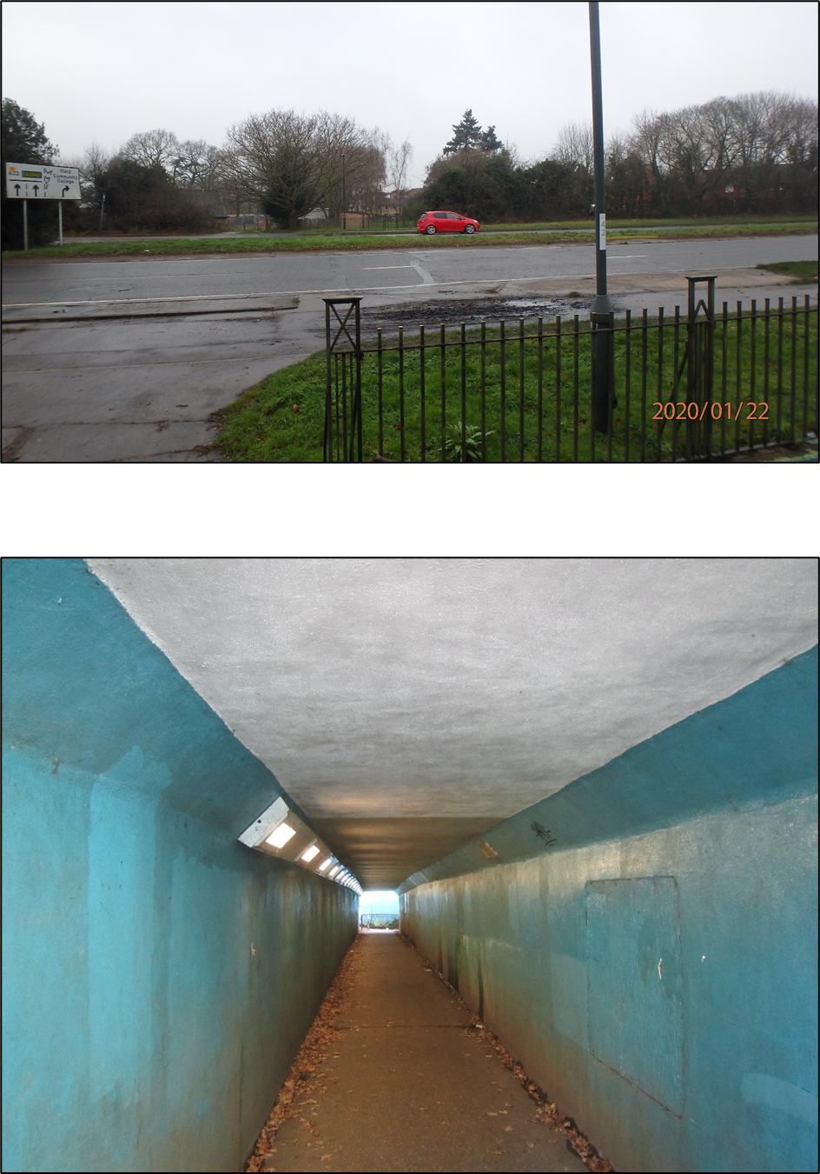

2009 – Bewbush Subway
Location: Horsham Road, RH11 9EJ Parish: Crawley
Easting: 525,333 Northing: 135,079
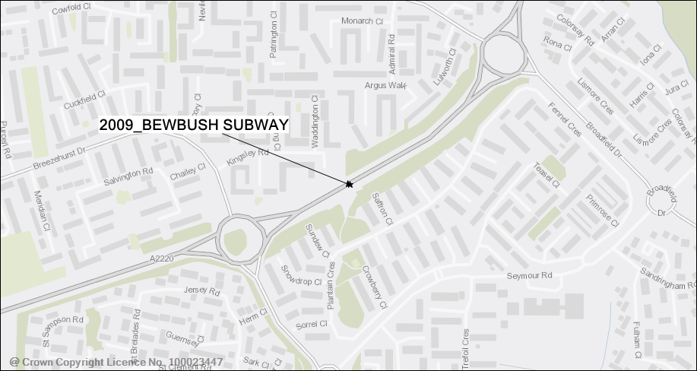
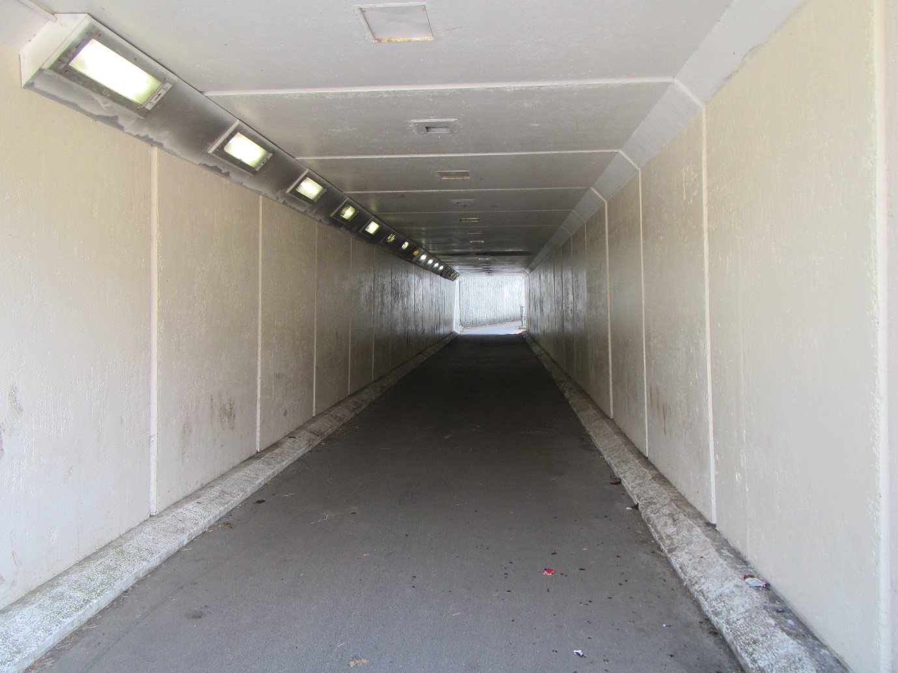
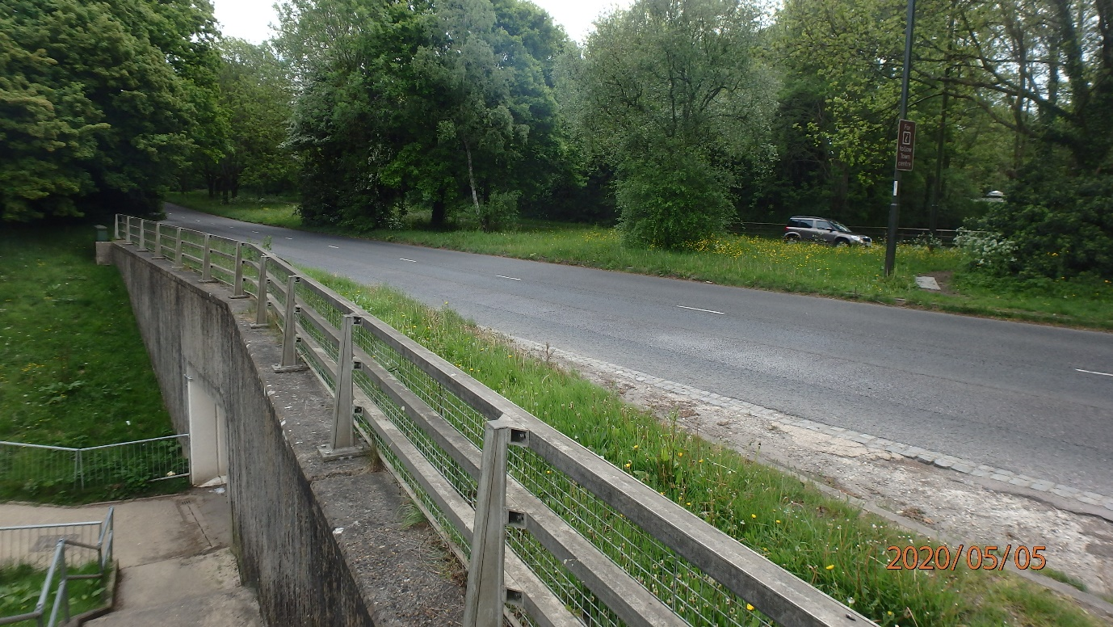

2012 – Seymour Road Subways
Location: Rathlin Road Roundabout, RH11 9PY Parish: Crawley
Easting: 525,875 Northing: 135,052
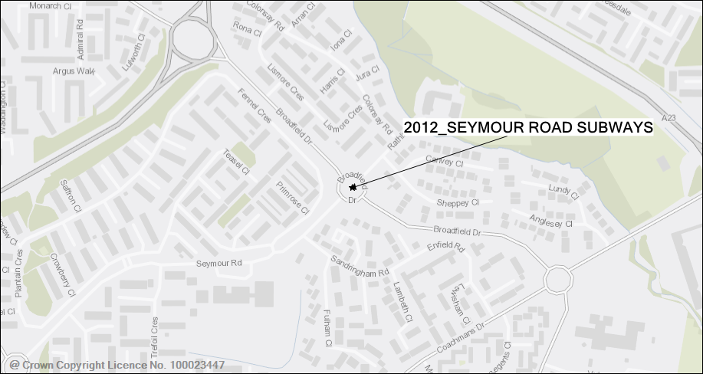
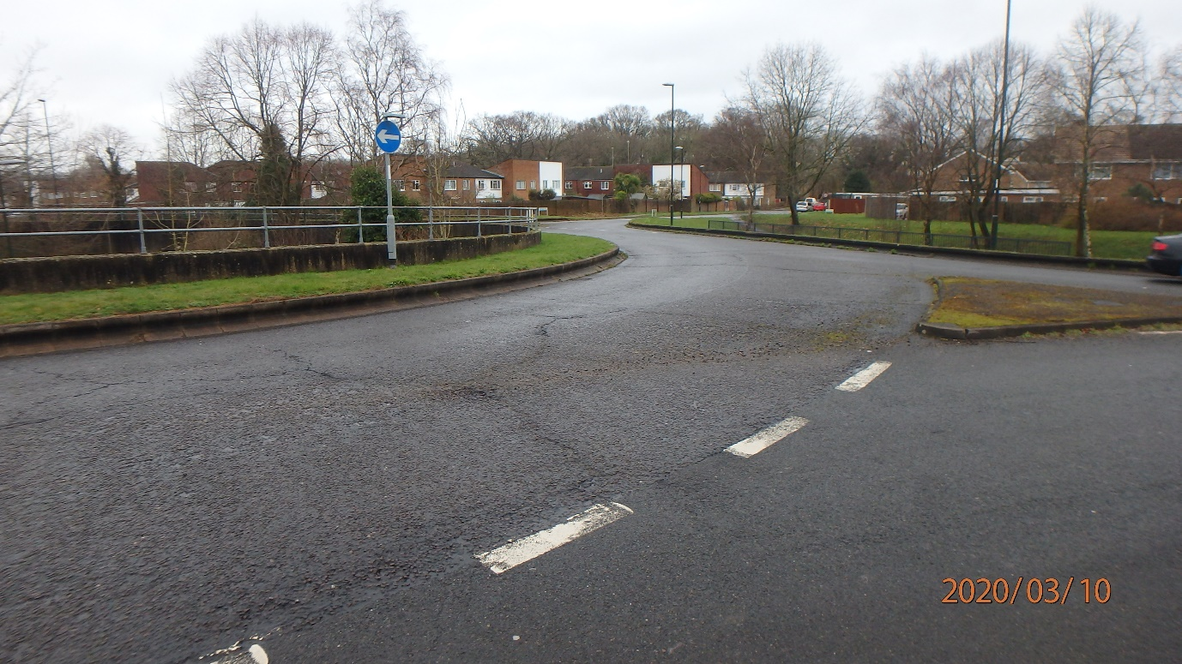
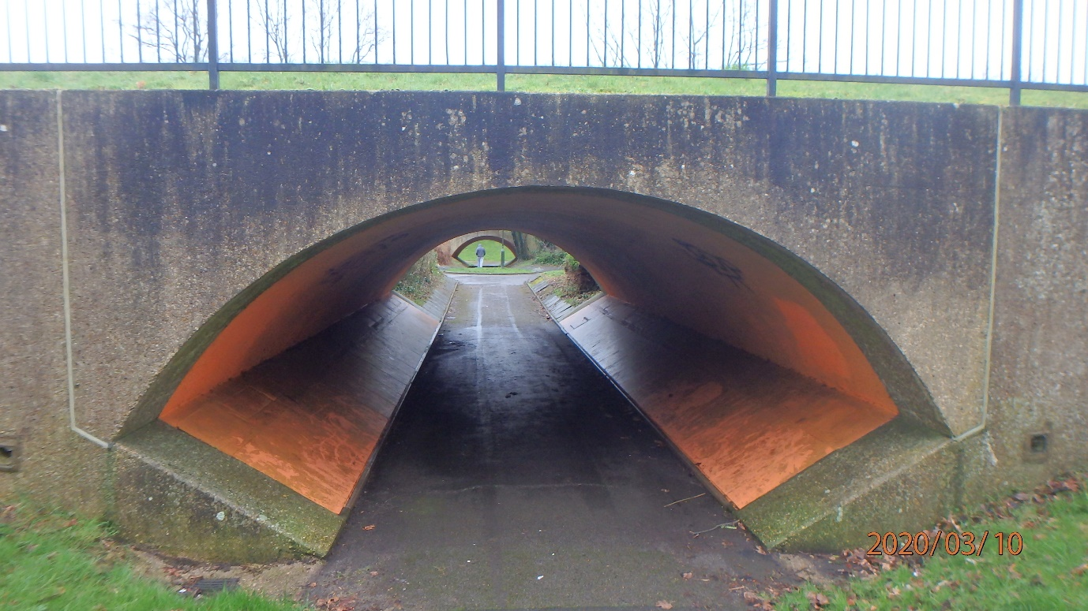

2020 – Breezehurst Drive Subways
Location: Breezehurst Drive Roundabout, RH11 8YH Parish: Crawley
Easting: 524,450 Northing: 135,240
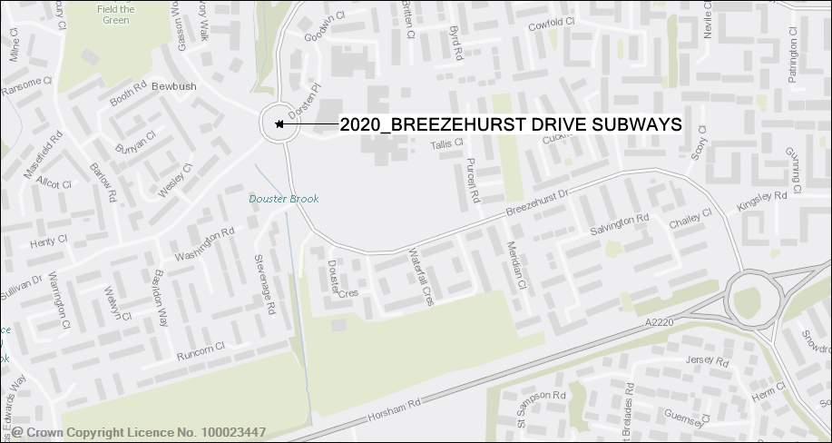

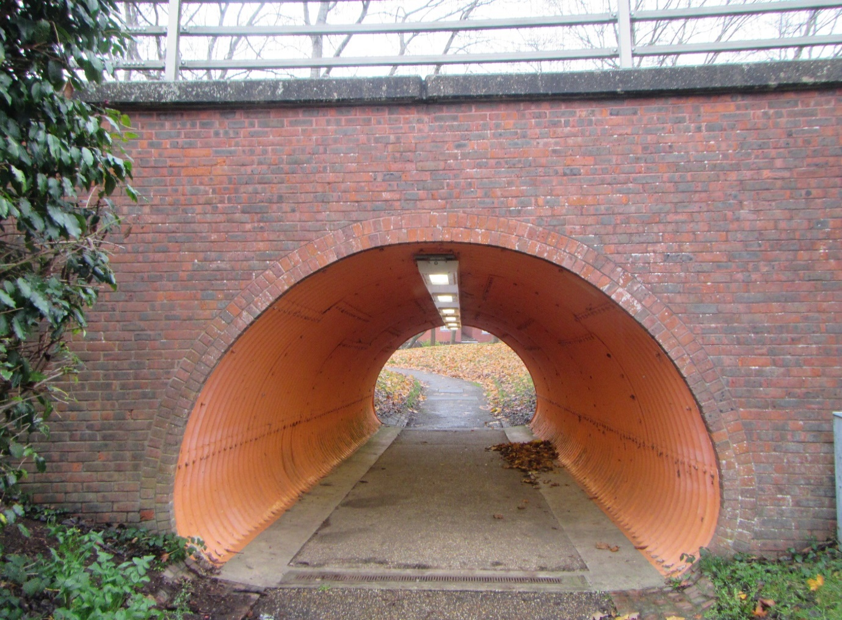
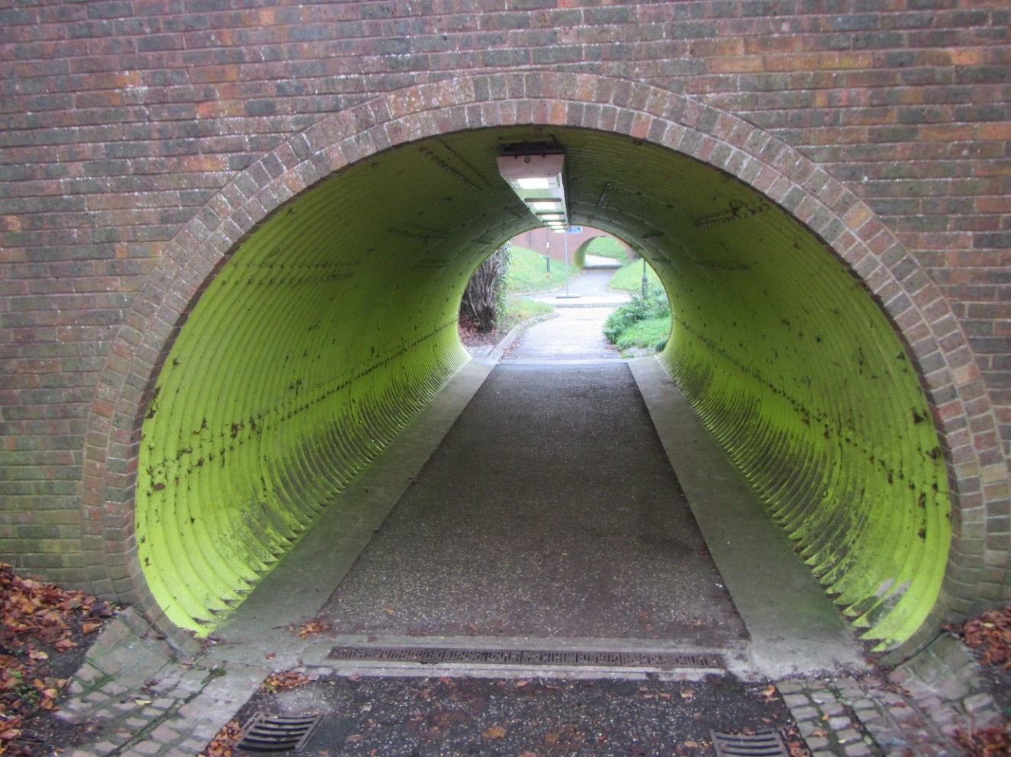

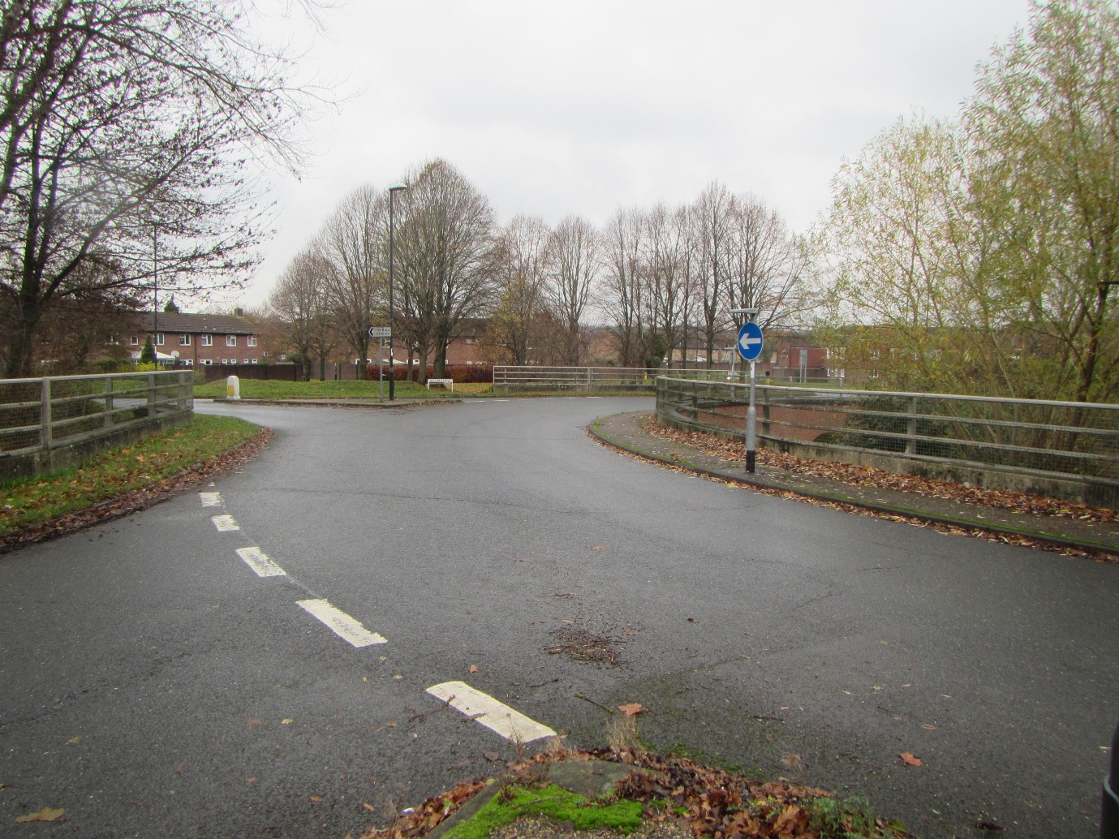

2021 – Wickhurst Lane Subway
Location: Upper Broadbridge Heath Bypass Eastbound, RH12 3LE
Parish: Broadbridge Heath. Easting: 515,049 Northing: 131,069
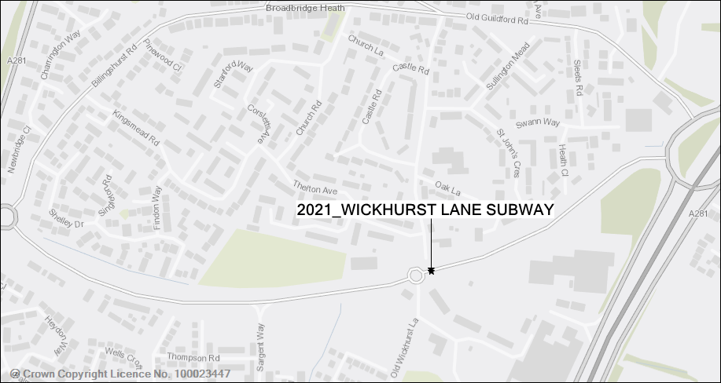
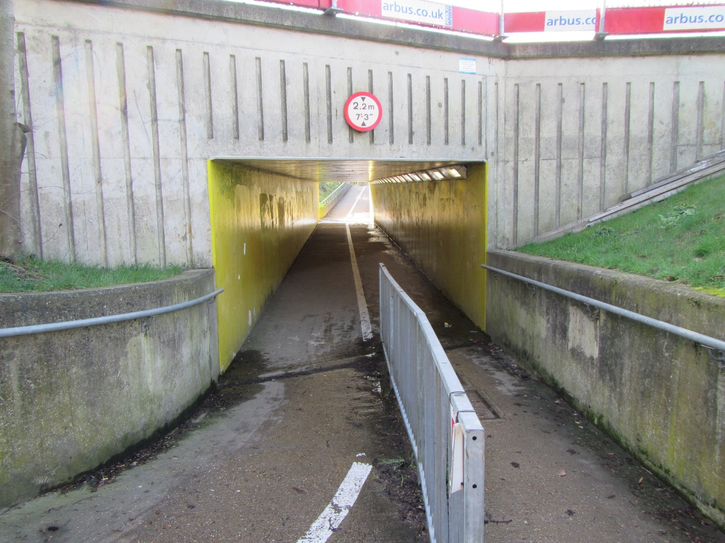
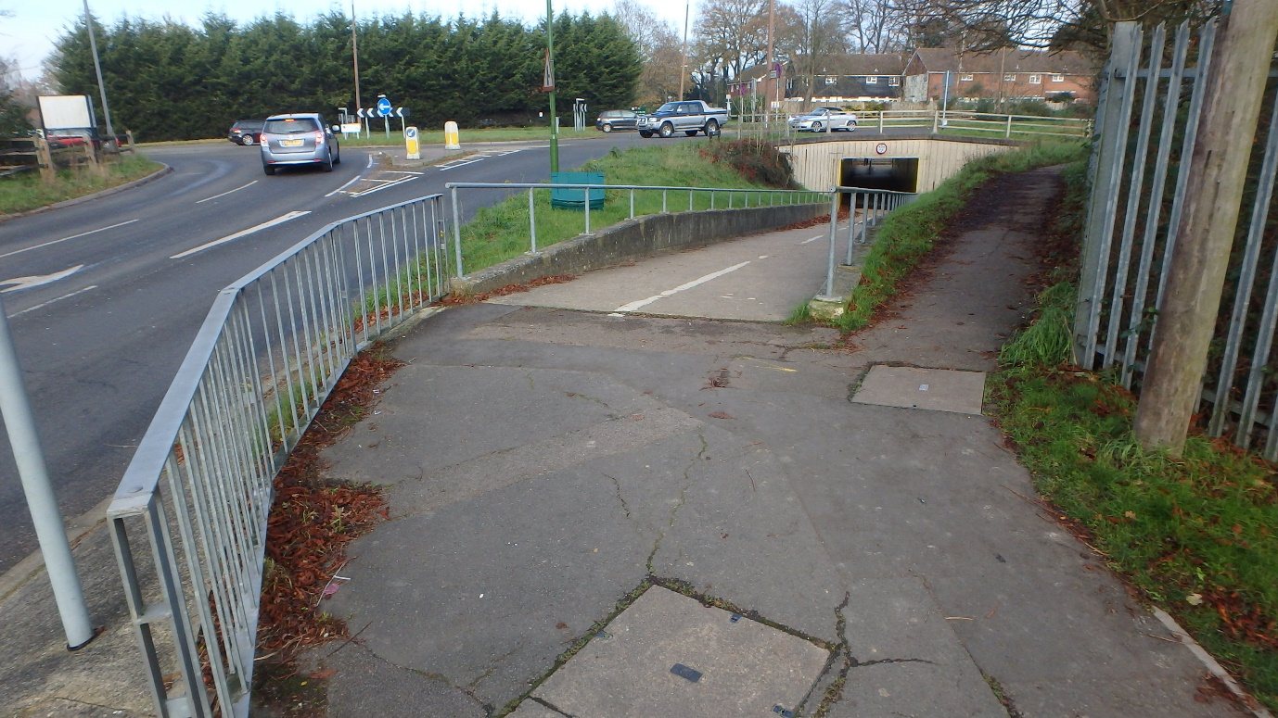

2022 – Lewes Road Subway
Location: Lewes Road, RH19 3HA Parish: East Grinstead
Easting: 540,132 Northing: 137,929
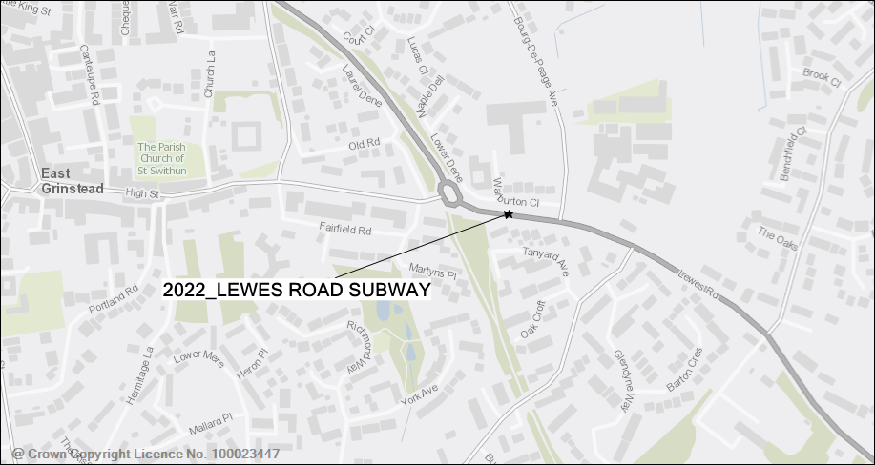
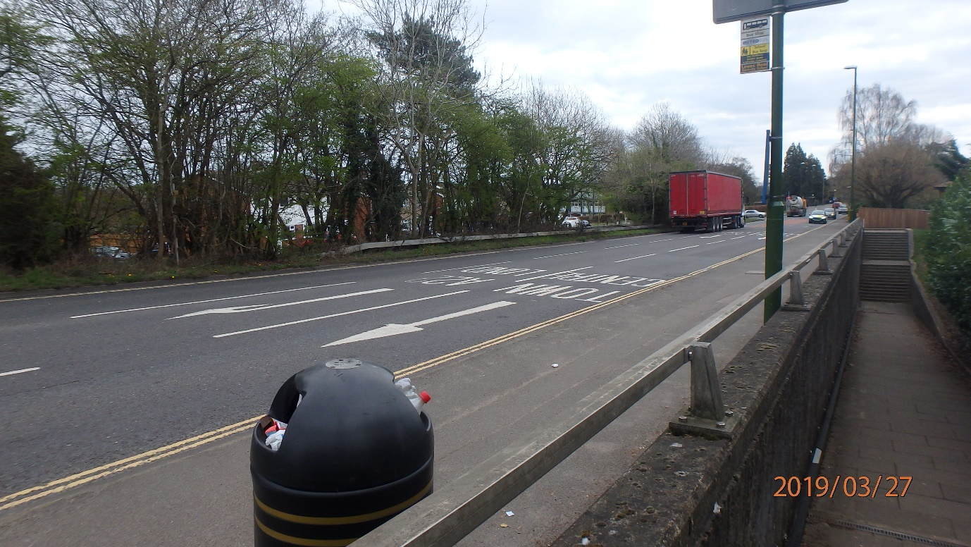
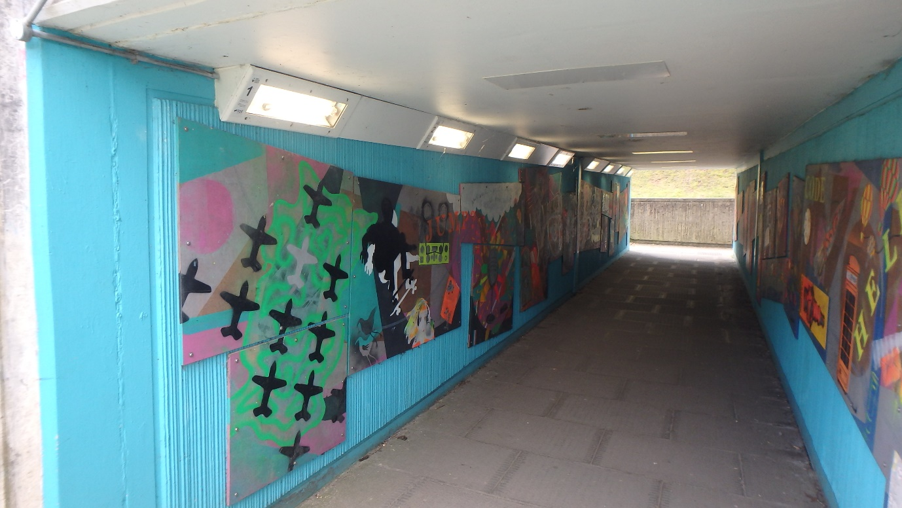

2024 – Rock Common Subway
Location: London Road Northbound, RH20 4TD Parish: Washington
Easting: 512,114 Northing: 113,530
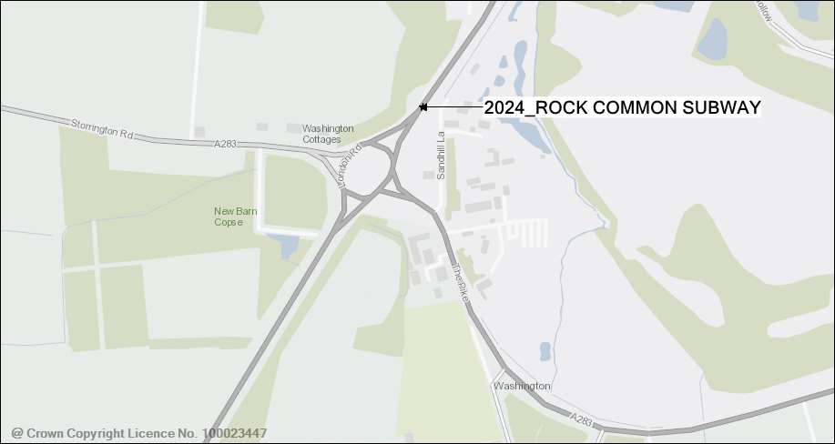
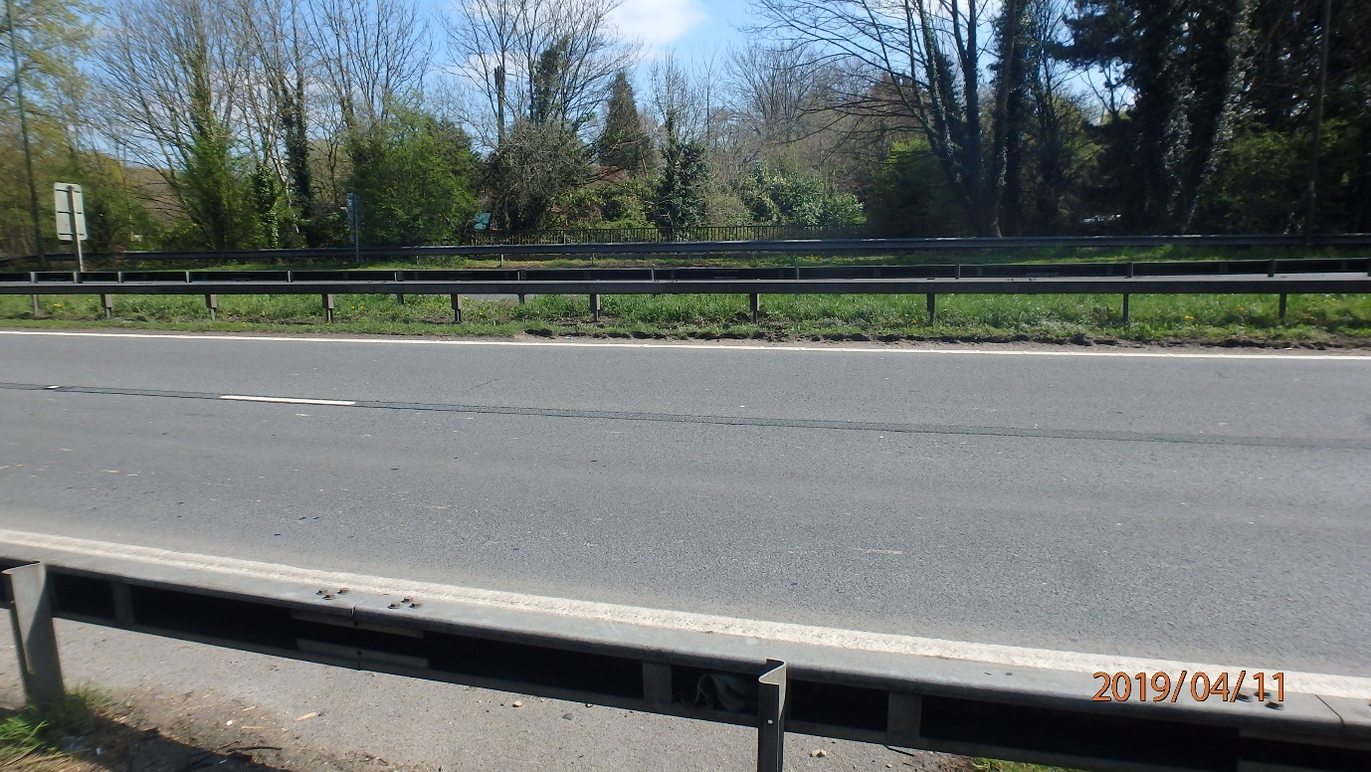
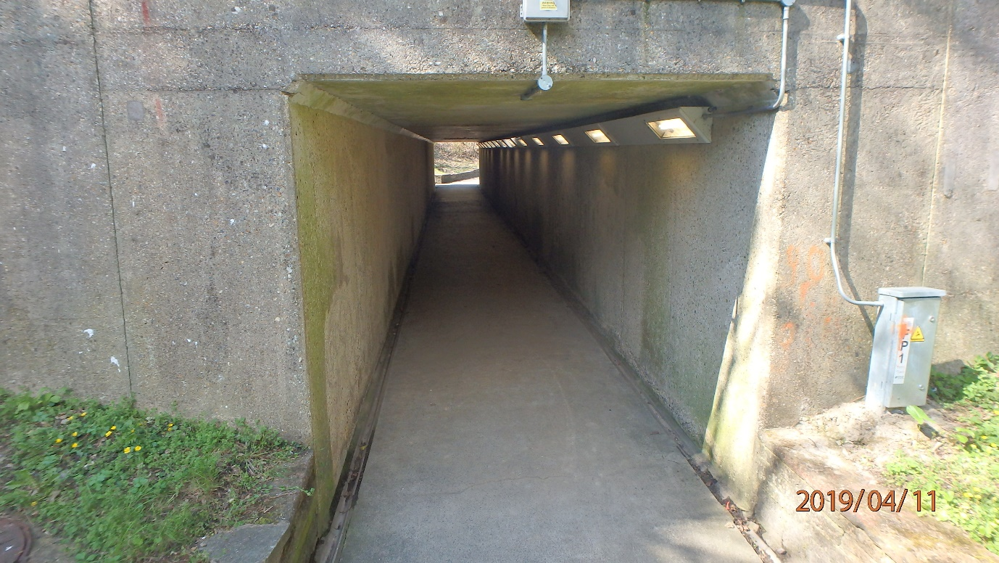

2025 – Chapel Road Subway
Location: Chapel Road, BN11 1BN Parish: Worthing
Easting: 514,810 Northing: 103,060
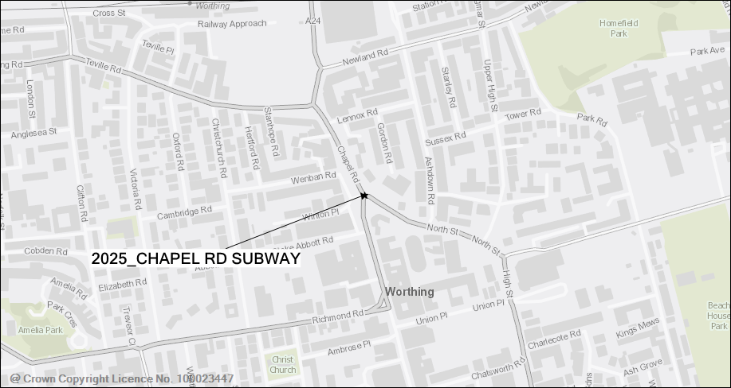
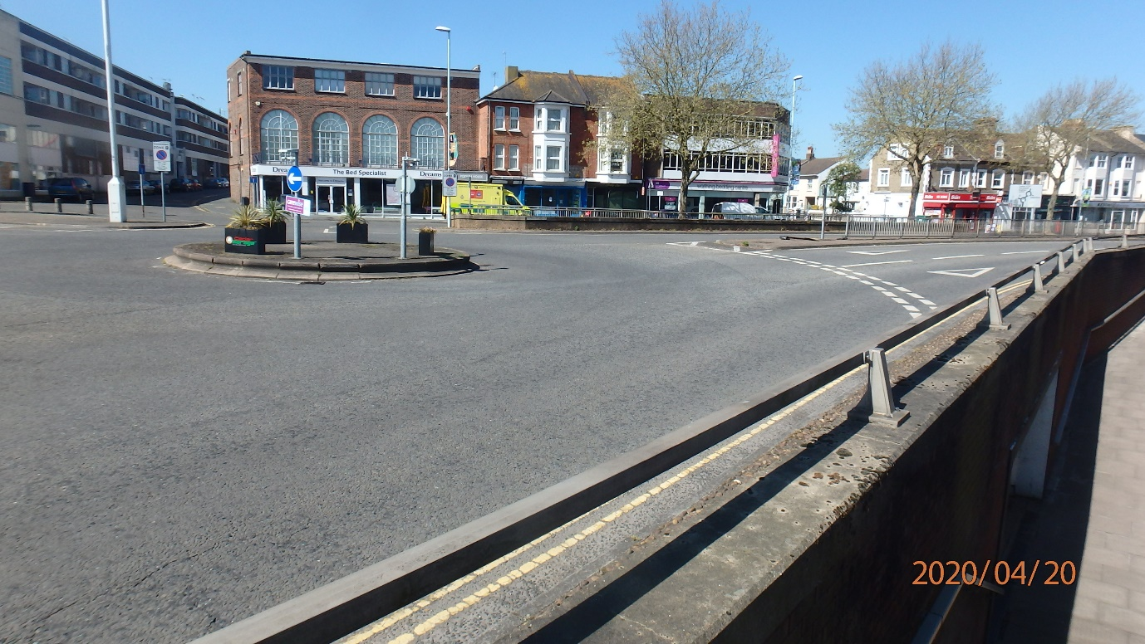
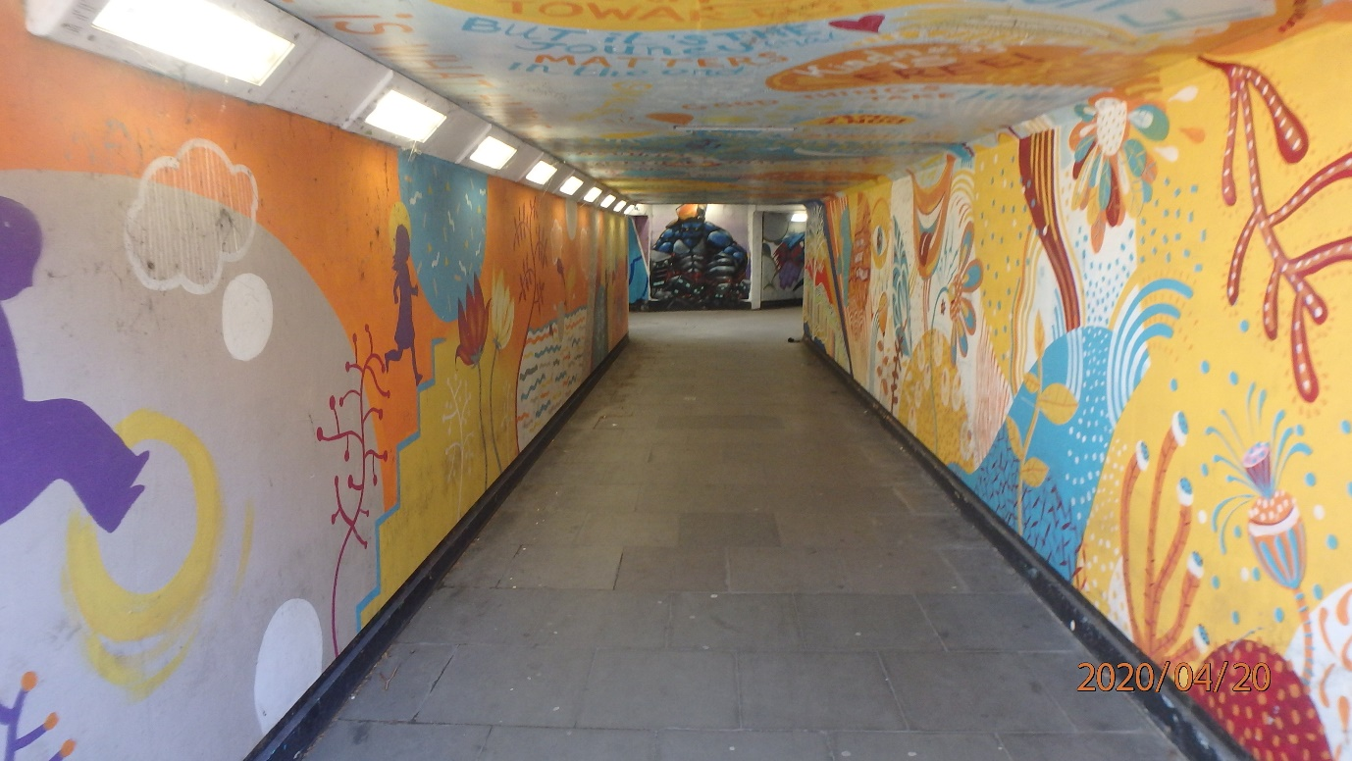

2026 – Northgate Subway
Location: Oaklands Way, PO19 6AR Parish: Chichester
Easting: 486,148 Northing: 105,284
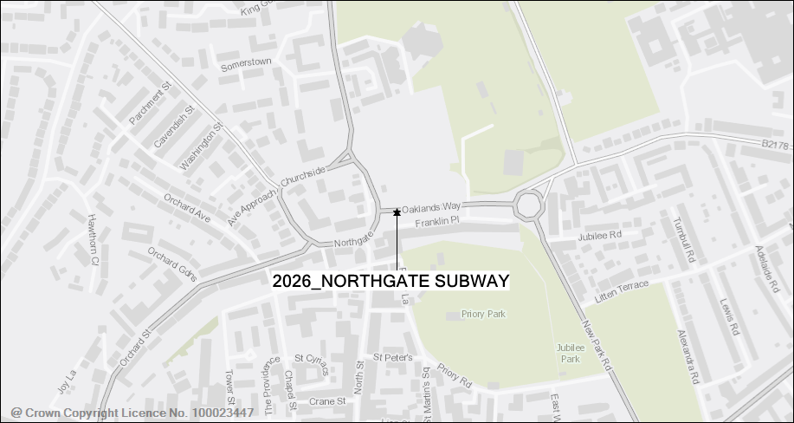
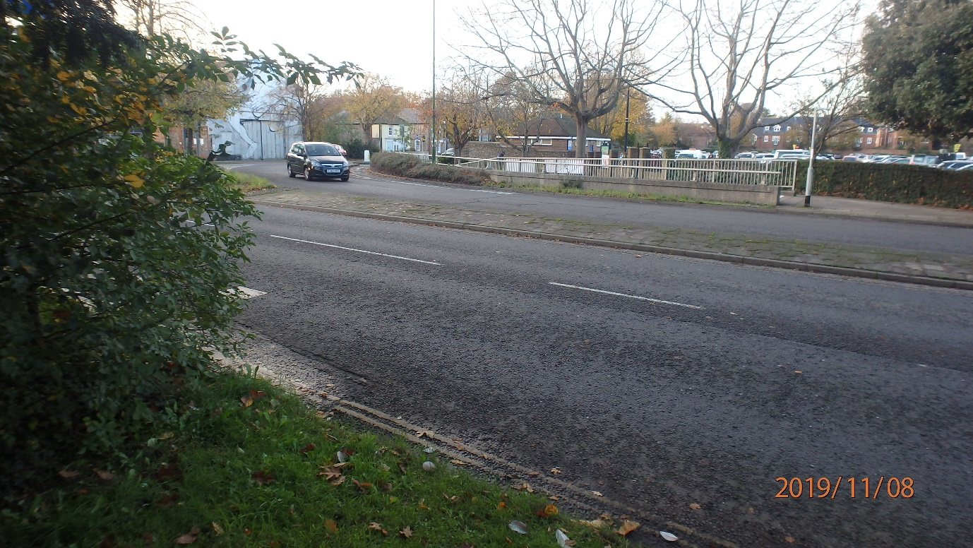
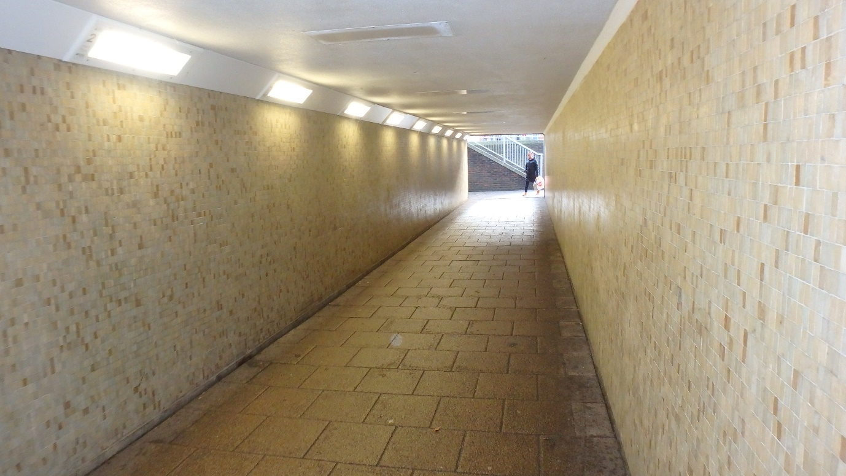

2029 – Leisure Centre Subway
Location: Via Ravenna, PO19 1RD Parish: Chichester
Easting: 485,705 Northing: 104,440
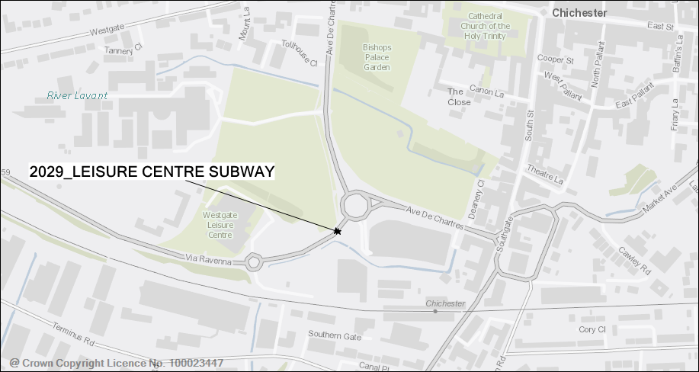
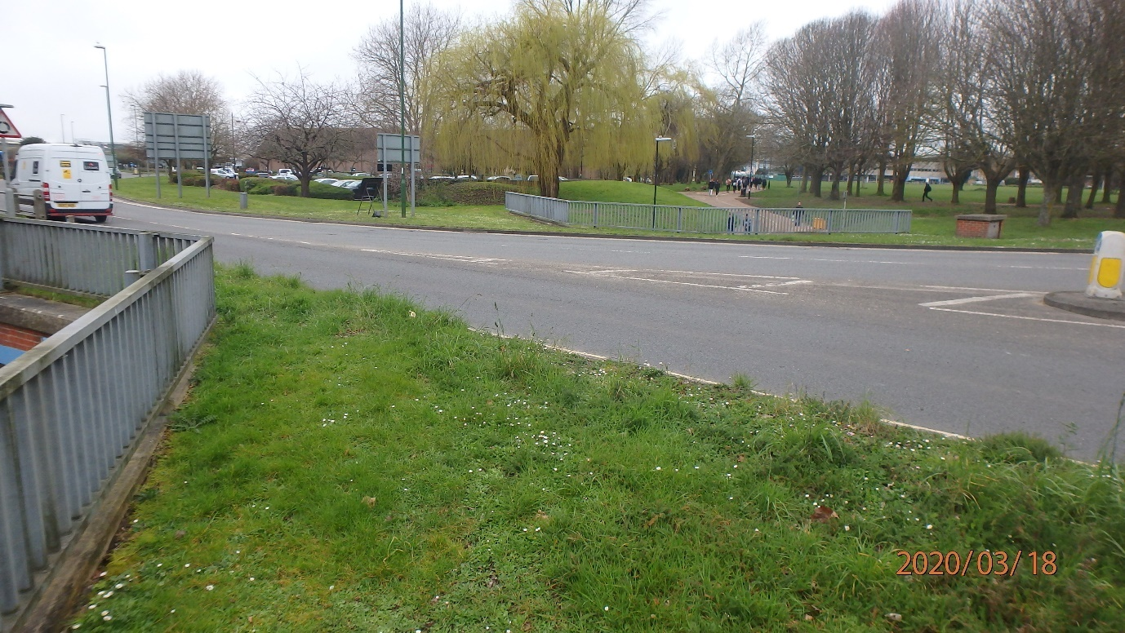
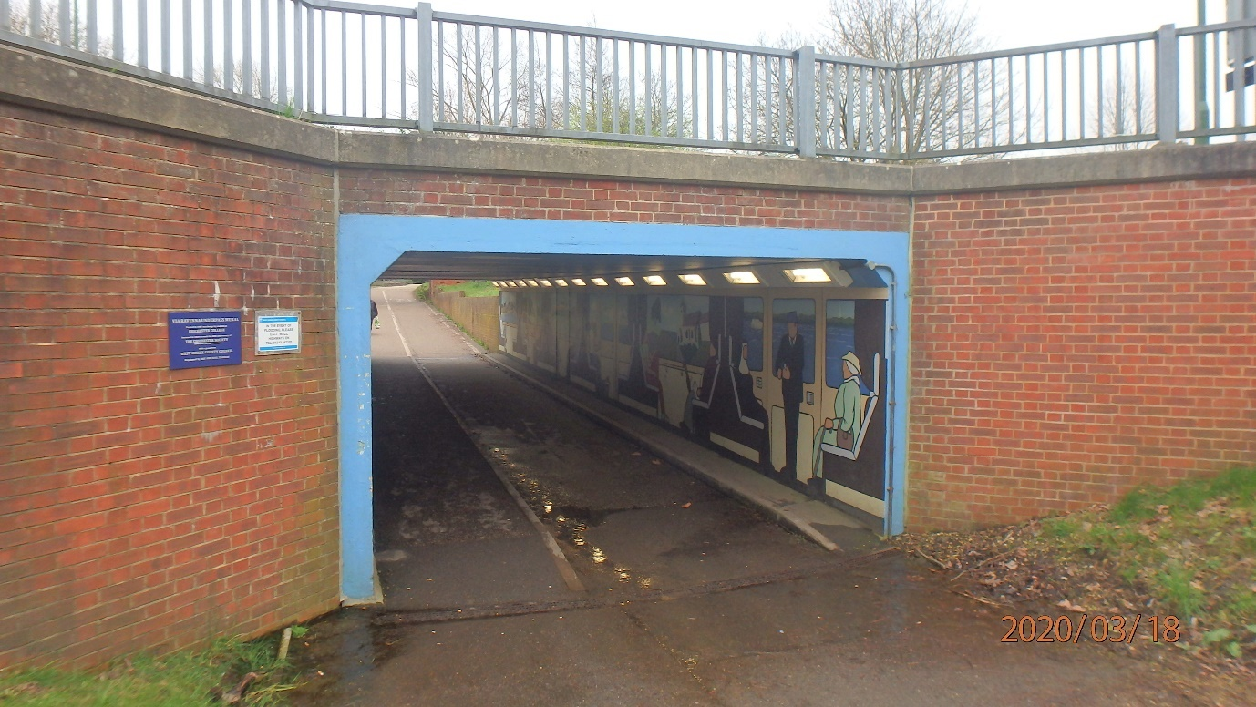

2030 – Church Path Subway
Location: Hotham Way Eastbound, PO21 1FG Parish: Bognor Regis
Easting: 493,806 Northing: 99,712
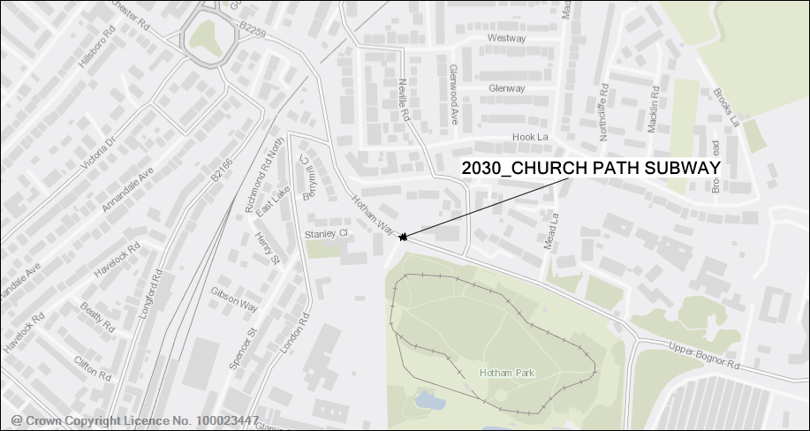
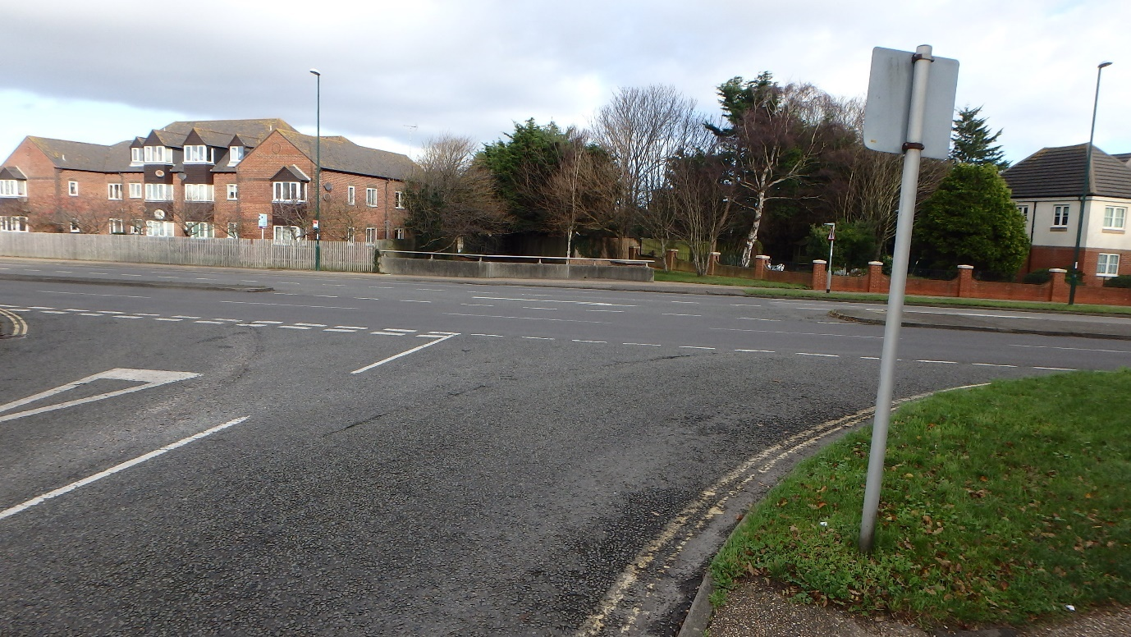
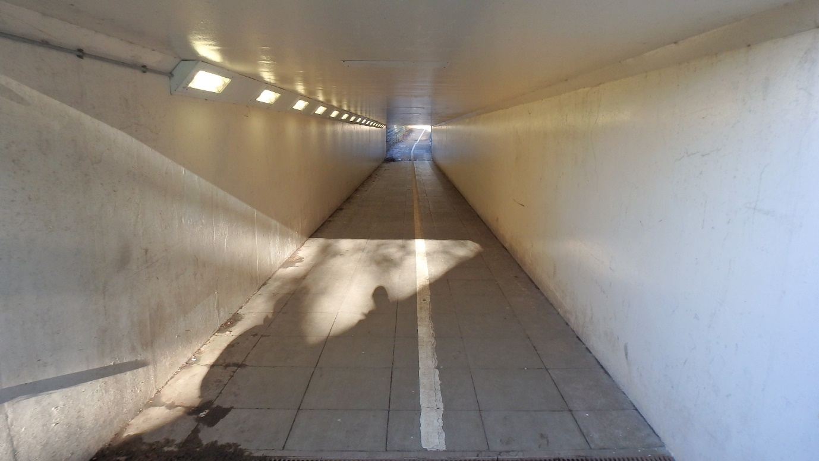

2033 – Mile Oak Subway
Location: Old Shoreham Road, BN42 4JD Parish: Shoreham/Southwick
Easting: 524,565 Northing: 105,986
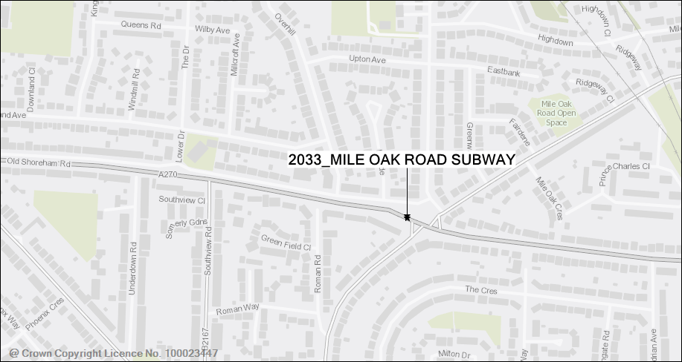
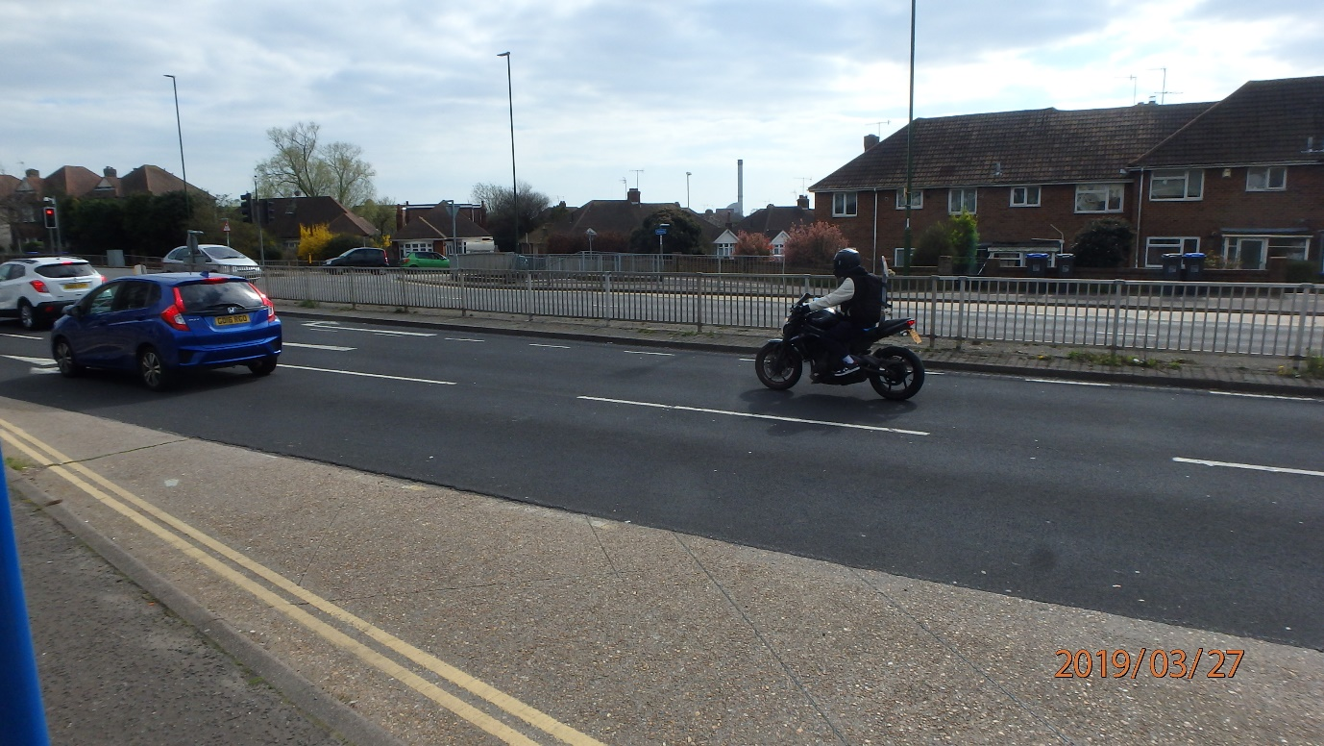
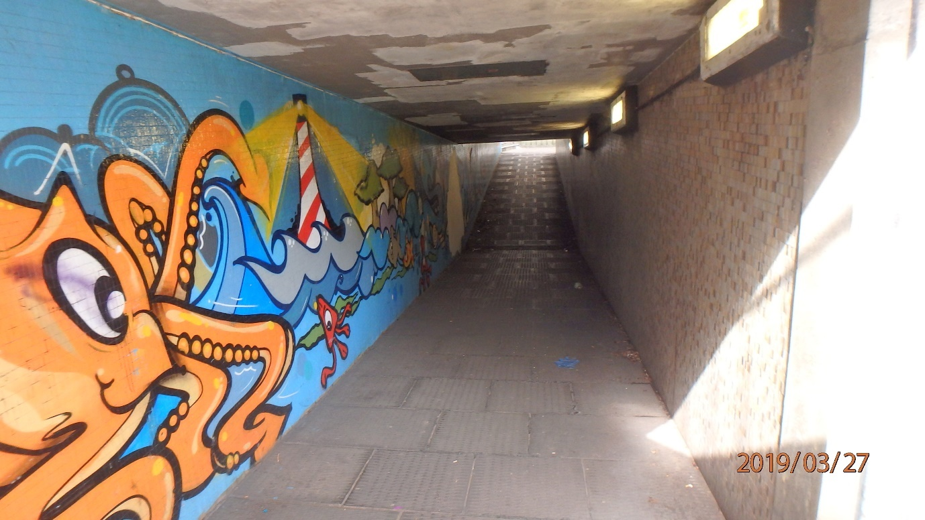

3031 Ferry Footbridge
Location: Wharf Road to Ferry Road, BN17 5DD Parish: Littlehampton
Easting: 502,240 Northing: 102,180
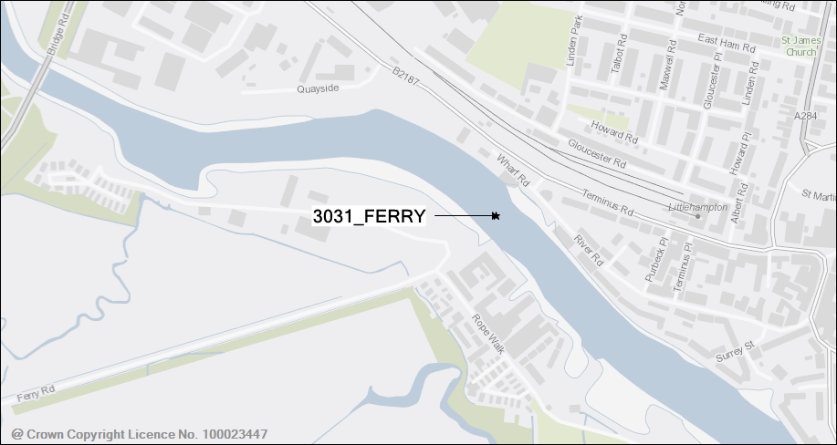
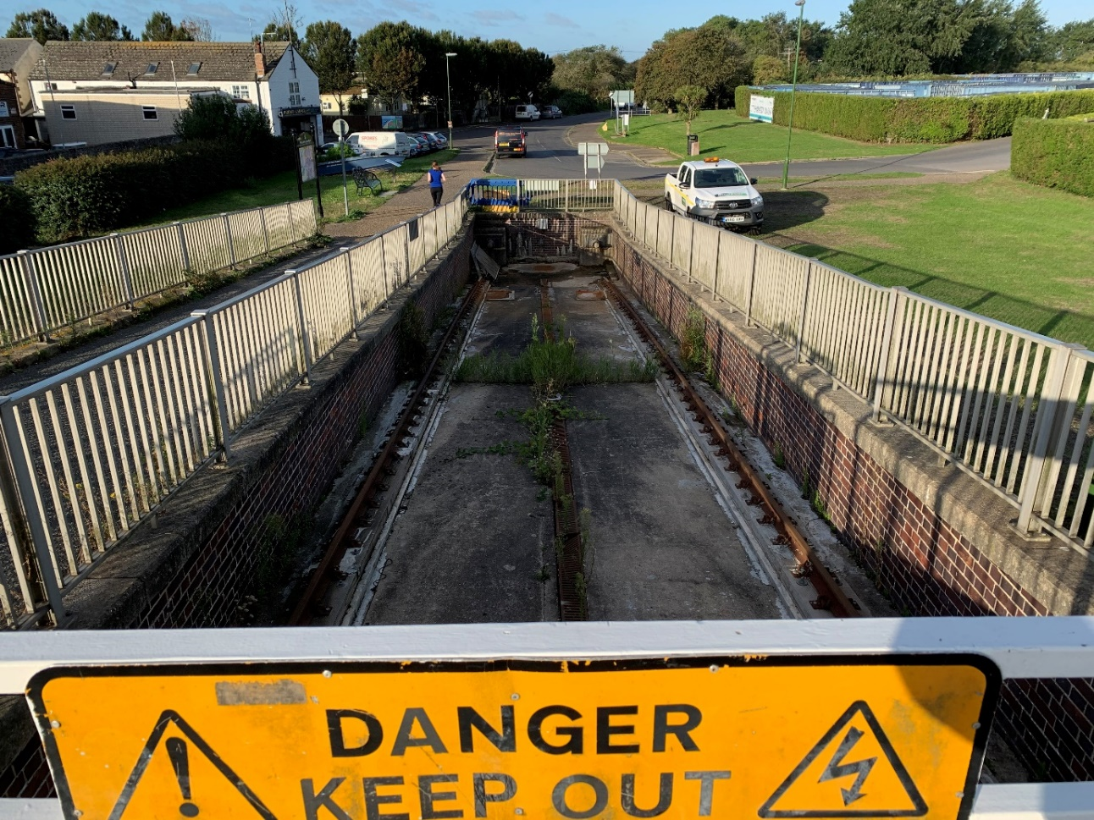
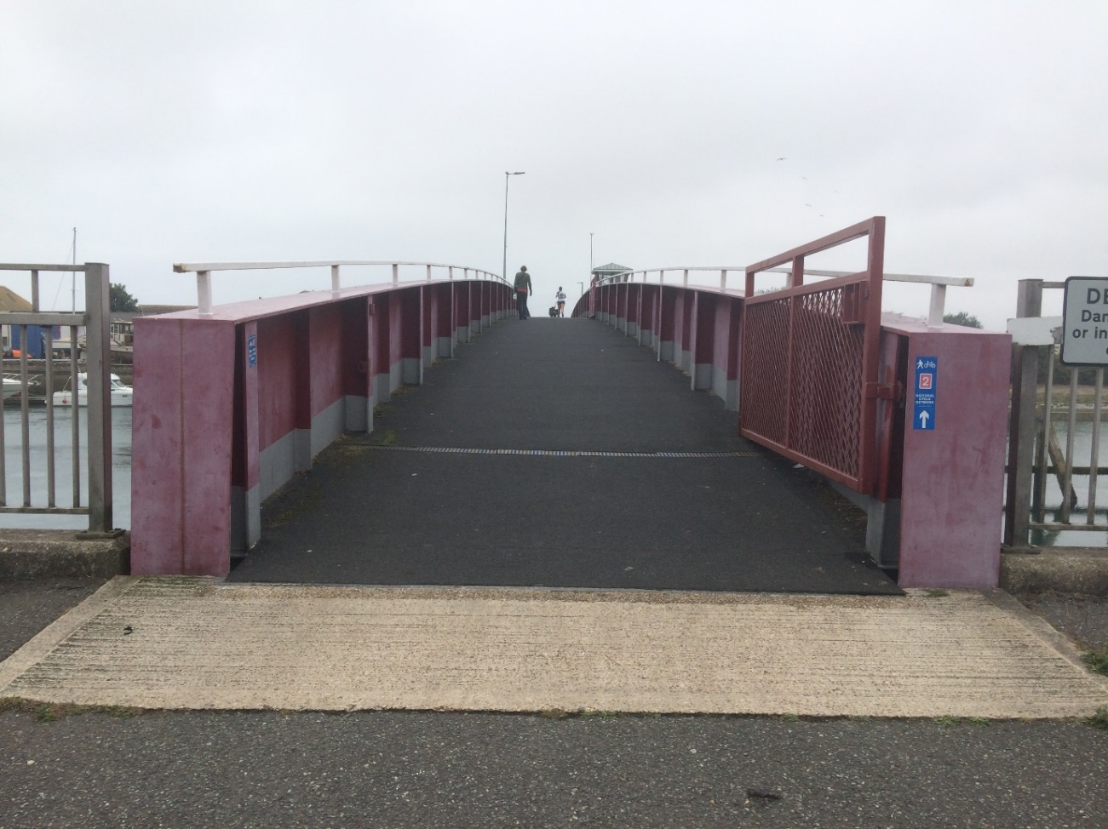
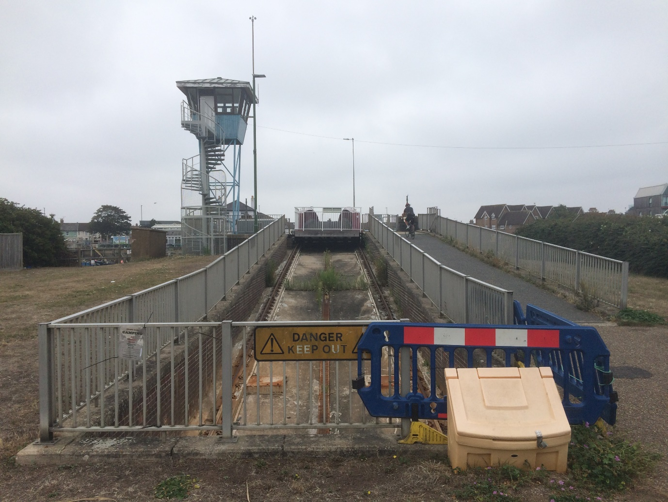

EWR East Wolves Roundabout
Location: A24 Ashington Southbound Exit Slip, RH20 3AX
Parish: Ashington Easting: 513,516 Northing: 116,536
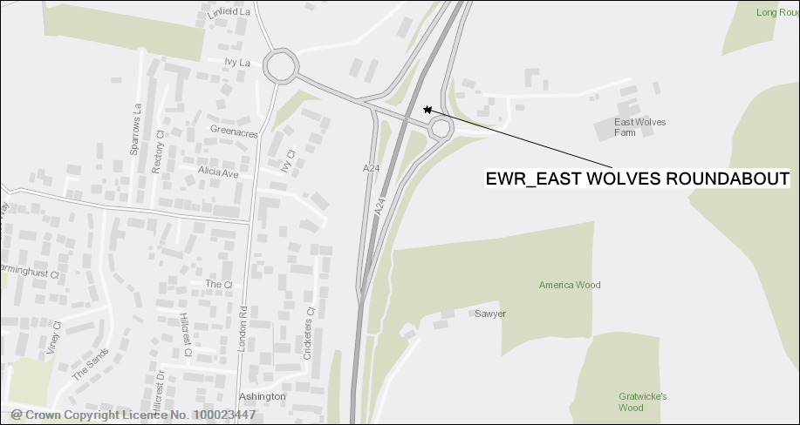
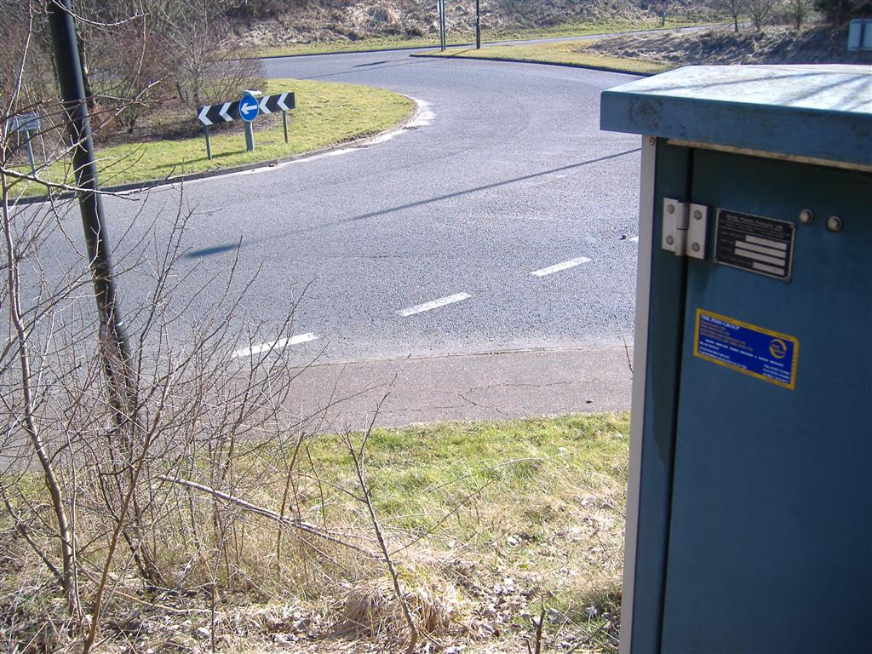
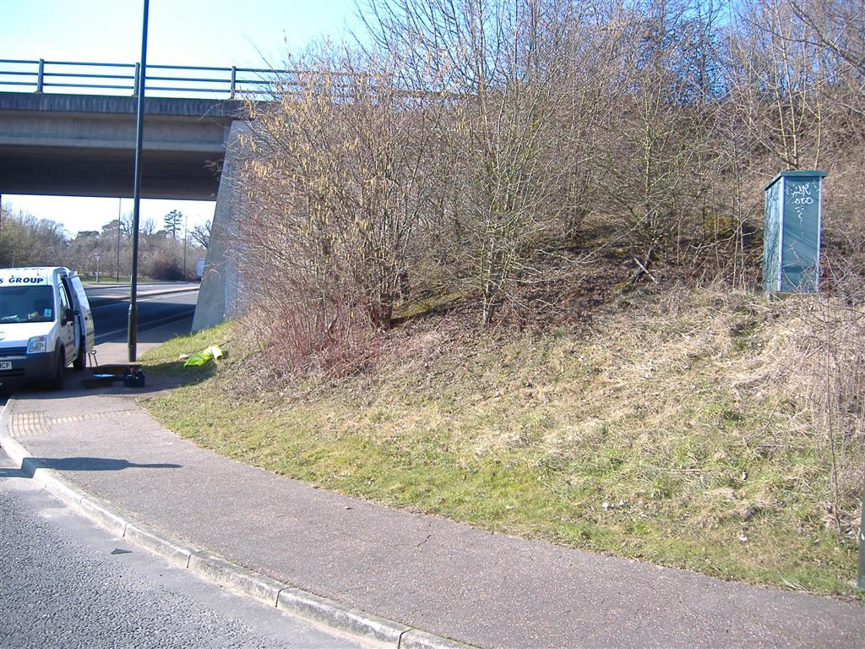

SAG St. Augustine Close
Location: St Augustines Close, RH17 7NB
Parish: Lindfield Rural (Scaynes Hill) Easting: 536,450 Northing: 123,242
