PART B – QUOTE RETURN

|  |
| --- |
| Footpath Maintenance 2023-25  Reference number: RFQ-001-23 |

|  |
| --- |
| Name of Applicant:  Date: |

Section 4 - Quote Completion Documentation

4.1 Selection Criteria

**Explanatory Notes**

Applicants are required to complete all questions in this section which have space for answers. Some sections refer to criteria which are not applicable to this RFQ. This will be clearly marked with “Not Applicable to this RFQ”, and you are not required to answer these sections.

All responses provided must be clearly referenced to the questions to which they relate. Copies of certificates or policies will need to be provided by the successful supplier before any contract or purchase order is placed with them.

All applicable sections of the following Selection Criteria must be completed. Failure to do so may result in your submission being excluded from further evaluation. Where the answer is a statement of fact, it must be accurate and supported by documentary evidence as appropriate. It is the Applicant’s responsibility to ensure that the Council is not misled.

It is the responsibility of the Applicant to inform the Council of any matter that may affect the Applicant’s continued qualification.

4.2 Financial Matters

The Council will carry out a financial check on the Applicant. This will take the form of a review of the Applicant’s accounts available from Companies House. If company accounts are not available then the Council will carry out a financial check on the information available as identified in Section 3.1 which could include an Experian Credit Assessment. The Applicant will be awarded an overall pass or fail mark based on the Council’s professional judgement. This professional judgement will be provided from the Council’s Responsible Finance Officer.

Any additional information provided should be clearly referenced to the question number in your submission.

4.3 Selection Questionnaire

|  |  |  |  |  |  |  |  |  |  |  |  |
| --- | --- | --- | --- | --- | --- | --- | --- | --- | --- | --- | --- |
| NOTE TO APPLICANT: Part 1 must be completed but will not be scored | | | | | | | | | | | |
| **Section 1.1** | | **Potential supplier information** | | | |  | | | | | |
| **Question number** | | **Question** | | | | **Response** | | | | | |
| 1.1(a) | | Full name of the potential supplier  submitting the information | | | |  | | | | | |
| 1.1(b) – (i) | | Registered office address (if applicable) | | | |  | | | | | |
| 1.1(b) – (ii) | | Registered website address (if applicable) | | | |  | | | | | |
| 1.1© | | Please mark ‘X’ in the relevant box to indicate your trading status | | | | 1. a public limited company | | | |  | |
| 1. a limited company | | | |  | |
| 1. a limited liability partnership | | | |  | |
| 1. other partnership | | | |  | |
| 1. sole trader | | | |  | |
| 1. other (please specify) | | | |  | |
| 1.1(d) | | Date of registration in country of origin | | | |  | | | | | |
| 1.1© | | Company registration number (if applicable) | | | |  | | | | | |
| 1.1(f) | | Charity registration number (if applicable) | | | |  | | | | | |
| 1.1(h) | | Registered VAT number | | | |  | | | | | |
| 1.1(k) | | Trading name(s) that will be used if successful in this procurement | | | |  | | | | | |
| 1.1(l) | | Please mark ‘X’ in the relevant box to indicate whether any of the following classifications apply to you | | | | 1. Voluntary, Community and Social Enterprise (VCSE) | | | |  | |
| 1. Small or Medium Enterprise (SME) | | | |  | |
| 1. Sheltered workshop | | | |  | |
| 1. Public service mutual | | | |  | |
| **Section 1.2** | | **Bidding model** | | | |  | | | | | |
| **Question number** | | **Question** | | | | **Response** | | | | | |
| 1.2(a) – (i) | | Are you bidding as the lead contact for a group of economic operators?  If yes, please provide details listed in questions below. | | | | **Please indicate your answer by marking ‘X’ in the relevant box.** | | | | | |
| **Yes** | | | | **No** | |
|  | | | |  | |
| 1.2(a) – (ii) | | Name of group of economic operators (if applicable) | | | |  | | | | | |
| 1.2(a) – (iii) | | Proposed legal structure if the group of economic operators intends to form a named single legal entity prior to signing a contract, if awarded. If you do not propose to form a single legal entity, please explain the legal structure. | | | |  | | | | | |
| 1.2(b) – (i) | | Are you or, if applicable, the group of economic operators proposing to use sub-contractors?  If yes, please provide details listed in questions below. | | | | **Yes** | | | | **No** | |
|  | | | |  | |
| Name of sub-contractors (if applicable) | | | |  | | | | | |
| The role each sub-contractor will take in providing the works and /or supplies e.g. key deliverables: | | | |  | | | | | |
| The approximate % of contractual obligations assigned to each sub-contractor: | | | |  | | | | | |
| Contact details and declaration | | | | | | | | | | | |
| I declare that to the best of my knowledge the answers submitted and information contained in this document are correct and accurate.  I declare that, upon request and without delay I will provide the certificates or documentary evidence referred to in this document.  I understand that the information will be used in the selection process to assess my organisation’s suitability to be invited to participate further in this procurement.  I understand that the authority may reject this submission in its entirety if there is a failure to answer all the relevant questions fully, or if false/misleading information or content is provided in any section.  I am aware of the consequences of serious misrepresentation. | | | | | | | | | | | |
| **Section 1.3** | | **Contact details and declaration** | | | |  | | | | | |
| **Question number** | | **Question** | | | | **Response** | | | | | |
| 1.3(a) | | Contact name | | | |  | | | | | |
| 1.3(b) | | Name of organisation | | | |  | | | | | |
| 1.3(c) | | Role in organisation | | | |  | | | | | |
| 1.3(d) | | Phone number | | | |  | | | | | |
| 1.3(e) | | E-mail address | | | |  | | | | | |
| 1.3(f) | | Postal address | | | |  | | | | | |
| 1.3(g) | | Signature (electronic is acceptable) | | | |  | | | | | |
| 1.3(h) | | Date | | | |  | | | | | |
| **Part 2: Exclusion grounds**  NOTE TO APPLICANT: this section must be completed and will be evaluated as a whole on a Pass or Fail basis. The section will be marked as a ‘Fail’ if “Yes” is answered to question 2.1(a) and 2.2(a) and satisfactory evidence of self-cleaning is not detailed in your response to question 2.1(b) and 2.2(b). | | | | | | | | | | | |
| **Section 2.1** | | **Grounds for mandatory exclusion** | | | |  | | | | | |
| **Question number** | | **Question** | | | | **Response** | | | | | |
| 2.1(a) | | **Regulations 57(1) and (2)**  The detailed grounds for mandatory exclusion of an organisation are set out on this [web page](https://www.gov.uk/government/uploads/system/uploads/attachment_data/file/551130/List_of_Mandatory_and_Discretionary_Exclusions.pdf), which should be referred to before completing these questions.  Please indicate if, within the past five years you, your organisation or any other person who has powers of representation, decision or control in the organisation been convicted anywhere in the world of any of the offences within the summary below and listed on the [webpage](https://www.gov.uk/government/uploads/system/uploads/attachment_data/file/551130/List_of_Mandatory_and_Discretionary_Exclusions.pdf). | | | | | | | | | |
|  | | | | **Please indicate your answer by marking ‘X’ in the relevant box.** | | | | | |
| **Yes** | | | | **No** | |
| Participation in a criminal organisation | | | |  | | | |  | |
| Corruption | | | |  | | | |  | |
| Fraud | | | |  | | | |  | |
| Terrorist offences or offences linked to terrorist activities | | | |  | | | |  | |
| Money laundering or terrorist financing | | | |  | | | |  | |
| Child labour and other forms of trafficking in human beings | | | |  | | | |  | |
| 2.1(b) | | If you have answered yes to question 2.1(a), please provide further details.  Date of conviction, specify which of the grounds listed the conviction was for, and the reasons for conviction,  Identity of who has been convicted  If the relevant documentation is available electronically please provide the web address, issuing authority, precise reference of the documents. | | | |  | | | | | |
| **Part 3: Selection questions** | | | | | | | | | | | |
| **Section 3.1** | | **Economic and financial standing** | | | |  | | | | | |
| **Question number** | | **Question** | | | | **Response** | | | | | |
| 3.1 | |  | | | | **Please indicate your answer by marking ‘X’ in the relevant box.** | | | | | |
| **Yes** | | | **No** | | |
| Are you able to provide a copy of your audited accounts for the last two years, if requested?  If no, can you provide **one** of the following: | | | |  | | | | | |
| (a) A statement of the turnover, Profit and loss Account/income Statement, Balance Sheet/Statement of Financial Position and Statement of Cash Flow for the most recent year of trading for this organisation. | | | |  | | | | | |
| (b) A statement of the cash flow forecast for the current year and a bank letter outlining the current cash and credit position. | | | |  | | | | | |
| (c) Alternative means of demonstrating financial status if any of the above are not available (e.g. forecast of turnover for the current year and a statement of funding provided by the owners and/or the bank, charity accruals accounts or an alternative means of demonstrating financial status). | | | |  | | | | | |
| **Section 4** | | **Technical and professional ability** | | | |  | | | | | |
| 4.1 | | Please provide details of up to three contracts, in any combination from either the public or private sector; voluntary, charity or social enterprise (VCSE) that are relevant to our requirement. VCSEs may include samples of grant-funded work. Contracts for supplies or services should have been performed during the past three years. Works contracts may be from the past five years.  Consortia bids should provide relevant examples of where the consortium has delivered similar requirements. If this is not possible (e.g. the consortium is newly formed or a Special Purpose Vehicle is to be created for this contract) then three separate examples should be provided between the principal member(s) of the proposed consortium or Special Purpose Vehicle (three examples are not required from each member).  If you cannot provide examples see question 4.2 | | | | | | | | | |
|  | | | Contract 1 | Contract 2 | | | Contract 3 | | | | |
| Name of customer organisation | | |  |  | | |  | | | | |
| Point of contact in the organisation | | |  |  | | |  | | | | |
| Position in the organisation | | |  |  | | |  | | | | |
| E-mail address | | |  |  | | |  | | | | |
| Contract Start date | | |  |  | | |  | | | | |
| Contract completion date | | |  |  | | |  | | | | |
| Estimated contract value | | |  |  | | |  | | | | |
| Description of contract 1: | | | | | | | | | | | |
| Description of contract 2: | | | | | | | | | | | |
| Description of contract 3: | | | | | | | | | | | |
| 4.2 | | If you cannot provide at least one example for questions 6.1, in no more than 500 words please provide an explanation for this e.g. your organisation is a new start-up or you have provided services in the past but not under a contract. | | | | | | | | | |
| Response: | | | | | | | | | | | |
| **Section 5** | | **Additional questions** | | | |  | | | | | |
| **5.1** | | **Insurance** | | | |  | | | | | |
| Please self-certify whether you already have, or can commit to obtain, prior to the commencement of the contract, the levels of insurance cover indicated below(Please indicate your answer by marking ‘X’ in the relevant box): | | | | | | **Yes** | | | | **No** | |
| Employer’s (Compulsory) Liability Insurance = £10 Million | | | | | |  | | | |  | |
| Public Liability Insurance = £10 Million | | | | | |  | | | |  | |
| * It is a legal requirement that all companies hold Employer’s (Compulsory) Liability Insurance of £5 million as a minimum. Please note this requirement is not applicable to Sole Traders. | | | | | |  | | | |  | |
| **Section 6** | **Project Specific Questions** | | | | | | | | | |
| **6.1** | **Health & Safety** | | | | **Yes** | | | **No** | | |
| Please self-certify that your organisation has a Health and Safety Policy that complies with current legislative requirements. | | | | |  | | |  | | |
| Has your organisation or any of its Directors or Executive Officers been in receipt of enforcement/remedial orders in relation to the Health and Safety Executive (or equivalent body) in the last 3 years?  If your answer to this question was “Yes”, please provide details in a separate Appendix of any enforcement/remedial orders served and give details of any remedial action or changes to procedures you have made as a result. | | | | |  | | |  | | |

Section 5 The Specification

1. **Location of work within the Parish**

The enclosed maps show the Public Right of Way network within the Parish provided by Cornwall Council. Those paths identified as ‘Gold Priority’ (as indicated on the schedule below) receive greater priority of maintenance and therefore this RFQ aims to reflect this with the number of cuts required.

1. **Description of the work**

The work consists of strimming / brush cutting / mowing vegetation from those paths specified below. Notice should be taken of Footpaths which also include the cutting of vegetation around stiles and gates. Vegetation result from works and/or chipping will need to be removed from site. The costs and arrangements for such circumstances must be agreed prior to works starting.

It is vital that any path worked on is left open and easy to use after trimming is carried out and must not be left obstructed.

Paths should be maintained consistent with their level of use and legal status (e.g. footpath or bridleway). As a guide:

* *footpaths should be cleared to a width of 1.5m (where possible) and to a height of 2m;*
* *Bridleways should be cleared to a width of 2.5m and a height of 3.5m where the path corridor allows.*

In some instances the path will be wider than this.

1. **Timing of work**

As a general rule, a path needing one trim per year should be cut in June (identified as Red on the footpath schedule below). Those requiring two trims should be cut in May and August (identified as Amber on the footpath schedule below). The Council may ask for a 3rd additional cut of some footpaths subject to growth during the season.

Any large-scale clearance work which involves heavy cutting of woody material should be undertaken during the winter months to avoid disturbance to nesting birds.

1. **Site Visit**

Before submitting a quote the contractor should examine the requirements of this contract through looking at the maps and visiting the sites. The Town Council would expect the contractor to carry out site visits of these areas within a reasonable timeframe to ensure they are fully aware of any workloads.

1. **Works Estimate**

The contractor shall give a quote based on the information contained within this contract and the information provided by Newquay Town Council. This should be on a price per km basis.

1. **Quote to be Inclusive**

The contractor is to include in their price, all costs in connection with labour, Health and Safety requirements, plant, materials, tool maintenance, fuel and transport and all other things necessary for the work to be undertaken.

1. **Agreement of work Programme**

Before starting work the contractor will provide a programme of work to Newquay Town Council’s approval. Should the Town Council require any additional work to be added, an amended works programme can be negotiated between the Town Council and the contractor.

1. **Responsible Person**

The contractor shall keep on site at all reasonable times when undertaking work on site a working foreman or other responsible person to whom Newquay Town Council can give instructions and who can co-ordinate the work of other operatives and sub-contractors. This will include providing a mobile phone number.

1. **Safety and Environmental Protection Issues**

Before starting work the contractor will:

* *Provide and agree Risk Assessments and method statements illustrating how they will go about the work (e.g. erecting safety signs, disposal of trimmings, tools to be used).*
* *Agree how they will comply with Health & Safety Regulations (e.g. use of petrol, herbicides etc.).*
* *Provide public liability insurance documents.*
* *Provide certificates of competency (such as certificates and operators licenses for machinery used for the works).*

Before starting work Newquay Town Council will:

* *Provide information concerning any other matter to be brought to the contractor's attention (e.g. archaeological or wildlife issues).*

1. **Site Access**

Newquay Town Council will provide the contractor information concerning access to the sites and landowner details where possible.

The contractor will arrange access with the landowners where necessary, e.g. if taking large machinery along a public footpath or bridleway, or when accessing the path across private land.

1. **Exceptions to clearance of vegetation**

Japanese knotweed must be left alone. The contractor must NOT CUT IT OR PULL IT UP as this could cause it to spread. Please tie it back if you can.

The contractor would need to report the location of any knotweed (or any other invasive non-native plants) seen to be growing on or immediately adjacent to a path to Newquay Town Council. The client should then inform the Invasive Species team at Cornwall Council of its location by filling in the relevant details on [www.cornwall.gov.uk](http://www.cornwall.gov.uk) or Tel: 0300 1234 202.

1. **Footpath Schedule**

|  |  |  |  |  |  |  |
| --- | --- | --- | --- | --- | --- | --- |
| **Footpath No** | **Description of Footpath Location** | **Footpath/ Bridleway** | **Path Priority** | **Total Length (Metres)** | **Total Length required (Metres)** | **No. of Cuts Required** |
| **12** | Footpath from Well Way, crossing Porth Way to Praze Road | Footpath | Gold | 365 | 730 | 2 |
| **13** | Footpath from Greenbank Crescent, crossing Porth Bean Road to Well Way | Footpath | Gold | 80 | 160 | 2 |
| **17** | Footpath from Pentire Crescent to the Gannel along ‘Rubblegates’ | Footpath | Gold | 195 | 390 | 2 |
| **18** | Footpath from Gannel Crescent to River Gannel down side of ‘Hotel California’ | Footpath | Gold | 136 | 272 | 2 |
| **20** | Footpath from the top of Crantock Street, over Golf links and along the Northern edge of Pentire Road | Footpath | Gold | 275 | 550 | 2 |
| **22** | Footpath over the Golf links from Footpath 21 to the Catholic Church on Tower Road | Footpath | Gold | 512 | 1024 | 2 |
| **23** | From Footpath 22 to Bredon Court | Footpath | Gold | 278 | 556 | 2 |
| **27** | Footpath from the Huers Hut Look-Out House to Fly Cove with a branch to King Edward Crescent | Footpath | Gold | 246 | 492 | 2 |
| **28** | Footpath between Toby Way and Headland Road | Footpath | Gold | 94 | 188 | 2 |
| **29** | Footpath from Mount Wise to Footpath 30 with a spur onto Mount Wise | Footpath | Gold | 327 | 654 | 2 |
| **30** | Footpath from the Gannel Road, west of Trenance Boating Lake to Footpath 29 at Cheviot Road | Footpath | Gold | 59 | 118 | 2 |
| **32** | Bridleway (Rawley Lane) from Tredour Road to Rawley Point | Bridleway | Gold | 151 | 302 | 2 |
| **33** | Footpath from Agar Road to Mount Wise | Footpath | Gold | 190 | 380 | 2 |
| **34** | Footpath from Tregurrian, South to the Town Boundary | Footpath | Bronze | 871 | 871 | 1 |
| **36** | Footpath from Watergate Road, branching into two leading to the Cliff edge | Footpath/ Stiles/Gates | Gold | 607 | 1214 | 2 |
| **38** | Footpath from East of Trevelgue Court to Tregustick | Footpath/ Stiles/Gates | Gold | 783 | 1566 | 2 |
| **39** | Footpath from Trevelgue Road to Penrose Farm | Footpath/ Stiles/Gates | Gold | 25 | 50 | 2 |
| **40** | Footpath from Penrose, across fields to Town Boundary near Rialton Mill | Footpath | Gold | 798 | 1596 | 2 |
| **41** | Bridleway from St Columb Minor Church to Tregustick Road, north of Penrose (also known as ‘The Goat Track’) | Bridleway | Gold | 592 | 1184 | 2 |
| **44** | Footpath from St Columb Minor Church to Lewarne Crescent | Footpath/ Stiles/Gates | Gold | 129 | 258 | 2 |
| **50** | Footpath from Gusti Veor Junction, across fields to Chapel | Footpath/ Stiles/Gates | Gold | 1035 | 2070 | 2 |
| **51** | Footpath from Wych Hazel Way, South across fields to Town Boundary near Trevemper Bridge | Footpath | Silver | 644 | 644 | 1 |
| **52** | Footpath from Edgcumbe Avenue to the top of Towan Blystra Road | Footpath | Gold | 146 | 292 | 2 |
| **53** | Footpath from Newquay Sports Centre to Trevenson Hill | Footpath/ Stiles/Gates | Gold | 538 | 1076 | 2 |
| **55** | Footpath between St Thomas Road, behind Newquay Hospital, through Trenance Gardens to Edgcumbe Avenue | Footpath | Gold | 206 | 412 | 2 |
| **56** | Footpath from Robartes Road to Edgcumbe Avenue | Footpath | Gold | 182 | 364 | 2 |
| **57** | Bridleway from Footpath 72, from the ford along Treloggan Lane to the level crossing | Bridleway | Gold | 426 | 852 | 2 |
| **58** | Footpaths over public open space at ‘The Barrowfields’, extending from Narrowcliff to Lusty Glaze | Footpath | Gold | 1705 | 3410 | 2 |
| **60** | Footpath from the Tavern Pub to Penina Avenue | Footpath | Gold | 99 | 198 | 2 |
| **61** | Footpath from the Tavern Pub to Mellanvrane Lane | Footpath | Gold | 155 | 310 | 2 |
| **62** | Footpath from the junction with Footpath 60 to Polwhele Road including alleyways between 79 Pendragon Crescent and 62 Polwhele Road and between 87 Polwhele Road and 37 Polwhele Road | Footpath | Gold | 655 | 1310 | 2 |
| **63** | Footpath from Parish Boundary to road south of Trencreek Road | Footpath | Gold | 31 | 62 | 2 |
| **66** | Bridleway 57 from ford to junction with Footpath 52 | Footpath | Gold | 108 | 216 | 2 |
| **68** | Footpath from Porth Bean Road to Greenbank Crescent | Footpath | Gold | 94 | 188 | 2 |
| **69** | Bridleway from junction with Bridleway 57 along fields to the rear of properties at Bedowan Meadows | Bridleway | Gold | 162 | 324 | 2 |
| **72** | Footpath from Tretherras Road to Towan Blystra Road | Footpath | Gold | 134 | 268 | 2 |
| **75** | Footpath from Treloggan Road to Trencreek Road | Footpath/ Stiles/Gates | Gold | 190 | 380 | 2 |
| **76** | Footpath from A392 to Doorstep Green Play Area | Footpath | Gold | 111 | 222 | 2 |
| **77** | Footpath from Doorstep Green to Treloggan Road | Bridleway | Gold | 118 | 236 | 2 |
| **Treloggan Footpath Unadopted Path** | Footpaths between Polwhele Road and Pendragon Cresent | Footpath | N/A | 246 | 492 | 2 |
| **Trenance School Footpath Unadopted** | Footpath behind Trenance Academy linking to Footpath 29 | Footpath | N/A | 252 | 504 | 2 |
| **Priory Woods** | Footpath through Priory Woods | Footpath | Gold | 636 | 1272 | 2 |
| **Total Length Red** |  |  |  |  | 1515 |  |
| **Total Length Amber** |  |  |  |  | 26,142 |  |
| **Total Length Combined** |  |  |  |  | **27,657** |  |
| **Red** | 1 Cut a year in June |
| **Amber** | 2 Cuts a year in May (1st Cut) and August (2nd Cut if required) |

1. **Footpath Maps**

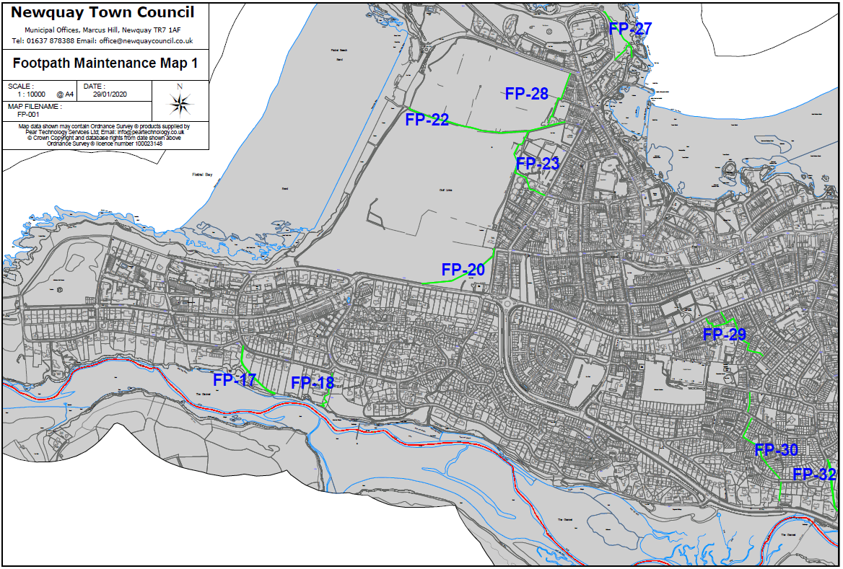

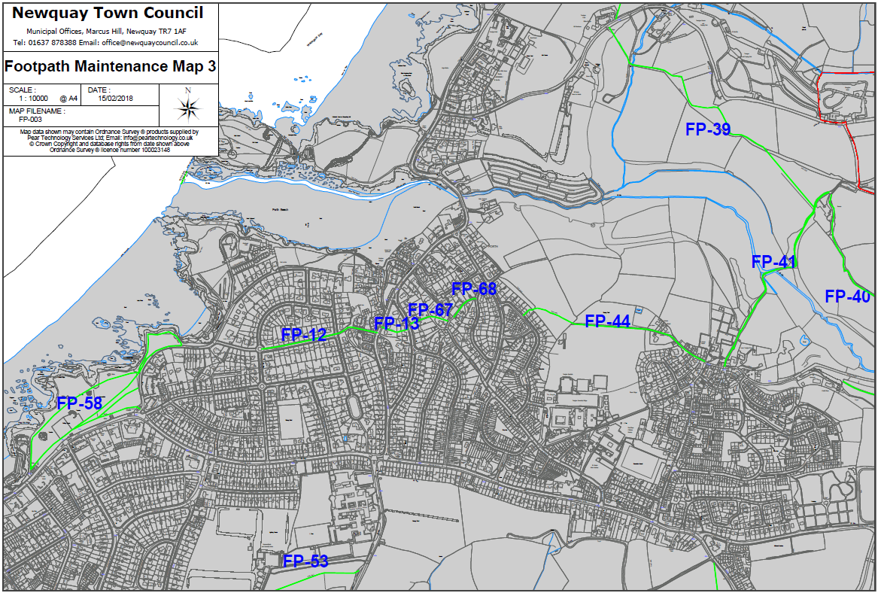

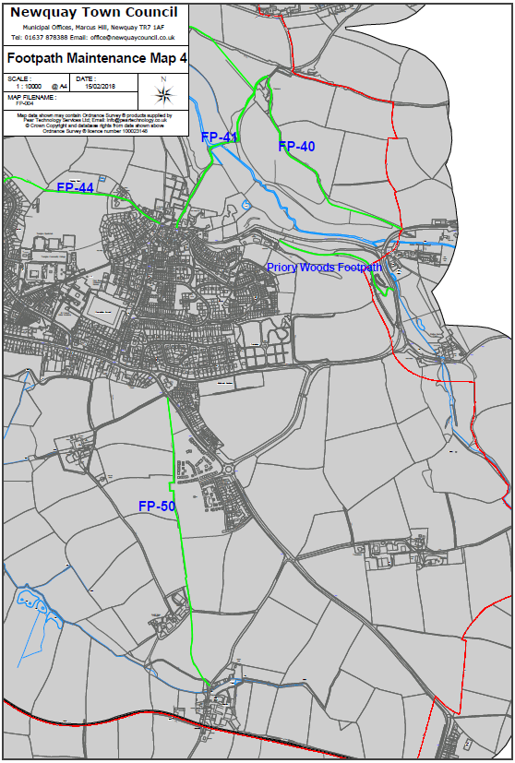

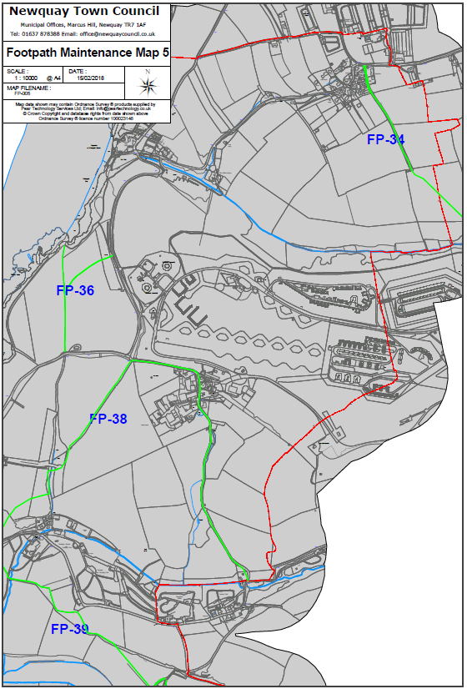

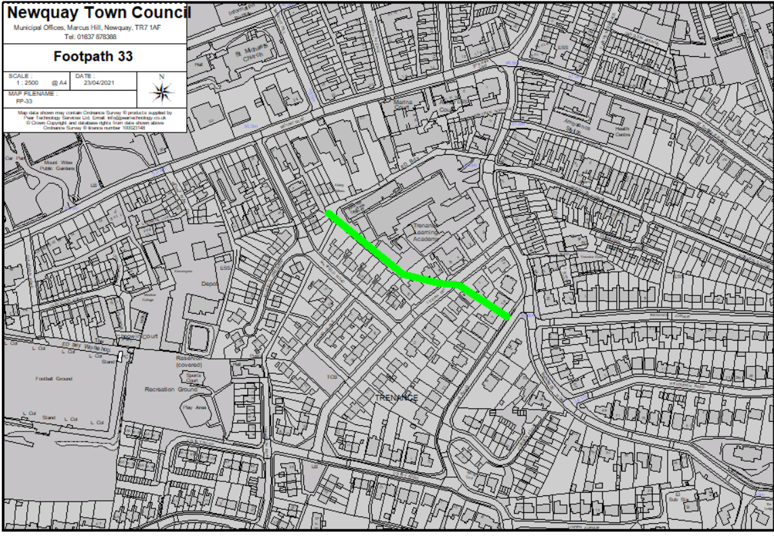

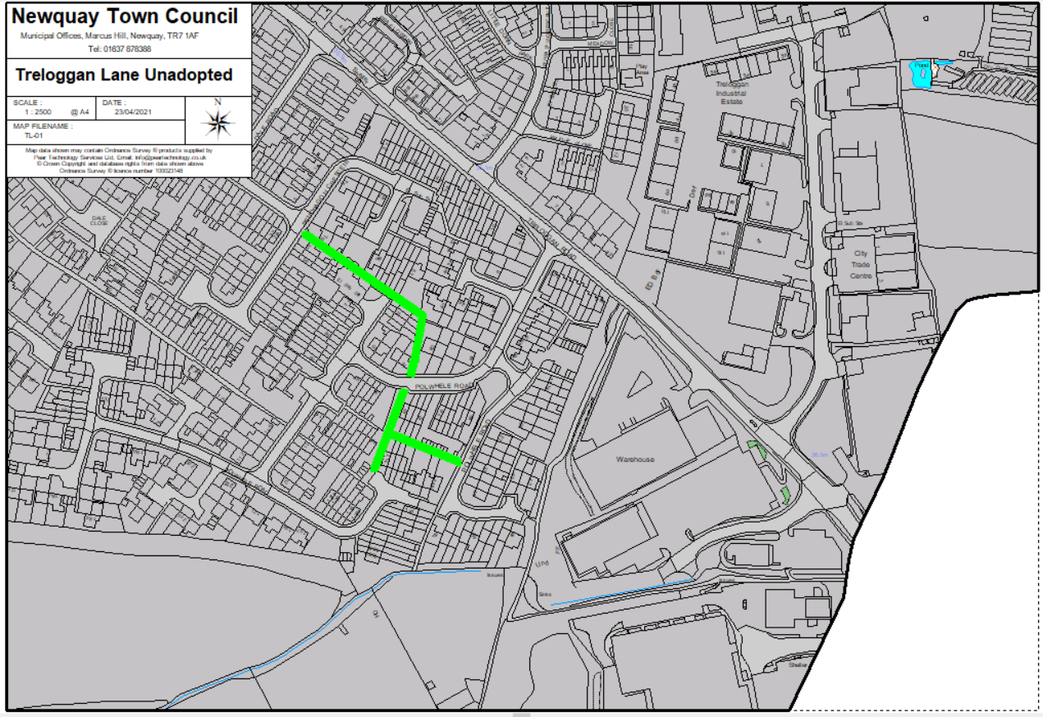

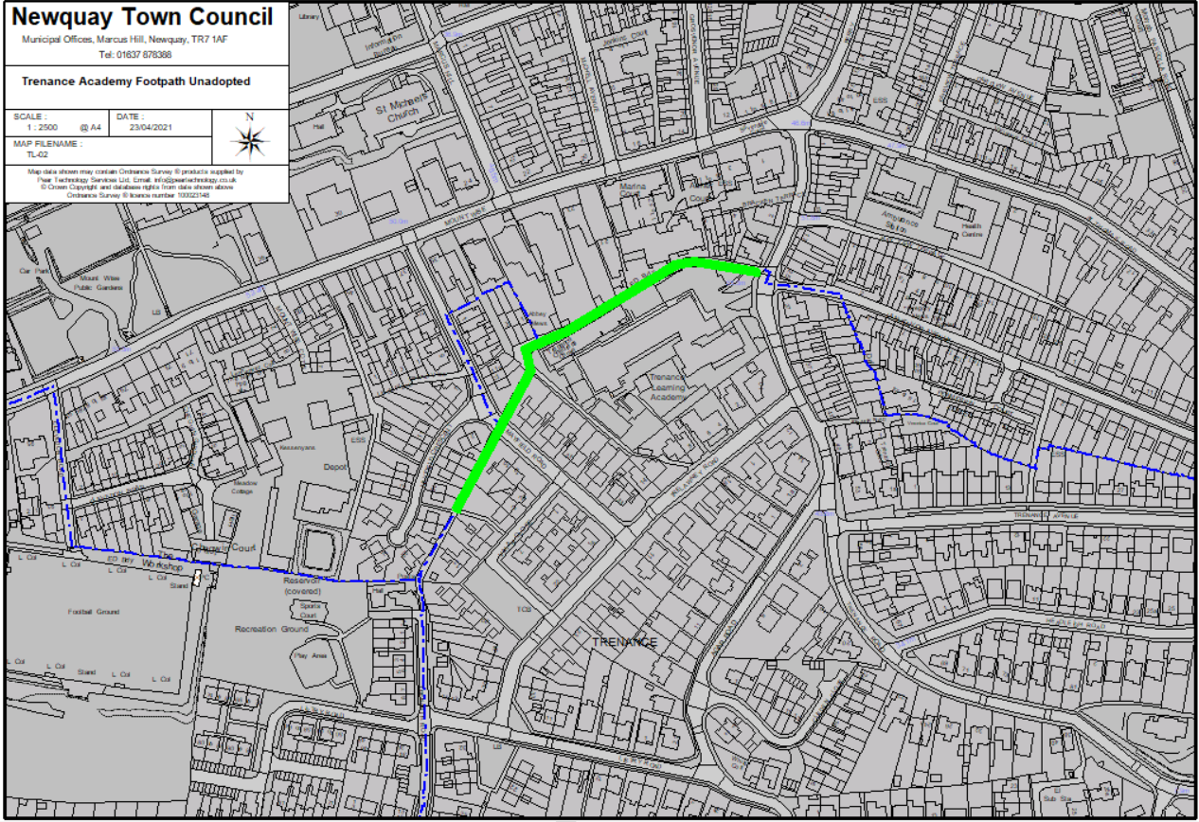

Section 6 The Pricing Document

All prices shall be stated in pounds sterling and exclusive of VAT.

|  |  |
| --- | --- |
| **Activity** | **Cost (£ excl VAT)** |
| **Cutting of Red Footpaths** | |
|  |  |
| **Cutting of Amber Footpaths** | |
|  |  |
| **Other** | |
| Include and describe any other costs not captured above |  |
| **Total (excluding VAT)** |  |
| The following costs are to be provided for information only but will not be scored as part of the evaluation. | |
| Day rate per member of staff |  |
| Daily rate of plant and equipment hire |  |

Section 7 The Quality Assessment

|  |
| --- |
| 1. **Understanding of the Council’s Brief *(20%)***   Please demonstrate your understanding of the Council’s brief outlining proposals on how the project will be managed and delivered. |
|  |
| **2. Experience of the team *(10%)***  Provide details of the team who will be used to deliver the services described in the specification and how their knowledge and experience gained on other projects referenced in section 4 of the questionnaire will be utilised to deliver this contract. |
|  |
| **3. Evidence of Supplier’s ability to respond quickly should problems arise during the display period *(10%)***  Please give information and evidence of the response times expected if any issues should occur during the strimming periods. Please include details of emergency (same day) response processes and non-emergency (next working day) response processes. |
|  |
| **4. Health and Safety and Risk Management processes *(15%)***  Include details of Health and Safety considerations and risk management processes.  Include in your response:   * your methodologies for testing and using all required equipment * Example risk assessment |
|  |
| **5. Project Delivery and Programme *(5%)***  Please demonstrate how you are able to ensure the works are completed on time.  Please include in your response a programme with key milestones. |
|  |

PART C - SCHEDULES

Schedule 1 - Form of Quotation and Declarations

**Request for Quotation Which Does Not Include a Formal Deed of Agreement**

Having examined the Request for Quotation and its accompanying documents (which I/we shall keep) and being satisfied as to my/our abilities and experience in all respects to satisfy the requirements of the Contract.

Offer to provide or supply upon the terms and conditions of the contract contained in Appendix 1 in its present form the Services for the prices on the quoted Pricing Document as indicated below for the contract period :-

|  |  |
| --- | --- |
| Pricing Document attached | YES / NO |

and/or during the contract period at the price ascertained under the terms and conditions of contract.

I/We understand and agree that your written letter of acceptance of our Quote shall constitute the making of a binding contract between us.

I/We understand that the information provided in this quotation document and any supporting information provided by us will be relied upon and taken to be true and accurate. If it is subsequently determined that any information supplied was inaccurate, I/we understand and accept that Council reserves the right to exclude our offer to supply (if still under evaluation) or if the Contract has been awarded and the information inaccurately supplied had a significant bearing on the award, that Council shall be at liberty to terminate the Contract.

I/We understand that you are not bound to accept the lowest or any Quote you may receive.

Signed……………………………………………………………………………..

Date ……………………………………………………………………………….

in the capacity of ……………………………………………………………….

duly authorised to sign for and on behalf of

(in BLOCK CAPITALS) ………………………………………………………….

Telephone No. ……………………………………………………………………

Postal Address ……………………………………………………………………

Schedule 2 - Commercially Sensitive Information

The Authority may be obliged to disclose information in or relating to this Quotation following a request for information under the Freedom of Information Act (FOIA) or Environmental Information Regulations (EIR). Please outline in the table below items which you consider are confidential and genuinely commercially sensitive and which should not be disclosed in respect of your Quotation.

I declare that I wish the following information to be designated as Commercially Sensitive.

|  |
| --- |
|  |

The reason(s) it is considered that this information should be exempt under Freedom of Information Act FOIA) or Environmental Information Regulations (EIR) is:

|  |
| --- |
|  |