**Market Engagement Event Booking Form**

**Market Engagement Event for the Essex Keyworker Service for Children and Young People with Learning Disabilities and or Autism**

The Essex CCG’s invite interested providers to attend a virtual market engagement event which will be broadcast via Microsoft (MS) Teams. The format of the event will be a presentation from the commissioners followed by a Q&A. The information gathered will support commissioners to understand better the service model to put in place and will be used to inform the approach to the procurement process.

All organisations wishing to attend the event must complete and return this form via Attain’s the eProcurement portal (<https://attain.bravosolution.co.uk/web/login.html>) **by no later than 10th May 2022 at 17:00.**

|  |  |  |
| --- | --- | --- |
| **Date:** | 16th May 2022 | |
| **Time:** | 2pm – 2.30pm | |
| **Link:** | The link to enable you to access this Webinar will be provided via the eProcurement Portal Message System, 48 hours prior to the event.  Once received, please copy the link and paste it into your web-browser.  *See pages 4 – 6 for instructions on using MS Teams Webinar.* | |
| **Organisation Name** | | [Insert] |
| **Attendee Name** | | 1. [Insert]  2. [Insert]  **Two delegates maximum** |
| **Nominated contact** | | [Insert] |
| **Nominated contact’s telephone number** | | [Insert] |
| **Nominated contact’s email address** | | [Insert] |
| **Brief description of your organisation’s principal fields of activity/experience**  **(Max 500 words)** | | [Insert] |
| **Do you have any special meeting requirements, *noting this is a virtual event*** | | [Insert] |
| **Are there any specific areas you would like to discuss or have clarified at the event?** | | [Insert] |

*Please Note: Any expenditure, work or effort undertaken by you prior to any subsequent procurement is a matter solely for your own commercial judgement. The commissioners reserve the right to withdraw from the process at any time or to not tender the service or to tender on a different basis. In such circumstances, and in any event, the commissioners and / or their advisors shall not be liable for any costs or loss of expenses whatsoever incurred by any organisation, agent or subsidiary that may have contributed to any proposals submitted to this notice.*

**Consent to share contact details with other participating organisations during the market engagement process**

The Commissioners believe it would be beneficial to compile a list of potential organisations who are interested in collaborative ways working in order to meet the needs of the proposed service contract.

As such and as the CCGs are the Data Controllers for this process, we wish to collect the following information from interested parties:

* Organisation name
* Named contact point
* Contact details of the above contact point (email and telephone)

In order for your consent to be fully informed, please ensure you have read and understood the following prior to providing your consent.

**How will this information be used and shared?**

The information supplied will only be used to compile a list of organisations that are interested in potential collaboration in relation to this grant funding application.

The compiled list will be shared for this specific project only, via the Attain e-Procurement portal and will be available to any potential organisation or other interested party who register their interest up until the conclusion of the formal contract award process when the successful Bidder(s) will be determined.

**How will this information be stored, accessed and protected, and for how long?**

The information will be held on the secure Attain e-Procurement portal / secure Attain shared drive and secure CCG shared drive through the market engagement exercise and formal procurement process. Once a successful Bidder(s) has been determined all information relating to the market engagement exercise and procurement will be archived on Attain e-Procurement portal / secure Attain shared drive and secure CCG shared drive and will not be accessible by third parties.

**Your rights as a data subject**

Going forward, you have the right to withdraw your consent at any time, for any reason. To do this, please contact the procurement team via the Attain e-Procurement portal – we will remove your details from the compiled list, and update the list shared on the portal.

You have the right of access to information held about you by the CCGs. Information on how to make such a request is available on the CCGs website as well as the Attain website:

<https://midessexccg.nhs.uk/about-us/our-key-documents/1951-fair-processing-notice/file>

<https://www.southend.gov.uk/privacynotice>

<https://southendccg.nhs.uk/your-health-services/your-information/fair-processing-notice>

<https://www.castlepoint.gov.uk/privacy-notices>

<https://basildonandbrentwoodccg.nhs.uk/about-us/your-information>

<https://www.attain.co.uk/wp-content/uploads/2018/05/Attain-privacy-notice.pdf>

Under the Data Protection Act 2018, you have a number of other rights as a data subject. Information on all your rights as an individual whose data we process are available here:

<https://ico.org.uk/for-organisations/guide-to-the-general-data-protection-regulation-gdpr/individual-rights/>

**Information for inclusion on the “Interested Organisations” list**

|  |  |
| --- | --- |
| Organisation |  |
| Named contact point |  |
| Email Address |  |
| Telephone Number |  |

**Consent for sharing of the above information**

|  |  |
| --- | --- |
| Data subject name |  |
| Data subject signature |  |
| Date |  |

**Instructions to access the Webinar**

**Getting Started:**

1. Copy the Link issued to you via the eProcurement Portal once received and Paste it into your web-browser:

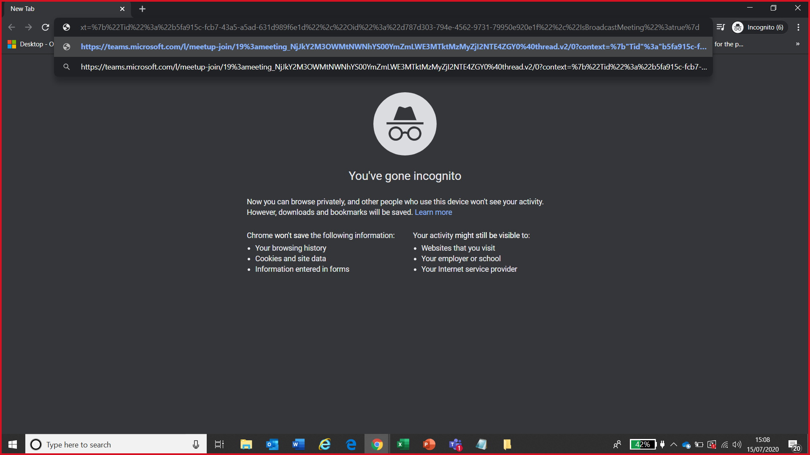

1. Click Enter. If you have the Microsoft Teams App, you can launch the Teams app as usual and participate in the Market Engagement Event. Only the event organisers (the Commissioners) will be able to identify your login username, should you submit a question during the event. No other attendees will see your login details.
2. If you do not already have the Microsoft Teams App, you can either download it for free or simply select the ‘Watch on the web instead’ option.

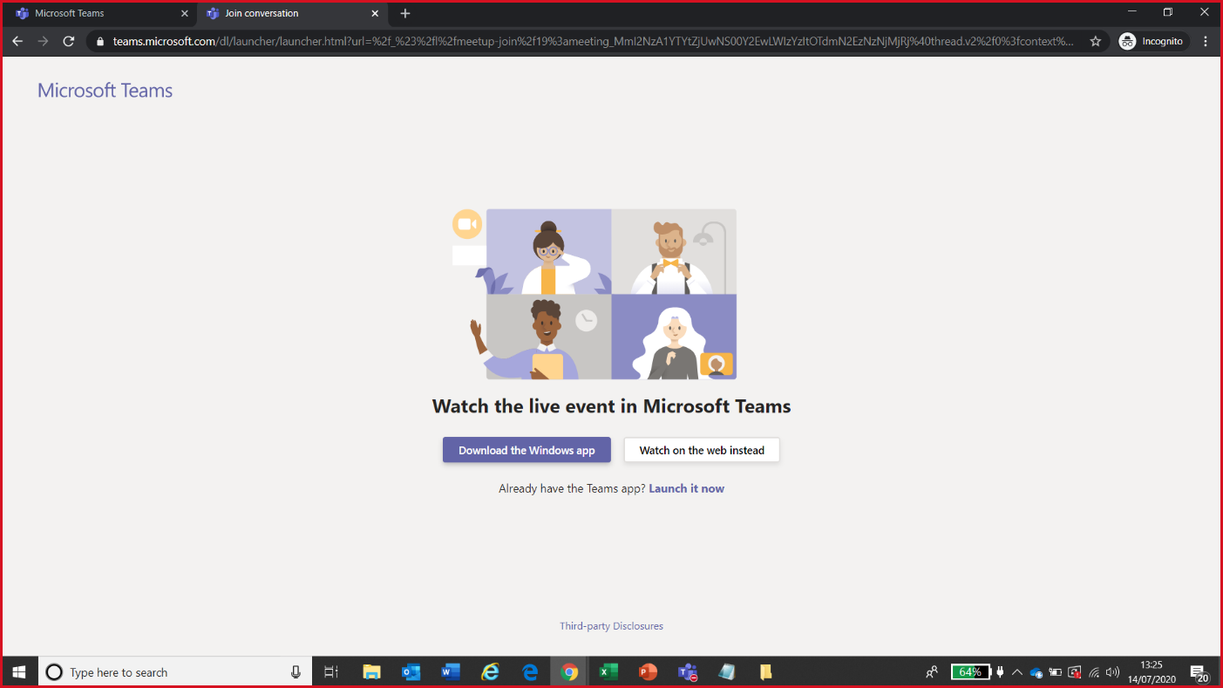

1. 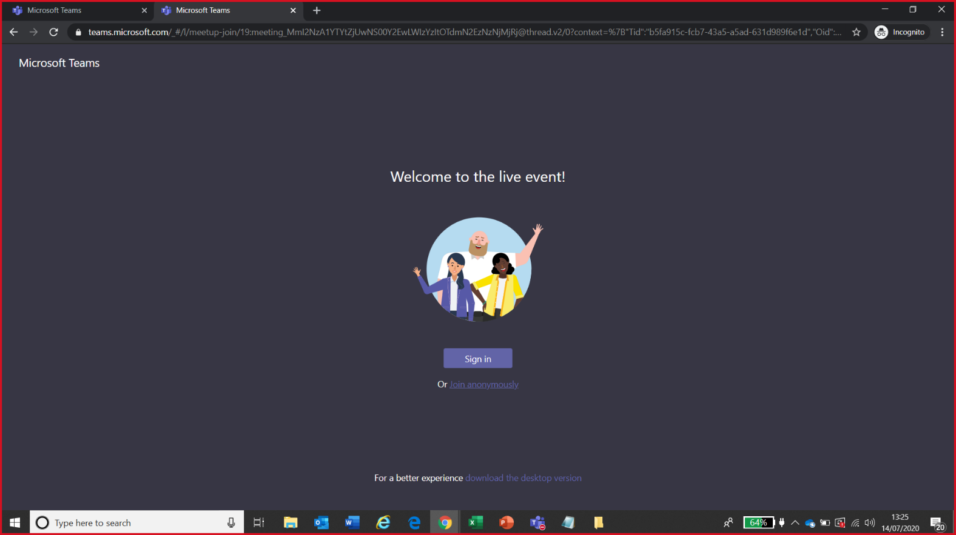You can either sign into your Teams account or select the option “Join Anonymously”

1. 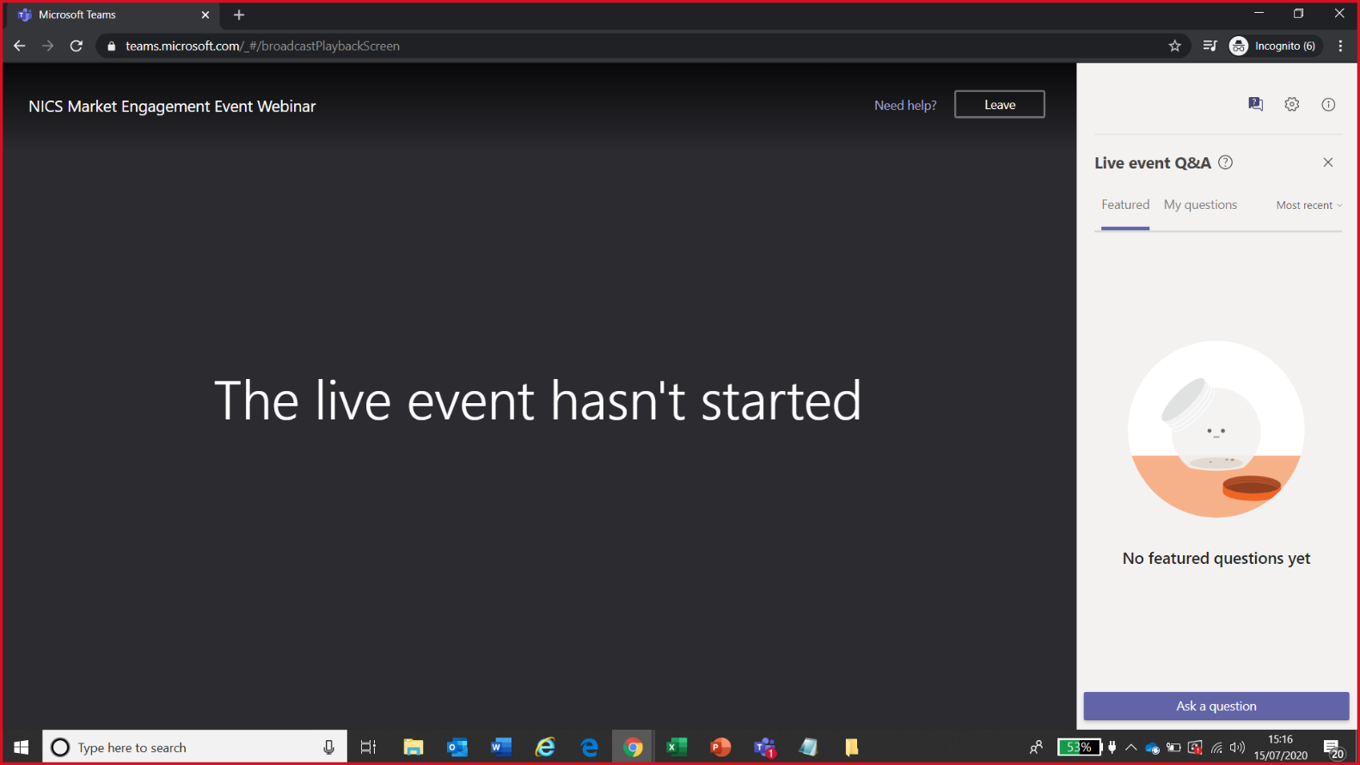Wait for the Live Event to start at the allocated time.
2. Utilise the Questions and Answers Function at any point during the Webinar. All Questions will be addressed at the end of the session.

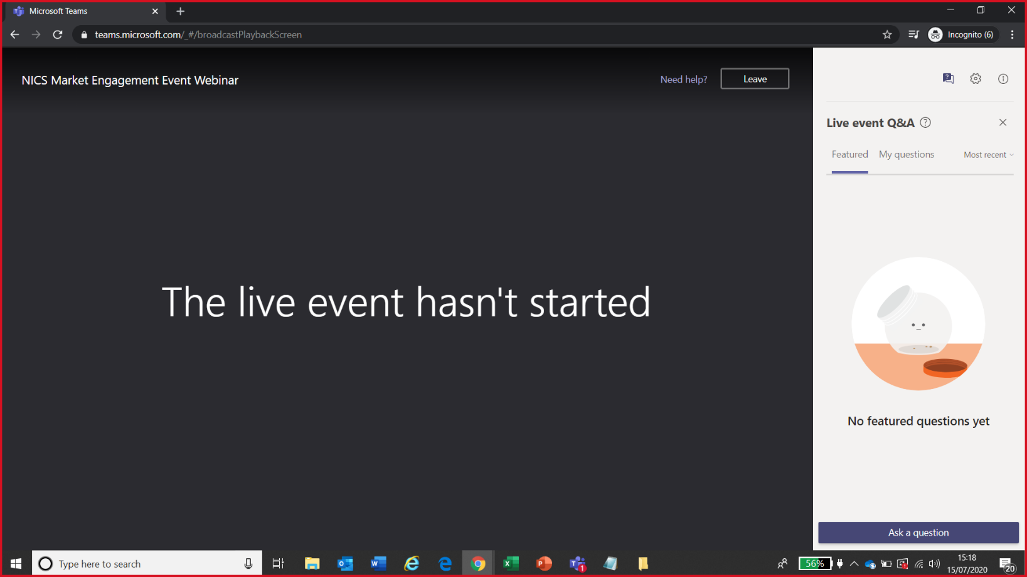To submit a question, click on the ‘**Chat’** function and ‘**Ask a Question**’