Contracts Finder: Opportunity
Horley Town Council: Edmonds Hall replacement windows

The Edmonds Hall is the main community hall owned by Horley Town Council and adjoins the council office building. The Town Council is seeking quotations to replace all the aged and dated windows in the hall which all show signs of damage, leaking, and rotting (as picture below).

The hall windows consist of:

4 x rectangular windows alongside the side of the hall

These are to be removed and replaced with toughened glass and white Georgian bars. The rectangular windows do not currently open and should remain so. Replacement windows should be like for like to retain the existing style. Replacements should be as energy efficient as possible.

2 x large windows at each end of the hall currently in wooden frames

These are to be removed and replaced with 2 x new white UPVC windows with toughened units.
The existing window openers will need to be removed prior to installation and refitted after installation.

The Town Council is seeking glazing and the most energy efficient type of glass and favours low emissivity (low-E) glass. Low-E glass has a microscopically thin coating of metal oxide on one of the internal glass surfaces. This coating reflects heat back into the building but still lets in the light from outside. The windows should be energy rated and we would be looking for the best rating at the best value.

The Town Council has set a guideline estimate of £15,000 ex VAT in total for the above ex vat for feasibility, removal of the existing windows, and installation. The location of the Edmonds Hall is 92 Albert Road, Horley RH6 7HZ

Contractors interested in submitting quotations are advised to make a site visit to fully assess the requirements. Please submit estimates by 5 January 2024 to:

Town Clerk
Horley Town Council
92 Albert Road
Horley
RH6 7HZ

Please refer any questions by email to town.clerk@horleytown.com or by telephone 01293 784765.

This contract opportunity is being procured in line with the Public Contracts Regulations 2015 and its own Financial Regulations (refer link)

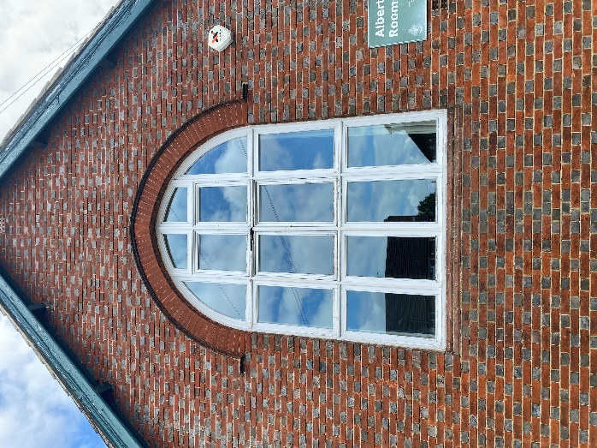 | 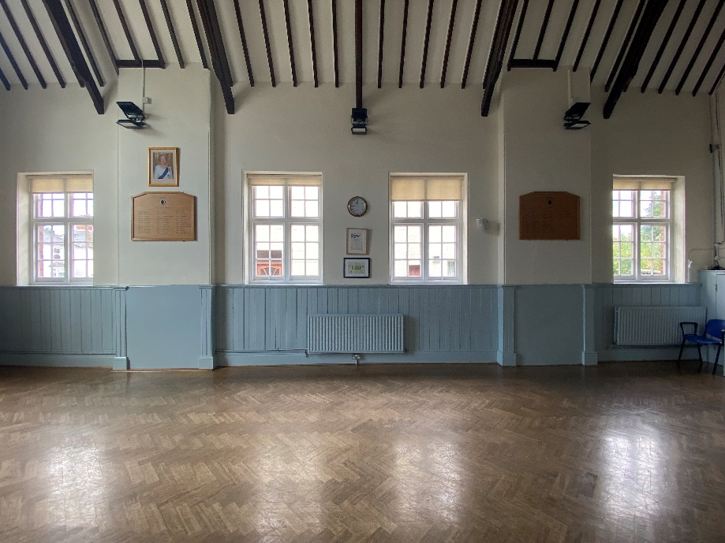
Front windows external | Side hall windows
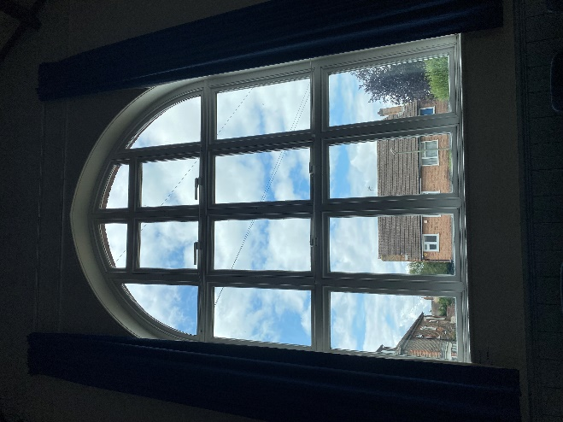 | 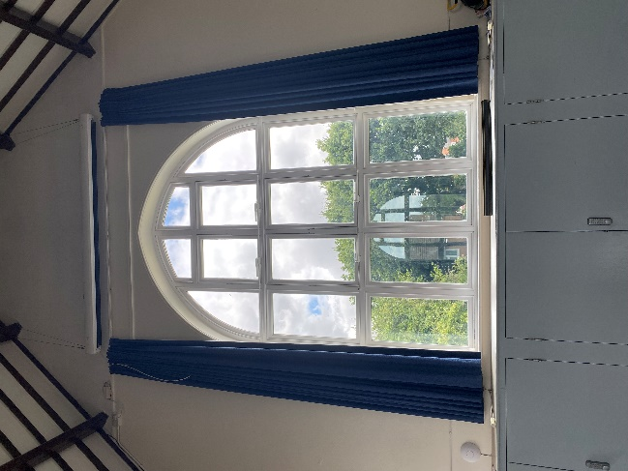
Front windows inside | Rear windows external

