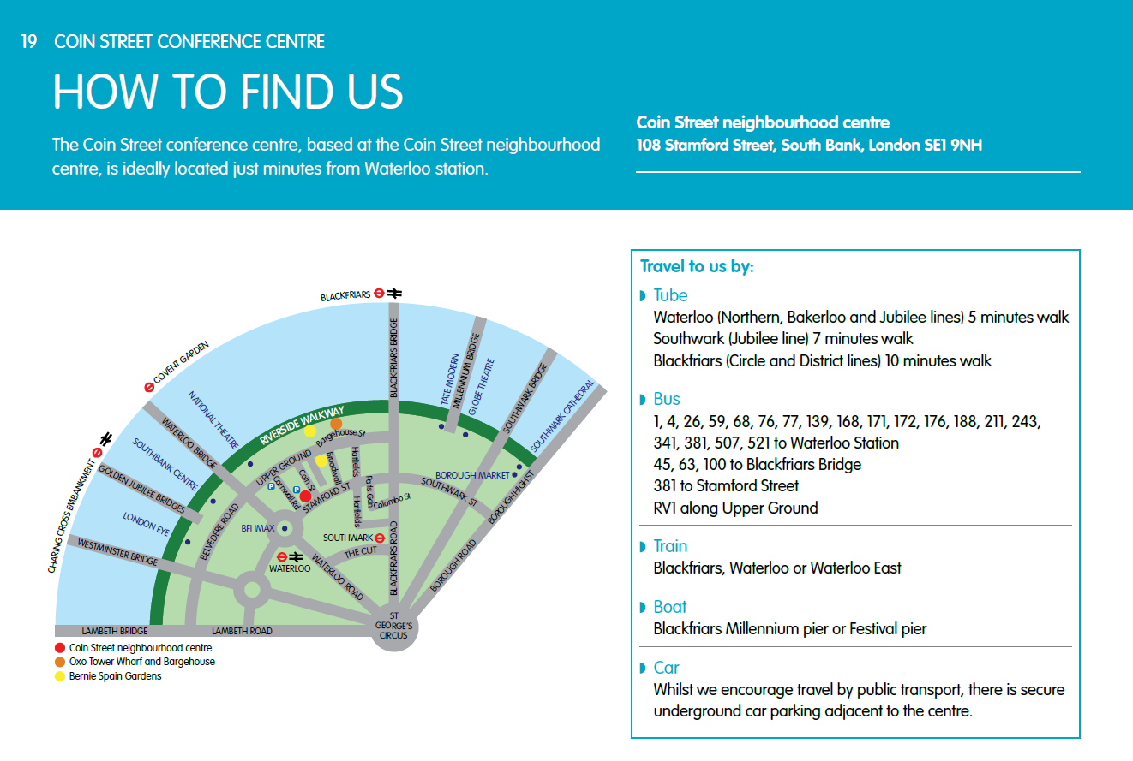
Arrival: Upon arrival please ask reception to direct you to Max Nasatyr Room. Please go up to the third floor suite via the stairs/lift, and follow the signs to the Max Nasatyr Room. Please sign in at the registration table set up in the third floor.
