JNCC Marine Feature Activity Sensitivity Tool (FeAST) replacement

Functional Specification v1.0

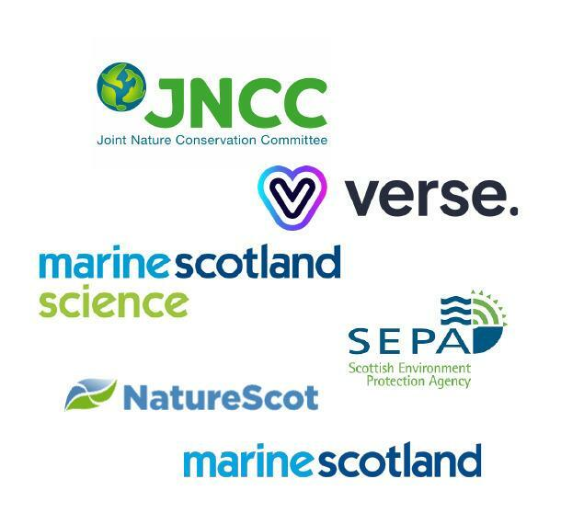

## Document Purpose

This Functional Specification is intended to support the development of a replacement for the FeAST tool, in particular to provide a third-party supplier of services tendering for the replacement project, (and if successful responsible for delivering the replacement), with a clear view of the purpose and scope of the replacement software tool, the functional and non-functional requirements, and the envisaged technical architecture and data design.

There are two key elements to this document: Conceptual Design sections and Technical Sections.

### Conceptual Design Purpose

The Conceptual Design sections include everything from the Project Aims through to the Functional Requirements (as well as appendix documents referenced from those sections).

The Conceptual Design is intended to enable iterative review and approval of the key functional components and overall design of the replacement FeAST tool. These document sections have been used to develop a more complete technical specification (the Technical Sections).

These sections should be understandable for the majority of project stakeholders.

### Technical Sections Purpose

The Technical sections include the full statements on Non-Functional Requirements and the additional sections beyond these, specifically the Architecture, Data Flow, Entity Relationship and Data Dictionary.

These sections are more relevant for technical project stakeholders.

## Contents

**Document Purpose** **1**

Conceptual Design Purpose 1

Technical Sections Purpose 1

**Contents** **1**

**Project aims** **4**

**Project Background** **4**

**Critical Success Factors** **4**

**Key Concepts** **5**

**High level data model** **7**

Features 8

Activities 8

Pressures 8

Biotopes 8

Other 9

Audit Capabilities 9

**User personas** **9**

**System profiles and permissions** **11**

**Principal workflows** **12**

**User Interface wireframe design** **13**

**Functional requirements** **13**

Search by Feature 13

Search by Activity 14

Activity Feature Comparison 14

Search by Pressure 14

Biotope Information 14

Data Exports 14

Access Help 14

Access Glossary 14

User Accounts 14

Content and Data Management 15

System Auditing 15

Landing Page 15

Evidence Quality Assurance 15

Page Branding and Styling 15

User Feedback 15

Sitewide Search 15

Privacy Policy 15

Cookies 15

Other 15

**Non functional requirements** **17**

Accessibility 17

Analytics 17

Proposed Key Metrics: 18

Proposed Site Goals: 19

Backups/Disaster recovery 19

Backwards compatibility 20

Contact 21

Future proofing 21

Hosting 22

Operational Acceptance 23

Legislation 24

Information Governance 24

Mobility 24

Performance 25

Permissions/security 25

Responsiveness 25

Scalability 26

Usability 26

Compliance 26

Open Data 26

Open Source 27

Open Standards 27

Consistent User Experience 28

**System Architecture** **29**

**Data Flow Diagram** **29**

**Data Model Modifications** **30**

Entity Relationship Diagram **31**

Data Dictionary **31**

**Appendices** **32**

Appendix A - Functional Requirements 32

Appendix B - User Personas 32

Appendix C - Wireframes 32

Appendix D - Data Flow Diagram 32

Appendix E - Entity Relationship Diagram 32

Appendix F - Data Dictionary 32

## Project aims

The Feature Activity Sensitivity Tool (FeAST) Working Group made up of JNCC, Marine Scotland, Marine Scotland Science, NatureScot and SEPA are investigating the options to replace the existing FeAST application. This is to address user feedback on areas where the current tool could be improved, allow the addition of different marine features and additional functionality. Verse is a digital agency with a specialism in UX and UI design. Verse are working with the FeAST Working Group on a redesign of the platform, including a review and improvement of the user experience, and costed proposals for delivery options for the solution.

## Project Background

The FeAST tool is used to collate information on feature sensitivities, pressures, activities, and the associated evidence base for Scottish features of conservation importance. It is possible through FeAST to search by either marine feature or activity. FeAST presents assessments of sensitivity of Scottish features of conservation importance to various pressures (e.g., siltation) and links these to marine activities that could be associated with these pressures. It assesses and combines assessments of tolerance and recovery to derive an overall sensitivity score. It does not consider the intensity, frequency or cumulative impacts from activities taking place at specific locations.

Although there are other sensitivity tools a key distinction is that FeAST is the only tool that provides assessments at the wider feature level. Other tools either assess sensitivity at a biotope level, i.e., a more detailed level in the habitat classification hierarchy, or focus on specific locations such as Marine Protected Areas. Retaining the current ‘feature’ level focus is needed to help ensure its usability in the future; much of the legislation and policy focus is on lists of habitats and species at a feature level, such as Priority Marine Features (PMFs) that are marine nature conservation priorities in Scottish waters.

## Critical Success Factors

Critical Success Factors are those aspects of a project that are absolutely imperative for the project to be judged in any way successful. These goals are for the replacement project overall and not just the current phase dealing with the specification of the replacement tool (they also apply to its delivery and ongoing use and support). The following critical success factors have been identified:

* The project seeks to replace unsupported, legacy software and so the primary critical success factor is the successful implementation and adoption of the new tool to the extent that the old tool can be decommissioned.
* The replacement tool should be based on commonly adopted, widely supported tools and technologies that are expected to remain current for at least ten years or more. This will ensure longevity of support and the ability to continue to make enhancements without being vulnerable to a lack of resource availability (which can drive up project costs). Tools and technologies used should meet government requirements for accessibility and open standards for software development.
* The replacement tool should provide a more effective user experience to the extent that users can achieve their site goals more quickly and efficiently than currently, and users have more confidence in the information they are accessing.
* The replacement tool should provide a user experience that educates and guides users to the extent that more valid results are returned for a majority of use cases.
* The number of users should increase relevant to current numbers of users, as a result of improved user experience and user confidence.
* The replacement tool should enable a high level of self-sufficiency in relation to content update and system maintenance, to reduce the ongoing ownership costs of the tool as much as possible.

## Key Concepts

These key concepts are key to an understanding of the proposed design

|  |  |  |
| --- | --- | --- |
| **Concept** | **Definition** | **Example** |
| Feature | Primarily this is a “Marine Protected Area protected Feature”. Including geological, geomorphological and ecological features. | Megascale glacial lineations, Seamounts, Burrowed mud, Basking shark and Fan mussel beds |
| Feature Category | A Feature category is how Features are classified in order to group together features with similar characteristics. | Quaternary of Scotland (Geological features), Cenozoic Structures of the Atlantic Margin, Habitats, Mobile Species, Low/limited mobility species |
| Feature Reference | A Feature reference is a piece of evidence (primarily Peer-reviewed or Grey literature) that is relevant for that Feature. | Clark, R.B. 1997. Marine Pollution, 4th ed. Oxford: Carendon Press., |
| Pressure | Force acting upon the marine environment, for example smothering of seabed habitats and species. | Electromagnetic changes - Basking shark and common skate only - Local electric field of 1 volt per meter; Local magnetic field of 10 telsa (µT). |
| Benchmark | A defined description or degree at which a pressure is exerted. These Benchmarks enable the assessment of sensitivity relative to a specified change in an environmental factor.This is an Attribute of Pressure. | A deposit of 100gC/m2/yr Permanent loss of existing marine habitat (to land or coastal infrastructure). |
| Feature-Pressure | The Feature Pressure combination is used to enable many-to-many relationships between Features and Pressures. It is also used as the node point for linking together the Evidence Base, Sensitivity and Confidence scores. Information about which activities cause the Pressure and whether the Feature is exposed to the Pressure are also captured here. | Feature - Deep Sea Sand  Pressure - Electromagnetic changes  Sensitivity - Not Assessed  Confidence - Not Assessed  Evidence Base - Relevant to basking shark and common skate only  –  Feature - Deep Sea Mud  Pressure - Removal of non-target species (lethal)  Sensitivity - High  Confidence - High  Evidence Base - Tillin et al. (2010) consider deep sea muds to have a high sensitivity to the pressure but with no further evidence presented. The degree to which particular examples of the habitat is sensitive to the pressure will be dependent on the species present. |
| Evidence Base | The body of evidence used to assign a sensitivity and confidence level to a given Feature-Pressure combination. This is an Attribute of the Feature-Pressure. | 'No evidence to assess at present time.'  'This feature is not intertidal and therefore not exposed to this pressure.'  'Coral gardens are thought to have a high sensitivity to the pressure but with no supporting evidence provided in Tillin et al. (2010).' |
| Sensitivity Assessment Score | The degree to which species or habitats are tolerant to change (resistance) and their ability to recover (resilience) when exposed to a given pressure at the given benchmark. | Medium - Features with medium sensitivity are those characterised by medium resistance and no to low recovery or no to low resistance and medium to high recovery. |
| Sensitivity Confidence Score | Indicates the level of confidence in the Sensitivity assessment score assigned to a particular Feature/Pressure combination. | Medium -There is some specific evidence or good proxy information on the sensitivity of the feature to the relevant pressure,  Not Assessed - n/a |
| Activity | An activity is effectively a human activity that may or may not exert (see Association) some form of pressure on a feature | Aggregate extraction, Beam trawling, Cables and pipelines |
| Association | An association allows qualification of whether an activity is the cause of a pressure, and whether a feature is exposed to the pressure. | Associated but not exposed - The pressure is thought to be caused by the activity, but the feature is not considered exposed to that activity |
| Activity Category | An Activity category is how Activities are classified in order to group together Activities with similar characteristics. | Extraction, Beach Replenishment, Fishing, Bioprospecting, Infrastructure |
| Military Activity | Military Activity is included to allow additional data (Activity Code) to be included against Activities in the Military Activity Category. It is effectively an additional hierarchical level. | Aerial Activity (Activity) : Air to Air firing (Military Activity) : AAF (Activity Code) |
| Evidence Source | The Evidence source is used to indicate the type of Evidence for a given Feature-Pressure (see above) | Directly relevant peer-reviewed literature,Directly relevant grey literature, Expert judgement |
| Species | The Non-indigenous species reference table for users is linked to the INIS pressure benchmark | *Crepidula fornicata* - Slipper Limpet  Sargassum muticum – Japanese Weed  Urosalpinx cinerea – American Oyster Drill |
| Biotope | A Biotope is a sub-Feature level entity that is more specific with respect to Habitats and Species. In the context of FeAST, these are the Habitat Types listed in Annex 1 of the EU Habitats Directive. | *Sponges, cup corals and anthozoans on shaded or overhanging circalittoral rock, A4.711* |

## High level data model

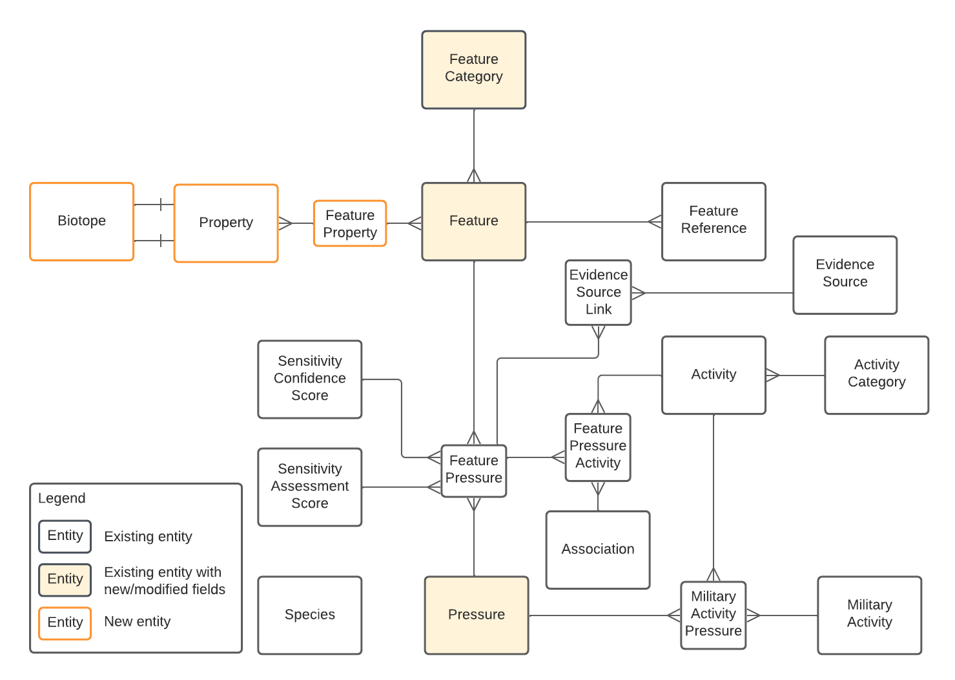

This diagram shows the key relationships between the above concepts. These relationships are also described below to aid understanding of the diagram.

The full data model is available in **Appendix E - Entity Relationship Diagram**

### Features

* Features belong to a single Feature category
* A Feature has one or more Feature References
* Features relate to Pressures via a Feature Pressure relationship (meaning the Feature may be sensitive to and/or exposed to the Pressure).
* Each Feature Pressure relationship is given both a Sensitivity Assessment Score, which indicates a Feature’s tolerance to change and ability to recover from the pressure at a given benchmark, and a Sensitivity Confidence Score (with the exception of one Feature subtype) which indicates how much confidence the Assessment is given.
* Each Feature Pressure also has additional information and cited references relating to the justification for these assessments and confidence; this is provided in the Evidence Base. Additionally, there is a link to an Evidence Source which gives the type of Evidence (e.g., peer-reviewed literature or expert judgement) for a given Feature-Pressure

### Activities

* Activities belong to a single Activity category
* Activities simultaneously relate to specific Pressures and Features via a Feature Pressure Activity relationship (meaning that an already defined Feature Pressure relationship has an additional specific relationship with an Activity)
* The Feature Pressure Activity relationship has an Association value, which allows qualification of whether an activity is the cause of a pressure, and whether a feature is exposed to the pressure.

### Pressures

* Pressures have no categorisation
* Pressures relate to Features through the Feature Pressure relationship already described
* Pressures relate to Activities through the Feature Pressure Activity relationship already described
* Via the many-to-many relationship entities, a Pressure can have a causal link to multiple Activities and may or may not impact multiple Features.

### Biotopes

* A Biotope is a sub-Feature level component of the FeAST data model
* Biotopes are related to Features via Annex 1 Sub Types and Depth Zones, represented within the Data Model by Property
* Biotopes have their own specific sensitivity to certain pressures and activities, however these data will be held in MarLIN
* Users will need to filter the FeAST data according to their work with the Annex 1 habitats, FeAST will hold information about the Sub Types and Depth Zones and provide aggregated sensitivity information at Feature level as well as directing the User to the source data held in MarLIN

Further information about the Feature - Biotope data model can be found in the Data Modelling Modifications section later in this document.

### Other

* Military Activities are defined separately in the data but behave as per Activities in terms of relationships with other entities.
* Species is a data entity that is provided as reference data specifically for the 'Introduction or spread of non-indigenous species & translocations (competition)' Pressure Benchmark. In this context, these data will be available to the user as a reference in the Glossary.

### Audit Capabilities

* The incumbent design for tracking data changes will be retained, this will ensure traceability on which data were changed, by whom and why. An Entity Relationship Diagram of these tables is in Appendix E and further details can be found in the data dictionary.

## User personas

User personas describe types of users, and help to focus prioritisation of software functions and requirements, by making it as clear as possible what each type of user needs to be able to achieve when using software. A range of users were articulated in earlier documentation including

* Regulators (e.g., Marine Scotland, Local Authorities, SEPA)
* Other advisers (e.g., JNCC, NatureScot staff)
* Industries
* Other interested users, including consultants, researchers and local communities.

Through further discussion and interviews, we have distilled the various specific user examples into six distinct User Personas which each represent common themes in terms of motivation for use of the tool, objectives when using the tool, and other relevant factors.

The User Personas that have been identified for FeAST v2 are:

* Public / General, e.g.:
  + A member of an environmental charity group or other group interested in marine features
  + A member of the general public who lands on the site through general search for a loosely related topic
* Academic, e.g.:
  + Masters or PhD students or postdoctoral researchers investigating an aspect of marine Pressures on one or more Features from one or more Activities
  + Researcher from within a Government Agency performing a specific research project for that Agency
* Consultant, e.g;
  + Marine ecologist providing advice on Activity Pressures for certain Features, to enable improvement to development practices, inform the priorities of conservation projects, etc
  + Consultants might use the tool in relation to some of these activities:
    - Support compiling Environmental Impact Assessments (informing but not directly active in the process).
    - Support Habitat Regulation Assessments
    - Support MPA assessments.
    - Benthic visual surveys requests.
* Developer, e.g;
  + Offshore wind developer doing preliminary research before working on an Environmental Impact Assessment for an offshore windfarm and associated infrastructure
  + Developers might use the tool in relation to some of these activities:
    - Initial site suitability assessment
    - Site-specific advice
    - Initial screening of development – checking for features and sensitivities
    - During more strategic liaison over plans and policies with Government Agencies and regulators
* Government Agency, e.g.:
  + Various roles within NatureScot, JNCC, Marine Scotland, Marine Scotland Science, SEPA using the tool to perform the requirements of their public role in regard to providing advice and reporting on matters such as Priority Marine Features, OSPAR Joint Assessment and Monitoring Programme, etc
  + Government Agencies might use the tool in relation to some of these activities:
    - Reporting and assessment duties (e.g., includes Scotland’s Marine Atlas, and reporting duties relating to the Scottish MPA network, Natura and OSPAR).
    - Developing a well-managed network of MPAs (management discussions, including Regional Marine Plans, priority work on the more sensitive features, developing detailed Conservation Objectives, understanding feature recovery and connectivity etc.)
    - Joint work on safeguarding Priority Marine Features
    - Climate change work – supporting recovery and resilience
    - Strategic and site-specific work in marine conservation, by better understanding and highlighting potential impacts and advising on protection.
    - Advice on regulated activities in marine waters - using the tool to help inform advice to developers/regulators working in Scottish waters. The actual advice production is outside of the scope of the tool, but it might use evidence from the tool and the developer might be referred to the tool if they haven't already used it.
* Administrator, e.g.:
  + Subcategory of user from Government Agency with additional responsibilities to maintain the content and data of the tool, manage users, etc
  + Could also be an outsourced role to a technical agency or team who support the Government Agency responsible for system administration

Note: it is possible for a single individual to be more than one type of User Persona. For example, one individual could act as both a Government Agency user and an Administrator, or as a Government Agency user and an Academic user.

Full details of the personas can be found in **Appendix B - User Personas**

## System profiles and permissions

System profiles are slightly different to User Personas, in that they describe the specific functions that different types of user accounts can use within the FeAST v2 system (note: some users are not represented in this way because they don’t require a user profile to use the site, e.g., the Public / General User Persona above).

We anticipate five system profiles:

* Ordinary User - covers the Academic, Consultant, Developer and Government Agency Personas. Implies that the User has created an account and can log in to the system
  + Can access all the publicly available content
  + Can create and save searches
  + Can manage profile data
* Contributor - Government Agency Persona (and possibly Consultant and Academic Personas)
  + Create new content in certain defined areas
    - Pressure (including setting Pressure Category, updating Pressure descriptions)
    - Activity (including setting Activity Category and Associations and updating Activity descriptions)
    - Feature (including setting Reference, Category, Evidence base summaries, Sensitivity Confidence and Sensitivity Score for Pressures)
  + Submit new content for approval and publication by a Data Manager
* Data Manager - Covers the Administrator Persona
  + Full content control
    - Everything available to Contributor
    - Ability to publish content submitted by a Contributor
    - Page content such as the Landing Page, Privacy Policy, etc.
    - Creation of new Pressure, Activity, Feature Categories
  + Access to bulk editing tools for all data
  + Access to revision history / restore versions of the tool data
* System Admin - Covers the Administrator Persona
  + Can make Ordinary users into Contributors or remove Contributor rights
  + Can add / block users
* System Owner / Super Admin - Covers the Administrator Persona
  + Controls the fundamental settings of the tool
  + Can create System Admins

## Principal workflows

A workflow in user-focused software is any kind of controlled process where the user has to follow defined steps to achieve a goal. This contrasts with general use of a software tool where a user can interact freely with components in any order, they see fit.

Some of a workflow may be partially automated for the user, and the user may or may not be able to move back from certain steps to earlier steps, and they may or may not be able to skip certain steps. A workflow may also involve more than a single user, e.g., an editor and an approver user.

Providing workflows is a good way to ensure that processes that need certain inputs in a certain order to achieve valid outputs are controlled.

We have identified the following principal ‘workflows’ for FeAST v2, all of which are comparatively simple with few steps.

* Adding New/Editing and Publishing Features
  + Deals with the creation and approval flow for Features and associated information
  + Involves the following actions and states
    - Create (state is ‘Draft’). Allowed users Contributor or Data Manager.
    - Submit (state is ‘Awaiting Approval’). Allowed users Contributor or Data Manager.
    - Approve (state is ‘Published’). Allowed users Data Manager.
* Adding New/Editing and Publishing Activities
  + Deals with the creation and approval flow for Activities and associated information
  + Involves the following actions and states
    - Create (state is ‘Draft’). Allowed users Contributor or Data Manager.
    - Submit (state is ‘Awaiting Approval’). Allowed users Contributor or Data Manager.
    - Approve (state is ‘Published’). Allowed users Data Manager.
* Adding New/Editing and Publishing Pressures
  + Deals with the creation and approval flow for Pressures and associated information
  + Involves the following actions and states
    - Create (state is ‘Draft’). Allowed users Contributor or Data Manager.
    - Submit (state is ‘Awaiting Approval’). Allowed users Contributor or Data Manager.
    - Approve (state is ‘Published’). Allowed users Data Manager.

## User Interface wireframe design

The wireframes provided as an annex to this Conceptual Design are intended as a visual guide to the intended user flow and overall user experience, to assist with understanding how the functional requirements will be met.

They are not intended to be viewed as a final design. The user interface choices made (typeface, colours, component spacing, etc) can be varied as part of creating the final design for the solution. The basic arrangement of components, their sequencing and the structure of data should be considered more fixed (though some modifications are still possible), for the areas of functionality covered by the wireframes.

Some functional areas of the Feast v2 tool have not been created as wireframes, for example some of the back-office management functions.

The wireframes can be viewed in **Appendix C - Wireframes.**

## Functional requirements

There are four categories of functional requirements described:

* Existing - functions that are currently provided by the FeAST tool and need to be retained as they are (which would include some UI improvements along with the overall UI / UX improvement)
* New and Modified - completely new, or significantly redeveloped / extended requirements.
* Deprecated - functions that are provided in FeAST that do not need to be preserved in FeAST v2.
* Out of Scope - functionality specifically ruled out after discussion (includes current functionality, and new functionality that has been under consideration but agreed not required)

The full breakdown of functional requirements, alongside delivery statements providing additional detail on how these requirements should be met, is included in **Appendix A - Functional Requirements.**

The following summary of the key requirement areas provides an overview of the key functionality before reviewing the detail in Appendix A.

### Search by Feature

The ability to execute a search for the Pressures that are linked with one or more Features and see the resultant Feature sensitivity assessment. Searches can be executed based on browsing Feature categories or by the user typing in a known Feature directly. Results should be filterable based on a range of criteria such as the level of sensitivity a Feature has to the Pressure, or Feature category or data flags, e.g., Features that are Priority Marine Features.

### Search by Activity

The ability to execute a search for the Pressures that are associated with a particular Activity, and see the Features and associated sensitivity scores for those Pressures. Also, able to filter based on a range of criteria such as the Activity type or the level of sensitivity a Feature has to the Pressure associated with the Activity.

### Activity Feature Comparison

The ability to be able to achieve a certain level of combined reporting on Activities and Features related to or associated with Pressures, within the same view.

### Search by Pressure

The ability to execute a search for either the Activities or the Features that are associated with one or more Pressures, and filter based on a range of criteria.

### Biotope Information

The ability to view which biotopes are part of features/feature categories and provide links to the biotope level sensitivity assessments hosted by MarLIN.

### Data Exports

The ability to export the results of various searches as common downloadable formats, and tailor the search results for export. Additionally, the ability to export a Feature sensitivity report containing Biotope information.

Additionally, the ability to export References in usable format for reference software.

### Access Help

The ability to access clear and easy to follow help, including training videos, and methodological reference data.

### Access Glossary

The ability to access a full range of terminology used in FeAST as well as the full library of Pressures, Activities, Features and their categorisations and the Invasive Non-indigenous species (INIS) list.

### User Accounts

The ability for users to create login accounts, manage their account settings, and access a range of additional functions dependent on user type.

### Content and Data Management

The ability for certain user types to control the full range of content and data presented through the tool, including bulk update tools.

### System Auditing

The ability for certain user types to review summaries of data, audit high level data quality, and access appropriate functions to enable good record keeping, monitoring and auditing of the tool, in compliance with the policies of the FeAST working group constituent organisations.

### Landing Page

Specific requirements for a proposed landing page including links to other similar tools and resources and presentation of information in relation to recently published updates to the FeAST v2 tool.

### Evidence Quality Assurance

Content page providing full explanation of the Evidence Quality Assurance methodology and standards for different types of Evidence in use in FeAST v2.

### Page Branding and Styling

High level requirements in relation to brand and styling.

### User Feedback

The ability for users to provide direct feedback on tool content, in particular to flag if they think there is an issue with any of the evidence presented.

### Sitewide Search

The ability for users to easily search for specific content across the entire site, and to receive relevant results.

### Privacy Policy

Best practice Privacy Policy content and features.

### Cookies

Best practice Cookies Policy content and features.

### Other

A range of other requirements that do not fit with a particular category.

## 

## 

## Non-functional requirements

### Accessibility

The system should be compliant with Public Sector Bodies (Websites and Mobile Applications) (No. 2) Accessibility Regulations 2018 which mandates at least WCAG 2.1 level accessibility.

Specifically, the FeAST v2 tool will meet WCAG level AA in line with both the UK Government [Making your service accessible: an introduction](https://www.gov.uk/service-manual/helping-people-to-use-your-service/making-your-service-accessible-an-introduction#meeting-government-accessibility-requirements) statement and the Scottish Government [Usable and Accessible](https://resources.mygov.scot/criterion/usable-and-accessible/) criterion from the Digital First Service Standard. Meeting this defined WCAG level AA standard will ensure the material presented on the tool will be accessible, meaning it can be used by as many people as possible. This includes those with:

* impaired vision
* motor difficulties
* cognitive impairments or learning disabilities
* deafness or impaired hearing

The FeAST v2 tool will follow the [WCAG 2.1 Guidelines](https://www.w3.org/TR/WCAG21/) against the four design principles:

* perceivable
* operable
* understandable
* robust

The site will have an accessibility statement that explains:

* how accessible the FeAST v2 tool is
* what accessibility issues the FeAST v2 tool has, if any
* a plan for how any issues to be fixed

The site will either pass a Third Party Accessibility Audit (indicated for a transactional service on GOV.UK to cost between £3,000 and £7,000) or if the delivery team includes an appropriately trained professional may include a full Accessibility Compliance statement against all the relevant components of the [WCAG 2.1 Guidelines](https://www.w3.org/TR/WCAG21/).

### Analytics

The system must be able to provide usage analytics such as user activity and functionality usage statistics. Implementation of a third-party analytics package (such as Google Analytics) is required to allow tracking of various metrics to show how users interact with the tool and to give greater insight into where improvements are needed. Defining and setting site goals will help develop the tool further and push for a better user experience.

These are the high-level recommendations for the key metrics that the FeAST Working Group may wish to track, and some proposed Site Goals.

For the avoidance of doubt, the requirement is to implement and integrate an appropriate third-party analytics package to enable tracking of key metrics and site goals such as those described here, but the specific metrics and goal tracking are expected to be more closely defined in later project stages. Therefore, the analytics design should be flexible and be able to support an evolving analytics strategy.

#### Proposed Key Metrics:

* Dwell time

This is the amount of time that goes by from the moment a user clicks on a search result to the moment they return to the search engine results pages. It will give an indication of how long a user spends on the tool before returning to their search engine.

* Bounce rate

This is more specific than dwell, as it shows the users that only visit one page and then leave. Given the nature of the tool is to perform a search this would be a good highlight to investigate as to why a user has visited and then left without interacting.

* Number of registered users (by user profile type)

Seeing statistics of users will give a better understanding as to who is using the tool and categorising by user profile allows for a more accurate insight.

* Number of weekly users

This metric will help show how many active users are on the tool on a weekly basis.

* Number of monthly users

This metric will help show how many active users are on the tool on a monthly basis.

* Average time on page

By highlighting the average time on each page, you can gather an overview of which sections are being used most or have low user activity.

* Average session duration

This will show how long users are active on the tool, giving a statistic on the average lengths. This could also be cross referenced with other metrics to show the session duration between different user profiles.

* User location

Traffic source destination to provide an indication of where the majority of site traffic is coming from geographically. It should be noted there are many factors that can obscure this information or provide misleading results (e.g., use of VPN).

#### Proposed Site Goals:

* Number of searches by Feature / search by Pressure / search by Activity

An event goal to view which will show when a user clicks a certain field of the tool, focusing on the searches will show the most active sections of the tool.

* Number of report downloads

As with above, being able to view how many users complete a search and download a report shows how many times users actually complete a full search.

* Number of saved searches

Could set a specific goal around targeting users to save searches which would be useful to the tool and how much output it gathers.

* Session duration

By monitoring the session duration metric, a duration goal could be set to reach a certain target and give focus to where improvements or help is needed.

* Pages per session

Highlighting the amount of pages that are visited will give an overview of how the user journey is being approached and if there are any possible navigation improvements.

Any analytics implementation is required to be compliant with legislation and industry best practice in relation to Cookies and other tracking technologies. Any use of analytics Cookies or other tracking technologies must be documented in the Cookies Policy for the FeAST v2 tool. Furthermore, it must be possible for individual users to disable analytics and tracking technologies and the analytics design must support this without compromising any of the other functional or non-functional requirements.

### Backups/Disaster recovery

The system must have the ability to recover from severe data corruption/loss through a backup system. The restoration of specific data is already included in the Functional Requirements under section UA4 for certain user profiles; this requirement deals with more complete disaster recovery provision.

Of relevance to this non-functional requirement is the later ‘Hosting’ non-functional requirement which stipulates cloud hosting.

Cloud hosting backups should be taken at a minimum frequency of daily (more frequent is fine) and include the full technical scope of the FeAST v2 software application (databases, content, front end UI components, etc).

Depending on the final solution architecture, multiple backups may be required in order to provide full coverage (for example, where different cloud-based components are used like a combination of directly managed cloud hosting combined with SaaS software products hosted by a third-party software vendor).

Disaster recovery requirements are based on the Scottish Government [Digital First Standard for Business Continuity](https://resources.mygov.scot/criterion/business-continuity/). On the basis that the user population for the FeAST v2 tool is expected to be relatively small, and within this population most users are not expected to use the tool every day, it is assumed that the ability to restore the data within 1 to 2 working days is sufficient to meet this requirement. The full restore process covering all components should be documented.

Backup processes should include adequate retention of data to restore the site if corruption/data loss is discovered some time after any causal incident.

The Scottish Government [Data Retention Policy for Emails and Records](https://www.gov.scot/publications/foi-19-02225/) stipulates the operation of a twin datacentre model in order to ‘provide maximum resilience and disaster recovery’. Essentially this would involve a further backup system using a mirrored backup for extra security and ease of recovery. If the FeAST v2 tool is hosted by the Scottish Government, the twin datacentre model may be needed, however if the tool is hosted elsewhere alternative backup systems may be more appropriate.

An alternative that may be simpler to implement but still provide an additional level of resilience would be to take an additional backup on a less frequent basis (e.g., monthly) and store this on secure cloud storage.

This approach also provides some additional resilience where SaaS products are used. Content and data will be backed up according to a given SaaS software vendor’s policies (which it can be expected will be stringent enough to meet this requirement, but should still be checked). However, SaaS products will put any content or data stored in them behind a paywall which effectively means a lapse in payment on the account could make the data and content inaccessible.

### Backwards compatibility

The system must be compatible with the data model (after transformation) of the current FeAST application.

The data models of FeAST and FeAST v2 are different, in order to better support the requirements of FeAST v2, particularly in relation to improved user experience and support for some new areas of data (e.g Biotopes).

However, the key data concepts from the original data model are preserved, and the changes are additions and restructures rather than data being made obsolete (with the exception of a small number of specific attributes).

It is not expected that it will be possible to directly apply an export of data from the FeAST database into the FeAST v2 database (or vice versa - and there is an expectation that the original FeAST tool will be decommissioned after FeAST v2 goes live anyway).

It will be possible to export the data from the current FeAST database and migrate it into the FeAST v2 database, without extensive reworking of the data, with some controlled transformations. These transformations and the migration process itself would be planned out during an implementation project of the FeAST v2 application described in this specification.

### Contact

The system must have a clear contact point/email for comments, suggestions, criticisms; (either a named person or role or group email) and options for the users to give feedback for the data or provide overall comments, which can then be actioned upon.

This non-functional requirement is addressed partially through the Functional Requirements under ‘User Feedback - Feedback on Content’.

Beyond this a general form of contact is still required - this will be achieved using an accessible contact form on the site, with standard fields for contact details and a text area for feedback. The notification and form content will be sent to an appropriate central email address to be determined by the FeAST Working Group. Further processes for onward routing of query types can also be decided but these processes will be outside the scope of the FeAST v2 tool.

It should be possible to easily change the destination email address of the contact form at a later date.

### Future proofing

The system must be extensible, allowing for additional parameters and fields to be added to the data model as other usable and relevant information becomes available, and allow for the extension of the model to further tables as well as the ability to update data and references within the existing data model.

The data model for the FeAST tool is quite complex, in particular in regard to the relationships between different entities - changes to the underlying model must be managed carefully.

Users can of course already update the relationships between existing data objects in the data model, with regard to the existing data objects. For example, a new relationship between a Feature and a Pressure (new Feature Pressure). These functions are covered in the Content and Data Management functional requirements.

It is not expected that any of the User Profiles would have the ability to make significant changes to the data model, but the solution should allow for the Data Manager user profile to be provided with edit access to some of the values (e.g., the names of labels and content of fields, or the definition of certain items in the Glossary). These changes should be subject to certain constraints (e.g., number of characters for labels or fields) and be subject to review and approval before publication to the live tool. Only the values that are realistically expected to need regular update should be enabled for this, and this is not expected to be many.

Other such changes can be accommodated through a change request to the team responsible for technical support of the tool.

For more extensive changes to the system in relation to the data model (above and beyond amending field values), the following broad types of changes should be supported but it is not expected or required that any of the user profiles would have any level of access which lets them do this directly - these changes should all be the subject of change request to the team responsible for technical support of the tool, or possibly a small development project in some cases.

These more granular summaries of ‘extensibility’ define the types of changes expected to be included in this requirement:

* Ability to add attributes to existing data objects (or remove them)
  + Add/remove values for these attributes for existing data
  + Amend the UI / UX to make use of the new attributes / accommodate loss of attributes
  + Add processes for users to add new instances of the attributes when creating / amending affected data objects
* Ability to add new data objects / remove data objects
  + Determine their relationships with all other data objects / redefine relationships to accommodate removal of objects
  + Add data attributes for any new objects
  + Possible amendment to attribution and relationships of other data objects
  + Significant amendment to the UI / UX to accommodate the addition or removal
  + Add processes for users to add new instances of the data objects and create relationships

To meet the requirement for extensibility, the database technology used should be modern, well documented and supported and in wide adoption, with a large user community. Any ongoing support and maintenance package should include flexible provision for these sorts of changes, with a rate card and estimated sizing against different examples of changes. Appropriate documentation should be maintained and updated with each change. Environments to enable development and testing prior to publication to live environments are required (see Operational Acceptance).

### Hosting

The Scottish Government [Digital First Service Standard](https://resources.mygov.scot/criterion/data-hosting-and-data-centres/) stipulates government agencies should “adopt cloud computing or virtualisation as the preferred approaches to the delivery of data hosting for the service” which rules out any element of on-premise hosting - this also corresponds with best practice industry approach for the vast majority of modern software applications.

In terms of the preferred ownership model of cloud hosting, the FeAST v2 tool hosting can be provisioned through one of two scenarios:

* Fully outsourced hosting infrastructure managed by the service provider responsible for maintaining and supporting the solution, including all environments (e.g., development, test and live/production)
  + Use of any appropriate high security, high availability enterprise level hosting solution
  + Environment access is managed by the service provider alongside maintenance and support of the solution on all environments. End users only provided access to the live/production environment
  + The codebase management and deployment pipelines will be managed entirely by the service provider responsible for maintaining and supporting the application
  + Some elements of the complete solution (depending on the option selected) may sit outside this model. For example, some components and packages are taken as fully managed SaaS cloud applications. The configuration management of any SaaS products will be the responsibility of the service provider.
* Deployment of the solution to hosting infrastructure and environments owned and managed by a member of the FeAST Working Group constituent organisations.
  + Expected to be based on either a Microsoft Azure or Amazon Web Services package to take advantage of government agency commercials with these providers
  + Environment access management for all environments would be controlled by the relevant government agency, and access provided to the service provider responsible for maintaining and supporting the solution
  + The codebase management and deployment pipelines can be managed to an extent by the service provider responsible for maintaining and supporting the application
  + Some elements of the complete solution (depending on the option selected) may sit outside this model. For example, some components and packages are taken as fully managed SaaS cloud applications. Configuration management of SaaS products will be the responsibility of the service provider but some coordination with the FeAST Working Group constituent organisations for some integration configuration may be required.

### Operational Acceptance

To achieve operational acceptance, during the implementation project the FeAST v2 tool will regularly be tested, and further testing will be required in the long term to support changes and functionality enhancements, bug fixing, etc.

It must be possible to test the end-to-end service in an environment identical to that of the live version, including on all common browsers and devices, and using dummy accounts and a representative sample of users.

There will be a development environment to implement any changes before being updated to the live version and allowing tests to be completed without impacting any true users.

Deployment of content updates should follow a QA procedure ahead of going live, by using unit tests before a thorough test plan to ensure the performance of the tool and the user experience is always of high quality.  
  
Updates should include browser testing with focus on any styling changes and site speed for larger updates. Device tests should be incorporated to allow flexibility for any future users accessing the site via mobile. At all times the tests should also consider the Accessibility non-functional requirements, with consideration for how users navigate the tool.

### Legislation

The system must be compliant with the [National Cyber Security Centre 14 Cloud Security Principles](https://www.ncsc.gov.uk/collection/cloud-security/implementing-the-cloud-security-principles) and be GDPR compliant by design.

1. ​​Data in transit protection
2. Asset protection and resilience
3. Separation between users
4. Governance framework
5. Operational security
6. Personnel security
7. Secure development
8. Supply chain security
9. Secure user management
10. Identity and authentication
11. External interface protection
12. Secure service administration
13. Audit information for users
14. Secure use of the service

### Information Governance

Evaluate what user data and information the digital service will be providing or storing, and address the security level, legal responsibilities, privacy issues and risks associated with the service (consulting with experts where appropriate).

The user data and information the FeAST v2 application will collect from users will be limited in scope to that required to provide user account functionality, and some very broad categorisation data so that managers have some understanding of the types of users that are attracted to the application.

### Mobility

The system is not required to function through a mobile device such as a smartphone or tablet, we only expect to use our preferred method of access through a desktop or laptop at this time, however the solution should not prevent mobile access at some point in the future.  
  
Whilst it is not a priority the design can be easily adapted to work in a mobile environment with minimal work on the development side. This is due to most of the design focusing around two main columns. While in desktop the content would be fluid and take up the width of both of the columns and for mobile devices it would stack. Whilst interactive elements have been styled to a high quality on desktop, it will allow users on devices to easily interact without any issues on touch inputs.

### Performance

The system must be appropriately available, excepting downtime for development, maintenance, and scheduled tasks, which will be agreed with the stakeholders. It should provide adequate performance levels for a user to manage and analyse their data without significant impairment. Availability will be maximised by:

* Use of separate development and testing environments to minimise any disruption in the live environment when changes are being planned and made
* The provisions of the Backup/Recovery non-functional requirements
* Regular updates and maintenance to the tool including any required security patches or software version upgrades

The Scottish Government Digital First Standard stipulates that tools for the analysis of performance data should be used. Some of this analysis will be provided through the data captured through the provisions of the Analytics non-functional requirement (for example, pages with high abandonment rates provide an indication of issues with specific pages; sudden changes in tracked metrics performance across the site indicate systemic problems).

Above and beyond this, there should be server monitoring and notifications of common automatically detectable issues and errors, with notifications in place for the supporting service provider to be able to respond rapidly.

### Permissions/security

The system must be secure against the most common forms of attack (e.g., SQL injection) and incorporate a suitable access and permissions model which enables organisations to confidently manage their own data and ensure that users out with their organisation cannot accidentally or maliciously alter their data, the system should maintain an audit trail of access as well as any CRUD operations.

### Responsiveness

The system must reflect any changes or updates made to the system (when saved) are made immediately and available to others (rather than through a batched process).

The latest updates to data and content are to be shown in a summary on the landing page.

In order to meet this requirement without compromising the overall performance of the tool in terms of page and asset load speed etc, the tool will have appropriate caching enabled (meaning users will view content that is ‘old’ but served to them more efficiently) but certain content updates will force invalidation of the caching to ensure that content is refreshed close to real time whenever changes are made.

The system requires no offline capability (e.g., the ability to have a ‘local’ version of the application that Users can interact with followed by their updates are integrated with the database once connectivity is restored). If Users have no internet access the tool will not be accessible or usable.

### Scalability

The system must be scalable in its architecture to allow for additional data to be held without the need for architectural change, and to be able to cope with an increase in the numbers of users quickly and easily, such as simply increasing the capacity of a hosting service. Data Manager Users will have access to full content control, with access to version of the tool data.

In particular, the system must comply with the standards set out in the Scottish Government [Digital First Service Standard for Sustainability](https://resources.mygov.scot/criterion/sustainability/), which sets out that digital services should be built in a way that they ‘can be iterated and improved on a frequent basis and make sure that you have the capability, resources and technical flexibility to do so.’

This non-functional requirement is closely related to, and in large part met by, the provisions of the Future Proofing non-functional requirement.

### 

### Usability

The system should be documented, providing all information that users and administrators require to competently interact with all aspects of the system. User interfaces should be fully descriptive and laid out in a manner that guides the user along the process required to enter/edit/view and audit data in a simple and logical manner so that the system is easy to operate.

Improved help section will help guide users through the tool with categories that can be easily searched on the main navigation. Training videos will help expand on topics, ranging from new users to the more advanced. Users can search for terms through a pop-up glossary search without leaving the current page.

### Compliance

The system will need to comply with the various governance procedures employed by the stakeholders.

In particular, the Scottish Government [Digital First Standard](https://resources.mygov.scot/standards/digital-first/) (which has been referenced above in relation to other non-functional requirements) includes a number of other relevant areas that have not already been covered.

#### Open Data

*Make all non-personal, non-commercially sensitive data from the service available for re-use by others under an appropriate licence.*

The extent to which this can be met relies on the relevant policies and procedures of the organisation members of the FeAST working group (in particular any organisation that adopts formal/legal responsibility for the tool) and whether those policies and procedures allow for this type of licensing.

In relation to technical aspects to support compliance, there are types of licences that enable a greater or lesser degree of control over the content. For example, the licence types covered under the [Creative Commons organisation licenses](https://creativecommons.org/licenses/) include various options in regard to whether content can simply be copied, whether it can be copied and amended / incorporated into other content or products, whether any resulting new content needs to carry the same licence type, and whether attribution to the original creator is required.

The specific licence stipulated under the [Scottish Government Open Data Strategy](https://www.gov.scot/publications/open-data-strategy/) is the [Open Government Licence for Public Sector Information](https://www.nationalarchives.gov.uk/doc/open-government-licence/version/3/).

The tool should enable users to identify data and content that is covered by a particular licence and what the requirements of this licence are. The tool should also enable users to identify content that is restricted in regard to intellectual property.

#### Open Source

*Make all new source code open and reusable, and publish it under appropriate licences (or provide a convincing explanation as to why this cannot be done for specific subsets of the source code).*

The extent to which this non-functional requirement can be met is dependent on the delivery option selected. Options which include fully bespoke development using already open-source development languages and frameworks are likely to meet this requirement more fully. Where any commercial third-party products are used (even if these are ‘free’ community editions), there are likely to be limitations to the extent the solution can be considered ‘open source’.

Source code for any proprietary tools used within the tech stack to deliver the solution will almost certainly be excluded from any open-source licences, and the source code for these products will remain the property of the organisations that develop and provide them.

Based on the delivery options presented, the areas of code excluded from an open-source licence may relate to back-office functionality around the way data and content can be managed on the site, the way updates are managed through a deployment pipeline, tools for managing the hosting configuration and security configuration etc.

However, all the delivery options presented alongside this specification rely on bespoke front end UI development, so the data, final code outputs (e.g., html and css) and all the public user functionality are more likely to be able to be included in an open-source licence.

#### Open Standards

*Use open standards and common government platforms where available.*

This requirement is concerned with ensuring that existing tools and technology platforms already in use by the Scottish Government are re-used for efficiency wherever possible. Examples include common hosting platforms to leverage already-negotiated preferential commercial terms, re-use of design systems.

The areas where compliance with this requirement is likely to be achieved are:

* Use of the existing [Digital Scotland Design System](https://designsystem.gov.scot/), or a design system already in use by organisational members of the FeAST Working Group
* Use of photographic assets already owned or licensed by the Scottish Government or organisational members of the FeAST Working Group
* Use of hosting providers with which the organisational members of the FeAST Working Group have preferential commercial terms in place (if the solution is hosted by one of these organisations and not outsourced).

#### Consistent User Experience

*Build a service consistent with the user experience of the rest of mygov.scot including using the design patterns and style guide.*

The tool will follow the [Digital Scotland Design System](https://designsystem.gov.scot/)

## 

## System Architecture

The recommended system architecture is based on the concept of ‘Headless’ systems. Headless architecture is a version of Decoupled Architecture in which the presentation layer of an application is separate from backend services. These services (which include the content and data users of FeAST v2 will consume) are exposed as well-defined services through an API. This API can serve multiple user facing applications in the future if necessary, or if the future requirements of the application change significantly, an entirely different user interface could be created (e.g., FeAST v3) without the need to replace the backend services (the database, the CMS, etc.).

This form of system architecture also allows for the introduction of additional sources of data in the future with relative ease - for example, geospatial data for Features, direct integration of Biotope data from a third party source, etc.

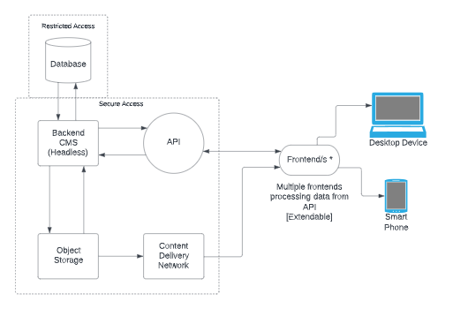

The above diagram shows an overview of the system architecture, the focus is on the technology being used rather than specific hardware or software. The main points to highlight are:

* Access to the server directly will be restricted
* Content will be served through the API to the frontend /s
* Image content will be stored on a separate server or service which will be distributed to the frontend via a content delivery network

## Data Flow Diagram

The Data Flow Diagram shows an overview of data flow from the customer and admin perspective. A Data Flow Diagram (DFD) is a graphical representation of the “flow” of data through an information system, giving an indication of the main processes and helping to understand the functions of the system.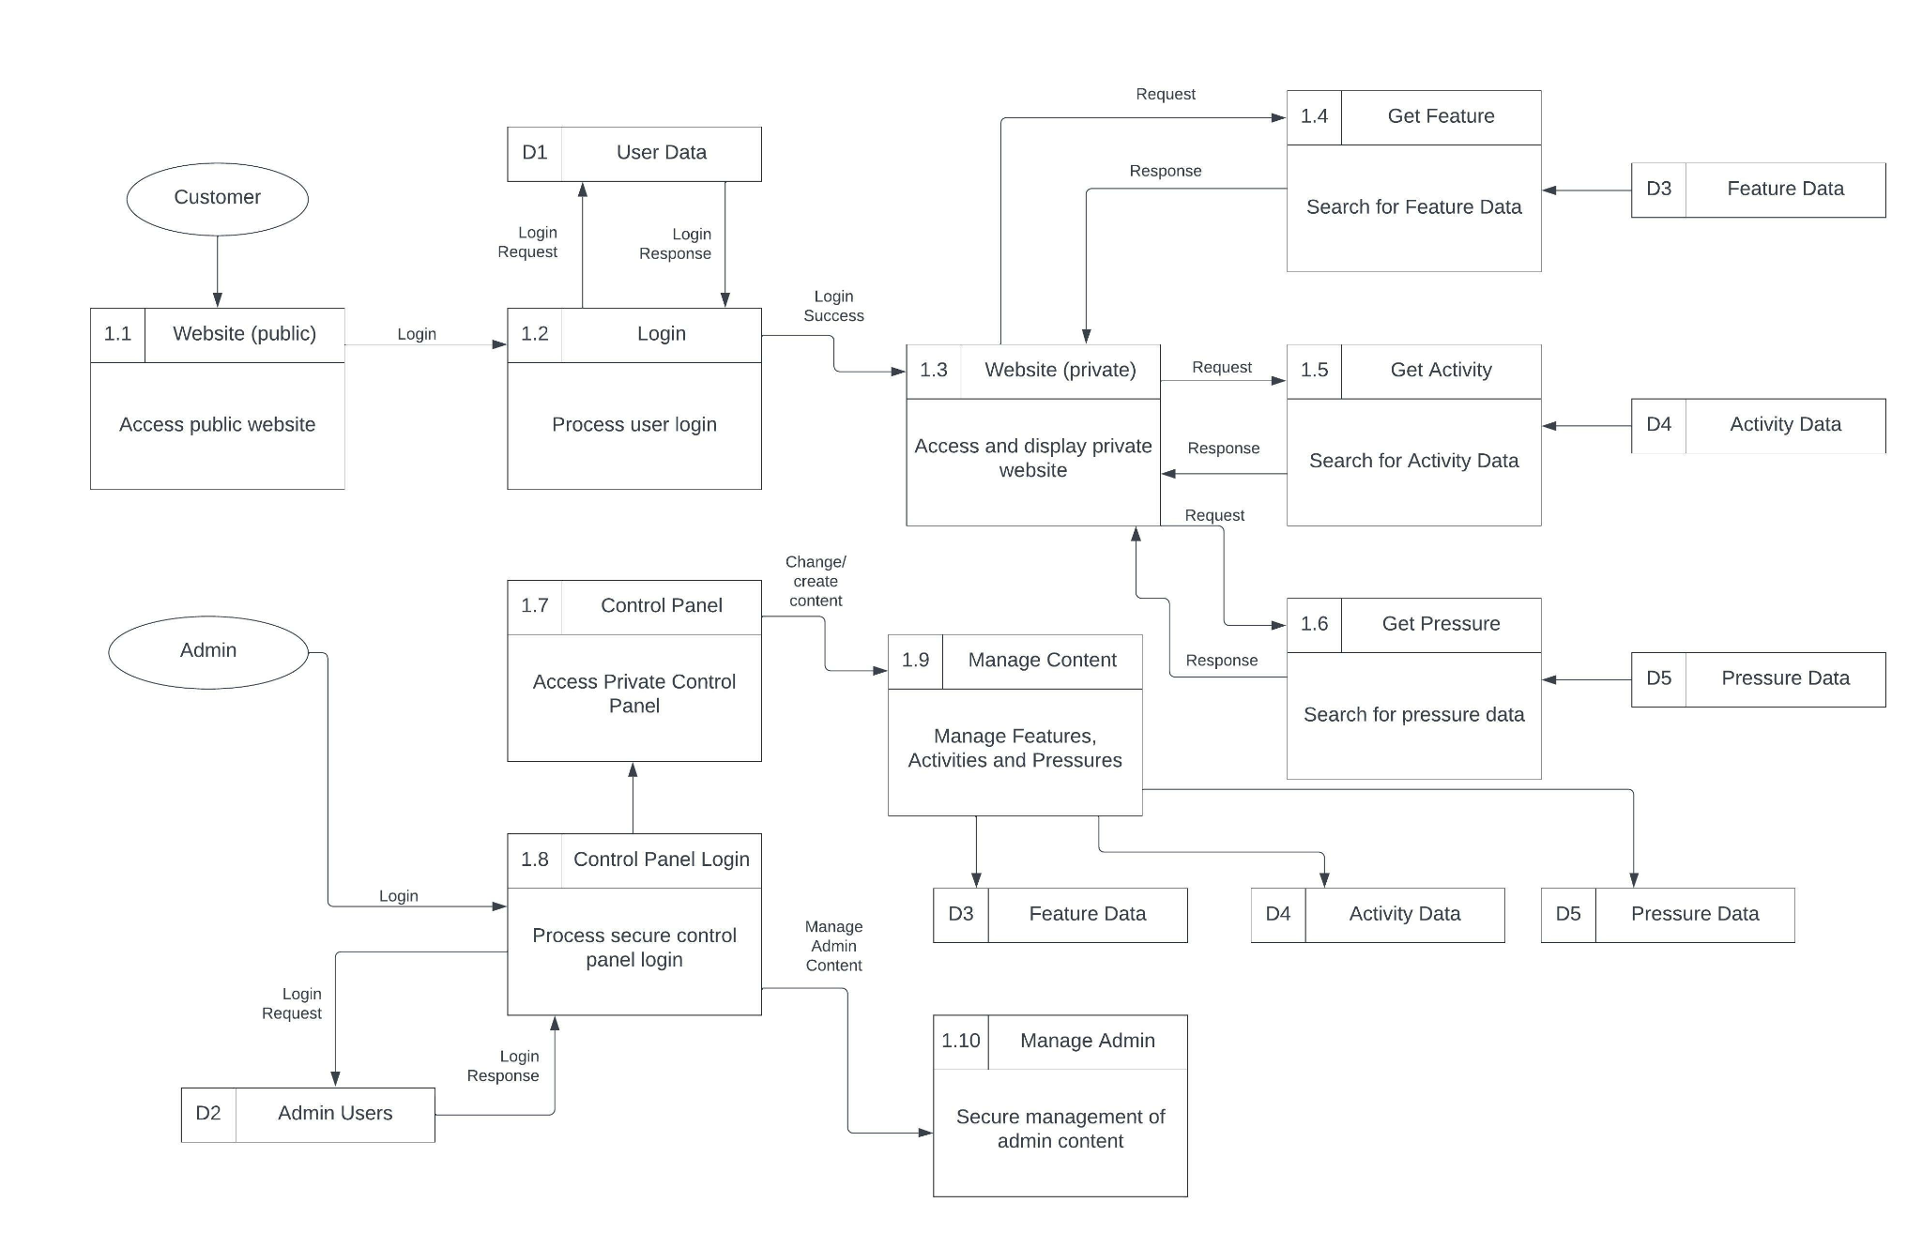

The Data Flow Diagram is also presented as a separate **Appendix D - Data Flow Diagram** .pdf file so that it can be reviewed more closely.

## Data Model Modifications

As part of the project workshops, every effort was made to ensure that any data additions on the FeAST working group roadmap were taken into account, this meant that the functional requirements included features that are not possible with the existing data model. To add further context and technical information relating to these requirements, Verse endeavoured to analyse the incumbent data model to highlight areas where changes will be required to ensure that the functional requirements can be achieved by the FeAST replacement tool.

These data model additions take two forms:

1. Additional fields on existing entities
2. New entities and relationships

The former category of additions are low impact, and only involve minor data migration activities to update the existing records. The latter is more involved, and required additional effort to propose a draft data model that would be suited to the functional requirements expressed as part of this project.

The largest data model change related to the inclusion of Biotope information at Feature level in the FeAST replacement tool. Currently, Nature Scot have an alternative tool for providing Biotope/habitat level sensitivities; MarLIN. It was important that FeAST did not try to replicate the function of MarLIN, however it is also key that the FeAST replacement tool provides high level Biotope data and directs the User to MarLIN so that they can reach more detailed Biotope-level information if they need to.

To satisfy this need, new data model components that provide a relationship between Features and Biotopes via an intermediate Entity called a Property have been drafted. At Day 0, the Property entity will be used to assign Annex 1 Sub Types and Depth Zones to both Features and Biotopes. With a generic approach, it will be much easier to add additional Properties in the future in the event of requirements evolving or new features being added. Modelling the data like this means we can minimise the number of tables (and therefore database calls), but also provide the ability for Features to be filtered according to their Properties. Additionally, once the User has filtered their results according to their desired Properties, the appropriate Biotope information can be included, whether that be on the screen within the tool itself, or as part of the fuller “download data” option. These more specific requirements will be determined when the FeAST replacement tool is in development.

It is important to note that this approach will impose some requirements on the Biotope data, namely that a Biotope must have a Sub Type and a Depth Zone. Without this information (in some instances new information) then filtering Features by Sub Type and Depth Zone will be an unreliable way of identifying Biotopes that are related to the Feature(s). This draft data model will require additional design work to ensure that the solution is fit for purpose. This design work should take place prior to any development taking place on the data model relating to Features, Biotopes and Properties. More information about this part of the data model can be found in the ERD and Data Dictionary (see below).

## Entity Relationship Diagram

The Entity Relationship Diagram is a more detailed and complete version of the High Level Data Model in the Conceptual Design sections above.

The diagram is too detailed to usefully include in the body of this document and is instead attached as **Appendix E - Entity Relationship Diagram .**pdf file. Note that new fields and tables are identified in the Entity Relationship Diagram by being coloured Orange.

## Data Dictionary

The Data Dictionary is a full breakdown and definition of all the data objects in the FeAST v2 tool and their attributes.

The document is too detailed to usefully include in the body of this document and is instead attached as a **Appendix F - Data Dictionary .**xls file. Note that new fields and tables are identified in the Data Dictionary document by being coloured Orange.

## Appendices

### Appendix A - Functional Requirements

* Additional Excel Document

### Appendix B - User Personas

* Additional PDF Document
* [**Link to the Personas**](https://www.figma.com/file/SJds1CFshQHTH0x14oSI9z/Personas)**.** This link is to a Figma file. Figma is an interface design tool. Users will need to be able to access the Figma system to view these.

### Appendix C - Wireframes

* Additional PDF Document (for an example selection of the Wireframes only)
* [**Link to the full Wireframes**](https://www.figma.com/file/5qvb5G9g7ruoCTYWad4inq/FeAST%2FMoodBoard?node-id=11%3A2). This link is to a Figma file. Figma is an interface design tool. Users will need to be able to access the Figma system to view these.

### Appendix D - Data Flow Diagram

* Additional PDF Document

### Appendix E - Entity Relationship Diagram

* Additional PDF Document (E.1 = core Data Model)
* Additional PDF Document (E.2 = Audit Model)

### Appendix F - Data Dictionary

* Additional XLS Document