Biggleswade Town Council (BTC)
Football Infrastructure Specifications

This document includes facts on the current locations, sizes, quantities and condition of the football pitches and associated infrastructure at the Town Council. This information should be taken into account when preparing a bid in response to the expression of interest exercise on the CCS online procurement portal.
BTC has three sports grounds across the town set out below in the three maps, at Stratton Way, Eagle Farm road, and the Lakes.

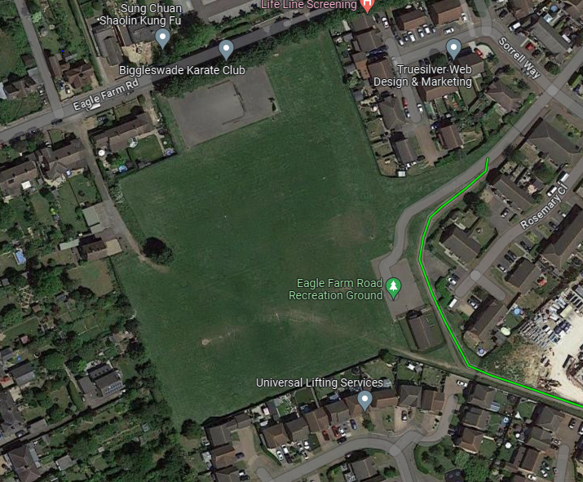

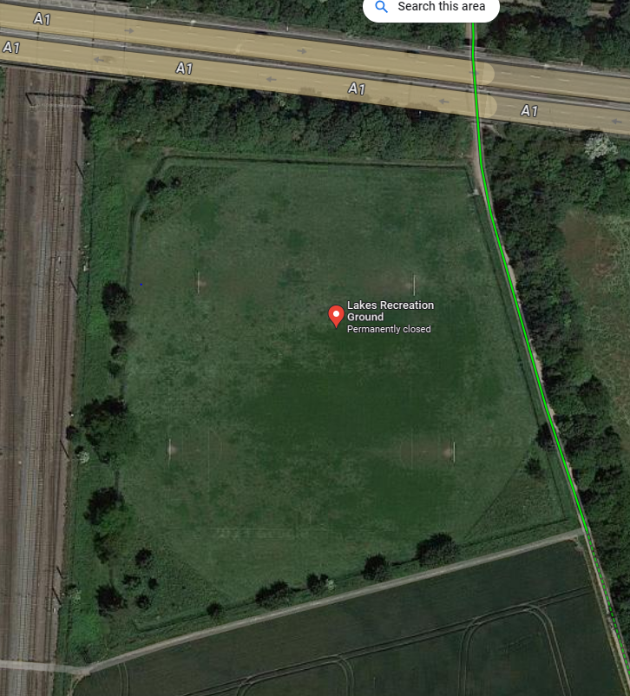

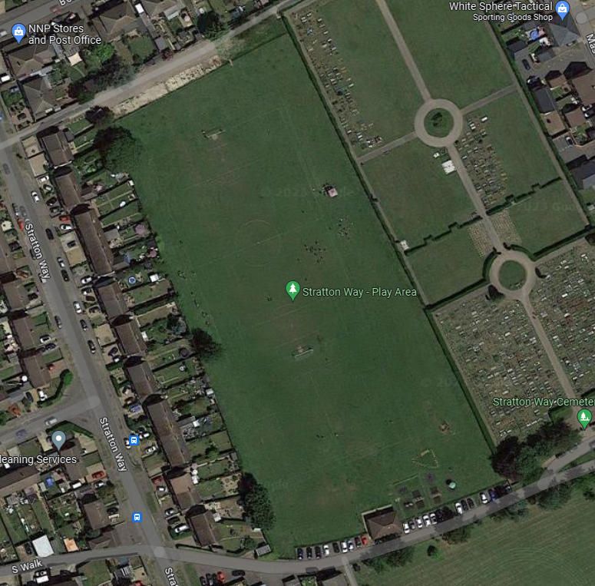

For the 2023-2024 season, BTC has line painted 8 football pitches of varying sizes as per the below dimensions;
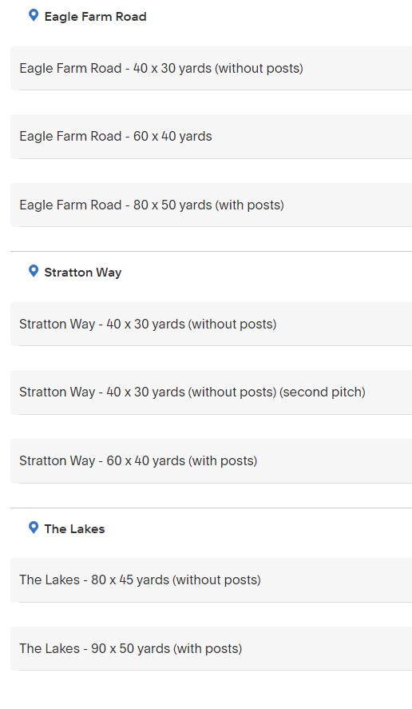

Pitches Maintenance Equipment Required:

-Sisis True Level Roller (2 metres width)
-Bertollini Rotavator (10 bhp plus)
-Line marking equipment

Football Equipment Required:

-Three complete sets of 7 v 7 goal posts, 3.6m x 1.83m all on rolling wheels
-Two complete sets of 9 v 9 goal posts, 4.88m x 2.13m all on rolling wheels
-Three complete sets of senior goal posts, 7.32m x 2.44m all on rolling wheels
-Eight complete sets of corner flags, poles and markers
-Three sets of 30 foot shipping containers for storage.

