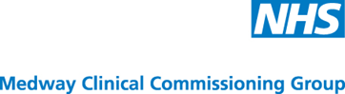

North Kent Clinical Commissioning Groups
Market Engagement Events
January 2016

Working with

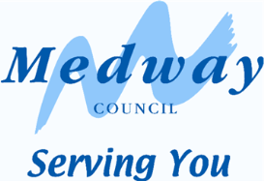
Information for Interested Service Providers
Medway Council Procurement Services

1.0 Introduction
Medway Clinical Commissioning Group (CCG) is expecting to commence the formal procurement process for the procurement of its wellbeing café service to operate across the Medway area. The Commissioners are looking to get early engagement with providers and the market in general who share our passion and commitment and who are dedicated to providing the very best choice, service and patient care standards. In particular the commissioners would like to discuss our plans with the market to understand capacity and the ability of providers to deliver the service. The CCG would be open to ideas around different models of providing the service and are looking for some innovative ideas from providers.
A detailed service specification will be published as part of the procurement process. However, the CCGs would like to get potential provider views and ideas as well as assess current market appetite to provide this service. The outcomes of the event will then determine next steps.
The event will be held on the 8th January 2016 at 13.00
For further Information on the events and to attend, a booking form must be submitted to the nominated contact, please download the attachments to this notice and follow the instructions.
In due course the relevant OJEU notice will be published and the tender will commence via the Kent Business portal www.kentbusinessportal.org.uk

1.1 Market Engagement Events
The event will provide the opportunity for you to meet the Commissioning Team in an informal and interactive setting where we can share information and ideas. We are very keen to hear your views, suggestions, and questions. The aim and outcomes of the market engagement process is:

- To provide opportunity for suppliers in the market to engage and provide pre-tender input with regard to the service going out to tender.

When The event will take place on Friday 8th January 2016 at 13:00 start

Venue 50 Pembroke Court,
Chatham Maritime, Chatham
Kent. ME4 4EL

Medway Council will be assisting the Medway CCG with the Procurement process.

1.2 Booking Attendance
In order to attend you need to book by email, using the embedded booking form ensuring that the following information is included within your response:

- Name of organisation.
- Name of person attending (please note – due to limitations of space we would ask that organisations send a maximum of two representatives each)
- Contact details of representatives attending.
- A very brief description of any experience that you have of delivering the service and related services.

Please send confirmation of your attendance (the booking form) to Thomas Beaumont, Programme Manager via email to: thomas.beaumont@nhs.net.

The booking form is embedded below

