

**Evaluation Report**

**Contract Title: Supply of Telecoms Severs**

**Contract Reference: PS/21/46**

**Prepared by: Gareth Peters**

**Date: 11/03/2021**

**Roles and Responsibilities**

|  |  |
| --- | --- |
| Responsible Owner | Brian Sullivan |
| Lead Officer | Phil Griffiths |
| Contract Owner | Kim Hughes |
| Commercial Lead | Gareth Peters |
| Financial Advisor | Simon Rosser |

# Purpose of the Document

This document will act as a record of the Evaluation panel’s recommendation in relation to the *Tender* stage of the procurement exercise to secure *PS/21/46 Supply of Telecoms Severs & Support* for DVLA.

1. **Evaluation process**

The evaluation was conducted in compliance with the DVLA Commercial Policy & Commercial Procedures and utilised the published criteria for this procurement exercise as the basis for evaluation of responses.

1. **Requirement**

The Authority requires a contract to allow the purchase of:

4 Dell R640 PowerEdge Servers are required with detailed specifications required. Attached is the detailed specifications.

Amount required Device Model

2 R640 See description below attached.



2 R640 See description below attached.



For each Server, the following support is required:

Dell ProSupport and Data Protection - Keep Your Hard Drive is also requested for 3 years.

1. **Procurement Route**

CCS Technology Products and Associated Services Framework Agreement (RM6068) Lot 2: Hardware and Associated Services.

1. **Investment Approvals**

See IT Purchase Requisition.

1. **Cabinet Office Controls**

*N/A*

1. **Procurement Timetable**

|  |  |
| --- | --- |
| **Description** | **Date** |
| Upload ITT to portal for procurement exercise | 3/03/2021 |
| Closure of clarification questions period | 8/03/2021 12:00 noon |
| Closure of competition (bid submission deadline) | 11/03/2021 14:00 |
| Evaluation | 11/03/2021 |
| Intended award of contract | 12/03/2021 |

1. **Responses received**

There were 4 supplier responses, these were from CDW Limited, Computacenter (UK) Limited, Insight and Daisy.

All suppliers met the mandatory requirements.

1. **Evaluation Panel (including Declaration/Conflicts of Interest)**

There were no conflicts of interest between the evaluation panel:

Kim Hughes, Rachel Stirrup and Simon Rosser.

1. **Evaluation**

|  |  |  |  |  |
| --- | --- | --- | --- | --- |
| **Role** | **Scoring member (Y/N)** | **Name** | **Title** | **Any Conflict of Interest raised (Y/N).**  **If Yes please confirm any action taken** |
| Chairman | N | Gareth Peters | Commercial Category Lead | N |
| Panel Member | N | Rachel Stirrup | Lead Officer | N |
| Panel Member | N | Kim Hughes | Contract Owner | N |

**Financial Evaluation**

|  |  |  |  |
| --- | --- | --- | --- |
| **Role** | **Name** | **Title** | **Any Conflict of Interest raised (Y/N)**  **If Yes please confirm any action taken** |
| Financial Advisor | Simon Rosser | Finance and Assurance services | N |

**10. Evaluation Panels Assessment**

The evaluation was carried out by a Commercial Finance Accountant on the basis of price.

The tender was evaluated using the following weightings:

|  |  |
| --- | --- |
| **Evaluation criteria** | **Score** |
| Financial / Price Factors | 100% |

**11. Evaluation Panel Outcome**

**CDW Limited**

|  |  |  |
| --- | --- | --- |
| **Evaluation Criteria** | **Your Score** | **Winning Tenderer’s Score** |
| Price - Weighted Maximum Score 100% | 89.35 | 100 |
| Overall Bid Score | 89.35 | 100 |

**Computacenter (UK) Limited**

|  |  |  |
| --- | --- | --- |
| **Evaluation Criteria** | **Your Score** | **Winning Tenderer’s Score** |
| Price - Weighted Maximum Score 100% | 80.63 | 100 |
| Overall Bid Score | 80.63 | 100 |

**Insight**

|  |  |  |
| --- | --- | --- |
| **Evaluation Criteria** | **Your Score** | **Winning Tenderer’s Score** |
| Price - Weighted Maximum Score 100% | 81.01 | 100 |
| Overall Bid Score | 81.01 | 100 |

**Daisy Ltd**

|  |  |  |
| --- | --- | --- |
| **Evaluation Criteria** | **Your Score** | **Winning Tenderer’s Score** |
| Price - Weighted Maximum Score 100% | 100 | 100 |
| Overall Bid Score | 100 | 100 |



**Winning Tender – Daisy**

**Total Contract Value – £31,092.66**

**Term – 3 years**

**12. Recommendation**

Following evaluations, the panel recommended to award the contract to Daisy. This provides the best VFM for the Agency from the costed options provided.

**Evaluation Panel Chair (CD member)**

**Name: Gareth Peters Date: 12/03/2021**

**Signature:** 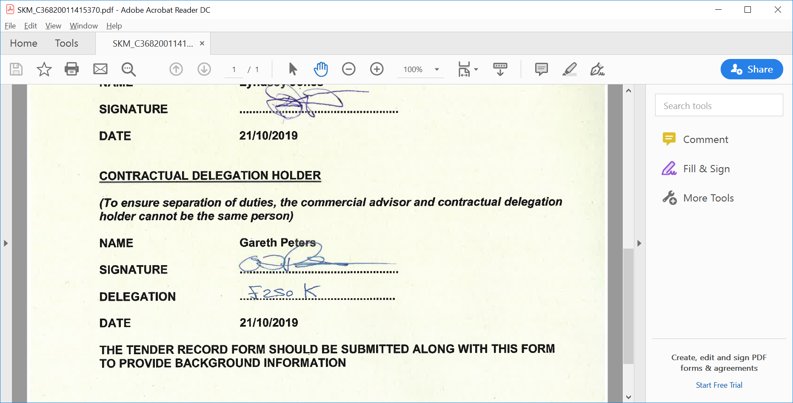

**Financial Advisor**

**Name: Simon Rosser Date: 12/03/21**

**Signature: See email**

**Evaluation Panel Members:**

**Name: Kim Hughes Date: 12/3/2021**

**Signature:** 

**Name: Rachel Stirrup Date: 12/3/2021**

**Signature: **

**Approval to Award Contract: (Contractual Authority Holder)**

**Signature:** cid:image001.png@01D6189C.B91A4640

**Name: Matthew Bromham**

**Job Title: Category Manager**

**Contractual Authority: £1 Million**

**Date: 12/3/21**