SWP No: SWP 22 | Title: Whole Body Entry to RCV for Cleaning |  | Risk Assessment:
Description: Whole body entry to RCV (Cleaning) |  | Area: Refuse Collection Vehicle |  | Task: Whole body entry Cleaning

PPE:
Issued Overalls
High visibility waist coat or coat
Nitrile gloves
Safety Footwear
Protective glasses

Purpose: - to detail the safe system of work to be used when undertaking a whole body entry to RCV for the purposes of cleaning the rear body of compacted waste debris affecting efficient operation of the vehicle.
Note: This activity is only to be undertaken by a qualified Boston Borough Council Vehicle Workshop employee (Mechanics / Technicians).
No: | Description | Key Points & Diagrams
1 | Employee Safety  Drivers are responsible for cleaning out the rear body of the RCV at regular intervals. Drivers should report to the garage to request entry to the rear body. Drivers and Vehicle Workshop employees (Mechanics) shall keep their colleagues informed of their location and activities at all times.  In particualr drivers shall inform the garage that they will be working in the rear of a vehicle for the purposes of cleaning and provide them a timescale for the activity. | Vehicle Workshop employees are responsible for opening up the side entry door, securing the vehicle ignition keys and switching off the power isolation.
2 | Report to garage for cleaning operation  The RCV should be empty of waste with the plate in the correct position towards the rear. Drivers shall report to garage and request assistance. Drivers reverse vehicles using reversing assistants to the vehicle wash area.
3 | Install DANGER DO NOT START OR MOVE VEHICLE steering wheel sign  Vehicle Workshop employees shall install the steering wheel sign on the steering wheel of the RCV. | Photograph showing sign  
4 | Switch off the vehicle ignition and secure keys  Before entering the rear of the RCV, vehicle workshop employee will switch off the engine and remove keys from ignition and place in their overall pocket. | The second set of keys to each vehicle is kept in a locked cabinet in the vehicle workshop office.  Employees must not remove the second set of keys from the cabinet.  Communicate this requirement to all new employees.  Ignition keys are fitted with an immobilizer, therefore only correct keys will operate the vehicles.
5 | Switch off Power Isolation Switch  Vehicle Workshop employees to turn off the power isolation switch. The switch is located under the body of the vehicle on the right hand side as you face the cab. | Photograph showing the electrical power isolation switch seen in centre.  Switch ‘off’ by turning to downward position  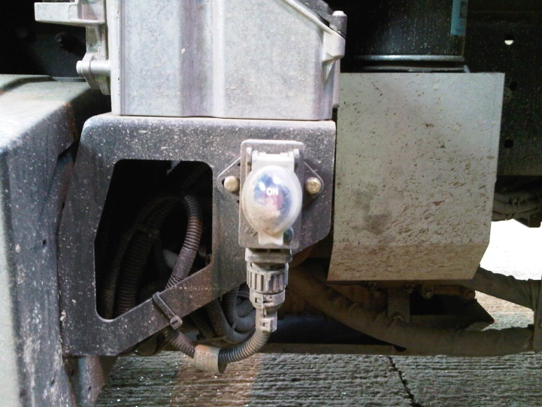
6 | Entry to rear body using side entry door  Unfasten the securing hatch bolt attaching the side ladder to the vehicle body, and lower the ladder.  Vehicle Workshop employees will use the security key to unlock the upper and lower catches and open the side entry door.  Drivers / crew members shall then use the ladder and handles to climb into the rear body of the RCV for the purposes of cleaning. | 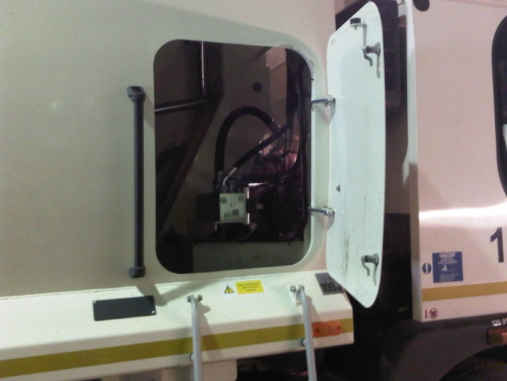  To eliminate the risk of an un-authorised person completing this task, the secure key used to access the side door will be used and retained by mechanics ONLY and second set of keys are locked away in a secure key cabinet.
7 | Cleaning Operation  The driver or crew member will confirm that the vehicle ignition keys are removed and that the power isolation switch is turned to off.  After confirming the vehicle has been correctly isolated, the driver or crew member will then enter the rear body via the ladders.  Wearing the required PPE, a spade will be used to shovel out / remove ALL debris collected on the floor and sides including at the front of the body around the drainage hole.  Debris should be removed to a wheeled bin and disposed of correctly. | The driver or crew member should at all times make his crew and garage staff aware of their location.  The vehicle workshop employee opening up the side entry door shall assume responsibility for informing his mechanic colleagues that the vehicle is being cleaned.
8 | Returning the RCV back to operation  The driver will contact the garage to request the side entry door be secured and locked with the security key.  The driver will then switch on the power isolator and operate the vehicle as required.

