# BH logo 1

Service Specification

WANDSWORTH END OF LIFE CARE COORDINATION SERVICE

# DRAFT v8

# Service Specification

|  |  |
| --- | --- |
| **Service Specification No.** |  |
| **Service** | WANDSWORTH END OF LIFE CARE COORDINATION SERVICE |
| **Commissioner Lead** |  |
| **Provider Lead** |  |
| **Period** | 1 APRIL 2018 – 31 March 2022  (4 years with the option to extend for 3 years). |
| **Date of Review** |  |

## Overarching Governance Structure within the wider MCP Model

The EOLC Coordination Service will form part of the overarching Multi-Speciality Community Provider (MCP) model within Wandsworth. As commissioner of the Service, the MCP Lead Provider (“MCPLP”) recognises that the EOLC Coordination Service is a vital service within the overarching model and will therefore work closely with the EOLC Coordination Service Provider (“the Provider”) to support the successful delivery of the service set out within this specification. The MCPLP therefore considers the below points as essential to the success of their relationship with the Provider:

* The MCPLP and the Provider must consider the working relationship as stretching beyond a typical sub-contractual relationship, that is managed at arm’s length, in order to promote effective relationships and to ensure the Provider and the EOLC Coordination Service delivers a high standard of services;
* This collaborative approach to working will be delivered through some form of joint Governance structure. The purpose of this approach will be used to support the Provider to develop and improve services over the duration of the contract;
* Transparency around issues and risks in the service must be shared with the MCPLP at the earliest opportunity;
* Serious incidents or incidents being considered as SIRIs should be reported to the MCPLP within 24 hours;
* Regular meetings (normally monthly) between the MCPLP and the Provider will take place to monitor performance via contractual KPIs;
* Additionally, regular monthly meetings between the MCPLP and the Provider will take place to monitor the clinical quality of the service where it will be expected the Provider will produce a monthly quality report in an agreed format;
* The MCPLP will require the Provider to engage with a wider stakeholder group of organisations that are seen as key partners in the success of the MCP model.

*\*Please see Appendix 1 for a diagram of how the Governance is proposed to work. It should be noted that this is an evolving model and the Governance will become more established as the MCP Lead works more closely with the Provider*

## Population Needs

### National/local context and evidence base

Difficulties with understanding and coordinating the complexities of an EOLC system is a nationally recognised issue and similar local feedback at an EOLC PPI event in 2013 led to development of the Wandsworth EOLC Coordination Centre model and development of a highly successful 2-year pilot. The service was recognised with a National Council of Palliative Care award for Effective Coordination of Care in early 2017. The pilot service has been extended for a third year, to end on 31 March 2018.

The EOLC Coordination Service in Wandsworth is recognised as a system-wide resource that is and can continue to support the transformational change that is taking place across the Wandsworth health and social care system. It provides a “stable” contact point for patients and Health Care Professionals (HCPs) whilst contributing to, adapting to and incorporating changes to processes and pathways as the system changes. This oversight maximises the use of commissioned services across the system to support quality patient care and improve outcomes for individuals and the system as a whole.

This document sets out a specification for an on-going End of Life Coordination Service that is based on learning from the pilot and so offers a robust model of care that builds on the investment already made. The specified model provides the opportunity to build on the integrated pilot model, seeks to maximise and extend the evidenced benefits and develop greater efficiencies within the wider system.

The specification for the End of Life Coordination Service also includes the following elements:

* Direct provision of rapid response care for fast-track continuing healthcare eligible patients;
* Commissioning and management of the Marie Curie Planned Variable Nursing Service for end of life care patients.

## Outcomes

**2.1 NHS Outcomes Framework Domains & Indicators**

| Domain 1 | Preventing people from dying prematurely |  |
| --- | --- | --- |
| Domain 2 | Enhancing quality of life for people with long-term conditions | Yes |
| Domain 3 | Helping people to recover from episodes of ill-health or following injury |  |
| Domain 4 | Ensuring people have a positive experience of care | Yes |
| Domain 5 | Treating and caring for people in safe environment and protecting them from avoidable harm | Yes |

**2.2 Local defined outcomes**

It should be recognised that the Wandsworth EOLC Coordination Service provides a resource that is part of the system-wide transformation process to improve patient care, in particular through better integration of the HCP teams involved in providing care, supporting the avoidance of hospital inappropriate admissions and supporting faster discharges from hospital. In addition, it has been shown save clinical time across the system. The Service’s activities, therefore, have an intrinsic benefit across the system rather than being seen to “stand alone”. Whilst the Coordination Service must continue to demonstrate its own contribution to key outcomes (as included within the KPIs), these build on those sitting with other elements of the local EOLC system.

## Scope

**3.1 Aims and objectives of Service**

The EOLC Coordination Service provides a dedicated, specialised coordination resource and central point of contact for EOLC patients, their families and those looking after them. The Service aims to deliver the following benefits:

* **Continue to deliver key success and core benefits identified through the pilot scheme evaluation:**
  + The ability to provide clinical reassurance and respond appropriately and quickly in times of crisis: this is a recognised fundamental factor in avoiding admissions and key to facilitating faster discharge, both having qualitative and quantitative impacts;
  + Good working links between the Coordination Service and other organisations across the local EOLC landscape to facilitate patient care, including ensuring effective and ongoing communication and exchange of information about patient care and activating care and support as and when needed. This is described further within this document;
  + An ability to identify and solve operational issues in the system.
* **To integrate with and support other local EOLC-related initiatives and commissioned care providers.**

As described in Section 1 above, incorporating the EOLC Coordination Service as part of the overarching local MCP provides an opportunity to further integrate and ground the work of a dedicated EOLC Coordination Service within primary care, as well as facilitating and maximising integration with other services the MCP is commissioned to provide, including Community Adult Health Services (CAHS). The Service has a key role in ensuring §that patients have access to all appropriate available services in order to maintain their independence as far as is possible, manage their symptoms, engage in supportive therapies and address their sense of wellbeing, all within the context of their cultural needs and preferences.

Because of the nature of the work and role of the (dedicated) Coordination Service, their “intelligence” around the functioning of the EOLC and wider health and social care system is key to maximising quality of care and effectiveness of the system. As such, it is imperative that the EOLC Coordination Service Provider is included (proactively) within key operational discussions, including those relating to:

* MDT discussions about individual patients, including those as part of Gold Standard Framework (GSF) and the Enhanced Care Pathway (ECP);
* MDT discussions as part of the SGH Integrated Discharge Team and other hospital discharge discussions;
* Discussions with the Continuing Healthcare lead provider around individual patient care and ensuring integration of care;
* Service development discussions that impact on the care of EOLC patients, either through direct involvement of the Provider or representation via the CCG or MCPLP as appropriate. This might include, for example, provision of Care Home support, 111/OOH GP service developments, delivery of fast-track care etc. Subject to agreement with the MCPLP, this is likely to include attendance at the CCG’s End of Life Care Clinical Reference Group meetings.

Involvement with and participation in such meetings and discussions by the Provider forms part of the contractual framework in order to ensure accountability.

Many patients referred to the End of Life Care Coordination Service will already be known to other services and organisations. There is a recognised cohort of ageing /frail patients and/or patients with long term conditions who are being cared for by their GP and through existing/developing pathways and initiatives in the community (such as the Enhanced Care Pathway). These pathways are designed to improve their care and to reduce A&E visits and hospital admissions. Over time, some of these patients may be identified as nearing the end of their life as their health deteriorates and, consequentially, referred to the EOLC Coordination Service. Equally, there will be a group of patients referred to the EOLC Coordination Service who are not “transitioning” from other community-based care pathways and services where they are already known but who are identified as nearing the end of their life, usually in an acute setting. This might include, for example, patients with a short prognosis directly referred by an acute/specialist provider as no further oncology treatment is possible or wanted. As the needs of any patient change as they move towards the end of their life, it is important that they can easily be referred to and readily access the full range of EOLC related services to meet their changing requirements and those of their family/carers to ensure the best possible quality of care. Ensuring this happens in a proactive and planned way, where and whenever that is possible, requires active joint working and clear and robust pathways between services – this a clear role of the dedicated EOLC Coordination Service.

The EOLC Coordination Service team will ensure that each patient referred to them has an identified Key Worker. Usually, the Key Worker role will sit with a CAHS team member, although there may be cases where it is held jointly with the Coordination Service team or (in *very* exceptional cases and by agreement) is transferred to be the sole responsibility of a clinical Coordination Service team member. The decision of who is best placed to hold the Key Worker role for an individual patient will be based on the patient’s needs, the relationships already established with the patient/their family or carers and the nature of the care that needs to be coordinated. The role of the Coordination Service is to support the Key Worker. The designated Key Worker will be identified within key documents relating to the patient’s care, including clinical records held by the Coordination Service and the patient’s Coordinate My Care care plan (as described later).

The Provider/Coordination Service team are required to ensure an ongoing programme of “marketing” of the EOLC Coordination Service. This should include a range of both planned activities (including participating in integrated activities with other relevant organisations) and adhoc opportunities to share information about the Service and its role to both health and social care professionals across the local system and with members of the public. The aim of such activities is to increase awareness of the Service and to encourage referrals.

The Provider must ensure the provision of clear, efficient and effective referral documentation that is easily accessible to referrers across the wider EOLC system. As part of their “marketing strategy” as described above, the Provider/Coordination Service team must regularly communicate how to access the referral documentation to key referrers, for example to GPs/GP Practices, to provide reminders about the Service and how to access it for their patients.

Although subject to change as other services develop, the diagram below demonstrates the key role of the EOLC Coordination Service as part of an integrated system, facilitating access to and coordinating local pathways and services for HCPs, patients and their families. Further information is also provided in Appendix 2 of this specification.

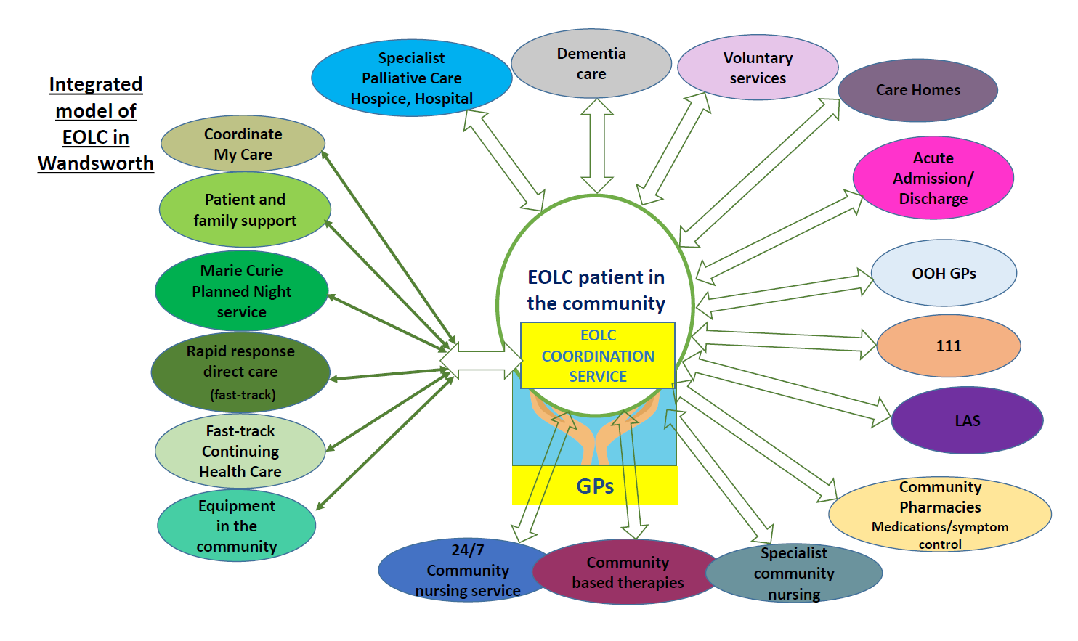

As part of an integrated model, the EOLC Coordination Service provides:

* A resource to support QIPP initiatives for Providers across the system;
* Dedicated support for GPs in caring for their EOLC patients in the community. The EOLC Coordination Service clinical team will be required to work closely with GP surgeries to ensure that EOLC patients on Practice Supportive Care Registers (GSF) are appropriately referred to the Coordination Service to ensure benefits from the Service are realised for more patients and the wider system;
* Integration with CAHS pathways, particularly in supporting the care of patients on the Enhanced Care Pathway and all patients on the CAHS caseload who have end of life care needs;
* Dedicated support for acute providers with rapid discharges to home or care home, if that is the patient’s preference, including via the SGH integrated discharge team;
* Support for Care Homes with the care of residents who have end of life care needs;
* Close working with social care and specialist palliative care teams to ensure a joint and integrated approach to EOLC patient care and that of their families/carers;
* Close working with the local commissioned CHC Provider (and care agencies), ensuring the rapid delivery of fast-track continuing healthcare care packages to support admission avoidance, speed up discharges and improve quality of care for patients.
* A key resource for the local 111 and OOH GP services to support them in caring for EOLC patients.
* **To support greater efficiencies within the EOLC system**

The activities of the Coordination Service aim to directly and indirectly increase the benefits to be gained through numbers of avoided admissions as well as faster discharges. The Provider is required to actively “track” and report patient outcomes (for example why a patient was admitted) in order to maximise the potential “conversion” rates. Identification of system issues (by the Provider) can enable them be appropriately addressed. This will have the effect of maximising efficiencies for the wider system.

The EOLC Coordination Service team will continue to forge strong and focussed relationships with the commissioned CHC lead provider (currently CHS Ltd) to oversee and manage, using jointly agreed processes and protocols, the provision of high quality fast-track continuing healthcare packages to end of life care patients as well as ensuring integration of decision making around need.The Coordination Service has a key role to play in managing patient/family expectations around care and ensuring the follow-up/ongoing assessment of care being provided.

* **To deliver positive patient outcomes:**

It is expected that the EOLC Coordination Service will continue to deliver effective and high levels of patient outcomes, as demonstrated and delivered by the pilot project. There is scope to further improve on levels of performance delivered by the pilot project, particularly through increased marketing of the Coordination Service across the local EOLC system. Specific Key Performance Indicators (as well as for the direct care service described later in this specification) will be included within the contract but an indication of required patient outcomes are provided below:

* + An increasing number of referrals year-on-year (c100 new referrals per quarter in Year 1 increasing to 150+ per quarter by Year 4);
  + Patients being referred for both fast-track CHC packages and coordination of their care;
  + Referred patients have both cancer (c60% in pilot service) and non-cancer diagnoses (c40% in pilot service). Traditionally, patients with cancer have benefitted from specialist palliative care and end of life care services to a far greater extent than those with other conditions and an important role for the Coordination Service is to encourage referrals for patients with any diagnosis;
  + Referred patients are from a range of ethnic backgrounds. The Coordination Service team must ensure that care is personalised and that specific cultural needs and other preferences and wishes are known and taken in to account in the delivery of their care. This may be through ensuring communications with health and social care professionals, liaising with care agencies to ensure they are aware and can meet requests and/or ensuring specific information is included within CMC records;
  + Recognising the limitations of such a measure in terms of patient preferences at the end of life, c75% of patients being actively supported by the Service are expected to achieve their preferred place of death, where this is known;
  + As a measure of effectiveness of the Coordination Service to the wider system, number of admissions avoided through intervention of the Service per 100 referrals (minimum of 41 per 100 referrals). Whilst it is recognised that identifying avoided admissions is likely to be subjective (but based on agreed criteria), it is important to reflect the potential increasing impact of the Coordination Service’s interventions and potential cost savings to the system, particularly as referral numbers increase over time;
  + Referred patients are receiving all services that they need, some of which frontline staff are not aware of, to ensure good symptom management and optimum quality of life.

In order to provide further context, the pilot service Referrer information leaflet is attached at Appendix 3.

**3.2 Service description/care pathway**

**END OF LIFE CARE COORDINATION SERVICE**

The operating model, as described below, is based on the learning from the Service pilot and provides a basis for a service that is evidenced as delivering high quality outcomes for patients, health care professionals and the wider EOLC system. The operating budget has been built to reflect the model below. As such, it is anticipated that the Service will be delivered as described. Any changes will be subject to agreement and discussion between the Provider, MCPLP and the CCG.

The proposed EOLC Coordination Service model includes 2 key clinical roles who are able to provide expertise in specialist palliative care and end of life care. This enables them to discuss changing patient needs with a range of professionals (eg GPs, community service teams, social care staff, care agencies, Care Home staff etc) and ensure rapid advice and support/resources to meet those needs in the most effective and efficient way and most appropriate setting. Where requested by community nurse (CAHS) team colleagues (and subject to appropriate governance arrangements being in place), the Coordination Service clinicians are able to provide rapid response clinical care for patients eg to address a need for urgent pain relief.

|  |  |  |
| --- | --- | --- |
| **SERVICE ELEMENT** | **OVERVIEW** | **NOTES** |
| **Operating hours** | Coordination Service: 8am – 8pm x 7 days per week  Staffed by fully trained Care Coordinators across these hours with clinical support (within the team) available during core weekday hours. Clinical support and advice available outside of these times from the wider system (through agreements across Providers). | Activity monitoring shows that few calls are received 7-8am and after 8pm. Call volumes are greatest during these hours.  There is a 24 hour support system in place for EOLC patients regardless of the Coordination Service being open (eg CNS on call 24/7, 111 and OOH GP service, community nursing). |
| **Head of Coordination Service** | Equivalent to NHS Band 8a  1.0 wte  Essentially Monday – Friday 9am – 5pm  Role requires (specialist) clinical palliative care experience and knowledge, including significant knowledge around Fast Track CHC applications.  Role to include (not exhaustive):   * Clinical leadership; * Head of operational delivery; * PR/marketing/communications; * Engagement with wider system around clinical elements of service eg providing advice and support, MDT discussions, discharges etc; * Working with the MCPLP and wider system, identify opportunities to further improve and develop the activities of the Coordination Service to improve quality of care/outcomes; * Approval of fast-track CHC applications (covered outside of postholder’s working hours by wider team following agreed protocols); * Authorising of equipment; * Patient/Family liaison and support; * Approval of CMC records; * Responsible for the Marie Curie Planned Variable Nursing Service budget spend to ensure operational continuity and equity.; * Cover for Lead Nurse role in relation to care plans for fast-track care packages and operational supervision/management of rapid response care team (see below). | Clinical expertise and leadership maximises benefits to be drawn from the Coordination Service in terms of supporting the wider system to deliver high quality care and “advocating” for the patient in terms of their wishes;  PR/marketing and communication elements of the role are key to support increased referrals and increased integration within the wider system. |
| **Lead Nurse/Deputy Head of Coordination Service** | Equivalent to NHS Band 6   1. wte   Essentially Monday – Friday 9am – 5pm  Role requires end of life care/palliative care experience and knowledge and advanced communication skills training.  Role to include (not exhaustive):   * Working with Key Workers, agencies, CAHS etc to develop and assure (fast-track) care plans/packages for referred patients; * Direct operational supervision/management of rapid response care team for fast-track continuing healthcare eligible patients, including care planning; * Engagement with wider system around clinical elements of service eg providing advice and support, MDT discussions, discharges etc; * Proactive patient/family support; * Approval of CMC records; * Cover for Head of Service. | Clinical element of the Coordination Service team is key for patients and professionals.  Role will ensure cover in absence of Head of Service. |
| **Care Coordinators** | 5.5 wte Band 3 Care Coordinators  Fully trained non-clinical team members to answer calls and activate a response to meet need across operating hours.  Role is to:   * Provide front- line/first response telephone support to callers to the Service; * Contact with services to activate a response to patient need; * Communication with patients, families and professionals caring for them; * Completion of CMC records for approval by clinical team members; * Record keeping/administration. | Undertake administrative coordination tasks that would have otherwise been undertaken by clinicians within the system (evidenced saving of clinical time). |

**DIRECT PROVISION OF RAPID RESPONSE CARE FOR FAST-TRACK CONTINUING HEALTHCARE ELIGIBLE PATIENTS**

Many patients referred to the EOLC Coordination Service who require care at home (usually through fast-track continuing healthcare) will require it urgently and care agencies are usually unable to provide the full package of care for several days. This potentially leaves a gap in time where the patient/family manage without care, the patient is at risk of an unplanned admission or they remain in hospital longer than might otherwise be necessary. Direct provision of this rapid response care through the Coordination Service ensures fast access to a responsive, highly competent and flexible team of carers to respond to urgent patient need, particularly for those at risk of admission to hospital or to those who are to be discharged from hospital. It is important to note that, based on learning from the pilot model, it is expected that this service will be *directly* provided by the Coordination Service provider and not sub-contracted out to an alternative/partner provider.

|  |  |  |
| --- | --- | --- |
| **SERVICE ELEMENT** | **OVERVIEW** | **NOTES** |
| **Rapid response care for fast-track continuing health care eligible EOLC patients** | Service to operate from 7am – 10.30pm x 7 days  2 Carers on duty  7.0 wte  Health and Personal Care Assistants  Equivalent to NHS Band 3  Service to be provided as a rapid response, short-term “Planned Transition/Admission Avoidance” service to support discharges and for patients who have an urgent support need.  Service will provide “first response” care (for 72 hours but up to maximum 7 days) whilst an ongoing fast-track care package (from an agency) is set up and put in place.  The rapid response care service will not be available to referred patients who already have a package of care.  Carer duties to include (but not limited to):   * Demonstrating warmth to patients and their families treating each with dignity and respect; * Undertaking personal care for patients; * Assisting with continence care including catheter and stoma care; * Performing light domestic duties and preparing light meals; * Assisting with feeding; * Administering oral medication under the guidance of the Lead Nurse; * Renewing simple dressings; * Being alert to and able to recognise when changes occur notifying the Care Coordination Service; * Collecting information to assist in planning care; * Caring for the body after death and supporting family and friends appropriately. | Service model mitigates the delay between the request for an agreed fast-track package of care and operational delivery by the agency. Delay could delay discharge or result in an unplanned admission.  Direct “control” of specialised resource enables care to be delivered on a flexible basis as part of a coordinated specialised package of services and care being provided to the patient and family.  Model offers an opportunity to transition to agency care package, enabling active “handover” of patient.  Turnover of patients in and out of the service will maximise access to this high quality of service.  Expectations of patients/carers around short-term nature of team intervention to be managed effectively.  Service Provider will be responsible for the recruitment, training and ongoing management/support of the team (key role of the Lead Nurse).  Recruitment processes need to recognise and address the emotional and physical aspects of the role.  Service to be sensitive to and appropriately manage individual cultural needs and preferences. |

Specific Key Performance Indicators for direct provision of rapid response care will be included within the contract but an indication of required patient and delivery outcomes for this service element are provided below:

* Number of individual patients cared for by the rapid response care service;
* Demographics of patient cohort;
* Length of time from patient requiring fast-track continuing health care at home to receipt of care by the rapid response team;
* Length of time until handover to care agency providing ongoing (fast-track) care package;
* % utilisation of rapid response care team.

**COMMISSIONING AND MANAGEMENT OF THE MARIE CURIE PLANNED VARIABLE NURSING SERVICE FOR END OF LIFE CARE PATIENTS**

This block contract with Marie Curie provides (waking) overnight nursing or HCA care for Wandsworth EOLC patients, providing reassurance to patients and offering respite to families. This arrangement has been in place for many years and is recommissioned annually as a specialist and highly cost effective service, providing highly trained EOLC nurses and HCAs. The Marie Curie service has been overseen and managed on a day-to-day basis by the pilot EOLC Coordination Service team and, as such, can be utilised as part of a coordinated “suite” of care services for patients and their families, based on need. For example, it may be incorporated with a fast-track continuing healthcare package to maximise support across a 24 hour period when occasionally required to support a patient/their family.

The dedicated budget for this Marie Curie service is (currently) £55k per annum, the full cost of the service being subsidised by Marie Curie. This *ring-fenced* funding will be included within the overall budget for the EOLC Coordination Service and the Provider expected to establish a direct contractual arrangement with Marie Curie to deliver the service for Wandsworth patients[1]. The Head of the EOLC Coordination Centre will be responsible for the service activity and budget spend on a day to day basis to ensure operational effectiveness and equity within budget. Management of the Marie Curie service budget and service provision to patients will form part of the Service’s performance and reporting framework to the MCPLP. Although the Provider will be responsible for performance management of the Marie Curie contract, subject to agreement, joint (ie MCPLP and EOLC Coordination Service Provider) contractual/performance discussions with Marie Curie may be required.

Marie Curie provide a standard set of reports on service activity/provision on a monthly basis.

**3.3 Population covered**

Referral criteria for the EOLC Coordination Service is as follows:

* Any identified EOLC patient (ie they are considered as likely to be within the last 12 months of their life) who is aged 18 or over, with or without current end of life care needs;
* Patients must live in Wandsworth and/or be registered with a Wandsworth GP (including Care Home residents);
* Patients must have given their consent for referral or have had a (documented) best interest decision made on their behalf.

Where patients are registered with a Wandsworth GP but live outside the Borough boundary, the EOLC Coordination Service team will need to work with local care providers to ensure patients are able to access appropriate services (eg community nursing services). This may at times require discussion with and the support of the MCPLP to resolve.

**3.4 Any acceptance and exclusion criteria and thresholds**

See referral criteria above.

**3.5 Interdependence with other services/providers**

See Section 3.1

## Applicable Service Standards

**4.1 Applicable national standards (eg NICE)**

It is expected that all care provided by the EOLC Coordination Service team will meet the highest standards of good practice for end of life care. Whilst not an exhaustive list, the content of the following documents form an integral part of this specification in terms of contextual framework:

* Quality Standard for End of Life (NICE) 2011
* NICE Care of Dying Adults in the Last Days of Life (2015)
* Ambitions for Palliative and End of Life Care: a national framework for local action 2015-2020
* The Five Priorities for Care - One Chance to get it Right (LACDP) June 2014

**4.2 Applicable standards set out in Guidance and/or issued by a competent body (eg Royal Colleges)**

See 4.1 above

**4.3 Applicable local standards**

**Continuing Health Care (CHC) provision:** The EOLC Coordination Service will work closely with the commissioned CHC lead provider (currently CHS Ltd) to oversee and manage, using jointly agreed processes and protocols, the provision of high quality fast-track continuing healthcare packages to end of life care patients. Such provision is included within the Wandsworth CCG Continuing Healthcare Operational Policy and Equity and Choice Policy. These documents provide a clear local framework within which the provision of care for fast-track patients must be agreed and delivered and form part of the commissioning and contractual framework for the EOLC Coordination Service provider to ensure accountability around decision-making, efficiency of resources and joint working.

**Coordinate My Care (CMC):** CMC allows healthcare professionals to electronically record patient's wishes and ensures their personalised urgent care plan is available 24/7 to all those who care for them. It is recognised as the “standard” across London. The EOLC Coordination Centre team are required to ensure that, where patient consent has been given, any patient referred to them has a published CMC care plan that is kept up to date, thereby contributing to the availability of key patient information to LAS, 111, OOH GPs etc. to support their decision-making when with a patient. This will include key information held within the patient’s Personalised Care Plan if they are within the Enhanced Care Pathway. The aim of this requirement is to support an integrated approach to maximising the use and benefits of CMC across the EOLC system. The EOLC Coordination Service has a key role in encouraging other members of the multi-disciplinary team caring for an EOLC patient to utilise CMC effectivity for the benefit of the patient’s care.

**Patient records:** The EOLC Coordination is required to hold an up to date clinical record for each patient referred to them, adhering to contractual requirements in relation to information governance and confidentiality. The EOLC Coordination Service is also required to work with other providers of care to EOLC patients to ensure effective recording of information across different clinical systems. This includes supporting the development of improved integration of electronic clinical systems over time.

**Yellow Communication Books:** Wandsworth has implemented an EOLC patient held record, known as the Yellow Communication Book. The EOLC Coordination Service is required to support and encourage use of the Books, in line with agreed local guidance and protocols.

**Provision of Equipment:** The EOLC Coordination Service team will be responsible for ensuring that patients on their caseload are provided with appropriate and suitable equipment, following discussion and agreement with other clinicians caring for the patient. Agreed local processes and protocols for ordering and authorising of appropriate equipment must be adhered to.

**Education:** The EOLC Coordination Service provider must ensure that all team members are provided with appropriate and relevant EOLC education and development to ensure a skilled and knowledgeable team who are able to meet the aims and objectives of the Service as set out within this specification. Members of the EOLC Coordination Service team, particularly those with a clinical role, are key to educating other providers and individual members of their teams in the range of resources and services that are available to support the care of end of life care patients and their families/carers.

**Data collection:** The EOLC Coordination Service has a key role to play in collecting and reviewing data in relation to the EOLC patient cohort in Wandsworth and their “journey” through the local health and social care system. Such data not only provides information to track the benefits of the Coordination Service interventions, including avoided admissions, but will also identify where other elements of the EOLC system may not be effective in reducing unplanned hospital admissions and/or facilitating discharges from hospital. Such information is fundamental to service improvements across the wider system. The nature and framework for data collection will be agreed with the MCPLP.

**Communication with the wider system:** The Coordination Service is in a unique position in terms of being a “hub of intelligence” in relation to a patient and their care. As such, the Coordination Service has a key role to play in ensuring that systems are in place to ensure that important information is passed in to the Service by other care providers and then passed appropriately onwards to other in a timely and effective way. This is aimed at optimising patient care (and that of their family/carers) and has the effect of also ensuring an efficient use of resources across the system. Examples include knowing when a patient is admitted to hospital from home or has died during the out of hours period, ensuring that community nursing, agency carers etc are aware and can adapt accordingly.

**Service User feedback:** Feedback from patients, as well as their family members/carers, is recognised as being key to service improvement. That said, it is also recognised that many care providers are required to collect service user feedback as part of their contractual framework and it is not intended that the Coordination Service adds to the potential burden for patients and their family/carers at a time when they are very unwell and/or distressed. As such, although required to collect and utilise feedback, the Coordination Service provider must agree any feedback mechanisms that it intends to use with the MCPLP to ensure integration with other care providers to avoid burdening individual patients. The Coordination Service team are required to participate in Patient and Public Involvement events as required in order to publicise the Service.

The Provider is required to collect feedback from health care professionals who refer in to the service in a format agreed with the MCPLP.

## Applicable quality requirements and CQUIN goals

**5.1 Applicable Quality Requirements (See Schedule 4A-C)**

**Performance Indicators (NHS Outcome measures this will have a positive impact on):**

**Domain 2: Enhancing quality of life for people with long-term conditions:**

* Reducing time spent in hospital by people with long-term conditions;
* Enhancing quality of life for carers;
* Enhancing quality of life for people with dementia;
* Improving quality of life for people with multiple long-term conditions

**Domain 4: Ensuring that people have a positive experience of care:**

* Improving the experience of care for people at the end of their lives;
* Improving people’s experience of integrated care and ease of access to care provision.

**Domain 5: Treating and caring for people in a safe environment and protecting them from avoidable harm:**

* Ensuring people at the end of their life have access to necessary equipment and appropriate care to keep them safe at home.

**5.2 Key Performance Indicators (KPIs) and Quality Reporting Framework**

A range of KPIs will be developed and agreed as part of the contractual framework.

An overview of outcomes is provided within Section 3 above. The KPIs will be regularly reviewed (monthly) as part of the performance management arrangements and must be reported in a format agreed with the MCPLP.

Whilst subject to change and development, initial KPIs are likely to relate to the following key measures:

* **Patient demographics**: ethnicity, age, gender, sexuality, diagnosis (to support evidence of equity of access);
* **Activity**:
  + **Coordination Service:** Referral source, referral reason, new referral numbers, contact activity, responsiveness etc;
  + **Rapid Response service activity**: Number of patients cared for, length of care period (days), % utilisation of team etc;
  + **Marie Curie service**: utilisation (Marie Curie reported).
* **Outcomes** (making a difference):
  + **% of caseload with an up to date CMC record;**
  + **Location of death;**
  + **PPD achievement where PPD is known;**
  + **Avoided hospital admissions (against agreed criteria);**
  + **Supported discharges**.

In addition, there will be a requirement to report on a number of quality indicators:

* **Complaints, compliments and incidents** in relation to the Services provided;
* **Identified risks;**
* **Patient satisfaction outcomes:** see Section 4.3 above**;**
* **Evidence of “marketing” of the Coordination Service** to increase referrals and maximise the benefits of the Service to patients, their families and the wider system;
* **Evidence of working with GPs** to maximise the % of patients on GP Supportive Care Registers who are referred to the Coordination Service;
* **Evidence of joint working with other key care providers** including social care, community adult health service teams, specialist palliative care teams, discharge teams and the CHC provider to ensure an integrated approach to patient and carer/family care;
* **Evidence of support to Care Homes;**
* **Audit/”tracking” of patient journeys,** undertaken within an agreed framework (eg number of patients to be audited, methodology, etc) to identify system issues that may have affected patient outcomes and to enable them be appropriately addressed by the MCPLP/commissioners. This will have the effect of improving patient care and maximising efficiencies for the wider system;
* **Reporting of “intelligence”** around the functioning of the EOLC and wider health and social care system in Wandsworth: exception reporting of identified issues;
* **Workforce including vacancies, sickness, turnover and education/training.**

**5.2 Applicable CQUIN goals (See Schedule 4D)**

Not applicable.

## Location of Provider Premises

The EOLC Coordination Service must be located in suitable premises that allow for reasonable travel time to patients resident within the London Borough of Wandsworth or who are registered with a Wandsworth GP but who live outside the Borough.

## Individual Service User Placement

Not applicable.

Appendix 1

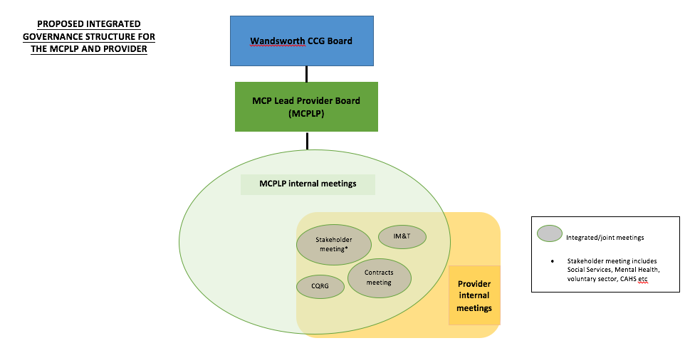

Appendix 2

**EOLC COORDINATION SERVICE: INTEGRATED PATHWAYS**

**COMMUNITY ADULT HEALTH SERVICES**

Enhanced Care Pathway (ECP)

It has been agreed that a clinical member of the Coordination Service team will participate in the CAHS MDTs being developed for the ECP patient cohort. Each ECP patient will have a Personalised Care Plan (PCP) to which the participating Coordination Service team member will be able to contribute, alongside primary care and other members of the MDT. This will ensure that any patients on the ECP who are considered to be nearing the end of their life can be identified and an appropriate care plan discussed within an MDT setting on a regular and ongoing basis. This could/should include referral (with the usual consent in place) to the EOLC Coordination Service as and when appropriate. Keeping a track on each patient’s decline in health is the role of the MDT.

The Key Worker for any Enhanced Care Pathway patient must be *“a clinically or socially trained professional who will remain responsible for overseeing the production of a multidisciplinary care plan and coordinating the care planning review process with the patient to meet individual personal outcomes. The key worker must be the most appropriate individual who is able to manage and coordinate the patient’s condition to meet their need and oversee the delivery of the individualised care plan”*[2]. As part of these MDT discussions, the CAHS and EOLC Coordination Service teams can agree who is best placed to take on/maintain the Key Worker role for identified EOLC patients as their needs change. This will usually mean that the Key Worker role remains with the CAHS team member, is held jointly with the Coordination Service team or (in *very* exceptional cases and by agreement) is transferred to be the sole responsibility of a clinical Coordination Service team member. The decision of who is best placed to hold the Key Worker role for an individual patient will be based on the patient’s needs, the relationships already established with the patient/their family or carers and the nature of the care that needs to be coordinated. The designated Key Worker will be identified within key documents relating to the patient’s care, including their PCP, clinical records held by the Coordination Service and their Coordinate My Care care plan (as described later).

Appropriate and agreed referral of an ECP patient to the EOLC Coordination Service can ensure that the coordination of the EOLC-related services for that patient will sit with the dedicated EOLC Coordination Service team who have specialist knowledge and pathways to effectively access the full range of EOLC services for patients and their family/carers. Appropriate transition of the coordination of the care of these patients ie from the ECP Health and Social Care Coordinators to the EOLC Coordination Service team will be agreed as part of the MDT discussions as described above.

Patients receiving routine (ie non-ECP) CAHS services

Patients requiring routine CAHS services (ie those outside of the Enhanced Care Pathway) can be directly referred (with the usual consent in place) to the EOLC Coordination Service should they become identified as nearing the end of their life. Discussions can then take place (as described above) between the CAHS (Complex Care) and Coordination Service teams around who is best placed to be the Key Worker for that patient to ensure they get the best care and the appropriate transfer of the care coordination role to the EOLC Coordination Service.

Care at home, including intermediate care and rapid response

All patients requiring care at home need careful and appropriate assessment to ensure the care provided to them is accessed through the most appropriate route to meet their needs and in the most efficient and cost effective way. It is also clearly important that services for patients are not duplicated within the commissioning framework.

A number of routes for assessment and to access care at home will be in place:

* The SGH Integrated Discharge Team (IDT) will review all discharges home from St George’s and agree the requirements for the patient post-discharge, including the provision of rapid response care where required. Additionally, the IDT will be responsible for reviewing all fast-track CHC applications for patients being discharged from SGH to ensure their appropriateness etc. The IDT will include representatives from the EOLC Coordination Service and the SGH hospital palliative care team to ensure EOLC patients requirements are reviewed and assessed by specialist clinicians;
* The Discharge to Assess process will appropriately route discharged patients to an “intermediate care” function within the new CAHS specification so that they can be “held” at home, with the support of appropriate services, for a short period of time (up to 2 weeks) whilst they are assessed and to ensure they needs are fully met. They may only require a short period of care at home for rehabilitation or they may require a more longer-term package of continuing healthcare provision. This initial “holding” period will provide an opportunity to ensure an accurate assessment of need as the patient settles back at home;
* In the case of some EOLC patients (for example those being discharged as they wish to die at home) it will be clear that a continuing healthcare package of care is required immediately (with or without the need for rapid response whilst it is set up) as the patient’s condition will not improve. It is important that such care can be commissioned and activated quickly from an appropriate source and coordinated as part of the overall care provision to the patient and their family. This is a key role for the EOLC Coordination Service, particularly in relation to fast-track applications, as described within this specification;
* Some patients will deteriorate at home (ie outside of hospital) and become eligible for continuing healthcare at home. Clear and efficient pathways need to be in place to support the agreement of and provision of such care. This is again a key role for the EOLC Coordination Service, particularly in relation to fast-track applications, as described within the service specification.

An integrated (health and social care) Rapid Response service to provide care at home for patients who are at risk of unplanned admission to hospital as well as for those who can be discharged home faster is to be commissioned as part of the new CAHS specification for delivery in Autumn 2017. This is a service for all patients on the CAHS caseload who meet the referral criteria. The care of individual end of life care patients will be subject to discussion and agreement between CAHS and the EOLC Coordination Service.

**GENERAL PRACTICE AND THE MCP**

Many General Practice colleagues now recognise the availability and benefits of using the EOLC Coordination Service to support them in caring for their patients as well as providing support across extended hours for their patients and their family/carers. There is, however, a need for an ongoing “marketing and information campaign” by the Coordination Service clinical team to continually reinforce the availability and benefits of the Service. GPs, alongside the wider primary care teams, can make direct referrals in to the EOLC Coordination Service where they have identified a patient who would benefit from such a referral. The “one-stop” support provided by the Coordination Service frees up clinical time by actioning all requests made by the GP in the care of the patient. The Coordination Service is able to support GPs in accessing the full range of EOLC-related services for their patients that might not otherwise have been considered.

The development of an MCP in Wandsworth provides an opportunity for the MCP Lead Provider to further integrate and ground the work of a dedicated EOLC Coordination Service within primary care, as well as facilitating and maximising integration with other services it is commissioned to provide, such as CAHS. The majority of people will choose to be cared for and die at home and, as such, their care will be led by their GP, supported by a range of other specialist and generalist professionals, many of whom will fall under the oversight of the MCP over time.

**CARE HOMES**

It has been agreed that clinicians from the EOLC Coordination Service, alongside team members from other EOLC providers, will be part of the operational group developing in-reach support for Care Homes as part of the Enhanced Care Pathway. Clinical support for Care Homes to continue to care for residents who are nearing the end of their life is available from the CNS team from Royal Trinity Hospice but this wider work will provide a route to further improve the care of Care Home residents as they near the end of their life. The Coordination Service team will provide equitable support to Care Homes to support them to maximise all the resources available to them to care for their residents.

**CONTINUING HEALTHCARE (CHC)**

It is recognised that the statutory provision of continuing healthcare, to those who are eligible, requires close scrutiny and oversight. The CCG has commissioned CHS Ltd to oversee the provision of CHC and they are accountable for quality, spend and budget management. It is recognised that fast-track CHC applications require careful scrutiny to ensure close controls are in place over eligibility and the nature of care being provided.

More than 70% of patients who have been referred to the EOLC Coordination Centre to date have required a CHC fast-track package of care. Activation and oversight of fast-track care packages for EOLC patients (with the exception of very high-cost care and Care Homes) sits with the Coordination Service team, thereby speeding up getting care in place, maximising the coordination of care, enabling rapid response to changing needs and ensuring an effective and efficient use of this resource within the statutory framework. The ability of the Coordination Service team to respond quickly to patient need across extended hours, 7 days a week (ie outside of CHC office hours), contributes to reducing hospital admissions and facilitating discharges, as well as improving the quality of care for patients. The directly provided Rapid Response service supports the provision of fast-track CHC from care agencies by filling the gap between the patient’s need for care being identified/required and mobilisation of a care package from an agency.

EOLC and fast-track CHC provision is included within the Wandsworth CCG Continuing Healthcare Operational Policy and Equity and Choice Policy. This document provides a clear local framework within which the provision of care for fast-track patients is agreed and delivered. The document also forms part of the commissioning and contractual framework for both the future EOLC Coordination Service provider and the CHC provider to ensure accountability around decision-making, efficiency of resources and joint working.

Close working between CHS as the CHC provider and the Coordination Service team is key to ensuring that each “organisation” is able to undertake its own commissioned responsibilities effectively. As such, jointly-developed and agreed processes must be in place between the 2 “organisations” to ensure work is not duplicated, transparency and a joint approach.

**ACUTE/SPECIALIST PROVIDERS**

The external evaluation of the EOLC Coordination Centre/Service pilot evidenced the benefit of effective referral pathways between a dedicated Coordination Service and both acute (eg St George’s) and specialist (eg Royal Marsden) providers, particularly when a dying patient wishes to die at home. Such a situation requires intense coordination of a range of activities, both within the acute/specialist provider setting and within the community to ensure swift discharge of the patient to a safe home environment where both they and their family/carers feel safe and anxiety and distress is minimised. The EOLC Coordination Service is key to the success of such discharges, both to them taking place faster as well as to minimising the likelihood of the patient having to return to hospital if that isn’t their wish.

The development of the St Georges Integrated Discharge Team (as described earlier) will provide a clear route for oversight and management of all patients being discharged from St George’s, including EOLC patients, to ensure their needs are met. The Coordination Service team clinicians will be an integral part of the IDT.

The marketing/communication activities of the Head of the EOLC Coordination Service must include key clinicians who operate at the front-line of unplanned admissions to hospital, such as A&E clinicians and London Ambulance. Ensuring that they have contact information for the Coordination Service during operating hours may contribute to a reduction in the number of such admissions, through better coordination of care planning aligned to patients’ wishes.

**COORDINATE MY CARE**

Coordinate My Care (CMC) allows healthcare professionals to electronically record patient's wishes and ensures their personalised urgent care plan is available 24/7 to all those who care for them. It is recognised as the “standard” across London. The EOLC Coordination Service team are required to ensure that, where patient consent has been given, any patient referred to them has a published CMC care plan that is kept up to date, thereby contributing to the availability of key patient information to LAS, 111, OOH GPs etc. to support their decision-making when with a patient. This will include key information held within the patient’s Personalised Care Plan if they are within the Enhanced Care Pathway.

**111 AND THE OUT OF HOURS GP SERVICE**

The EOLC Coordination Service is included within the 111 Directory of Service as a key local service provider for patients with EOLC needs. The Coordination Service’s ability to respond quickly to need is particularly important to avoid unplanned hospital admissions out of hours. A considerable amount of work has been undertaken to develop and implement effective joint pathways and processes with the 111/OOH GP service provider to ensure a full understanding of the EOLC service landscape and how advice and services can be accessed by 111 clinicians/OOH GPs to support them in the care of EOLC patients. These discussions need to be replicated by the EOLC Coordination Service team on a regular basis with the 111/OOH GP providers (currently Vocare and Seldoc) in order to ensure continuation of an effective “one stop” resource for these services and to contribute to established system benefits.

**SOUTH WEST LONDON STRATEGY**

End of life care has been identified as an area where there is potential to improve care and reduce costs across SWL. This will include particular focus on supporting staff to better identify patients in their last year of life and improving the coordination of care, including improving the use of Coordinate My Care. The Wandsworth EOLC Coordination Service has been recognised, particularly in view of the external evaluation outcomes, as a model that is able to deliver savings within parts of the wider the system, as well as supporting the identification of EOLC patients and increasing the use of CMC in Wandsworth. As such, the provision of an EOLC Coordination Service, beyond the pilot, provides the opportunity to continue to deliver those evidenced benefits as part of the SWL strategy.

Appendix 3

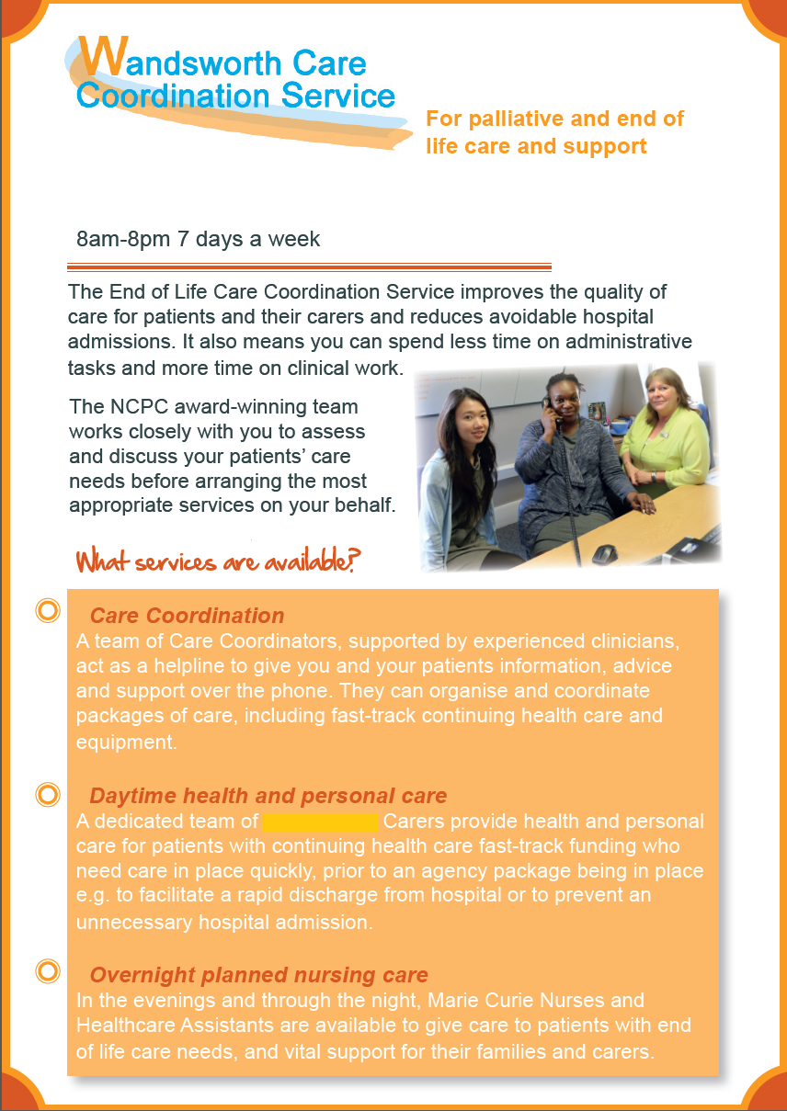

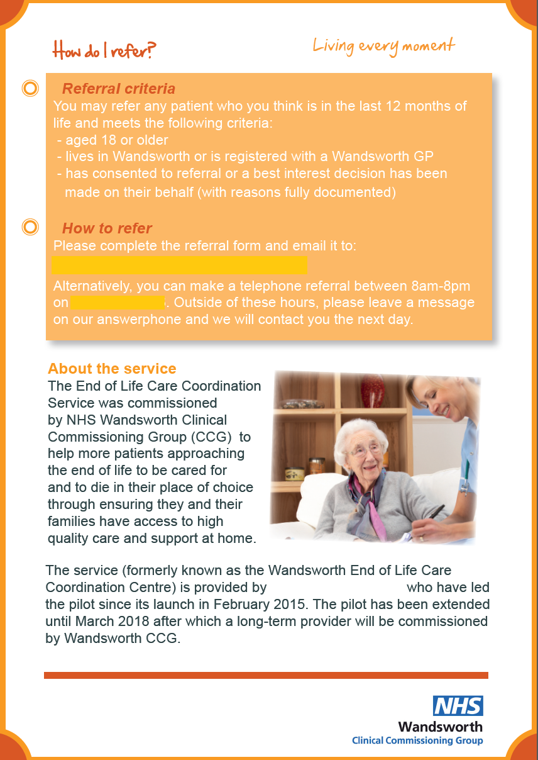

1. Please note that the proposed arrangement (ie a direct contractual arrangement between the Provider and Marie Curie) is subject to agreement by Marie Curie Trustees, once the EOLC Coordination Service Provider is known. Because of the charitable financial subsidy made by Marie Curie, the Trustees need to assure themselves that the Coordination Service provider (particularly if they are new to the local EOLC system) will not seek to gain financially from the arrangement.
2. Excerpt from the Enhanced Care Pathway provider specification 2016