**Contractor questions – 17 November 2020**

1. Where are the Wind posts to be positioned, they are detailed but not shown on the layout plan ?

2. Fixing detail/spec for Blockwork back to Columns, and centres ?

3. Is Screed required to roof Slab, We have answered no just the 110mm RC Slab

4. C2C Consulting Engineers general note 8 describes 50mm concrete blinding but on their drawings a depth of 150mm MOT is shown ?

5. Is the Engineer providing a Civils drawing ?

**Responses**

1. Apologies, the wind posts appear to have been on a non printing layer - 2No locations for wind posts (doors each side of steel framed area);

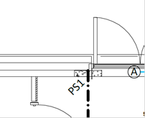 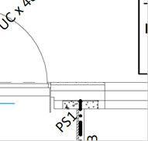

1. We will update drawing with frame tie details for concrete columns. Ancon PPS ties at 450mm vert ctrs with debonding sleeves.
2. No screed
3. We will update the note to state that 50mm blinding is required below he ground beams only.
4. We did not price for Civils design. Your details are sufficient.