Invitation to tender

Attachment 2 – How to bid

RM6290 - Executive and Non Executive Recruitment Services

Contents

1. How to make your bid 3
2. Selection stage 4
3. Selection process 4
4. Selection criteria 4
5. Selection questionnaire 5
6. Award stage 5
7. Award criteria 5
8. Award process 6
9. Quality Evaluation 7
10. Award quality questionnaire 9
11. Price evaluation 9
12. Final decision to award 13

- How to make your bid
  - Your bid must be made by the organisation that will be responsible for providing the goods and/or services if your bid is successful.
  - You may bid for one or more of the lots. Ensure you read paragraph 3.3 of Attachment 1.
  - Your bid must be entered into the eSourcing suite. We can only accept bids that we receive through the eSourcing suite.
  - Upload ONLY those Attachments we have asked for. Do not upload any attachments we haven’t asked for.
  - Make sure you answer every question.
  - You must submit your bid before the bid submission deadline, in paragraph 5 “Timelines for the competition” in Attachment 1 - About the framework.
  - It will be our decision whether we will accept bids submitted after the bid submission deadline.
  - You must regularly check for messages in the eSourcing suite throughout the competition. You must log on to the eSourcing suite and access your message inbox for this competition to check for messages.
  - If anything is unclear, or you are unsure how to complete your bid submission, you can raise a question before the clarification question deadline, via the eSourcing suite. Read paragraph 6 “When and how to ask questions” in Attachment 1 - About the framework.
  - We may require you to clarify aspects of your bid in writing and/or provide additional information. Failure to respond within the time required, or to provide an adequate response will result in the rejection of your bid and your exclusion from this competition.
- Selection stage
  - At the selection stage, we evaluate bidders’ technical, professional and financial capabilities. We will ask a range of questions appropriate to the procurement. It is important that you answer these questions accurately.
  - If you are relying on any key subcontractors to provide the answers to the technical and professional ability or you are relying on a guarantor to pass the economic and financial assessment, they must complete Parts 2 and 3 for themselves.
  - In addition, if you are the lead member of a consortium, you must get each of the other members to answer the questions in Parts 2 and 3 for themselves.
  - We are providing the ‘Information and declaration’ workbook (attachment 4) to enable you to collect and submit this data to us, whether from organisations on whom you are relying (for example a key subcontractor or a guarantor) or from other members of a consortium.
- Selection process
  - After the bid submission deadline we will check all bids to make sure we have received everything we have asked for.
  - We may ask you to clarify information you provide, if that is necessary. Don’t forget to check for messages in the eSourcing suite throughout the competition. You must log on to the eSourcing suite and access your message inbox for this competition to check for messages.
  - If your bid is not compliant we will reject your bid and you will be excluded from the competition. We will tell you why your bid is not compliant.
  - Not all selection questions need guidance as the questions are self-evident. However other questions such as the financial question, require a process to be undertaken before we can assess your response. In those instances we have told you what we will do in the evaluation guidance.
- Selection criteria
  - We may exclude you from the competition at the selection stage if:
    - you receive a ‘fail’ for any of the evaluated selection questions.

    - any of the information you have provided proves to be false or misleading.

    - you have broken any of the competition rules in Attachment 1 About the Framework, or not followed the instructions given in this ITT pack.
  - If we exclude you from the competition we will tell you and explain why.

- Selection questionnaire
5.1 Please refer to Attachment 2a Selection Questionnaire. Remember you must complete the questionnaire online in the eSourcing suite (Qualification Envelope).

- Award stage
6.1 If you have successfully passed the selection stage, you will proceed to the award stage.
6.2 We have tried to make our award stage as simple as possible, whilst achieving the best possible commercial outcomes.
6.3 Your bid must deliver what our buyers need, at the best possible price you can give.
6.4 When completing your bid you must:
- Read through the entire ITT pack specifically Attachment 1a Framework Schedule 1 (Specification) carefully, and read more than once
- Read each question, the response guidance, marking scheme and evaluation criteria
- Read the contract terms.
- If you are unsure, ask questions before the clarification questions deadline See paragraph 5 ‘Timelines for the competition’ and paragraph 6 ‘When and how to ask questions’ in Attachment 1 - About the framework document
- Allow plenty of time to complete your responses; it always takes longer than you think to submit
- Your prices should be in line with the service level you offer, in response to the award quality questions.
- Award criteria
7.1 The Award Stage consists of a quality evaluation (see paragraph 9 of this document) and a price evaluation (see paragraph 11 of this document).
7.2 The award of this framework will be on the basis of the ‘Most Economically Advantageous Tender’ (MEAT).
7.3 The weighting for the quality evaluation is:
Lots | Quality | Price
Lot 1 - Executive Search - Grade 6, SCS1 & SCS2 (and equivalents) | 90% | 10%
Lot 2 - Executive Search - SCS3 & SCS4 (and equivalents) | 90% | 10%
Lot 3 - Non-Executive and Public Appointments | 90% | 10%

- Award process
  - What YOU need to do
- Answer the mandatory questions in section A of the quality questionnaire in the eSourcing suite in the technical envelope.
- Answer the Lot Specific Questions, relevant to the Lot(s) you are bidding for in section B, section C and section D of the quality questionnaire in the eSourcing suite in the technical envelope.
- Complete the relevant Price Matrix Attachment 3 (a-c) for the lot(s) for which you are bidding.
- Upload your completed Price Matrix into the eSourcing suite, for the lots that you are bidding, in the commercial envelope to question PQ1 for Lot 1, PQ2 for Lot 2 and PQ3 for Lot 3.

  - What WE will do at the award stage
1. | Compliance Check  First, we will do a check to make sure that you completed the pricing matrix in line with our instructions.
2. | Quality Evaluation  We will give your responses to our evaluation panel. Each evaluator will independently assess your responses to the quality questions using the response guidance and the evaluation criteria. Each evaluator will give a mark and a reason for their mark for each question they are assessing. Each evaluator will enter their marks and reasons into the eSourcing suite.
3. | Consensus  Once the evaluators have independently assessed your answers to the questions we will arrange for the evaluators to meet and we will facilitate the discussion. At this consensus meeting, the evaluators will discuss the quality of your answers and discuss their marks and reasons for that mark. The discussion will continue until they reach a consensus regarding the mark, and a reason for that mark, for each question. These final marks will be used to calculate your quality score for each lot that you have bid for.
4. | Evaluate Pricing  We will then give your pricing to the price evaluation panel, who are different evaluators from those who assessed your quality responses.  They will calculate your price score using the evaluation criteria in Part 11 – Price Evaluation.
5. | Final Score  Your quality score will be added to your price score, to create your final score as illustrated in Part 12 Final decision to award.
6. | Award  Awards will be made to the successful bidders following the standstill period, subject to contract.

- Quality Evaluation
  - Questions QA1 -QA6 are mandatory questions and will be evaluated PASS / FAIL. If you answer no to these questions, we will reject your bid and you will be excluded from the competition. We will tell you that your bid has been excluded and why.

  - Question QA3 is a mandatory question. Question A2 is a mandatory question but will not be evaluated, the responses are for information only.
9.3 Each question must be answered in its own right. You must not answer any of the questions by cross referencing other questions or other materials for example reports or information located on your website.
9.4 Each of the quality questions in section B of the Quality Questionnaire will be independently assessed by our evaluation panel.
9.5 When the consensus meeting has taken place and the final mark for each question has been agreed by the evaluators, your final mark for each question will be multiplied by that question's weighting to calculate your weighted mark for that question.
9.6 Each weighted mark for each question for each lot you have submitted a bid for will then be added together to calculate your quality score for that lot.
9.7 Please see tables A, to C inclusive below for an example of how your quality score will be calculated.

Table A – Lot 1 Executive Search - Grade 6, SCS1 & SCS2 (and equivalents)

Question |  | Question Weighting | Maximum mark available | Your final mark | Your weighted mark
QB1 | Meeting Public Sector Priorities - Methodology and Tools | 25% | 100 | 100 | 25.00
QB2 | Service to Buyers | 25% | 100 | 66 | 16.50
QB3 | Service to Candidates | 25% | 100 | 66 | 16.50
QB4 | Continuous Improvement | 25% | 100 | 33 | 8.25
Quality score |  |  |  |  | 66.25

Table B – Lot 2 Executive Search - SCS3 & SCS4 (and equivalents)
Question |  | Question Weighting | Maximum mark available | Your final mark | Your weighted mark
QC1 | Meeting Public Sector Priorities - Methodology and Tools | 25% | 100 | 100 | 25.00
QC2 | Service to Buyers | 25% | 100 | 66 | 16.50
QC3 | Service to Candidates | 25% | 100 | 66 | 16.50
QC4 | Continuous Improvement | 25% | 100 | 33 | 8.25
Quality score |  |  |  |  | 66.25

Table C - Lot 3 Non-Executive and Public Appointments

Question |  | Question Weighting | Maximum mark available | Your final mark | Your weighted mark
QD1 | Meeting Public Sector Priorities - Methodology and Tools | 25% | 100 | 100 | 25.00
QD2 | Service to Buyers | 25% | 100 | 66 | 16.50
QD3 | Service to Candidates | 25% | 100 | 66 | 16.50
QD4 | Continuous Improvement | 25% | 100 | 33 | 8.25
Quality score |  |  |  |  | 66.25

- Award quality questionnaire
Please refer to Attachment 2b - Award Questionnaire Response Guidance and Marking Scheme

- Price evaluation
This paragraph 11 contains information on how to complete the Pricing Matrix attachment 3 and the price evaluation process.
  - How to complete your pricing matrix:
Read and understand the instructions in the pricing matrix, and in this paragraph, before submitting your prices.
- Your prices should compare with the quality of your offer.
- Your prices must be sustainable and include your operating overhead costs (inc. standard marketing activity) and profit.
- You should also take into account our management charge of one point five (1.5%) which shall be paid by you to us, as set out in the Framework Award form
- You should have read and understood the information on TUPE in paragraph 8 of attachment 1 – About the Framework. You are reminded that it is your responsibility to take your own advice and consider whether TUPE is likely to apply and to act accordingly. You are encouraged to carry out your own due diligence exercise on the application of TUPE when completing your pricing matrix.
Your prices submitted must :
  - exclude VAT.
  - be inclusive of any expenses/travel and subsistence
  - be in British pounds sterling, up to two decimal places
  - submitted up to two decimal places
Pricing will be based on:
- eight (8) hour Working Day; and
- rounded to the nearest £10.
Zero or negative bids will not be allowed. We will investigate where we consider your bid to be abnormally low.
The prices submitted will be the maximum payable under this framework. Prices may be lowered at the call-off stage. Refer to Framework Schedule 3 – Framework Prices.
You must download and complete the Pricing Matrix for the lot(s) you are submitting a bid for. :
- Attachment 3a - Lot 1 Pricing Matrix
- Attachment 3b - Lot 2 Pricing Matrix
- Attachment 3c - Lot 3 Pricing Matrix
You must provide a price, where one has been requested, in the cells highlighted yellow.
When you have completed your pricing matrix, you must upload this into the eSourcing suite at question PQ1(Lot 1), PQ2 (Lot 2) or PQ3 (Lot 3) in the commercial envelope. If you do not upload your pricing matrix your bid may be rejected from this competition.
Do not alter, amend or change the format or layout of the pricing matrix Attachment 3.
  - Price evaluation process
This is how we will evaluate your pricing:
- We will check you have completed all the yellow cells for each lot you are bidding for.
- Failure to insert an applicable price may result in your bid being deemed non-compliant and may be rejected from this competition. Remember zero or negative prices will not be accepted.
- The price evaluation will be undertaken separately to the quality evaluation process.
- For all lots we will calculate your price based on a fixed fee sum.
- The calculation we will use to evaluate your total score, for each lot you are bidding for, is as follows:
- The average of all fees submitted, for each salary band, will be calculated (sum of all fees submitted divided by total number of bids received).
- This average less 20% (of the average) will form the stretch target fee from which all bid scores for that salary band will be calculated.
- Fees submitted that are lower than or equal to the stretch target fee will receive the maximum score available.
- Fees submitted that are higher than the stretch target fee will receive a score relative to the amount that the submitted fee is higher than the stretch target fee.
- A weighting will then be applied to each salary band to give the weighted score for that band. Each of the weighted band scores will be added to give the overall lot score.
- Once the individual salary band scores have been calculated, we will then apply the weighting as indicated in the Lot tabs in the Pricing Model
- So in the below example Lot, if you choose to offer varying on-costs for each salary band we would calculate your total weighted score as follows:

Worked example Lot (fixed £GBP fee)
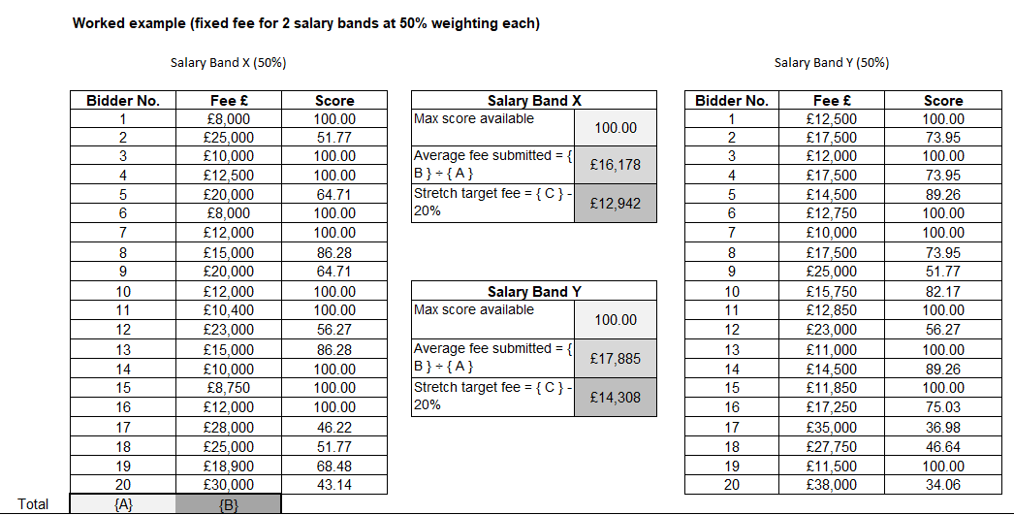
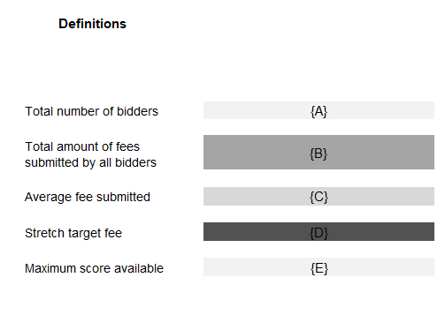
Once the individual salary band score has been calculated, we will then apply the weighting as indicated in the Lot tabs in the Pricing Model.
So in our example, if you choose to offer a fixed fee of £15,000 for Salary Band X and £17,500 Salary Band Y, we would, using the above example, calculate your total weighted score as follows:

Salary Band | Fixed fee bid | Score Calculated (using above methodology (x) | Weighting (y) | Weighed score (x*y)
Salary Band X | £15,000.00 | 86.28 | 50% | 43.14
Salary Band Y | £17,500.00 | 73.95 | 50% | 36.98
Final Commercial Score for example Lot |  |  |  | 80.12

As the maximum price score available is 10 your Final Commercial Score for the lot is then divided by 10 to provide you Total Weighted Score.
So in the example above provided above:
Final Commercial score 80.12 % 10 would provide a Total Weighted Score of 8.12.
Please note: the bidder numbers and fees shown in the examples given above are purely to help demonstrate the evaluation methodology to be used and are in no way representative of expectations.

  - Abnormally low tenders
Where we consider any of the basket price(s) you have submitted to have no correlation with the quality of your offer or to be abnormally low or will ask you to explain the price(s) you have submitted (as required in regulation 69 of the Regulations).
If your explanation is not acceptable, we will reject your bid and exclude you from this competition, we will inform you if your bid has been excluded and why.
- Final decision to award
  - How we will calculate your final score
We will add your quality score to your price score to calculate your final score.
Example: Lot 1
Bidder | Quality score | Price score | Final score
 | (Maximum score available 90) | (Maximum score available 10) | (Maximum score available 100)
Bidder A | 90.00 | 10.00 | 100.00
Bidder B | 70.00 | 5.00 | 75.00
Bidder C | 60.00 | 2.00 | 62.00

We will then rank all final scores from highest to lowest.
We will offer the number of bidders a framework contract as set out in paragraph 3.1 of Attachment 1 – About the Framework.
The maximum number of bidders for each lot of this framework may increase where two (2) or more bidders have tied scores in last position only.
  - Reserved rights
We also reserve the right to award a framework to any bidders whose final score is within 1% of the last position, this applies for Lot 1, Lot 2 and Lot 3.
For example the last position for Lot 1 is 50th position.
Example:
If the bidder in 50th place, last position has a final score of 60.00
The calculation we will use is:
Lot 1 - 50th place bidders final score is 60.00
1% of 60.00 = 0.06
The calculation will be rounded to two decimal places in Excel.
60.00 - 0.60 = 59.40
So any bidder whose final score is 59.40 or above will be awarded a lot 1 place on the framework.

  - Intention to award

You can submit a bid for one or more lots.
We will tell you if you have been successful or unsuccessful via the eSourcing suite. We will send an intention to award letters to all bidders who are still in the competition i.e. who have not been excluded.
At this stage, a standstill period of ten (10) calendar days will start, the term standstill period is set out in regulation 87(2) of the Regulations. During this time, you can ask questions that relate to our decision to award. We cannot provide advice to unsuccessful bidders on the steps they should take and they should seek independent legal advice, if required.
If during standstill we do receive a substantive challenge to our decision to award and the challenge is for a certain lot, we reserve the right to conclude a framework contract with successful bidders for the lot(s) that have not been challenged.
Following the standstill period, and if there are no challenges to our decision, successful bidders will be formally awarded a framework contract subject to signatures.
  - Framework contract
You must sign and return the framework contract within 10 days of being asked. If you do not sign and return, we will withdraw our offer of a framework contract.
The conclusion of a framework contract is subject to the provision of due ‘certificates, statements and other means of proof’ where bidders have, to this point, relied on self-certification. These will be detailed in the award letter.

