**STRATTON ST MARGARET PARISH COUNCIL**

|  |  |
| --- | --- |
| **Date** | 11/03/2025 |
| **Report Title** | Brooks Close Tender Document |
| **Author** | Open Spaces Officer |

**Location:**

Brooks Close Play Park

Brooks Close

Swindon

SN2 7TP

What3words: engrossed.tone.lined

**Plot size:**

100x50m

Mature trees to the north of the park need consideration with equipment location.

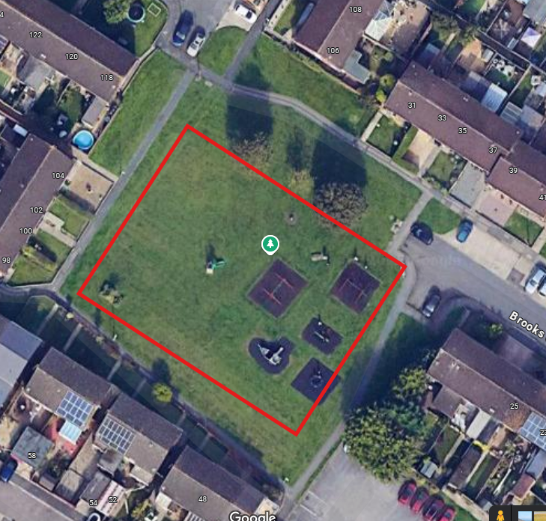

**Budget:**

Up to but not exceeding £70,000 excl. VAT

**Usage:**

Play park infant+

**Existing equipment:**

Pirate ship climbing frame

2x infant swings

2x junior swings

Seesaw

Rock/ Spin

Junior slide with climbing wall

Spinning disk

**Brief:**

Large, flat site with good accessibility for installers. Residential setting, overlooked.

* New equipment to complement existing equipment
* Metal equipment
* Toddler friendly equipment
* Basket swing or similar
* Junior multi-play unit with slide
* Roundabout
* Defining feature of the playpark (e.g. Crocodile at Delamere or Dragon at Stephens Road)

Items are to be placed on wet pour where necessary. For the purpose of other items. grass matting is appropriate. Existing wet pour to be left, some repairs may be necessary on swing wet pour.

SPARE PARTS NEED TO BE READILY AVALIABLE IN THE UK.

**Tender scoring process:**

All submitted tenders will be taken to a parish council meeting. Tenders will be looked on favourably regarding price and play value.

**Tender submission:**

Please submit all tenders via email.

**Completion deadline:**

Project completion summer 2025.

