Natural England /Cefas Partnership Video & Stills Processing Protocol – revised for 2015 MPA surveys undertaken using Cefas and/or Environment Agency platforms.
- Video and stills processing protocol for Monitoring surveys
The primary purpose of the analysis of the video/stills is to identify which seabed habitats are present in a video record/still image, provide quantitative (where possible) or semi-quantitative data on the observed physical habitat and biological assemblages (species records at the highest taxonomic level) and to note where one substrate/habitat type changes to another. Secondarily, the intension is to undertake video and stills processing in such a way as to provide data to inform potential MSFD indicators development. This may include:
- Shallow sublittoral rock biodiversity indicator development – Kelp
- Sublittoral rock biodiversity indicator development –sponge and anthozoa
- Development of indicators for biogenic structures

The contractor may also be made aware of additional specific requirements relating to a particular survey/dataset which may require completing at the same time.
Contractors should note that video analysis is to be undertaken based on either time or distance, dependant on whether a USBL devise was deployed and functioning adequately. It is therefore important for the contractor to understand the average speed that each camera transect was run at (which can be calculated using the positional data and time), so that the time taken to run set distances (such as 5m), or time (such as 30s) as specified in this document) can be calculated.

Video Analysis
  - An initial quality check of the video footage for each transect should be performed. If the contractor feels that any transect videos contain footage too poor for analysis to be undertaken, the video should be subdivided according to image quality, and this should be flagged with the project officer immediately (see Annex 9 for video quality guidance). The start and end points (time as well as the spatial positions in Lats/Longs) of the whole video sequence, and any quality based subdivisions should be logged.
  - It is recommended that the video record is initially viewed rapidly (at approximately 4x normal speed) in order to gain an overview of the habitat types visible in the complete camera tow.
  - Then, at normal speed, the video can be viewed again and the start and end points (time as well as the spatial positions in Lats/Longs) of each segment are logged; each of these segments will then be subjected to more detailed analysis.
Figure 1 Simplified illustration of method for segmenting seabed video tows based on changes in habitat. Marine Recorder Briefing Note, JNCC.

  - It should be specified on the video analysis log whether the spatial positions relate to the Central Reference Point (CRP = GPS antenna), Side/Stern Gantry or HiPAP/USBL.
  - Brief changes in substrate type covering less than 5 meters in length (which aligns with the minimum biotope area defined by MNCR (5m²)), are therefore to be considered as incidental patches and are not logged – however, these should be recorded as part of the habitat description. The time taken to cover a linear transect of seabed will dependant on towing speed. All video time must be linked to positional data so that when this is combined with the field of view of the camera the area can be calculated. Therefore if identifying substrate patches utilising tow duration, minimum linear patch size would equate to a 30s video sequence when the video is traversing the seabed at a target speed of 0.3 knots.
  - As noted in ‘a.’ above, record the start and end times and positions of each segment (habitat patches and video quality categories) from the information provided (by Cefas). As stated above, it should also be specified on the video analysis log whether the spatial positions relate to the Central Reference Point (CRP = GPS antenna), Side/Stern Gantry or HiPAP/USBL. For each segment identified during this review the following must be noted from the information on the video overlay or accompanying metadata:
      - Start and end time
      - Start and end position
      - Depth at the start and the end of each section. However, if there are large variations in depth throughout the tow then the range, including minimum and maximum depths, must be noted.
  - View each segment at a slower than normal speed, recording the physical habitat (substrate type, seabed character/morphology) and biological components (organisms to the lowest taxa/taxon at which ID can be certain) as detailed on the recording form. If available, still images from the respective video tow should be viewed alongside the video to assist with interpretation due to their higher resolution. Record the analyses on the video pro-forma; detailed instructions of how to fill this in can be found below.
  - The area of each transect should be estimated. The field of view of the camera can be determined using the scaling device. Transect length can be calculated from the positional data.
  - For each identifiable taxon record presence/ absence, an actual abundance or percentage cover and a semi quantitative SACFOR abundance score (Annex 1 – determining organism abundance).
  - The data collected across these surveys may inform the development of up to four MSFD indicators:
    - Shallow/ shelf sub-littoral rock – sponge morphological diversity
    - Shallow sub-littoral rock – Kelp park and kelp forest depth
    - Biogenic structures – Blue mussel reef
    - Biogenic structures – Sabellaria spinulosa reef

Please refer to Annex 6 (a-d) for further specific methodological protocols relevant to theses MSFD indicators
  - When each segment has been analysed, review all the information recorded and assign the segment to the most relevant level of the JNCC marine habitat classification and the EUNIS habitat classification system as per the guidance provided by Parry (2015).
  - A Video_Sample_Ref by species matrix should be completed for each survey.

Stills analysis
- Still images should be analysed separately, to supplement and validate the video analysis, and provide more detailed (i.e. higher resolution) information than can be extracted from a moving video image.
- Analyse all stills and assign them to their parent segment (see Stills analysis proforma instructions below). For each image, note the time and position it was taken, using information from the metadata provided by Cefas.
- View the image at normal or greater than normal magnification, noting the physical and biological characteristics, such as substrate type (according to ‘Modified folk’, seabed character, species and life forms present.
- If enough information on depth (biological zone), vegetation, faunal composition or energy (for rock biotopes) is available then allocate a lower level EUNIS code.
- Record the analysis on the stills proforma; detailed instructions of how to fill this in can be found below.
- Optional: Calculate the area (m²) of each still using the laser points for scale.
- Assign each still to the relevant habitat classification as described above for video analysis. This does not have to be the same as its ‘parent’ segment in the video. A comment should be added where there is discrepancy between the still and the 'parent' video segment.
- For each taxon, record presence/ absence, an actual abundance (where possible) or percentage cover for encrusting/turf/colonial organisms and a SACFOR (semi-quantitative) score. (Annex 1 – determining organism abundance).
- A Still_Sample_Ref by species matrix should be completed for each survey.

Taxon ID
In all analyses, the identification of taxa should be limited to a level that can be confidently achieved from the available image. Hence, taxon ID could range from the ‘life form’ level (e.g. sponge, hydroid, and anemone) to the species level (e.g. Asterias rubens, Alcyonium digitatum). Avoid the temptation to guess the species ID if it cannot be determined positively from the image. For example, Spirobranchus sp(p). would be acceptable, but Spirobranchus triqueter would not, as the specific ID normally requires the specimen to be inspected under a microscope. A list of life forms to be used is provided in Annex 8 to aid in consistency.

- Quality Assurance (QA)

Internal QA
Cefas will require contractors to provide quality assured products under this contract. Contractors should also supply a quality plan as part of the contract. All products supplied will be subject to quality checks by Cefas to ensure they meet the agreed standards.
Contractors should clearly describe their data management facilities and procedures in proposals related to this work.

Documentation
The following documents must be provided by the contractor upon the request of the contract manager. Contractors must also ensure they have a document control system in place to manage these documents (i.e. documents are kept electronically live and there is version control of hard copies to prevent the inadvertent use of obsolete documents).

Standard Operating Procedure
The contractor must provide copies of all relevant Standard Operating Procedures (SOPs) for the contracted work. An SOP should include:
- A clear statement of the qualitative and quantitative goals of the contract work, which demonstrates that the specified methods are fit for purpose.
- Methodological details of all steps performed.
- Details of the procedures related to the analysis of data.
- Details of the quality assurance system in place.

Quality Manual
The contractor should be able to provide on request a quality manual which details an organisation’s quality assurance system/policy (i.e. all aspects of quality assurance described in this document), which allows systematic audits of a monitoring programme to ensure that all aspects of quality assurance are being met. This should include details of the contractor’s Quality Manager, who is deemed responsible for overseeing the entire QA within the contracted organisation.

Quality Management System
It is recommended that the contractor should have the following Quality Management System (QMS) documentation (or alternative documentation proposed by the contractor which is demonstrated to be equivalent) to demonstrate there is a working QA system in place:

Quality Control Audit
Examination of in-house QC data, check of appropriate control limits, and corrective action is documented where QC data has breached control limits.

Vertical Audit
A random selection of data points, where each data point is traced to the Method, Instrument/Equipment, Calibration and internal and external QC.

Method Witnessing
Comparison of written procedure to observed procedure under real conditions. Any differences must be resolved through corrective action where needed.

Training Manual
Criteria stating the minimum competency (education, training, work experience and/or other demonstrated skills) necessary for staff to undertake different types of marine monitoring work must be defined in the Training Manual. The competency of each staff member must be signed off initially against all criteria and evidence of ongoing competency must be maintained on a regular basis in a document such as a Training Log (or individual staff member’s Curriculum Vitae’s).

Adherence to standardised methods
The contractor must adhere to relevant national, European or international standardised methods. The NMBAQC website gives the current list of all British Standards (BSi), International Organization for Standardisation (ISO) standards and European Committee for Standardisation (CEN) standards which currently exist for marine biological monitoring.
The contractor must provide details of any additional standard methods which they adhere to if these are not explicitly stated in the SOP (e.g. UK government agencies protocols and standards for marine monitoring programmes, ICES or NMBAQC standard methods).
Documentary evidence must be provided if the contractor is certified or accredited to a standard method (or their own method) through an accreditation scheme such as Good Laboratory Practice (GLP) or United Kingdom Accreditation Service (UKAS).

Adherence to data standards and guidelines
The contractor must adhere to the relevant data standards and guidelines.
- Species lists which are compliant with current taxonomic names and synonyms (e.g. World Register of Marine Species (WoRMS), which is now endorsed by the Healthy and Biologically Diverse Seas Evidence Group (HBDSEG)).
- Data and metadata guidelines relevant to the contracted work, which define data and metadata formats (e.g. Marine Environmental Data and Information Network (MEDIN) data guidelines and Mapping European Seabed Habitats (MESH) standards).

Taxonomic resources
The contractor must use the taxon dictionary supplied within Marine Recorder (which is the WoRMS dictionary) to aid in the identification of marine biological taxa.

Staff competency
Staff involved in identifying marine species should have a relevant degree level qualification (or equivalent) in a relevant discipline, plus 3 years relevant work experience. If less experienced staff are proposed to conduct species identification, this must be under the direct supervision of a fully trained staff member. Staff should also have substantial experience of field recognition of marine biotopes.
The up-to-date competency of each contracted staff member must be demonstrated via a list of the most up to date and relevant contracted marine work (along with client contact details) and proof of continual professional development of staff through:
- Participation in workshops (run internally or externally through universities, museums or marine organisations/associations),
- Participation in proficiency tests (Interlaboratory Comparisons) and/or external quality control tests run through an external quality assurance scheme
- Proof of tertiary qualifications and other qualifications (e.g. Identification Qualification awarded by a professionally recognised institute).

Stated project personnel
The names of proposed project personnel and their role in the contracted work must be specified. Only those staff proposed in the tender submission will be expected to undertake the work. Changes to contracted staff (including subcontractors) will only be accepted following written approval from the contract manager.

Internal Quality Control
The contractors must demonstrate their internal Quality Control (QC) system (which is demonstrated in the Quality Control Audit), which includes routine checks of data and analysis.
QC of data and analysis is where samples are re-checked and compared against the original and compared to an expected standard/limit of error/deviation from the original. It is also where electronic records (in spreadsheets or databases) are checked against the data on the original field/laboratory datasheets. This measures the repeatability of the method of analysis and data entry, and highlights factors such as inter-worker variability. QC must also include details of remedial action in cases where expected standards/limits are not met.
- The contractors should demonstrate their internal system of validation for 10% of the samples analysed (identification and enumeration of species and biotopes from photographs and videos).
- The contractor should also be able to demonstrate their internal system of validation for 10% of the electronic records (in spreadsheets or databases) of biological/environmental data.
- The above 10% should include samples across the range of habitats recorded/observed.
Internal QC must be undertaken by a staff member other than the staff member who conducted the original sample analysis.

- External Quality Assurance

External Training, Qualifications and Proficiency Tests
The contractor should provide evidence (Certificates or Statement of Performance) of their up-to-date expertise through active participation in:
External training (e.g. workshops run through universities, museums, marine organisations/associations),

Qualification schemes (e.g. Identification Qualification awarded by a professionally recognised institute)

Participation in proficiency tests (Interlaboratory Comparisons) and/or external quality control tests run through an external quality assurance scheme

External Quality Control
JNCC subscribes to the NMBAQC ‘own sample’ scheme (http://www.nmbaqcs.org/scheme-components/invertebrates.aspx ). The contractor shall facilitate the completion of these independent QA/QC checks. In all cases, if the products do not meet the relevant quality standard the contractor will be required to undertake appropriate remedial action and then re-supply the product. All costs associated with such remedial action will be borne by the contractor and will not be charged to Cefas/JNCC.

- Suggested Report Outline
Introduction: Brief details on the work undertaken, including number of videos and stills analysed.
Methods: Brief details on the methodology followed for the video and stills analysis and the QA followed
Results: Table of results for each video station segment and notes on any features of interest observed. Also note any evidence of human activities seen at each station.
QA: Details on which stations were reanalysed and by whom and a table detailing the QA’d results against the originals.

- Survey image reference collections

Species/taxon reference collection
- A reference image is required for each species/taxon from the combined video and stills species list for each survey, including those where positive ID was difficult/not possible
- At least one image per species/taxon, either from the video (snapshot/screen grab) or the stills with the preference being the stills due to image resolution.
- Highlight the species/taxon on the image (e.g. box or circle) and save the image with the relevant species/taxon name and video/still file name
- Fill in a new row in the SpeciesBiotopeRefCollection.xlsx spreadsheet
- See examples below

Video screen shot Still image
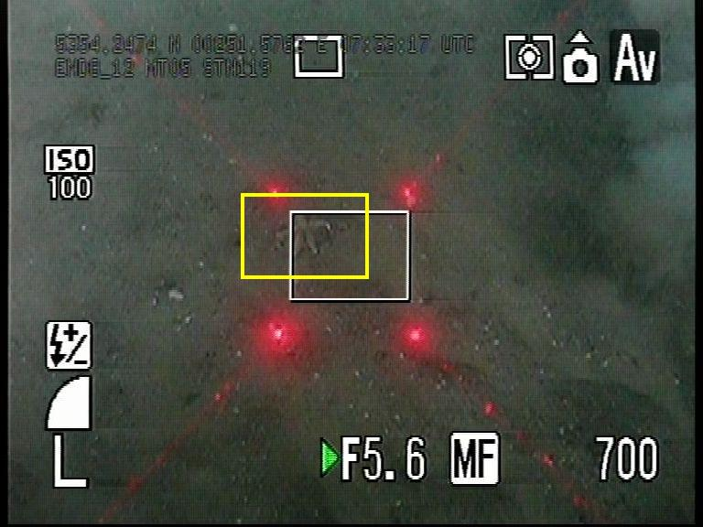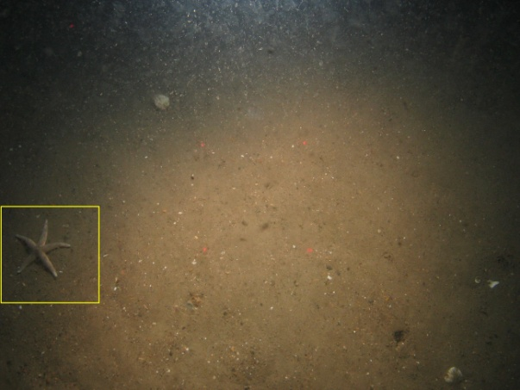
Example file names: Video Still
Asterias rubens_Video_MRTR_CEND08a12_MT05_STN_119.jpg Asterias rubens_Still_MRTR_CEND08a12_MT05_STN_119_005.JPG

Biotope reference collection
- A reference image is required for each biotope recorded within the survey
- At least 1 image per biotope, either from the video (snapshot/screen grab) or the stills with the preference being the stills due to image resolution. In addition, a short (30 second/1 minute) video clip showing examples of habitats/biotopes identified should be included. This may be better than a video screen shot and could accompany a still image to highlight possible variation within the habitat.
- Save the image with the relevant biotope code, both the EUNIS and MNCR, and video/still file name. See examples below.
- Fill in a new row in the SpeciesBiotopeRefCollection.xlsx spreadsheet
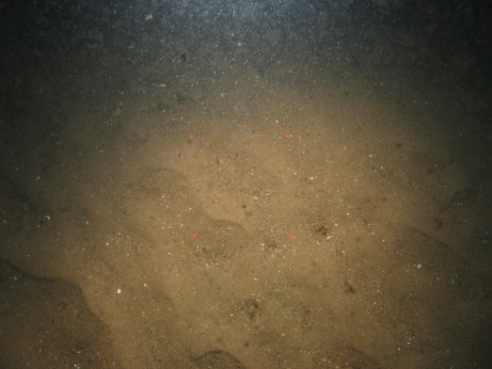

Example file names: Biotope_A5.25_SS.SSa.CFiSa_Still_MRTR_CEND08a12_MT05_STN_119_003.JPG

Video Analysis Proforma
The following is a detailed description of how to fill out the Video Analysis Proforma.
- SURVEY NAME: Enter the name of the rMCZ and the year of the survey
- Station code: Enter the station code for the video being analysed
- Date: Enter the date the video was taken
- Video Sample Ref: This should be the station code along with the segment number. E.g. if the video is separated into 3 segments due to change in substrate type or biological community (communities identifiable by different biotope codes) the first sample ref would be StnCode_S1 (subsequent segments would be StnCode_S2, StnCode_S3 etc.). If, for example, the first and third segments contain the same habitat they should still be labelled _S1 and _S3 and not both labelled _S1. See example on the video analysis proforma.
- BriefHabitatDescription: Give a brief description of the physical and biological features visible in the appropriate video segment including surface relief, overhangs, crevices and fissures for rock habitats.
- Method: Enter drop camera or camera sledge depending on the gear used from drop-down menu
- StartTime: This should be taken from video overlay at the start of the segment.
- EndTime: This should be taken from video overlay at the end of the segment.
- Duration: This should automatically calculate when the two above rows are filled in.
- SurveyRunBy: Enter the name of the company that undertook the survey (e.g. Cefas, EA etc)
- Start – Latitude: Enter the start latitude for the video segment. This should be taken preferentially from the nearest still position or video overlay (converted from degrees and decimal minutes to decimal degrees) if no still position available.
- Start – Longitude: Enter the start Longitude for the video segment. This should be taken preferentially from the nearest still position or video overlay (converted from degrees and decimal minutes to decimal degrees) if no still position available. Note that longitudes west of the meridian are negative, e.g. -1.00 for 1° 00’ W.
- End - Latitude: Enter the end latitude for the video segment. This should be taken preferentially from the nearest still position or video overlay (converted from degrees and decimal minutes to decimal degrees) if no still position available.
- End - Longitude: Enter the end Longitude for the video segment. This should be taken preferentially from the nearest still position or video overlay (converted from degrees and decimal minutes to decimal degrees) if no still position available. Note that longitudes west of the meridian are negative, e.g. -1.00 for 1° 00’ W.
- SeaLevelUpper: Enter upper depth taken from spreadsheet provided
- SeaLevelLower: Enter lower depth taken from spreadsheet provided
- Area covered (m²): Enter the approximate area covered by the video segment. This can be done by multiplying the length of the segment by the width (calculated using the laser scalers). For drop cameras, use the approximate average width of the tow.
- Substratum%: Under this section enter the % of each observed substrate. Make sure that when combined they add to 100%.
- Broadscale Habitat: Enter the relevant broadscale habitat from the drop-down menu for each segment. For sediments, use the modified Folk trigon in Annex 2 to differentiate between Coarse Sediment, Sand, Mud, Mixed Sediment. Note that a mixture of sand and gravel (incl. granules, pebbles and unstable cobbles) is to be classified as Coarse Sediment in the absence of significant amounts of mud.
- Habitat FOCI: Enter a Habitat FOCI from the drop-down menu for each segment if relevant (MCZ Only).
- Annex 1 Habitats: Enter an Annex 1 habitat from the drop-down menu for each segment if relevant (SAC Only).
- Scottish MPA Search Features: Enter a SMPA search feature from the drop-down menu for each segment if relevant (SMPA Only).
- EUNIS code: If enough information on depth (biological zone), vegetation, faunal composition or energy (for rock biotopes) is available then use this space to allocate a higher level biotope code. Some sections of video may show the habitat more clearly; if this is the case use the spaces in the proforma to allocate separate codes.
- MNCR code: As above
- Classification: Exact copy of MNCR descriptor.
- DeterminedBy: Name of analyst for this video segment
- Visual quality of sample: E.g. Excellent, Good, adequate, poor etc.
- COMMENTS: Any other information or comments about the video segment should be entered here. Especially any evidence of human activities seen on the video tow.
- Litter: Note any litter seen within the video segment
- COMPLETED BY: Name of person who completed the spreadsheet

Stills Analysis Proforma
The following is a detailed description of how to fill out the Stills Analysis Proforma. The results for the stills analysis for each station should be entered in separate tabs in the proforma.
- SURVEY NAME: Enter the name of the rMCZ and the year of the survey
- Station code: Enter the ‘parent’ / ‘segment’ code for the still being analysed. E.g. StnCode_S1
- Date: Enter the date the still was taken
- Still Sample Ref: This should be the same as station code with the name of the still added. E.g. StnCode_S1_Img001.
- BriefHabitatDescription: Give a brief description of the physical and biological features visible in the still.
- Method: Enter drop camera or camera sledge depending on the gear used from drop-down menu
- Fix Time (hh:mm:ss): Enter the time the still was taken. This can either be taken from the video overlay or from metadata provided by Cefas.
- SurveyRunBy: Enter the name of the company that undertook the survey (e.g. Cefas, EA etc)
- Latitude (DecDeg): This should be taken from metadata provided by Cefas.
- Longitude (DecDeg): This should be taken from metadata provided by Cefas. Note that longitudes west of the meridian are negative, e.g. -1.00 for 1° 00’ W
- SeaLevelUpper: Enter the water depth
- Still surface area (m²): Calculate the area (m²) of each still, where possible using the laser points for scale.
- Substratum%: Under this section enter the % of each observed substrate. Make sure that when combined they add to 100%.
- Broadscale Habitat: Enter the relevant broadscale habitat from the drop-down menu for each segment. For sediments, use the ‘Modified’ Folk trigon in Annex 2 to differentiate between Coarse Sediment, Sand, Mud, Mixed Sediment.
- Habitat FOCI: Enter a Habitat FOCI from the drop-down menu for each segment if relevant (MCZ Only).
- Annex 1 Habitats: Enter an Annex 1 habitat from the drop-down menu for each segment if relevant (SAC Only).
- Scottish MPA Search Features: Enter a SMPA search feature from the drop-down menu for each segment if relevant (SMPA Only).
- EUNIS code: This does not need to be the same as the parent segment
- MNCR code: This does not need to be the same as the parent segment
- Classification: Exact copy of MNCR descriptor.
- DeterminedBy: Name of analyst for this video segment
- Visual quality of sample: E.g. Excellent, Good, adequate, poor etc.
- COMMENTS: Any other information or comments about the video segment should be entered here. Especially any evidence of human activities seen on the video tow.
- Litter: Note any litter seen on the still.
- COMPLETED BY: Name of person who completed the spreadsheet

- References
BELL, J.J. & BARNES, D.K.A. 2001. Sponge morphological diversity: a qualitative predictor of species diversity? Aquatic Conservation: Marine and Freshwater Ecosystems, 11(2): 109–121.
BELL, J. J., BURTON, M., BULLIMORE, B., NEWMAN, P., & LOCK, K. 2006. Morphological monitoring of subtidal sponge assemblages. Marine Ecology Progress Series, 311: 79–91.
BERMAN, J., BURTON, M., GIBBS, R., LOCK, K., NEWMAN, P., JONES, J., & BELL, J. J. 2013. Testing the suitability of a morphological monitoring approach for identifying temporal variability in a temperate sponge assemblage. Journal for Nature Conservation, 21(3): 173-182.
BOURY-ESNAULT, N. & RUTZLER, K. 1997. Thesaurus of sponge morphology. Smithsonian contributions to zoology 596. Smithsonian Institute Press, Washington, DC

PARRY, M.E.V. 2015. Guidance on Assigning Benthic Biotopes using EUNIS or the Marine Habitat Classification of Britain and Ireland JNCC report No. 546

Annex 1. Determining Organism Abundance
It is recommended that quantitative data are collected where possible. This enables analyses of abundance, diversity and population structure with some degree of statistical significance. Quantitative data should be more widely used in the future, in order to make comparisons. However, it is acknowledged that, for some surveys a semi-quantitative or qualitative study may be acceptable, especially if the video is of lower quality.
There are several ways that organism presence and abundance may be recorded, either quantitatively or qualitatively. The options that the analyst has may depend on the equipment set-up, analyst time and also the quality of the footage, as detailed below. Options for organism records are detailed below, in order of increasing information:
Presence / Absence
Note whether a taxon is present along a particular tow. Quick but offers few options for statistical analysis. The power to detect change in community structure is reduced as no information is recorded about the relative abundance of each taxon. However this option does offer a quick method which to analyse data. Errors in the dataset are also likely to be few in number when compared to other methods of analysis although there will still be issues with regards to cryptic and hard to identify taxa.
Counts
Actual numbers of organisms allow for the greatest variety of statistical analyses to be conducted on the data as well as providing increased certainty in results. For quantitative analyses countable organisms must be counted by viewing the video and consistently recording each identifiable organism according to the analysis schedule being used. The raw count can be converted into density (individuals / m²) by dividing the count by the calculated area sampled using the length of the video tow and the field of view of the camera. It should be noted that colonial and encrusting organisms are often recorded as percentage (%) cover, this is detailed further in section 4.2. Percentage cover should be used for imagery where one organism covers a considerable proportion of the survey area (e.g. barnacles covering rock, where it would take too long to count each barnacle, this is detailed below.
SACFOR
A scale that can be used to produce semi-quantitative estimates of abundance. This provides a useful guide for qualitative studies and can give an idea of the composition of species assemblages, and the relative abundance of species within an assemblage. With experience, the scale can be used to make useful broad comparisons between different sites. The SACFOR scale is often used in the process to determine biotopes. Details can be found on the JNCC website.
SACFOR
 | Growth form |  | Size of individuals or colonies |  |  |  | Density measures
% cover | Crust or  Meadow | Massive  or Turf | <1cm | 1-3 cm | 3-15 cm | >15 cm | No per unit area | Nos per m² | Nos per  0.5m² image | Nos per  0.4m² image | Nos per  0.3m² image | Nos per  0.2m² image
>80% | S |  | S |  |  |  | >1/ 0.001 m2 | >10,000 / m² | 50,000 | 40,000 | 30,000 | 20,000
40-79% | A | S | A | S |  |  | 1-9/ 0.001 m2  (1x1 cm) | 1000-999 / m² | 5,000 | 4,000 | 3,000 | 2,000
20-39% | C | A | C | A | S |  | 1-9 / 0.01 m2  (10 x 10 cm) | 100-999 /m² | 500 | 400 | 300 | 200
10-19% | F | C | F | C | A | S | 1-9 / 0.1 m2  (0.316 x 0.316 m) | 10-99 m² | 50 | 40 | 30 | 20
5-9% | O | F | O | F | C | A | 1-9 / m2  (1 x 1 m) | 1-9 / m² | 5 | 4 | 3 | 2
1-5% or density | R | O | R | O | F | C | 1-9 / 10m2  (3.16 x 3.16 m) | 1-9 / 10m² | 1 | 1 | 1 | 1
<1% or density |  | R |  | R | O | F | 1-9 / 100m2  (10 x 10 m) | 1-9 / 100m² | - | - | - | -
 |  |  |  |  | R | O | 1-9 / 1000m2  (31.6 x 31.6 m) | 1-9 / 1000m² | - | - | - | -
 |  |  |  |  |  | R | 1<1/1000 m2 | 1<1/1000 m² | - | - | - | -
MNCR Notes
- Whenever an attached species covers the substratum and percentage cover can be estimated, that scale should be used in preference to the density scale.
- Use the massive/turf percentage cover scale for all species, excepting those given under crust/meadow.
- Where two or more layers exist, for instance foliose algae overgrowing crustose algae, total percentage cover can be over 100% and abundance grade will reflect this
- Percentage cover of littoral species, particularly the fucoid algae, must be estimated when the tide is out.
- Use quadrats as reference frames for counting, particularly when density is borderline between two of the scale.
- Some extrapolation of the scales may be necessary to estimate abundance for restricted habitats such as rock pools.
- The species (as listed above) take precedence over their actual size in deciding which scale to use.
- When species (such as those associated with algae, hydroid and bryozoan turf or on rocks and shells) are incidentally collected (i.e. collected with other species that were superficially collected for identification) and no meaningful abundance can be assigned to them, they should be noted as present (P)

Cefas notes
- As the count for individual taxa can never be less than 1 per photo, those in size range >15 cm (e.g. Asterias) can never be scored less than Common in a photo.
- Similarly, size range 3-15 cm (e.g. Echinus) can never be scored less than Frequent and size range 1-3 cm (e.g. Ebalia) cannot be scored less than Occasional.
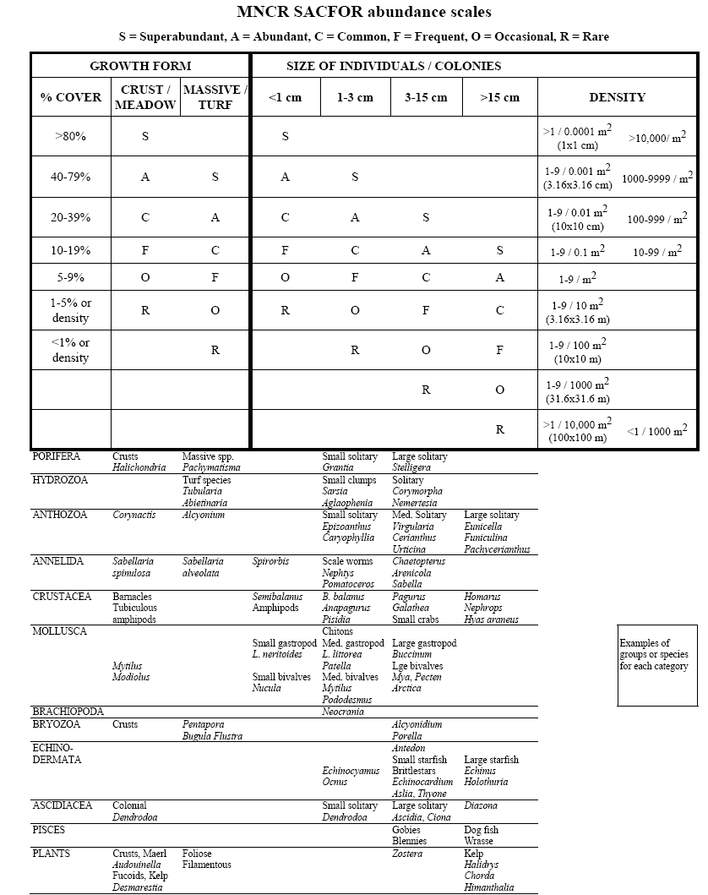
Percentage cover - Some organisms (e.g. sponges) have individuals that vary enormously in size whereas for others (e.g. colonial ascidians or zoanthids) the extent of a single individual is not obvious. In these situations, abundance should be recorded using percentage cover. The most common methods are:
- Visual estimation, where a quadrat is overlain on a video frame or still image and the percentage cover recorded. This is the simplest procedure to undertake, but is inherently the least accurate. Figure 2 provides further assistance with estimating percentage cover.

- Point counts, where a quadrat with a pre-determined number of points (usually 50 or 100), is overlain on a video frame grab or still image. Points can be either randomly or evenly spaced, and the percentage of those points which contain the organism in question is recorded. Points could also be stratified if two or more clear habitats were in all quadrats. Point counts can be sensitive to change if a statistically valid number of points is analysed, but can result in the failure to record rare organisms, thus underestimate species richness.

50% cover 25% cover
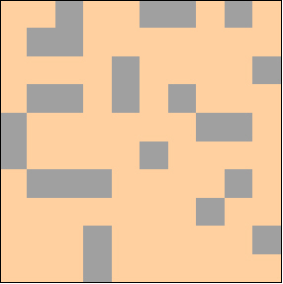
10% cover 5% cover
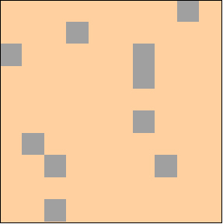
Figure 2. Graphical illustrations to assist with estimation of percentage cover (from Envision 2010, video ring test analysis tools).

Annex 2. ‘Modified’ Folk Trigon
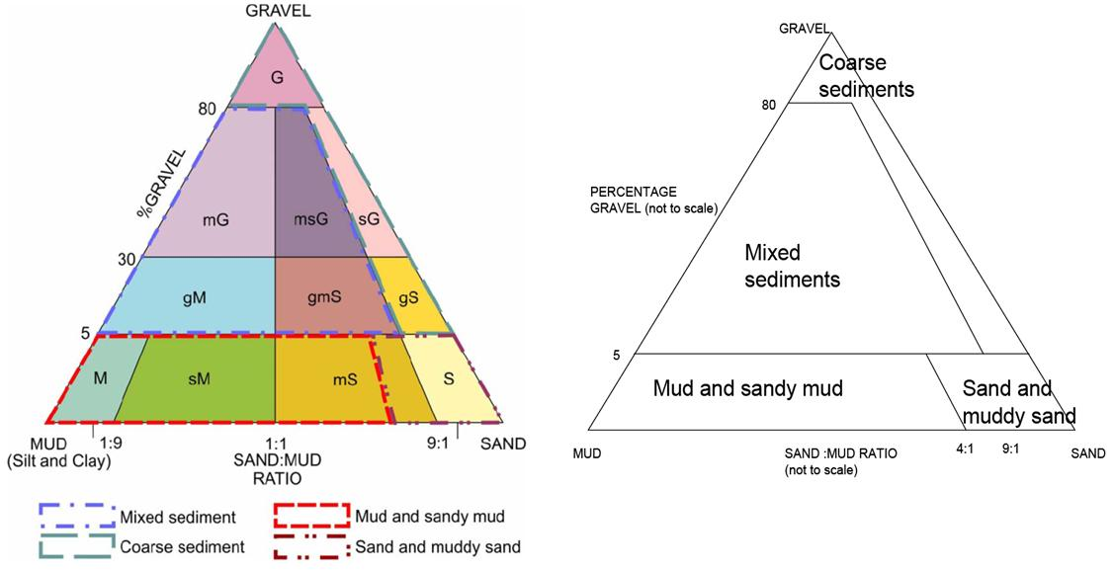
- ‘Modified’ Folk trigon (left) showing the classification used by the UK SeaMap and MESH projects to assign Folk sediment classes to the four broader sediment classes used in the EUNIS habitat classification scheme (after Long, 2006)

Annex 3. Broadscale habitat features listed in the ENG.
Broadscale Habitat Type | EUNIS Level 3 Code
High Energy Intertidal Rock | A1.1
Moderate Energy Intertidal Rock | A1.2
Low Energy Intertidal Rock | A1.3
Intertidal Coarse Sediment | A2.1
Intertidal Sand and Muddy Sand | A2.2
Intertidal Mud | A2.3
Intertidal Mixed Sediments | A2.4
Coastal Saltmarshes and Saline Reed Beds | A2.5
Intertidal Sediments Dominated by Aquatic Angiosperms | A2.6
Intertidal Biogenic Reefs | A2.7
High Energy Infralittoral Rock* | A3.1
Moderate Energy Infralittoral Rock* | A3.2
Low Energy Infralittoral Rock* | A3.3
High Energy Circalittoral Rock** | A4.1
Moderate Energy Circalittoral Rock** | A4.2
Low Energy Circalittoral Rock** | A4.3
Subtidal Coarse Sediment | A5.1
Subtidal Sand | A5.2
Subtidal Mud | A5.3
Subtidal Mixed Sediment | A5.4
Subtidal Macrophyte Dominated Sediment | A5.5
Subtidal Biogenic Reef | A5.6
Deep Seabed*** | A6
- *Infralittoral rock includes habitats of bedrock, boulders and cobble which occur in the shallow subtidal zone and typically support seaweed communities
- **Circalittoral rock includes habitats of bedrock, boulders and cobble characterised by animal dominated communities, rather than seaweed dominated communities
- ***The deep seabed broadscale habitat encompasses several different habitat sub-types, all of which should be protected within the MPA network. The broadscale habitat deep seabed habitat is found only in the southwest of the MCZ project area and MCZs identified for this broadscale habitat should seek to protect the variety of sub-types known to occur in the region.

Annex 4. Habitat FOCI listed in the ENG.
Habitat Features of Conservation Importance (FOCI)
Blue Mussel Beds (including intertidal beds on mixed and sandy sediments)**
Coldwater Coral Reefs ***
Coral Gardens***
Deepsea Sponge Aggregations***
Estuarine Rocky Habitats
File Shell Beds***
Fragile Sponge and Anthozoan Communities on Subtidal Rocky Habitats
Intertidal Underboulder Communities
Littoral Chalk Communities
Maerl Beds
Horse Mussel (Modiolus modiolus) Beds
Mud Habitats in Deepwater
Sea Pen and Burrowing Megafauna Communities
Native Oyster (Ostrea edulis) Beds
Peat and Clay Exposures
Honeycomb Worm (Sabellaria alveolata) reefs
Ross Worm (Sabellaria spinulosa) reefs
Seagrass Beds
Sheltered Muddy Gravels
Subtidal Chalk
Subtidal Sands and Gravels
Tide-Swept Channels
- * Habitat FOCI have been identified from the ‘OSPAR List of Threatened and/or Declining Species and Habitats’ and the ‘UK List of Priority Species and Habitats (UK BAP)’.
- **Only includes ‘natural’ beds on a variety of sediment types. Excludes artificially created mussel beds and those which occur on rocks and boulders.
- ***Coldwater coral reefs, coral gardens, deep sea sponge aggregations and file shell beds currently do not have distributional data which demonstrate their presence within the MCZ project area.

Annex 5. Annex I Habitats
Annex I Habitats
Atlantic salt meadows
Estuaries
Lagoons
Large shallow inlets and bays
Mediterranean and thermo-Atlantic halophilious scrubs
Mudflats and sandflats not covered by seawater at low tide
Reefs
Salicornia and other annuals colonising mud and sand
Sandbanks which are slightly covered by seawater all the time
Spartina swards
Submerged or partially submerged caves

Annex 6: MSFD Indicator - additional analysis methodologies.

    - Shallow/ shelf sub-littoral rock – sponge morphological diversity.

In addition to taxon ID, sponge morphologies should be divided into appropriate pre-defined categories (Figure 2) i.e. Arborescent, Encrusting, Flabellate, Globular, Massive, Papillate, Pedunculate, Repent, and Tubular, following Bell & Barnes, (2001). Sponges should be captured using counts for erect, percentage cover for colonial/encrusting and SACFOR for both.
If any difficulties distinguishing between types are found, a set method should be followed based on the Thesaurus of Sponge Morphology (Boury-Esnault and Rutzler 1997). For example, massive and encrusting sponges should be determined based on elevation from substrate.
Please note that some sponge species can display plasticity (i.e. have multiple morphology types). For example, some adults species are likely to show environmental induced morphological variation such as the Haliclona species (e.g. from cushions to fistulae) and Halichondria species (from cushions to fistulate seasonally) (see Bell and Barnes, 2001).
When assigning morphologies, a note should be made of species showing morphological variation where possible.

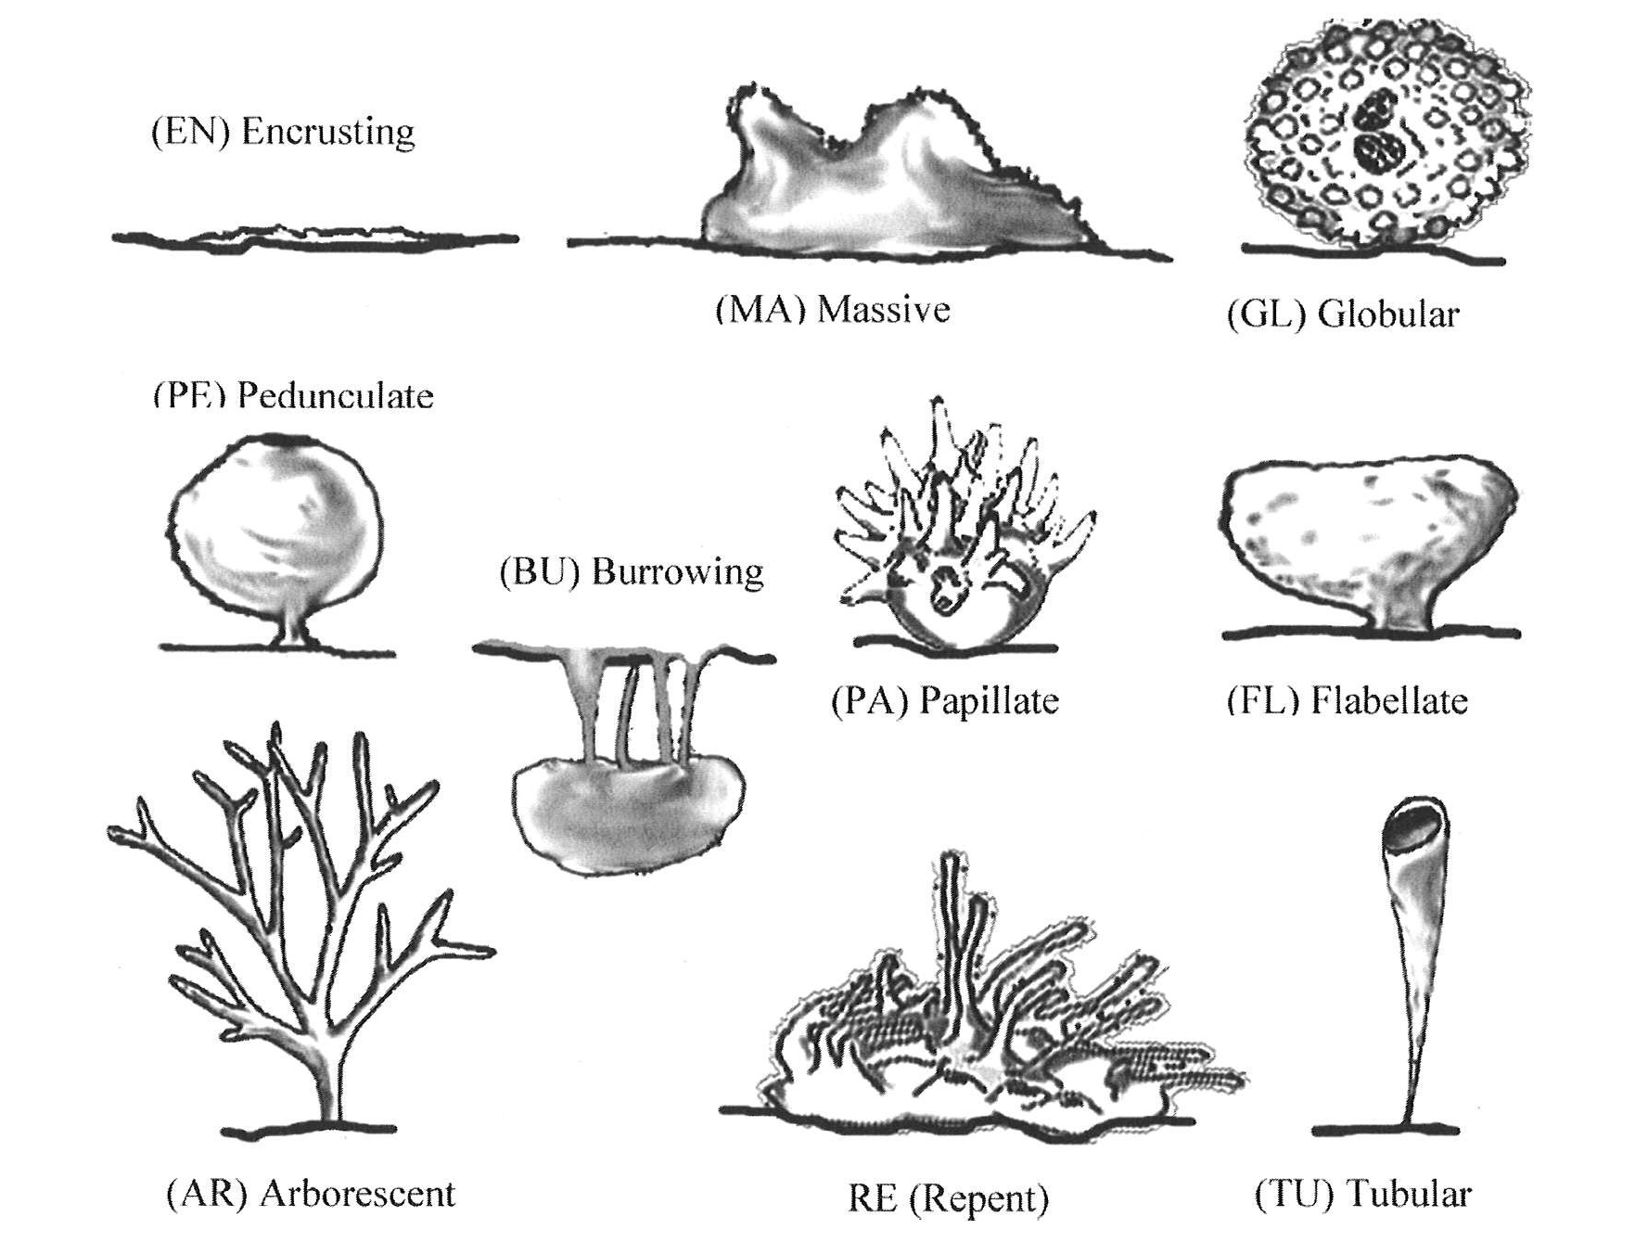

    - Biogenic structures – Subtidal Sabellaria reef

When Sabellaria reef is encountered, a reefiness assessment must be carried out on all Sabellaria reef encountered following the criteria below:

Table 1 Summary of reefiness scoring criteria (adapted from Gubbay, 2007 and Hendrick & Foster-Smith, 2006).
 | Definition | Not a reef | Low | Medium | High
A. Elevation | Maximum tube height | <2 | 2-5 | 5-10 | >10
B. Consolidation | Percentage cover of substratum by consolidated S. spinulosa tubes  Degree of consolidation | <10  rubble | 10-20  veneers, crusts | 20-30  upright tubes, some concretion | >30  Matrix of well-developed tubes
C. Area (km²) | Extent of total area | <0.025 | 0.025-0.1 | 0.1-1 | > 1
D. Patchiness | Percentage cover of consolidated S. spinulosa within overall spatial extent of the reef |  | 10-20 | 20-30 | >30
E. Density | Average density of S. spinulosa m⁻² |  | ~800 | ~1500 | ~3000
F. Biodiversity | Margalef's species richness  Shannon diversity index  Simpson's diversity index |  | ~5.0  ~2.5  ~0.85 | ~6.5  ~2.7  ~0.87 | ~8.0  ~3.0  ~0.90
G. Biotope | MNCR biotope code | Other | CR.MCR.Csab.Sspi | S S.SBR.PoR.SspiMX

The refines assessment must be undertaken on all stills and segments of video where Sabellaria is identified, and this must be accompanied by a full assessment of associated species in accordance with the standard methodologies identified in this document – so that community composition metrics can be tested against refines score.

In addition to the above the MSFD indicator suggest that tube occupancy counts (from HD stills) are attempted alongside the overall density counts identified in the methodology above. NE would like this step to be tested, and evaluated for practical operability.

Annex 7. Low or limited mobility species FOCI listed in the ENG.
Group | Scientific name | Common Name
Brown Algae | Padina pavonica | Peacock’s Tail
Red Algae | Cruoria cruoriaeformis  Grateloupia montagnei  Lithothamnion corallioides  Phymatolithon calcareum | Burgundy Maerl Paint Weed  Grateloup’s little-Lobed Weed  Coral Maerl  Common Maerl
Annelida | Alkmaria romijni**  Armandia cirrhosa** | Tentacled Lagoon Worm**  Lagoon Sand Worm**
Teleostei | Gobius cobitis  Gobius couchi  Hippocampus guttulatus  Hippocampus | Giant Goby  Couch’s Goby  Long Snouted Seahorse  Short Snouted Seahorse
Bryozoa | Victorella pavida | Trembling Sea Mat
Cnidaria | Amphianthus dohrnii  Eunicella verrucosa  Haliclystus auricular  Leptosammia pruvoti  Lucernariopsis campanulata  Lucernariopsis cruxmelitensis  Nematostella vectensis | Sea Fan Anemone  Pink Sea Fan  Stalked jellyfish  Sunset Cup Coral  Stalked Jellyfish  Stalked Jellyfish  Starlet Sea Anemone
Crustacea | Gammarus insensibilis**  Gitanopsis bispinosa  Pollicipes  Palinurus elephas | Lagoon Sand Shrimp**  Amphipod  Gooseneck Barnacle  Spiny Lobster
Mollusca | Arctica islandica  Atrina pectinata  Caecum armoricum**  Ostrea edulis  Paludinella littorina  Tenellia adspersa** | Ocean Quahog  Fan Mussel  Defolin’s Lagoon Snail**  Native Oyster  Sea Snail  Lagoon Sea Slug**
- *Species FOCI have been identified from the ‘OSPAR List of Threatened and/or Declining Species and Habitats’, the ‘UK List of Priority Species and Habitats (UK BAP)’ and Schedule 5 of the Wildlife and Countryside Act.
- **Those lagoonal species FOCI may be afforded sufficient protection through coastal lagoons designated as SACs under the EC Habitats Directive. However, this needs to be assessed by individual regional projects.

Annex 8. Life Form list
Algal_Turf
U. brown algae_filamentous
U. brown algae_foliose
U. brown algae_kelpU. green algae_filamentous
U. green algae_foliose
U. red algae_encrusting
U . red algae_mearl
U. red algae_foliose
U. red algae_filamentous
U. anemone
U. anemone_white
U. anthozoa
U. ascidian_solitary
U. ascidian_colonial
U. bryozoan_encrusting
U. bryozoan_massive
U. bryozoan_foliaceous
U. bryozoan_dendroid
U. bryozoan_fenestrate
U. bryozoan_plumose
U. faunal turf
U. holothurian_burrowing
U. hydroid
U. hydroid turf
U. hydroid crust
U. gastropod
U. sediment with life apparent
U. sponge_encrusting
U. sponge_cushion
U. sponge_massive
U. sponge_globular
U. sponge_pedunculate
U. sponge_papillate
U. sponge_flabellate
U. sponge_arborescent
U. sponge_cuplike
U. sponge_columnar

Annex 9. Video and still Quality Guidance

  - A number of criteria can be used to determine video quality including:
    - Camera distance to seabed
    - Angle of the field of view of the camera
    - Speed of camera over ground
    - Level of turbidity
    - Presence or absence of scale
    - Lighting quality

  - Example categories can include:
    - Excellent - Water is clear, perfect illumination, colour is excellent, camera moving at ideal speed and at a constant angle, sea bed is visible at all times. There may be very occasional issues with viewing the seabed but these occurrences last for <5% of the tow. All levels of analysis are expected to be possible;

    - Good - Seabed easily observed, small amounts of suspended matter but this does not affect the visibility, speed may occasionally vary, lighting is sufficient to appropriately illuminate organisms. There may be occasional issues with viewing the seabed but these occurrences last for 5-20% of the tow. This level of quality is not expected to affect analysis;

    - Poor - Suspended matter, dense fauna or flora (e.g. Kelp beds) or disturbed sediment results in a partially obscured view of the seabed. Camera speed and distance to the seabed is consistently variable throughout the tow. The constant stop-start, particularly in the case of sledge systems on sediments, can often result in reduced visibility. Uncertain if all target objects can be accounted for. These problems are present for 20-50% of the tow. High level taxonomic identification will be difficult from this point. Quantification of organisms may still be possible but it is recommended that a qualitative assessment of abundance is used. Broadscale habitat mapping (EUNIS Level 3) is still possible;

    - Very Poor - Suspended matter, dense fauna or flora (e.g. Kelp beds) or disturbed sediment obscures most of the seabed. Camera is often moving too fast resulting in constant blurring of organisms. Camera often moves too far from the seabed resulting in a lack of illumination and visibility. These problems are likely to be present for 50-80% of the tow. Quantitative or qualitative estimates of abundance of organisms is not recommended. It may still be possible to determine broadscale habitats;

    - Zero - For whatever reason (camera too far from the seabed, camera moving too quickly, lack of illumination, sediment disturbance, dense gathering of fauna or flora (e.g. Kelp beds), etc.) there is no view of the seabed at all for >80% of the tow. Data is not usable.

  - If the quality is deemed very poor or zero then it is recommended that the video should not be analysed further, or in cases where it is necessary for it to be analysed, that caveats are placed on the data.
  - In some cases the quality of footage may significantly deteriorate / improve during a video tow. In this case, the video should be segmented into subsection which fall in to the differing quality categories.

Excellent | 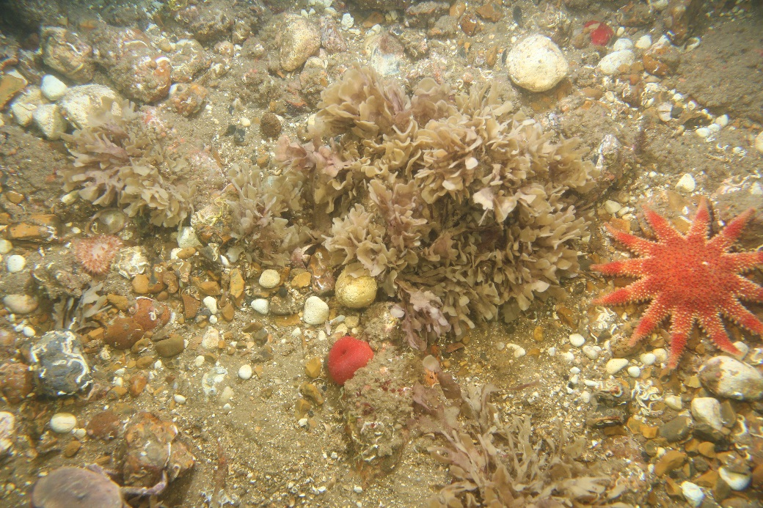
Good | 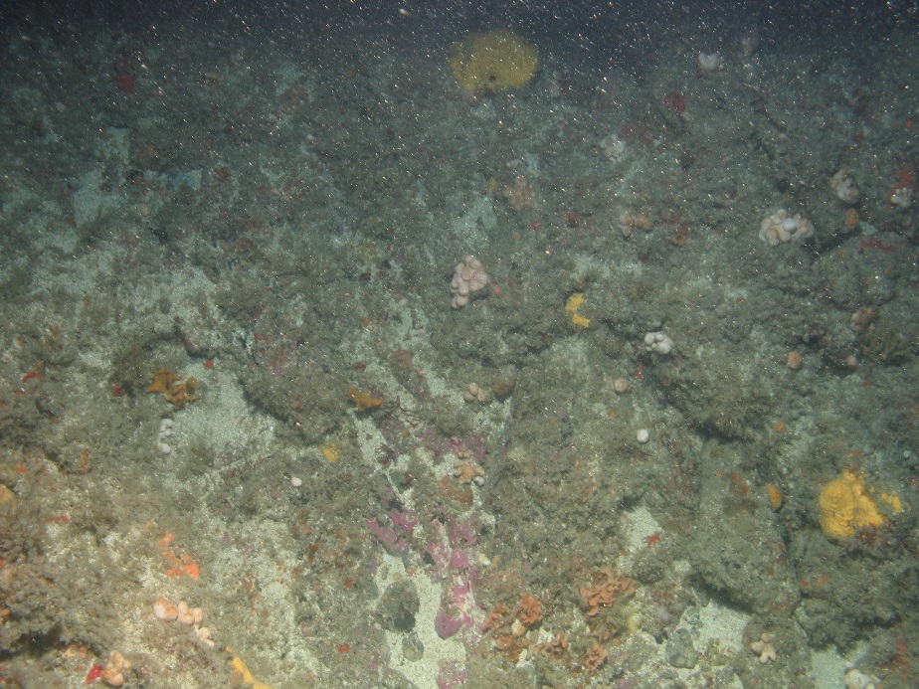
Poor | 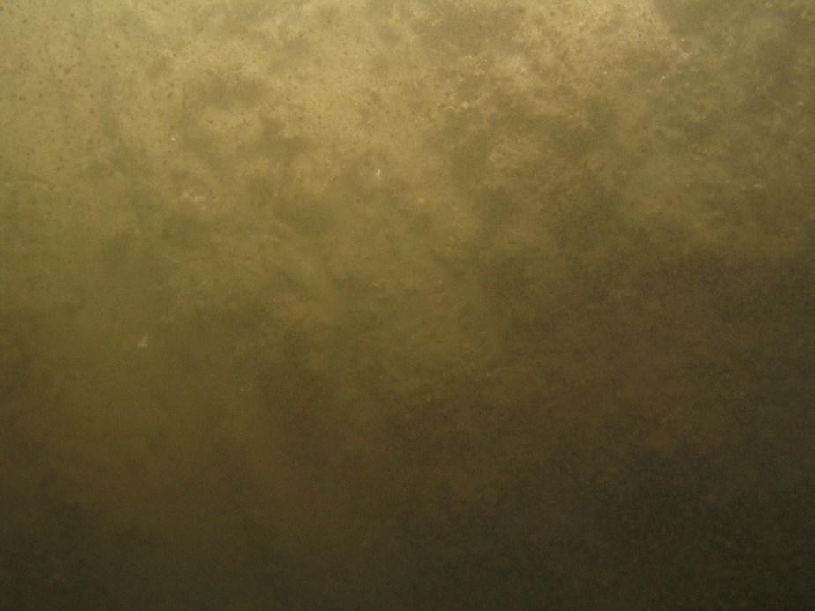
Very poor | 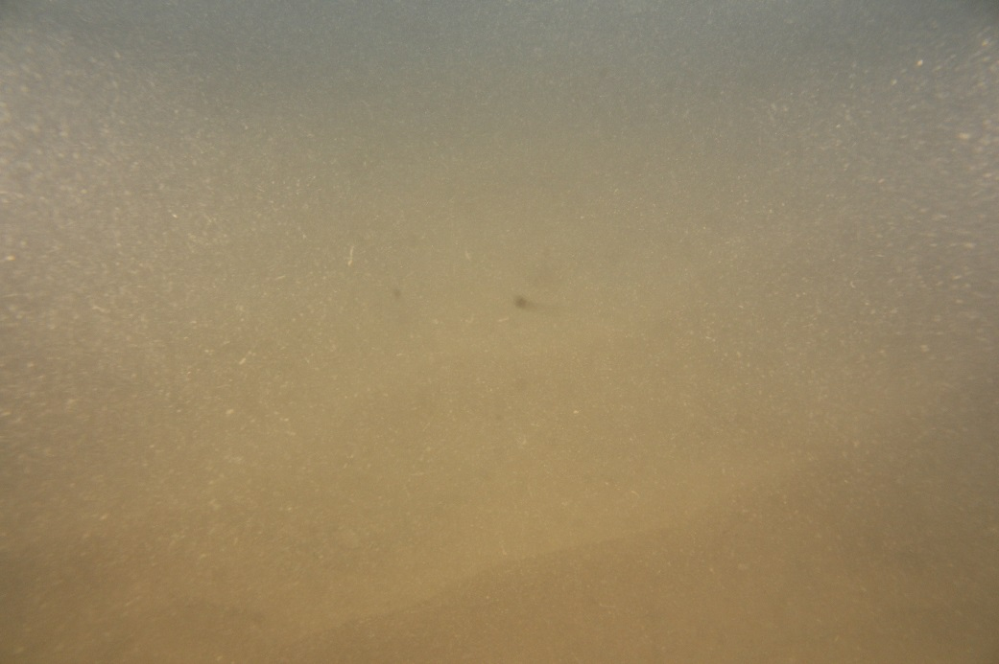
Zero | 

