Croydon MSK Service

Memorandum of Information (MOI)

NHS Croydon
Clinical Commissioning Group (CCG)

Contents
1. | Purpose | 3
2. | Definition | 3
3. | Strategic Context | 3
4. | The Commissioning Organisation | 5
5. | The Proposed MSK service | 7
6. | Service Mobilisation | 8
7. | Governance and Administration | 8

- Purpose
The purpose of this Memorandum of Information (MOI) is to support a market testing exercise being undertaken by NHS Croydon CCG (CCCG). The market testing exercise is intended to inform future commissioning plans with respect to the potential future procurement of a Croydon Musculoskeletal (MSK) Service.
The MOI is intended only as a preliminary background explanation for the procurement of the service. It is in no way intended to form the basis of any decision on the terms upon which CCCG will enter in to any contractual relationship.

2. Definition
CCCG wishes to inform the potential future commissioning of an MSK service for Croydon residents. The service is intended to deliver safe, high quality and innovative MSK services in line with the CCG’s strategic vision.

3. Strategic Context

3.1 National context
CCCG has taken into consideration national, regional and local strategies and frameworks in the development of initial commissioning plans for MSK. There are strong and robust strategic drivers for change and key related strategies have been highlighted in this section of the MOI.
Over recent years, the NHS has been increasing its focus on improving the provision, access and quality of care provided outside of an acute hospital setting. The White Paper ‘Our Health, Our Care, Our Say’ outlined the ambition to create a fundamental shift of care from hospitals to more community-based settings and this was reiterated by Lord Darzi in ‘Our NHS, Our Future with the principle to ‘localise where possible, centralise where necessary’.
The NHS Five Year Forward View further emphasised the need to break down barriers in how care is provided; with far more care delivered locally, supported by specialist centres for more complex needs. The provision of more MSK services outside of hospital settings is a step towards meeting this objective of care closer to patients and primary care. This has significant benefits; providing a more convenient service to patients and helping to relieve the pressure on secondary care services, focusing the most complex MSK diagnostics and treatment in secondary care. Patient feedback from other similar community services indicates high satisfaction by patients for community alternatives to hospital outpatient care.
In July 2006 the Department of Health (DH) published the Musculoskeletal Services Framework, which promotes the redesign of services’ together with the development of multidisciplinary interface services (that act as) a one-stop shop for assessment, diagnosis, treatment or referral to other specialists. This framework encouraged the sharing of care across organisational boundaries and improvements to integration and collaboration between primary and secondary care. Service redesign of this nature would achieve for health economies the avoidance of unnecessary patient attendances and elective admissions.
NHS England’s publication; ‘London: A Call to Action’, reported that London’s diverse population has resulted in a broad and growing range of health needs and that there had been a failure to close the inequalities gap. It considered that the pattern of healthcare provision with its emphasis on hospital services would not address this problem in the future and that much more should be done to support people to live healthier, independent lives through services provided in community settings that are more accessible to patients. The publication recommended that care needs to move away from traditional hospital-centred delivery and that local community based health services are developed to address the type and severity of local needs and to raise the health and wellbeing of those who are the least healthy to be in line with the healthiest. The report recognises that doing nothing is not an option and that bold transformational change is needed to the way in which services are currently delivered.

3.2 Local context

3.2.1 CCCG’s vision and strategy
CCCG’s vision, strategic objectives and values are as follows:
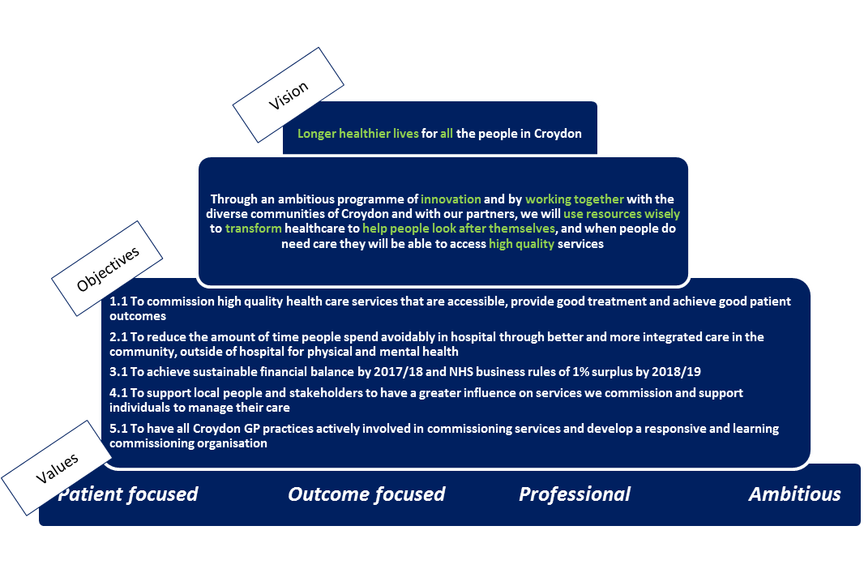

3.2.2 Historic model of care and future vision
The historic model of care and CCCG’s future vision for Croydon patients is as follows:
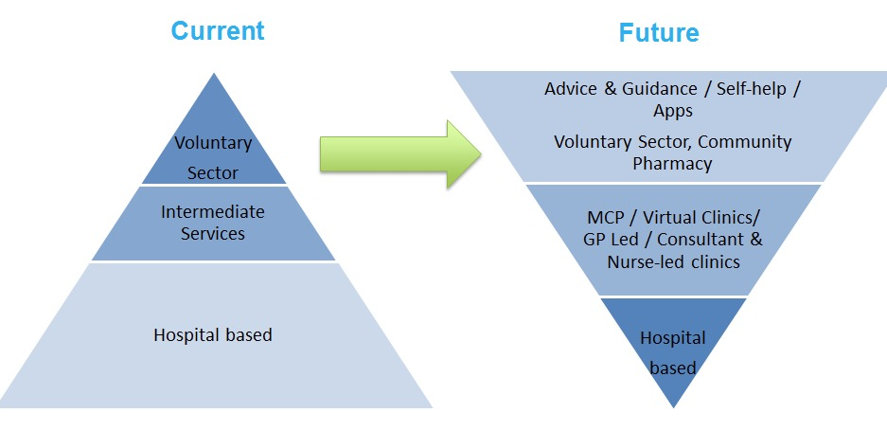

3.2.3 CCCG’s new model of care
CCCG has developed the “rainbow approach” to describe the components that will underpin the new Planned Care model of care. These components, shown in the figure below, are:
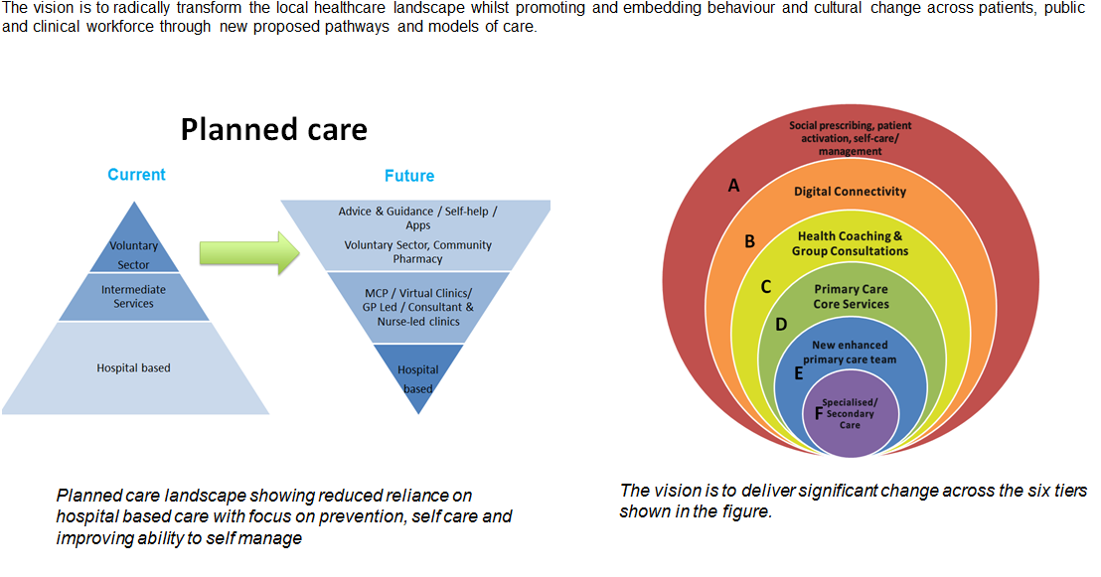
- Social prescribing, patient activation, self-care/management
- Digital Connectivity
- Health Coaching & Group Consultations
- Primary Care Core Services
- New enhanced primary care team
- Specialised/secondary care

3.2.4 CCCG’s vision for MSK care is that it is more closely aligned to and enhances primary care. The following diagram shows how CCCG envisages MSK care being delivered in Croydon:

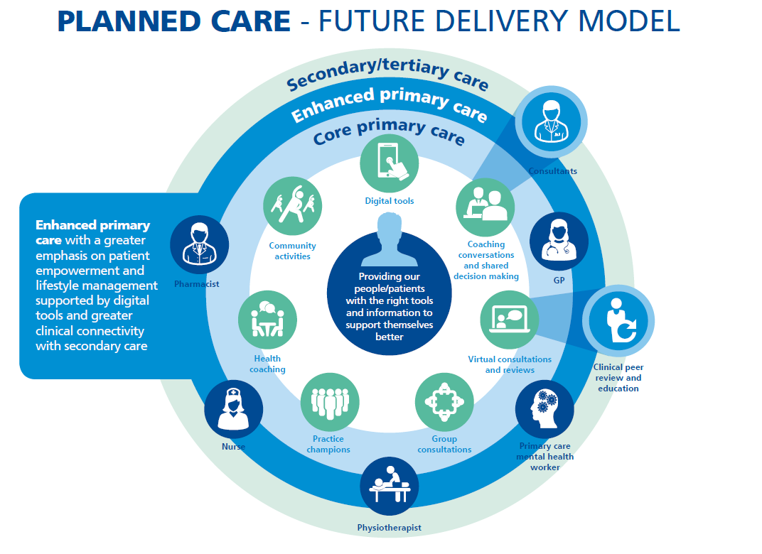

4. The Commissioning Organisation

4.1 Croydon CCG
CCCG is a membership organisation made up of all 56 GP practices in the borough of Croydon.​​ CCCG was established in April 2011 as a shadow organisation and received authorisation from the NHS Commissioning Board (now NHS England) in March 2013. On 1 April 2013, CCCG became legally responsible for commissioning health services for the residents of Croydon.
CCCG manages local healthcare budgets in excess of £465 million and commission a range of Croydon health services on patients’ behalf. These include hospital, community and mental health services.
Details of CCCG’s member practices can be found at http://www.croydonccg.nhs.uk/about-us/clinical-networks/Pages/GP-Practices.aspx.
4.2 Population
Croydon’s population (382,304) is the second largest of London’s 32 boroughs after Bexley. Source: ONS 2016 Population Estimate.
4.2.1 Age
The age distribution of Croydon’s population is as follows:
Age (years) | Numbers | Percentage
0-4 years | 28,621 | 7.5%
5-10 years | 32,859 | 8.6%
11-17 years | 32,955 | 8.6%
18-64 years | 237,663 | 62.2%
65+ years | 50,206 | 13.1%
Total Population | 382,304
Source: ONS, Mid-Year Population Estimates, 2016
4.2.2 Disability
The 2011 Census identified that there were 53,113 people in Croydon who considered their day to day activities were limited a little or a lot by a disability or long term illness, 65% of whom were aged 50 and over:
Disability category | Numbers | Percentage
Day-to-day activities limited a lot | 24,380 | 6.7%
Day-to-day activities limited a little | 28,733 | 7.9%
Day-to-day activities not limited | 310,265 | 85.4%
Total of all categories. | 363,378 | 100.0%
Source: ONS, Census 2011, Table QS303UK
4.2.3 Ethnicity
Croydon is an ethnically diverse borough with 55.1% of residents identifying as White and 45.9% identifying as from BME groups (20.1% Black, 16.4% Asian, 6.6% Mixed Ethnicity and 1.8% Other); Source: GLA 2015 Round of Demographic Projections - long-term migration scenario.
4.2.4 Gender
Croydon’s population pyramid shows a fairly even distribution of males (48.6%) and females (51.4%).
4.2.5 Language
82.6% of households in Croydon have English as their main language whilst English is not the main language in 7.9% of households. Source: ONS Census 2011.
4.2.6 Religion
The religion of Croydon residents is reported as follows:
Faith | Number | Percentage
Christian | 205,022 | 56.4%
Buddhist | 2,381 | 0.7%
Hindu | 21,739 | 6%
Jewish | 709 | 0.2%
Muslim | 29,513 | 8.1%
Sikh | 1,450 | 0.4%
Other Religion | 2,153 | 0.6%
No Religion | 72,654 | 20%
No Response | 27,757 | 7.6%
Source: ONS Census 2011

5. The Proposed MSK Service

5.1 Current MSK services in Croydon
MSK services in Croydon are currently structured in a two-tier system: intermediate and secondary care. The intermediate service (Community Integrated MSK Service (CIMS)) is provided by Croydon Health Services NHS Trust (CHS) and its purpose is to support, manage and coordinate the needs and conditions of Croydon MSK patients through an integrated model across primary, community and secondary care.
Where a patient requires further intervention, CIMS refer onto a specialist team in an acute hospital of the patient’s choice such as an Orthopaedic, Pain Management or Rheumatology service.
5.2 The current pathway
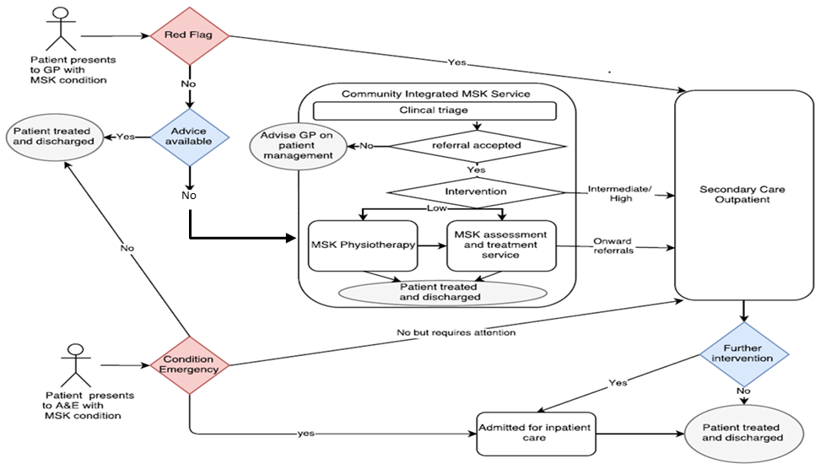

5.3 Scope of proposed service
The scope of the service will be developed by CCCG in response to the needs of the local community. Other than the type of locations of service detailed in the draft service specification, CCCG has not currently mandated the scope or the method for delivering the service, and encourages providers to take account of CCCG’s vision set out above and consider how they would innovate to deliver the specification.

5.3 Anticipated activity & contract value
5.3.1 The anticipated activity for the service is as follows:
50,000 - 55,000 patient contacts per annum.
The current service appointment types are first appointments face-to-face (25% of all contacts), follow-up appointments face-to-face (36% of all contacts) and telephone / group appointments (39% of all contacts). Again, CCCG does not mandate this method for delivering the service, and encourages providers to innovate to deliver the specification.
5.3.2 The anticipated contract value for the service is as follows:
£1.4m - £1.6m per annum.

5.4 Expected service outcomes
It is anticipated that commissioning a new MSK service will result in the following local outcomes:
- Reduction in secondary care activity by reducing inappropriate referrals to secondary care services, and by facilitating early discharge back to a community setting
- Promotion of self-care as the first port of call wherever appropriate
- Improved clinical outcomes for patients
- High levels of patient satisfaction with care
- High levels of shared decision making
- Increased knowledge within general practice regarding MSK conditions and treatment options
- Standardised educational tools and resources for GPs and patients, and a robust education programme for primary care
- Improved waiting times for patients, for both physiotherapy and secondary care
- Reduced health inequalities by providing equitable access to MSK services
5.5 Anticipated contract model
The anticipated contract model for the service is a 2 part model made up of a block funding element and a funding element dependent up delivery of agreed operational standards and quality requirements. We anticipate that the quality requirements are based on previous years performance to ensure realistic expectations.
The incentive element may take the form of a ‘reward for success’ scheme – assuming all operational standards and quality requirements are met. If the providing organisation fails to gain all the available reward within the Incentive payment scheme, money will be withheld by CCCG. The provider may bid for part or whole of this withheld sum via a proposal which would need to detail a cogent plan to recover performance against missed targets.
As such we are keen that proposals received describe how risk will be managed and that governance and sub-contracting arrangements are robust.

6. Service Mobilisation
Once the contract has been awarded, a detailed mobilisation plan will be developed by the provider and agreed by CCCG. The plan will include key activities and milestones to provide reasonable assurance that the service will be mobilised on time.
It is envisaged that in order to support the effective set up, mobilisation and implementation for the new service, there will be a provider-side resource with the knowledge, skills and experience to achieve and deliver the service specification.
During the service mobilisation period, the Provider is expected to deliver the following milestones:
Description | Target Threshold
Provider mobilisation lead identified | Contract signature
Mobilisation plan developed (including but not limited to mobilisation meetings schedule, locations of service, staffing, information governance, information management and technology, risk and issues logs, communication plan) | 2 weeks after contract signature

Further milestones will be as per the mobilisation plan developed by the provider and agreed by CCCG.

7. Governance and Administration
Further details on the requirements for the MSK Service are provided separately in the draft service specification.
Disclaimer
The information contained in this MOI is presented in good faith and does not purport to be comprehensive or to have been independently verified.
Neither CCCG, nor any of its advisers accept any responsibility or liability in relation to its accuracy or completeness or any other information which has been, or which is subsequently, made available to any potential Bidder, Provider, Bidder Member, Clinical Services Supplier, financiers or any of their advisers, orally or in writing or in whatever media.
Interested parties and their advisers must therefore take their own steps to verify the accuracy of any information that they consider relevant. They must not, and are not entitled to, rely on any statement or representation made by the Commissioner or any of its advisers.
This MOI is intended only as a preliminary background explanation of CCCG’s activities and plans and is not intended to form the basis of any decision on whether to enter into any contractual relationship.
The Commissioner reserves the right to change the basis of, or the procedures (including the timetable) relating to, the Procurement process, to reject any, or all, of the submissions and applications, not to invite a potential bidder to proceed further, not to furnish a potential bidder with additional information nor otherwise to negotiate with a potential bidder in respect of the Procurement, subject to compliance with general EU principles on equal treatment, non- discrimination and transparency and procurement law.
CCCG shall not be obliged to appoint any of the Bidders and reserves the right not to proceed with the Procurement, or any part thereof, at any time. Nothing in this MOI is, nor shall be relied upon as, a promise or representation as to any decision by NHS Croydon CCG in relation to this Procurement. No person has been authorised by the Commissioner or their advisers or consultants to give any information or make any representation not contained in this MOI and, if given or made, any such information or representation shall not be relied upon as having been so authorised.
Nothing in this MOI or any other pre-contractual documentation shall constitute the basis of an express or implied contract that may be concluded in relation to the Procurement, nor shall such documentation/information be used in construing any such contract. Each bidder must rely on the terms and conditions contained in any contract when, and if, finally executed, subject to such limitations and restrictions that may be specified in such contract. No such contract will contain any representation or warranty in respect of the MOI or other pre-contract documentation.
In this section, references to this MOI include all information contained in it and any other information (whether written, oral or in machine-readable form) or opinions made available by or on behalf of the Commissioner, or any of their advisers or consultants in connection with this MOI or any other pre-contract documentation.

