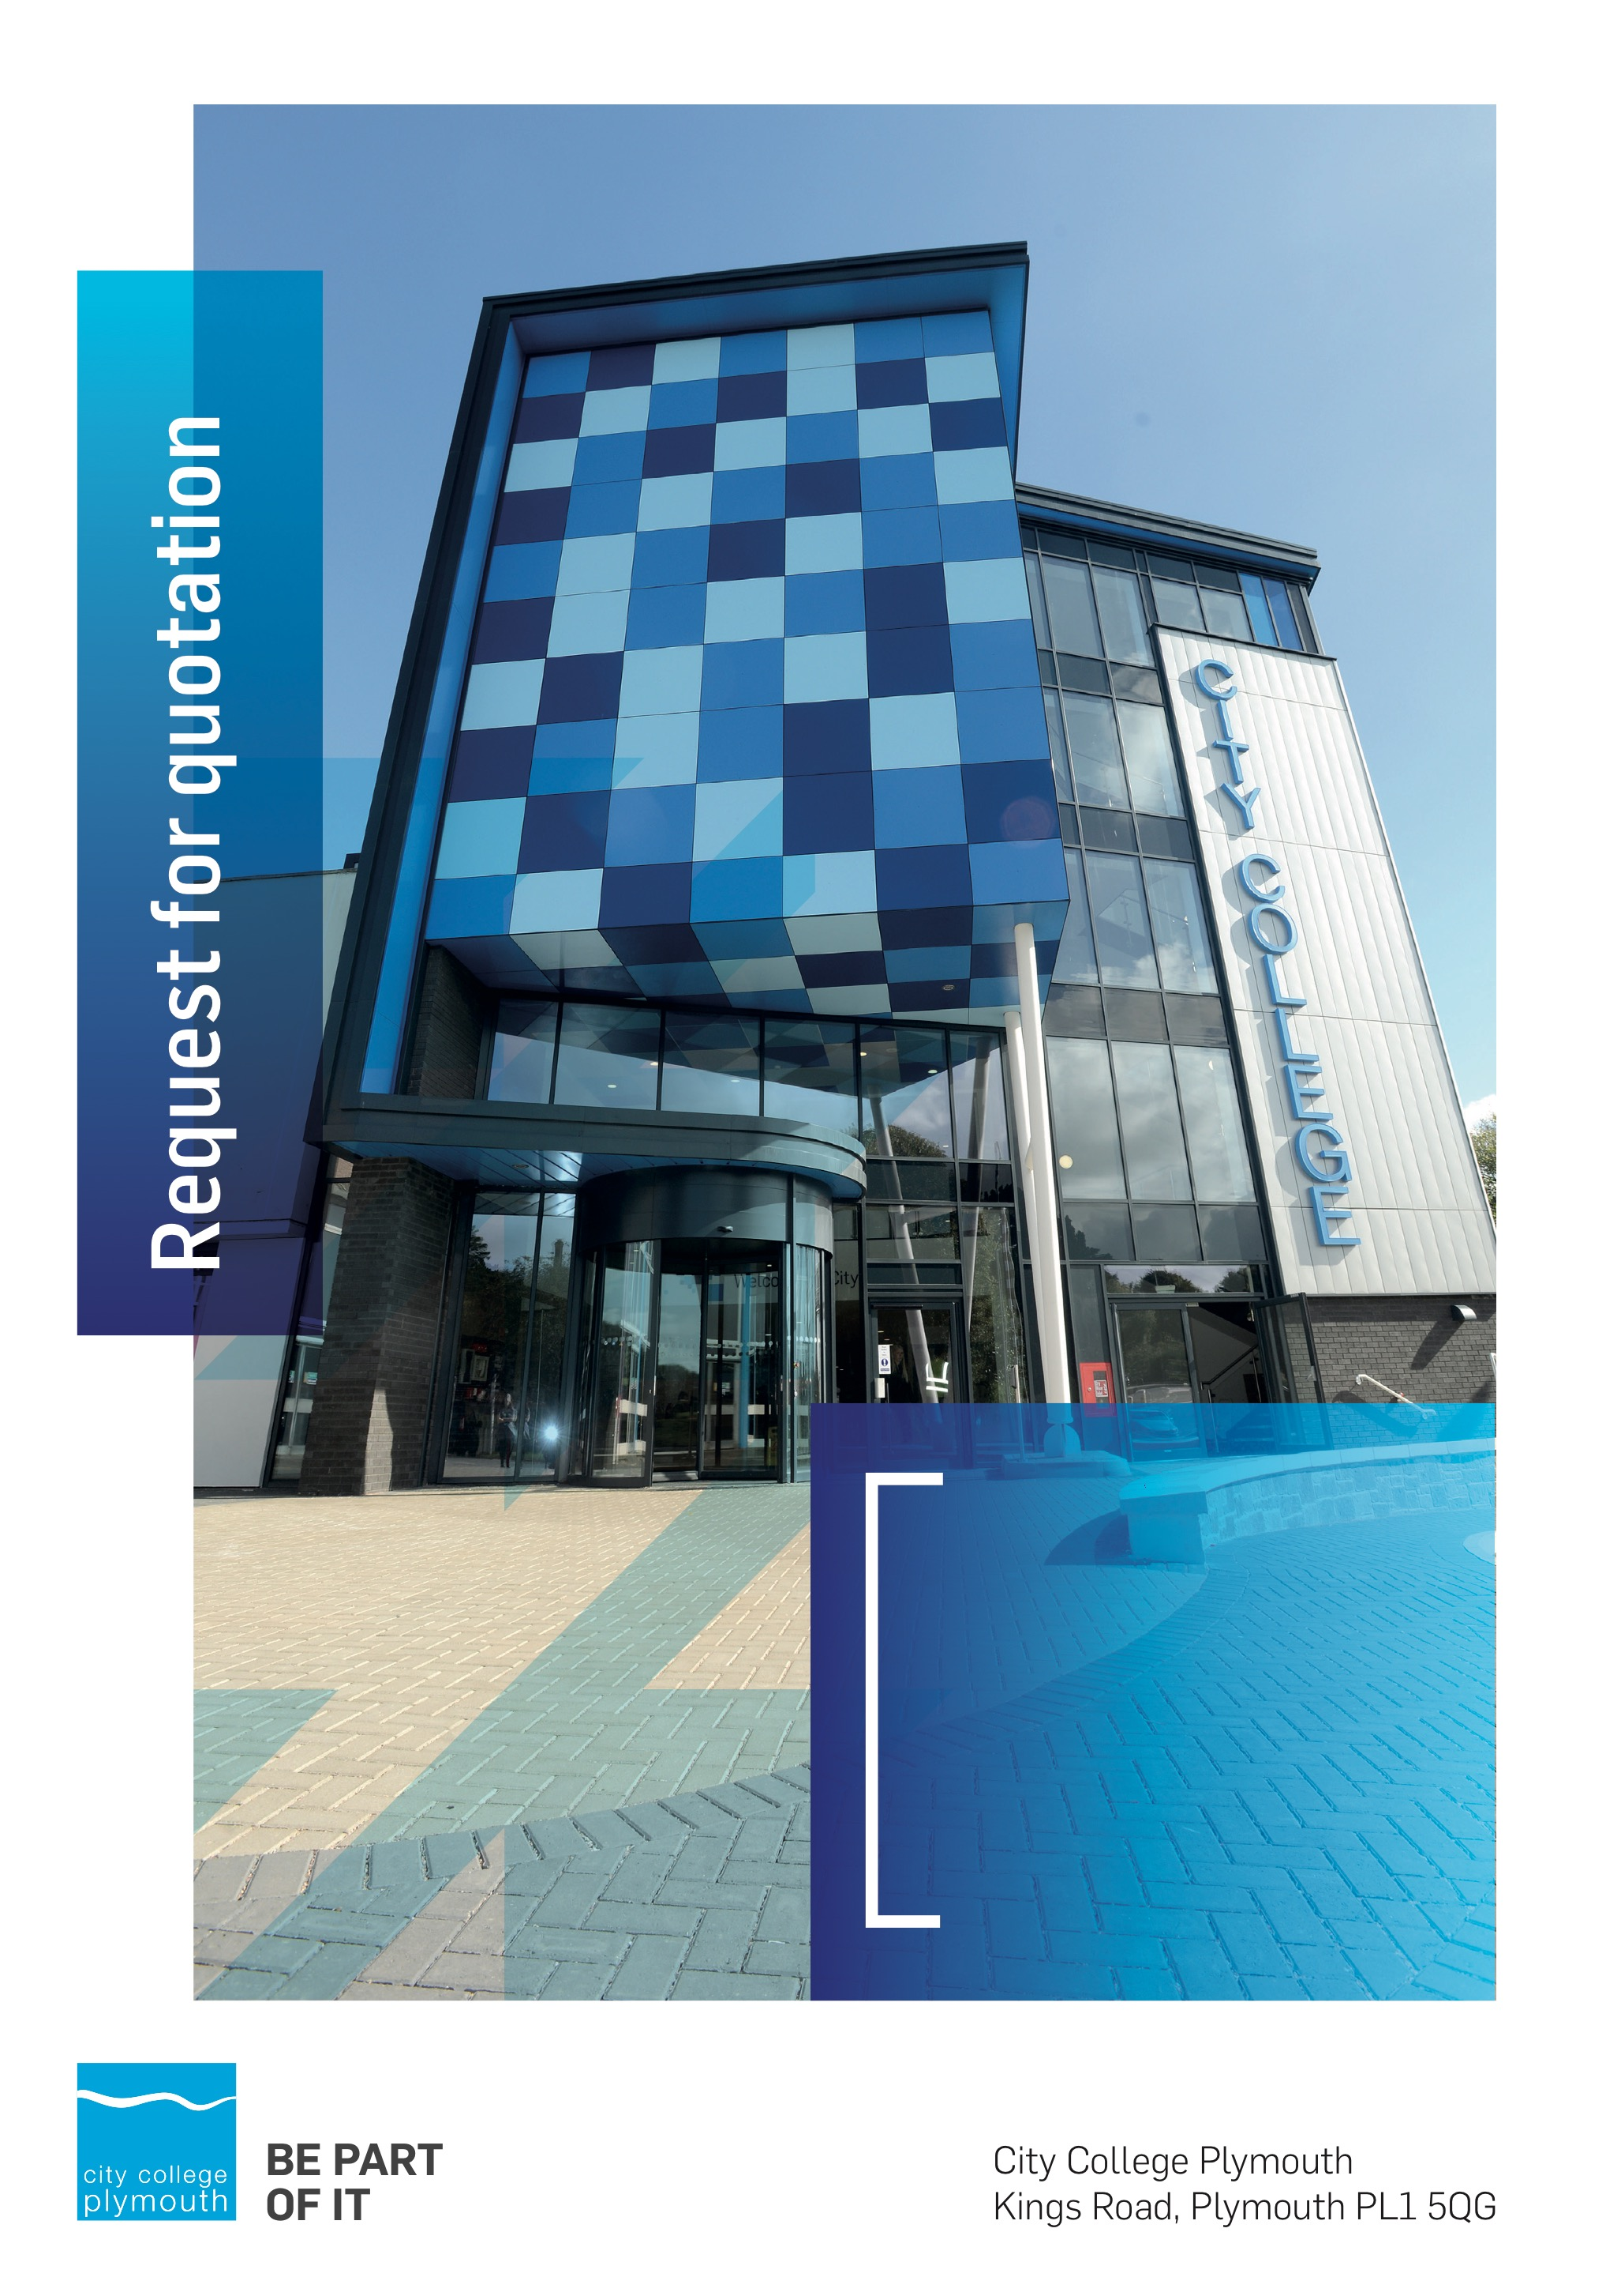

**Request for Quotation**

**RFQ170**

**Digital Transformation Infrastructure Partner**

**Issued 19th April 2021**

# Table of Contents

Table of Contents 2

Confidentiality Statement 3

Open Procedure 4

Submission Details 4

Submission Deadlines 4

Submission Questions and Clarifications 4

Electronic Submissions 5

Introduction and Executive Summary 5

Business Overview & Background 6

Our GUIDING PRINCIPLE 6

Our Vision 6

Our CORE VALUES 6

Our CULTURE 7

The Way Forward - our Priorities 7

Detailed Requirement 7

Timescales 11

Written Submission 11

Pricing 12

Terms and Conditions 12

Validity 12

Selection Criteria 12

Award Price 13

Written submission 13

Assessment of Quotations 13

Freedom of Information Act 2000 14

General Data Protection Regulation (GDPR) 2018 14

Agreement Conditions Acceptance and Declaration 14

Supporting Documentation 14

# Confidentiality Statement

This document, and any attachments thereto, regardless of form or medium, is intended only for use by the addressee(s) and may contain legally privileged and/or confidential, copyrighted, trademarked, patented or otherwise restricted information viewable by the intended recipient only. If you are not the intended recipient of this document (or the person responsible for delivering this document to the intended recipient), you are hereby notified that any dissemination, distribution, printing or copying of this document, and any attachment thereto, is strictly prohibited and violation of this condition may infringe upon copyright, trademark, patent, or other laws protecting proprietary and, or, intellectual property. In no event shall this document be delivered to anyone other than the intended recipient or original sender and violation may be considered a breach of law fully punishable by various domestic and international courts. If you have received this document in error, please respond to the originator of this message or email him/her at the address below and permanently delete and/or shred the original and any copies and any electronic form this document, and any attachments thereto and do not disseminate further.

Thank you for your consideration, City College Plymouth.

Where no notice is given, all information contained herein is Copyright 2021 City College Plymouth.

# Open Procedure

The College fully adheres to the requirements of the Public Contracts Regulations 2015, including for opportunities which are under threshold amounts.

Any Contractor who directly or indirectly canvasses any Member or Officer of the Institution, or advisor concerning the award of the contract for the provision of the services, or who directly or indirectly obtains or attempts to obtain information from any such member or Officer concerning any Tender or proposed Tender for the service will be disqualified from having his/her Tender considered.

# Submission Details

## Submission Deadlines

All submissions for responding to this Request for Quote must be submitted via email as stated below, no later than:

**7th May 2021**

**12:00 Noon**

Any submissions received after this date will not be considered.

## Submission Questions and Clarifications

You may contact the following person if you have any questions or require clarification on any topics covered in this Request for Quotation: by 30th April 2021

**Carol Williams**

Procurement Officer

Phone: 01752 856809

Email: tenders@cityplym.ac.uk

All correspondence during the Tender should be channeled via the Procurement Officer using the above details only. Bidders found to have gained an unfair advantage shall be disqualified from the current opportunity and future opportunities with the College for a minimum of four (4) years.

## Electronic Submissions

Electronic submissions in response to this Request for Quotation are required and must meet the following criteria:

Sent via email to: [tenders@cityplym.ac.uk](mailto:tenders@cityplym.ac.uk)

Document standards:

* Text must be in Microsoft Word format;
* Price tables must be in Microsoft Excel format (using pricing schedule in Appendix A);
* Supportive evidence may additionally be submitted in PDF format;
* Images, Designs, and other supporting evidence may be in either JPEG or PDF format
* Completed Appendix C Suitability Assessment & Selection Questionnaire (Including Mandatory & Discretionary Exclusions) Parts 1, 2 and 3. - *Please note this suitability assessment will not be viewed unless you are the winning tenderer. Failure at this stage may prevent the contract from being awarded.*
* Signed Agreement Acceptance and Declaration.

*Please note that the College is able to accept submissions sent in a compressed or “.zip” file format, so long as the files contained meet the standards described above.*

**WARRANTY**:

By submitting your tender bid, you are warrantying to the College that you have not breached our canvassing or soliciting clause.

If any successful tenderer awarded a contract is found to have provided an inaccurate warranty, then the College reserves the right to terminate the awarded contract with immediate effect and re-tender the contract from which the successful tenderer will be excluded from re-bidding and shall be disqualified from any future opportunities for a period of four years.

# Introduction and Executive Summary

City College is currently conducting an end to end review of its systems and processes as part of a new 10 year Digital strategy that is aiming to move us to become a leading digital practitioner with a thriving digital culture

The anticipated value of the supply contract will exceed £25,000. Therefore, as per the Public Contracts Regulations 2015 the opportunity will be advertised on the government portal ‘Contracts Finder’.

# Business Overview & Background

City College Plymouth has a learning environment and organisational culture that impacts positively on the health, wellbeing and sustainability of our community and enables all of our students and staff to achieve their full potential.

City College Plymouth is one of the largest providers of innovative, technical and professional, education in the South West with a national reputation for promoting enterprise, employability and science, technology, engineering and mathematics (STEM). The College plays a central role in the educational, cultural and economic life of the region and works with strategic partners to facilitate growth, raise aspirations and foster wealth creation.

The College was awarded the Teaching Excellence Framework (TEF) Gold award for its university-level provision and its most recent Ofsted inspection confirmed that the College continues to be ‘Good’ with many outstanding features. The College was rated first in the South West and second nationally for student satisfaction in the latest FE Choices student satisfaction survey.

City College Plymouth is also one of the first Institutes of technology in the UK Working in collaboration with education providers and employers across the South West to improve the training in science, technology, engineering and maths in order to address skills gaps within these industries and support regional growth.

City College supports the region’s employers with their award-winning Apprenticeship provision, as well as providing a range of courses and bespoke training programmes which enable employees to upskill or retrain to better support their business’ requirements.

The College operates on two main sites within the city, serving 12,500 students and employing over 650 staff. The College operates year round, with opening times from 0800-2100 on some days.

## Our GUIDING PRINCIPLE

City College Plymouth has a learning environment and organisational culture that impacts positively on the health, wellbeing and sustainability of our community and enables all of our students and staff to achieve their full potential.

## Our Vision

To be the learning destination of choice

## Our CORE VALUES

Respect, ownership, integrity for all

## Our CULTURE

Nurturing a passion for teaching and learning

Enriching our community through knowledge, experience and skills

Enabling every student to be the best that they can be

## The Way Forward - our Priorities

• Staff - our most important investment

• Students - our purpose

• Community - making a difference

• Achievement - reputation for success

• Wellbeing - infusing health into every day

# Detailed Requirement

The College is currently conducting an end to end review of its systems and processes as part of a new 10 year Digital strategy that is aiming to move us to become a leading digital practitioner with a thriving digital culture.

Some of the goals within the strategy are;

* To be a cloud first, Google First, digital-first college, maximising the use and benefits of our technologies
* Creating a college that is more connected and integrated, using digital to reimagine services and delivery that is user-focussed
* To ensure that we optimise our work by creating and utilising a single source of the truth/data
* Using automation, systems and technology to reduce workload and increase the time and space required high-value activity
* To enable frictionless learning and collaboration from classroom to workshop to online

A core aim is to move the College away from having a traditional approach to IT provision with fixed IT resources and to move - where appropriate - to a flexible, mobile working and learning environment.

For students this focus on replacing traditional IT classrooms with the use of flexible classroom resources with Chromebooks in charging units in classrooms for use as required to facilitate the switch from traditional seminar / theory delivery to IT focused project work environments.

For staff we will implement a number of strategies to support agile / flexible working patterns such as moving our teaching staff from fixed desktops to Chromebooks to allow seamless moves from the home to office to the classroom (and automated association to smart boards) and investment in softphone solutions to allow transportable communications.

Outside of this there will be significant focus on creating vibrant Digital hubs within the college estate to support innovation, training and development of skills and embed digital practice.

Our College management will move into Digital Leadership practices through the use of mobile devices and appropriate technology supported by a digitally enabling infrastructure.

We have an agreed strategic direction as being a Google College (moving to Google Reference College within 2 years) and our business processes and storage are already in the process of fully moving to G-suite although a substantive element of this has already been achieved. Our email solution is Gmail and we use the Enterprise version of Google. We are separately tendering for a Google Partner to maximise the use of these technologies and they will at times work with our selected infrastructure partner.

The College IT department supports the College IT infrastructure for some 9000 students and 700 staff. It is made up of some 2400 PCs, laptops, tablets, Chromebooks and other devices. The underlying infrastructure is based around Windows (AD, DNS, Server etc), WMWare/VEEAM as well as a number of Linux systems (Redhat/Centos) and DevOp tools (Gitlab/Vagrant/apache etc). We have a JANET network connection which is in the process of being expanded to provide a second connection to the college for resiliency.

For all these (and other) ambitious objectives and strategies to be successful in delivering a cloud first, digital first College we will need to modernise an aging IT infrastructure including - but not limited to - improved wireless infrastructure and authentication as well as security & resilience of our infrastructure to support agile remote working.

We are seeking a partner to help us realise these objectives.

This tender is for two separate strands to support this process;

**1 Development of a Digital Transformation infrastructure roadmap**

We are looking for a Digital Transformationpartner to work with key college staff to help translate our strategy, vision and goals into a clear actionable roadmap. This work is for a 6- 8 week period to commence by May 2021 with a completion date of July 2021.

The desired outcome must include:

1. A critical assessment of our strategic goals leading to a review of existing digital infrastructure & associated technologies highlighting what technology could be retained and built upon and what should be reviewed and replaced to ensure the college is positioned for the 10-year project. This should include substantial information gathering through group work, interviews, questionnaires and other mediums as required.

The scope of this project spans the full breadth of digital technology from the underpinning architecture to the physical hardware implemented to deliver our desired digital outcomes.

Security considerations are obviously paramount and any solutions put forward are required to adhere to best practice guidelines to protect the college and its stakeholders.

1. A strategic overview document mapped to the College’s digital strategy (summarising the roadmap below) and providing:
2. A visualisation (or simplified design brief) highlighting recommended technology & infrastructure investments & outcomes and how they deliver on our core objectives and position the college for the duration of the plan
3. A set of overarching objectives / high level actions and how they deliver on our core objectives to set timescales
4. A detailed roadmap with:
5. Recommendations showing step by step milestones to deliver strategic objectives
6. A comprehensive set of recommended technologies for each milestone
7. Critical paths, success factors and key risk mitigations
8. Clear, coherent procurement priorities and clear budget expectations
9. A skills audit of existing IT team to identify skills gaps and essential training requirements to support the infrastructure

**2 Delivery of the Digital Transformation infrastructure roadmap**

We are looking for an experienced IT infrastructure partner to take the defined strategies and roadmap and assist in fully implementing these (working with the college Senior Leadership Team, Digital & IT team and wider project leads).

This work is for an initial 1 year period to commence July 2021.

The required elements of this part of the tender are:-

1. Project management
2. Creating a detailed project plan from the Digital Transformation infrastructure roadmap using mature project methodology ensuring mapping of delivery objectives
3. Overseeing the full cycle from project initiation to the initiation and closure of each stage of the project lifecycle and the project closedown supported as required by the College project team.
4. Communicating with the Head of MIS & IT and the Project board and reporting on progress, highlighting and managing risk and ensuring success criteria met
5. Producing a detailed end of stage review and end of project summary to be provided to the project board and College Senior Leadership Team to demonstrate delivery of the strategic aims.
6. Procurement
7. Working in conjunction with the College’s procurement team (and within required financial regulations and Public Procurement Regulations) the successful party will be responsible for;
   1. Identification, shortlisting and recommendations for procurement for each stage in line with budget and in consultation with defined College leads
   2. Preparing specifications for tender by the procurement team as required
   3. Subject to procurement regulations and processes, negotiating with vendors to secure the best price, support and delivery and installation to required project dates
   4. Ensuring all infrastructure investments are covered by effective support and warranties for a minimum of 5 years or longer as needed.
8. Reviewing financial projections with key college staff to mitigate project creep and ensure delivery to budget. Production of a monthly overview of spend to budget in conjunction with the College finance team.
9. Delivery of works
10. Overseeing the implementation of each project stage in line with the project plan
11. Liaising with the Chief Digital Transformation Officer, Head of MIS & IT, College Estates manager, Head of Finance and - wider Project board - to ensure effective communication of stages, work requirements and potential impacts.
12. Securing the resources - where possible from within the College - to deliver each stage of the project - or securing best value where external resources required with financial guidelines and processes and in liaison with college procurement team.
13. Liaising with vendors over installation and configuration work, testing and post implementation checks to ensure that the meets the defined meets quality criteria
14. Ensuring all resources are correctly configured, documentation is completed by the relevant owner
15. Recommendations for sign off of deliverables.

For these two Tender elements we would prefer to work with a single partner across both elements however submissions will be accepted for individual elements.

Following the successful completion for these two projects a further tender process will be instigated to focus on ongoing partnership to provide 3rd/ 4th line support for the college infrastructure as well and regular technology reviews to ensure the college remains at the forefront of education technology - details will provided at a later date.

## Timescales

|  |  |
| --- | --- |
| **Action** | **Date** |
| Tender Issued | 19/04/2021 |
| Deadline for Queries | 30/04/2021 |
| Tender Response Date | 07/05/2021 |
| Shortlisting of tenders | 11/05/2021 |
| Presentations | 13/05/2021 |
| Award Date | 14/05/2021 |
| Implementation Date | 18/05/2021 |

## Written Submission

You are required to submit a written document which outlines how you can support the college on its google journey as outlined above. You should include any additional benefits you are able to provide to the college should you be selected as our preferred partner. This submitted document will be scored as per the table on page 13.

* Provide evidence of experience in developing end to end Digital Transformation roadmaps
* Provide evidence of experience in the successful delivery of end to end Digital Transformation projects
* Value added/additional benefits – what can you offer to us as a College over and above the basic requirements.

You should include any professional accreditations you hold and provide the names of two reference sites.

# Pricing

Bidders should provide their pricing for each of the key products in Appendix A.

Prices should be firm and valid for at least the initial contract period (12 months) and not subject to increase or escalation of any kind throughout the contract.

# Terms and Conditions

The College’s normal business terms are 1-2 months from the date of invoice. Payment will become due subject to the above upon the College’s full acceptance of the goods/services. This Request for Quotation and any resulting purchase order will be subject to the College’s General Terms and Conditions of Purchase of Goods/Services – see Appendix B.

# Validity

Bidder’s offers should be open and valid for acceptance for a period of no less than ninety [90] days from the date of submission.

# Selection Criteria

The successful supplier will have provided the Most Economically Advantageous Tender (MEAT) to the college. It should be noted that the bidder with the lowest submitted prices will not necessarily be down-selected. All bidders will be notified via email of the results of the outcome no later than 90 days from the date of submission. The date of contract award will be provided within that email.

The marking criteria follows:

|  |  |
| --- | --- |
| Category | Weight |
| Price | 50% |
| Evidenced experience in developing end to end Digital Transformation roadmaps | 20% |
| Evidenced experience in successful delivery of end to end Digital Transformation projects | 20% |
| Ability to demonstrate value for money and value added outcomes | 10% |

Please see table below for more details on the scoring method.

## Award Price

Lowest quote price divided by quote price multiplied by 100

## Written submission

|  |  |  |
| --- | --- | --- |
| **Assessment** | **Score** | **Interpretation** |
| **Excellent** | 4 | *Comprehensive response supported by examples*  *Description fully supported by details that demonstrate the applicant’s ability to provide the required services.* |
| **Good** | 3 | *Broad response supported by relevant examples.*  *Description well supported by details that demonstrate the applicant’s ability to provide the required services.* |
| **Satisfactory** | 2 | *Reasonable response supported by some evidence.*  *Description adequately supported by details that demonstrate the applicant’s ability to provide the required services.* |
| **Poor** | 1 | *Limited response not well supported by evidence.*  *Description inadequately supported by details that demonstrate the applicant’s ability to provide the required services.* |
| **Unacceptable** | 0 | *No response or insufficient information provided.* |

# Assessment of Quotations

Bidders must ensure that their quotation fully addresses all information requested within this RFQ document. Bidders must ensure that any quotation fully meets the specification required. The College reserves the right to discount any quotation which does not fully meet the specification.

The College reserves the right to seek clarification with bidders upon receipt of quotations.

# Freedom of Information Act 2000

Under the Freedom of Information Act 2000 the College cannot guarantee that information provided by bidders during the course of this RFQ procedure or any resulting contract will be held a confidential. The College will not routinely release information to interested parties unless required to do so in order to meet our statutory obligations.

# General Data Protection Regulation (GDPR) 2018

All bidders must comply with the General Data Protection Regulation (GDPR) 2018 in respect of using and processing personal information. Bidders must have in place technical and organisational safeguards to protect personal data from unauthorised use, disclosure or loss.

The College reserves the right to request a copy of your privacy statement if you are the successful bidder.

# Agreement Conditions Acceptance and Declaration

Bidders are required to sign and return the attached Agreement Conditions Acceptance and Declaration. Appendix D

# Supporting Documentation

Appendix A: Pricing Schedule

Appendix B: City College Plymouth Standard Terms & Conditions

Appendix C: Suitability Assessment & Selection Questionnaire

Appendix D: Agreement Conditions Acceptance and Declaration