Refurbishment of Norden Car Park Public Toilets
& Office, Corfe Castle, Dorset

Information and Instructions for Tenderers

- Introduction

1.1 Purbeck District Council (“the Council”) is seeking Tenders from suitably qualified and experienced persons to provide the services described in the Specification as set out in Schedule 1 of this document. This document explains some rules you need to follow when preparing your tender, tells you how to submit your tender and alerts you to some things to be aware of if you are awarded the contract. It also gives you some hints and tips to help you submit a successful bid.

1.2 If you do not follow the rules set out below, there is a risk your tender will be rejected.

2. Preparing your tender:

Rules you must follow:

2.1. Make sure your tender is completed legibly (either typed or in ink), in English, with all prices in Sterling (exclusive of VAT), and that it is signed and dated where required. If you need to make any amendments or corrections to your printed tender before you send it, you must initial these.

2.2. Your tender must tell us if you are registered for VAT and how this applies to the goods or services you are providing for us - for instance standard, reduced rate, zero, exempt or outside scope.

2.3. As part of your tender, you must provide (on headed paper) full contact details for the legal entity we would be contracting with including the name, registered address (and any alternative address for accounts etc.), contact name and numbers, payment and banking details and e-mail and website addresses.

2.4. You must not alter any of our Invitation to Tender documents. The conditions of contract are set out in Schedule 2 and will apply to this contract, so please do not include your own with your tender.

2.5. We publish details of successful bids as part of the Government’s transparency agenda to show how public money is being spent. We may also be required to release details under the Freedom of Information Act 2000 if requested. For these reasons, please do not put general confidentiality clauses in your tender as we can only accept them in very exceptional and narrowly defined circumstances. If you do consider any information to be confidential, please clearly set it out in a separate schedule (along with your reasons). The conditions of contract contain clauses about confidential information - please read these thoroughly before submitting your tender.

2.6 Do not tell anyone what your tender price is (even approximately) before the contract is awarded. The only exceptions are when obtaining an insurance quote to include in your tender or when seeking legal advice about the contract - on condition that you give this information in strict confidence.

2.7 Do not try to obtain information about anyone else’s tender before the date of contract award or discuss with anyone else whether or not they should tender, or about their (or your) tender price. The only exception is where you are considering a joint or team bid - on condition that all suppliers involved in the discussions are named in your tender.

2.8 You must complete all aspects of the tender including the Qualification Questionnaire, Tender Form, Analysis of Resources (Appendices A, B and C)

2.9 If you can see a different way of approaching the requirement to the one we have described in our specification, you can submit an “alternative” tender. But if you do this then you must also submit a separate “primary” tender based strictly on our original specification. You must fully price both options showing clearly how and where costs differ.

2.10 If you decide to join with other suppliers to submit a joint or team bid, be aware that (if successful) the group will need to nominate a lead partner who we can contract with. Alternatively the group will need to form themselves into a single legal entity before the contract is awarded and you must provide an undertaking with your tender that the group is prepared to do this.

Important things to be aware of:

2.11 If we refer to an International, European or British Standard in our specification, you can offer an equivalent provided that it offers equivalent guarantees of safety, suitability and fitness for purpose to the one we specified.

2.12 The expense you incur in preparing this tender is a matter for your own commercial judgement. Be aware that exceptionally we may need to withdraw the tender invitation or re-invite tenders on the same or an alternative basis.

2.13 We reserve the right not to accept the lowest (or any) tender, or to accept any part of your tender without accepting the rest.

2.14 It is not the Council’s policy to reimburse tendering costs.

Pricing & Cost Breakdown

2.15 The Service Provider must complete and return the Pricing Schedule.

2.17 The price submitted shall be fixed and firm.

Some hints and tips:

2.19 Please read the documents carefully and make sure you provide all the information we ask for.

2.20 Pay attention to the evaluation criteria - these tell you what we are looking for. It’s helpful if you can use the criteria headings to organise the information in your tender so that the evaluation team can immediately see that you have addressed them.

2.21 Please keep tenders brief and to the point - don’t send lots of additional information if it is not relevant.

2.22 Make sure you properly explain how you propose to undertake the work. If you spot issues that need to be addressed or particular risks - cover these too (and tell us what you plan to do about them). This gives us confidence that you have understood our requirement and are capable of delivering it.

2.23 Please provide the price breakdown in the format we have requested.

2.24 Do not leave it until the last minute before sending your bid, even if you are using a courier. Unforeseen transport problems can result in your tender missing the deadline and being rejected.

3 Submitting your tender:

3.1. The process for submitting tenders is very tightly controlled to make sure everyone is treated equally. Unfortunately this means that we cannot accept e-mailed tenders so you will need to send your tender by post or courier. Two completed sets of Tender Documents are to be returned to:

Purbeck District Council
C/O Mrs S Attwater
Westport House,
Worgret Road,
Wareham
Dorset, BH20 4PP

Tenders should be in a sealed plain envelope clearly marked “Tender for the Refurbishment of Norden Car Park Public Toilets & Office. Corfe Castle”. Your company’s name must not be on the envelope or any other packaging or labelling (please make sure your courier is aware of this too).

3.2. The tender return date and time is noon on Friday 6th April 2018 and you must make sure it is received by us before then. If the tender is delivered by hand you should ensure that you obtain a receipt from one of our officers. Be aware that late tenders will be rejected even if the reason for the delay is not your fault.

3.3. Your tender will remain open for acceptance for 90 calendar days from the Tender Deadline

4. Awarding the contract and mandatory / discretionary grounds for exclusion.

4.1. We will take into account the information provided by you in the tender along with pricing information any other information specifically related to the evaluation of tenders that we have requested.

4.3 Tenders will be excluded if the mandatory grounds for exclusion set out in the Qualification Questionnaire are submitted. If there are any discretionary grounds for exclusion please provide as much information with your tender as possible for us to make a reasoned decision. The Qualification Questionnaire will be assessed using the form below:

Mandatory Exclusion from the tender process
Are there any grounds for mandatory exclusion (Section 2 Qualification Questionnaire) | Yes - Fail | No - Pass
Discretionary Exclusion from the tender process
 | Yes - Fail | No - Pass
Are there any grounds for discretionary exclusion (Section 3 Part 1)
Are there any grounds for discretionary exclusion under Section 5 of the Qualification Questionnaire: Economic and financial standing
Are there any grounds for discretionary exclusion under Section 6 of the Qualification Questionnaire: Technical and Professional ability
Are there any grounds for discretionary exclusion under Section 7 of the Qualification Questionnaire: Insurance, Compliance with Equality Legislation, Environmental Management, Health and Safety

4.2 The assessment of tenders will be evaluated against the Qualification Questionnaire and award criteria up to a maximum of 100 points for your submission.

4.3 The price and quality of submission carry predetermined weightings which relate to the maximum number of points that can be scored for each criterion. Each criterion will be assessed from 0 - 1 (as set out below) and then applied to the weighting.

Tender for the Refurbishment of Norden Car Park Corfe Car Public Toilets & Office
 | Weighting
Price | 70%
Quality of Submission | 30%

Tender for the Refurbishment of Norden Car Park Corfe Car Public Toilets & Office
Price | Weighting | Score
Price | Max points 70  (The Cheapest Tendered Price / Your Tendered Price X 70)
Quality of submission:  Consisting of: | Max points 30
- Demonstrate and evidence ability to deliver the works and to add value. | Max Points 20
- Demonstrate and evidence experience working on similar public sector building / refurbishment projects | Max Points 10
Total for Works | 100

Assessment Criteria

Qualification questionnaire - Where evidence is submitted or it is later discovered, that mandatory grounds for exclusion exist the tender will fail and be rejected.

Tenders will be assessed using the following criteria:

Fully Compliant and Exceeds Requirements
Scores 1: A score of 1 will indicate that the Contractor has addressed all, or the vast majority of, points under the Quality of Submission as well as demonstrating a deep understanding of the project. All solutions offered are linked directly to project requirements and show how they will be delivered and the impact that they will have on other areas and stakeholders. Proposals will contain novel or creative ideas which are realistic and which would enhance the service provision. To be awarded a score of 1, bids would exceed normal expectations and should clearly be seen as offering value added solutions.

Fully Compliant
Scores of 0.8: A score of 0.8 will reflect that the Service Provider will have addressed in some detail all, or the majority of, the points listed under each criterion. Evidence will have been provided to show not only what will be provided but will give some detail on how this will be achieved. Service Providers should make clear how their proposals relate directly to the aims of the project and be specific, rather than general, in the way proposed solutions will deliver the desired outcomes.
Partially Complaint
Scores of 0.6: A score of 0.6 will again address the majority of the points under each criterion but will lack some clarity or detail in how the proposed solutions will be achieved. Evidence provided, while giving generic or general statements, is not specifically directed toward the aims and objectives of this project. Any significant omission of key information as identified under each criterion will point towards a score of 0.6.
Barely Compliant
Scores 0.2: A score 0.2 will reflect that the Service Provider has not provided evidence to suggest how they will address a number of points under the evaluation criterion. Tenders will in parts be sketchy with little or no detail given on how they will meet project requirements. Evidence provided is considered weak or inappropriate and it is unclear how it relates to desired outcomes.
Not Compliant
Scores of 0: A score of 0 will result if no response is given or if the response is not acceptable and does not cover the required criteria

4.3 If on checking the tender, we find arithmetical errors you will be told in writing and given the opportunity to amend your tender to rectify the error so that it is arithmetically correct, to confirm the tender as submitted or to withdraw the offer. The alteration of Tender rates is not permitted.

4.4 If you are successful, we will let you know, formally, in writing.

4.5. If this tender opportunity was originally advertised in the Official Journal of the European Community (OJEU) we will need to apply a mandatory minimum 10 day “standstill period” between communicating the award decision to tenderers and awarding the contract.

5. If you are unhappy with the outcome…

5.1. You are entitled to feedback on your tender if you would like it.

5.2. If you have a complaint about our tender process please let us know as soon as possible and we will do our best to resolve it.

Appendices to this Invitation to this Tender are:

Appendix A: Tender Form & Pricing Schedule
Appendix B: Analysis of Resources
Appendix C: Method Statement
Appendix D: Certificate
Appendix E: Plan of Public Toilets

Schedules to this Tender are:

Schedule 1 - Specification
Schedule 2 - Form of Agreement & JCT Minor works Contract
Schedule 3 - Qualification Questionnaire
Schedule 4 - Certificate of good standing

Appendix A:
Tender Form and Pricing Schedule

To: The General Manager - Public Health and Housing, Purbeck District Council

1. I/we have read the documents listed below and, subject to and upon the terms and conditions contained in the documents, I/we offer to supply the items specified in the price schedule (to the extent to which the Council may determine in accepting this tender) at the price or prices at the time or times stated

2. Terms and Conditions.

I/we agree that this tender and any contract which may result from it shall be based upon the documents listed below which I/we confirm to be those provided by the Council:

(i) Information and Instructions for tenderers

(ii) Tender Form and Pricing Schedule

(iii) Specification

(v) General Conditions of Contract

I/we agree that any other terms or conditions of contract or any reservations which may be printed on any correspondence or document from me/us either in connection with this tender, or any contract resulting from this tender, shall not be applicable to the Contract.

3. Law.

I/we agree that any contract that may result from this tender shall be subject to the law of England and Wales.

4. Confidentiality

I/we have abided by the requirements set out in the Instructions for Tenderers, including confidentiality.

5. Validity of tender

The prices quoted in this tender are valid for 90 days from the tender return date.

Signed ....……………………….…… | In the capacity of ………………………
duly authorised to sign tenders for and on behalf of (in BLOCK CAPITALS)
Postal Address ……………………………………… | Tel No.………………………………….
……………………………………… | Fax No.…………………………….……
……………………………………… | Email……………………………….……
……………………………………… | Date …………………………………….

PRICING SCHEDULE

Tenderers should submit a price to deliver the services described in Section 1 of Schedule 1 which should be fixed and firm (non-revisable).

Nature of Work
Tender for the Refurbishment of Norden Car Park Public Toilets & Office Corfe Castle as described in Schedule 1 | Price | £……………….…..

Appendix B: Analysis of Resources

Organisation and Method of Working

The Tenderer is required to set out below the proposed management, supervisory and administrative structure and give details of the way the workforce to carry out the elements of the service.
(Use additional sheets if necessary)

Appendix C:
Method Statement

A Method Statement giving an illustration of the way in which the Tenderer proposes to carry out the Service, Your submission should also include the following structure questions which will be included in the scoring for the quality section of this tender.
(Please use additional sheets if required)
Tender for the Refurbishment of Norden Car Park Public Toilets & Office Corfe Castle
- Demonstrate and evidence ability to deliver the works and to add value.
- Demonstrate and evidence experience working on similar public sector building / refurbishment projects

Appendix D:
Certificate

In recognition of the principle that the essence of competitive tendering is that the client shall receive bona fide competitive tenders from all those tendering

We certify that:

1.1 The Tender ('the Tender') submitted with this certificate is a bona fide tender intended to be competitive.

1.2 We have not fixed or adjusted the amount of the Tender under or in accordance with any agreement or arrangement with any other person.

1.3 We have not, and we undertake that we will not, at any time before the hour specified for the return of the Tenders:

1.3.1 communicate to a person, other than the person calling for tenders, the amount or the approximate amount of the Tender (except where the disclosure, in confidence, of the approximate amount of the Tender was essential to obtain insurance premium quotations required for the preparation of the Tender);

1.3.2 enter into any agreement with any other person that that person shall refrain from tendering, or as to the amount of any tenders to be submitted;

1.33 offer or pay or give or agree to give any sum of money or valuable consideration, directly or indirectly, to any person for doing or having done, or causing or having caused to be done, in relation to any other tenders or proposed tenders, any act or thing of the sort described above.

1.4 In this certificate:

1.4.1 'person' includes any person or any body or association, corporate or incorporate, and

1.4.2 'any agreement or arrangement' includes any transaction of the sort described above, formal or informal, and whether legally binding or not.

………………………………………………… Dated (date)……………………..
(signature on behalf of tenderer)

Appendix E: Plan of Norden Car Park Public Toilets & Office Corfe Castle

Existing Building Material Types

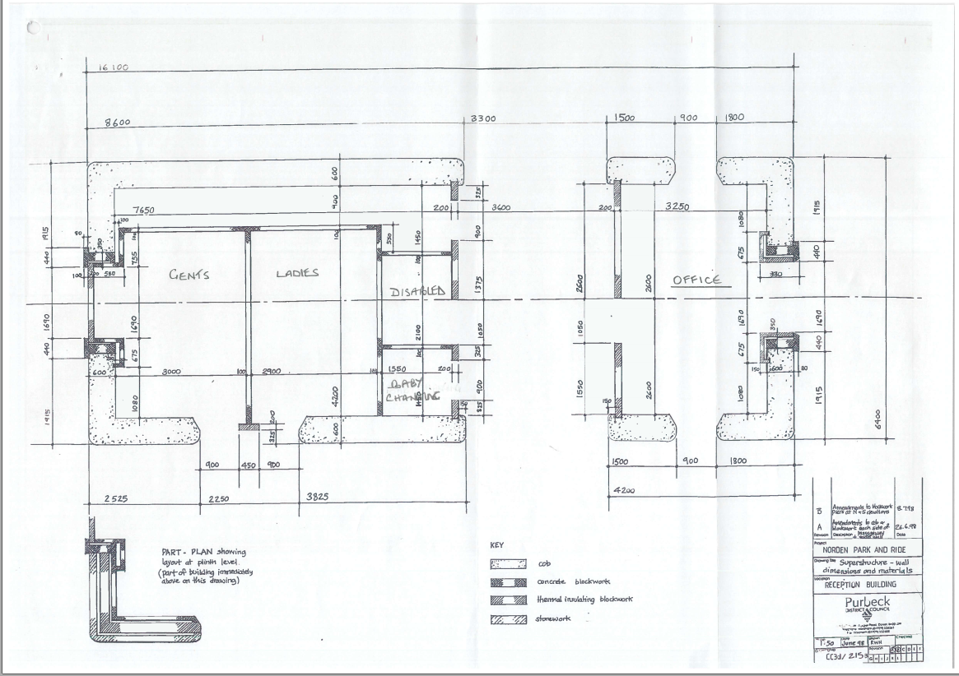

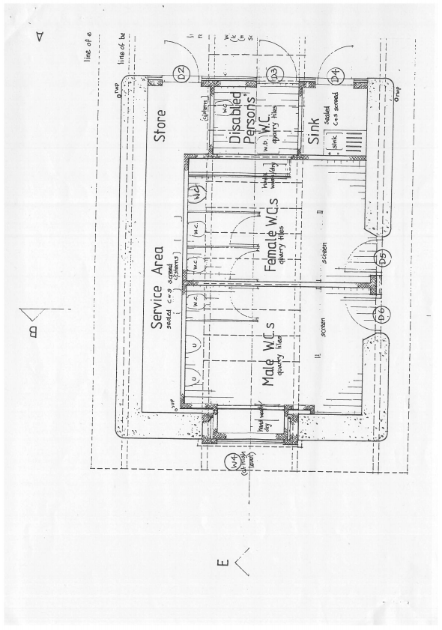
Existing Building Layout

