COMMUNITY DERMATOLOGY SERVICE SPECIFICATION

This specification is currently in draft format. The CCG is engaging with the market to finalise the specification. This is intended illustrate a potential community dermatology service for NHS North Hampshire CCG.

SCHEDULE 2 – THE SERVICES

- Service Specifications

This is a non-mandatory model template for local population. Commissioners may retain the structure below, or may determine their own in accordance with the NHS Standard Contract Technical Guidance.

Service Specification No. | 1.
Service | Preferred Provider or Any Qualified Provider Community Dermatology Service  18/19 – NHS STANDARD COMMUNITY SERVICES CONTRACT FOR THE PROVISION OF COMMUNITY HEALTH SERVICES FOR NHS NORTH HAMPSHIRE CLINICAL COMMISSIONING GROUP  This specification is currently in draft format. The CCG is engaging with the market to finalise the specification. This is intended illustrate a potential community dermatology service for NHS North Hampshire CCG.
Commissioner Lead | Mary Idowu – Associate Director of Commissioning
Provider Lead | TBC
Period | 3 Years plus 24 month extension
Financial envelope | £550-750k per annum
Date of Review

1. Population Needs
  - National/local context and evidence base
National General Practice Profiles published by Public Health England provides health profiles for each area of England (https://fingertips.phe.org.uk/profile/general-practice)

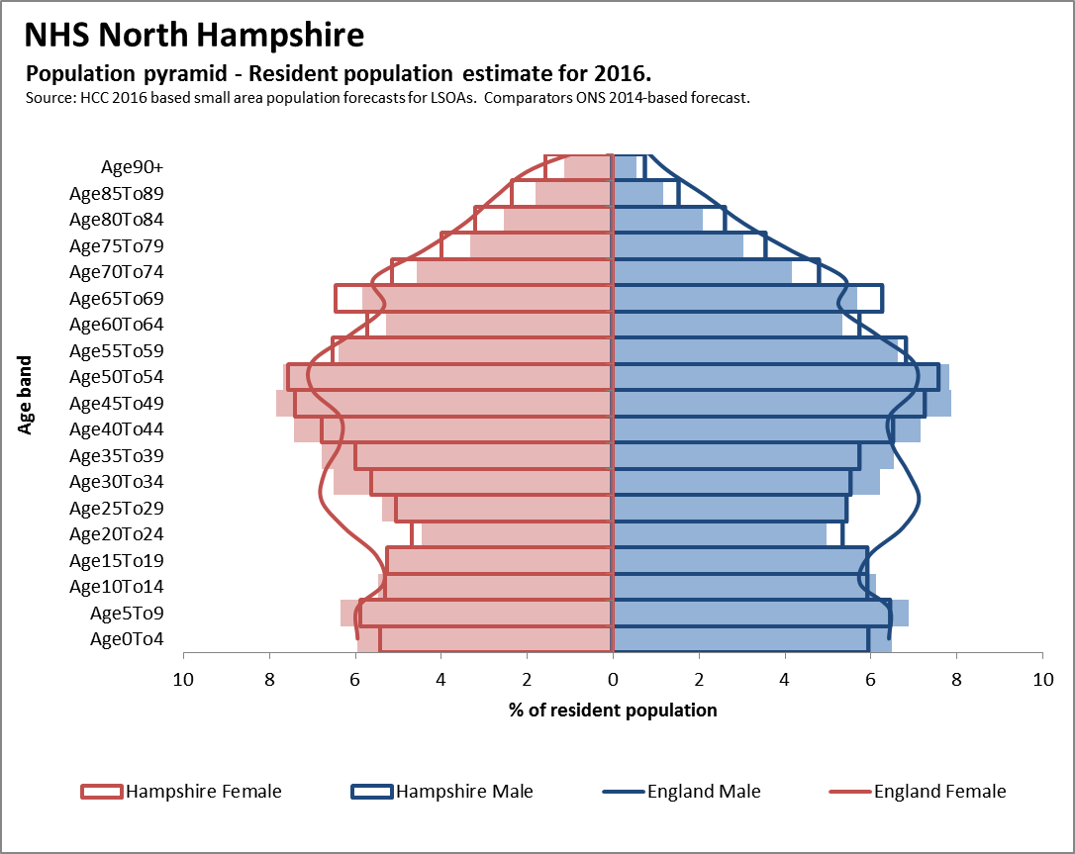
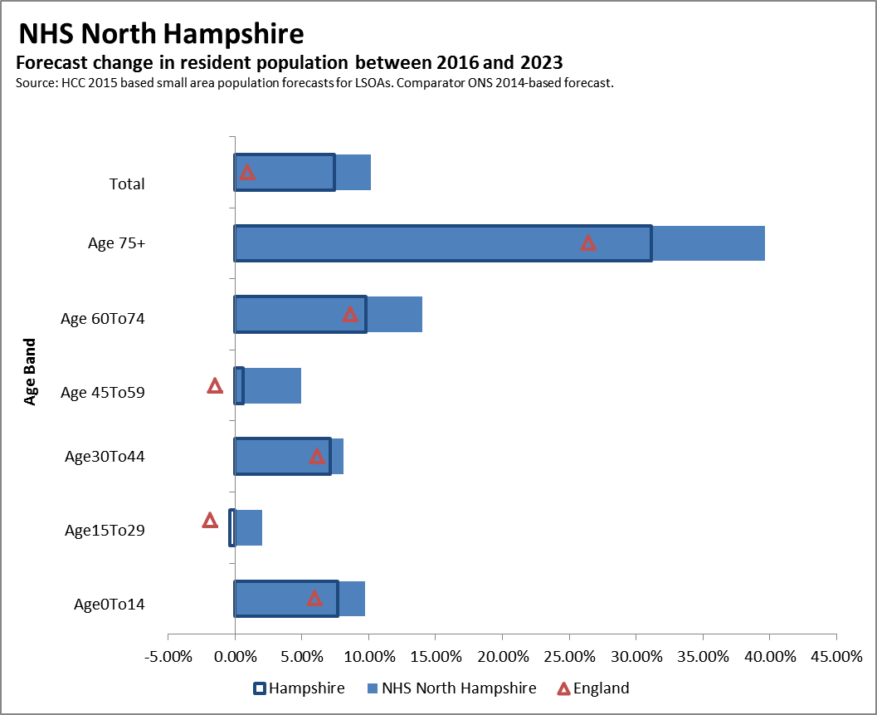

- numbers of patients registered with GPs – 224,856

It is expected that referral and clinical pathways should be reviewed regularly to incorporate best clinical practice. The service is responsible for ensuring that it is applying the most up-to-date agreed referral and clinical criteria and management regimes. Please refer to the:

- Referral pathway for the Community Dermatology Service -3.2 Care Pathways
- Detailed clinical management pathways

2. Outcomes
2.1 NHS Outcomes Framework Domains & Indicators

Domain 1 | Preventing people from dying prematurely
Domain 2 | Enhancing quality of life for people with long-term conditions
Domain 3 | Helping people to recover from episodes of ill-health or following injury
Domain 4 | Ensuring people have a positive experience of care
Domain 5 | Treating and caring for people in safe environment and protecting them from avoidable harm

2.2 Local defined outcomes
Expected Outcomes including improving prevention

  - Equitable access and treatment of dermatology patients within different levels of deprivation
  - A reduction inappropriate 1st out-patient referrals to secondary care services to meet local QIPP initiatives
  - Achievement of a reduction in follow-up ratios to no greater than 1:1.5
  - Increased overall patients satisfaction with dermatology services
  - Services closer to patients home
  - Improved communication between provider specialist clinicians and GP’s
  - Improved quality of care within primary and community setting regardless of provider
  - Increased patient choice
  - Improved access to advice and information and increased knowledge and the awareness of the management of dermatology
  - Reduced waiting time for patient access to specialist care.

3. Scope
3.1 Aims and objectives of service
All community dermatology services should be commissioned using the same principles to ensure that all services are:
- Safe – ensuring that the services are as safe
- Effective – focused on delivering best outcomes for patients
- Standardised – all services are provided to consistent standard and format so patient can expect the same quality of care and access to care where ever they are treated.
- Fair – available to all, taking account of personal circumstances and diversity

The purpose this service specification document is to specify the outline for a Community Dermatology Service (Level 3 of the overall Dermatology Service) for patients seen locally in a community setting. The key drivers for the development of a community dermatology service are to provide a local, more accessible and cost effective service for patients, as set out in government documents such as
- ‘Our Health, Our Care, Our Say; A New Direction for Community Services,
- ‘Improving Outcomes for People with Skin Tumours including Melanoma’.
- ‘Model of Integrated Service Delivery in Dermatology’
- Next Stage Review and;
- High Quality Care for All.

Service Aims
- To provide a one stop primary care led dermatology service where patients with dermatological or low risk skin cancer conditions can be diagnosed and treated in the community by a range of appropriately trained and accredited dermatology staff working as teams that may include :
- Consultants
- Associate specialists
- Staff grade doctors/speciality doctors
- Hospital specialist / Clinical Assistants
- Dermatology specialist nurses
- GPwSI’s
- Improve knowledge of local health professionals and patients around the management of skin disease through the development and implementation of education programmes for GP’s.
- Ensure Rapid access clinics for urgent referrals from GPs for specialist opinion or treatment.
- Providing diagnosis and treatment of skin lesion in line with NICE Skin cancer guidance 2010 and local cancer network guidance.

Evidence Base
The Government’s White Paper Our Health, our care, our say: a new direction for community services (published 2006) proposed a planned shift of care closer to the patient and their community. The National Dermatology Workforce Group (sub group of the Long Term Conditions Care Group Workforce Team) was commissioned by the Workforce Review Board to assess current service models for dermatology and suggest future models. A report was published in January 2007.
In summary, the report found that the present balance of service provision may be skewed with too many patients attending hospital based services for the provision of care that could be managed in a community setting. Any future model should concentrate on service delivery governed by three broad statements:

- Secondary care teams should do those things that only they can do;
- Care should be delivered in the right place by individuals with the right skills and at the right time (first time);
- Policies should facilitate patient self-management.

Services should be delivered in line with the following guidance:
- Our Health, Our Care, Our Say; A new direction for community services (DH January 2006)
- Commissioning Framework for Health and Well being (DH 2007)
- Commissioning safe and sustainable specialised paediatric services (DH 2008)
- Shifting care closer to home dermatology report (DH 2006)
- Implementing care closer to home, Parts 1 – 3 (DH 2007)
- Revised guidance and competences for the provision services using GPwSI (DH 2011)
- Commissioning Guidance (British Association of Dermatologists 2008)
- Improving Outcomes for People with Skin Tumours including Melanoma ( NICE 2006)Model of Integrated Service Delivery in dermatology
Improving Outcomes Guidance for Skin Tumours including Melanoma (NICE updated May 2010)
Skin cancer Peer Review Measures (NCAT 2008 and update 2011)
Referral guidance for skin cancer (NICE 2005)

Please note: these guidance documents are not an exhaustive list and providers will be expected to work to new and emerging policy guidance which relates to and links the delivery of dermatology community services and the and well-being of local populations.

General Overview
Skin disease is a common and distressing problem. It is estimated that Of the nearly 13 million people presenting to general practitioners with a skin problem each year in England and Wales, around 6.1% (0.8 million) are referred for specialist advice. Most (92%) are referred to NHS specialists rather than private dermatologists.
Whilst there are some 3000 dermatological diseases, 10 of them (eczema, psoriasis, acne, eratosis, rosacea, infections/infestations, leg ulcers and gravitational disorders, lichen planus and drug rashes) account for 80% of consultations for skin disease in General Practice.
Although it is the case that the commonest disorders are not life threatening, if not treated appropriately patients can suffer harm and longer term health problems. Many of the rare and some of the severe common skin conditions have an associated morbidity and mortality thus early and accurate diagnosis is critical to appropriate management. For those disorders that are not life threatening, the psychological impact on everyday life, work, social interaction and healthy living are substantial.
Objectives
A community dermatology service should have the following objectives:
- Enhancement of the current dermatology pathway.
- To improve access, maintain a high quality service and effectively manage more patients in the community setting.
- To give patients the choice to attend a local service with equitable access across their local area.
- To provide a service which demonstrates cost effectiveness and clinically based interventions.
- To provide a patient centred service with a strong emphasis on patient education, self management and prevention.
- To support primary care management of conditions and the implementation of local guidance on Restricted Treatments and Procedures (RTaP) or exclusion criteria for low priority procedures.

3.2 Service description/care pathway

Service Description
The key elements of the community dermatology service should be as follows –
- The assessment and management of Patients with skin diseases shall be performed by a multidisciplinary team. This may comprise of Dermatology Specialists as listed under 1.1 above.
- The Provider will co-operate and collaborate with the RMS or clinical triaging team by ensuring that referrals are easily received and processed.
- Assessment, investigation and treatment of patients suffering with skin disease, this will include full diagnostic service including phlebotomy, biopsy and swab taking and reporting of results
- Advice and education for referring GP’s, patients and primary care staff.
- Patients can be expected to be supplied with up to 4 weeks of new medications from a list of prescribing choices agreed with the CCG. The referring GP will be expected to provide all repeat prescription
- Management and follow up when indicated (service is aimed at one stop so follow-up should be minimised)
- Ensure that referring GP’s are given prompt and full information about their patient’s diagnosis or treatment in line with national standards. Discharge summary for patients should be sent to the GP within 2 working days with a copy sent to patient.
- Maintain a full clinical register and record of all patients treated, collect data for agreed KPIs and network wide audit and conduct audit.
- The service will treat all ages but for children under the age of 16 presenting with severe skin conditions or requiring any surgical procedure must be referred to secondary care.
- Children and young persons aged 24 and under presenting with a suspected skin cancer including BCCs must be referred to a member of the skin cancer MDT.
- The Service is managed and delivered in accordance with the rights, principles and values set out in the NHS Constitution
Figure 1: Levels of Dermatology Service Provision

Clinical Assessment Service (Triage)

The Community Dermatology Service should manage a range of dermatological conditions (See Appendix B), including the management of low risk BCCs where appropriate which are in line with Implementing care closer to home (DH 2007) Part 1-3 and the ‘Revised guidance and competences for the provision services using GPwSI 2011’.
It is expected that the following services/treatments could be undertaken by the Community Service:
- Management of mild to moderate forms of common rashes in adults such as eczema, psoriasis, lichen planus, eratosis, fungal infections – refer to dermatology referral guidelines (see 3.2 Care Pathways)
- Premalignant skin lesions such as solar eratosis or Bowen’s disease
- Low risk BCCs on trunks and limbs in line with NICE skin cancer guidance 2010
- Mild to moderate acne not requiring isotretinoin. Non scarring acne unresponsive to routine treatment in primary care
- Diagnosis, investigation or management of other chronic rashes in adult unless diagnostic doubt
- Diagnosis, investigation or management of mild/moderate/non-worrying dermatoses and skin lesion in children unless diagnostic doubt
- Conditions of hair scalp and nails
- Medication review
- Management and advice including follow up of skin cancer conditions treated in secondary care by agreement

Accessibility/acceptability
The use of referral management application, such as Electronics Referrals Service (e-RS) or other such referral systems should be taken to apply to all arrangements that incorporate any intermediary level(s) of triage, assessment and treatment between traditional primary and secondary care including paper-based screening systems (or their electronic equivalent). Any system of reviewing referrals must take proper account of the expert opinion of primary and secondary care clinicians and should only be undertaken by properly-qualified clinical professionals. Referrals should be based on the expert views of GPs, consultants and other specialists. GPs should only refer to the community assessment service if it is clinically appropriate and to the benefit of the patient.
- Patients should be offered a choice of treatments times and locations across the area subject to available sites.
- The booking of patients who require a secondary care appointment (onward referral) should be made via the e-RS including free choice.
- Providers should ensure that services are accessible in terms of geographical location, promoting equity of access for the population and should take into account equality and diversity as well as the most appropriate clinical setting.
- Locations of sites should be accessible to public and private transportation and parking facilities. Sites should also be accessible by patient transportation service vehicles for those patients with identified clinical need for transportation.
- Providers should make reasonable adjustments in order that services are accessible e.g. appointments times, length of appointments, information and signage to demonstrate compliance with their Disability & Equality Duty. All premises are required to be DDA (Disabilities Discrimination Act) compliant.
- All suspected skin cancer must be referred directly to secondary care using a 2 week referral form on e-RS which contains detailed information on the patient and their medical history (Appendix A).

Service model
The referral and clinical pathways should be reviewed regularly to incorporate best clinical practice. The service is responsible for ensuring that it is applying the most up-to-date agreed referral and clinical criteria and management regimes (see Appendix A, B, C&D).
The Community Dermatology Service (see figure 1) model comprises of the following areas:

- Level 3 Community Specialist Services should include links between the different levels of care especially (Level 2) Generalist Care and Level 4 Specialist Care. The Specialist Care (level 4) being a hub and the Community Specialist Service (level 3) normally based in a number of geographical locations with a number of GP practices (Level 2) feeding into them.
- Level 3 can be provided by a multidisciplinary team which can includes a range of dermatology clinicians as listed under 1.1 Service Aims.
- It is anticipated that patients with skin conditions designated suitable for diagnosis, management and treatment in the community (see Appendix B & C) will have their needs met via access to levels 2 and 3 with only the more severe and complex clinical care requiring level 4 intervention.
- Any Level 3 service provider using local GPwSI’s must ensure their dermatology consultants act as mentors and monitor their practice. All providers will be responsible for ensuring that any GPwSI used as part of their services has local arrangements in place with their dermatology department for their ongoing accreditation and revalidation.
- GPwSI Service will vary depending on local need and resources and the skills of the clinician. Possible models of service are outlined in the guidance and competences for the provision of services using GPSI 2009.
- Level 3 providers are expected to provide education to local GPs and demonstrate they have links in place with their local secondary care dermatology department (level 4)
- It is anticipated that a high quality service community dermatology service will require nursing staff with considerable dermatology expertise and experience, who are able to manage their own caseload of patients normally in eczema and psoriasis clinic if they are trained in this area.

Care Pathway
It should be noted the CCG will be commencing a teledermatology pilot. The results from this should further refine the pathway.

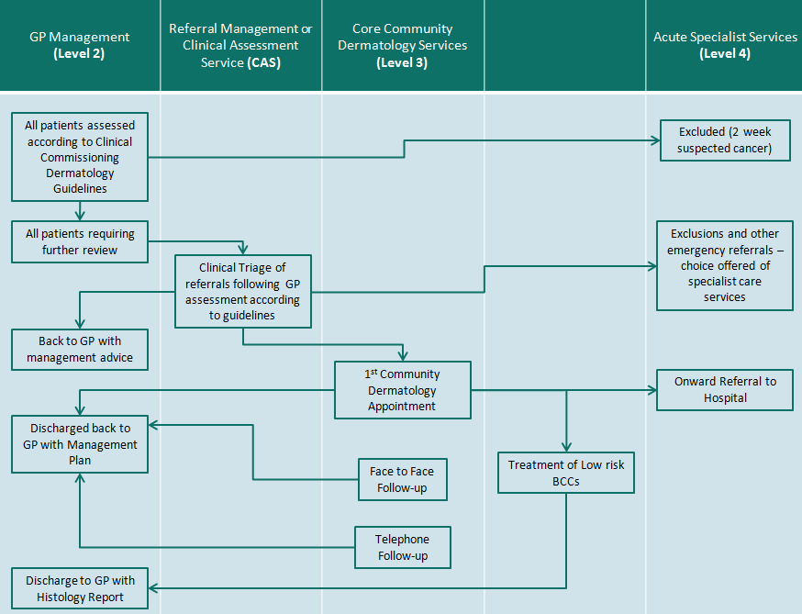
Tele dermatology

Treatment
- The Service Provider is to deliver services which are evidence based i.e. NICE Guidance and British Association of Dermatologists (BAD) guidelines, and meet best practice.

- Providers are expected to offer a comprehensive range of patient information and shall direct Patients to other resources such as support groups in order to educate, support and empower them to live with their skin problems. Information leaflets should be made available in different languages and formats as required.

- The Service Provider should aim to be the focal point for patient management, linking, where appropriate with secondary care and provide advice and guidance to the referring GP for the on-going maintenance of the condition.

- The Service should be available for both paediatric and adults who are registered with the local CCG’s GP practices. In addition, the provider should adhere to the local Safeguarding children and Safeguarding adult’s policies of both the NHS and Local Authority.

- The provider must be a member(s) or have links/agreements in place with the local acute hospital skin cancer multidisciplinary team (LSMDT). This is to ensure best clinical practice compliance with NICE and NCAT/ Cancer Network and providers should not remove lesions that they suspect to be melanoma or SCC. In instances where a skin cancer is excised unknowingly the Providers shall adhere to guidance by NICE Cancer Peer Reviews, and inform LSMDT/SSMDT.

- The planned treatment of low risk BCCs shall be restricted to approved doctors who have specialist training in skin cancer work, and are a member of the LSMDT.

- All letters to Patients and GPs shall be clearly legible, shall be posted within 48 hours of the appointment and shall contain as a minimum:
- Named clinician in charge
- Primary and where appropriate, secondary diagnosis and/ or procedure
- Full management plan and follow up arrangements and suggestions for further treatments, which could if necessary be added by the GP in case the Patient fail to respond to initial therapy
- A medication update for the Patient stating dose, frequency and duration of course of newly prescribed drugs and notification if any medications are stopped
- Skin specialist contact number for ease of communication and query
- Where possible copies of clinical protocols/guidelines

Medicine Management
The service provider shall have a named clinical governance lead that shall ensure that all prescribing is within national and locally agreed guidelines and treatment pathways. All prescribers must adhere to both legal and good practice guidance on prescribing and medicines management in line with the Medicines Act 1968, associated legislation and regulations.
The service provider shall comply with all statutory regulatory requirements and have robust, auditable systems in place to cover responsibility, reconciliation, record keeping and disposal requirements for the movement of drugs for which they are responsible.
The service provider shall record and report significant events and trends on near misses to the commissioner regarding prescribing or medicines management.

Prescribing
- The Provider shall ensure that prescribing is safe, clinically effective and cost efficient.
- Prescribing shall be in accordance with national and local guidelines and in line with local preferred prescribing list.

- Prescribing decisions and recommendations shall only be made by suitably qualified medical or non-medical independent prescribers. All independent prescribers shall adhere to local, DH and professional body Medicines Management standards.

- Patients should be supplied with 4 weeks (or full treatment course if intended duration less than 4 weeks) of new medications from a list of prescribing choices agreed with the CCG. The referring GPs will be expected to provide all subsequent repeat prescriptions.

Staffing
The service provider shall ensure that all practitioners who provide the service are competent and should be able to provide demonstrable evidence of competence. Evidence should include:
- The service provider will be responsible for ensuring that all clinical staff hold current professional registration, are current members of their irrespective professional bodies and have current CRB clearance. The CCG will require evidence that all GPwSI’s, clinicians working within independent contractor status and independent or third sector providers are appropriately indemnified.
- Certificate of any external postgraduate courses or accreditation.
- Certificate or a sign off letter from the mentoring Consultant(s) for any clinician working within an extended scope of practice, e.g. Nurse Specialist or GPwSI.
- Evidence of ongoing and continued competence.
- Evidence of completion of statutory and mandatory training.
- All staff (clinical and non-clinical) should have an annual appraisal and an agreed personal development plan.
- Appropriate supervision arrangements for all levels of staff will be in place, including induction and clinical supervision.
- Competent practitioners will assess referrals and patients in accordance with agreed protocols and pathways which are based on national clinical guidelines and evidenced good practice.
- A clinical lead for the service will be required with responsibility for overseeing the clinical governance framework and processes, (see Section 3.6), including Medicines Management and Prescribing.

The service provider will be responsible for ensuring that it maintains a staffing complement which allows it to meet the objectives set out in this specification. In particular, all staff will be required to work flexibly to ensure continuity of care and equity of access across all sites and treatment pathways.
Premises and Equipment
- Clinic(s) must be fully approved for infection control and be stocked with the required equipment which meets Health and Safety standards.
- Processes to monitor stock control and regular reviews to ensure standards are complied with are to be in place.
- The consultation room should have good lighting and adequate facilities for diagnosis and treatment procedures, and operative equipment that meets the requirements necessary to undertake skin surgery.
- Where skin surgery sessions are performed, there should be appropriate documentation of lesions, including photographic records and established links to the local dermatology and histopathology departments.
- There should be adequate space to provide a ‘waiting’ area and have disabled access to the premises.
- Depending on locality of GP practice, diagnostic testing will be provided by a pathology department attached to an LSMDT to ensure continuity and quality of both the requesting and reporting of diagnostic tests, and to inform treatment decisions made at LSMDT/SSMDT.
- Sites where appointments are received through e-RS must have full IT support and ensure that staffs are trained to the appropriate standard to manage the appointment system.

Governance
The service provider will have an established clinical governance programme which will be lead a senior clinician or other senior member of staff and a deputy with clear responsibility for ensuring clinical governance arrangements are in place and for monitoring the effectiveness of the clinical governance systems which as a minimum considers the following:
- Patient, public and carer involvement.
- Fit for purpose patient booking and administration systems.
- Risk management, including incidents and complaints reporting and investigation processes.
- Serious untoward incident reporting processes.
- Staff management and performance, including recruiting workforce planning and appraisals.
- Medical equipment
- Appropriate and sufficient clinic rooms covering the North Hampshire CCG population
- Education, training and continuous professional development.
- Clinical effectiveness and audit programme.
- Information governance policies and procedures (e.g. Caldicott).
- Communication with both internal and external organisations.
- Leadership at all levels of the organisation.
- Infection control arrangements.
- Regular audits of the service.

Response time & detail and prioritisation
- Referrals should be dealt with on a first come, first served basis irrespective of the location of the practice to which the patient belongs. Prioritisation will be made purely on clinical grounds.
- Referrals to the service will be triaged as soon as possible by the RMS or clinical triage team, with all new appointments following a GP referral taking place no more than 28 calendar days from the date the referral was received by the RMS /Clinical triaging team unless the patient chooses to attend at a later date (after being offered at least two different appointment dates and two different appointments times within the 21 days)
- Patients who do not attend (DNA) will be returned to the GP. The Provider will not be paid for DNAs.
- The provider will work to ensure that the waiting times are kept as short as possible and will ensure they comply with the 18 week waiting time standard
- The provider will ensure that systems are in place for the transportation and analysis of diagnostic tests.
- The provider will ensure that any biopsy results are received and acted upon within 3 working days of receipt of result for the appropriate intervention or arrangements for follow-up. The provider will report results back to the referring GP for their records only.

Discharge Criteria and Planning
The provider will be responsible for ensuring that the referring GP and patient is sent a typed discharged summary letter outlining the diagnosis, investigations, treatment plans, medication and patient advice following each patient consultation and sent to the referring GP and patient within 5 working days of discharge (see Appendix E) .

Prevention, Self-Care and Patient and Carer Information

The Service will offer a comprehensive range of patient information including advice on self-management and will direct patients to other resources as appropriate.
The Service should give relevant information to patients as to what services to access should a treatment complication arise outside normal working hours.
The Service will make available to patients the agreed procedure for booking appointments and the policy on DNAs and cancellations.
Patient Information will be formatted according to agreed guidelines and should be made available in different languages as required.
Treatment and care, and the information patients are given about it, should be culturally appropriate. It should also be accessible to patients with additional needs such as physical, sensory or learning disabilities, and to patients who do not speak or read English.
If patients do not have the capacity to make decisions, healthcare professionals should follow the Department of Health’s advice on consent and the code of practice that accompanies the Mental Capacity Act

Patient & Public Involvement

Patient and public participation in commissioning health and care: statutory guidance for CCGs and NHS England places a duty on CCG to make arrangements to involve and consult with service users and the public in the planning and organisation of services. The service provider will therefore be expected to consult with patients by equality characteristic as required by the above Act and to facilitate the CCG in meeting all statutory responsibilities in this area. The service provider will also ensure that the views of people who use services are taken into account when making decisions about how services are delivered and improved.
Patient Experience
The service provider will be asked to provide evidence of methods they use to capture patient experience in order to improve their service. The Service provider will also be required to provide evidence on how they ensure any issues or areas of concern are identified and addressed; ideas taken forward; elicit views on patient satisfaction and changes made as a result of the information collected are communicated to patients and other stakeholders.
Communications
The provider is responsible for communications and marketing of the services specified. All such activity must conform to the NHS Identity Guidelines, the NHS Promotions Code and communications guidelines produced by NHS. The provider's communications plan should be proportionate to the scale of service being provided and should be agreed with the CCG's communications department prior to implementation.
The provider must alert the CCG’s communications department to any enquiries from public stakeholders (e.g. politicians, key professional groups) relevant to the services commissioned by the CCG and should agree a response.
The provider should also alert the CCG to potential adverse media coverage and statements/media releases regarding the service commissioned by the CCG should be agreed with the CCG’s communications department before release.

3.3 Population covered
The services should provide equitable access for service users across North Hampshire.

3.4 Any acceptance and exclusion criteria and thresholds

Geographic coverage/boundaries
The services will be available to all patients in registered with the CCGs local GP services who have been assessed by their GP or clinical triaging service as suitable to attend.
Location(s) of Service Delivery
The service will ensure equitable access to local residents by providing clinics in accessible areas with suitable transport links. The service provider will be responsible for providing appropriate equipment at each of the designated locations and ensure that those are adequately maintained. The tariff is inclusive of premises costs.

Days/Hours of operation
The service opening hours will be by agreement with the CCG; however the service will be required to offer appointments between the core clinical hours of 9am and 5pm on the days on which the service operates. The CCG would expect the provider to deliver evening and weekend availability where appropriate.
The service will be available throughout the year at a frequency that ensures that sufficient capacity exists to meet demand and that waiting time standards are achieved.
The service provider must ensure flexible capacity to cope with seasonal and unexpected changes in demand.
3.5 Referral criteria & sources
The following general criteria must be met to access the Community Dermatology Service:
- Patients must be registered with a GP within the CCG.
- Patients must have been assessed as by the Clinical Triage services as not requiring acute hospital care.
- Skin Cancer that is not thought to be the most likely diagnosis*

* Patients with suspected cancer must follow the 2 week cancer pathway and be referred directly to the acute provider.
Referral route
GPs
All GP referrals must be accepted through Electronic Referral System (e-RS). GPs will indicate whether the referral is routine or urgent to aid triage and prioritisation of treatment, excluding suspected skin cancer which must be referred directly to secondary care.

Clinical Assessment Service (CAS)
GP referrals at the start of the pathway can be directed to the CAS through e-RS. E-RS will provide the ability for GPs to book a slot appointment for clinical triage. Depending on the outcome of the clinical triage, the triager will either return the referral back to the GP with management advice or direct the referral to the Patient Referral Centre, indicating the most appropriate care setting i.e. community dermatology service or onward referral to acute specialist care.
Clinical Triage
The service provider will need to indicate their availability for appointment slots on the e-RS system to enable a seamless booking system by the Practices/patients and in accordance to patient choice.
Community Dermatology Service Provider
The service provider shall refer on to the following services in line with the onward referral protocol, if appropriate:
- Back to GP with a treatment plan or discharge.
- Acute Specialist Care clinicians.

Patients referred onwards from the Community Dermatology Service to Primary Care or Specialist Care shall have a full treatment plan and/or reasons for referral to the referring clinician, and include:
- The results of all tests and preoperative health assessment including scans, films and reports.
- Reason for referral.
- Recommended treatment or procedure(s).

The above is referral route areas do not reflect all current systems and pathways being used by CCGs. The most direct access to care for patients is always recommended.

Exclusions
Exclusion criteria
- Urgent 2 week wait cancer referrals
- Urgent referrals, e.g. severe, deteriorating symptoms

Prospective service providers are not expected to undertake procedures excluded by the CCG Exceptional Treatment Policy/Restricted Treatments and procedures or specialist services already provided by existing acute specialist care providers including:

- Severe inflammatory skin disease requiring non-conventional therapy
- Specialised skin surgery
- Laser treatment
- Life threatening skin disease
- Severe paediatric skin disease
- Specialised skin cancer
- Genital dermatology
- Non-malignant lymphoedema
- HIV and infectious disease of the skin
- Leprosy
- Specialised dermapathology
- Medical mycology
- Occupational dermatoses and contact dermatoses
- Genetic dermatology
- Hair and Nail disease

3.6 Interdependence with other services/providers

Whole System Relationships
The service should relate to a whole system approach by dealing with the following key stakeholders/services who can influence the Dermatology service:
- GPs
- Acute trust dermatology department
- District Nurses
- Health Visitors
- Practice nurses
- Health education
- Tissue viability/leg ulcer service
- Podiatrists
- Psychology and counselling
- Paediatric departments
Interdependencies
- Access to acute diagnostics, e.g. (laboratory services, pathology, radiology etc)
- Collaborative Working with the Referral Management Service or clinical triaging service
- Regular access to Local Acute MDTs in line with required NICE protocols
- Securing facilities in locations that meet equitable patient access for local residents
- Develop pathways with community minor surgery services

4. Applicable Service Standards
4.1 Applicable national standards (eg NICE)
- NICE

4.2 Applicable standards set out in Guidance and/or issued by a competent body (eg Royal Colleges)
- British Association of Dermatologists
- General Medical Council
- Royal College of Nursing

4.3 Applicable local standards

General Standards – all services will be expected to meet these standards

Registration & Assurance

The provider must be able to demonstrate current registration with the Care Quality Commission (CQC) for the service to be delivered where this is applicable to the service or provider. The provider must notify the commissioner of registration renewal dates and of any amendments, variations or applications. The provider must also notify the commissioner of any penalties imposed for non registration (services can no longer provide a service if not registered as this is a legal requirement), CQC inspections (planned or unannounced) and enforcements for delivery of poor quality. The provider should make available all inspection reports, CQC periodic and special reviews, national audit reports, and national patient and staff surveys as applicable.

Care Quality Commission Registration Regulations, Requirements
The service must be able to demonstrate compliance with all generic and service specific Registration Requirements, Regulations of the Care Quality Commission. This applies even in cases where CQC registration is not required of the provider. These regulations and outcomes ensure that the care people receive meets essential standards of quality and safety. The regulations and outcomes cover;
- Involvement & information – The provider will ensure that patients and carers are involved in making decisions about their care, treatment & support. They will also ensure that the views of people who use services are taken into account when making decisions about how services are delivered and improved. Providers shall make information available so that people can make informed choices about their care, treatment & support.
- Personalised care, treatment & support – The provider will ensure that people who use services receive effective, safe & appropriate care, treatment and support that meets their individual needs. Providers will assess health needs, develop care plans, take account of published research and best practice, cooperate with other agencies involved in the care, treatment and support of a person and share information in a confidential manner with all relevant services, teams or agencies.

- Safeguarding & safety – The provider will ensure that people who use the service, workers and others who visit are as safe as they can be and that risks are managed. They will also ensure that the human rights and dignity of people who use services are respected and identify and respond when people are in vulnerable situations. Providers will ensure that the premises and equipment they use to provide care, treatment & support are safe and suitable. Providers will comply with guidance for safeguarding people who use services from abuse, cleanliness and infection control, management of medicines, safety & suitability of premises and safety and suitability of equipment.

- Suitability of staffing – The provider will ensure that they have the right staff with the right skills, qualifications, experience and knowledge to support people. Providers will comply with guidance relating to staffing and supporting workers.

- Quality and management – The provider will manage risk in order to ensure that essential standards of quality and safety are maintained and have systems in place to assess and monitor the quality of service provision. Providers will also take account of comments and complaints, investigations into poor practice and advice from and reports by the Care Quality Commission. The provider will improve the service by learning from adverse events, incidents, errors and near misses, the outcome from comments and complaints and the advice from expert bodies. The provider will also notify the Care Quality Commission about incidents that affect the health, safety and welfare of people who use services including injuries to people, making an application to deprive someone of their liberty, allegations of abuse and police investigations.

5. Applicable quality requirements and CQUIN goals
  - Applicable Quality Requirements

Quality Improvement

The service will identify, implement and demonstrate continuous improvements to the quality of the service as part of their quality framework. Evidence of action plans, progress monitoring and improvements / outcomes achieved will be reported to the commissioner at regular intervals. These will be reviewed as part of the monitoring of the service.

Management & Monitoring of Quality

The service will provide an Annual Quality Report providing evidence against clinical effectiveness, patient safety and patient experience. This report will be used to assure the commissioner of the quality of service delivered.

Service Specific Quality Standards

Specific service standards will be included in the service specification. For example consider relevant
- Quality Assurance and Improvement Schemes (CQUIN schemes)
- PROMs and PREMs
- Clinical effectiveness guidance (NICE, NSFs etc)
- National audits

  - Applicable CQUIN goals

Continuos Service innovation and Improvement plan to be agreed with the commissioning organisation and included within the contract between service provider and commissioner.

Compliance with Legislation
The service must be compliant with Health and Safety at Work Acts and associated policies which include, but not limited to the following:-
- NHS Estates – Infection Control in Built Environments HMSO2002
- Health & Safety Executive 1999 CoSHH Regulations
- Health Services Advisory Committee of the Health & Safety Commission - Safe Disposal of Clinical Waste
- Health and Safety at Work Act
- Decontamination of Instruments and Medical Devices

Confidentiality
- Confidentiality must be an integral part of the service and confidentiality statements must be prominently displayed throughout clinics.
- Interview and clinical areas will be required to offer patients absolute confidentiality and cast iron policies and procedures must be in place to ensure the patients’ right to confidentiality is not breached.
- Appropriate reception areas must be provided, and systems must be in place to ensure all patient identifiable information, including electronic information is stored securely and all data is protected.

Accommodation
- Clinical rooms must be appropriately sized and equipped and must offer patients privacy and dignity in line with Essence of Care 2003 and the Disability Discrimination Act (1995) and Health and Safety Act 1974. Providers should also consider and implement any clinical guidance/recommended where required.
- Discrete and single sex toilet facilities must be made available for patients.

Safety
Security measures must be in place to ensure the safety of both staff and patients and all staff should receive Health & Safety training.
Patient Engagement
- The Health and Social Care Act 2012 places a duty on CCGs to make arrangements to involve and consult with clients and the public in the planning and organisation of services. The service will be expected to consult with patients as required by the above Act, and to facilitate CCG in evidencing that all legislative responsibilities are met in this regard.
- The service will take part in the “Mystery Shopper” scheme, will undertake annual patient satisfaction surveys and will initiate regular focus groups across equity groups. Outcomes will be shared with the Commissioner and agreed actions will be actioned and included in the Annual Quality Improvement Planning Cycle.

6. Baseline Performance Targets – Quality, Performance & Productivity

Outcome | Indicator |  | Threshold |  |  | Method of Measurement |  | Frequency of Monitoring
Quality
Service User Experience  Experience Improvement Plan  Reducing Inequalities  Reducing Barriers  Personalised Care Planning | Patient Experience Survey including patient satisfaction monitored by equality characteristic  Customer experience survey  Local benchmarking against national patient experience standards |  | 80% of services users deem their experience as good or better |  |  | Survey – Questionnaire |  | Annually with the opportunity for patients to comment after each contact with the services
Outcomes
Reduce a number of inappropriate referrals/inappropriately managed patients | Numbers of referrals rejected, broken down by practice and with reasons  Number of inappropriately managed patients based on a valid sample –  - Referred to level 3 but should have been managed in level 2  - Managed in level 3 but should have been referred to level 4  - Referred to level 4 but should have been managed in level 3 |  | 10%  Tolerance:  10% of total referrals in Year 1 afterwards  5% inappropriate referrals |  |  | Dataset  Audit |  | Monthly  Quarterly
Reduce number of post operative/procedure infections | Number of post Operative Infections  Number of operations/procedures |  | Less than 5% post operative infection rate |  |  | Provider dataset  Provider dataset |  | Monthly  Monthly
Conversion rate of referrals into diagnosed cancer by referral type and by practice | Number of cancer diagnosed by category and diagnosis (low/high BCC, SCC, MM) including stage of diagnosis |  |  |  |  | Open Exeter dataset/Local data sources |  | Quarterly
Breakdown of incidents and complaints | Number of incidence and complaints |  | N/A |  |  | Dataset |  | Quarterly
Audit of reasons for follow up appointments | Number and % of patients that were given a follow up appointment by reason and diagnosis |  | Ratio of new to follow up 1: 1.3 |  |  | Audit or dataset |  | Quarterly
Timely turnaround times | Turnaround time for the production of letters |  | 90% within 2 working days |  |  | Provider dataset |  | Quarterly
Timely turnaround times | Turnaround time for diagnostic and pathology results |  | 90% within 2 weeks |  |  |  |  | Monthly
Access | Patients waiting by number of weeks |  | 2 weeks |  |  | Dataset |  | Monthly
Improved cancer patient care | % of cancer patients discussed by MDT |  | 100% |  |  | Dataset |  | Monthly
7. Activity

Activity Performance Indicators |  | Method of measurement |  | Baseline Target | Threshold |  | Frequency of Monitoring
Total number of referrals received (by practice and GP) and by reason for referral |  | Dataset |  |  |  |  | Monthly
Number of referrals by type of condition or diagnosis |  | Dataset |  |  |  |  | Monthly
Number of new appointments by treatment and diagnosis including data disaggregated by equality characteristic |  | Dataset |  |  |  |  | Monthly
Number of follow up appointments by treatment and diagnosis
Number on the active caseload by diagnosis and treatment |  | Dataset |  |  |  |  | Monthly
Type and number of diagnostics tests requested |  | Dataset |  |  |  |  | Monthly
Number of patients referred to secondary care providers, by provider and reason for onward referral |  | Dataset |  |  |  |  | Monthly
Number of clinics held |  | Dataset |  |  |  |  | Monthly
Number of Did Not Attend by new and FU (against total period appointments) |  | Dataset |  |  |  |  | Monthly
Number of patients discharged by reason |  | Dataset |  |  |  |  | Monthly
Number of cancellations made by patient |  | Dataset |  |  |  |  | Monthly
Number of clinics cancelled by provider |  | Dataset |  |  |  |  | Monthly
Number of unused slots |  | Dataset |  |  |  |  | Monthly

SCHEDULE 2 – THE SERVICES

- Clinical Networks
Relevant networks and screening programmes
- Local Cancer Network
- Acute Provider skin cancer MDT meeting
- GPwSI community skin cancer MDT (4 times yearly including audit and teaching)

NICE outcome measures. Quality outcomes that reflect clinical care are included in those clinical areas that relate to NICE guidance and must be measured. For example:
- NICE skin cancer guidance (for example discussion of cases at MDT, information provision for patients)
- NICE guidance for children with atopic eczema
- NICE guidance requirements for the prescribing of biological agents for psoriasis
Specific quality of life (QoL) measures are available for a range of inflammatory skin conditions and should be used to measure outcome of care in the common skin diseases as follows:
- Atopic eczema
- Psoriasis
- Acne
- Other types of eczema

The QoL tools can be used in generalist and specialist settings (http://www.dermatology.org.uk/)

NHS Digital (April 2017)
Our Health, Our Care, Our Say; A New Direction for Community Services, DH (2006)
Improving Outcomes for People with Skin Tumours including Melanoma
Model of Integrated Service Delivery in Dermatology, Skin Care Campaign (2007)
Next Stage Review 2008
High Quality Care for All 2009
Skin Conditions in the UK: A Health Care Needs Assessment: Schofield, Grindlay, Williams 2009
BMA Referral Management Principles http://www.bma.org.uk/healthcare_policy/independent_sector/Referralmanagement.jsp

