

Elvetham Heath Local Nature Reserve
Specification: Replacement Boardwalk 2024

- SCOPE OF WORKS
- Removal of current boardwalk (2m x 54m, with handrail along one side), and disposal offsite at a licensed facility.
- Installation of DDA compliant boardwalk, as per the specification below, to replace the current one. Width of structure must be 2m with a handrail on one side along its full length.
- Retain the two decorative wooden panels – one at either end, currently mounted on the handrail of the existing boardwalk. To be mounted on the handrail of the new structure.

- QUOTATION REQUIREMENTS
Quotations to be received as detailed in the RFQ.
- SITE OVERVIEW
Site Description:
Elvetham Heath LNR comprises 19.5 Ha of heathland with areas of wet woodland (in which the boardwalk is located), mire and conifer plantation. As well as being a Local Nature Reserve, it is also a Site of Importance for Nature Conservation (SINC). There are multiple footpaths running through the site and it is used predominantly by local residents as an outdoor space for the surrounding housing development. The footpath leading to both ends of the boardwalk will need to be closed for the duration of the works.
The wet woodlands through which the boardwalk runs become flooded in Autumn/Winter, which may affect works, although access to the boardwalk via raised paths remains good all year round.
Access:
The best access onto site is off St Swithins Road (see map below)
Access is subject to alteration due to essential pipe works being carried out by Thames Water. This will depend on what stage the pipe works are at. To be discussed with client before the start date of works.
Boardwalk What3Words location: shelf.crumples.stables

Access off St Swithins Road (bollards removeable):
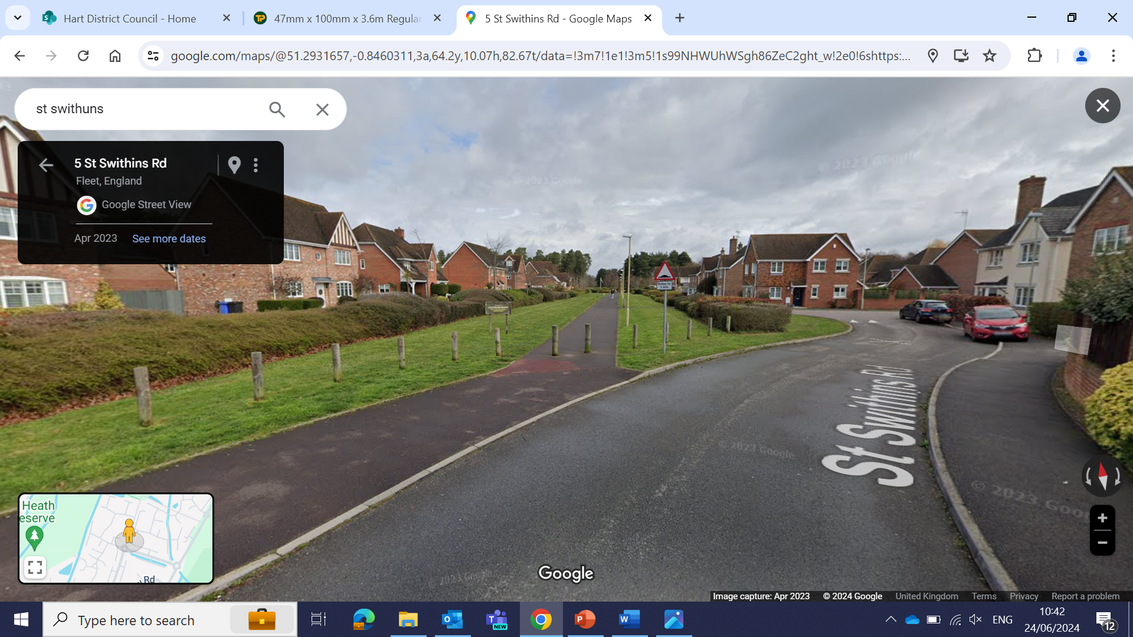

Access onto the heath:
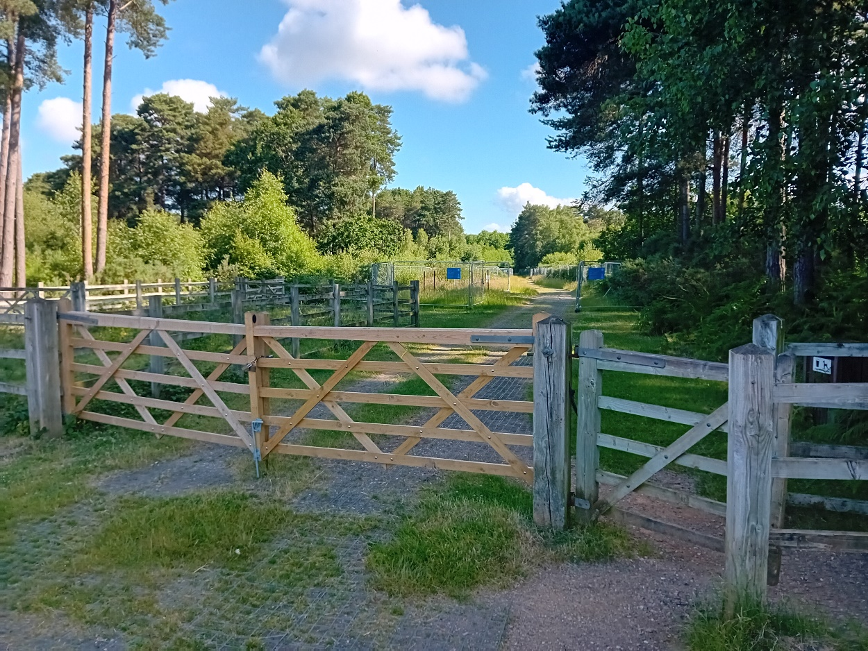

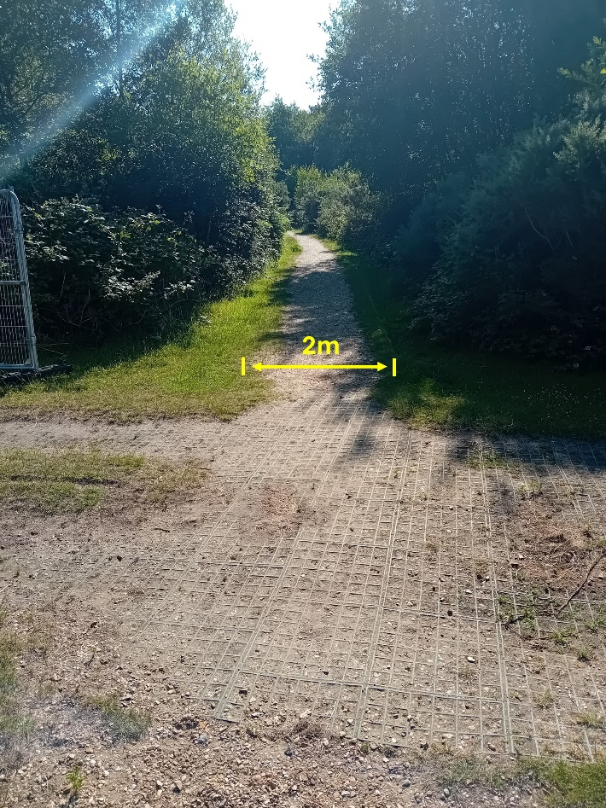

Footpath to the boardwalk:

Footpath to the boardwalk (above) is 2m wide, with wooden shuttering along either side. Suitable access for vehicles such as 3 tonne dumper.

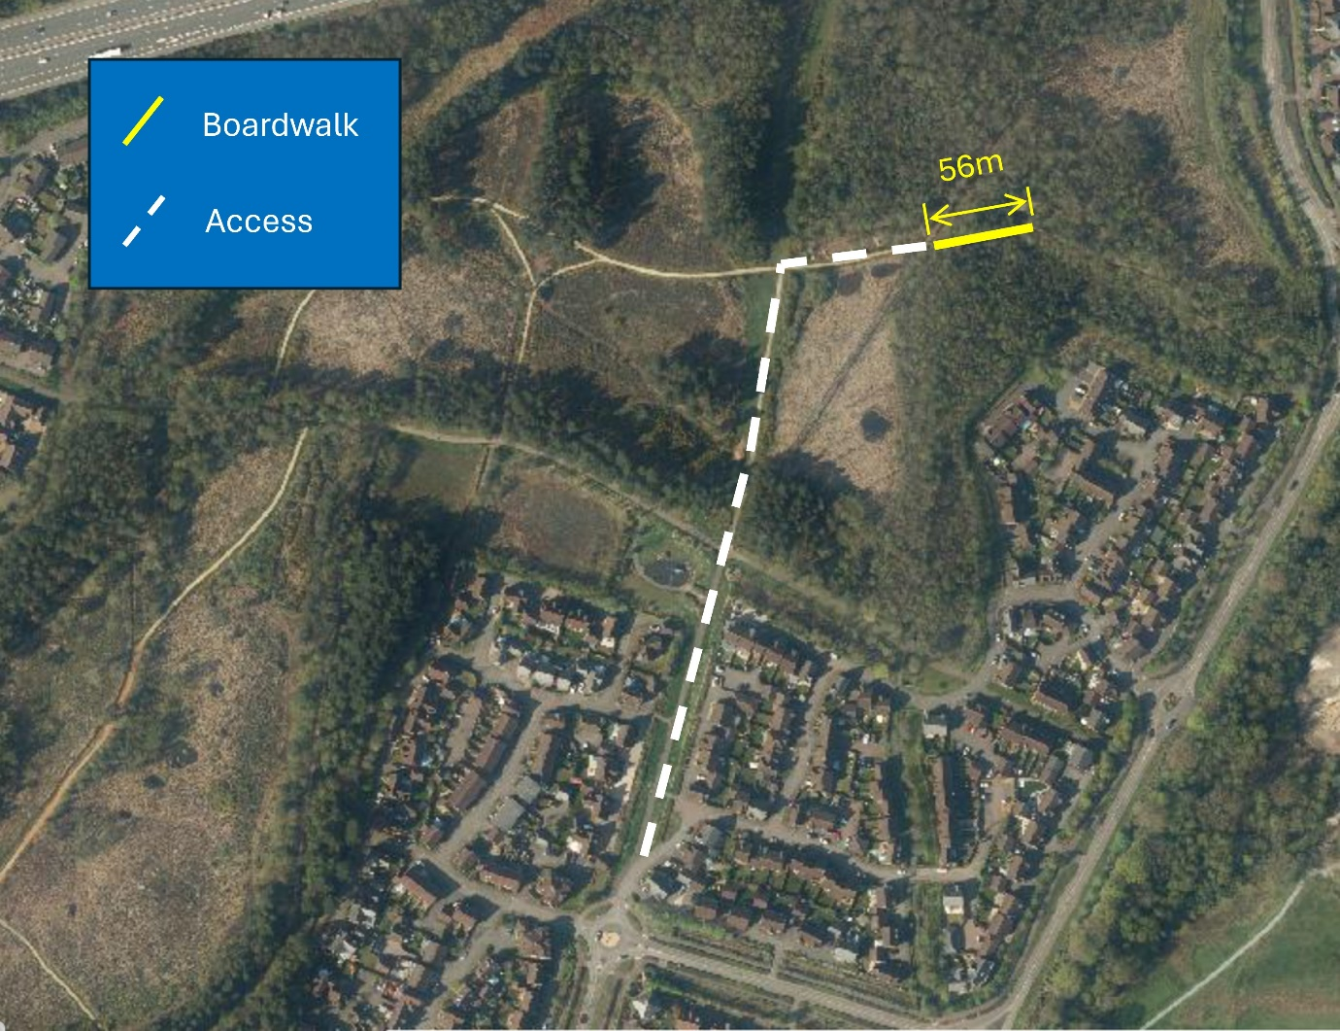
- MAP OF WORK

St Swithins Road

- DESCRIPTION OF WORK
- Provision can be made for storage of materials on site for duration of project, but contractor is responsible for ensuring material storage is secure. Location to be agreed before works commence. Access for emergency vehicles must be maintained.
- Security of materials on site is the responsibility of the contractor at all times.
- Line of the new boardwalk may be straight (the current structure has several minor changes in direction).
- Support posts to be installed with the addition of an appropriate ‘post protector tape’ product (see below), to be positioned where the post meets the ground/water.
- Boards to be installed with 5mm joints for drainage.
- Handrail to be the same height as the current one (105cm when measured from walking surface), installed on same side as existing boardwalk (southern side).
- Handrail to be installed on the outside of the 2m width to avoid making it narrower than the specified 2m.
- Boardwalk to be the same height as the path at either end, to avoid any steps up onto the structure.

The below diagram is for clarification of structure and components. Suitable modifications need to be made to include a handrail along one side.
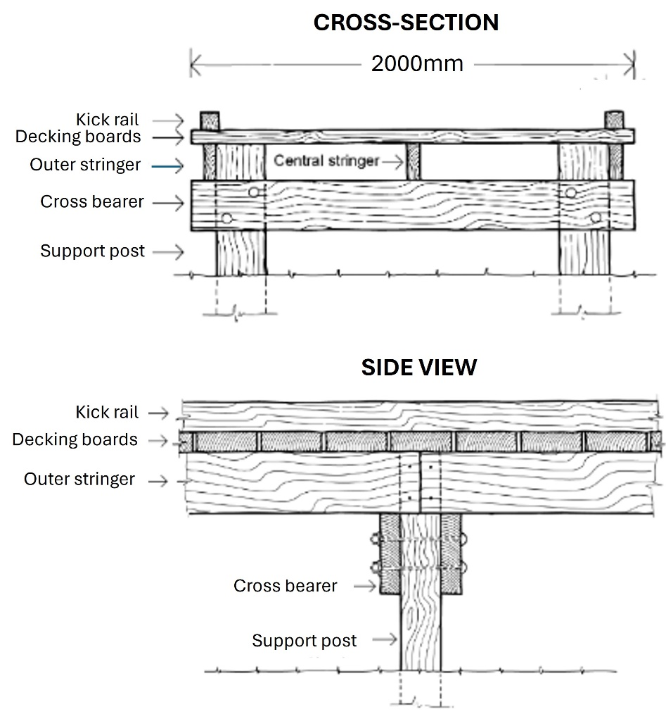
- MATERIALS

- Any timber used must be FSC (or similar) certified and must be a timber that is durable in wet environments, such as green oak. Where softwood is specified for use, it must be Use Class 4 and tanalised with 20-year desired service life.

  - Support posts: 100mm x 100mm Grade ‘A’ green Oak, with the addition of an appropriate ‘post protector tape’ product, to be positioned where the post meets the ground/water.
  - Decking boards: May be softwood. Must have integral anti-slip strips manufactured into them, rather than exterior strips laid on top. Integral strips must be a natural colour such as tan.
  - Stringers / Joists: 100 x 75mm
  - Cross bearers: 100mm x 75mm
  - Handrail: Uprights – 100mm x 100mm.
Rails – Softwood
  - Kick rails: 3600 x 75 x 75mm with planed finish
- Oak has been suggested for its strength and longevity. However, alternative suitable timber will be considered if proposed in the contractor’s design. Final timber materials to be specified by contractor as part of quote.
- All metal components (bolts, screws and fixings) must be suitable for outdoor use and are to be specified as part of quote.
- Post protector tape used on the support posts must be non-butyl and UV stable, such as can be found in the following link:
https://waltherstrong.com/product/posttape-1-x-roll-200mmx20m/

- ADDITIONAL WORKING REQUIREMENTS

- All works to be completed in line with Hart’s Contractor Procedural brief (see Appendix), in addition to the points below:
- When working within the canopy of trees avoid damage to roots and avoid compaction of soil in tree root zones. Use the smallest, lightest machinery possible to undertake the works.
- The boardwalk spans two ditches – water flow in the ditches must not be impeded either during the works, nor upon completion of the boardwalk.
- Set out line of paths on site for checking by client prior to carrying out any works.
- Contractor to consider how operational activities may impact on interaction with site users and put in provision to ensure users and dogs are kept safe (e.g. use of barriers to temporarily block access along route or sections of route). Section of path being worked on to be closed (with barriers) for the duration of the work.
- There must be a clear, accessible route maintained to the area of works for emergency vehicular access at all times.
- Tree and scrub works are not expected to be necessary, but must be discussed with client before commencing. This is due to the potential presence of nesting birds, which must not be disturbed, and other general habitat sensitivities.
- Site ranger to view works with site foreman to view the work and ensure that the work has been completed to satisfaction. This is to take place ideally before any machinery and material are removed from site.

- REINSTATEMENT AND COMPLETION

  - Remove any temporary signage, barriers and fencing from site.
  - Make good all damage to any natural and man-made surfaces caused by the works, by access to the works by plant and machinery, by storage of materials and other causes within the contractor’s control.
  - Compacted soil should be de-compacted and re-graded. Contaminated soil (for example accidental spillage of fuel) must be excavated and removed from site to an approved landfill site and replaced with uncontaminated subsoil and topsoil to match existing soil profile.
  - Make good any damage to retained trees and other woody plants by pruning back damage to healthy growth in accordance with good arboriculture practice.
  - Leave site clean and tidy. Remove all excess materials from site to the contractor’s store or to an approved tip, unless otherwise agreed in writing.

P.T.O.

- PHOTOS

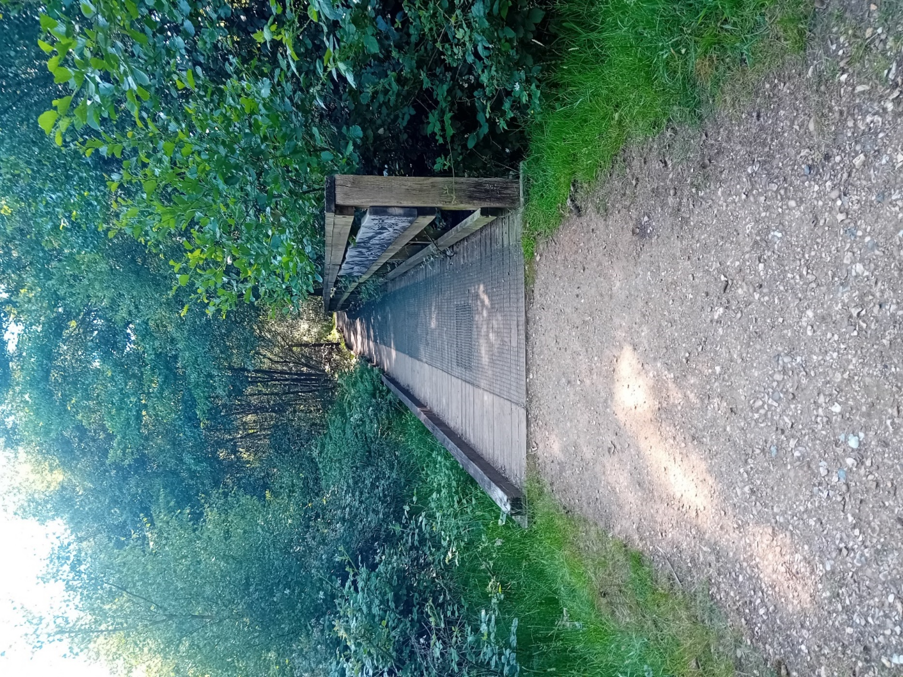

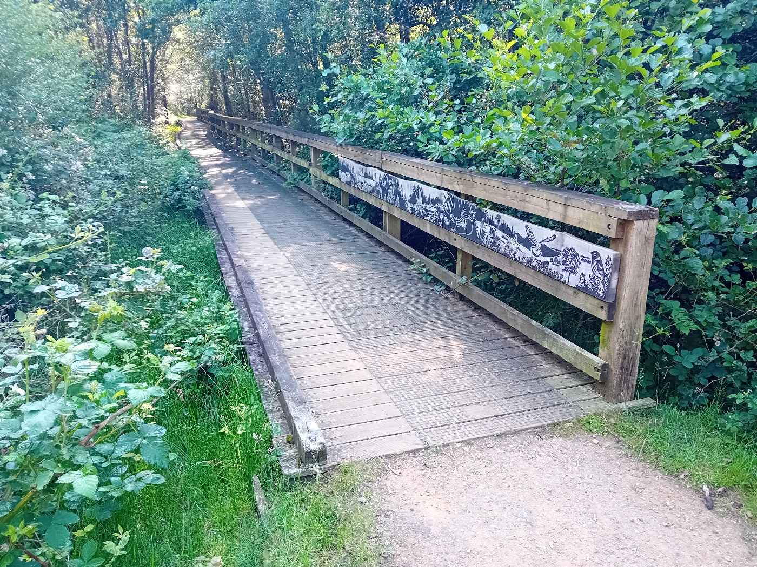
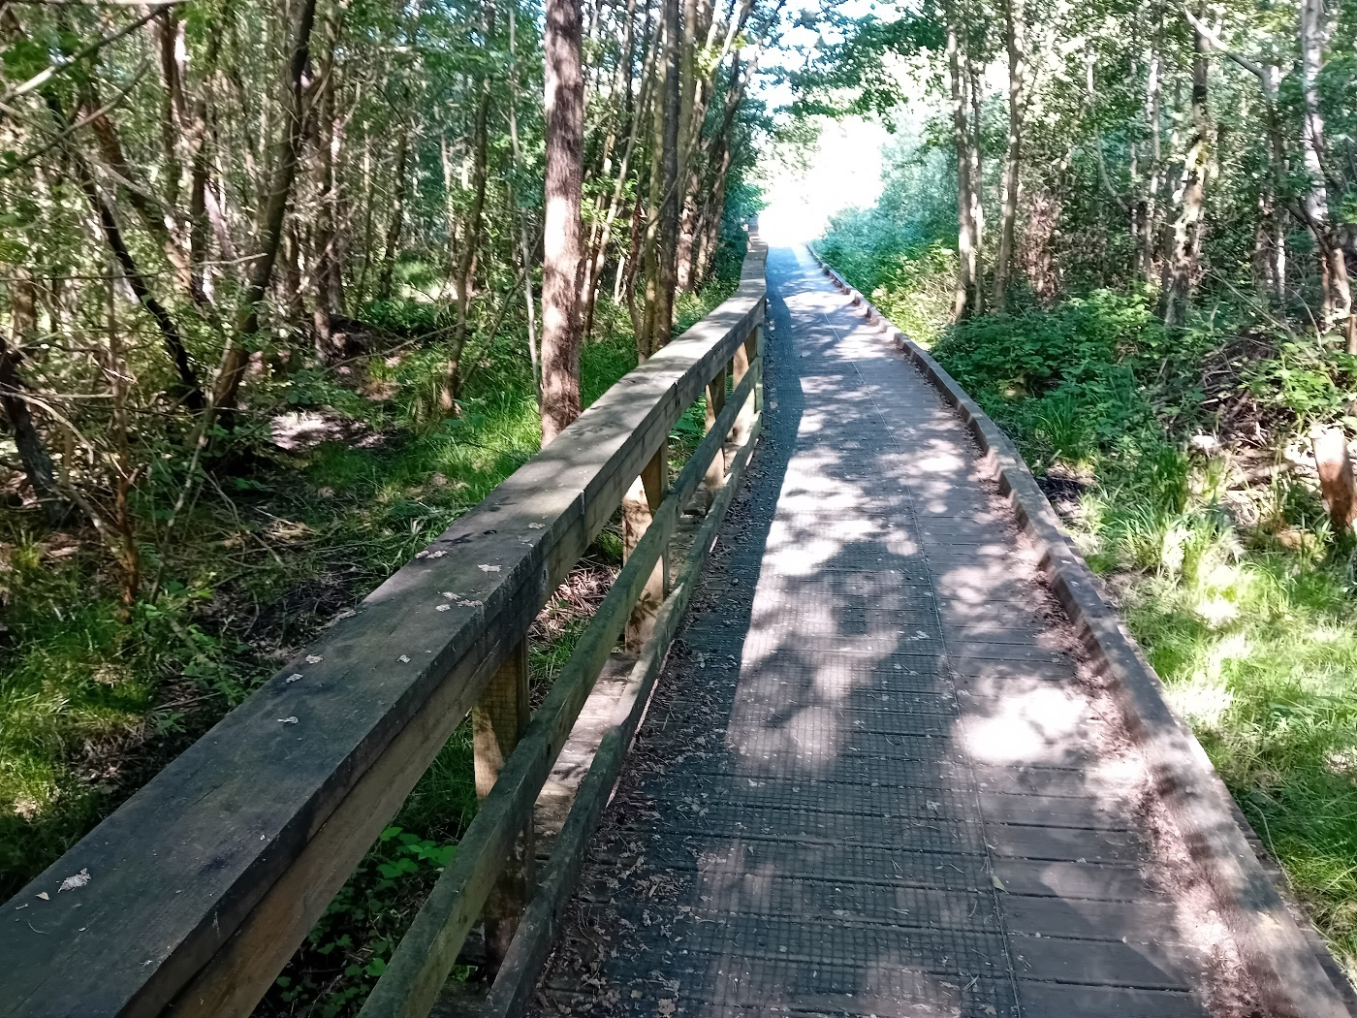
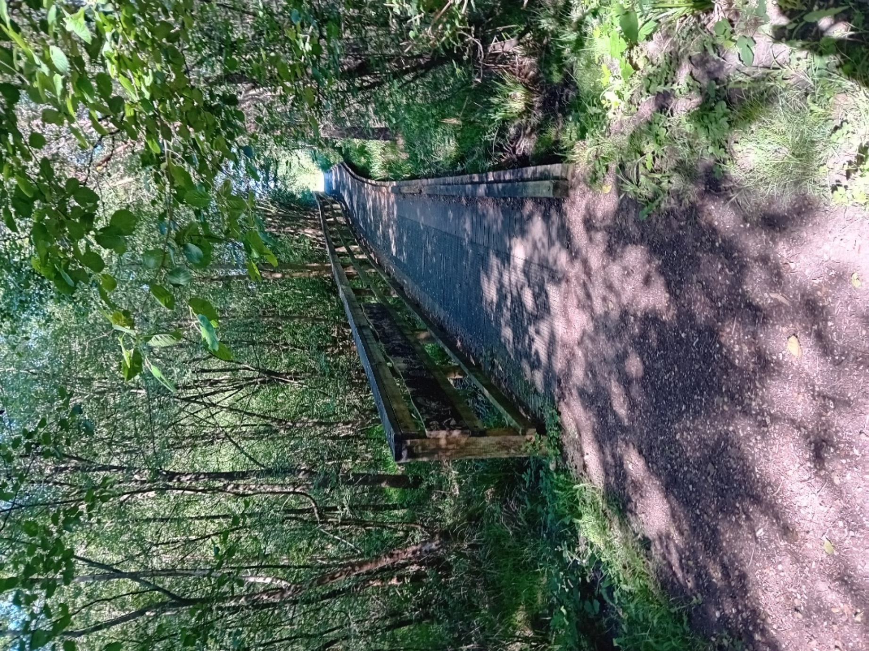

APPENDIX

Contractor’s Procedural Brief

Permits to Work – Contractors must notify sub-contractors of any safety systems in place. Contract of working is between Hart District Council and the Contractor with whom the purchase order has been placed. Contractor takes full responsibility for any sub-contracted works and must obtain prior permissions from Hart Council in writing, when planning to use sub-contractors.
Safety Standards
- All contractors working on site must sign in at reception/office daily.
- Observe all local site rules. e.g. No smoking etc.
- Always notify the Site Manager of any hot works, welding etc.
- The creation of dust and fumes shall be controlled and kept to an absolute minimum.
- Contractor must provide adequate and appropriate signage and set clearly defined work zones that are a safe distance away from members of the public, including closing path sections where appropriate. In the event of path closures, contractor must do so with prior agreement from Hart DC staff.
- Contractor’s electrical tools and other equipment must be suitable for the work and environment in which the work is being performed. Tools and equipment must also be adequately maintained and conform with current regulations.
- Contractors are not permitted to make use of any premises services without the prior approval of the Site Manager.
- Contractors must not operate any dead eye, hoist, lift or any other equipment without the approval of the Site Manager.
- Contractors must maintain safe means of access and egress from every area where the contractors’ employees will be working.
- Contractors are required to use premises roads and gangways to and from the site of operation and are unauthorised to be in any other part of the site.
- All excavations at all times must be securely protected and sign posted with warning lights. Some sites may require trenches to be filled/covered if left overnight.
- Contractors shall report all accidents/incidents to the Site Manager immediately.
- Good housekeeping is to be undertaken at all times by the contractor. All gangways, corridors and roads are to be kept clear of obstruction at all times.
- The premises shall provide a safe place of work. The contractor and sub-contractors have a duty to implement and maintain a safe system of work.
- On completion of work the contractor shall ensure that all materials and waste is removed from site and appropriately disposed of.
- All contractors’ personnel must be competent, adequately trained and equipped to perform the specific task required.

All works to be carried out in accordance with the Code of Safety document below.

Specific site rules:

The areas designated to be flailed all form part of the ex-landfill area. Contractors must check the area before cutting to ensure there are no protruding objects which can cause damage to machinery and those in the vicinity.
If any hazardous material such as asbestos is uncovered during the work, contractors must react accordingly by ensuring the area is re-covered and HDC staff notified.
Countryside Site Works
Due to the very varied sites covered by the Service and varied weather conditions “contractors” must inform the Rangers when and where they are working at all times on council land.
Contractors must be courteous to the general public at all times and communicate any positive or negative feedback from the public back to the Countryside Service.

Any weekend working must be authorized before proceeding.

CODE OF SAFETY

It is expected that all contractors, sub-contractors and consultants, awarded contracts by Hart District Council shall perform all work with due regard to the Health and Safety at Work etc Act 1974, the Management of Health and Safety Regulations 1992/99, the Construction (Design and Management) Regulations 2015 and all other relevant Regulations, Approved Codes of Practice and HSE guidance. It is also expected that all contractors and their employees will be conversant with any specific safety rules of the premises and the particular area in which they are to work prior to any work commencing.
The contractor shall be responsible for nominating a representative/officer (Site Manager) whose name will be documented in any written contract prior to works proceeding. The contract document shall also name the officer responsible, who will act as the site contact for all matters concerning the works.
The main contractor shall be responsible for notifying all sub-contractors of any factors affecting their health, safety and welfare and the safety of others who could be affected by the work activites being carried out. The main contractor shall ensure that any sub-contractors receive a copy[s] of the site rules and that they are understood. The main contractor shall fully inform the Site Manager of the fact that sub-contractors will be used to perform the works.
Starting work
Appropriate arrangements for health, safety and welfare and safety shall be made and a safe system of work arranged with the Site Manager before the contractor’s operations begin.
Daily, prior to commencing work, the contractor must report to the Site Manager or other previously designated manager in his/her absence.
When contractors’ operations are expected to create special hazards on any particular day(s) e.g. hot works, electrical work, work in confined spaces, demolition work, use of dangerous substances or articles, working at height or any other activity then the attention of the Site Manager must be drawn to these hazards and adequate precautions must be taken. A “permit to work” scheme may be deemed necessary for the given examples dependent upon the findings of any assessment (i.e. serious risk, COSHH, confined spaces or fire).
When Contractors’ employees may be at risk when working in certain areas on the premises, the Contractor will be notified accordingly and will also be provided with all relevant information relating to the identified risk. There will be a joint responsibility on the Site Manager and the Contractor to assess and inform their employees and to advise Hart DC of such hazards. Instruction and training will also need to be considered if the hazard is significant.
Services
Contractors must not connect or interfere with any electrical, gas, water, compressed air or other service on the premises without the expressed written permission of the Site Manager. The connection of portable electrical tools, such as drills, by means of a standard plug top is exempt from this rule provided that the appliances are of the 110volt centre tapped to earth type. The provision of any step-down transformer shall be designated as the responsibility of the Contractor.
Tools & Equipment
All plant, tools, tackle and equipment used by contractors on the premises must be suitable for the work and environment, in which it is being undertaken, must comply with all relevant legal standards and must be maintained in accordance with appropriate safety standards. The personnel using such equipment must be adequately trained and competent in the use of such equipment. Hart DC encourage the use of battery operated wherever possible.
Contractors are expressly forbidden to use any plant, tools, tackle or equipment which belongs to the premises at which the work is being performed.
Electrical Plant & Equipment
The contractor or his employees shall not enter any area of the premises without the expressed permission of the Site Manager or other previously designated manager in his/her absence.
It is recommended that battery powered tools and equipment are used whenever practicable. They have shown to emit lower noise levels and far lesser hand, arm vibration.
Portable electrical tools and equipment must be sufficiently earthed or double insulated. In appropriate cases, i.e. working in a wet environment e.g. swimming pools, such equipment must be of a voltage not exceeding 50volts for lighting and 100volts for portable tools. The electrical supply shall be by means of a double-wound transformer with the secondary circuit being centre tapped to earth.
As further means of protection from excess electrical current all equipment shall be sufficiently fused and the contractor shall use circuit breakers, miniature circuit breakers and residual current devices where possible. All such devices incorporate earth monitoring devices capable of switching off the electrical supply in the event of the earth connection being broken.
Guards, Fences, Barriers, Screens and Enclosures
Guards or fences must not be removed from any machinery or plant except to carry out work on that equipment and then only with the written permission of the Site Manager. Guards or machinery must not be removed while machinery plant is in motion or energized. Guards or Fences must also always be replaced and secured as soon as work is complete and before the machinery/plant is reinstated or energized.
All contractors’ machinery brought onto the premises must comply with the Provision and Use of Work Equipment Regulations 1998 (PUWER) relating to that type of equipment, and must where appropriate, be adequately guarded or fenced. Where a contractor is performing work on the premises which involves the breaking of stone, grinding of metals, sand blasting etc. then the contractor shall be responsible for the installation and maintenance of suitable screening or enclosures to protect persons other than their employees who may be endangered by the activity. Test and examination certificates shall be made available as requested.
Working above ground
When work by a contractor involves the erection and use of any scaffold support, mobile tower scaffolds, mobile elevated work platforms, cradles and/or ladders then the contractor shall be responsible for the safety of such structures. The contractor’s responsibility extends to incorporate features such as scaffold “fans”, ties, walkways, covers, guard rails, toe boards, warning lights etc. as may be deemed necessary for reasons of safety. Daily inspections and precautions must be taken to ensure safety on such structures by the removal of ladders or other means of access when work ceases. Test and examination certificates shall be made available as requested.
Working below ground
Ground on premises may not be broken without the expressed permission of the Site Manager and Hart DC. Nearby underground services must be positively located by the contractor and their presence pointed out to those persons performing the excavations, prior to the work commencing. Excavators and JCB’s should not be used in the vicinity of buried services. A “permit to excavate” may be issued to ensure these precautions are carried out. The excavation must be made safe by means of barriers, stop blocks and suitable warning notices until the ground is restored to its previous state.
All trenches and excavations, particularly those adjacent to roads or existing buildings must be adequately “shored”, and falls of material prevented by “battering back”, caissons, or other effective means in accordance with any guidance and good practice. The safety of other persons on site is to be a continuous priority and excavations boarded over where practicable and/or otherwise suitably protected and signed when work is not actually proceeding.
Confined Space Entry
Contractors employees may not enter any chamber, tank, pit, vat, silo, trench, pipe, sewer, flue, well or other similar confined space where there may be dangerous fumes or lack of oxygen, without the expressed permission of the Site Manager and Hart DC. If permission is given then work in such spaces shall be carried out taking all necessary precautions and using the methods outlined in The Confined Spaces Regulations 1997.
Permits to work
In cases of specifically hazardous work or where contractors operations need to be strictly coordinated with those of the premises to ensure safety, the work shall be governed by means of a formal permit system. The relevance of such a system to the work envisaged must have been discussed and documented wherever possible during the planning stage. The necessity for such a system to be adopted must be noted before work commences and the Site Manager and Hart DC informed.
Control of pollution/waste
Contractors may not deposit any waste, chemical or other substance whatsoever into any drains, skips, bins or any other area on the premises. All waste must be disposed of as agreed in the contract, by an approved and authorised waste disposal contractor(s). Further advice can be obtained from the Environment Agency.
Cartridge operated fixing tools
Cartridge fixing tools may not be used on the premises without prior permission from the Site Manager. If permission has been granted, such tools may only be used in compliance with the standards set out in the PUWER Regulations..
Personal Protection
The contractor shall be responsible for providing his own employees with personal protective equipment as may be required for the work in hand. Such equipment may include eye and ear protection, respirators, head protection and breathing apparatus etc.
Reporting an near miss, accident or incident involving a contractors’ employee or other person affected by the contractors’ work
Any accidents of this nature must be reported to the Site Manager immediately. Copies of Reports should also be submitted to the Councils’ Corporate Health and Safety Adviser in Environmental Health Services department. All accident reports should be presented on an official Council accident/incident report form (ARF1) and completed on the same day as the accident/incident or within 3 days if a weekend.
Reporting an unsafe condition or hazard.
Unsafe conditions or unexpected hazards must be reported to the Site Manager immediately.
Contractor Code of Conduct

Whilst carrying out contracted work for Hart District Council Leisure & Environmental Promotion Department all contractors, their employees and any sub contractors are expected to abide by the following:-

- Be polite, respectful and considerate to others be they Hart DC staff or members of the Public
- Not to discriminate unlawfully against any person for any reason
- Bad language, unnecessarily raised voices and language or behaviour that could be offensive on the grounds of age, physical appearance, gender, sexuality, disability, ethnicity or religion are all forbidden. Examples include –
  - Verbal abuse, or insulting behaviour
  - Sexist jokes, racist jokes, jokes about an individual’s sexual orientation or jokes about disability
  - Unwanted physical contact ranging from touching to serious assault
  - Display or circulation of sexually suggestive or racially abusive material
  - Bullying, coercive or menacing behaviour
  - Ridicule or exclusion of an individual for cultural or religious differences
  - Obscene slogans on T-shirts, other items of clothing, stuck to tool boxes, etc.
- No alcohol or drugs (unless prescription medication) are to be consumed whilst in the work place or brought into the workplace. [Work place can mean a building or out on land owned or controlled by Hart DC]
- All should be in a fit state to work and not under the influence of drink or drugs
- Must observe any relevant national codes of practice and standards for his or her particular area of work
- Be appropriately trained and certificated for what they are doing and / equipment they are operating
- Comply with agreed arrangements relating to where, when and how works are to be completed
- Observe operational regulations, safety rules, regulations and codes of practice, safe working procedures
- Provide copies of all relevant paperwork regarding health & safety for what they are doing, i.e. Risk assessments, hot works certification, etc.
- Be responsible for their personal safety, mindful for that of others working with them, that of staff members of Hart DC and of members of the public

