Brief for ABSS Coproduction and parent engagement development

- Context
In June 2014, the Pre-school Learning Alliance (PLA) and Southend-on-Sea Borough Council was successful in its bid to the Big Lottery Fund’s ‘Fulfilling Lives: A Better Start’ for investment of £40.44m over ten years to deliver a step change in the use of preventative approaches in pregnancy and the first three years of life, to improve the life chances of disadvantaged babies and young children.

Led by the PLA, the ‘A Better Start for Southend’ (ABSS) proposal sets out how the area will improve the life chances of children by investing in their earliest years – starting in pregnancy, and achieve positive outcomes in three main areas of child development:

- Communication and language development
- Social and emotional development
- Diet and nutrition.

A Better Start Southend is inviting quotation proposals from suitably qualified and experienced organisations and consortia with good local knowledge to develop our coproduction model. This includes the development of:

- A Coproduction Strategy
- A map of the volunteering offer including opportunities and volunteer training.
- A review of the current volunteering offer making recommendations
- A Community Innovation Grant model and process
- Parents Champions
- The Volunteer Workforce working with under 4’s

This contract will be in place from 1st December 2016 until 30th June 2017, after this time, this provision will be reviewed and if appropriate retendered for the implementation of the ABSS Coproduction Service.
The value of this contract for 7 months will be up to £75,000.
- The Work and Outcomes
Outline requirement
The diagram below is the coproduction governance structure for which we require organisational development support. Central to this is ensuring a link to whole system influence and change across Southend and how all opportunities impact skills development and employability. Alongside this programme will be workforce development project to help professionals with coproduction. It is imperative that both projects are integrated in their approach.

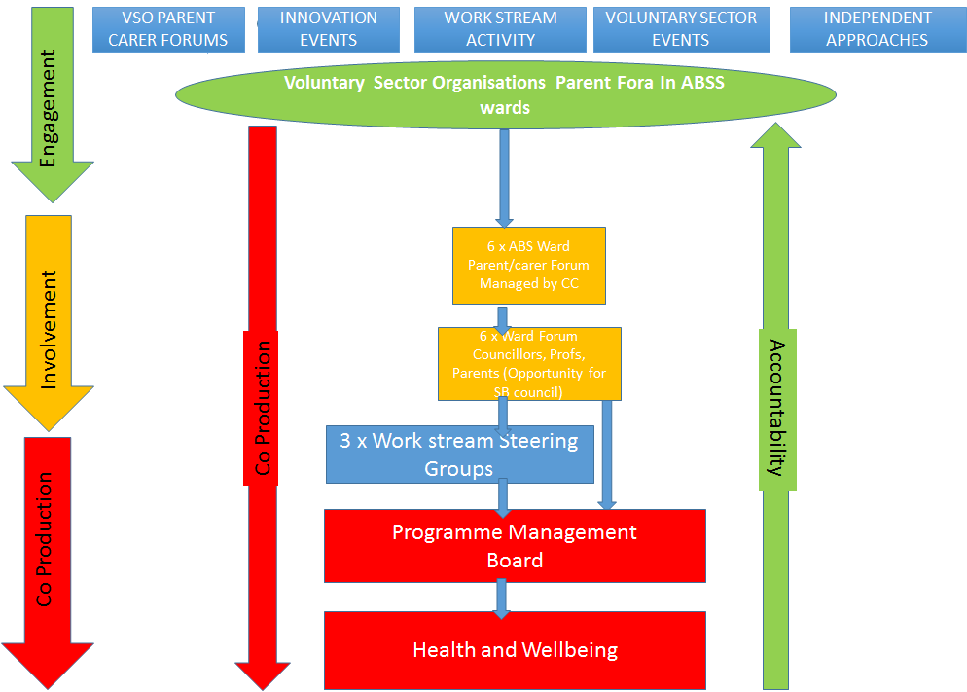
Coproduction governance structure.

Approach
We would like you to consider the four D’s at the appropriate point when scoping and running this project;
- Discover what the problem/issues are by reviewing the existing offer, understand its effectiveness and identifying gaps
- Define the factors that will determine what success looks like, (outcomes and outputs)
- Design the approach, structure, systems and processes required to meet the outcomes and outputs
- Deliver the design to the agreed stage of implementation
Outputs and Outcomes

Outputs | Outcomes
- Southend Strategy for Coproduction | Strategy in place approved by all ABSS partners
- Parent Champions trained | 12 parent champions attending/promoting/supporting ABSS governance arrangements
- Active parent involvement in governance at all levels | 12 Parent representatives attending all governance meetings
- Volunteer opportunity pathway | Volunteer development plan  Pathways identified for volunteering opportunities mapped for ABSS volunteers post ABSS involvement
- Volunteer opportunity map/database | An online accessible/searchable data base of volunteering and training opportunities
- Volunteer training programme | Training programme in place with 90% satisfaction rates
- Parent forums operating with and in development | 4 parent forums in operation with a minimum of 10 attendees  2 in development
- Ward forums operating and in development | 4 ward forums operating with full representation across services, partners and parents feed into work stream steering groups with 2 in development  2 parents siting on each work stream steering group
- Innovation fund operating in the wards with parent forums | Minimum of 10 Parents representing parents forums distributing funds through an effective process
- Terms of Reference developed (in partnership with parents) for Parent Forums and Ward Forums. | Terms of reference in place

Objectives
- To coproduce a borough wide coproduction strategy and get approval from parents and ABSS partners
- To map and review current volunteering opportunities in the borough to establish type, range, extent of opportunities and a model for sustainability in line with needs and aspirations of parents as part of a route to employment
- To coproduce and implement the role and function of parents champions
- To coproduce a volunteer training programme for parents champions taking in to account the review findings
- To develop a progressive volunteer training programme to reflect the different levels of involvement in the opportunities ABSS offers and tie in to wider volunteering and coproduction opportunities for post ABSS age range involvement (e.g. Education and Health).
- To coproduce a borough wide parent engagement model (structure, governance, systems and processes) around the new governance arrangements for ABSS providing different opportunities for different levels of participation and involvement to meet all parents
- To pilot the coproduction model through test and learn and develop for up scaling
- To coproduce and establish a community ABSS focused Innovations Grant process to be run by parents

Secondary Outcomes
The Coproduction work will deliver the following secondary service outcomes:

- Recommendations for further implementation
- A job description for a Coproduction Coordinator
- A method for providing coproduction development support to services and organisations.

- Enquiries and Quotation Submissions
Providers should note that clarification questions may be made in writing (including email) and/or at a half hour drop in session on the morning of 17th Nov from 8.30am for each prospective bidder. Slots must be booked in advance with beverleykilworth@southend.gov.uk. ABSS at their discretion reserves the right to circulate any response to all providers. All clarification questions must be clearly marked CLARIFICATION with the question and Provider details clearly set out. Any clarification questions from the Provider to A Better Start Southend should be sent to garymay@southend.gov.uk
To allow information to be circulated in time, the deadline for receiving clarification questions is 12:00hrs on Friday 25th November 2016.
The quotation return date is 12:00hrs on Friday 2nd December 2016. Quotations should be submitted by email to beverleykilworth@southend.gov.uk (you are recommended to request confirmation of receipt).
- Evaluation of Quotations
All quotations will be subjected to a thorough evaluation. ABSS will examine quotations for completeness and may seek clarification where necessary. A quotation determined to be incomplete or not substantially fulfilling the conditions in this document will be rejected.
- Technical (Quality) evaluations will be conducted, based on the information submitted in Section A. in writing, as part of this quotation submission.
- Commercial (Price) evaluations will be conducted, based on the information submitted in Section B, in writing, as part of this quotation submission.

AWARD CRITERIA
A Better Start Southend does not bind itself to accept the lowest priced quotation, or any quotation for this service. A Better Start Southend will have no obligation to Providers arising from this quotation unless and until it enters into a formal contract with the successful Provider for the provision of the goods and/or services that are subject to this Quotation document. Any contract awarded will be to the Provider whose proposal is determined to be the most economically advantageous.
30% PRICE ALLOCATION: To be detailed within this written quotation submission, by the Provider. It is the requirement of A Better Start Southend to maximise the budget available for this project. The Quotation is accepted on a “Fixed Price” basis and the Provider will not be entitled to claim any additional payments or expenses including but not limited to any increase in the price of the service and / or cost of, or incidental to, the employment of labour. The prices included in the Quotation shall be the maximum payable by A Better Start Southend for the duration of the contract.
Pricing Evaluation (30%) – Using the Prices submitted by Providers a percentage will be allocated to the total cost as follows:
- Score = (Lowest Price Quotation / Your Price) * 30%
- The Table below gives an example of how the methodology works when applied to contract prices. The prices used here are examples of the pricing methodology and do not reflect any expectation of this contract in relation to any aspect of the pricing.
 | Bid A | Bid B | Bid C | Bid D
Contract Price | £60,000 | £65,000 | £70,000 | £75,000
Points Score | 30 | 27.7% | 25.7% | 24%
The scores awarded in the example table to Bid A and Bid D is calculated as follows:
- Bid A and Bid D with the lowest contract price in relation to the other bids are awarded the score of 40. The applied methodology gives a calculation as follows: (£60,000 / £60,000) x 30 = 30.00%
- Bid B with the highest contract price in relation to the other bids is therefore the lowest scoring bid in the pricing section, awarded 37.3%. The applied methodology arrives at this score through a calculation as follows: (60,000 / £65,000) x 30 = 25.4%.

70% QUALITY ALLOCATION: To be detailed within this written quotation submission, by the Provider, in Section A (Technical Questionnaire). Your quote in response to this brief should consider and provide the following:
 | SECTION | SECTION WEIGHTING
 | Method for delivering the brief against the objectives | 20%
 | Track record of delivery of similar pieces of work in Southend | 35%
 | Individuals and team involved | 10%
 | Social Value | 5%

Evaluation of Responses will be carried out on an individual question basis. Grade labels and definitions are as follows:
SCORING MATRIX |  | SCORE
Deficient | Question not answered – or – Response to the question significantly deficient. Answer does not provide satisfactory evidence as to the organisation’s capability. | 0
Limited | A response that is inadequate or only partially addresses the question. Answer provides some evidence as to the organisation’s capabilities. | 1
Acceptable | An acceptable response submitted in terms of the level of detail, accuracy and relevance. Answer provides sufficient evidence as to the organisation’s capability. | 2
Good | A good response submitted in terms of the level of detail, accuracy and relevance. Answer provides significant evidence as to the organisation’s capability. | 3
Excellent | A very good response in terms of the level of detail, accuracy and relevance. Accompanying evidence provides strong assurance as to the organisation’s capability. | 4

Section A- Basic Contact Details & Technical Questionnaire
Contact name for enquiries about
this bid:
Address:

Post Code:
Telephone Number:
Email Address:
Company Registration Number (if this applies):
VAT Registration number: (if this applies):
Have you ever been employed by ABSS or Preschool Learning Alliance? (if yes please provide details) |  | Yes  No
Please state if you have a relative(s) who is employed by A Better Start Southend at a senior level or who is a Councillor for Southend-on-Sea Borough Council? (if yes please provide details) |  | Yes  No

PROSPECTIVE PROVIDER RESPONSE FORM
TECHNICAL QUESTIONNAIRE
Please note that page limits are on the basis of font Arial 12 and also include charts, diagrams, tables etc. Additional appendices are not permitted other than CVs as details in question 3.
1. Method for delivering the brief against the objectives

Explain how you will deliver the brief as outlined within this specification. Set out your approach to coproduction, knowledge and expertise that you can bring to deliver a fit for purpose piece of work of the highest quality. Describe how you will ensure coproduction is at the heart of your approach.
(2 pages max. Weighting = 20%)
2. Track record of delivery of similar services, including examples of how you have carried out such services in the past.

Please set out evidence of successful work in similar fields and the areas of expertise that you will bring to this contract
(2 pages max. Weighting = 35%)
3. Individuals and team involved
Provide an overview of the individual/s you are proposing to complete this work and how their skills and knowledge will help deliver this work.

(1 page max. Please note that CVs can be provided in addition to this page limit. Weighting = 10%)
4. Social Value
Please provide a statement which outlines the social value outcomes you aim to deliver under this contract. Please include evidence of the approaches you will deploy and the way you will demonstrate that the social outcomes have been achieved.
(1 page max. Please note that CVs can be provided in addition to this page limit. Weighting = 5%)

PROSPECTIVE PROVIDER RESPONSE FORM
B – COMMERCIAL QUESTIONNAIRE

Please provide a quote for the full cost of delivering this project- please provide a breakdown of the full costs.

Please note the maximum budget for this is £75,000 any submissions that are above this figure will be disqualified.

(Weighting = 30%)
Please provide a breakdown of your costs per objective

Objective | Price (£)
1
2
3
4
5
6
7
8

