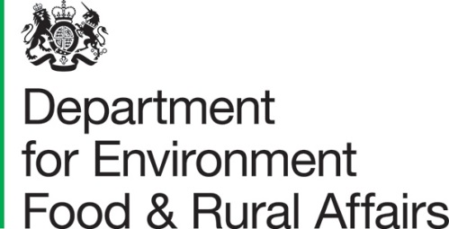 |  | Defra group Commercial  Lateral House  8 City Walk  Leeds  LS11 9AT | T: 03459 335577  helpline@defra.gsi.gov.uk  www.gov.uk/defra
 | All Interested Parties  Published Online |  | Our ref: P-37394  Date: 18th March 2025

To Whom It Will Concern

Market Engagement: Hive Side Education Pilot
The UK and Welsh Government’s Healthy Bee Plan (“HBP 2030”) aims to address the challenges facing beekeepers and bee farmers and to sustain the health of honey bees and beekeeping in England and Wales over the next decade. As part of the HBP 2030 we are seeking to provide hive side training to intermediate level hobbyist beekeepers for the purpose of reducing problem pests and diseases affecting the UK bee population.

We are planning to appoint a Supplier to pilot hive side training across England and Wales. The pilot will cover the 2025 beekeeping season (April – September). In this context, “hive side training” means the provision of face-to-face and practical training inside bee hives, as opposed to classroom based or online training.

Prior to seeking quotes from suppliers to provide hive side training, we are testing our draft specification of requirement with potential suppliers. The “specification of requirement” is the document that describes how the supplier will deliver hive side training on our behalf.

Our ask of potential suppliers and interested parties is to review the draft specification and provide feedback to us. Overleaf you will find a questionnaire to provide your feedback in. This represents your opportunity to help shape, change and define our approach to the hive side training pilot.

If you would like to provide feedback on our draft specification, please review the draft specification & our questionnaire overleaf. Please return your questionnaire, along with any other comments you have to tom.redfearn@defra.gov.uk by 28th March 2025. We will then take your feedback on board and formally request quotes in early April.

I hope you have an interest in hive side training and will take the time to review our draft specification. I look forward to hearing from you,

Yours faithfully,

Tom Redfearn
Senior Category Officer, Defra group Commercial
Enc. Draft Specification of Requirement

Questionnaire: Hive Side Education Pilot
Question | Response
Can you deliver training in all three geographical regions (listed below)?

Lot 1: North of England and Midlands
Lot 2: South of England
Lot 3: Wales
We want to target intermediate level beekeepers for the training, do you think we have defined what an “intermediate level beekeeper” is appropriately?

Our definition of intermediate level beekeepers: non-commercial beekeepers with at least three years’ experience in managing at least one hive.

Would you propose a different definition?
What qualifications and experience do you / your staff have that will provide hive side training?
How many training courses could you deliver with the below budgets & how many people would be trained:

£10k per lot (£30k total)
£20k per lot (£60k total)
£30k per lot (£90k total).

If you are prepared to do so, please explain how you have costed the training. E.g., £X per day for the trainer, £Y to prepare for each course etc.
Please provide any other comments or feedback here

