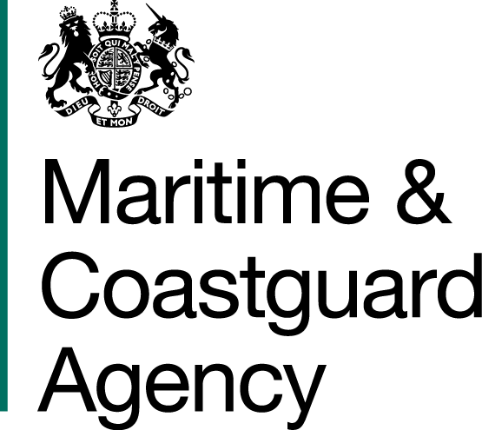 |  |  | Bay 3/21  Spring Place  105 Commercial Road  Southampton  SO15 1EG
 | To whom it may  Concern, |  | Tel:  E-mail: | +44 (0)20 381 72476  contracts@mcga.gov.uk
 |  |  | Your ref:  Our ref: |  | TCA 3/7/1112
First issued 18th July 2019
Last updated 29th August 2019

Dear Sirs

REVIEW OF THE RISK TO THE UK FROM MARINE OIL POLLUTION
QUESTIONS AND ANSWERS -

We have received questions for the above-mentioned tender, and to ensure that all tenderers have access to the same information, we have copied the questions and our answers to you:

Question 1: Would it be possible to view a copy of past Risk Reviews? This would help us to understand what level of detail is required in deliverable.

MCA response: The Authority agrees to provide the executive summaries and contents pages for some of these previous risk reviews which will give an idea of the scope, scale and subject matter covered in these papers. The Authority also agrees to provide a link to the National Audit Office report Dealing with Pollution from Ships, which is already publicly available online:

https://www.nao.org.uk/report/dealing-with-pollution-from-ships/

The rationale for not providing all of the papers in full is that the Authority wishes to avoid a situation where bidders interpret this provision as a desire on the part of the Authority for this risk review to replicate the methodologies used in previous risk reviews, thereby stifling the innovation we are looking for. It should also be noted that these reviews do in themselves vary in terms of approach and focus, depending on the Authority’s stated requirement for those studies and on the analysis tools available at the time.

In terms of level of detail, given the level of resource available and the timescale, the MCA understands that the data analysis carried out to inform this risk review will not be exhaustive. On the other hand, the level of detail and accuracy of the findings should be sufficient to inform the MCA’s resourcing for oil spill response, providing a reasonable basis for this planning. Striking this balance and providing a rationale for the chosen approach is the purview of the bidder and, again, the Authority encourages innovative approaches. To dictate or indicate the appropriate level of detail risks stifling any innovation.

Question 2: Would it be possible if an extension to the deadline for submission of tenders?

MCA response: MCA has extended the deadline for receipt of tenders until midday on the 30th August 2019.

Question 3: Will the MCA provide any tabulated marine traffic and/or tabulated accident statistics data following contract award? If so, what might this include please?

MCA response: AIS data for the UK EEZ is available in a .csv format rendered down into individual days from 2013 up to the end of July 2018. The file sizes are considerable, and an external drive will be the fastest method of transfer. This drive should be provided by the successful bidder.

AIS data from August to December 2018 can be extracted, but at present the timescale for this is not known.

Data on incidents/accidents is available in the weekly summaries of the MCA’s Counter Pollution and Salvage Officers. The successful bidder will have access to these. UK Annual Marine Pollution Surveys published by the Advisory Committee on the Protection of the Sea (ACOPS) are also available up to 2016.

No data held by the MCA will be released prior to contract award.

Question 4: Stage 1 refers to oil cargo. Will this include Hazardous and Noxious Substances?

MCA response: No, the Risk Review will not include hazardous and noxious substances unless the substance in question is also defined as oil under Annex I of the MARPOL Convention. The purpose of the Review is to inform the MCA’s resource planning for its response to marine oil spills and must be confined to this. If this is unclear, bidders should refer to the definition(s) of oil under Annex I of the MARPOL Convention and the examples laid out therein.

Question 5: Annex 3 – Price Evaluation states that “the total project price shall be paid in accordance with Clause 2.4 in the form of contract (Annex 4)”. Clause 2.4 is not in Annex 4 (form of contract). Please clarify.

MCA response: This is a typo – it should refer to Clause 2.1 in the Form of Contract.

Question 6: The ITT refers to Annex 5 on page 8. Annex 5 is not in the provided documentation. Is this an additional document? If so, can a copy please be made available?

MCA response: This is a typo and should refer to the Form of Contract in Annex 4.

Question 7: Can you confirm that we are only to offer against the Awarding Authority (MCA) request

MCA response: The Contracts Finder advert will be updated with the Authority’s published responses to bidders’ clarification questions. This is to ensure open and fair competition by enabling all potential bidders to access any new information published in response to a clarification question. You should ensure you check the Contracts Finder Website on a regular basis for any new information.

Question 8: Can you confirm that the following documents we are to be used to provide our submission:

ITT Specification of Requirement v4
Oil Spill Review Questions v2

MCA response: The ITT Specification of Requirement is the document you need to use to submit your bid, with any of your own supporting documentation. The Oil Spill Review Questions document is updated with every new question from a bidder and answer from the Authority; it is not a template to use in the submission of your bid, but it will contain information you should be aware of.

Question 9: Can you confirm that the submission date is now August 30th, 2019.

MCA response: This is correct.

Question 10: Can you confirm that we are still to provide our submission via e-mail to: AviationContracts@mcga.gov.uk

MCA response: This is correct.

Question 11: Would you be able to confirm that we can subcontract part of the data engineering and data gathering to? If so, are there any subcontracting guidelines we should follow?

MCA response: Subcontracting is indeed permissible but is subject to the conditions set out in Part F of the Department for Transport General Conditions of Contract for Services.

Where Paragraph F.1 of that document states that “the Contractor shall not assign, sub-contract or in any other way dispose of the Contract or any part of it without prior Approval”, for the purposes of this tender, bids shall detail any sub-contracting arrangements (including the status of any arrangement or relationship) and the Authority’s awarding of the Contract shall constitute its approval of these arrangements. Any initiation of or change in subcontracting arrangements subsequent to the submission of a bid, including after contract award, shall require the approval of the authority.

Question 12: The ITT makes reference to analysis of AIS data in order to establish a representative picture of ship types and transit routes etc. Please could you confirm whether:

a. The MCA will provide the AIS data, or whether the consultant will be expected to source this externally;
b. If the MCA can provide AIS data:
a. What format will it be provided in (i.e. raw and in need of decoding; partially processed (e.g. MMSIs with coordinates), or fully processed and fit for use in GIS software); and
b. Will the coverage be limited to the MCA’s network of terrestrial receivers, or is there data available further offshore?

Any further clarification on the above would be greatly appreciated.

MCA response: Yes, the MCA can provide AIS data for 2013 to 31 July 2018 upon contract award, if this is requested by the successful bidder.

The AIS data has been processed and formatted as CSV files for the various message types, easily imported into all the leading GIS software packages.

Please note that the body of AIS data that the MCA hold has been processed/rendered down to CSV files for each day for a given year. This was done to limit the size of each file covering a period of time (AIS data files are inherently large) and to facilitate extraction and focus for a particular date. However, even this restriction results in “heavy” files not easily transferred by electronic means and therefore a physical medium (e.g. portable USB drive) is recommended.

The MCA’s C-Scope VTM Integrated Track Table (ITT) contains terrestrial radar tracks, terrestrial AIS tracks, Satellite-AIS tracks and LRIT tracks. The coverage is for the whole of the UK EEZ.

Question 13: We are completing our tender document for the MCA Review of the risk to the UK from Marine Oil Pollution (closing on August 30th). We note that S.29a of the ITT document states that a Form of Tender must be completed and that the document is included on the Contract Finder advert.
We are unable to locate the Form of Tender and wonder if you might provide a copy for completion.

MCA response: The reference to the Form of Tender was included in error, the Form of Contract is the document that you will need to complete and return.

Yours faithfully,

Kathy Monk
MCA Procurement Team

