Bidders Questions and response

Date: | Question: | Response
09/07/20 | We cannot locate the specific questions that relate to the evaluation criteria below  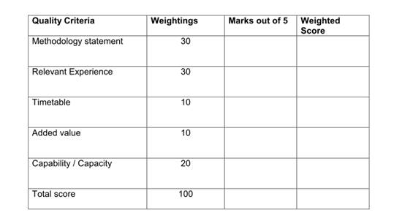 | In response to your questions please see below which adds reference to the sections referred to.  Methodology Statement – Refers to the below sections shown within the tender document.  Section 3.0 - Employers Agent Specification and Core aims and objectives  Section 4.0 - Health and Safety – With ref to CDM and RIBA  Relevant experience – Refers to the experience criteria as outlined within the Tender document.  Timetable – I can give further narrative if required.  Added Value – Will be measured against criteria that shows additional facilitation/experience to assist the process.  Capability and Capacity - I can give further narrative if required

