The Invitation
We invite you to bid in this competition for Quality Assurance and Testing for IT Systems (RM3810). Our invitation to tender (ITT) is in four parts. This is the first part. The other three parts are:
The Buyer Needs | – Everything you need to know about ‘the deal’.
CCS Needs | – The competition rules, obligations and rights, plus the  framework agreement (agreement).
Your Offer | – The document you complete as your bid.

Your Offer
Part 1 - CCS eSourcing Suite Questions
Part 2 - Standard Selection Questionnaire
Part I
Part II
Part III
Part 3 – Award Stage

The Buyer Needs
1. Introduction
Buyer needs statement
The current situation
The opportunity
2. Specification
Our priorities
Scope
Metrics
3. Call-Off Contract
RM3810 Call-Off Contract
Call-Off Procedure

CCS Needs
Part A – The competition
What you can expect from us
What we expect from you
Our rights
General

Part B – The framework agreement
Making the agreement work

In addition, you will need to review our standard terms and conditions on the web.

In this part we explain:
- What ’we’ and ‘you’ means
- Who can bid
- How to bid
- How our buyers will buy the goods and or services
- When and how to ask questions
- Timelines for the competition
Make sure you read the guidance, information and instructions that we provide – they are there to help you make your best bid.
We hope everything is clear – tell us if it’s not (see 5. When and how to ask questions).

- What ’we’ and ‘you’ means
When we use “CCS”, “we”, “us” or “our” we mean Crown Commercial Service;
We are the central purchasing body which procures common goods and services for central government departments and the wider public sector.
The Public Contracts Regulations 2015 regulate how we buy. This means that we and you have to follow processes that are fair, transparent and equitable for all bidders.
When we use “you” or “your” we mean your organisation, or the organisation you represent, in this competition.
When we use “buyer”, we mean the departments using the agreement to buy your services.

- Who can bid
We are running this competition using the ‘open procedure’. This means that anyone can submit a bid in response to the published contract notice.
You can submit a bid as a single legal entity. Alternatively, you can choose one or both of the following options:
- You can decide to work together with other legal entities to form a consortium. If you do, we ask the consortium to choose a lead member who will submit the bid on behalf of the consortium.
- You can bid with named sub-contractors to deliver certain parts of the requirements. This applies whether you are bidding as a single legal entity or as a consortium.
If you are using either of these options, you will have to identify what each of the parties is contributing to the bid (in your Selection Questionnaire Responses – See Your Offer).
We recognise that plans in relation to sub-contracting or a consortium may be subject to change up to contract award. You must tell us about any changes to these plans as soon as you become aware of them.

- How to bid
After you have read this invitation, read ‘The Buyer Needs’ next. It explains what we want, so that you can:
- Decide whether this competition is right for you
- Make your best bid
- Deliver what the buyers need.
Then read ‘CCS Needs’. It explains the commitments on both sides when you work with us in this competition.
Finally, you need to complete ‘Your Offer’ to create your best bid, which explains how your bid will be assessed.

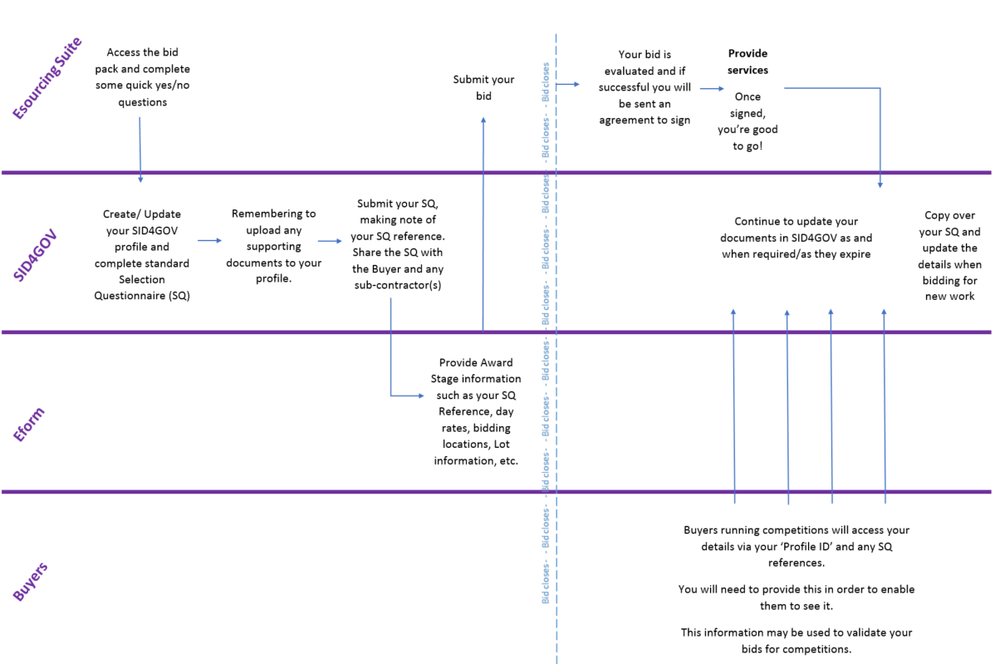
We have tried to explain this process below
- How our buyers will buy the goods and or services
The bidders who are successful in the competition will have to sign an agreement with us. They will then become suppliers. The terms of the agreement are not negotiable under the open procedure.
One of the schedules to the agreement is the Call-Off Contract – this will be the contract between you and the Buyer, if you are successful in winning a Call-Off Contract. You and the Buyer will need to complete and sign this before any work can start.
This visual shows the contractual relationships between you, the buyers and us:
Your Call-Off Contracts
Your Call-Off Contracts
Your Call-Off Contracts

Our agreement

Contract management

As you can see in the visual above, if you are successful in this competition you will have commitments to us for the life of the agreement, as well as to buyers who award Call-Offs. We will manage performance at agreement level. The agreement commitments are explained in ‘CCS Needs’ and the agreement.
Each buyer will manage their Call-Off Contract. The Call-Off commitments are explained in ‘The Buyer Needs’ and the Call-Off Contract.

- When and how to ask questions
We hope everything is clear to you when you have read all our guidance, information and instructions.
If you do have questions, you need to ask them as soon as possible after the Start Date. This is because we have set a deadline for submitting questions (the Bid Questions Deadline). This will give you the chance to check that you understand everything before you submit your bid. All the important dates are set out in the timetable in the next section.
You need to send your questions through the eSourcing Suite. This is the only way we can communicate with bidders. Try to ensure your question is specific and clear. Do not include your identity in the question. This is because we publish all the questions and our responses to all bidders.
If you feel that a particular question should not be published, you must tell us why when you ask the question. We will decide whether or not to publish the question and response.
We will also run a clarification webinar where you can have the opportunity to ask clarification questions “in the moment”. All questions and answers will be published on the eSourcing suite.
Remember that you can ask us questions about the agreement and Call-Off Contract but please do not attempt to ‘negotiate’ the terms. All awards will be made under identical terms.

- Timelines for the competition
Below are our intended timelines for this competition. We will try to achieve these but, for a range of reasons, dates can change as the competition progresses. We will tell you if and when timelines change:
Start Date (this is the date the OJEU Contract Notice is sent for publication) | 25/11/2016
Bidder Clarification Webinar – Briefing and Q&A | 06/12/2016
Bid Questions Deadline | 23:59 16/12/2016
Deadline for our responses to questions | 23:59 23/12/2016
Bid submission deadline | 12:00 06/01/2017
Issue of intention to award notices to successful and unsuccessful bidders | w/c 13/03/2017
End of mandatory standstill period | w/c 27/03/2017
Agreement start date | w/c 27/03/2017

Thank you for reading this through. We recommend you read ‘The Buyer Needs’ next.

