

**Contract Documents**

**ProWatch & Lobbyworks Hardware and Software Upgrade**

Contract Reference N/A

|  |  |  |
| --- | --- | --- |
| Contract Data | | |
| **NEC3 Engineering and Construction Short Contract 2013** | |  |
| A contract between | Public Health England  Porton Down, Salisbury, SP4 0JG |  |
| and | Total Security Protection Ltd  6 Century Court, Tolpits Lane, Watford, Herts WD18 9RS |  |
| for | Prowatch & Lobbyworks Hardware & Software Upgrade |  |
|  | Contents | Page |
|  | Contract Forms |  |
|  | Contract Data  The *Contractor*’s Offer  The *Employer*’s Acceptance  Price List  Works Information  Site Information  Appendix A – The Prices & Supplier Proposal  Appendix B – NEC3 ECSC Core Clauses | 2  5  5  6  8  10 |
|  | 1 | |

|  |  |  |
| --- | --- | --- |
| Contract Data | | |
|  |  |  |
|  | The *Employer* is |  |
| Name  Address  Telephone  E-mail address  The *works* are | Public Health England, Porton Down, Salisbury, SP4 0JG  ProWatch and Lobbyworks Hardware & Software Upgrade | |
| The *site* is  The *starting date* is  The *completion date* is  The *period for reply* is  The *defects date* is  The *defect correction period* is  The *delay damages* are  The *assessment* *day* is the  The *retention* is | **PHE Porton Down**  **15th September 2021**  **30th March 2022**  **2**  **52**  **2**  **N/A**  **Last Friday**  **0** | weeks.  weeks after Completion.  weeks.  of each month.  %. |
| Does the United Kingdom Housing Grants, Construction and  Regeneration Act (1996) apply? | | **Yes** |
|  | The *Adjudicator* is |  |
| Name  Address  Telephone  E-mail address | **The President of Royal Institution of Chartered Surveyors**  **Parliament Square**  **London , SW1P 3AD**  **0870 333 1600**  **contactrics@rics.org** | |
|  |  |  |
|  | 2 | |

|  |  |  |
| --- | --- | --- |
| Contract Data | | |
|  |  |  |
| The interest rate on late payment is ………………………2…………………….. % per complete week of delay. | | |
| The *Contractor* is not liable to the *Employer* for loss of or damage to the *Employer*’s | | |
| property in excess of | **£1,000,000** | for any one event. |
| The *Employer* provides this insurance | N/A | |
| The minimum amount of cover for the third insurance stated in the | | |
| Insurance Table is | **£1,000,000** | |
| The minimum amount of cover for the fourth insurance stated in the | | |
| Insurance Table is  The *Adjudicator nominating body* is  The *tribunal* is  If the *tribunal* is arbitration, the arbitration procedure is | **£1,000,000**  **Royal Institute of Chartered Surveyors**  **The courts of England and Wales**  **TB**C | |
| The conditions of contract are the NEC3 Engineering and Construction Short Contract (April 2013) and the following  additional conditions  **Z1: Assignment**  **The Contractor shall not, without the written consent of the Employer, assign this Contract. In the event of transfer by the Employer of this freehold or of a grant by the Employer of a leasehold interest in the whole of the premises comprising the Works, the Employer may at any time after Completion of the Works, assign to any such transferee or lessee, the right to bring proceedings in the name of the Employer (whether by arbitration or litigation) to enforce any of the terms of this contract made for the benefit of the Employer hereunder. The assignee shall be stopped from disputing any enforceable agreements reached between the Employer and the Contractor and which arise out of and relate to this Contract (whether or not they are or appear to be a derogation from the right assigned) and made prior to the date of any assignment.** | | |
|  | 3 | |

|  |  |
| --- | --- |
| Contract Data | |
| **Z2: Site Rules and Regulations**  **The Contractor shall ensure that all of its staff shall comply with all the Employer’s site rules and regulations when visiting or carrying out work at the Employer’s premises and shall comply with all safety and security policies and procedures of the Employer in each case as notified to such staff. If access to the Employer’s premises is required outside of normal business hours, the representative nominated by the Employer for the purposes of this Agreement should be notified in advance, in order for appropriate security arrangements to be made.**  **The Contractor shall note that smoking is strictly prohibited other than in a designated external area in the Employer’s site. This regulation is rigidly enforced and any breach of this policy will involve the offender being removed from the site.**  **Z3: Publicity**  **The Contractor shall not issue any press release or other publicity materials or make any representation in respect of the existence of this Agreement or the subject matter thereof without the prior written consent of the Employer. However, this restriction shall not apply to announcements or disclosures required by law except that in such event the parties shall co-ordinate to the extent possible with respect to the wording of any such announcement.** | |
|  |  |
|  | 4 |

|  |  |  |  |
| --- | --- | --- | --- |
| Contract Data | | | |
| The *Contractor*’s Offer | | | |
|  | |  |  |
|  | | The *Contractor* is |  |
| Name  Address  Telephone  E-mail address | | **Total Security Protection Ltd**  **6 Century Court, Tolpits Lane, Watford, Herts WD18 9RS** | |
| The percentage for overheads and profit added to the Defined Cost for people is . . .18 . %.  The percentage for overheads and profit added to other Defined Cost is . . . . .15 %. | | | |
| The *Contractor* offers to Provide the Works in accordance with the *conditions of contract* for an amount to be determined in accordance with the *conditions of contract*. | | | |
| Signed on behalf of the *Contractor*  Name  Position  Signature | | . . . . . . . . . . . . . . . . . . . . . . . . . . . . . . . . . . . . . . . . . . . . . . . . . . . . . . . . . . . . . . .  . . . . . . . . . . . . . . . . . . . . . . . . . . . . . . . . . . . . . . . . . . . . . . . . . . . . . . . . . . . . . . .  . . . . . . . . . . . . . . . . . . . . . . . . . . . . . . . . . . Date . . . . . . . . . . . . . . . . . . . . . . . . | |
| The *Employer*’s Acceptance | | | |
| The *Employer* accepts the *Contractor*’s Offer to Provide the Works | | | |
| Signed on behalf of the *Employer*  Name  Position  Signature | | . . . . . . . . . . . . . . . . . . . . . . . . . . . . . . . . . . . . . . . . . . . . . . . . . . . . . . . . . . . . . . .  . . . . . . . . . . . . . . . . . . . . . . . . . . . . . . . . . . . . . . . . . . . . . . . . . . . . . . . . . . . . . . .  . . . . . . . . . . . . . . . . . . . . . . . . . . . . . . . . . . Date . . . . . . . . . . . . . . . . . . . . . . . . | |
|  | | | |
|  | 5 | | |

|  |  |  |
| --- | --- | --- |
| Contract Data | | |
| Price List | | |
| **Item number Description Price** | | |
| Please Refer to Appendix A | | |
|  | | |
|  | **The total of the Prices** | £60,500.72 |
|  | 6 | |

|  |  |
| --- | --- |
| Contract Data | |
| Works Information | |
| 1 Description of the *works* Upgrade to the ProWatch and Lobbyworks Hardware and Software as described in the accepted proposals in Appendix A and B of this contract. 2 Drawings | |
| **Drawing number Revision Title** | |
| All drawings  **N/A** | |
|  | 7 |

|  |  |
| --- | --- |
| Contract Data | |
| Works Information | |
| 3 Specifications | |
| **Title Date or revision** | |
| **TSP-DN3731-QTN001v2-PHE_Porton Down_ProWatch & LobbyWorks Software & Control Hardware Upgrade**  4 Constraints on how the Contractor Provides the Works  **N/A** | |
|  | 8 |

|  |  |
| --- | --- |
| Contract Data | |
| Works Information | |
| 5 Requirements for the programme  **Outline Programme including any Design work, Approvals, Procurement, and Installation & Commissioning as required. As a minimum the programme must show the proposed sequencing and timing of the following sections and should clearly identify the critical path:**  **Mobilisation**  **Approvals**  **Procurement for various elements/Equipment**  **Site Set Up**  **Equipment Installation**  **Testing/Commissioning**          6 Services and other things provided by the *Employer* | |
|  | |
|  | |
|  |  |
|  | 9 |

|  |  |
| --- | --- |
| Contract Data | |
| Site Information | |
| **Contents**  SI 100 The Site  SI 200 Existing Services  SI 300 Site Access  SI 400 Health And Safety  SI 500 Site Visit  **SI 100 THE SITE:**  The works are situated at Public Health England, Porton Down, Salisbury, Wiltshire  THE EXISTING BUILDING(S):  The Contractor’s attention is drawn to the adjacency and close proximity of existing buildings which will remain fully operational throughout the construction period and the access and working limitations of the site. The Contractor shall be deemed to have visited the site and to have satisfied himself as to the means of communication, access to the site, the areas available for storage, the extent of work, the nature of the site, the existence of asbestos or other potentially hazardous circumstances affecting health & safety, and all the conditions under which the works will be carried out, together with conditions affecting the supply of labour and materials and to have made due allowance within the Contract sum. No claim arising from the lack of any such knowledge will be entertained.  The existing buildings, plant, equipment and paved areas adjacent to this site will be in constant use throughout the contract period and access to all areas surrounding the Contractor’s site must be maintained free from all obstructions at all times for the use of the Employer’s staff and other authorised personnel and the Contractor is to liaise with all others working within the site on the mutual use of access routes and any necessary diversions.  The Contractor is to be restricted to the working areas required to carry out the works, the authorised access routes to and from the working areas and other restrictions shown on drawings.  **SI 200 EXISTING BUILDINGS ON/ADJACENT TO THE SITE:**  Refer to the Pre-construction Information for the Installation of  PROTECTION TO EXISTING BUILDING:  The Contractor must protect, uphold and maintain all existing structures, live drainage, ducts, water, gas and other mains or power services and if any such items are damaged he shall be liable for and shall indemnify the Employer against any expense, liability, loss, claim or proceedings provided always that the damage is due to any negligence, omission or default of the Contractor’s workpeople or those of his subcontractors.  The Contractor shall ensure there is no unauthorised access to the site or building. | |
|  |  |
|  | 10 |
| Contract Data | |
| Site Information | |
| The Contractor must not make connections or interfere with the operation of existing services, such as live drainage, water, gas or other mains or power services without the written permission of the Employer. The Contractor is to comply in all respects with the Public Health England Permit to work Policy.  The Contractor must give two weeks notice before any service is interrupted except by agreement in accordance with the Permit to Work Procedure.  EXISTING MAINS/SERVICES:  The Contractor must undertake his own investigations to ascertain the service positions or positions of other unknown services. Prior to any construction taking place the Contractor is to confirm in writing that through his own investigations of the area has been undertaken and that the service utilities have been consulted. No claim for additional costs will be accepted due to information being inaccurate/incomplete.  The Contractor is responsible for taking all necessary precautions for protecting the services during the building operation and ensures that these are not damaged in any way. Any such damage must be made good to the satisfaction of the Employer any Statutory Authority, and adjoining owners or occupiers at the Contractors expense.  SITE INVESTIGATION:  The Contractor shall be responsible for all additional site investigation works required as necessary and include all such costs within his Contract Sum. No variation will be issued through the Contractor’s lack of knowledge of the existing building, its structure, services, ground conditions etc.  **SI 300 ACCESS TO THE SITE:**  Access to the site for construction and delivery vehicles shall be from the A30, access shall not be permitted through the villages of Porton or Idmiston  The Contractor is required to ensure that access and public rights of way outside the site are maintained at all times for the duration of the project and kept clean and clear of mud and debris. To this end the Contractor is required to install on site a system of wheel washing for approval by the Employer prior to construction activities starting on site. The Contractor shall not be entitled to a Compensation Event if works are halted for a failure to comply with this requirement.  Within the secure area of the existing PBL facility:  Security must be maintained at all times, the Contractor shall liaise with DSTL’s security personnel to ensure this requirement is fulfilled. See Pre-Construction Information Pack for PHE Health, Safety and Security Guidance Notes.  ACCESS TO EXISTING ADJACENT BUILDINGS:  The Contractor’s attention is drawn to the adjacent and close proximity of existing buildings and the access and working limitations of the restricted site.  There is to be no access for the Contractor’s personnel including his sub-contractors’ into existing buildings unless specific site works are to be carried out and subject to the prior written consent of the owner. | |
|  |  |
|  | 11 |

|  |  |
| --- | --- |
| Contract Data | |
| Site Information | |
| PARKING:  USE OF THE SITE:  Do not use the site for any purpose other than carrying out the Works. The Contractor shall obtain the approval of the Employer for the erection of all temporary structures, temporary paths and roads, spoil heaps, material dumps, plant, machinery and the like which are necessary for the execution of the works.  Do not display or permit advertisements to be displayed on site without the consent of the Employer.  Ensure that no material or equipment is brought onto site except that required for the works.  SURROUNDING LAND/BUILDING USES:  The Building will be in constant use over the duration of the contract. The contractor must ascertain for himself any information he may require to ensure the safety of all persons and the works.  Do not use the surrounding land or building(s) for any purpose other than carrying out the Works.  **SI 400 RISKS TO HEALTH AND SAFETY:**  Refer to the Construction Information Pack  The accuracy and sufficiency of this information is not guaranteed by the Employer and the Contractor must ascertain for himself any information he may require to ensure the safety of all persons and the works.  **SI 500 SITE VISIT:**  The Contractor shall be deemed to have visited the Site and acquainted himself with the restrictions and other matters, which may affect the works.  The Contractor must undertake his own investigations to ascertain positions of unknown services. Prior to any excavations taking place the Contractor is to confirm in writing that a thorough CAT scan of the area has been undertaken.  The Contractor is responsible for taking all necessary precautions for protecting services to be retained during the installation and ensure that these are not damaged in any way. Any such damage must be made good to the satisfaction of the Employer, any Statutory Authority affected and adjoining owners or occupiers, if appropriate, at the Contractor’s expense.  No diversion of any of the existing services, etc shall be carried out without the prior written approval of the Employer.  The Contractors attention is drawn to the presence of existing services crossing the proposed site access route. Appropriate protection measures are to be agreed with the Employer. | |
|  |  |
|  | 12 |

Appendix A – The Prices & Suppliers Proposal

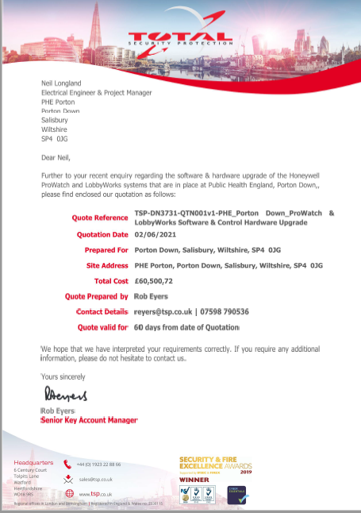

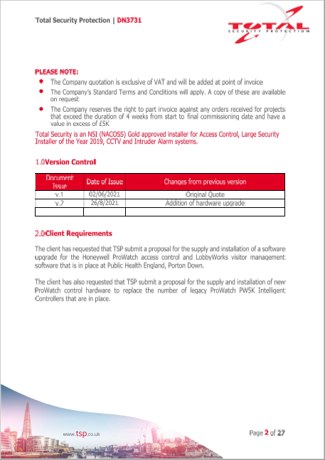

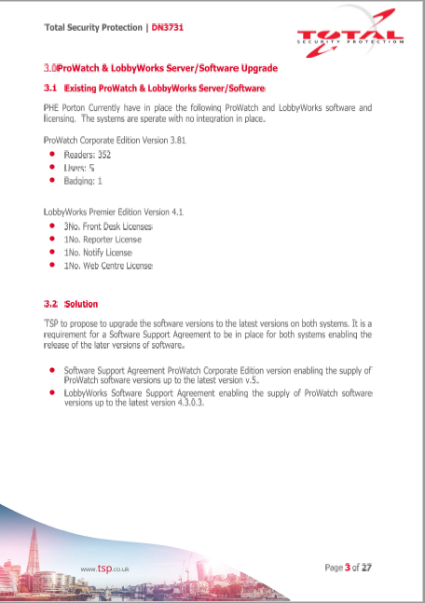

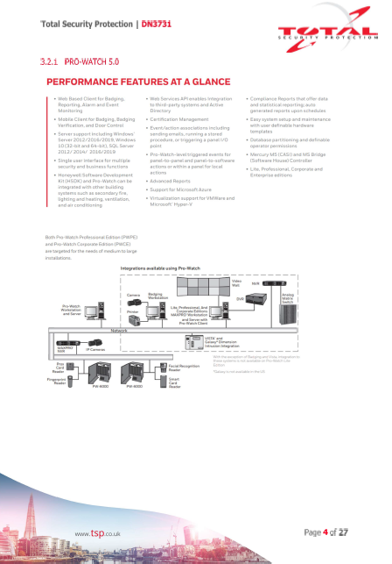

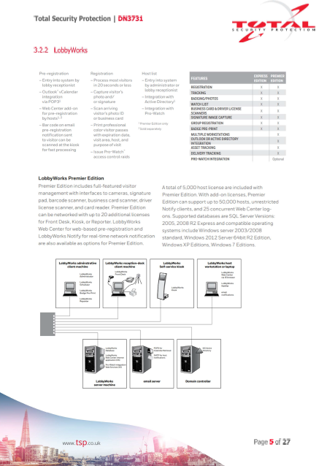

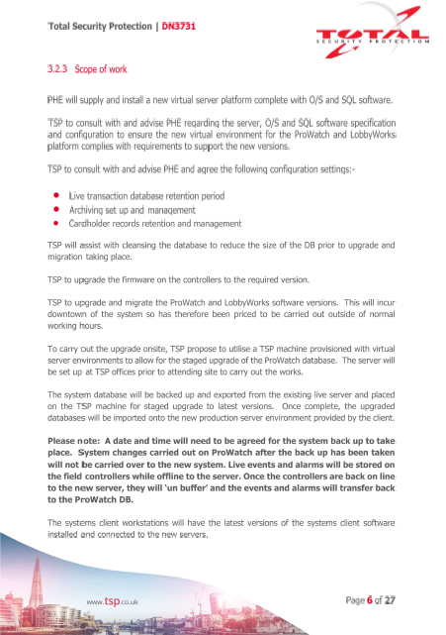

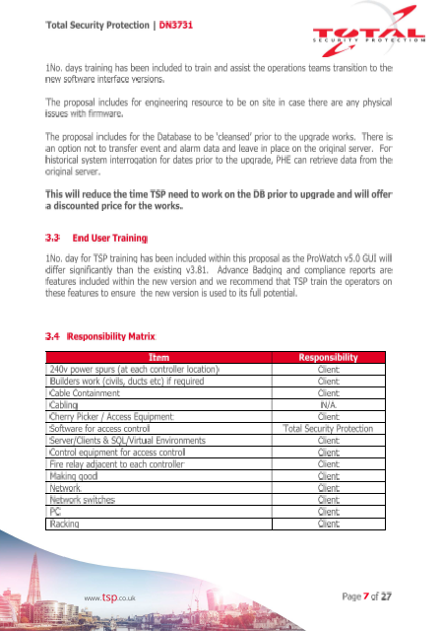



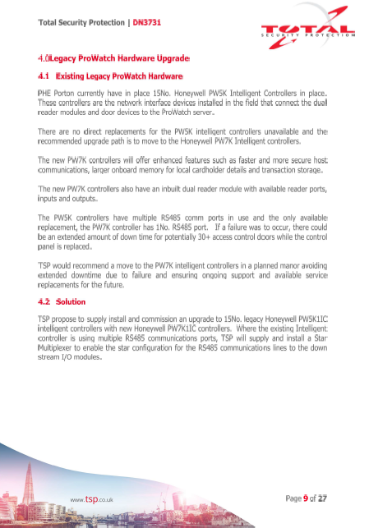



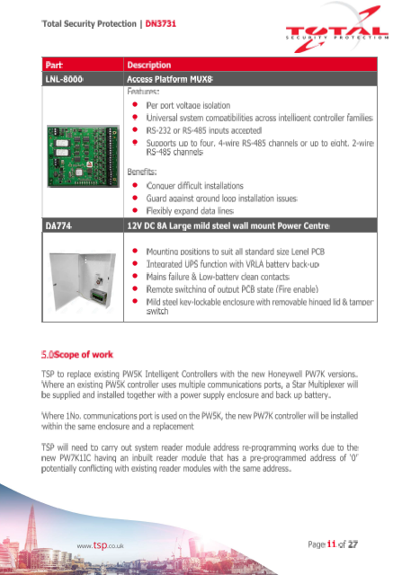

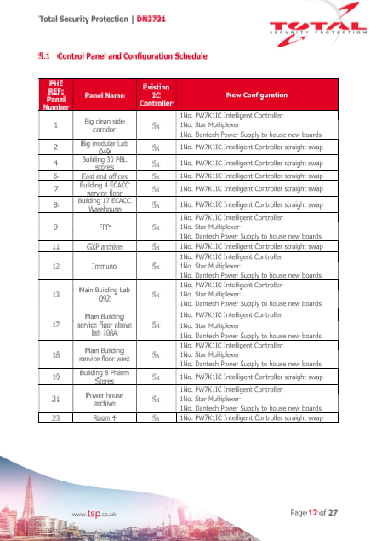

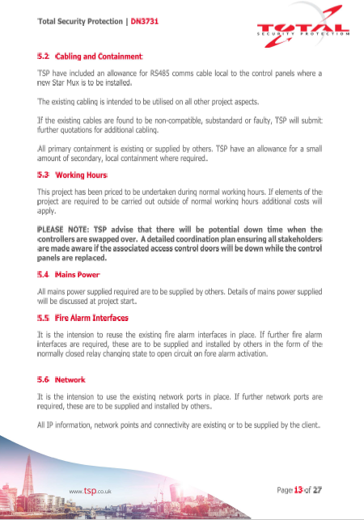

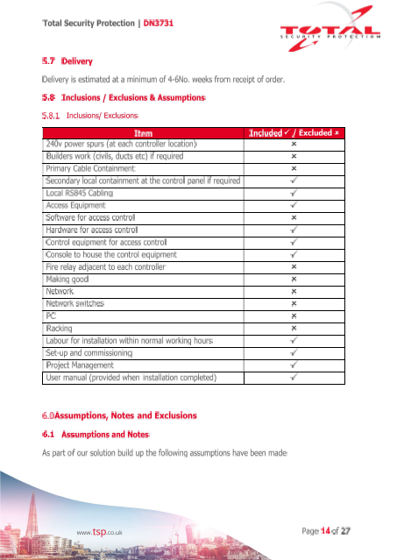

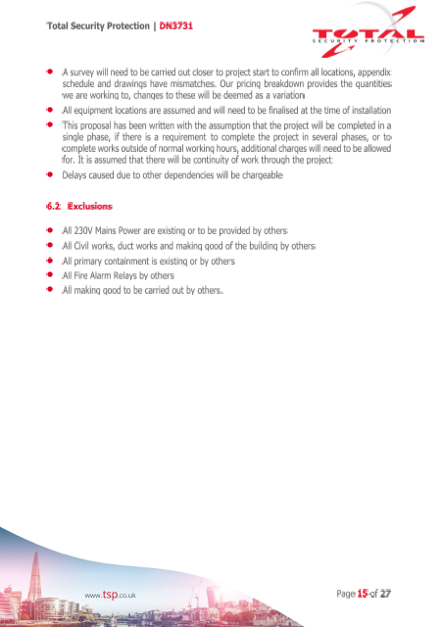



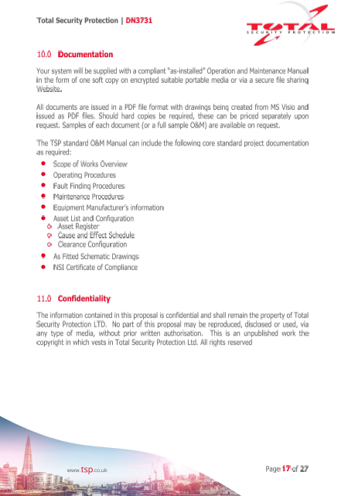

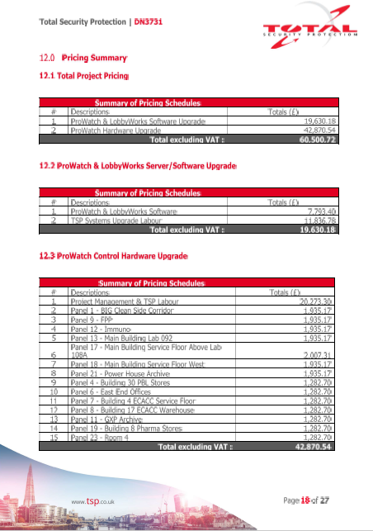

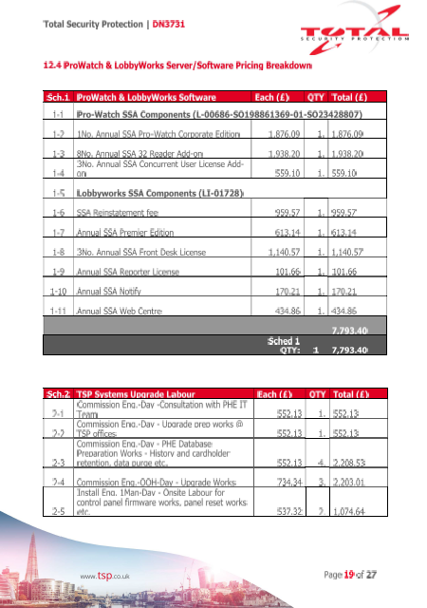

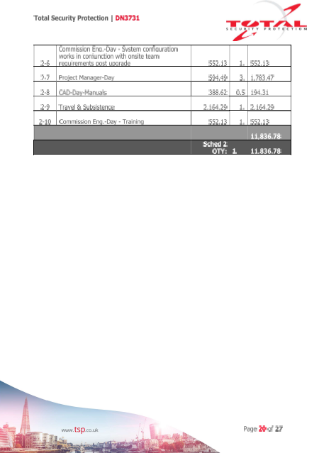

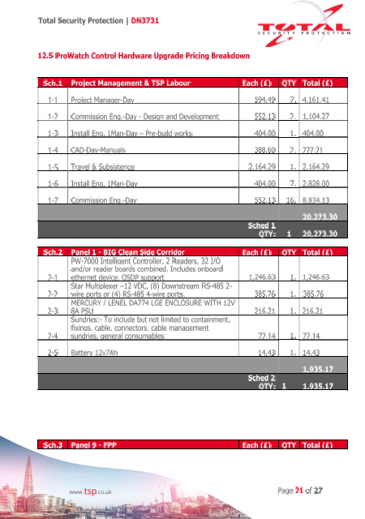

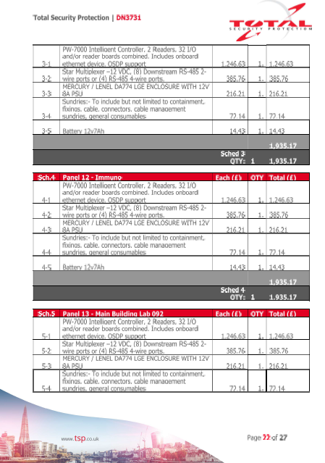

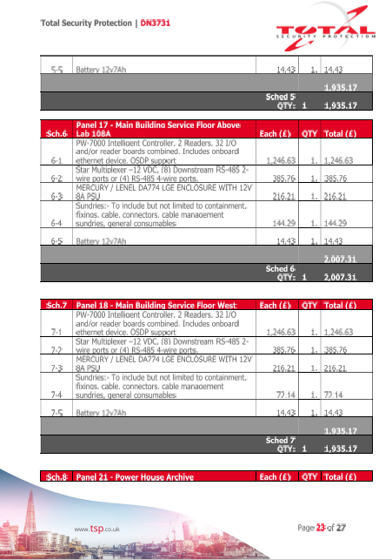

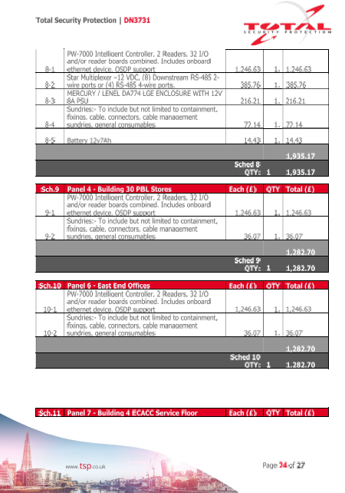

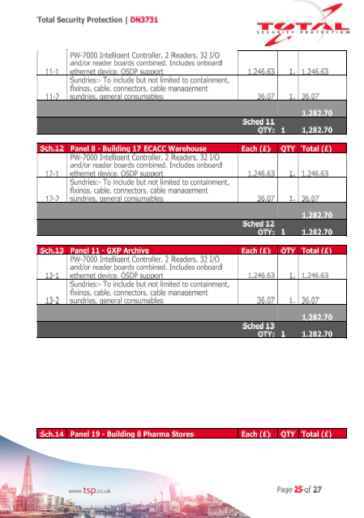

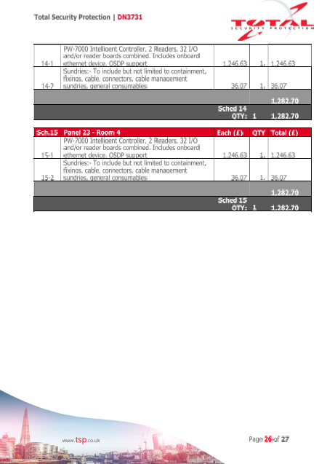

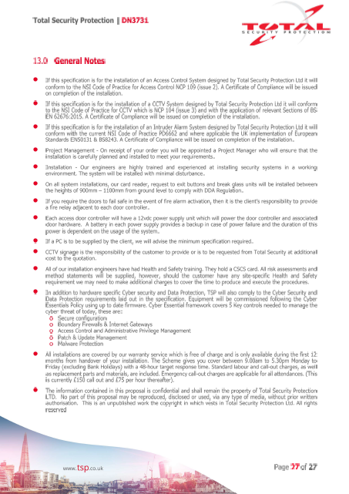

Appendix B – NEC3 ECSC Core Clauses

CONDITIONS OF CONTRACT

1 General

|  |  |  |
| --- | --- | --- |
| Actions | **10** 10.1 | The *Employer* and the *Contractor* shall act as stated in this contract and in a spirit of mutual trust and co-operation. |
| Identified and defined terms | **11** 11.1 | In the *conditions of contract*, terms identified in the Contract Data are in italics and defined terms have capital initials. |
|  | 11.2 | (1) Completion is when the *Contractor* has completed the *works* in accordance with the Works Information except for correcting notified Defects which do not prevent the *Employer* from using the *works* and others from doing their work.  (2) The Completion Date is the *completion date* unless later changed in accordance with this contract.  (3) A Defect is a part of the *works* which is not in accordance with the Works Information.  (4) The Defects Certificate is either a list of notified Defects which the *Contractor* has not corrected by the *defects date* or a statement that there are no such Defects.  (5) Defined Cost is the amount paid by the *Contractor* in Providing the Works (excluding any tax which the *Contractor* can recover) for   * people employed by the *Contractor*, * Plant and Materials, * work subcontracted by the *Contractor* and * Equipment   The amount for Equipment includes amounts paid for hired Equipment and an amount for the use of Equipment owned by the *Contractor* which is the amount the *Contractor* would have paid if the Equipment had been hired.  (6) Equipment is items provided by the *Contractor*, used by him to Provide the Works and not included in the *works*.  (7) The Parties are the *Employer* and the *Contractor*.  (8) Plant and Materials are items intended to be included in the *works.*  (9) The Price for Work Done to Date is the total of   * the Price for each lump sum item in the Price List which the *Contractor* has completed and * where a quantity is stated for an item in the Price List, an amount calculated by multiplying the quantity which the *Contractor* has completed by the rate.   (10) The Prices are the amounts stated in the Price column of the Price List. Where a quantity is stated for an item in the Price List, the Price is calculated by multiplying the quantity by the rate.  (11) To Provide the Works means to do the work necessary to complete the *works* in accordance with this contract and all incidental work, services and actions which this contract requires.  (12) Site Information is information which describes the *site* and its surroundings and is in the document called ‘Site Information’.  (13) Works Information is information which either   * specifies and describes the *works* or * states any constraints on how the *Contractor* Provides the Works   and is either   * in the document called ‘Works Information’ or * in an instruction given in accordance with this contract. |
| Law | **12** 12.1 | In this contract, except where the context shows otherwise, words in the singular also mean in the plural and the other way round and words in the masculine also mean in the feminine and neuter. |
|  | 12.2 | This contract is governed by the law of the country where the *site* is. |
|  | 12.3 | No change to this contract, unless provided for by the *conditions of contract*, has effect unless it has been agreed, confirmed in writing and signed by the Parties. |
|  | 12.4 | This contract is the entire agreement between the Parties. |
| Communications | **13** 13.1 | Each communication which this contract requires has effect when it is received in writing at the last address notified by the recipient for receiving communications. |
|  | 13.2 | If this contract requires the *Employer* or the *Contractor* to reply to a communication, unless otherwise stated in this contract, he replies within the *period for reply*. |
| The *Employer*’s authority and delegation | **14** 14.1 | The *Contractor* obeys an instruction which is in accordance with this contract and is given to him by the *Employer*. |
|  | 14.2 | The *Employer* may give an instruction to the *Contractor* which changes the Works Information. |
|  | 14.3 | The *Employer*’s acceptance of a communication from the *Contractor* or of his work does not change the *Contractor*’s responsibility to Provide the Works or his liability for his design. |
|  | 14.4 | The *Employer*, after notifying the *Contractor*, may delegate any of the *Employer*’s actions and may cancel any delegation. A reference to an action of the *Employer* in this contract includes an action by his delegate. |
| Access to the *site* and provision of services | **15** 15.1 | The *Employer* allows access to and use of the *site* to the *Contractor* as necessary for the work included in this contract. |
|  | 15.2 | The *Employer* provides services and other things as stated in the Works Information. |
| Early warning | **16** 16.1 | The *Contractor* and the *Employer* give an early warning by notifying the other as soon as either becomes aware of any matter which could   * increase the total of the Prices, * delay Completion or * impair the performance of the *works* in use.   The *Contractor* may give an early warning by notifying the *Employer* of any other matter which could increase his total cost. Early warning of a matter for which a compensation event has previously been notified is not required. |
|  | 16.2 | The *Contractor* and the *Employer* co-operate in making and considering proposals for how the effect of each matter which has been notified as an early warning can be avoided or reduced and deciding and recording actions to be taken. |

2 The *Contractor*’s main responsibilities

|  |  |  |
| --- | --- | --- |
| Providing the Works | **20** 20.1 | The *Contractor* Provides the Works in accordance with the Works Information. |
|  | 20.2 | The *Contractor* does not start work which the *Contractor* has designed until the *Employer* has accepted that the design complies with the Works Information. |
| Subcontracting and people | **21** 21.1 | If the *Contractor* subcontracts work, he is responsible for Providing the Works as if he had not subcontracted. |
|  | 21.2 | contract applies as if a subcontractor’s employees and equipment were the *Contractor*’s. |
|  | 21.3 | The *Employer* may, having stated reasons, instruct the *Contractor* to remove an employee. The *Contractor* then arranges that, after one day, the employee has no further connection with the work included in this contract. |
| Access for the *Employer* | **22** 22.1 | The *Contractor* provides access for the *Employer* and others notified by the *Employer* to work being done for this contract and to stored Plant and Materials |

3 Time

|  |  |  |
| --- | --- | --- |
| Starting and Completion | **30** 30.1 | The *Contractor* does not start work until the *starting date* and does the work so that Completion is on or before the Completion Date. |
|  | 30.2 | The *Contractor* submits a forecast of the date of Completion to the *Employer* each week from the *starting date* until Completion. |
|  | 30.3 | The *Employer* decides the date of Completion and certifies it to the *Contractor* within one week of the date. |
|  | 30.4 | The *Employer* may instruct the *Contractor* to stop or not to start any work and may later instruct him to re-start or start it. |
| The programme | **31** 31.1 | The *Contractor* submits programmes to the *Employer* as stated in the Works Information. |

4 Defects

|  |  |  |
| --- | --- | --- |
| Searching for and notifying Defects | **40** 40.1 | Until the *defects date,* the *Employer* may instruct the *Contractor* to search for a Defect. |
|  | 40.2 | The *Employer* may notify a Defect to the *Contractor* at any time before the *defects date*. |
| Correcting Defects | **41** 41.1 | The *Contractor* corrects a Defect whether or not the *Employer* notifies him of it. |
|  | 41.2 | Before Completion, the *Contractor* corrects a notified Defect before it would prevent the *Employer* or others from doing their work. |
|  | 41.3 | After Completion, the *Contractor* corrects a notified Defect before the end of the *defect correction period.* This period begins at the later of Completion and when the Defect is notified. |
|  | 41.4 | The *Employer* issues the Defects Certificate to the *Contractor* at the later of the *defects date* and the end of the last *defect correction period*. |
| Uncorrected Defects | **42** 42.1 | If the *Contractor* has not corrected a notified Defect within its *defect correction period*, the *Employer* assesses the cost of having the Defect corrected by other people and the *Contractor* pays this amount. |
| Repairs | **43** 43.1 | Until the Defects Certificate has been issued and unless otherwise instructed by the *Employer*, the *Contractor* promptly replaces loss of and repairs damage to the *works*, Plant and Materials. |

5 Payment

|  |  |  |
| --- | --- | --- |
| Assessing the amount due | **50** 50.1 | The *Contractor* assesses the amount due and, by each *assessment day,* applies to the *Employer* for payment. There is an *assessment day* in each month from the *starting date* until the month after the Defects Certificate has been issued. |
|  | 50.2 | The *Contractor*’s application for payment includes details of how the amount has been assessed. The first application for payment is for the amount due. Other applications are for the change in the amount due since the previous payment |
|  | 50.3 | The amount due is   * the Price for Work Done to Date * plus other amounts to be paid to the *Contractor* (including any tax which the law requires the *Employer* to pay to the *Contractor*) * less amounts to be paid by or retained from the *Contractor*. |
|  | 50.4 | The *Employer* corrects any wrongly assessed amount due and notifies the *Contractor* of the correction before paying the *Contractor*. |
|  | 50.5 | The *Contractor* pays *delay damages* for each day from the Completion Date until Completion. |
|  | 50.6 | An amount is retained from the *Contractor* in the assessment of each amount due until Completion. This amount is the *retention* applied to the Price for Work Done to Date. The amount retained is halved in the first assessment made after Completion and remains at this amount until the *assessment day* after the Defects Certificate is issued. No amount is retained in the assessment made after the Defects Certificate has been issued. |
|  | 50.7 | If the *Employer* requires a programme to be submitted, one quarter of the Price for Work Done to Date is retained in assessments of the amount due until the *Contractor* has submitted a first programme to the *Employer* showing the information which the Works Information requires. |
| Payment | **51** 51.1 | Each payment is made within three weeks after the next *assessment day* which follows receipt of an application for payment by the *Contractor*. |
|  | 51.2 | Interest is paid if a payment is late or includes a correction of an earlier payment. Interest is assessed from the date by which the correct payment should have been made until the date when it is paid. Interest is calculated at the rate stated in the Contract Data or, if none is stated, at 0.5% of the delayed amount per complete week of delay. |

6 Compensation events

|  |  |  |
| --- | --- | --- |
| Compensation events | **60** 60.1 | The following are compensation events.  (1) The *Employer* gives an instruction changing the Works Information unless the change is in order to make a Defect acceptable.  (2) The *Employer* does not allow access to and use of the *site* to the *Contractor* as necessary for the work included in this contract.  (3) The *Employer* does not provide something which he is to provide by the date for providing it stated in this contract.  (4) The *Employer* gives an instruction to stop or not to start any work.  (5) The *Employer* does not work within the conditions stated in the Works Information.  (6) The *Employer* does not reply to a communication from the *Contractor* within the period required by this contract.  (7) The *Employer* changes a decision which he has previously communicated to the *Contractor*.  (8) The *Employer* instructs the *Contractor* to search for a Defect and no Defect is found.  (9) The *Contractor* encounters physical conditions which   * are within the *site*, * are not weather conditions and * an experienced contractor would have judged, at the date of the *Contractor*’s Offer, to have such a small chance of occurring that it would have been unreasonable to have allowed for them.   Only the difference between the physical conditions encountered and those for which it would have been reasonable to have allowed is taken into account in assessing a compensation event.  (10) The *Contractor* is prevented by weather from carrying out all work on the *site* for periods of time, each at least one full working day, which are in total more than one seventh of the total number of days between the *starting date* and the Completion Date. In assessing this event, only the working days which exceed this limit and on which work is prevented by no other cause are taken into account.  (11) The *Employer* notifies a correction to an assumption which he has stated about a compensation event.  (12) An event which   * stops the *Contractor* completing the *works* or * stops the *Contractor* completing the *works* by the Completion Date   and which   * neither Party could prevent, * an experienced contractor would have judged at the date of the *Contractor*’s Offer to have such a small chance of occurring that it would have been unreasonable for him to have allowed for it and * is not one of the other compensation events stated in this contract.   (13) A difference between the final total quantity of work done and the quantity stated for an item in the Price List.  (14) A loss of or damage to the *works*, Plant and Materials which   * is not the fault or responsibility of the *Contractor* or * could not have been prevented by any reasonable action of the *Contractor*. |
|  | 60.2 | In judging the physical conditions for the purposes of assessing any compensation event, the *Contractor* is assumed to have taken into account   * the Site Information, * publicly available information referred to in the Site Information, * information obtainable from a visual inspection of the *site* and * other information which an experienced contractor could reasonably be expected to have or to obtain. |
| Notifying compensation events | **61** 61.1 | The *Contractor* notifies the *Employer* of an event which has happened or which he expects to happen as a compensation event if   * the *Contractor* believes that the event is a compensation event and * the *Employer* has not notified the event to the *Contractor*.   If the *Contractor* does not notify a compensation event within eight weeks of becoming aware of the event he is not entitled to a change in the Prices or Completion Date unless the event arises from an instruction of the *Employer*. |
|  | 61.2 | If the *Employer* decides that an event notified by the *Contractor*   * arises from a fault of the *Contractor*, * has not happened and is not expected to happen, * has no effect upon the Defined Cost or upon Completion or * is not one of the compensation events stated in this contract,   he notifies the *Contractor* of his decision that the Prices and the Completion Date are not to be changed.  If the *Employer* decides otherwise, he instructs the *Contractor* to submit a quotation for the event. The *Employer* notifies the decision to the *Contractor* or instructs the *Contractor* to submit a quotation within one week of the *Contractor*’s notification to the *Employer* of the event. |
|  | 61.3 | If the *Employer* decides that the *Contractor* did not give an early warning of the event which the *Contractor* could have given, the *Employer* notifies that decision to the *Contractor* when instructing the *Contractor* to submit a quotation. |
|  | 61.4 | If the *Employer* decides that the effects of a compensation event are too uncertain to be forecast reasonably, the *Employer* states assumptions about the event when instructing the *Contractor* to submit a quotation. Assessment of the event is based on these assumptions. If any of them is later found to have been wrong, the *Employer* notifies a correction. |
|  | 61.5 | A compensation event is not notified after the *defects date*. |
| Quotations for compensation events | **62** 62.1 | A quotation for a compensation event comprises proposed changes to the Prices or rates and any delay to the Completion Date assessed by the *Contractor*. The *Contractor* submits details of his assessment with each quotation. The *Contractor* submits a quotation within two weeks of being instructed to do so by the *Employer* or, if no such instruction is received, within two weeks of the notification of a compensation event. |
|  | 62.2 | The *Employer* may instruct the *Contractor* to submit a quotation for a proposed instruction or a proposed changed decision. The *Contractor* does not put a proposed instruction or a proposed changed decision into effect. |
|  | 62.3 | If the *Contractor* does not provide a quotation for a compensation event within the time allowed, the *Employer* assesses the compensation event and notifies the *Contractor* of his assessment. |
|  | 62.4 | The *Employer* replies within two weeks of the *Contractor*’s submission.  For a proposed instruction or proposed changed decision, the *Employer*’s reply is   * notification that the proposed instruction will not be given or the proposed changed decision will not be made, * notification of the instruction or changed decision as a compensation event and acceptance of the quotation or * notification of the instruction or changed decision as a compensation event and notification that the *Employer* does not agree with the quotation.   For other compensation events, the *Employer*’s reply is   * acceptance of the quotation or * notification that the *Employer* does not agree with the quotation. |
|  | 62.5 | If the *Employer* does not agree with the quotation, the *Contractor* may submit a revised quotation within two weeks of the *Employer*’s reply. If the *Employer* does not agree with the revised quotation or if none is received, the *Employer* assesses the compensation event and notifies the assessment. |
|  | 62.6 | After discussing with the *Contractor* different ways of dealing with the compensation event which are practicable, the *Employer* may instruct the *Contractor* to submit alternative quotations for a compensation event. |
| Assessing compensation events | **63** 63.1 | For a compensation event which only affects the quantities of work shown in the Price List, the change to the Prices is assessed by multiplying the changed quantities of work by the appropriate rates in the Price List. |
|  | 63.2 | For other compensation events, the changes to the Prices are assessed by forecasting the effect of a compensation event upon the Defined Cost or, if the compensation event has already occurred, the assessment is based upon the Defined Cost due to the event which the *Contractor* has incurred. Effects on Defined Cost are assessed separately for   * people employed by the *Contractor*, * Plant and Materials, * work subcontracted by the *Contractor* and * Equipment.   The *Contractor* shows how each of these effects is built up in each quotation for a compensation event. The percentages for overheads and profit stated in the *Contractor*’s Offer are applied to the assessed effect of the event on the Defined Cost. |
|  | 63.3 | The effects of compensation events upon the Defined Cost are assessed at open market or competitively tendered prices with deductions for all discounts, rebates and taxes which can be recovered. The following are deducted from the Defined Cost for the assessment of compensation events   * the cost of events for which this contract requires the *Contractor* to insure and * other costs paid to the *Contractor* by insurers. |
|  | 63.4 | A delay to the Completion Date is assessed as the length of time that, due to the compensation event, Completion is forecast to be delayed. |
|  | 63.5 | If the *Employer* has decided and notified the *Contractor* that the *Contractor* did not give an early warning of a compensation event which an experienced contractor could have given, the event is assessed as if the *Contractor* had given early warning |
|  | 63.6 | Assessment of the effect of a compensation event includes risk allowances for cost and time for matters which are at the *Contractor*’s risk under this contract. The cost of preparing quotations for compensation events is not included in the assessment of compensation events. |
|  | 63.7 | Assessments are based on the assumptions that the *Contractor* reacts competently and promptly to the compensation event and that any additional cost and time due to the event are reasonably incurred. |
|  | 63.8 | A compensation event which is an instruction to change the Works Information in order to resolve an ambiguity or inconsistency is assessed as if the Prices and the Completion Date were for the interpretation most favourable to the Party which did not provide the Works Information. |
|  | 63.9 | Assessments for changed Prices for compensation events are in the form of changes to the Price List. |
|  | 63.10 | The assessment of a compensation event is not revised if a forecast upon which it is based is shown by later recorded information to have been wrong. |

7 Title

|  |  |  |
| --- | --- | --- |
| Objects and materials within the *site* | **70** 70.1 | The *Contractor* has no title to an object of value or of historical or other interest within the *site*. The *Contractor* does not move such an object unless instructed to do so by the *Employer*. |
|  | 70.2 | The *Contractor* has title to materials from excavation and demolition only as stated in the Works Information. |

8 Indemnity, insurance and liability

|  |  |  |
| --- | --- | --- |
| Limitation of liability | **80** 80.1 | For any one event, the liability of the *Contractor* to the *Employer* for loss of or damage to the *Employer*’s property is limited to the amount stated in the Contract Data. The *Contractor* is not liable to the *Employer* for the *Employer*’s indirect or consequential loss except as provided for in the *conditions of contract*. Exclusion or limitation of liability applies in contract, tort or delict and otherwise and to the maximum extent permitted in law. |
| Indemnities | **81** 81.1 | The *Employer* indemnifies the *Contractor* against claims, proceedings, compensation and costs payable which are the unavoidable result of the *works* or of Providing the Works or which arise from   * fault, * negligence, * breach of statutory duty, * infringement of an intellectual property or * interference with a legal right   by the *Employer* or by a person employed by or contracted to the *Employer* except the *Contractor*. |
|  | 81.2 | The *Contractor* indemnifies the *Employer* against other   * losses and claims in respect of * death of or injury to a person and * loss of and damage to property (other than the *works*, Plant and Materials) and * claims, proceedings, compensation and costs payable arising from or in connection with the *Contractor*’s Providing the Works. |
|  | 81.3 | The liability of one Party to indemnify the other is reduced to the extent that events which are the other Party’s responsibility contributed to the losses, claims, proceedings, compensation and costs. |
| Insurance cover | **82** 82.1 | The *Contractor* provides, in the joint names of the Parties and from the *starting date*, the insurances stated in the Insurance Table. The *Contractor* does not provide an insurance which the *Employer* is to provide as stated in the Contract Data.  INSURANCE TABLE   |  |  |  | | --- | --- | --- | | **Insurance against** | **Minimum amount of cover or minimum limit of indemnity** | **Cover provided until** | | Loss of or damage to the *works* | The replacement cost | The *Employer*’s certificate of Completion has been issued | | Loss of or damage to Equipment, Plant and Materials | The replacement cost | The Defects Certificate has been issued | | The *Contractor*’s liability for loss of or damage to property (except the *works*, Plant and Materials and Equipment) and for bodily injury to or death of a person (not an employee of the *Contractor*) arising from or in connection with the *Contractor*’s Providing the Works | The amount stated in the Contract Data for any one event with cross liability so that the insurance applies to the Parties separately | | Liability for death of or bodily injury to employees of the *Contractor* arising out of and in the course of their employment in connection with this contract | The greater of the amount required by the applicable law and the amount stated in the Contract Data for any one event | |

9 Termination and dispute resolution

|  |  |  |
| --- | --- | --- |
| Termination and reasons for termination | **90** 90.1 | If either Party wishes to terminate the *Contractor*’s obligation to Provide the Works, he notifies the other Party giving details of his reason for terminating. The *Employer* issues a termination certificate promptly if the reason complies with this contract. After a termination certificate has been issued, the *Contractor* does no further work necessary to Provide the Works. |
|  | 90.2 | Either Party may terminate if the other Party has become insolvent or its equivalent (Reason 1). |
|  | 90.3 | The *Employer* may terminate if the *Employer* has notified the *Contractor* that the *Contractor* has defaulted in one of the following ways and the *Contractor* has not stopped defaulting within two weeks of the notification.   * Substantially failed to comply with this contract (Reason 2). * Substantially hindered the *Employer* (Reason 3). * Substantially broken a health or safety regulation (Reason4).   The *Employer* may terminate for any other reason (Reason 5). |
|  | 90.4 | The *Contractor* may terminate if   * the *Employer* has not paid an amount due under the contract within ten weeks of the *assessment day* which followed receipt of the *Contractor*’s application for it (Reason 6) or * the *Employer* has instructed the *Contractor* to stop or not to start any substantial work or all work for a reason which is not the *Contractor*’s fault and an instruction allowing the work to re-start or start has not been given within eight weeks (Reason 7). |
|  | 90.5 | The *Employer* may terminate if an event which the Parties could not reasonably prevent has substantially affected the *Contractor*’s work for a continuous period of more than thirteen weeks (Reason 8). |
| Procedures on termination | **91** 91.1 | On termination, the *Employer* may complete the *works* himself or employ other people to do so. The *Contractor* leaves the *site* and removes the Equipment. |
| Payment on termination | **92** 92.1 | The amount due on termination includes   * an amount due assessed as for normal payments, * the cost of Plant and Materials provided by the *Contractor* which are on the *site* or of which the *Contractor* has to accept delivery and * any amounts retained by the *Employer*. |
|  | 92.2 | If the *Employer* terminates for Reason 1, 2, 3 or 4, the amount due on termination also includes a deduction of the forecast additional cost to the *Employer* of completing the *works*. |
|  | 92.3 | If the *Contractor* terminates for Reason 1, 6 or 7 or if the *Employer* terminates for Reason 5, the amount due on termination also includes 5% of any excess of a forecast of the amount due at Completion had there been no termination over the amount due on termination assessed as for normal payments. |
| Dispute resolution | 93 93.1 | A dispute arising under or in connection with this contract is referred to and decided by the *Adjudicator*. |
| The *Adjudicator* | 93.2 | (1) The Parties appoint the *Adjudicator* under the NEC Adjudicator’s Contract current at the *starting date*. The *Adjudicator* acts impartially and decides the dispute as an independent adjudicator and not as an arbitrator.  (2) If the *Adjudicator* is not identified in the Contract Data or if the *Adjudicator* resigns or is unable to act, the Parties choose a new adjudicator jointly. If the Parties have not chosen an adjudicator, either Party may ask the *Adjudicator nominating body* to choose one. The *Adjudicator nominating body* chooses an adjudicator within four days of the request. The chosen adjudicator becomes the *Adjudicator*.  (3) The *Adjudicator*, his employees and agents are not liable to the Parties for any action or failure to take action in an adjudication unless the action or failure to take action was in bad faith. |
| The adjudication | 93.3 | (1) A Party may refer a dispute to the *Adjudicator* if   * the Party notified the other Party of the dispute within four weeks of becoming aware of it and * between two and four further weeks have passed since the notification.   If a disputed matter is not notified and referred within the times set out in this contract, neither Party may subsequently refer it to the *Adjudicator* or the *tribunal*.  (2) The Party referring the dispute to the *Adjudicator* includes with his referral information to be considered by the *Adjudicator*. Any more information is provided within two weeks of the referral. This period may be extended if the *Adjudicator* and the Parties agree.  (3) The *Adjudicator* may take the initiative in ascertaining the facts and the law related to the dispute. He may instruct a Party to take any other action which he considers necessary to reach his decision and to do so within a stated time.  (4) A communication between a Party and the *Adjudicator* is communicated to the other Party at the same time.  (5) If the *Adjudicator’*s decision includes assessment of additional cost or delay caused to the *Contractor,* he makes his assessment in the same way as a compensation event is assessed.  (6) The *Adjudicator* decides the dispute and notifies the Parties of his decision and his reasons within four weeks of the referral. This period may be extended by up to two weeks with the consent of the referring Party, or by any period agreed by the Parties.  If the *Adjudicator* does not notify his decision within the time allowed, either Party may act as if the *Adjudicator* has resigned.  (7) Unless and until the *Adjudicator* has notified the Parties of his decision, the Parties proceed as if the matter disputed was not disputed.  (8) The *Adjudicator*’s decision is binding on the Parties unless and until revised by the *tribunal* and is enforceable as a matter of contractual obligation between the Parties and not as an arbitral award. The *Adjudicator*’s decision is final and binding if neither Party has notified the other within the times required by this contract that he intends to refer the matter to the *tribunal*. |
| Review by the *tribunal* | 93.4 | A Party may refer a dispute to the *tribunal* if   * the Party is dissatisfied with the *Adjudicator*’s decision or * the *Adjudicator* did not notify a decision within the time allowed and a new adjudicator has not been chosen,   except that neither Party may refer a dispute to the *tribunal* unless they have notified the other Party of their intention to do so not more than four weeks after the end of the time allowed for the *Adjudicator*’s decision. |

If the United Kingdom Housing Grants, Construction and Regeneration Act 1996 as amended by the Local Democracy, Economic Development and Construction Act 2009 (the Act) applies to this contract, the following additional conditions apply.

|  |  |  |
| --- | --- | --- |
| Definitions | 1.1 | (1) The payment due date for an application for payment by the *Contractor* is the *assessment* day which follows receipt of that application.  (2) The final date for payment is three weeks after the payment due date. |
| Assessing the amount due | 1.2 | The *Contractor*’s application for payment is the notice of payment specifying the sum that the *Contractor* considers to be due at the payment due date (the notified sum). The *Contractor*’s application states the basis on which the amount is calculated and includes details of the calculation. |
|  | 1.3 | The following replaces clause 50.4  If the *Employer* intends to pay less than the notified sum, he notifies the *Contractor* of the amount which the *Employer* considers to be due not later than seven days (the prescribed period) before the final date for payment. The *Employer*’s notification states the basis on which the amount is calculated and includes details of the calculation. A Party pays the notified sum unless he has notified his intention to pay less than the notified sum. |
| Compensation event | 1.4 | If the *Contractor* exercises his right under the Act to suspend performance, it is a compensation event. |
| The adjudication | 1.5 | The following replaces clause 93.3(1)  A Party may issue to the other Party a notice of his intention to refer a dispute to adjudication at any time. He refers the dispute to the *Adjudicator* within one week of the notice. |
|  | 1.6 | The *Adjudicator* may in his decision allocate his fees and expenses between the Parties. |
|  | 1.7 | The *Adjudicator* may, within five days of giving his decision to the Parties, correct the decision to remove a clerical or typographical error arising by accident or omission. |
|  | 1.8 | If the *Adjudicator*’s decision changes an amount notified as due, payment of the sum decided by the *Adjudicator* is due not later than seven days from the date of the decision or the final date for payment of the notified amount, whichever is the later. |