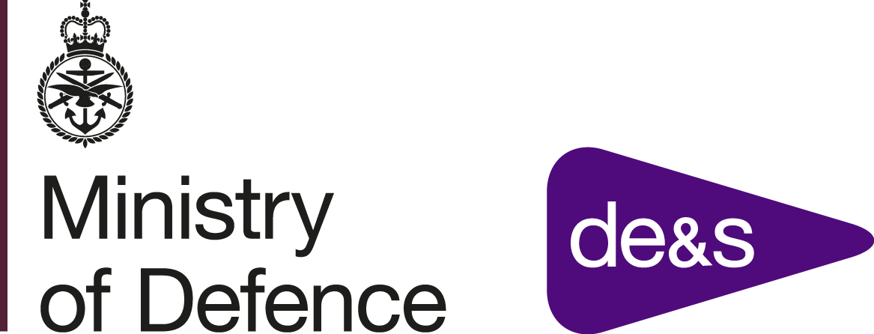 | Contractor’s Logo
Workboats DRACAS Monthly Report – Month Year | Author:
The Data Reporting, Analysis and Corrective Action System (DRACAS) Report is a techical support requirement of the Workboats In-Service Support Contract. This report will be used to inform the Authority on all incidents (equipment failures, faults, accidents) raised to them, and outline the corrective actions suggested by the Contractor. The Contractor shall identify if the incident had or could have had an impact on the safety of the vessel. The Contractor shall identify if a change is required to the design as a result of this incident and how this impacts on DORCS (Documentation, Obsolescence, Reliability, Configuration, Security).
The Contractor shall update this report thorughout the contract and provide an updated version to the Authority on the first working day of the month.
Example prompts in italics, please delete on first issue. Please use format provided by Authority with minimal changes. Add detailed tables as required in same format.
DRACAS Number | Incident Title | Safety | OPDEF Category | Status
YY-01 |  | Y/N |  | Open/Closed
YY-02.. |  | Y/N

DRACAS Number |  |  | Incident Title
Vessel |  |  | Status
Incident Description |  |  |  |  |  | Safety | Y/N
Corrective Action |  |  |  |  |  | OPDEF Category
Design Change Required | Y/N | DORCS Update Details

DRACAS Number |  |  | Incident Title
Vessel |  |  | Status
Incident Description |  |  |  |  |  | Safety | Y/N
Corrective Action |  |  |  |  |  | OPDEF Category
Design Change Required | Y/N | DORCS Update Details

DRACAS Number |  |  | Incident Title
Vessel |  |  | Status
Incident Description |  |  |  |  |  | Safety | Y/N
Corrective Action |  |  |  |  |  | OPDEF Category
Design Change Required | Y/N | DORCS Update Details

DRACAS Number |  |  | Incident Title
Vessel |  |  | Status
Incident Description |  |  |  |  |  | Safety | Y/N
Corrective Action |  |  |  |  |  | OPDEF Category
Design Change Required | Y/N | DORCS Update Details

