

Request for Quotation

Noise Disturbance – Baseline Level Monitoring in the Solent

17 July 2023

Contents

Request for Quotation 1

Section 1: General Information 2

Glossary 2

Conditions applying to the RFQ 2

Acceptance of Quotations 3

Costs 3

Self-Declaration and Mandatory Requirements 3

Clarifications 3

Amendments 4

Conditions of Contract 4

Prices 4

Disclosure 4

Disclaimers 5

Protection of Personal Data 5

General Data Protection Regulations 2018 6

Equality, Diversity & Inclusion (EDI) 6

Sustainable Procurement 7

Conflicts of Interest 7

Section 2: The Invitation 8

Specification 8

Sustainability 22

Payment 23

Award Stage 23

# Request for Quotation

### Noise Disturbance – Baseline Level Monitoring in the Solent

You are invited to submit a quotation for the requirement described in the specification, Section 2.

Please confirm by email, receipt of these documents and whether you intend to submit a quote or not.

Your response should be returned to the following email address by:

Email: [Caitlin.Napleton@naturalengland.org.uk](mailto:Caitlin.Napleton@naturalengland.org.uk)

Date: 14 August 2023

Time: 12 noon

Ensure you include the name of the quotation and ‘Final Submission’ in the subject field to make it clear that it is your response.

Contact Details and Timetable

Caitlin Napleton will be your contact for any questions linked to the content of the quote or the process. Please submit any clarification questions via email and note that, unless commercially sensitive, both the question and the response will be circulated to all tenderers.

|  |  |
| --- | --- |
| Action | Date |
| Date of issue of RFQ | 17 July 2023 |
| Deadline for clarification questions | 12 noon on 07 August 2023 |
| Deadline for receipt of Quotation | 12 noon on 14 August 2023 |
| Evaluation of bids | Week commencing 14 August 2023 |
| Intended date of Contract Award | 18 August 2023 |
| Intended Contract Start Date | 21 August 2023 |
| Intended Delivery Date / Contract Duration | 21 August 2023 – 22 March 2024 |

Section 1: General Information

## Glossary

Unless the context otherwise requires the following words and expressions used within this Request for Quotation shall have the following meanings (to be interpreted in the singular or plural as the context requires).

|  |  |
| --- | --- |
| Words/Expression | Meaning |
| “Authority” | Means Natural England who is the Contracting Authority |
| “Contract” | Means the contract to be entered into by the Authority and the successful supplier |
| “Response” | Means the information submitted by a supplier in response to the RFQ |
| “RFQ” | Means this Request for Quotation and all related documents published by the Authority and made available to suppliers |

## Conditions applying to the RFQ

You should examine your Response to the RFQ and related documents ensuring it is complete and in accordance with the stated instructions prior to submission.

Your Response must contain sufficient information to enable the Authority to evaluate it fairly and effectively. You should ensure that you have prepared your Response fully and accurately and that prices quoted are arithmetically correct for the units stated.

By submitting a Response, you, the supplier, are deemed to accept the terms and conditions provided in the RFQ. Confirmation of this is required in Annex 2.

Failure to comply with the instructions set out in the RFQ may result in the supplier’s exclusion from this quotation process.

## Acceptance of Quotations

By issuing this RFQ the Authority does not bind itself to accept any quotation and reserves the right not to award a contract to any supplier who submits a quotation.

## Costs

The Authority will not reimburse you for any costs and expenses which you incur preparing and submitting your quotation, even if the Authority amends or terminates the procurement process.

## Self-Declaration and Mandatory Requirements

The RFQ includes a self-declaration response (Annex 1) which covers basic information about the supplier, as well as any grounds for exclusion. If you do not comply with them, your quotation will not be evaluated.

Any mandatory requirements will be set out in Section 2, Specification of Requirements and, if you do not comply with them, your quotation will not be evaluated.

## Clarifications

Any request for clarification regarding the RFQ and supporting documentation must be submitted via email no later than the deadline for clarifications set out in the Timetable. The Authority shall be under no obligation to respond to queries raised after the clarification deadline.

The Authority will respond to all reasonable clarifications as soon as possible but cannot guarantee a minimum response time. The Authority will publish all clarifications and its responses to all suppliers via email unless deemed commercially sensitive.

If a supplier believes that a request for clarification is commercially sensitive, it should clearly state this when submitting the clarification request. However, if the Authority considers either that:

* the clarification and response are not commercially sensitive; and
* all suppliers may benefit from its disclosure,

then the Authority will notify the supplier (via email), and the supplier will have an opportunity to withdraw the request for clarification by sending a further message requesting the withdrawal of the clarification request. If not withdrawn by the supplier within 2 working days of the Authority’s notification, the Authority may publish the clarification request and its response to all suppliers and the Authority shall not be liable to the supplier for any consequences of such publication.

The Authority reserves the right to seek clarification of any aspect of a quotation and/or provide additional information during the evaluation phase to carry out a fair evaluation. Where the Authority seeks clarification on any aspect of the quotation, the supplier must respond within the timeframe requested by the Authority.

## Amendments

The Authority may amend the RFQ at any time prior to the deadline for receipt. If it amends the RFQ the Authority will notify you via email.

Suppliers may modify their quotation prior to the deadline for Responses. No Responses may be modified after the deadline for Responses.

Suppliers may withdraw their quotations at any time by submitting a notice via the email to the named contact.

## Conditions of Contract

The Authority’s standard [Condensed Terms and Conditions](https://www.gov.uk/government/organisations/natural-england/about/procurement) provided as part of the RFQ will be included in any contract awarded as a result of this quotation process. The Authority will not accept any changes to these terms and conditions proposed by a supplier.

Suppliers should note that the quotation provided by the successful bidder will form part of the Contract.

## Prices

Prices must be submitted in £ sterling, inclusive of VAT.

## Disclosure

All Central Government Departments, their Executive Agencies and Non Departmental Public Bodies are subject to control and reporting within Government. In particular, they report to the Cabinet Office and HM Treasury for all expenditure. Further the Cabinet Office has a cross-Government role delivering overall Government policy on public procurement, including ensuring value for money and related aspects of good procurement practice. For these purposes, the Authority may disclose within Government any details contained in your quotation. The information will not be disclosed outside Government during the procurement.

In addition, the Authority is subject to the Freedom of Information Act 2000 and the Environmental Information Regulations 2004, which provide a public right of access to information held by public bodies. In accordance with these two statutes, the Authority may be required to disclose information contained in your quotation to any person who submits a request for information pursuant to those statutes.

Further to the Government’s transparency agenda, all UK Government organisations must advertise on Contract Finder in accordance with the following publication thresholds:

* Central Contracting Authority’s: £12,000
* Sub Central Contracting Authority’s and NHS Trusts: £30,000

For the purpose of this RFQ the Authority is classified as a Central Contracting Authority with a publication threshold of £12,000 inclusive of VAT.

If this opportunity is advertised via Contracts Finder, we are obliged to publish details of the awarded contract including who has won the contract, the contract value, and indicate whether the winning supplier is a small and medium-sized enterprise (“SMEs”) or voluntary organisation or charity. A copy of the contract must also be published with confidential information redacted.

By submitting a Response, you consent to these terms as part of the procurement.

## Disclaimers

Whilst the information in this RFQ and any supporting information referred to herein or provided to you by the Authority have been prepared in good faith the Authority does not warrant that this information is comprehensive or that it has been independently verified.

The Authority does not:

* make any representation or warranty (express or implied) as to the accuracy, reasonableness or completeness of the RFQ;
* accept any liability for the information contained in the RFQ or for the fairness, accuracy or completeness of that information; or
* accept any liability for any loss or damage (other than in respect of fraudulent misrepresentation or any other liability which cannot lawfully be excluded) arising as a result of reliance on such information or any subsequent communication.

Any supplier considering entering into contractual relationships with the Authority following receipt of the RFQ should make its own investigations and independent assessment of the Authority and its requirements for the goods and/or services and should seek its own professional financial and legal advice.

## Protection of Personal Data

In order to comply with the General Data Protection Regulations 2018 the supplier must agree to the following:

* You must only process any personal data in strict accordance with instructions from the Authority.
* You must ensure that all the personal data that we disclose to you or you collect on our behalf under this agreement are kept confidential.
* You must take reasonable steps to ensure the reliability of employees who have access to personal data.
* Only employees who may be required to assist in meeting the obligations under this agreement may have access to the personal data.
* Any disclosure of personal data must be made in confidence and extend only so far as that which is specifically necessary for the purposes of this agreement.
* You must ensure that there are appropriate security measures in place to safeguard against any unauthorised access or unlawful processing or accidental loss, destruction or damage or disclosure of the personal data.
* On termination of this agreement, for whatever reason, the personal data must be returned to us promptly and safely, together with all copies in your possession or control.

## General Data Protection Regulations 2018

For the purposes of the Regulations the Authority is the data processor.

The personal information that we have asked you provide on individuals (data subjects) that will be working for you on this contract will be used in compiling the tender list and in assessing your offer. If you are unsuccessful the information will be held and destroyed within two years of the award of contracts. If you are awarded a contract it will be retained for the duration of the contract and destroyed within seven years of the contract’s expiry.

We may monitor the performance of the individuals during the execution of the contract, and the results of our monitoring, together with the information that you have provided, will be used in determining what work is allocated under the contract, and in any renewal of the contract or in the award of future contracts of a similar nature. The information will not be disclosed to anyone outside the Authority without the consent of the data subject, unless the Authority is required by law to make such disclosures.

## Equality, Diversity & Inclusion (EDI)

The Client is striving to create a diverse and inclusive working environment where every individual has equality of opportunity to progress and to apply their unique insights to making the UK a great place for living. The Service Provider is expected to respect this commitment in all dealings with Natural England staff and service users.

Suppliers are expected to;

* support Defra group to achieve its Public Sector Equality Duty as defined by the Equality Act 2010, and to support delivery of [Defra group’s Equality & Diversity Strategy](https://www.gov.uk/government/publications/defra-group-equality-diversity-and-inclusion-strategy-2020-to-2024/defra-group-equality-diversity-and-inclusion-strategy-2020-to-2024).
* meet the standards set out in the [Government’s Supplier Code of Conduct](https://www.gov.uk/government/publications/supplier-code-of-conduct)
* work with Defra group to ensure equality, diversity and inclusion impacts are addressed (positive and negative) in the goods, services and works we procure, barriers are removed and opportunities realised.

## Sustainable Procurement

Addressing global sustainability impacts and realising additional community benefits within commercial activity is core to Defra group’s approach, working with its supply chain is key to achieving sustainable outcomes. In addition to supporting Defra group to meet its outcomes we look to understand and reduce negative sustainability impacts associated with our commercial activity and realise benefits.

The Client encourages its suppliers to share these values, work to address negative impacts and realise opportunities, measure performance and success.

Suppliers are expected to have an understanding of the Sustainable Development Goals, the interconnections between them and the relevance to the Goods, Services and works procured on the Client’s behalf

## Conflicts of Interest

The concept of a conflict of interest includes but is not limited to any situation where an Involved Person or Relevant Body has directly or indirectly, a financial, economic or other personal interest which might be perceived to compromise their impartiality and independence in the context of the procurement procedure and/or affect the integrity of the contract award.

We expect suppliers to mitigate appropriately against any real or perceived conflict of interest through their work with government. A supplier with a position of influence gained through a contract should not use that position to unfairly disadvantage any other supplier or reduce the potential for future competition

Where the supplier is aware of any circumstances giving rise to a conflict of interest or has any indication that a conflict of interest exists or may arise you should inform the Authority of this as soon as possible (whether before or after they have submitted a quotation). Tenderers should remain alert to the possibility of conflicts of interest arising at all stages of the procurement and should update the Authority if any new circumstances or information arises, or there are any changes to information already provided to the Authority. Failure to do so, and/or to properly manage any conflicts of interest may result in a quotation being rejected.

Provided that it has been carried out in an open, fair and transparent manner, routine pre-market engagement carried out by the Authority should not represent a conflict of interest for the supplier.

Section 2: The Invitation

## Specification

1. **Background**
   1. **Background to Natural England**

Natural England (NE) is the government’s advisor on the natural environment. We provide practical advice, grounded in science, on how best to safeguard England’s natural wealth for the benefit of everyone.

NEs remit is to ensure sustainable stewardship of the land and sea so that people and nature can thrive. It is NEs responsibility to see that England’s rich natural environment can adapt and survive intact for future generations to enjoy.

Further information on the Authority can be found at: [Natural England](http://www.naturalengland.org.uk/)

* 1. **Background to the specific work area relevant to this purchase**

The Solent coastline hosts thriving harbours, ports and other coastal industry, meaning there is a high volume of activity interacting with the marine environment. The majority of this activity creates a level of noise that can lead to the disturbance and displacement of Special Protection Area (SPA) bird features.

In particular, most birds are sensitive to above water noise. This pressure relates to any loud noise made onshore or offshore by construction, vehicles, vessels, tourism, mining, blasting etc. that may disturb birds and reduce time spent in feeding or breeding areas. Above water noise is benchmarked as the introduction of airborne noise above background levels, however we currently have a lack of data on what background noise levels are. Therefore, assessing the risk of an activity disturbing birds through the introduction of above water noise has proven difficult.

This bid is for the monitoring of noise levels in key areas across SPA sites in the Solent with the objective of providing data on background noise levels in order to more accurately determine the likely significant effect on birds when responding to casework.

* 1. **Background to the sites**

The SPAs in the Solent area with marine components are the Solent and Southampton Water SPA, Portsmouth Harbour SPA, Chichester and Langstone Harbour SPA and Solent and Dorset Coast SPA, hereby referred to as the Solent SPAs. The majority of the Solent intertidal area is designated within these SPAs. Table 1 summaries the bird features of these SPAs.

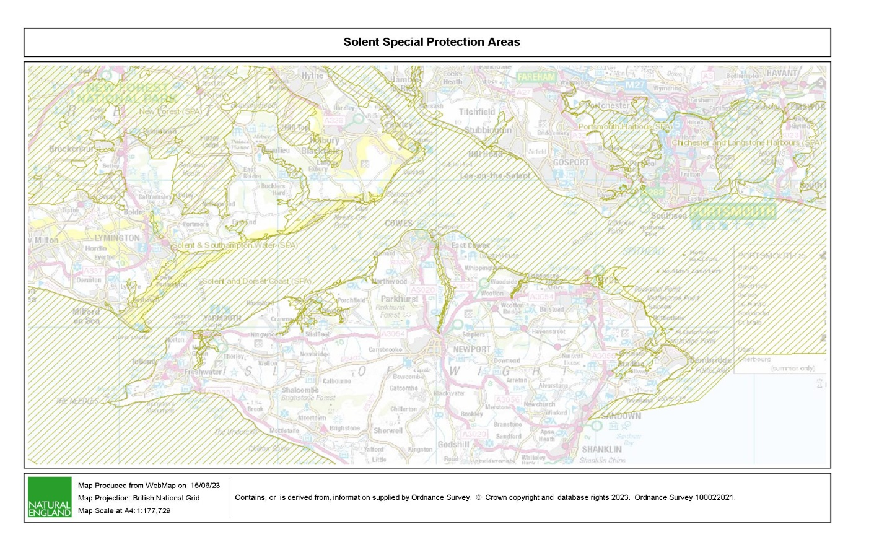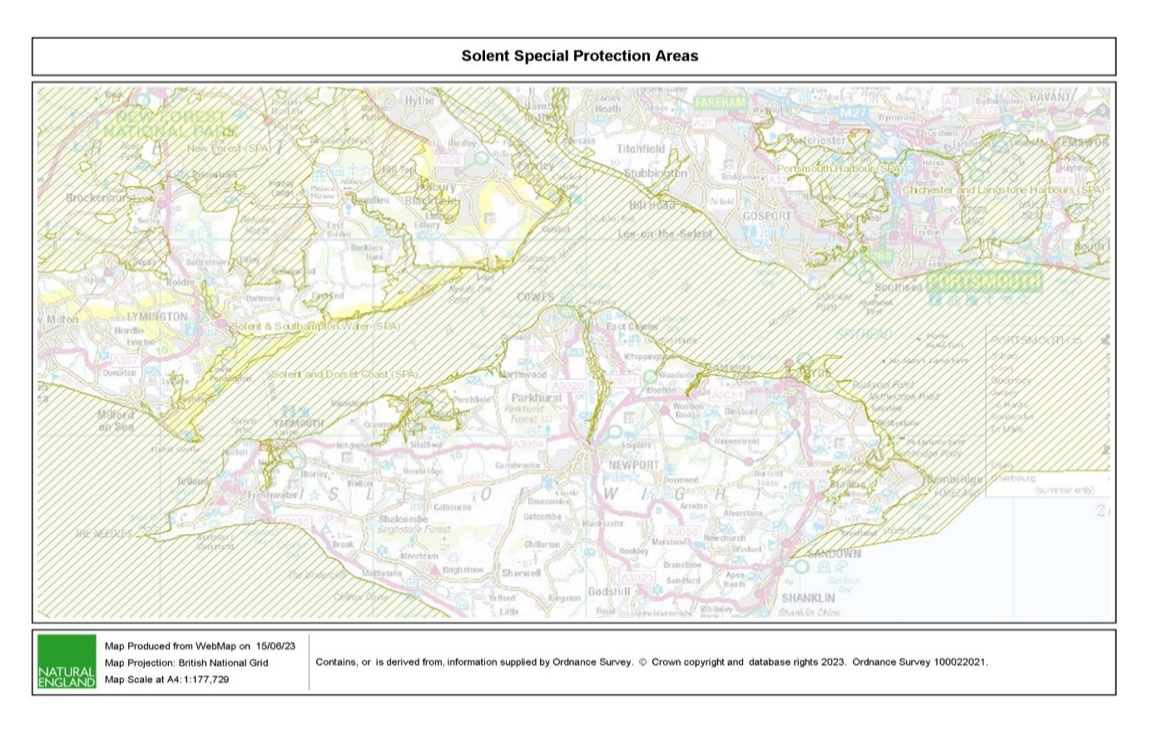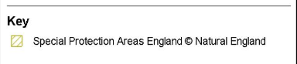

*Figure 1. Map of Special Protection Area*

*Table 1. Lists of the qualifying features of the Solent SPAs separated by non-breeding and breeding bird species*

|  |  |  |  |
| --- | --- | --- | --- |
| **Solent and Southampton Water** | **Portsmouth Harbour** | **Chichester and Langstone Harbours** | **Solent and Dorset Coast** |
| **Non-breeding** | **Non-breeding** | **Non-breeding** | **Non-breeding** |
| Black-tailed godwit Dark-bellied brent goose Ringed Plover Teal Waterbird assemblage | Black-tailed godwit Dark-bellied brent goose Dunlin Red-breasted merganser | Bar-tailed godwit Curlew Dark-bellied brent goose Dunlin Grey plover Pintail Red-breasted merganser Redshank Ringed plover Sanderling Shelduck Shoveler Teal Turnstone Waterbird assemblage Wigeon |  |
| **Breeding** | **Breeding** | **Breeding** | **Breeding** |
| Common tern Little tern Mediterranean gull Roseate tern Sandwich tern |  | Common tern Little tern Sandwich tern | Common tern Little tern Sandwich tern |

Solent and Southampton Water SPA

This site is located in one of the only major sheltered channels in Europe, stretching from Hurst Spit to Hill Head across Hampshire and the north coast of the Isle of Wight. Solent and Southampton Water is composed of extensive intertidal mudflats and sandbanks, intertidal and subtidal rock, saltmarsh, coastal lagoons, coastal reed beds, shingle banks and grazing marsh. These habitats host rich populations of invertebrates that in turn provide a food source for birds. The Solent as a whole exceeds 90,000 waders annually, with both overwintering and breeding birds coming here.

Portsmouth Harbour SPA

Portsmouth Harbour is a large, heavily industrialised estuary, designated as a SPA due to the internationally and nationally important birds that utilise the area. The habitats comprising this area include intertidal mudflats and sandflats, seagrass beds, areas of saltmarsh, shallow coastal waters, coastal lagoons and coastal grazing marshes. The intertidal seagrass beds provide a vital food source for dark-bellied brent geese in particular.

Chichester and Langstone Harbours SPA

Chichester and Langstone Harbours covers two large estuarine basins with a mix of urban development and farmland surrounding them. They are composed of intertidal mudflats and sandflats, seagrass, saltmarsh, shallow coastal waters, coastal lagoons, coastal grazing marsh and shingle ridges and islands. Similar to Portsmouth Harbour, they support internationally and nationally important birds, with seagrass providing feeding grounds and saltmarsh used to feed and roost in by overwintering birds. As well as this, the shingle ridges and islands provide important nesting habitats for three species of terns during the summer.

Solent and Dorset Coast SPA

This is the largest SPA site in the area, covering 88,980.5 ha, and protects the foraging areas of breeding colonies of terns between Poole Harbour and Pagham Harbour. This site overlaps and shares boundaries with the other SPAs in order to protect and support the surrounding waters of these sites as they are used by terns for foraging and maintenance activities. This SPA supports over 12% of the UK’s breeding tern population. The Solent and Dorset Coast SPA is specific to foraging breeding birds, as this study is focused on the overwintering period for non-breeding birds, no sites specific to this SPA have been chosen.

* 1. **Survey Area**

Nine areas of high activity have been identified in the table below, here by referred to as the Key Sites. These areas are hotspots for anthropogenic activity and cross over with key areas of designated SPA, therefore will be used as the main sites for the background noise surveys. Polygons have been placed on the map in Fig 2.1-2.6 showing these Key Sites, the tenderer should use available data to determine the best location within these areas for monitoring.

*Table 2. List of identified key sites for surveys and the SPA they are designated under*

|  |  |  |  |
| --- | --- | --- | --- |
| **Key Site Name** | **SPA** | **Central Coordinate *(Decimal Degrees – Lat/Long)*** | **Polygon Number** |
| Lymington | Solent and Southampton Water | 50.75 N 1.53 W | 1 |
| Hythe | Solent and Southampton Water Solent and Dorset Coast | 50.87 N 1.40 W | 2 |
| River Itchen | Solent and Southampton Water Solent and Dorset Coast | 50.91 N 1.38 W | 3 |
| Hook Lake | Solent and Southampton Water | 50.84 N 1.30 W | 4 |
| Thorness Bay | Solent and Southampton Water | 50.75 N 1.35 W | 5 |
| Ryde | Solent and Southampton Water Solent and Dorset Coast | 50.73 N 1.16 W | 6 |
| Portchester | Solent and Dorset Coast  Portsmouth Harbour | 50.84 N 1.11 W | 7 |
| Farlington Marshes | Chichester and Langstone Harbours | 50.83 N 1.03 W | 8 |
| Emsworth | Chichester and Langstone Harbours | 50.84 N 0.94 W | 9 |

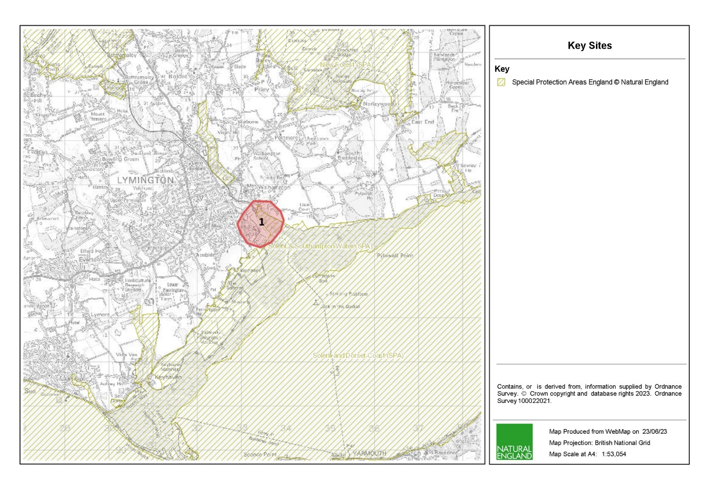 *Figure 2.1 – Map showing SPAs (yellow shaded area) and key sites (red polygons) – Lymington (polygon 1)*

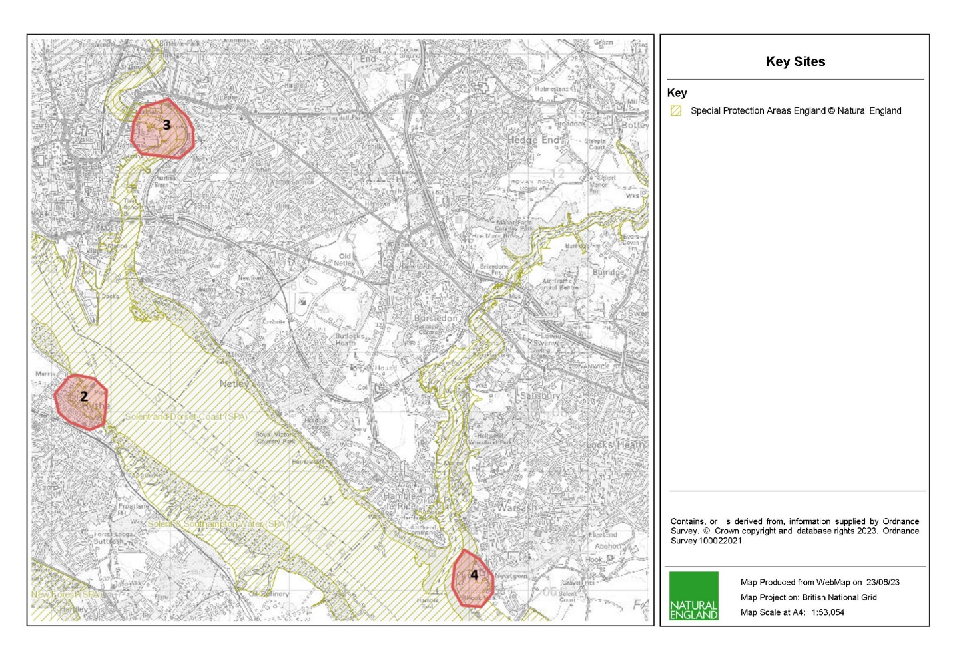

*Figure 2.2 – Map showing SPAs (yellow shaded area) and key sites (red polygons) – Hythe (polygon 2), River Itchen (polygon 3) and Hook Lake (polygon 4)*

*Figure 2.3 – Map showing SPAs (yellow shaded area) and key sites (red polygons) – Thorness Bay (polygon 5)*

*  
Figure 2.4 – Map showing SPAs (yellow shaded area) and key sites (red polygons) – Ryde (polygon 5)*

*Figure 2.5 – Map showing SPAs (yellow shaded area) and key sites (red polygons) – Portchester (polygon 6) and Farlington Marshes (polygon 8)*

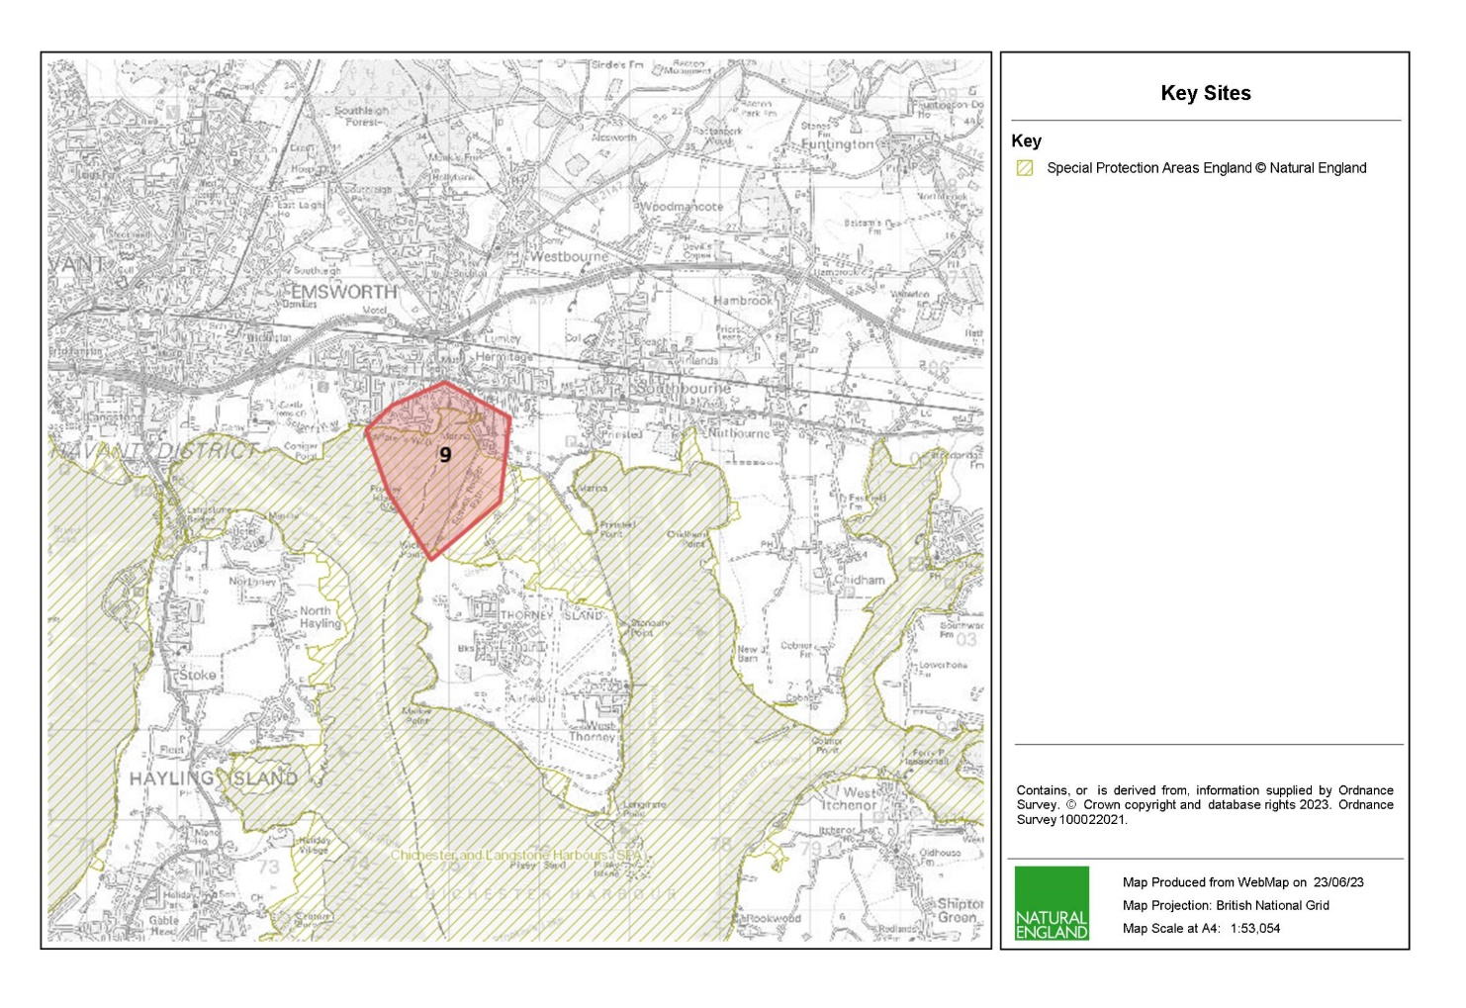  
*Figure 2.6 – Map showing SPAs (yellow shaded area) and key sites (red polygons) – Emsworth (polygon 9)*

1. **Aims and Objectives**
   1. **Aims**

Natural England wishes to commission background noise level surveys across specified sites from October 2023 to January 2024 to fill the current data gap on noise levels for the Solent SPA sites.

**Please note, this invitation to tender covers 9 key sites, however, these geographical elements can be awarded as two separate tenders for sites in Hampshire (polygons 1, 2, 3, 4, 7, 8 and 9) and sites on the Isle of Wight (polygons 5 and 6). Tenderers should therefore cost for these elements separately but indicate where cost savings could be made if both elements were awarded to a single tenderer.**

Natural England are seeking tenderers to pay particular attention to survey design so that qualitatively robust data is acquired which will permit rigorous statistical analysis.

Should tenders identify limitations or positive improvements within the survey design these suggestions should be indicated. In doing so tenderers should consider the costs and benefits offered by an alternative survey design and incorporation of existing sites to allow historical comparison of data. **You should indicate any cost savings in your tender bid.**

The survey designed for this tender should achieve the following aims:

* Acquire long-term monitoring data (≥1 week) of noise levels at key sites using long-term sound level meters
* Survey the anthropogenic activity immediately visible from the key site using Advice on Operations activities for each site (listed in methods)
* Survey the key sites for bird responses and ID
  1. **Objectives**

The specific objectives of this contract are to, in collaboration with Natural England, plan, undertake and report on background noise levels in key sites within the Solent SPA sites in order to inform accurate assessment of the likely significant effect of above water noise on birds.

Under this specification tenderers must:

* Monitoring survey of long-term background noise levels from one key location at each site
* Identify and record any anthropogenic activity visible from the key site, quantifying and mapping where possible at both high tide and low tide
* ID birds using the area and survey for any bird responses at both high tide and low tide
* Evaluate the effectiveness of data collection methods, techniques, and equipment
* Ensure that the survey can be replicate for future comparison by providing fully detailed data collection methods and operating protocols
* Report the detailed findings of the project in a succinct and clear final reports, with appropriate GIS outputs

1. **Methods**
   1. **Pre-Survey Deskwork**

Before the survey is carried out the successful contractor will discuss any pre-survey work with the Natural England project officer, including:

1. Clarification of roles, responsibilities and expectations
2. Acquisition and checking of sources of relevant information and gathering of local advice in preparation of a project plan
3. Review existing information provided by Natural England
4. Ways of working and close collaboration with NE in developing a project plan, particularly selection of survey sites, taking account of NE/EA pre-survey scoping work, and finalising survey design and methodologies
   1. **Development of a Suitable Sampling Design**

The successful contractor will need to develop an appropriate mapping strategy design in order to meet the aims of the project outlined above. The full detail of this design will be provided to, and subsequently owned by Natural England.

In developing an appropriate background noise level strategy contractors should seek to implement any improvements to deliver Natural England’s requirements for a more statistically robust approach.

Tenderers should make the best use of available GIS datasets in the design of their project plan and sampling process. Natural England will be able to provide the following GIS datasets under license to successful contractor for use in this contract:

* Base map data from Ordnance Survey
* Imagery from Next Perspectives
* Environmental data from Environment Agency
* Site specific datasets

Before commencing the survey, the successful Contractor will produce a project plan. In addition, before the survey is carried out the successful Contractor will:

A) Discuss any pre-survey work with the Natural England Project Officer, including checking information about the site and identifying sources of relevant information.

B) Review existing information provided by Natural England or any datasets known to the successful Contractor.

* 1. **Site Access**

Survey work will not be able to begin until access permissions have been obtained.

The successful contractor may be expected to obtain permission for access. Verbal authority for entry onto privately owned land from the relevant owner/occupier may suffice but should be fully documented and made available to the Natural England project officer. Each member of the survey team must carry a letter from Natural England to confirm that they are doing work on the behalf of Natural England.

The Natural England project officer should be contacted on commencement of any fieldwork.

* 1. **Protected Species and Licensing**

The successful contractor should ensure that all appropriate marine and protected species licences and legal requirements (such as a Habitats Regulations Assessment) for the survey have been attained and are valid before the survey commences. The Natural England Project Officer will support this process.

* 1. **Field Survey**

Natural England envisages that the required survey work under this specification should be completed within a maximum of 12 days on site. Please note this is for the full 9 sites. In the bid it must be stated how the survey will be conducted and the full costs associated with this.

Proposed dates for survey work under the contract to be scheduled and completed and contingency dates should be included in the quotation response e.g. in case of weather downtime. A maximum of one day weather downtime will be paid for by Natural England.

* + 1. **Long Term Noise Monitoring**

Sound level meters should be used to monitoring noise levels at each key site for a minimum of 1 week each month.

* + 1. **Anthropogenic Activity Survey**

When the sound level meter is put in place at each key site, a survey of anthropogenic activity should be conducted using the following categories (from [Advice on Operations](https://designatedsites.naturalengland.org.uk/Marine/FAPMatrix.aspx?SiteCode=UK9011061&SiteName=solent%20and%20southampton%20water&SiteNameDisplay=Solent+and+Southampton+Water+SPA&countyCode=&responsiblePerson=&SeaArea=&IFCAArea=&NumMarineSeasonality=9)):

* Aggregate Extraction
  + Aggregate dredging
  + Beach sand extraction
* Aquaculture
  + Finfish aquaculture
  + Seaweed aquaculture: suspended rope/net culture
  + Shellfish aquaculture: bottom culture
  + Shellfish aquaculture: suspended rope/net culture
  + Shellfish aquaculture: trestle culture
* Beach Management
  + Herbicide spraying & vegetation removal
  + Sand raking
  + Strandline clearance
* Cables
  + Cables: horizontal directional drilling
  + Power cable: decommissioning
  + Power cable: laying, burial and protection
  + Power cable: operation and maintenance
  + Telecommunication cable: decommissioning
  + Telecommunication cable: laying, burial and protection
  + Telecommunication cable: operation and maintenance
* Coastal Development and Flood and Erosion Risk Management Schemes (construction)
  + Construction and operation of offshore coastal defence structures (wave screens/breakwaters)
  + Construction of coastal flood and erosion risk management schemes
  + Intertidal recharge
  + Managed realignment
  + Piling
  + Reclaim and land take
* Coastal Development and Flood and Erosion Risk Management Schemes (maintenance)
  + Maintenance of hard coastal defences
  + Maintenance of soft coastal defences
  + Collapse
* Coastal Development and Flood and Erosion Risk Management (operation)
  + Operation of coastal flood and erosion risk management schemes
  + Collapse
* Coastal Infrastructure
  + Outfalls/ Intake pipes (maintenance/construction/usage)
  + Slipway (maintenance/construction)
  + Collapse
* Commercial Shipping (operation)
  + Commercial hovercraft
  + Navigation markers/lights
  + Vessel anchorages
  + Vessel discharges/emissions
  + Vessel moorings
  + Vessel movements
  + Collapse
* Electricity from Renewable Energy Sources
  + Offshore wind: decommissioning (if relevant see Cables also)
  + Offshore wind: during construction (if relevant see Cables also)
  + Offshore wind: operation and maintenance (if relevant see Cables also)
  + Tidal lagoon/impoundment: decommissioning
  + Tidal lagoon/impoundment: during construction
  + Tidal lagoon/impoundment: operation and maintenance
  + Tidal stream: decommissioning
  + Tidal stream: during construction
  + Tidal stream: operation and maintenance
  + Wave: decommissioning
  + Wave: during construction
  + Wave: operation and maintenance
  + Collapse
* Fishing
  + Anchored nets/lines
  + Demersal seines
  + Demersal trawl
  + Diving
  + Dredges
  + Electrofishing
  + Hydraulic dredges
  + Pelagic fishing (or fishing activities that do not interact with sea bed)
  + Seaweed harvesting
  + Shore-based activities
  + Traps
  + Collapse
* Oil, Gas and Carbon Capture Storage
  + Oil and gas decommissioning
  + Oil and gas exploration and installation
  + Oil and gas production
  + Pipelines
  + Collapse
* Ports and Harbours (construction)
  + Anchorages/moorings
  + Capital dredging
  + Capital dredging disposal
  + Construction of port and harbour structures
  + Habitat creation
  + Land reclaim
  + Piling
  + Collapse
* Ports and Harbours (maintenance)
  + Clearance slipways, similar structures and water ways
  + Maintenance dredging
  + Maintenance dredging disposal
  + Maintenance of port and harbour structures
  + Collapse
* Ports and Harbours (operations)
  + Berths/moorings/anchorages
  + Cargo operations and landward transportation
  + Operation of port and harbours
  + Shoreside industry and operations
  + Vessel maintenance
  + Collapse
* Recreation
  + Firework displays
  + Horse riding & dog walking
  + Hovercraft
  + Leisure (e.g. swimming, rock pooling)
  + Light aircraft and drones
  + Non-motorised land craft (e.g. sand yachting, kite buggying)
  + Non-motorised water craft (e.g. kayaks, windsurfing, dinghies, paddleboards)
  + Powerboating or sailing with an engine: launching and recovery, participation
  + Powerboating or sailing with an engine: mooring and/or anchoring
  + Sailing without an engine: launching and recovery, participation
  + Sailing without an engine: mooring and/or anchoring
  + Wildfowling
    1. **Bird Survey**

A survey of bird responses should also be conducted at the site of the long term monitoring. Including identifying the bird species and categorising the response. The time of each response should be recorded in order to cross-reference this with the noise level data for the site. This should be completed at a range of tidal states, prioritising a survey at high tide and a survey at low tide at each site.

Weekdays and weekends are likely to have different noise profiles as the source generating the noise shifts from mostly industrial during the week to mostly recreational during the weekends. For completeness, the bird response surveys should cover both.

Bird responses include, but are not limited to, the following categories:

* Flight response with settlement within 100m
* Flight response out of area
* Stopping activity (freeze/stress response)
* Staying at the site, but moving away from noise
* No response
  1. **Invasive Non-Native Species**

Invasive Non-Native Species (INNS) are considered to be one of the top five pressures directly driving biodiversity loss globally. Prevention is the key focus, particularly in marine environments. The contractor needs to be aware of and work in accordance with standard good practice biosecurity measures to avoid spread of INNS:

* Equipment, clothes and boots should be clean before carrying out any work on site
* When on or near water it is important that equipment is drained after use and as far as possible dried
* Dry all clothes and boots thoroughly
* Boats or other watercraft (e.g. hovercraft) to be used in survey work should have their hulls cleaned on a regular basis. Best practice guidelines should be followed as outlined by The Green Blue

A statement of biosecurity measures that the successful Contractor will undertake is required with the tender.

The successful Contractor shall report any records of INNS observed on site to the Marine Biological Association <http://www.mba.ac.uk/recording> and to the Natural England project officer. More information and guidance including ID guides can be found at [www.nonnativespecies.org](http://www.nonnativespecies.org) and the [Marine Aliens Project](http://www.marlin.ac.uk/marine_aliens/).

* 1. **Risk Assessments**

All risk assessments need to be seen and signed off by the Natural England project officer (ideally presented with the project plan), as part of the contract management process.

* 1. **Data Analysis**

Natural England expect that robust and appropriate statistical analysis is employed as required, and the results presented and briefly discussed with the Natural England project officer. An explanation of why certain methods have been chosen should be appended, and a brief justification and data gathered or created during the project. Base mapping including OS tiles and aerial photographs can be provided by Natural England under licence if required.

* 1. **Data Outputs and Management**

All project outputs should be delivered to agreed deadlines.

Data must be interpreted, analysed and presented in light of the overarching aims stated above. Tenderers should pay particular consideration to the data and GIS required formats for information compatibility including MEDIN metadata standards and Marine Recorder provisions:

* + - 1. All sample data (e.g faunal analysis, PSA analysis) need to be entered into Marine Recorder and delivered with the final reports. Natural England will provide licence keys for Marine Recorder to the successful Contractor for use in this contract. A Snapshot file of the data should also be provided. <https://www.esdm.co.uk/marine-recorder>. Guidance ‘Marine Recorder Evidence for Contractors’ will be provided to the successful Contractor.
      2. All GIS datasets need to be provided in ESRI ArcGIS format compatible with ArcGIS9.3.1 and have attached metadata.
      3. If not included in the GIS data layers listed above all sampling locations, vessels tracks and links to data obtained should also be included as a single GI layer.
      4. Accompanying metadata for the data set must meet the MEDIN metadata discovery standard. Metadata derived as part of this project must be submitted to Natural England in an XML file which Natural England will archive through Data Archive Centres (DACs). Guidance ‘MEDIN Evidence for Contractors’ will be provided to the successful Contractor.
      5. Copies of the original data spreadsheets or databases are to be provided in the appropriate Microsoft Office format.
      6. Stills photographs to be provided in their raw format on CD/DVD or USB compliant external hard drives.
      7. Natural England will be provided with two bound hard copies and one electronic copy (on disc or USB) of the final report. The final report should contain:

1. Executive summary
2. Introduction
3. Methods
4. Results including long term noise monitoring and anthropogenic activity surveys
5. Presentation of noise level data to show monthly averages, daylight hours vs non-daylight hours and weekdays vs weekends
6. Recommendations for further work
7. Catalogue of data provided
8. References
9. Appendices to include full faunal and particle size data
10. **Outputs**
    1. **Timeline for Project Delivery**

|  |  |
| --- | --- |
| **Event** | **Date** |
| Contract Award Date | 21 August 2023 |
| Finalise sampling design | 11 September 2023 |
| Produce final project plan | 15 September 2023 |
| Obtain any necessary permissions | 20 September 2023 |
| Survey to be completed by | 26 January 2024 |
| Submission of brief field report by | 16 February 2024 |
| Draft report and associated products to be provided by | 08 March 2024 |
| Final report and full data output to be delivered | 22 March 2024 |

Any delays should be discussed with the Natural England project officer.

1. **Other**

In support of this contract Natural England will provide the successful Contractor with:

* Project support from dedicated project lead
* Opportunity to feedback and discuss progress and the project
* Additional survey staff if appropriate

The intellectual property rights and copyright for all products (including photographs) will lie with Natural England. All data will be made available by Natural England under the Open Government Licence at the end of the project via MESH and the MEDIN Data Archiving Centres.

As part of this contract the successful Contractor will provide a pre-survey planning meeting with Natural England.

1. **References**

* Natural England, 2021, Solent and Dorset Coast SPA Citation
* Natural England, 1998, Solent and Southampton Water SPA Citation
* Natural England, 2014, Portsmouth Harbour SPA Citation
* Natural England, 2014, Chichester and Langstone Harbours SPA Citation

## Sustainability

Natural England protects and improves the environment and is committed to reducing the sustainability impacts of its activities directly and through its supply chains. We expect he Contractor to share this commitment and adopt a sound, proactive sustainable approach in keeping with the 2 yr environmental plan/our commitments compliant with all applicable legislation. This includes understanding and reducing direct and indirect sustainability impacts and realising opportunities, including but not restricted to; resilience to climate change, reducing greenhouse gas emissions, water use and quality, biosecurity, resource efficiency and waste, reducing the risk of pollution, biodiversity, modern slavery and equality, diversity & inclusion, negative community impacts.

As a delivery partner, the successful Contractor is expected to pursue sustainability in their operations, thereby ensuring the Contracting Authority is not contracting with a supplier whose operational outputs run contrary to the Contracting Authority’s objectives. The successful Contractor will need to approach the project with a focus on the entire life cycle of the project.

## Payment

The Authority will raise purchase orders to cover the cost of the services and will issue to the awarded supplier following contract award.

The Authority’s preference is for all invoices to be sent electronically, quoting a valid Purchase Order number.

It is anticipated that this contract will be awarded for a period of 9 months to end no later than 22 March 2024. Prices will remain fixed for the duration of the contract award period. We may at our sole discretion extend this contract to include related or further work. Any extension shall be agreed in writing in advance of any work commencing and may be subject to further competition.

## Award Stage

**Evaluation: Award Stage (Stages 3 to 4)**

Evaluation comprises the stages set out in the table below.

|  |  |  |  |
| --- | --- | --- | --- |
| **Stage** | **Section Reference** | **Evaluation Criteria** | **Question Scoring/Weighting (%)** |
| 1 | Complete quotation | Responses have been provided to all of the questions | Pass/Fail |
| 3 | Technical & Professional Ability – Project Specific Requirements (Technical Requirements) | This stage will be evaluated in accordance with the criteria set out in the Technical Questionnaire | Technical Requirements will make up 70% the total marks available.  Overall technical score will be formed from the following breakdown:  E01 – Quality of proposal and sampling Strategy (weighting 55%)  E02 – Experience (20% weighting)  E03 – Ability to mobilise a survey team (weighting 20%)  E04 – GDPR (5% weighting) |
| 4 | Pricing Schedule | Prices will be evaluated in accordance with the criteria set out in the Pricing Schedule | Commercial score will make up 30% of the total marks available |
| 5 | Final score | If you pass stages 1 to 2 your Tender will be evaluated in stages 3 to 4  The final score is calculated as follows:  70 % is made up of the total of Stage 3  30 % is made up from Stage 4  The most economically advantageous Tender will be the Tender with the highest final score. | |

Tenders will be evaluated on quality and price using the evaluation criteria set out in Bravo

to determine which Tender is the most economically advantageous. The Authority will

award the Contract to the Tenderer which submits the most economically advantageous

tender which will be the highest scoring Tender after the weightings below are applied.

Each question will be scored separately, and no reference will be made between the

questions.

To ensure that the relative importance of both sets of criteria is correctly reflected in the

Overall score, a weighting system will be applied to the evaluation:

The total quality scores awarded will form 70% of the final score;

The score awarded for price will form 30% of the final score.

Each scoring question in the quality evaluation is given a weighting to indicate the relative

importance of that question in the overall quality score. Weightings for quality scores are

provided with the evaluation criteria and are detailed in the response form. The evaluation criteria for price are set out in the Pricing Schedule.

Evaluation of Tenders will be undertaken by the two selected case officers. Each officer will first undertake an independent evaluation of the Tenders applying the Relevant evaluation criteria for each question. Then the two case officers will agree on the winning Tenderer.

**Questions E01 – E04 will be assessed using the following scoring criteria**:

|  |  |
| --- | --- |
| **Score** | **Justification** |
| For a score of hundred  (100): | Excellent - Response is completely relevant and excellent overall. The response is comprehensive, unambiguous and demonstrates a thorough understanding of the requirement and provides details of how the requirement will be met in full. |
| For a score of seventy  (70): | Good - Response is relevant and good. The response demonstrates a good understanding and provides details on how the requirements will be fulfilled. |
| For a score of fifty (50): | Acceptable - Response is relevant and acceptable. The response provides sufficient evidence to fulfil basic requirements. |
| For a score of twenty  (20): | Poor - Response is partially relevant and/or poor. The response addresses some elements of the requirements but contains insufficient / limited detail or explanation to demonstrate how the requirement will be fulfilled. |
| For a score of zero (0): | Unacceptable - Nil or inadequate response. Fails to demonstrate an ability to meet the requirement. |

If a bidder scores 20 (twenty) or below for any of the technical evaluation questions (E01 – E03), they will be eliminated from the procurement.

For avoidance of doubt please note: no half marks or a score other than those whole

numbers above will be awarded to responses.

Tenders are required to complete Appendix D: Pricing Schedule and submit this within their

Tender response. This document is for information purposes only and will be used by the

Authority to understand how the submitted price is calculated. The information provided

may be used to inform the Pricing Schedule of the final Contract.

The appendices will include several worksheets which the Tenderer is requested to complete

for information purposes in order for the Authority to understand how the Tenderer’s costs

are calculated. This information may be used to inform the Pricing Schedule of the

Contract. The weighting and maximum marks available for the price will be 30% and will

be awarded to the Tenderer with the lowest Tender Price. The remaining Tenderers will

receive marks on a pro rata basis from the lowest to the highest price. The calculation

used is the following:

Score = Lowest Tender Price x 30% (Maximum available marks)

Tender Price

For example, if three Tender Responses are received and Tenderer A has quoted £30,000 as their total price, Tenderer B has quoted £50,000 and Tenderer C has quoted £60,000 then the calculation will be as follows:

Tenderer A Score = £30,000/£30,000 x 30% (Maximum available marks) = 30%

Tenderer B Score = £30,000/£50,000 x 30% = 18%

Tenderer C Score = £30,000/£60,000 x 30% = 15%

**Appendices**

**APPENDIX A**

**FORM OF TENDER**

To be returned by 12:00 noon (BST) on 14 August 2023

TENDER FOR: **Noise Disturbance – Baseline Level Monitoring in the Solent**

Tender Ref:

1. We have examined the invitation to tender and its schedules set out below (the **ITT**) and do hereby offer to provide the services specified in the ITT and in accordance with the attached documents to the Authority commencing 21 August 2023 for the period specified in the ITT.

* Specification of Requirements
* Evaluation
* Form of Tender (Appendix A)
* Authority’s Conditions of Contract (Appendix B)
* Technical Questions (Appendix C)
* Pricing Schedule (Appendix D)
* Conflict of Interest declaration form (Appendix E)

1. If this tender is accepted, we will execute the Contract and any other documents required by the Authority within 10 days of being asked to do so.
2. We agree that:
3. before executing the Contract substantially in the form set out in the ITT, the formal acceptance of this tender in writing by this Authority or such parts as may be specified, together with the documents attached shall comprise a binding contract between the Authority and us;
4. pursuant to EU Directive 1999/93/EC (Community Framework for Electronic Signatures) and the Electronic Communications Act 2000, the Contract may be executed electronically using the Authority’s electronic tendering and contract management system, Bravo;
5. we are legally bound to comply with the confidentiality provisions set out in the ITT;
6. any other terms or conditions or any general reservation which may be provided in any correspondence sent by the Authority in connection with this procurement shall not form part of this tender without the prior written consent of the Authority;

1. this tender shall remain valid for 120 days from the closing date for tenders specified in the ITT; and
2. the Authority may disclose our information and documents (submitted to the Authority during the procurement) more widely within Government for the purpose of ensuring effective cross-Government procurement processes, including value for money and related purposes.

4. We confirm that:

* 1. there are no circumstances affecting our organisation which could give rise to an actual or potential conflict of interest that would affect the integrity of the Authority’s decision making in relation to the award of the Contract; or
  2. if there are, or may be such circumstances giving rise to an actual or potential conflict of interest we have disclosed this in full to the Authority.

5. We undertake and it shall be a condition of the Contract that:

1. the amount of our tender has not been calculated by agreement or arrangement with any person other than the Authority and that the amount of our tender has not been communicated to any person until after the closing date for the submission of tenders and in any event not without the consent of the Authority;
2. we have not canvassed and will not, before the evaluation process, canvass or solicit any member or officer, employee or agent of the Authority or other contracting authority in connection with the award of the Contract and that no person employed by us has done or will do any such act; and
3. made arrangements with any other party about whether or not they may submit a tender except for the purposes of forming a joint venture.

6. I warrant that I am authorised to sign this tender and confirm that we have complied with all the requirements of the ITT.

**Signed _____________________________________________________________**

**Date _____________________________________________________________**

**In the capacity of _________________________________________________________**

**Authorised to sign**

**Tender for and on**

**behalf of _____________________________________________________________**

**Postal Address __________________________________________________________**

**Post Code _____________________________________________________________**

**Telephone No. ___________________________________________________________**

**Email Address ___________________________________________________________**

**APPENDIX B**

*Authority’s Conditions of Contract*

Please visit the following link and download ‘Standard Condensed Terms and Conditions’ -<https://www.gov.uk/government/organisations/natural-england/about/procurement>. These terms and conditions are non-negotiable.

**APPENDIX C**

*Technical Questions*

The questions below are those which you will be scored against.

If a bidder scores twenty (20) or below for any of the evaluation questions (E01 – E04), they will be eliminated from the procurement.

Technical Evaluation Questions

**E01 – Quality of proposal and sampling strategy (weighting 55%)**

Your response will be marked against the quality of the proposal based on the survey design meeting the requirements of the proposal, number of samples, statistical rigour and power of the design.

Your response should include a summary of how you would use the previous survey design methodology to ensure comparability with historic datasets and ensure cost savings both in the field and during reporting.

Please submit a document with the filename: “E01_Your Organisation Name”.

Your response must not exceed a maximum of three sides of A4, font size 11.

**E02 – Experience (20% weighting)**

Please provide details of your experience surveying within Marine Protected Areas and identification of marine species and habitats.

Your response should include any accreditations, e.g. NMBAQC Scheme accreditation, that the processing laboratory holds.

Please submit a document with the filename: “E02_Your Organisation Name”.

Your response must not exceed a maximum of two sides of A4, font size 11.

**E03 – Ability to mobilise a survey team (weighting 20%)**

Please provide details to demonstrate that you can mobilise a survey team and complete the survey specified according to the timetable in this ITT.

Please submit a document with the filename: “E03_Your Organisation Name”.

Your response must not exceed a maximum of two sides of A4, font size 11.

**E04 – GDPR (weighting 5%)**

Please provide details of the technical facilities and measures (including systems and processes) you have in place, or will have in place by contract award, to ensure compliance with the General Data Protection Regulation and to ensure the protection of the rights of data subjects.

Your response should include, but should not be limited to facilities and measures:

* to ensure ongoing confidentiality, integrity, availability and resilience of processing systems and services;
* to comply with the rights of data subjects in respect of receiving privacy information, and access, rectification, deletion and portability of personal data;
* to ensure that any consent based processing meets standards of active, informed consent, and that such consents are recorded and auditable;
* to ensure legal safeguards are in place to legitimise transfers of personal data outside the EU (if such transfers will take place);
* to maintain records of personal data processing activities; and
* to regularly test, assess and evaluate the effectiveness of the above measures.

Responses should not exceed three sides of A4, font size 11.

Please upload your response to this question with the filename: E04_Your Organisation Name

**APPENDIX D**

*Pricing Schedule*

|  |  |  |  |  |  |
| --- | --- | --- | --- | --- | --- |
| **Costs** | | | | | |
| **ITEM** | **SPECIFICATION TITLE** | **Staff to deliver work** | **No. of days** | **UNIT PRICE (ex. VAT) £** | **TOTAL PRICE**  **(ex.VAT) £** |
| **1** | Project set up/design and review |  |  |  |  |
| **2** | Pre survey planning and design |  |  |  |  |
| **3** | Initial project meeting (to be held by phone) |  |  |  |  |
| **4** | Equipment requirements and duration |  |  |  |  |
| **5a** | Field work (long-term monitoring surveys for noise levels) |  |  |  |  |
| **5b** | Field work (short term monitoring surveys for anthropogenic activity and bird resposne) |  |  |  |  |
| **10** | Data analysis and mapping (if required) |  |  |  |  |
| **11** | GIS data to electronic format |  |  |  |  |
| **12** | Travel and subsistence |  |  |  |  |
| **13** | Customer support / contract management |  |  |  |  |
| **14** | Please detail any assumptions made during pricing |  |  |  |  |
| **15** | Other – please detail, including contingency planning for weather downtime/equipment failure etc. a separate costing for any additional elements/effort that may be required). |  |  |  |  |

**Prices**

Prices must be submitted in £ sterling, exclusive of VAT.

**Quotation Submission**

Details of the Qualification, Technical and Commercial requirements can be located through the Governments Procurement with Natural England Portal: [Procurement at Natural England - Natural England - GOV.UK (www.gov.uk)](https://www.gov.uk/government/organisations/natural-england/about/procurement)

**Disclosure**

All Central Government Departments, their Executive Agencies and Non Departmental Public Bodies are subject to control and reporting within Government. They report to the Cabinet Office and HM Treasury for all expenditure. Further the Cabinet Office has a cross-Government role delivering overall Government policy on public procurement, including ensuring value for money and related aspects of good procurement practice.

For these purposes, the Authority may disclose within Government any details contained in your quotation. The information will not be disclosed outside Government during the procurement.

In addition, the Authority is subject to the Freedom of Information Act 2000 and the Environmental Information Regulations 2004, which provide a public right of access to information held by public bodies. In accordance with these two statutes, the Authority may be required to disclose information contained in your quotation to any person who submits a request for information pursuant to those statutes.

You should also note that the Authority will publish the RFQ and the Contract on the Contracts Finder Website.

By submitting a quotation, you consent to these terms as part of the procurement.

**Disclaimers**

Whilst the information in this RFQ and any supporting information referred to herein or provided to you by the Authority have been prepared in good faith the Authority does not warrant that this information is comprehensive or that it has been independently verified.

The Authority does not:

* make any representation or warranty (express or implied) as to the accuracy, reasonableness or completeness of the RFQ;
* accept any liability for the information contained in the RFQ or for the fairness, accuracy or completeness of that information; or
* accept any liability for any loss or damage (other than in respect of fraudulent misrepresentation or any other liability which cannot lawfully be excluded) arising as a result of reliance on such information or any subsequent communication.

Any supplier considering entering into contractual relationships with the Authority following receipt of the RFQ should make its own investigations and independent assessment of the Authority and its requirements for the goods and/or services and should seek its own professional financial and legal advice.

**Protection of Personal Data**

In order to comply with the General Data Protection Regulations 2018 the contractor must agree to the following:

* You must only process any personal data in strict accordance with instructions from the Authority
* You must ensure that all the personal data that we disclose to you or you collect on our behalf under this agreement are kept confidential.
* You must take reasonable steps to ensure the reliability of employees who have access to personal data.
* Only employees who may be required to assist in meeting the obligations under this agreement may have access to the personal data.
* Any disclosure of personal data must be made in confidence and extend only so far as that which is specifically necessary for the purposes of this agreement.
* You must ensure that there are appropriate security measures in place to safeguard against any unauthorised access or unlawful processing or accidental loss, destruction or damage or disclosure of the personal data.
* On termination of this agreement, for whatever reason, the personal data must be returned to us promptly and safely, together with all copies in your possession or control.

**General Data Protection Regulations 2018**

For the purposes of the Regulations the Authority is the data processor.

The personal information that we have asked you provide on individuals (data subjects) that will be working for you on this contract will be used in compiling the tender list and in assessing your offer. If you are unsuccessful the information will be **held and destroyed within two years** of the award of contracts. If you are awarded a contract it will be retained for the duration of the contract and destroyed within **seven years** of the contract’s expiry.

We may monitor the performance of the individuals during the execution of the contract, and the results of our monitoring, together with the information that you have provided, will be used in determining what work is allocated under the contract, and in any renewal of the contract or in the award of future contracts of a similar nature. The information will not be disclosed to anyone outside the Authority without the consent of the data subject unless the Authority is required by law to make such disclosures.

**Appendix E**

*Conflict of Interest Form*

[Guidance Note:

This Conflict of Interest declaration template aligns with the published template included within Procurement Policy Note Guidance 04/21: Applying Exclusions in Public Procurement, Managing Conflicts of Interest and Whistleblowing published by the Cabinet Office. By using this form DgC is consistent with the standard required by the procurement policy across government.

This form places greater expectation on individuals to highlight their own potential, perceived, or actual conflicts of interest during the lifecycle of any procurement activity. An individual is best placed to make this assessment for themselves, rather than a central procurement or contract manager. But DgC personnel, along with guidance published, can provide support to individuals when considering their situation.

Please read this document before using and follow the instructions below, prior to use.

* Select “Open in Desktop App”
* Save a copy of this form in your procurement or project folders.
* The requester needs to ensure that this form is completed, to aid the easy completion by individuals who are required to undertake this due to their involvement with a commercial activity.
* For procurement or contract management activities led by DgC, please ensure that the highlighted text within the square brackets is completed prior to being sent to the customer or stakeholder.
* Also prior to sending, it is recommended to delete these guidance notes.
* If the use of wet or electronic signatures is difficult for users to apply, then the complete form can be emailed back from the individual’s email account and this may be accepted as ‘signed off’. In that case, the associated email should be retained with the completed form.]

**Conflicts of Interest Declaration**

Please complete the declaration for the [ insert title of procurement, commercial, or relevant activity that the potential for conflicts must be checked for. select appropriate route for procurement, e.g. Single Tender Action/competed opportunity] [insert project reference and name].

(For a Grant Competition, where the term ‘procurement’ appears in this document, you can extend the meaning to include grants).

Introduction

This Declaration Form is intended to capture conflicts of interest relating to individuals involved in the aforementioned procurement in order to avoid any distortion of competition and to ensure equal treatment of all companies seeking to do business with the Contracting Authority.

For a procurement, involvement, in the context of conflicts of interest, may relate to any stage in the Commercial Lifecycle including preparation and planning, publication, selection and award and contract implementation.

For a grant, involvement in the context of conflicts of interest, may relate to any stage in the Grant Lifecycle including design and development – market engagement, application assessment, award, performance monitoring and final evaluation.

Individuals must avoid placing themselves in a position where there is a conflict between their personal and/or outside interest and their official duties in a procurement and must comply with internal policy relating to gifts, hospitality and conflicts of interest at all times.

Examples of conflicts of interest may include, but are not restricted to:

• if you are a current or previous employee of an organisation, or have a member of your family, your partner (married, civil partnership or not), your siblings, your children, or any close personal or professional relationships that are an employee of an organisation, that is seeking to do business with the Contracting Authority.

• if you, or a member of your family/friends (as set out above), has a financial interest in an organisation that is seeking to do business with the Contracting Authority.

• if you, or a member of your family/friends (as set out above), has a financial relationship of any kind with an organisation seeking to do business with a Contracting Authority.

This is a non-exhaustive list of examples and it is your responsibility to ensure that any and all actual, potential or perceived conflicts are disclosed prior to you being involved in the procurement.

If you are unsure whether your current or previous relationship or involvement with an organisation that is seeking to do business with the Contracting Authority constitutes a conflict of interest, you should seek advice from an Authorised Individual / DgC commercial contact.

stated below.

This Form also includes a requirement for individuals involved in the procurement to treat information (including but not restricted to bid documents, bidder / organisation evaluations etc.) with the appropriate level of confidentiality, and not make any unauthorised disclosures of this information.

32

All individuals with access to procurement information must sign this Form.

This COI declaration does not change the Conflicts of Interest Declaration process you must follow within your organisations.

Authorised Individuals

Authorised Individuals are responsible for managing the disclosure of procurement information and conflicts of interest. The Authorised Individuals for the procurement are:

[insert name and title of accountable officer and any person(s) to whom management has been delegated]

If conflicts of interest arise at any time during the commercial lifecycle, an Authorised Individual must be notified. Any disclosure of procurement information must also be approved by an Authorised Individual prior to disclosure.

Statements

1. I acknowledge that my official duties cause me to have access to documents or data pertaining to the above procurement. I am aware that unauthorised disclosure of information could damage the integrity of the procurement and that transmission or revelation of such information to unauthorised persons will subject me to disciplinary action.

2. I will not divulge, publish or reveal by word, conduct, or any other means such information or knowledge, except as necessary to do so in the performance of my official duties related to this procurement and in accordance with the laws of the United Kingdom, unless specially authorised in writing in each and every case by an Authorised Individual of the Contracting Authority.

3. I acknowledge that the information I receive will be given only to persons specifically granted access to the procurement, and it may not be further divulged without specific prior written approval from an Authorised Individual.

4. If at any time during the procurement my participation might result in an actual, potential or perceived conflict of interest, I will immediately report the circumstances to the appropriate Authorised Individual.

33

Declaration Guidance

Declaration A should be signed if there are no actual, potential or perceived conflicts of interest.

Declaration B should be signed if there are actual, potential or perceived conflicts of interest. The conflicts of interest and mitigation must be stated in Appendix 1 below, as must the role that the individual will be carrying out (where appropriate) within the procurement. An Authorised Individual must also sign Declaration B to confirm that they accept that appropriate mitigations have been put in place.

Declaration A (if no conflicts of interest)

By signing this Form, I declare that I have read and accept the Statements above, and that there are no conflicts of interest of any nature which would prevent me from participating in the aforementioned procurement.

If any actual, potential or perceived conflicts of interest arise in the future, I will inform an Authorised Individual immediately.

Name:

Job Title: Organisation / Department:

Signature: Date:

Declaration B (if actual, potential of perceived conflicts of interest)

By signing this Form, I confirm that the conflicts of interest in Appendix 1 have been mitigated appropriately to allow me to participate in a suitable role within the procurement.

If any other actual, potential or perceived conflicts of interest arise in the future, I will inform an Authorised Individual immediately.

Name:

Job Title: Organisation / Department:

34

Signature: Date:

35

Appendix 1

My conflict(s) of interest, including mitigations, is/are:

Conflict of interest [insert text]

Mitigation [insert text]

[Delete as appropriate]

Therefore, my role in the procurement will be [briefly describe role]

OR

Therefore, I will not have a role in the procurement.

Authorised Individual

By signing this Form, I confirm that the conflicts of interest in Appendix 1 have been mitigated appropriately, and therefore the individual’s role in the procurement, also stated in Appendix 1, is appropriate.

Name:

Job Title: Organisation / Department:

Signature: Date: