**Call-Off Schedule 5 (Pricing Details)**

Total Costs

SCS1 x 2 = **Redacted under FOIA section 43, Commercial Interests**

Band 5/6 x 4 = **Redacted under FOIA section 43, Commercial Interests**

Website/Advertising = **Redacted under FOIA section 43, Commercial Interests**

Total = £114.5k

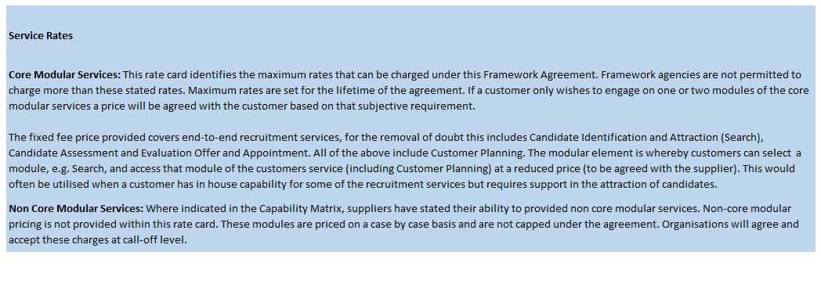

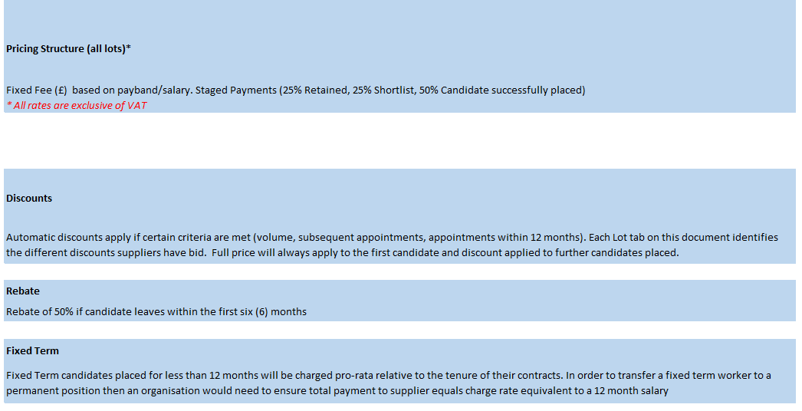



**Redacted under FOIA section 43, Commercial Interests**