Request
for
Information
(RFI)

Princess Royal University Hospital

Kings College Hospital NHS Foundation Trust

(KCH/KFM)
C302286

Retail Concession Units for Hospital Site – PRUH

Contents

Section | Point | Topic
 |  | General Information & Instructions
 | 1.1 | Overview of Trust
 | 1.2 | Documentation and Purpose
 | 1.3 | Receipt of Information Documentation
 | 1.4 | Clarification: Questions & Answers
 | 1.5 | Indicative RFI Timetable
 | 1.6 | How to Submit Your Information to the Trust
 | 1.7 | Information Cost and Rights to Cancel
 | 1.8 | Confidentiality and Information Governance
 | 1.9 | Freedom of Information Act 2000 (FOIA)
2. |  | Terms and Conditions
 | 2.1 | General Conditions
3. |  | RFI Specification
 | 3.1 | Specification
 | 3.2 | Format of the Response
 | 3.3 | Evaluation Criteria

Section 1 | General Information & Instructions

  - Overview of the Trust (KCH and KFM)

Kings College NHS Foundation Hospital (KCH)
1.1.1 Kings College Hospital NHS Foundation Hospital is one of London's largest and busiest teaching hospitals, with a strong profile of local services primarily serving the boroughs of Lambeth, Southwark, Lewisham and Bromley.
1.1.2 Our specialist services are available to patients across a wider catchment area, providing nationally and internationally recognised work in liver disease and transplantation, neurosciences, haemato-oncology and foetal medicine.
1.1.3 King’s College Hospital NHS Foundation Trust provide quality care and treatment for patients at:
- Princess Royal University Hospital (PRUH), Farnborough Common
- Orpington Hospital, Orpington
- Services at Beckenham Beacon and Queen Mary’s Hospital, Sidcup.
1.1.4 As a result of the integration we operate as one Trust across many sites. We are transforming King’s into a fundamentally new kind of Trust built around patient need, offering all our patients – local, national and international – the highest quality of care. We are delivering this as part of a joined-up and well-managed healthcare system, built in partnership with GPs, commissioners and other healthcare providers.
1.1.5 Patients come to King’s from all over the world – for the skill and compassion of our people and our reputation as pioneers in medical research. Transferring the results of this research from bench to patient bedside is now quicker and easier thanks to the formation (with King’s College London, Guy’s and St Thomas’ and South London and Maudsley Foundation Trusts) of King’s Health Partners, an Academic Health Science Centre.
1.1.6 Our vision is to become a fundamentally new kind of hospital built around patient need, offering all our patients – local, national and international – the highest quality of care, and to deliver this as part of a joined-up and well-managed healthcare system, built in partnership with GPs and other healthcare providers.
Kings Interventional Facilities Management (KFM)
1.1.7 KFM (KFM) is the trading name for KCH Interventional Facilities Management LLP. It provides fully managed services including procurement, equipment and the supply chain for diagnostic and treatment facilities for King’s College Hospital NHS Foundation Trust. KFM operates across all sites within the Trust, including King’s College Hospital, Princess Royal University Hospital and Orpington Hospital.

1.1.8 KFM is a Limited Liability Partnership controlled by the King’s College Hospital NHS Foundation Trust. KFM has no private sector partners. KFM has an annual turnover of circa £160 million and in excess of 300 staff. In addition, we manage the procurement of an additional circa £350m of annual spend for the trust.

1.1.9 In practice, KFM run and manage a number of interventional facilities and their supply chains for the Trust. This includes the provision and maintenance of the equipment used by these facilities. KFM also provide a full procurement service to all areas of the Trust. The benefit to the Trust is that KFM can manage the equipment and supply chain more efficiently using dedicated resources.

1.1.10 This gives back patient-facing time to clinical staff. By investing in our procurement and supply chain resources, we improve our expertise and enable smarter purchasing for the Trust.

  - Documentation and Purpose
1.2.1 KCH (“The Trust”) is the Contracting Authority for this Request for Information.
    - The Trust includes any subsidiary companies and other organisations that control or are controlled by the Trust from time to time.

1.2.4 The purpose and scope of the Request for Information (RFI) and supporting documents is to explain in further detail the requirements of the Trust and the procurement process for submitting information.

1.3 Receipt of Information Documentation

1.3.1 There is no need for you to inform us directly of your intention to participate in the process, as our email system will record that you have downloaded the documentation.

1.4 Clarifications: Questions and Answers

1.4.1 Where there is uncertainty with any element of the RFI, the Trust, will endeavour to provide any additional information required.
1.4.2 All questions must be submitted via the Atamis portal where this opportunity has been published. Any clarification requests should clearly reference the appropriate paragraph in the RFI documents.
1.4.4 The Trust reserves the right to issue any clarification request made by you, and the response, to all potential bidders unless you expressly require it to be kept confidential at the time the request is made. If the Trust considers the contents of the request not to be confidential, it will inform you and you will have the opportunity to withdraw the clarification query prior to the Trust responding to all potential Bidders.
1.4.5 The Trust may at any time request further information from potential Bidders to verify or clarify any aspects of their Information they may have provided. Should you not provide the requested information to the Trust by any deadline notified to you, your bid/information may be rejected in full, and you may be disqualified from this process.

1.5 Indicative RFI Timetable

1.5.1 The table below is to be used as a guide only:

DATE AND TIME | DESCRIPTION
23th September 2024 | Issue RFI
4th October 2024 | RFI Submission date
W/c 7th October 2024 | Review

1.6 How to Submit Your Information to The Trust

1.6.1 The completed Information must be submitted to the relevant section of the Closing date and time as set in the timetable shown above). Please ensure that your complete response has been both uploaded and submitted before the closing time and date, otherwise the response will be automatically rejected.
1.6.2 Please ensure that you send your submission in good time to prevent issues with technology – late responses may be rejected.
1.7 Information Costs and Rights to Cancel

1.7.1 The Trust shall not be liable for or pay any costs, expenses or losses, whatsoever which may be incurred by any Bidder in the preparation of their Information.

1.7.2 The Trust reserves the right to terminate, suspend, amend or vary (to include, without limitation, in relation to any timescales or deadlines) this Process.
1.8 Confidentiality and Information Governance
1.8.1 All information supplied to you by the Trust, including this RFI and all other documents relating to this Procurement Process, either in writing or orally, must be treated in confidence and not disclosed to any third party, save to your professional advisers, consortium members and/or sub-contractors strictly for the purposes only of helping prepare your Information unless the information is already in the public domain.
1.8.2 There must be no publicity by you regarding the Procurement Process or the future contract unless the Trust has given express written consent.
1.8.3 This RFI and its accompanying documents shall remain the property of the Trust and must be returned on demand.
1.8.4 The Trust reserves the right to disclose all documents relating to this Process, including without limitation your response, to any employee, third party agent, adviser or other third party involved in the procurement in support of, and/or in collaboration with, the Trust. By participating in this Procurement Process, you agree to such disclosure and/or publication by the Trust.

  - Freedom of Information Act 2000 (FOIA)

    - The Freedom of Information Act 2000 (FOIA) gives the public a legal right of access to information held by public authorities. The public now have a right to know about our work and it is our duty to operate with openness and transparency. All information held by the Trust is caught by the FOIA. The rules about disclosure apply regardless of where the information originated. This means that all the following types of information may be subject to disclosure:

- Information in any Information submitted to us.
- Information in any contract to which we are a party (including information generated under a contract or in the course of its performance).
- Information about costs, including invoices submitted to us.
- Correspondence and other papers generated in any dealing with the private sector whether before or after contract award.
2.1 General Conditions
2.1.1 In participating in this Information Process and/or by submitting a response it will be implied that you accept and will be bound by all the provisions of this RFI and its Annexes. Accordingly, responses should be on the basis of and strictly in accordance with the requirements of this RFI.
2.1.3 Information that is supplied to potential suppliers as part of this Procurement Process is supplied in good faith. The Trust will not accept any liability for its accuracy, adequacy or completeness and no warranty is given as such.
2.1.4 You are responsible for analysing and reviewing all information provided to you as part of this Procurement Process. You should notify the Trust promptly of any perceived ambiguity, inconsistency or omission in this RFI and/or any in of its associated documents and/or in any information provided to you as part of Process.
2.1.5 At any time prior to the Deadline, the Trust may amend the RFI. Any such amendment shall be issued to all potential bidders and your response must comply with any amendment made by the Trust or it may be rejected.
2.1.6 Any goods and/or services offered should be on the basis of and strictly in accordance with the RFI and its annexes and attachments as well as any clarifications or updates issued by the Trust as part of this Procurement Process.
2.1.7 An Information requested by the Trust may be rejected which:
- contains gaps, omissions, misrepresentations, errors, uncompleted sections, or changes to the format of the Information documentation provided.
- does not reflect and confirm full and unconditional compliance with all of the documents issued by the Trust forming part of the RFI.
- is not submitted in a manner consistent with the provisions set out in this RFI.
- is received after the Information Response Deadline.

2.1.8 The Trust will have the right to reject any information if you or your appointed advisers attempt to inappropriately influence this Procurement Process.

- to fix or set the price for goods or services.
- to collude in any other way.
- to engage in direct or indirect bribery or canvassing in relation to this Procurement Process.
2.1.9 It is your responsibility to ensure that any staff, consortium members, sub-contractors and advisers abide by these Conditions and the requirements of this RFI.
3.1 RFI Specification
3.1.1 Purpose and Scope

The purpose of this Request for Information (RFI) is to gather insights and gauge the level of interest from potential suppliers in occupying two retail concession units located on the ground floor of the Princess Royal University Hospital (PRUH). The goal is to improve the overall experience of patients, visitors, and staff by offering a varied range of retail and food options that cater to the needs of the hospital community. The information collected through this RFI will inform our sourcing strategy and help refine the requirements for the upcoming procurement process.

3.1.2 Information for Retail Concession Units at PRUH

This section provides detailed information about the available retail concession units and the expectations from potential suppliers.

3.1.2.1 Space Available for Operation

- Location: Both units are strategically located on the ground floor of Princess Royal University Hospital, benefiting from high footfall from staff, patients, and visitors.

  - Smaller Retail Unit (Annex 1):
    - Space Details:
      - (ME.06), PRA01004 – 31.39 sq.m.
      - (ME.07), PRA01005 – 8.82 sq.m.
    - Total Area: Approximately 40.21 sq.m.
    - Suitable For: A compact retail operation, ideal for a small convenience store or a specialized retail outlet.
    - Independent Air Con Unit and CCTV in place.
  - Larger Retail Unit (Annex 2):
    - Space Details:
      - Store (PRC0G026) – 5.69 sq.m.
      - Plant (PRC0G027) – 6.89 sq.m.
      - Kitchen (PRC0G028) – 32.61 sq.m.
      - Dining Room – 101.58 sq.m.
    - Total Area: Approximately 146.77 sq.m.
    - Suitable For: A more extensive retail experience, possibly incorporating a combination of food service, retail products, and dining options.
    - This will require new entrance to be constructed around the education centre area from the side.

- Ceiling Height: To be confirmed (TBC).

- Existing Infrastructure: The units are equipped with basic plumbing and electrical infrastructure. Suppliers are expected to assess the suitability of the existing setup for their intended operations and specify any additional requirements in their response.

3.1.2.2 Operating Requirements

- Trading Hours:
  - Standard Hours: 07:00 – 20:00 (Monday to Sunday). Suppliers are expected to adhere to these hours, with the possibility of extending them based on demand and operational capacity.
  - Holiday and Weekend Operations: Flexibility in opening hours during holidays and weekends is encouraged to meet the needs of the hospital community.
- Operational Considerations:
  - Customers: Suppliers should cater to a diverse demographic, including hospital staff, patients, visitors, and the local community.
  - Product Range: The retail offerings should include a varied selection of food and beverages (e.g., sandwiches, drinks, crisps), essential items (e.g., cards, stationery, toiletries), and any other goods that would meet the daily needs of hospital staff, patients, and visitors.

3.1.2.3 Site Visit and Pre-Submission Discussions

- On-Site Visit:
  - Suppliers are invited to participate in a scheduled site visit to assess the current condition of the units. The visit will cover key areas, including the shop floor, backrooms, and existing infrastructure.
  - Site Visit Schedule: Site visits will be conducted. The visit is expected to last approximately 30-40 minutes.
  - Guidance: A member of the project team will guide the site visit, providing an overview of the current space and answering any immediate questions.
- Registration Process:
  - Suppliers must register for the on-site visit. Request should be completed through the Atamis portal, specifying your preferred date and time. The project team will confirm the schedule based on availability.

3.1.2.4 Fit-Out and Design Requirements

- Fit-Out Responsibility: The contracting authority (the Trust) would require the selected supplier to provide a comprehensive fit-out and design service, transforming the unit into a fully functional retail concession aligned with their brand and operational needs.
- Design Standards: Suppliers would be expected to present design proposals that reflect a high standard of quality, with consideration given to accessibility, aesthetics, functionality, and the hospital environment. Proposals would need to include plans for signage, interior layout, lighting, and customer flow.
- Drawing Updates: While updated drawings will be provided in due course, suppliers should refer to the annexes for current layouts and use them as a basis for their proposals.

3.1.2.5 Additional Opportunities

- Vending Machines: The Trust is open to exploring additional vending machine placements in areas such as the staff breakout rooms, emergency department and other areas. Suppliers should indicate their capability and interest in providing vending services as part of their proposal – including options for hot and cold drinks, cold food snacks.
- Hot Food Provision: While a hot food counter is not essential, suppliers should specify if they can offer hot meals or ready-to-eat options that can be heated on-site. Consideration for a small seating area should also be included if space permits.
- Feasibility Support and Required Information: The Trust seeks to understand what information metrics suppliers would require to assess their participation in this opportunity. If certain information is not readily available, suppliers should also indicate whether they can provide services to support a feasibility study, helping to identify and address any gaps in the information/requirement.

3.1.2.6 Utilities and Service Charges

- Utility Management: Utilities will be managed on a service charge basis by the Trust. Suppliers would need to factor this into their cost and operational planning.

3.1.2.7 Community and Customer Focus

- Catering to the Community: The retail offerings should cater to the diverse needs of the hospital’s community. Suppliers should propose a varied product range that includes but is not limited to sandwiches, drinks, crisps, hot food (if feasible), stationery, and other everyday essentials.
- Customer Experience: Suppliers should demonstrate how their proposed operation will enhance the customer experience, focusing on quality, convenience, and accessibility.

3.1.2.8 Submission Requirements

- Proposals: Suppliers are invited to outline their intended use of the space, including initial ideas for design, fit-out, product offerings, and operations. We’re looking to understand your approach and how it fits with the hospital’s needs.
- Experience and References: Please share your relevant experience with similar projects, along with references from past clients to help us assess your capabilities.
- Innovation and Value-Add: We encourage you to highlight any innovative solutions or value-added services that could benefit the hospital, such as unique products, sustainability practices, or improved customer service.

3.2 Format of Response
3.2.1 Information should include a response to the questionnaire in Appendix 1. Max word limit stated in each of the questions.

APPENDIX 1

Q1 | Company Overview & Relevant Experience  To give us a better understanding of your company, briefly introduce your business and share your experience in operating retail concessions, particularly in healthcare or similar environments? We’re especially interested in examples of past projects that highlight your expertise and commitment in this area. | Max 1,000-words limit plus Attachments/ Case studies:

Name of Respondent:
Company Name:
Address of Registered Office:
Company Registration Number:
Telephone:
Email:
Web:
General Contact Person:
Company Classification Type:
Experience Window:

Q2 | Retail Offerings and Product/Service Mix  Provide an outline of the products or services you envision offering within the hospital retail units, based on the requirements outlined by the Trust? How might these offerings cater to the specific needs of patients, visitors, and staff, considering factors such as dietary needs, convenience, and accessibility? We are also interested in any unique or innovative product or service ideas that could enhance the hospital experience. | 500 Words
Response Window:

Q3 | Fit-Out and Design Proposals  Provide an overview of your approach to the design and fit-out of the retail space? | 500 Words Plus attachments
Response Window:

Q4 | Financial Proposal  What financial models (e.g., fixed rent, revenue-sharing, hybrid models) have you successfully implemented in similar retail operations? Please describe these models and provide examples of how they were structured? | 500 words plus attachments
Response Window:

Q5 | Innovation and Added Value  What innovative solutions or added-value services can you bring to this project opportunity? | 500 words
Response Window:

Q6 | Implementation Timeline and Support  From your experience – what are the estimated timelines for implementing a retail unit project of this size? If possible, please include a high-level project plan or timeline. | 500 words Plus attachments
Response Window:

Passage of Return of Documents
Please complete answers and responses to all questions and return via the portal:
Queries should be directed by via the messaging section of the Portal.
IMPORTANT
Please provide the RFI in PDF format to avoid the possibility of your response being accidentally or otherwise amended after submission.
RETURN NO LATER THAN
Friday 4th Oct at 3pm
Any late responses may, at the discretion of the KCH / KFM, be rejected

Annexes:
Annex 1 – Smaller Unit SHOP
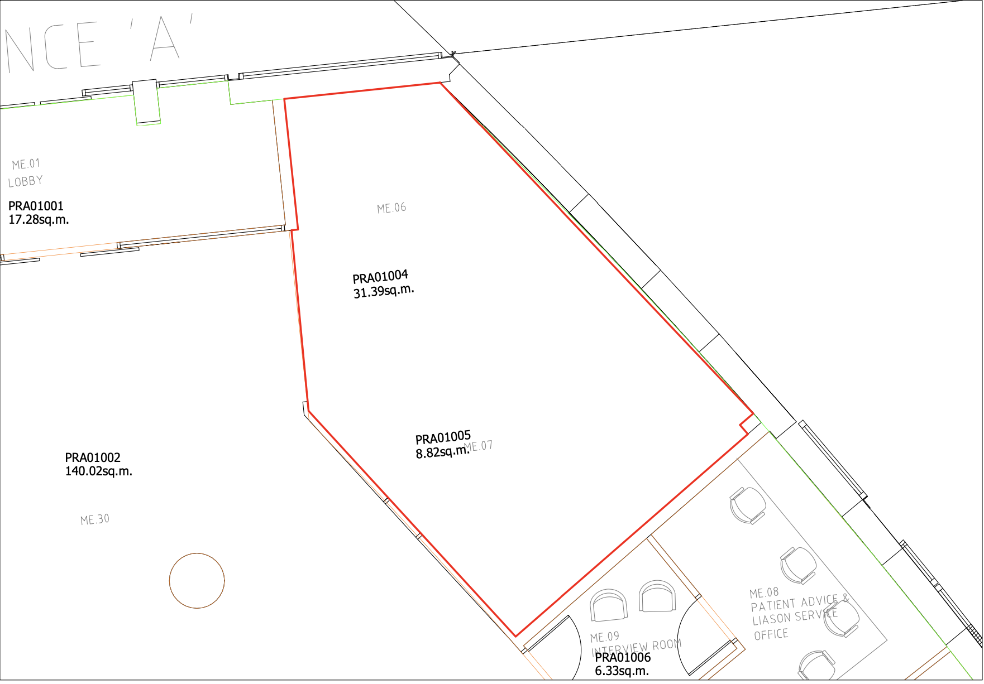

Annex 1a.
Photos Folder titled ‘Smaller Unit SHOP’

Annex 1b:

PRA01 - PRUH-A Princess Royal University Hospital, A Ground Floor, 01

Please refer to entrance A*

*Note Entrance A is the Hospital’s Main Entrance.

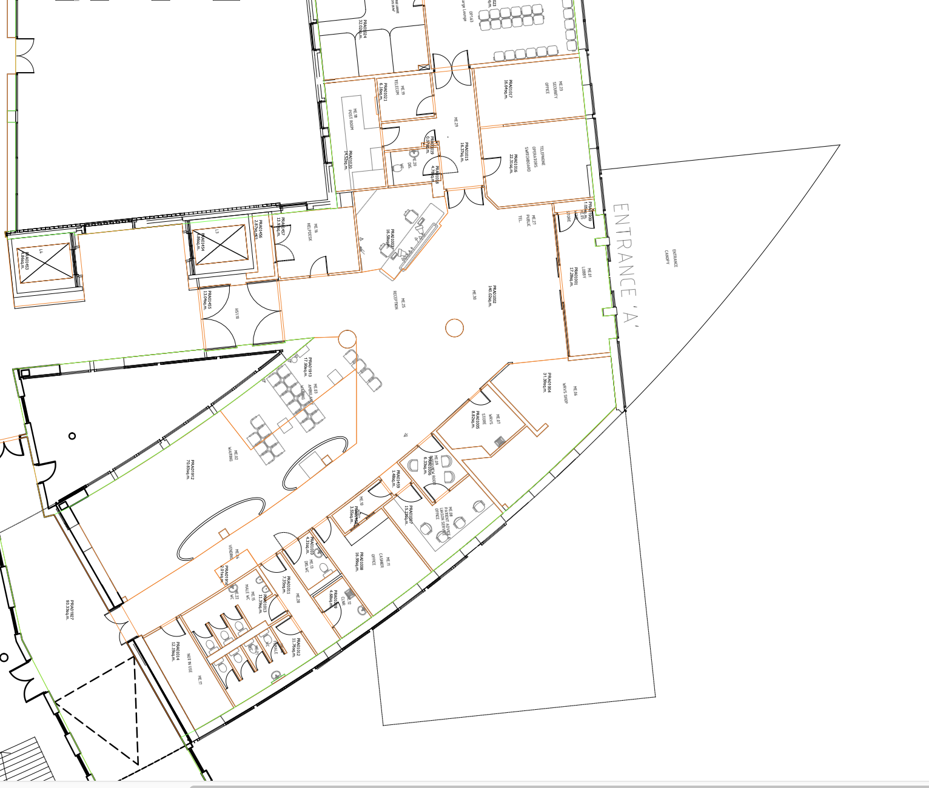

Annex 2: Bigger Unit (Education Centre Restaurant)
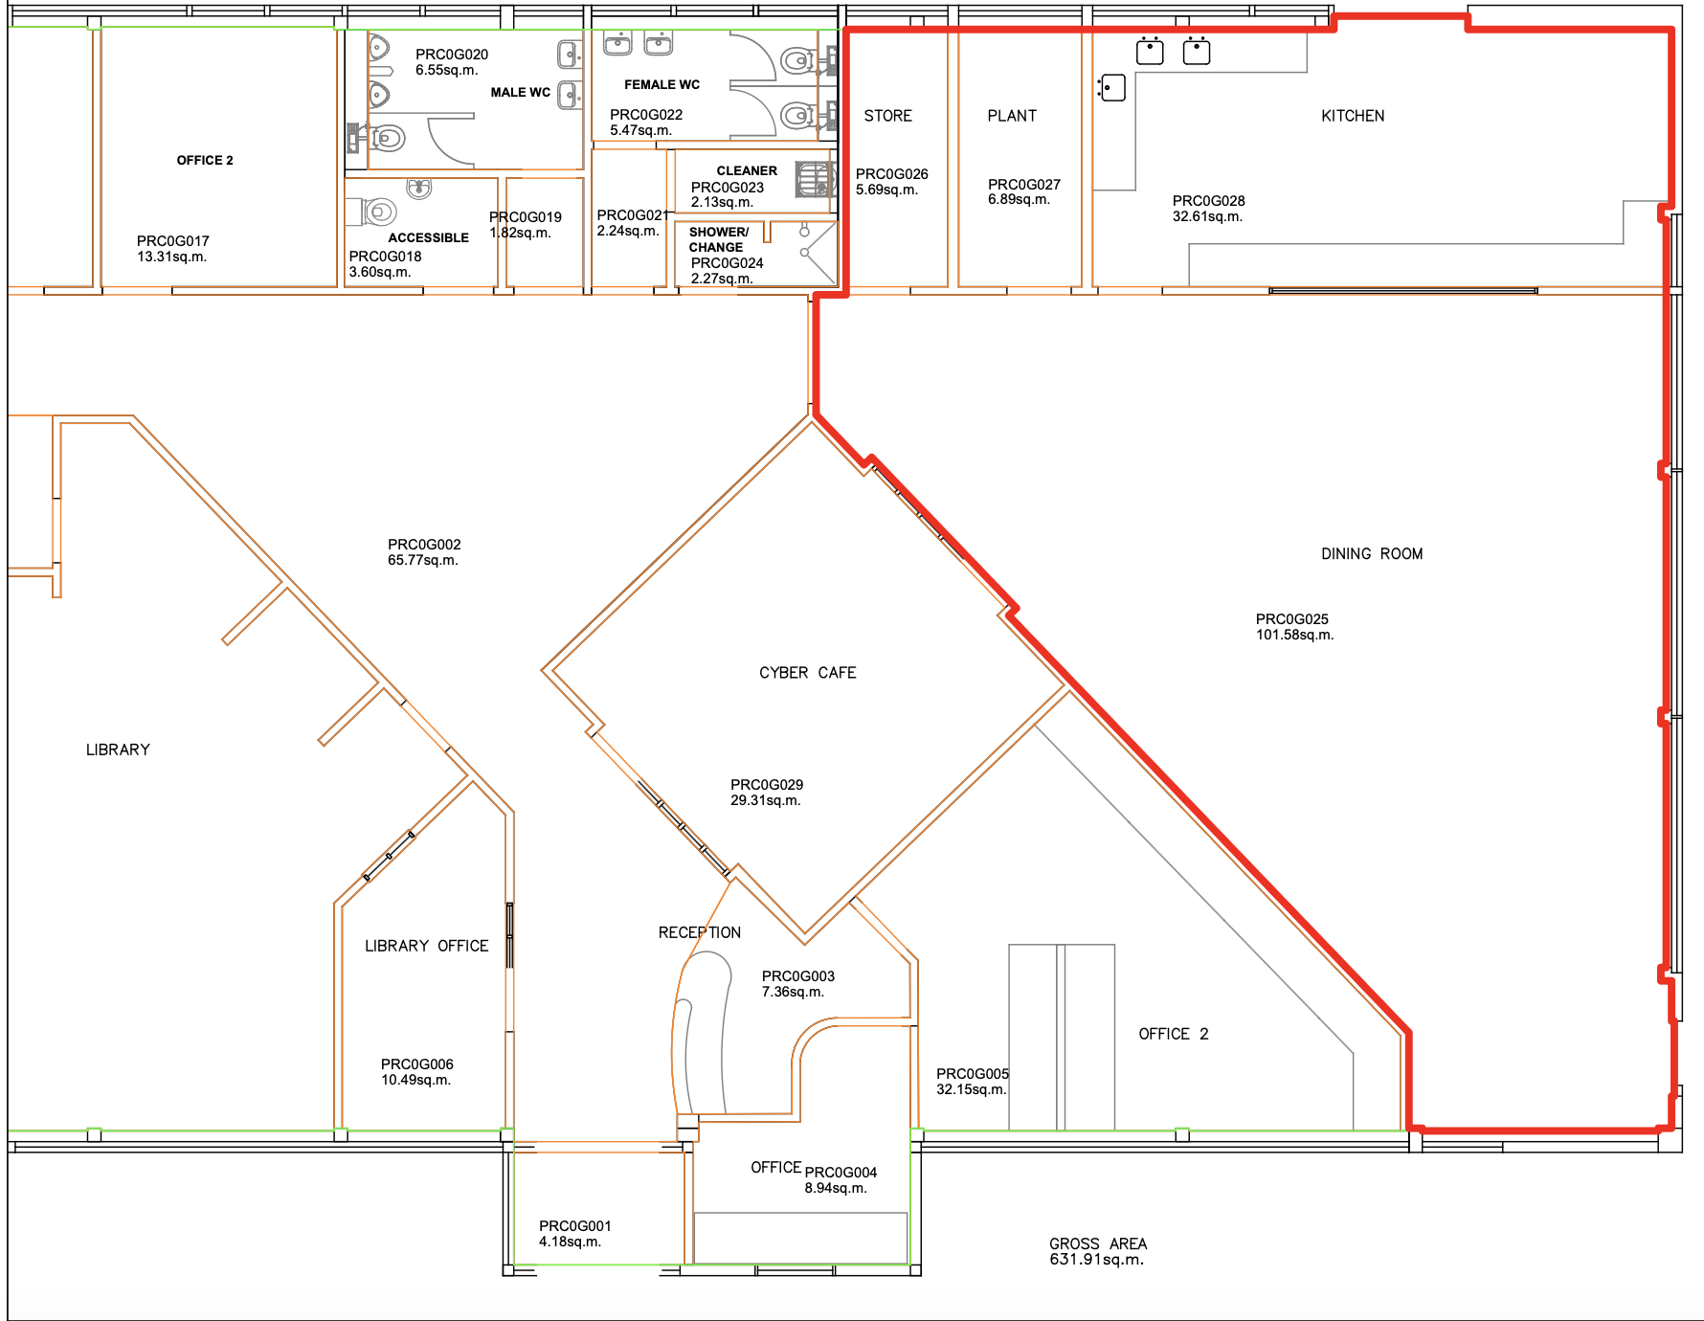
Annex 2a:

Photos Folder titled ‘Bigger Unit (Education Centre Restaurant)’

Annex 2b:
Please refer to building next to DTC with yellow box around*. Building I shlighted in red below – PGMB.

*Note Entrance A is the Hospital’s Main Entrance. Highlighted with green box. Red arrow reference below.

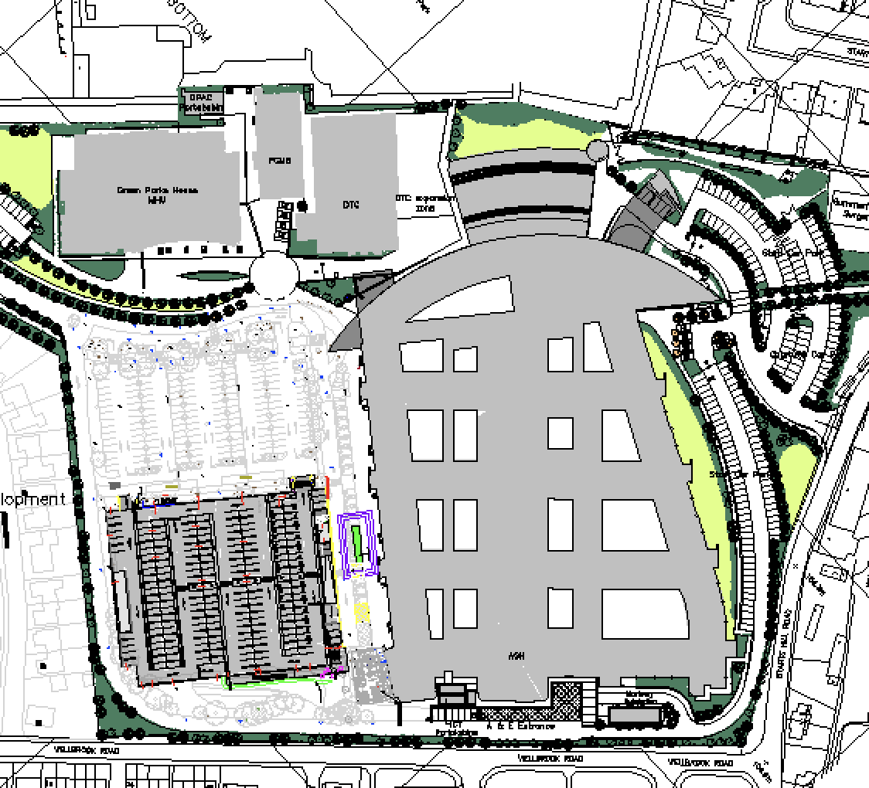
Entrance A

