The Electric Theatre Soft Market Testing Prospectus V3

Introduction

Guildford Borough Council wishes to secure a strong vibrant future for The Electric Theatre. It is an important entertainment venue in the town and provides a prominent facility for community theatre.
We recognise that a skilled operator must have sufficient headroom to put together a commercially sustainable programme of entertainments for which there is strong demand. Alongside this, we would like to see the venue remain as a performing arts facility with community use. This was agreed by the Council’s Executive in April 2016 and the report can be found here: http://www2.guildford.gov.uk/councilmeetings/documents/s4920/Item%2006%20-%20Electric%20Theatre%20and%20YAT%20Working%20Group.pdf.
Following a public consultation around the future operation of the Theatre ‘community use’ has been identified largely as ‘performances, theatre, festivals and education’.
We wish to consult skilled operators in this field as to how these aims can be balanced for The Electric Theatre in the future.
To this end, we are conducting soft market testing to garner your views on these aspects plus other important considerations including the procurement route.
Thus, the Council may choose a concession or lease route to secure the future of the Theatre.
We are keen to control your financial and time involvement in bidding for the work, but at the same time believe that a procurement route with the opportunity to talk about risks which worry you and to give the opportunity to negotiate, would give a better result for both parties.
Amanda Hargreaves will be project managing the procurement process on behalf of the Council. She has left her previous role of General Manager of The Electric Theatre and is no longer involved in its day to day operation. Her focus is solely on delivering a fair and open procurement process for the Theatre.

Applying

If you would like to see us to discuss this opportunity then please write, in no more than one thousand words, describing your interest in the procurement, your past experience in the field and the points you would like to discuss.
We plan to undertake soft market testing on 3 consecutive days which will occur close to the centre of Guildford in the date range between July and September. Each party would have two hours with a common agenda and the meeting will be held in Guildford.
If you are not seen please rest assured that this will not disadvantage you in any forthcoming formal procurement. All parties that express an interest will receive feedback from the soft market testing event before an Official Journal of the European Union notice is published (marking the start of the formal procurement procedure).
Please send your submission to amanda.hargreaves@guildford.gov.uk [Project Manager] and vincent.hunt@guildford.gov.uk [Procurement]

by 6th July 2016. Any clarification questions to these e- mail addresses please.

Project management

The procurement is being run on a project managed basis and we have engaged a dedicated Project Manager to ensure the programme remains deliverable. There is a Procurement Board in place to exercise robust governance and to ensure that communication channels between the Council and bidders remain robust.

Feedback to potential participants

Feedback will be given to those participating in the soft market testing exercise. This will be on an anonymised basis and we will ensure that information of a commercially confidential nature will not be included in feedback.

Freedom of information

The Council is subject to the Freedom of Information Act 2000 and the Environmental Information Regulations 1992 and may be obliged, when requested, to disclose information you provide to us even though it may be regarded as confidential. However, the exemption from disclosure applying to information which, if disclosed, would or would be likely to prejudice the commercial interests of any person including the Council (including such information relating to a procurement exercise) will apply, provided that the public interest in maintaining the exemption outweighs the public interest in disclosing the information.

Queries
Where we receive queries in relation to this prospectus and we believe the response will be of general interest, we will circulate the query and response to all the parties that have expressed an interest.

Canvassing

You should note that canvassing or lobbying (defined as communications with the Council or individual stakeholders) outside the channels identified in the Prior Information Notice might affect your ability to engage with any procurement process. Your attention is also drawn to the provisions of the Bribery Act 2010.

Indicative procurement timescales

Generic Timeline for Concession Procurement Route
Event | Duration in working days | Start Date | Finish Date
PIN notice | 1d | Wed 08/06/16 | Wed 08/06/16
Response time | 20d | Thu 09/06/16 | Wed 06/07/16
Selection of firms | 5d | Thu 07/07/16 | Wed 13/07/16
Firms preparing | 10d | Thu 14/07/16 | Wed 27/07/16
Soft market test- indicative | 5d | Thu 28/07/16 | Wed 03/08/16
Analysis | 5d | Thu 04/08/16 | Wed 10/08/16
Feedback | 5d | Thu 11/08/16 | Wed 17/08/16
Document preparation | 15d | Thu 18/08/16 | Wed 07/09/16
OJEU notice published (concession route) | 1d | Thu 08/09/16 | Thu 08/09/16
Statutory response period- 35 calendar days | 28d | Fri 09/09/16 | Tue 18/10/16
Initial submissions received | 0d | Tue 18/10/16 | Tue 18/10/16
Evaluation | 15d | Wed 19/10/16 | Tue 08/11/16
Selection of 5 firms to dialogue with -ITPD | 1d | Wed 09/11/16 | Wed 09/11/16
Firms preparing | 10d | Thu 10/11/16 | Wed 23/11/16
Active dialogue | 20d | Thu 24/11/16 | Wed 21/12/16
Call for final tenders | 1d | Thu 22/12/16 | Thu 22/12/16
Bidders preparing tenders | 20d | Fri 23/12/16 | Thu 19/01/17
Tenders received | 0d | Thu 19/01/17 | Thu 19/01/17
Evaluation | 15d | Fri 20/01/17 | Thu 09/02/17
Governance processes | 15d | Fri 10/02/17 | Thu 02/03/17
Standstill- both phases | 10d | Fri 03/03/17 | Thu 16/03/17
Contract award notice published | 1d | Fri 17/03/17 | Fri 17/03/17
Mobilisation | 20d | Mon 20/03/17 | Fri 14/04/17
Theatre begins operation under new regime | 0d | Fri 14/04/17 | Fri 14/04/17

Background information on The Electric Theatre
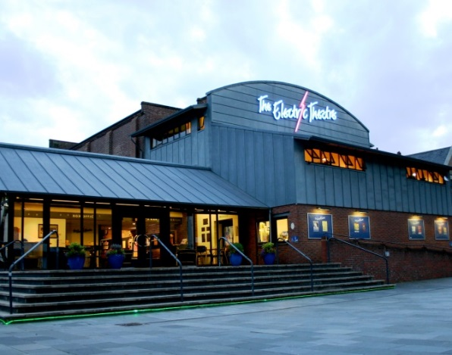
The Electric Theatre is a multi-purpose venue featuring community and professional work in the heart of Guildford. The Theatre is owned and operated by Guildford Borough Council in a building which was originally constructed as an electricity works in the early part of the twentieth century. In the 1990s the building was converted into a Theatre with an extension at the ground, first and second floor levels, with the venue opening in 1997.

Within the Theatre there is an open plan entrance foyer which encompasses a Café Bar; the main auditorium with retractable seating for 210 people; ancillary offices and dressing rooms; rehearsal space and basement storage/stage lift and workshop areas.

The Theatre’s current programme features several Festivals (Film, Family, International Music, Spring Music and Book) alongside local amateur dramatic performances, community / educational workshops and professional acts. The Theatre also plays host to an Urban Beach in the space outside the venue.

